**SWEET HOME- Hotel room booking application**

**Workflow as below:**

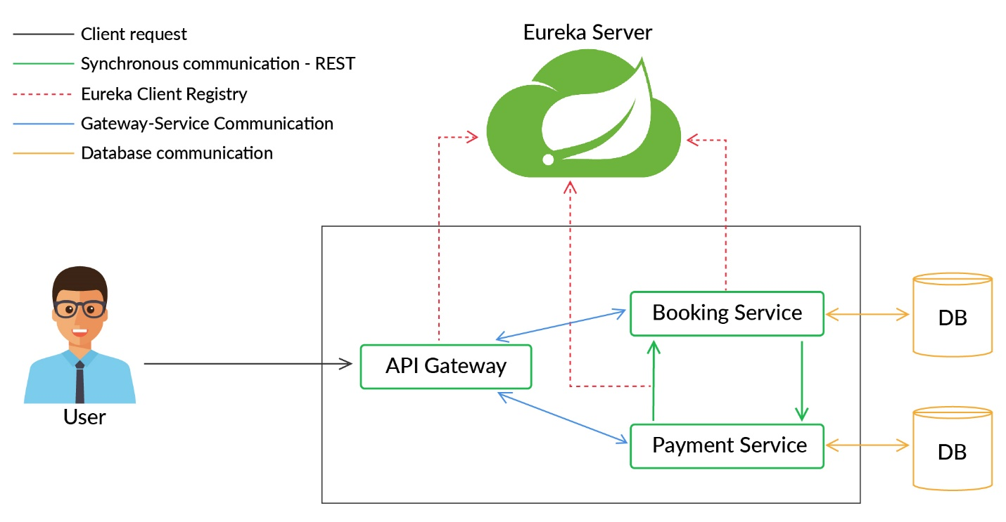

1. Created API Gateway, Booking Service and Payment service.
2. Registered them on Eureka server.

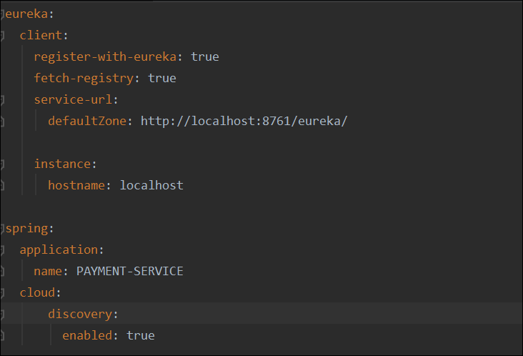

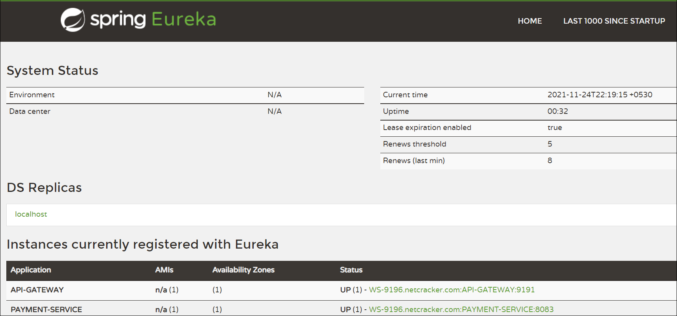

1. If user wants to make any request, request will first land on API Gateway.

Created configurations in API gateway accordingly.

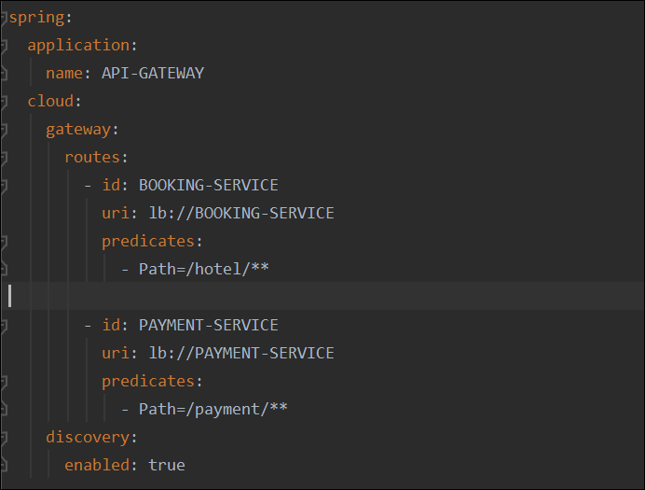

1. Data storage

Databases for Booking service and Payment service created and made configurations accordingly.

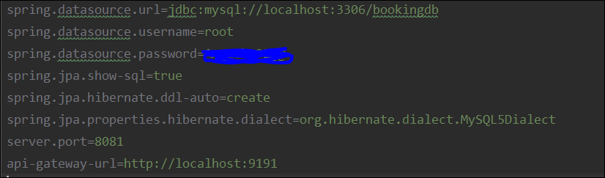

Similarly made configurations for payment service as well.

1. APIs for accessing Booking Services

The user initiates room booking using the 'Booking' service by providing information such as

toDate, fromDate, aadharNumber and number of rooms required (numOfRooms).

**Logic to calculate room prices.**

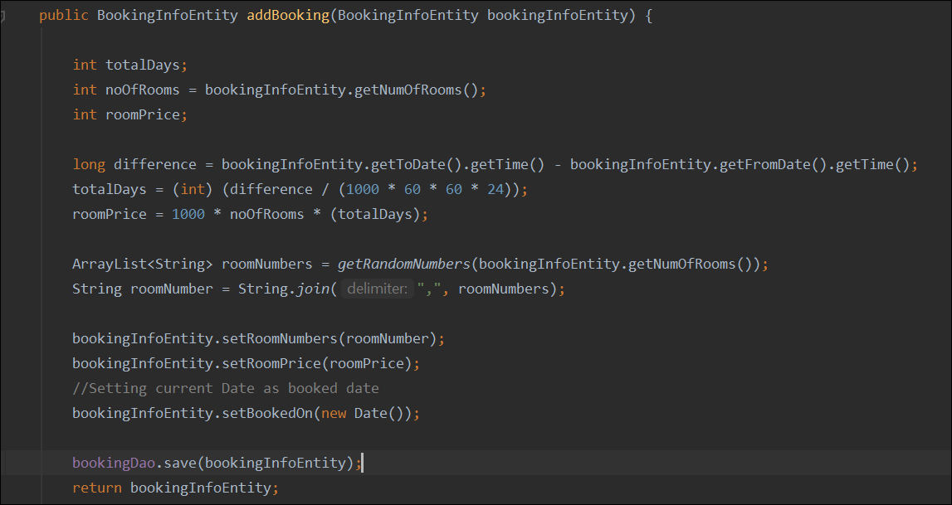

**Logic added as below to get random room numbers**

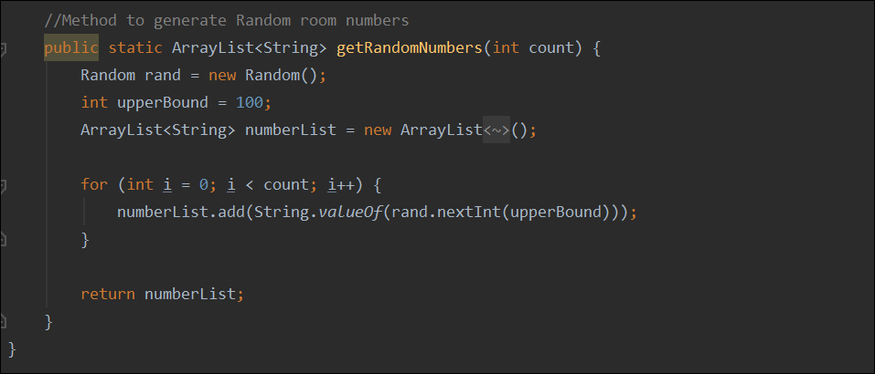

1. **APIs for accessing Payment Service**

If the user wants to go ahead with the booking, then they can simply provide the payment related details like bookingMode, upiId/ cardNumber to the 'Booking' service which will be further sent to the 'Payment' service. Based on this data, the payment service will perform a dummy transaction and return back the transaction Id associated with the transaction to the Booking service. All the information related to transactions is saved in the database of the payment service.

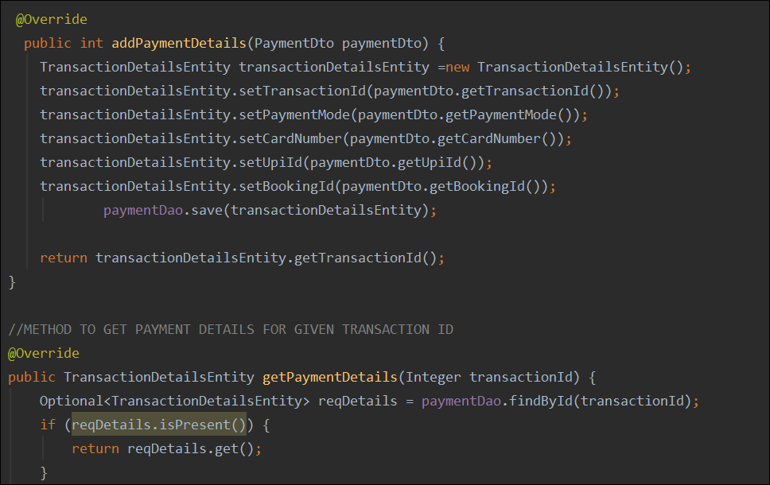

-----------------------------------------------------THANK YOU----------------------------------------------------------------------