Assignment - 4
Title: Business Model Canvas for Two Innovative Business Ideas

Business Idea 1: SafeFood AI

1. Introduction

Food safety and food waste are global challenges costing over $1 trillion annually, with millions of tons of edible food discarded due to static expiry labels and poor supply chain monitoring. Traditional packaging methods fail to provide accurate, real-time data about food quality, often causing premature disposal of safe products or exposing consumers to unsafe ones. This creates inefficiencies, health risks, and sustainability concerns across the food industry.
SafeFood AI solves this problem by embedding IoT-enabled sensors and AI algorithms into smart packaging that tracks freshness, contamination, and nutritional value dynamically. The system provides actionable insights to retailers, delivery companies, regulators, and consumers, ensuring transparency and efficiency throughout the supply chain. By reducing food waste, cutting recall costs, and building consumer trust, SafeFood AI positions itself not just as packaging innovation but as a transformative solution for safer, smarter, and more sustainable food ecosystems.

2. Objectives
The primary objective of SafeFood AI is to revolutionize the way food freshness and safety are monitored across global supply chains. By embedding IoT sensors and AI-powered analytics into packaging, the business aims to provide stakeholders—retailers, delivery companies, regulators, and consumers—with real-time visibility into food quality. This transparency ensures that food waste is reduced, recalls are minimized, and customer confidence is significantly strengthened.
Another key objective is to make the technology affordable and scalable, allowing even mid-sized retailers and local food businesses to adopt intelligent packaging without prohibitive costs. SafeFood AI intends to partner with packaging manufacturers, regulators, and global supermarket chains to create a trusted ecosystem of safe and sustainable food delivery. Over time, the platform also aims to expand beyond food to include pharmaceutical and cosmetic packaging, ensuring quality and safety in multiple industries.
Ultimately, SafeFood AI strives to become a global standard for intelligent packaging—improving public health, reducing environmental impact, and supporting the United Nations’ sustainability goals by cutting down food waste and carbon emissions across supply chains.

3. Business Model Canvas
1. Customer Segments: Grocery retailers, food delivery platforms, restaurant chains, regulators, and eco-conscious consumers.
2. Value Proposition: Dynamic freshness tracking, contamination alerts, and reduced waste with improved safety.
3. Channels: Online B2B sales, trade shows, distributor networks, e-commerce for small businesses.
4. Customer Relationships: Subscription support, pilot programs, corporate partnerships, customer success teams.
5. Revenue Streams: Subscription fees, label sales, integration charges, and analytics dashboards.
6. Key Resources: AI algorithms, IoT sensors, data analytics platform, strategic partnerships, skilled engineers.
7. Key Activities: R&D, packaging production, data analytics, customer onboarding, regulatory compliance.
8. Key Partnerships: Packaging manufacturers, IoT chip suppliers, food safety regulators, logistics partners.
9. Cost Structure: R&D expenses, manufacturing, marketing, regulatory certifications, and platform maintenance.
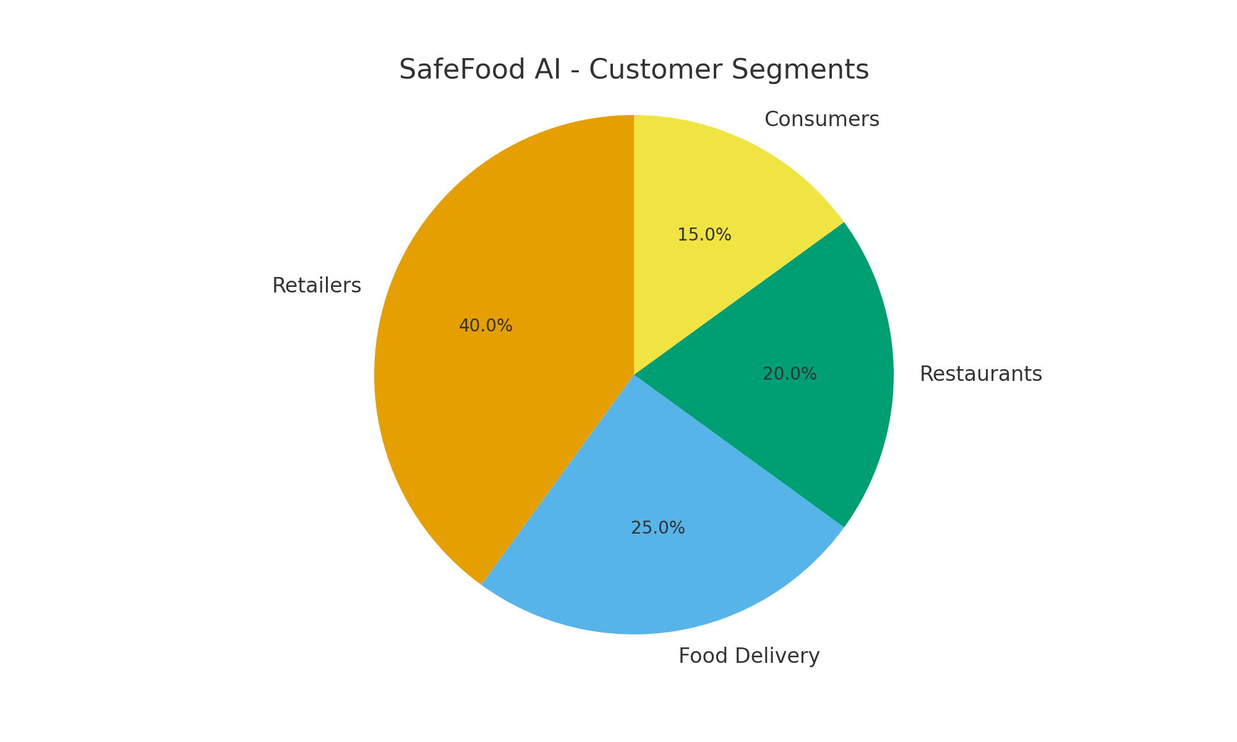

4. Revenue Model
- Subscription for analytics dashboard: $500/month per retailer.
- Smart Label Packs: $0.08 per unit sold in bulk.
- Premium Integration: $25,000 one-time setup.
- Data monetization through insights sold to regulators and research institutes.

5. Growth Opportunities
- Expansion into pharmaceuticals and cosmetics packaging.
- Partnerships with global supermarket chains.
- Integration with blockchain for supply chain transparency.
- Global exports targeting US, Europe, and Asia.

6. Challenges
- High initial R&D investment.
- Gaining regulatory approvals across different countries.
- Competing with established packaging companies.
- Convincing traditional retailers to adopt new technology.

7. Conclusion
SafeFood AI positions itself as a global leader in food safety and sustainability.
By merging IoT, AI, and packaging, it creates significant impact by reducing waste, boosting transparency,
and ensuring compliance. With scalable growth opportunities and a strong revenue model, SafeFood AI
has the potential to revolutionize the global food supply chain.

Business Idea 2: AquaHarvest 360

1. Introduction
Urbanization and climate change are placing unprecedented stress on global food systems. With 70% of people projected to live in cities by 2050 and water resources becoming scarce, traditional farming methods cannot sustainably meet rising demand. Cities face the dual challenge of limited space and increasing food insecurity, creating the need for innovative, resource-efficient farming solutions.
AquaHarvest 360 addresses this gap through an AI-driven vertical aquaponics system that merges fish farming with hydroponic plant cultivation in a closed-loop cycle. Using 90% less water and producing up to 5x more food per square foot, it enables year-round, eco-friendly urban food production. By transforming unused spaces like rooftops and warehouses into farming hubs, AquaHarvest 360 reduces carbon emissions, ensures fresher produce, and supports sustainable urban living. It represents a scalable blueprint for future-ready agriculture in smart cities worldwide.

2. Objectives
Urbanization and climate change are placing unprecedented stress on global food systems. With 70% of people projected to live in cities by 2050 and water resources becoming scarce, traditional farming methods cannot sustainably meet rising demand. Cities face the dual challenge of limited space and increasing food insecurity, creating the need for innovative, resource-efficient farming solutions.
AquaHarvest 360 addresses this gap through an AI-driven vertical aquaponics system that merges fish farming with hydroponic plant cultivation in a closed-loop cycle. Using 90% less water and producing up to 5x more food per square foot, it enables year-round, eco-friendly urban food production. By transforming unused spaces like rooftops and warehouses into farming hubs, AquaHarvest 360 reduces carbon emissions, ensures fresher produce, and supports sustainable urban living. It represents a scalable blueprint for future-ready agriculture in smart cities worldwide.

3. Business Model Canvas
1. Customer Segments: Urban developers, smart cities, eco-conscious communities, retailers, and restaurants.
2. Value Proposition: Year-round food production, water conservation, and zero-waste cycles.
3. Channels: Direct sales to cities, partnerships with real estate projects, retail networks, online platforms.
4. Customer Relationships: Long-term maintenance contracts, training programs, sustainability certifications.
5. Revenue Streams: System installation charges, recurring maintenance fees, produce sales, and licensing.
6. Key Resources: AI platform, aquaponics infrastructure, skilled engineers, water recycling technology.
7. Key Activities: Installation, monitoring, data analysis, R&D, community workshops.
8. Key Partnerships: Urban planners, real estate developers, sustainability NGOs, IoT technology firms.
9. Cost Structure: Infrastructure setup, R&D, staff training, marketing, and logistics.
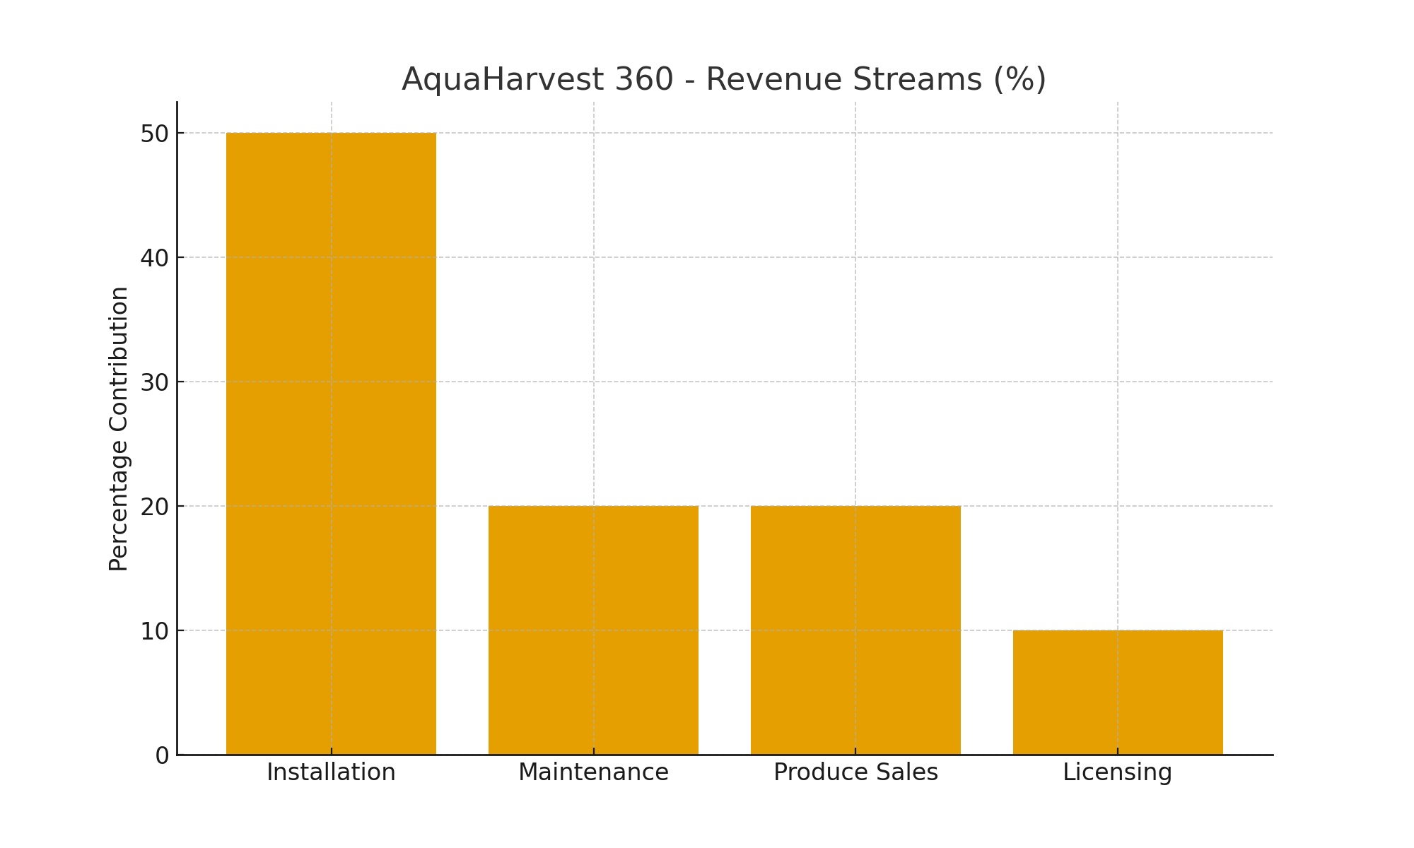

4. Revenue Model
- Installation Fees: $100,000–$250,000 per system depending on scale.
- Maintenance Contracts: $10,000 annually per installation.
- Produce Sales: Direct B2B sales to supermarkets and restaurants.
- Licensing: Intellectual property licensing for aquaponics design worldwide.

5. Growth Opportunities
- Expansion into Middle East and Africa for food security.
- Collaborations with smart city projects in Asia.
- Scaling into household-level compact aquaponics units.
- Integration with renewable energy sources like solar and wind.

6. Challenges
- High upfront installation costs may discourage adoption.
- Requires continuous monitoring and technical expertise.
- Competition from traditional agriculture and hydroponics.
- Consumer acceptance of lab-grown or aquaponics-based food.

7. Conclusion
AquaHarvest 360 redefines urban farming by merging aquaculture and hydroponics into a
sustainable, AI-driven system. With strong market demand for fresh, local, and eco-friendly food,
the business has significant growth opportunities. By addressing food security challenges while
promoting sustainability, AquaHarvest 360 can become a cornerstone of urban agriculture worldwide.

