GreenQuizyy - Upload excel help

Overview of the file green-quizyy-test.xls

- Total 2 sheets.
- Ignore the “DATA” sheet.
- “TEST” is the sheet to be used for uploading questions.
- There are 16 types of questions supported.
- Data sheet has a short description of each question type.

Don’ts

- DO NOT RENAME ANY OF THE SHEETS.
- DO NOT DELETE ANY OF THE SHEETS.

Table of contents
01. V-MCQ-1 [ Select 1 / 5 ] 3
02. V-TC-1 [ 1 blank, 5 choices, 1 correct ] 4
03. Q-MCQ-1 [ Choose 1 from 5 ] 5
04. Q-MCQ-2 [ Choose 1 or more from n ] 6
05. Q-NE-1 [ Numerical Entry, 1 TextBox ] 7
06. Image instructions 8

01. V-MCQ-1 [ Select 1 / 5 with a passage ]
- Select “V-MCQ-1” from the dropdown in the “Type” column.

- Fill up below fields marked for each question.
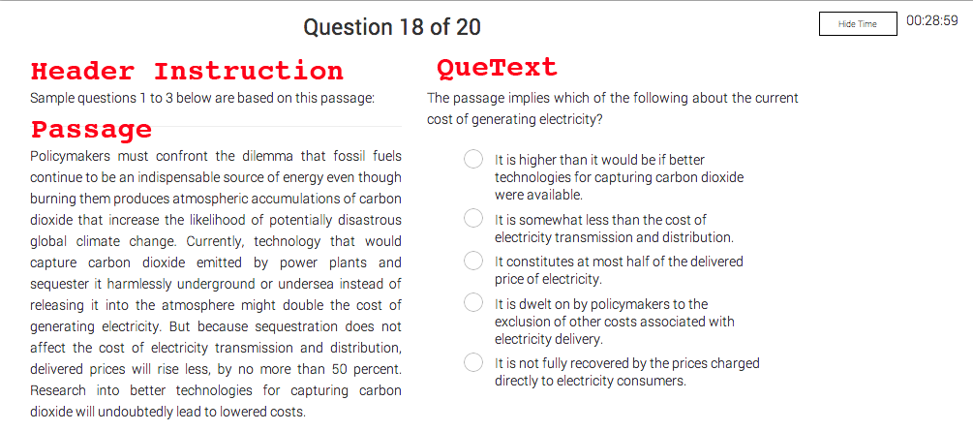
- Provide a passage to be displayed on the left.
- Provide 5 options
- Enter a number from 1-5 to indicate correct option.

02. V-TC-1 [ 1 blank, 5 choices, 1 correct ]
- Select “V-TC-1” from the dropdown in the “Type” column

- Fill up below fields marked for each question.
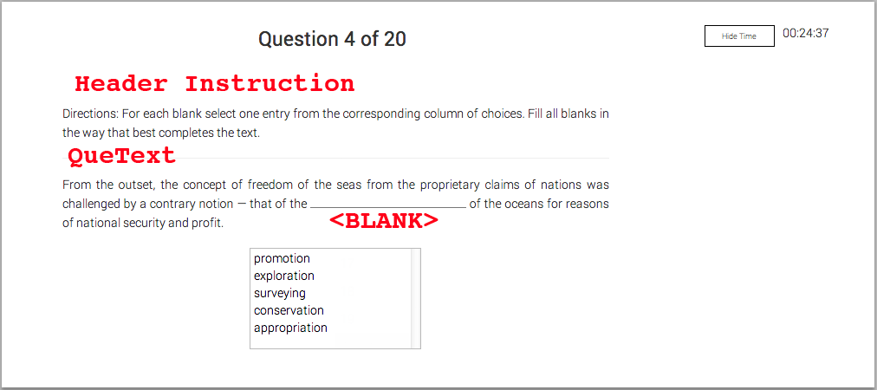
- Provide 5 options
- Enter a number from 1-5 to indicate correct option.
- Use <BLANK> to indicate the blank in the sentence.
  - Ex: Dramatic literature often <BLANK> the history of a culture....

03. Q-MCQ-1 [ Choose 1 from 5 ]
- Select “Q-MCQ-1” from the dropdown in the “Type” column
- Fill up below fields marked for each question.
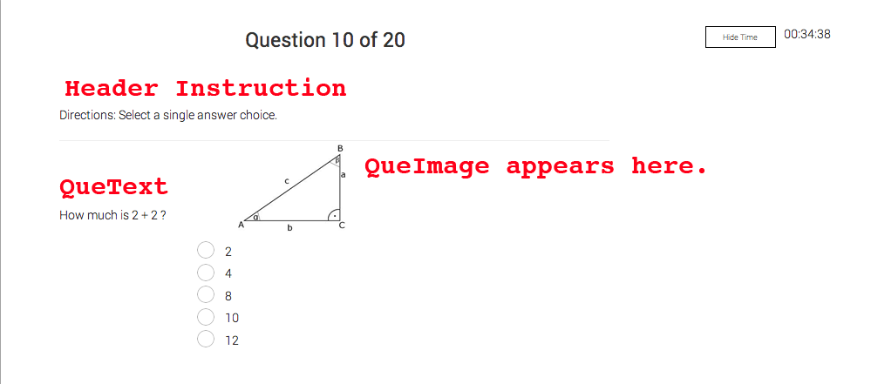

- Specify 5 options
- Enter an integer value indicating the correct answer.
- Specify the name of the image to be used in “QueImage”
  - Ex: que_15.png
  - Don’t use names with space for QueImage column. [ Ex: “que 14.png”]
  - Replace space with underscore in the image name.

04. Q-MCQ-2 [ Choose 1 or more from n ]
- Select “Q-MCQ-2” from the dropdown in the “Type” column
- “Options” field has a dropdown menu here. Select the number of options here.
- By default 5 options are taken.
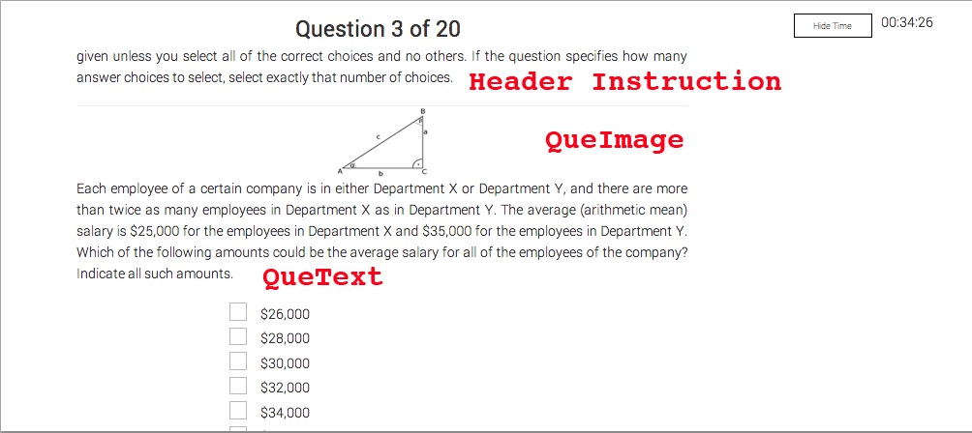

- Specify n options
- Enter comma separated integers to indicate correct answers.
  - Ex. 1,4,6
- Specify the name of the image to be used in “QueImage”

05. Q-NE-1 [ Numerical Entry, 1 TextBox ]
- Select “Q-NE-1” from the dropdown in the “Type” column
- Fill up the fields as marked in the below image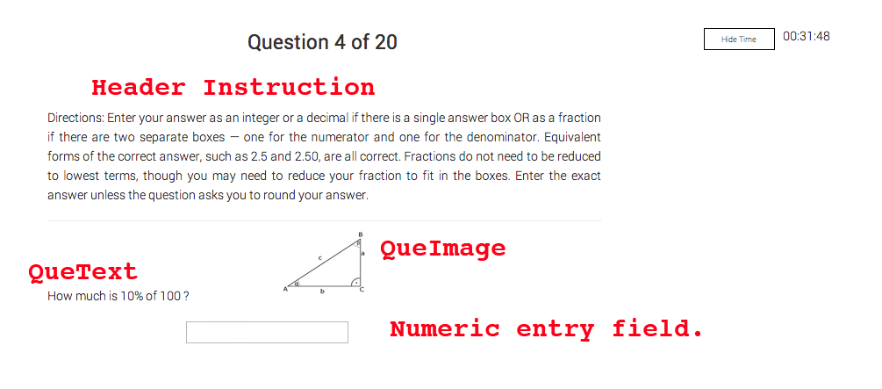
- No options required.
- Specify numeric answer in the correct field.
  - Be careful when entering decimal values.
  - Text that appears in the field will be considered as it is.
  - Manually check once to make sure correct value is entered.

06. Image instructions

- QueImage: Image that needs to appear for the question.
- SolImage: Image that needs to appear for the solution.
- Supported filetypes: “.png” & “.jpg”
- Filenames should end in “.png” or “.jpg”
- Don’t use a space as part of the filename.
  - Invalid filename: “que 15.png”
  - Valid filename: “que_15.png”
- When image field is not required make sure you put up “-” for QueImage or SolImage.

