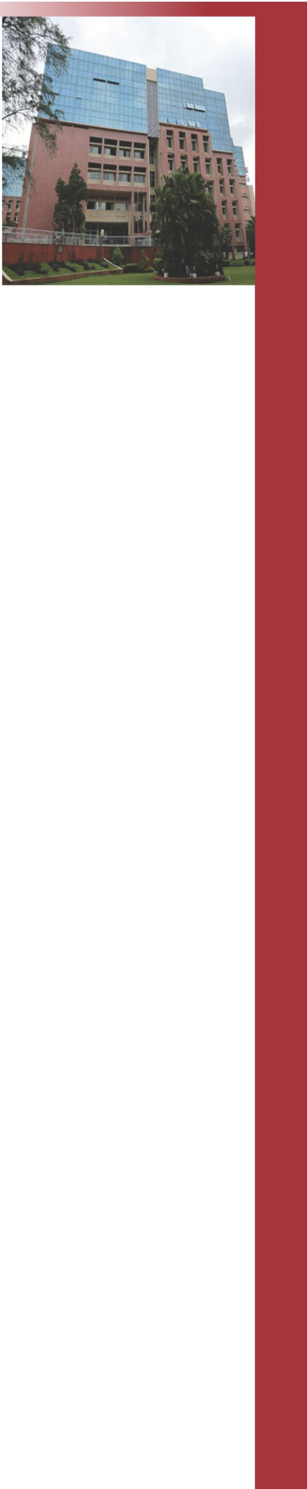



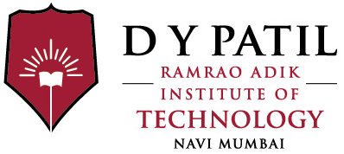

Hands-on Session

on

*“Python Web Development with Django Framework”*

Certificate of Appreciation

We deeply appreciate the excellent contribution of ${name}

as a ***${conduct}*** for the Hands-on session on ***${event}*** conducted by Department of ${branch} Engineering at Ramrao Adik Institute of Technology, Nerul, Navi Mumbai on 23,March 2018.

Dr. Leena Ragha

Head, Computer Engg.

 [**www.rait.ac.in**](http://www.rait.ac.in/)