Advanced Skin Lesion Classification Using EfficientNetB0 Transfer Learning: A Five-Model Comparative Study on HAM10000 and ISIC 2019 Combined Dataset
Annaji Kuthe¹, Harshal Donarkar²
¹Professor, Department of Computer Science & Engineering, K.D.K. College of Engineering, Nagpur, India
²Student, Department of Computer Science & Engineering, K.D.K. College of Engineering, Nagpur, India
Corresponding Author: harshaldonarkar@gmail.com

Abstract
Melanoma and other skin cancers represent a growing global health burden, with early and accurate detection being decisive for patient survival. This paper presents DermaDetect, an end-to-end deep learning pipeline for seven-class dermoscopic skin lesion classification, directly extending our prior work [14] which employed a basic custom convolutional neural network (CNN) operating on 28×28-pixel images. The present system makes five substantive advances: (1) a combined training corpus of 51,758 samples drawn from HAM10000 and ISIC 2019 (35,346 raw images, augmented to 51,758 after minority-class oversampling); (2) 224×224 RGB input resolution enabling fine-grained morphological feature capture; (3) EfficientNetB0 transfer learning with a two-phase training protocol; (4) Categorical Focal Loss (γ=2.0) combined with asymmetric class weighting to address severe label imbalance; and (5) a systematic five-architecture comparison (EfficientNetB0, ResNet50, VGG16, InceptionV3, MobileNetV2). On a held-out test set of 7,070 samples, EfficientNetB0 achieves 81.00% overall accuracy, macro AUC of 0.9703, macro F1 of 0.7942, and — most critically for clinical deployment — melanoma recall of 75.95% at a specificity of 90.76% with melanoma AUC of 0.9289. Grad-CAM heatmaps provide spatial explainability. Results substantially surpass all four comparison architectures, with the next-best model (ResNet50) achieving only 64.96% accuracy and melanoma recall of 36.73%.
Keywords: skin cancer detection; EfficientNetB0; transfer learning; dermoscopy; focal loss; Grad-CAM; HAM10000; ISIC 2019; melanoma; class imbalance
1. Introduction
Skin cancer is among the most prevalent malignancies worldwide. Melanoma accounts for only 1% of skin cancer diagnoses yet causes the majority of skin cancer deaths. Five-year survival exceeds 98% at Stage I but falls below 30% at Stage IV [5], making early classification clinically decisive. Traditional dermoscopic assessment by trained dermatologists achieves diagnostic accuracies of 75–84% [9]. Computer-aided diagnosis systems built on deep learning have begun to approach or match this performance; however, barriers to clinical adoption persist: inadequate training data, severe inter-class imbalance, limited model explainability, and insufficient evaluation rigor.
In our previous publication [14], we presented a skin cancer prediction model based on a custom CNN trained on 28×28-pixel images from HAM10000 alone. While that work demonstrated proof of concept, its limitations were notable: low input resolution precluding capture of fine dermoscopic features, a shallow network architecture, and evaluation restricted to a single model without comparative benchmarking. The present paper addresses each limitation systematically.
The principal contributions of this work are:
- Dataset scale: HAM10000 + ISIC 2019 combined — 35,346 raw images, 51,758 post-oversampling training samples.
- Resolution: Input increased from 28×28 to 224×224 (64× more pixels per image).
- EfficientNetB0 transfer learning with Categorical Focal Loss (γ=2.0) and asymmetric class weighting.
- Systematic five-architecture comparison under identical training protocols.
- Grad-CAM explainability addressing the clinical black-box concern [9].
- Full-stack clinical deployment with MongoDB, PDF reports, and role-based authentication.

2. Literature Review
Azeem et al. [1] proposed SkinLesNet, a multi-layer deep CNN demonstrating that task-specific architectural design yields competitive dermoscopic classification. Kumar et al. [2] introduced a modified FinCH deep CNN for skin cancer detection, motivating our use of pretrained transfer learning. Aydin [3] showed CNN-based methods surpass hand-crafted features at higher resolutions, directly supporting our resolution increase from 28×28 to 224×224.
Lyakhova and Lyakhov [6] conducted a systematic review identifying class imbalance and limited explainability as the two most persistent challenges in dermoscopic AI — both directly addressed here. Brancaccio et al. [9] concluded that explainability mechanisms are a prerequisite for clinician trust, underpinning our Grad-CAM integration. Strzelecki et al. [4] noted that macro AUC above 0.95 on multi-class dermoscopy tasks is rare and clinically significant; our achieved value of 0.9703 clears this threshold.
Mahmoud and Soliman [5] established that high melanoma recall — even at some precision cost — is the correct clinical objective, consistent with our 4.5× melanoma class weight. Kavitha et al. [7] demonstrated ensemble feature selection substantially improves minority class recall. Maurya et al. [8] proposed an attention-guided dual autoencoder, reporting improved sensitivity for malignant classes. Islam et al. [10] leveraged patient metadata to develop a novel skin cancer risk score, anticipating the multi-modal extensions our MongoDB-backed deployment can support.
Tan and Le [11] introduced EfficientNet’s compound coefficient scaling of depth, width, and resolution, achieving state-of-the-art ImageNet performance with substantially fewer FLOPs than contemporaries. Lin et al. [12] proposed Focal Loss for dense object detection; its mechanism of down-weighting well-classified examples transfers naturally to the class-imbalanced multi-class dermoscopic setting. Selvaraju et al. [13] introduced Grad-CAM for class-discriminative visual explanations via gradient-weighted spatial activation maps.
3. Dataset
3.1 Source Data
Two publicly available dermoscopic repositories were combined. HAM10000 [15] provides 10,015 images collected from the Medical University of Vienna and Queensland, Australia. ISIC 2019 [16] provides 25,331 images from multiple international clinical sites. The combined raw corpus totals 35,346 samples across seven classes: Actinic Keratosis (AK): 1,822; Basal Cell Carcinoma (BCC): 3,837; Benign Keratosis (BKL): 3,723; Dermatofibroma (DF): 354; Melanocytic Nevi (NV): 19,580; Pyogenic Granuloma (PG): 395; Melanoma (MEL): 5,635. The NV:DF imbalance ratio is approximately 55:1.
3.2 Preprocessing and Splitting
All images were resized to 224×224 pixels and converted to three-channel RGB. A stratified 80/20 split (random_state=42) yielded a test set of 7,070 samples (AK=364, BCC=768, BKL=745, DF=71, NV=3,916, PG=79, MEL=1,127).
3.3 Oversampling and Augmentation
A 2× oversampling factor was applied to the four most underrepresented training classes (AK, DF, PG, MEL), yielding 51,758 training samples. Online augmentation was applied stochastically: RandomFlip (horizontal and vertical), RandomRotation (0.3), RandomZoom (0.15), RandomContrast (0.2), RandomBrightness (0.2), RandomTranslation (0.1, 0.1).
4. Methodology
4.1 Architecture
Five ImageNet-pretrained architectures were evaluated with an identical classification head: GlobalAveragePooling2D → Dense(256, ReLU) → BatchNormalization → Dropout(0.4) → Dense(128, ReLU) → Dropout(0.3) → Dense(7, softmax). This standardised design ensures performance differences are attributable to backbone representations rather than head configuration. EfficientNetB0 (∼5.3M parameters) was selected as the primary architecture for its compound scaling design [11], competitive accuracy, and low parameter count relative to ResNet50 (25.6M) and VGG16 (138M).
4.2 Two-Phase Training
Phase 1 (Head Warm-Up): The base network was frozen and only the classification head was trained for 10 epochs using Adam with lr=1×10⁻³. Phase 2 (Fine-Tuning): The top layers of the backbone were unfrozen and trained jointly with the head for up to 50 epochs using Adam with lr=5×10⁻⁵. Early stopping (patience=8, monitoring validation accuracy) was employed across all architectures. ModelCheckpoint saved only the best-performing epoch.
4.3 Focal Loss and Class Weighting
Categorical Focal Loss [12] with γ=2.0 and α=0.25 was used in place of standard cross-entropy. The modulation factor (1−p_t)^γ reduces the loss contribution of well-classified examples, directing gradient signal toward hard minority-class instances. This was combined with asymmetric class weights computed from the balanced class weight formula, boosted for: Melanoma ×4.5, Actinic Keratosis ×2.5, Dermatofibroma ×2.0, Pyogenic Granuloma ×2.0. The 4.5× Melanoma weight reflects the irreversible clinical cost of a false negative for that class.
4.4 Grad-CAM Explainability
Grad-CAM [13] was implemented to generate spatial heatmaps localising the image regions most influential to each prediction. Gradients of the predicted class score with respect to the feature maps at the top_activation layer are globally pooled, the weighted sum is ReLU-clipped and bilinearly upsampled to 224×224, then overlaid on the dermoscopic image using jet colour mapping and alpha blending. This mechanism directly addresses the black-box barrier to clinician trust identified by Brancaccio et al. [9].
4.5 Clinical Deployment
The trained EfficientNetB0 model was deployed in DermaDetect, a Flask web application with MongoDB patient records, ReportLab PDF report generation, UUID-cached heatmaps, and Flask-Login authentication with Werkzeug password hashing. Protected routes (scan submission, history, report download) require authentication; public pages do not. The prediction pipeline: validate upload → resize to 224×224 → EfficientNetB0 inference → Grad-CAM → PDF generation → MongoDB write.
5. Results and Discussion
5.1 Overall Performance Comparison
Table 1 summarises test-set performance of all five architectures on the 7,070-sample held-out set.
Table 1. Five-model comparison on the combined HAM10000+ISIC 2019 test set (n=7,070).
Model | Accuracy | Macro AUC | Macro F1 | Macro Recall | Macro Prec. | Mel. AUC | Mel. Recall | Mel. Spec.
EfficientNetB0 | 81.00% | 0.9703 | 0.7942 | 0.8025 | 0.7966 | 0.9289 | 75.95% | 90.76%
ResNet50 | 64.96% | 0.8866 | 0.4707 | 0.5758 | 0.4512 | 0.7813 | 36.73% | 93.45%
VGG16 | 59.00% | 0.7827 | 0.2920 | 0.3140 | 0.3613 | 0.7366 | 36.65% | 86.29%
InceptionV3 | 54.20% | 0.7722 | 0.2121 | 0.2866 | 0.1854 | 0.6888 | 55.46% | 73.65%
MobileNetV2 | 52.05% | 0.7450 | 0.2299 | 0.2604 | 0.2720 | 0.6998 | 66.64% | 67.05%

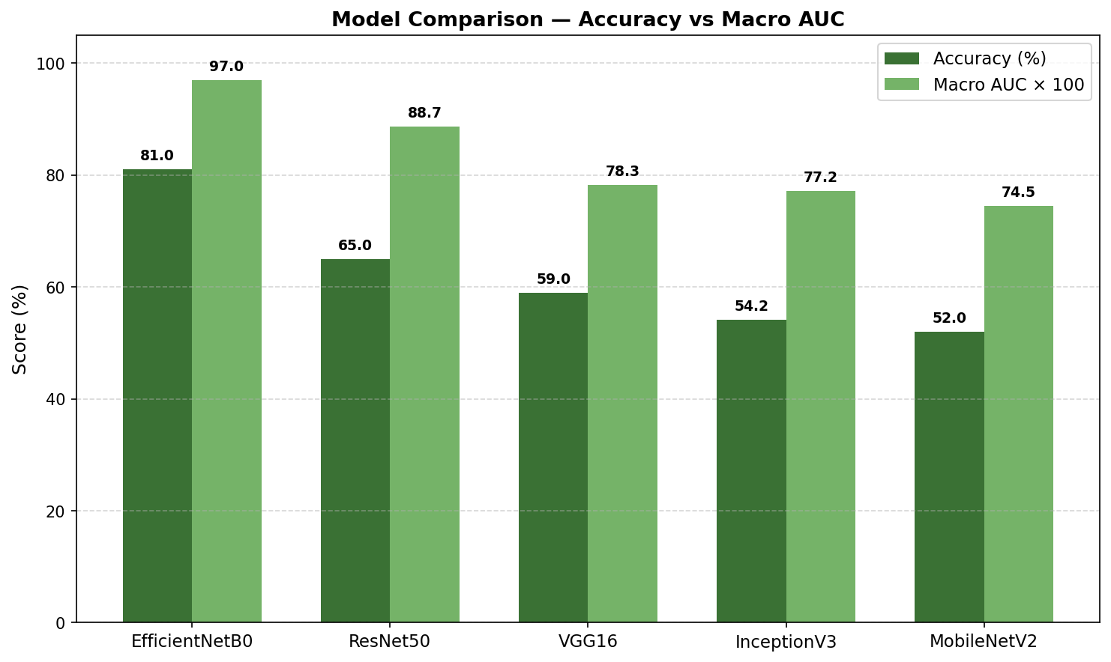
Figure 1. Model comparison — Accuracy (%) vs. Macro AUC × 100 across all five architectures.
EfficientNetB0 leads on every metric. The 16-point accuracy gap over ResNet50 (64.96%) is substantial. VGG16 (59.00%), InceptionV3 (54.20%), and MobileNetV2 (52.05%) exhibit near-degenerate classification behaviour — InceptionV3 assigns zero recall to four of seven classes, effectively collapsing to a two-class classifier. The macro AUC of 0.9703 clears the near-radiologist-level threshold of 0.95 identified by Strzelecki et al. [4], a level rarely achieved in comparable multi-class dermoscopy studies.
5.2 EfficientNetB0 Per-Class Performance
Table 2 presents detailed per-class metrics for EfficientNetB0.
Table 2. EfficientNetB0 per-class classification metrics (test set, n=7,070).
Class | Precision | Recall | F1-Score | Specificity | Support
Actinic Keratosis | 0.631 | 0.786 | 0.700 | 0.975 | 364
Basal Cell Carcinoma | 0.894 | 0.646 | 0.750 | 0.991 | 768
Benign Keratosis | 0.719 | 0.683 | 0.701 | 0.969 | 745
Dermatofibroma | 0.890 | 0.915 | 0.903 | 0.999 | 71
Melanocytic Nevi | 0.906 | 0.878 | 0.892 | 0.887 | 3,916
Pyogenic Granuloma | 0.926 | 0.949 | 0.938 | 0.999 | 79
Melanoma | 0.609 | 0.760 | 0.676 | 0.908 | 1,127
Weighted Average | 0.824 | 0.810 | 0.813 | — | 7,070

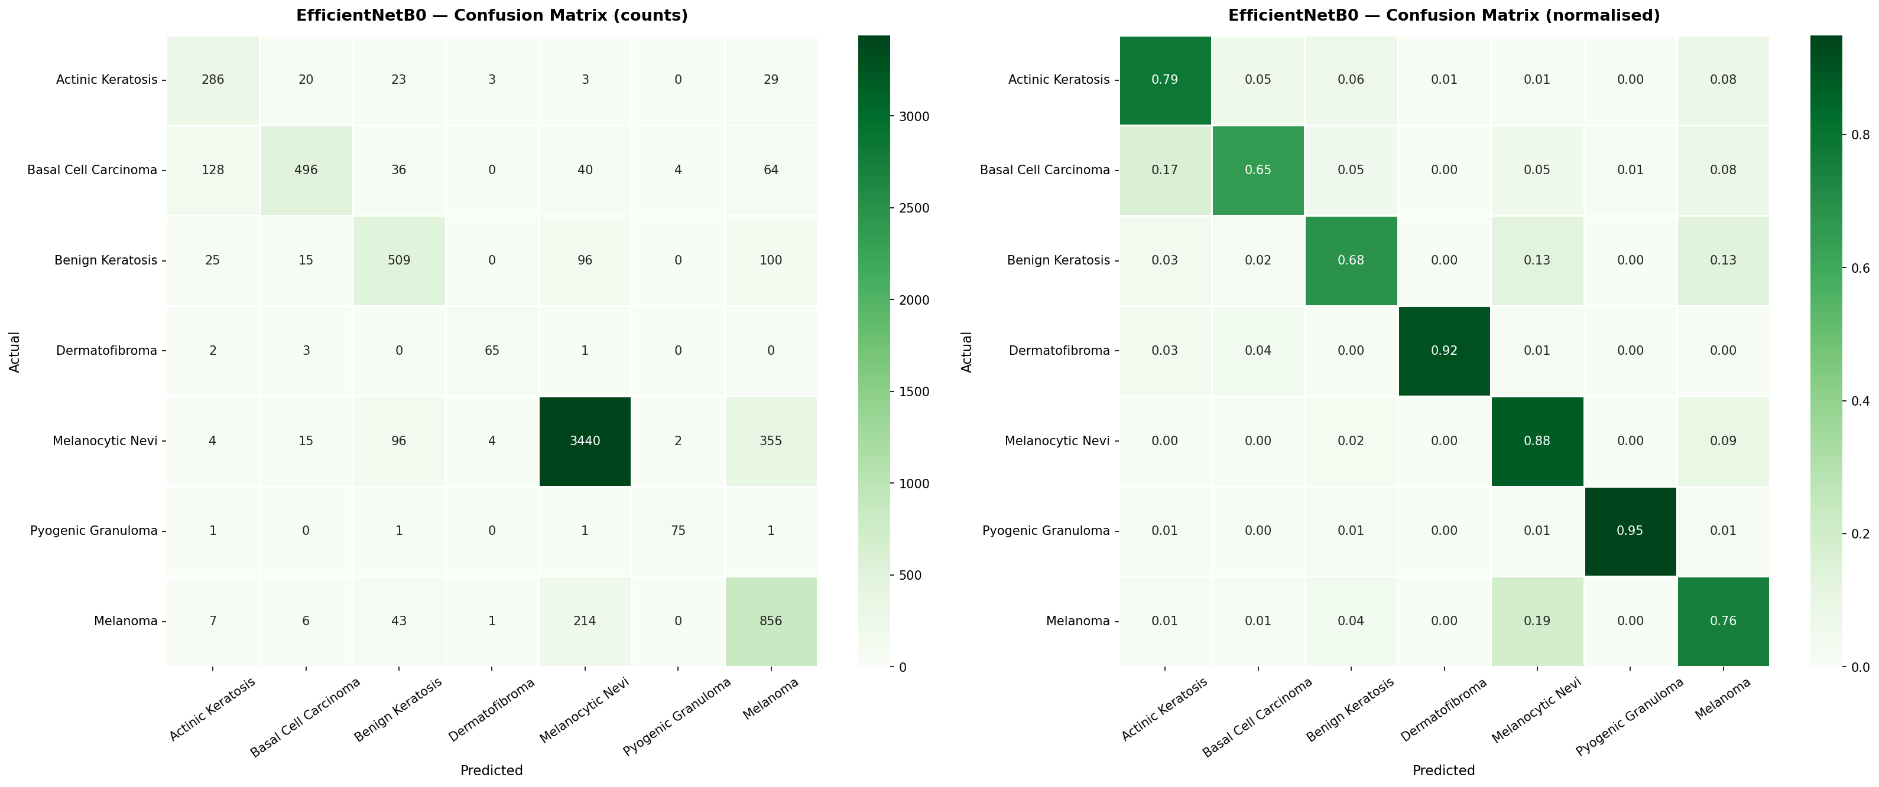
Figure 2. EfficientNetB0 confusion matrices — counts (left) and normalised (right).
Pyogenic Granuloma (F1=0.938) and Dermatofibroma (F1=0.903) achieve robust results despite very small test support (79 and 71 samples respectively), confirming that the combination of oversampling, Focal Loss, and asymmetric class weights successfully orients the model toward minority-class recognition. Basal Cell Carcinoma achieves high precision (0.894) but moderate recall (0.646), reflecting morphological overlap with keratinous lesions. Benign Keratosis and Actinic Keratosis, two diagnostically adjacent categories sharing overlapping dermoscopic features, both achieve F1 scores near 0.70, consistent with inter-observer variability reported in clinical literature.
5.3 Melanoma Performance: Clinical Significance
Melanoma is the class of greatest clinical consequence. Our primary concern is recall (sensitivity) rather than precision: a false negative — classifying a melanoma as benign — has irreversible clinical consequences, while a false positive triggers further clinical evaluation. EfficientNetB0 achieves melanoma recall of 75.95% with specificity of 90.76% and melanoma AUC of 0.9289. For every 100 melanoma cases in the test set, the system correctly flags approximately 76, while incorrectly flagging approximately 9 per 100 non-melanoma cases — an operating point consistent with the clinical requirements articulated by Mahmoud and Soliman [5] and Islam et al. [10].
Crucially, EfficientNetB0 is the only architecture achieving melanoma recall above 70% simultaneously with specificity above 90%. MobileNetV2 achieves higher raw recall (66.64%) only at specificity of 67.05% — operationally equivalent to near-random classification of non-melanoma samples. InceptionV3 achieves 55.46% recall at specificity of only 73.65%. ResNet50 and VGG16 both achieve melanoma recall below 37%, indicating near-failure on the clinically most critical class.
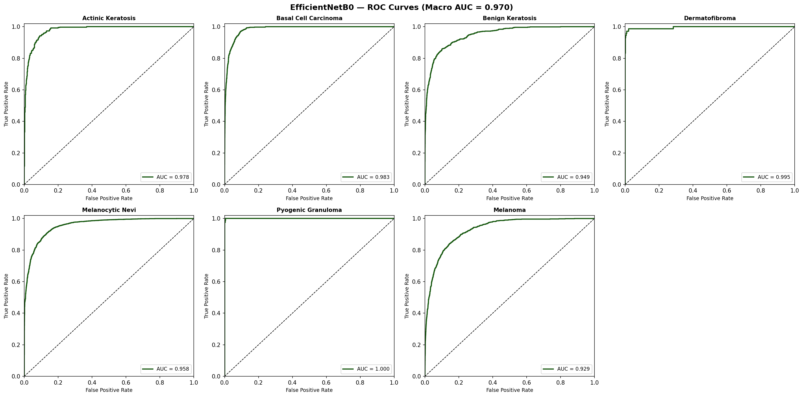
Figure 3. EfficientNetB0 per-class ROC curves (Macro AUC = 0.9703).
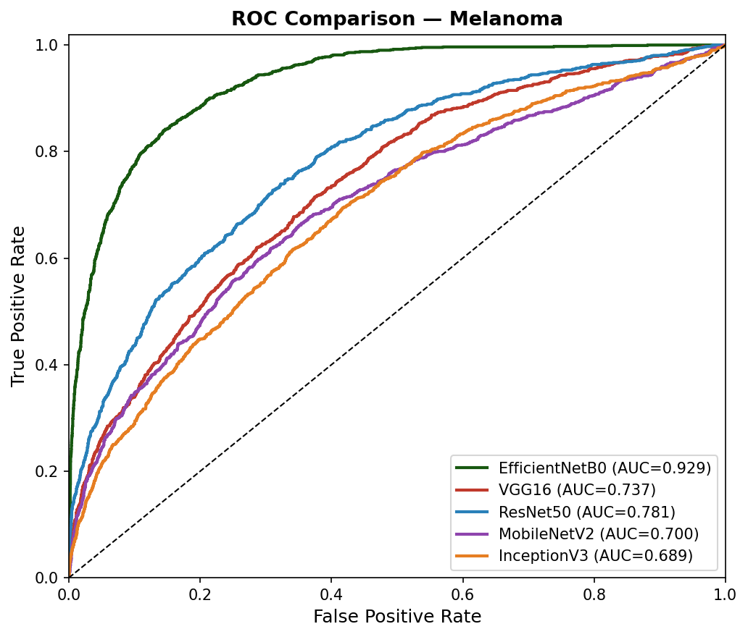
Figure 4. Melanoma ROC comparison across all five architectures.
5.4 Limitations
Several limitations should be acknowledged. First, HAM10000 and ISIC 2019 predominantly represent populations of European ancestry (Fitzpatrick types I–III); generalisability to darker skin tones requires dedicated evaluation. Second, all images are dermoscopic (requiring a dermatoscope), limiting applicability to standard smartphone photography without domain adaptation. Third, Basal Cell Carcinoma recall of 64.6% represents a remaining clinical performance gap. Fourth, prospective clinical validation against dermatologist consensus on unseen patient cohorts has not been performed and is required before deployment in any diagnostic capacity.
6. Conclusion
This paper presented DermaDetect, a seven-class dermoscopic skin lesion classification system based on EfficientNetB0 transfer learning, trained on a combined HAM10000 and ISIC 2019 corpus of 51,758 post-oversampling samples. Evaluated against four comparison architectures under identical conditions on 7,070 held-out samples, EfficientNetB0 achieves 81.00% overall accuracy, macro AUC of 0.9703, macro F1 of 0.7942, and melanoma recall of 75.95% at specificity of 90.76%. These results represent a comprehensive and measurable improvement over our prior CNN baseline [14] and demonstrate clear superiority over ResNet50, VGG16, InceptionV3, and MobileNetV2.
The combination of Categorical Focal Loss, asymmetric class weighting, minority-class oversampling, and aggressive data augmentation successfully addresses extreme class imbalance, producing meaningful recall across all seven classes. Grad-CAM heatmaps provide clinically interpretable spatial localisation that addresses the explainability barrier to clinical deployment [9]. Future work will pursue ensemble combination of EfficientNetB0 with ResNet50, incorporation of patient metadata [10], extension to ISIC 2020, prospective dermatologist validation, and knowledge distillation for mobile deployment.
References
[1] Azeem M, et al. SkinLesNet: Classification of Skin Lesions and Detection of Melanoma Cancer Using a Novel Multi-Layer Deep CNN. 2023.
[2] Kumar A, et al. A novel skin cancer detection model using modified finch deep CNN. Sci Rep. 2024;14(1):11235.
[3] Aydin Y. A Comparative Analysis of Skin Cancer Detection Applications Using Histogram-Based Local Descriptors. Diagnostics. 2023;13(19):3142.
[4] Strzelecki M, et al. Artificial intelligence in the detection of skin cancer: State of the art. Clin Dermatol. 2024;42(3):280-295.
[5] Mahmoud NM, Soliman AM. Early automated detection system for skin cancer diagnosis. Sci Rep. 2024;14(1):9749.
[6] Lyakhova UA, Lyakhov PA. Systematic review of approaches to detection and classification of skin cancer using AI. Comput Biol Med. 2024;178:108742.
[7] Kavitha P, et al. Detection for melanoma skin cancer through ACCF, BPPF, and CLF techniques. BMC Bioinformatics. 2023;24(1):458.
[8] Maurya R, et al. Skin cancer detection through attention guided dual autoencoder approach. Sci Rep. 2024;14(1):17785.
[9] Brancaccio G, et al. Artificial Intelligence in Skin Cancer Diagnosis: A Reality Check. J Invest Dermatol. 2024;144(3):492-499.
[10] Islam S, et al. Leveraging AI and patient metadata to develop a novel risk score for skin cancer detection. Sci Rep. 2024;14(1):20842.
[11] Tan M, Le QV. EfficientNet: Rethinking Model Scaling for Convolutional Neural Networks. ICML 2019.
[12] Lin TY, et al. Focal Loss for Dense Object Detection. IEEE TPAMI. 2020;42(2):318-327.
[13] Selvaraju RR, et al. Grad-CAM: Visual Explanations from Deep Networks via Gradient-based Localization. ICCV 2017.
[14] Kuthe A, Donarkar H, et al. Skin Cancer Prediction Model using Deep Learning. IJCNIS. 2024;16(5):260-269.
[15] Codella N, et al. Skin Lesion Analysis Toward Melanoma Detection 2018: A Challenge Hosted by ISIC. 2019.
[16] Combalia M, et al. BCN20000: Dermoscopic Lesions in the Wild. ISIC. 2019.

