In the java project of FEE REPORT .

There is a admin .Admin must login with name and password .

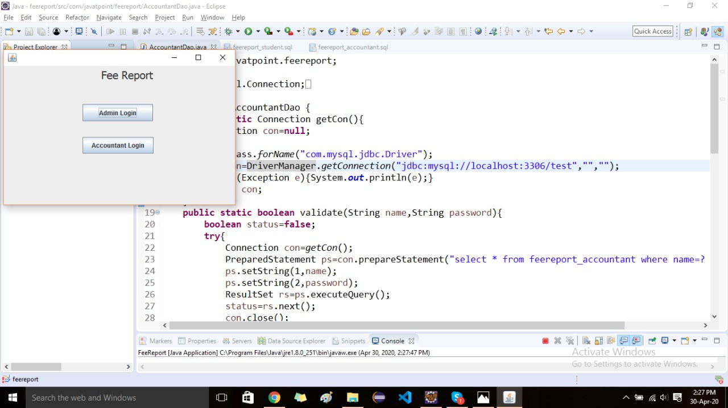

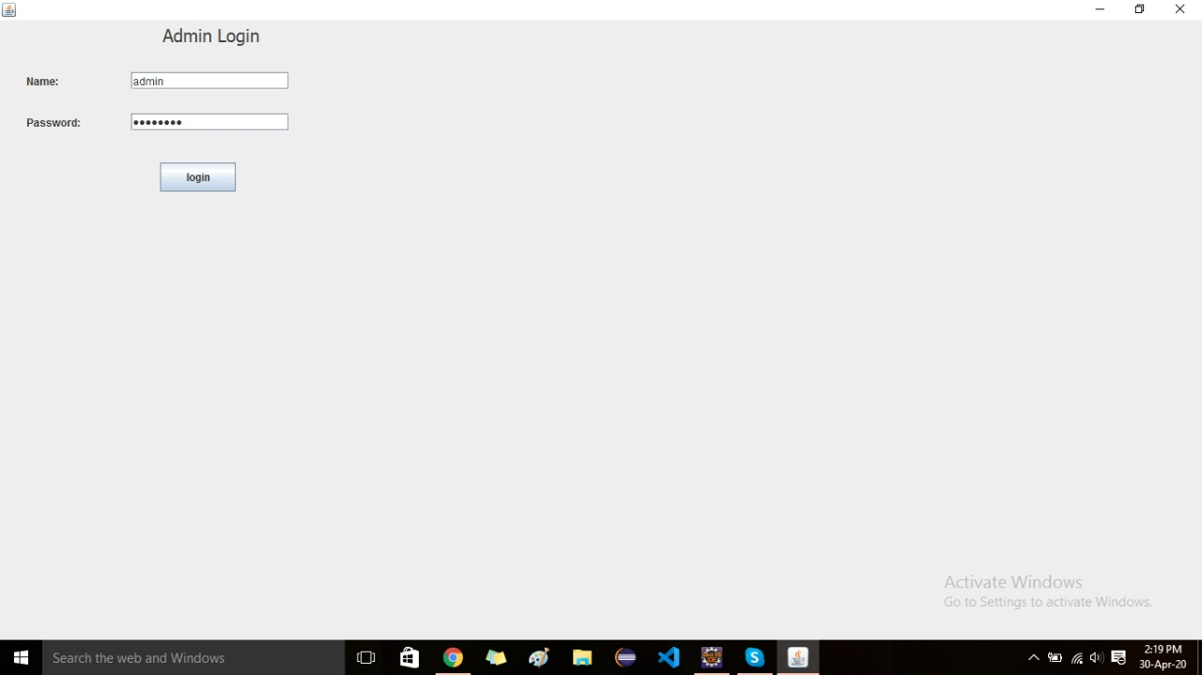

Admin can add accountant to the table by taking the information of the accountant name , password, email id, and contact no.

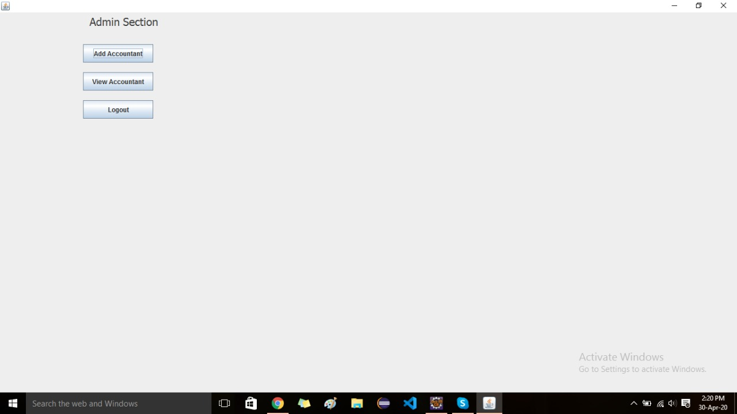

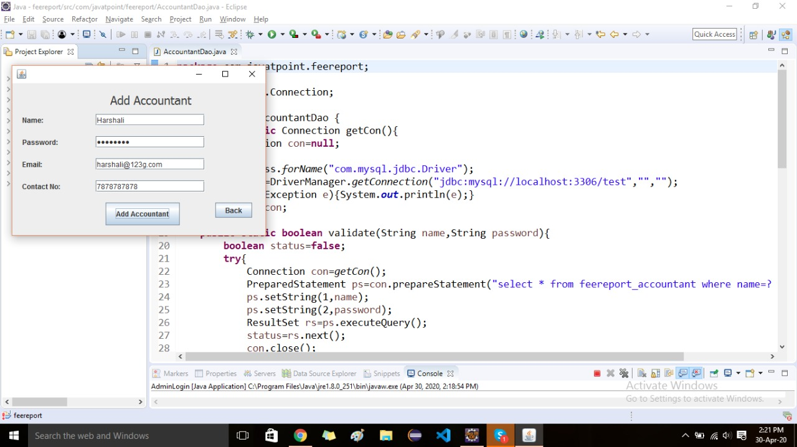

After adding accountant. Accountant can add students in which student name, mail id, course, fee, paid fee, due fee, address, city, state, country , contact no. accountant make a list of fee management of a student .

