Lingala Harshavardhan Reddy

EE14B088

Abstract

Spectral analysis of MST radar echoes through spectral movement estimation allowing us to find the velocity of the air at different levels in atmosphere. By adding sound source, we can calculate the height profile of temperature in atmosphere.

Simulation study of MST radar operation

Internship project

**Simulation Study of MST Radar Operation**

A summer Intern Project

Submitted by

Lingala Harshavardhan Reddy

EE14B088

in fulfilment of the summer internship in Indian Institute of Technology, Madras.

Guide: Dr.T.V.C.Sarma, Scientist/Engineer SF,

National Atmospheric Research Laboratory,

Gadanki 517112, Andhra Pradesh

5th May-28th July 2017 and

11th Dec 2017 – 5th Jan 2018

**ABSTRACT:**

The purpose of this project is to study the data processing techniques of the MST Radar. There is brief explanation about MST Radar system and its working process.

In MST Radar, we transmitted wave by the transmitter, which is back scattered from the irregularities of the radio refractive indexes of the atmosphere toward the radar and it is received by the same antenna in the case of mono static system by using duplexer. Duplexer is a device which switches the operation of transmission and reception. After receiving the echo, it pass through the RF Amplifier for amplification. The RF signal is passed through the mixing operation, where it is mixed with coherent local signal and down converted to an intermediate frequency signal. Then the signal passed through the process of quadrature detection, where one obtains the in phase and quadrature phase components. It is done by passing signal through the Low Pass Filter with bandwidth of base band signal. The In-phase and Quadrature phase outputs of the radar receiver are digitised and passed through a matched filter. The matched filter maximized the peak signal to noise power ratio or gain.

Then the ranging of the signal samples will be done. And it is coherently integrated over several inter pulse periods within the range of coherence time period in order to increase the signal-to-noise ratio. Coherent integration also reduces the data throughput. Then the signal is Fourier transformed into Doppler Spectra and power spectrum is computed. Then we do the spectrum cleaning by removing the clutter noise. Then we estimate the noise level in the signal and subtract it from the power spectrum to obtain the signal portion. The resultant is finally subjected to spectral moment estimation from which we obtain the spectral parameters such as the signal power, mean Doppler shift and spectral width. From these parameters, the three components u, v, w of the wind velocity will be obtained. So, finally we compute the wind speed and direction at particular height.

RASS(Radio acoustic sound system) is Doppler radar attached with sound source. Speed of sound is calculated using Doppler radar and temperature at certain height is determined as speed of sound of sound depends on temperature.

**The Structure of Atmosphere:**

The atmosphere is the gaseous envelope that surrounds the Earth. We live at the bottom of this sea of air. The extent of the atmosphere is from the ground to about 1000 km in altitude. Due to the gravitational stratification, the atmospheric pressure decreases exponentially with altitude. The Earth and its atmosphere receive solar radiation which drives all the activity.

The lowest region of the atmosphere is the troposphere in which the biosphere, cryosphere, and geosphere reside. Tropopause transition layer(TTL) acts as a “gate to the stratosphere” for atmospheric tracers such as water vapour and so-called very short lived (VSL) substances.

In stratosphere temperature increases due to presence of ozone laye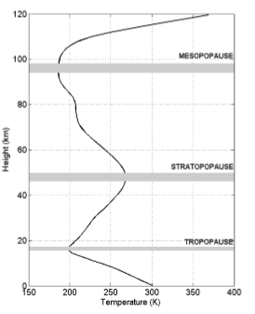r which absorbs uv light and release heat. Stratosphere is dynamically stable. Above stratosphere lies mesosphere where temperature decreases. Mesosphere has been characterized as a transition region, in which many processes of various temporal scales are taking place, such as diurnal, seasonal, inter-annual, quasi-biennial, solar cycle variations, etc.

**RADAR:**

Radar is an object detection system using Radio waves to determine the range, angle, velocity of objects. A radar system consists of a transmitter producing electromagnetic waves, a transmitting antenna, a receiving antenna and processor. Radar expansion is Radio Detecting and Ranging. In this region, the atmospheric temperature decreases with altitude. The temperature lapse rate with altitude is about 6-10 K/km. The height at which this decreasing trend reverses is known as the tropopause.

Radio waves from transmitter hit the target and return to the receiver. Location of object is determined by time taken by signal to reach receiver. Velocity of object is calculated by the change in frequency of the received wave.

**Atmospheric Radar principle:**

The target of atmospheric radar is clear air echos without ionization. The primary mechanism of backscatter from the clear atmosphere is the radio refractive index fluctuation experienced by an electromagnetic wave due to the presence of localized scattering centers known as refractive index irregularities that are flowing in the background mean flow.

**Refractive index:**

The radio refractive index of the atmosphere is given by

$n-1=\frac{3.73×{10}^{-1}p_{v}}{T^{2}}+\frac{77.6×{10}^{-6}p}{T}-\frac{N_{e}}{2N_{c}}$

where p is the absolute pressure in hPa, pv is the partial pressure of the water vapour in hPa, T is the absolute temperature, Ne is the number density of electrons, and for a frequency $f$, $N_{c}=1.24×{10}^{-2}f^{2}$ is the critical plasma density. The first term dominates in the lower atmosphere where the water vapour is large. As is well known, the water molecule has a dipole moment, which varies with frequency. At extremely high frequency of visible light, only the polarized electric field of the water molecules counts for the refractivity. Above the tropopause height, the partial pressure of the water vapour becomes negligibly small. The second term partial pressure due to dry air is of primary importance in the free troposphere, stratosphere and lower mesosphere. Unlike the first term, this term is frequency independent. The third term is dominate in the ionosphere, where the electron density increases rapidly with height.

**Ranging:**

The received signal is sampled and arranged as a function of a round-trip time from transmission to reception, which is generally called ranging. Transmitted pulse has finite length, at any instance the received signal is coming from volume of atmosphere than single point called range bin. Total range is divided into range bins. For mono static pulse radar the range of scatterer from radar is

$$R=c.\frac{T}{2}$$

R is range of scatterer, c is speed of electromagnetic wave, T is the time interval between pulse transmission and detection. Height of Range bin is

$r=c.Ͳ/2$

r is the height of range bin, Ͳ is the pulse length. The interval between two successive pulse is called Inter Pulse Period (IPP).Velocity of target is calculated using change in frequency of received signal compared to transmitted signal due to Doppler effect.

$fd=2fv/c$

Where fd is difference between frequencies of transmitted and received signal, f is the frequency of transmitted signal, *v* is velocity of target in direction of beam. To get 3 components of wind velocity we need 3 beams (all 3 not in same plane).

The detected quadrature signals are usually integrated for many pulses and made one integrated pulse in order to increase the signal to noise ratio. This signal processing is called the coherent integration. With coherent integration the total no of pulses will reduced by the factor N, if N no of coherent integrations is carried out. The integration will be done over several inter pulse periods in the case of the coherent echo. This reduces the maximum frequency change detectable by factor of N.

${fd}_{max}=1/{(2*ipp*N)}$

Where ipp is inter pulse period, N is no of coherent integrations and fdmax is the maximum change in frequency that can be detected without aliasing.

**Inter Pulse Period:**

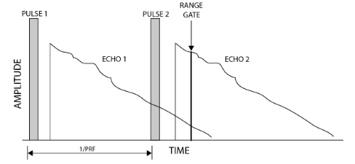 If one pulse is transmitted we have to wait till we receive back scattered signal the time difference between two pulses is ipp. If ipp is too short the return signals will overlap. Return signal will begin to be received from a pulse while signal from previous pulse are still arriving. This is called range aliasing because an return signal from a distant scatter would be attributed to a much closer range. This limits PRF(pulse repetition frequency, reciprocal of ipp).

Range bin length is directly proportional to time period of pulse. So short pulses are better for range resolution.

Received signal strength is proportional to time period. So long pulses are better for signal reception.

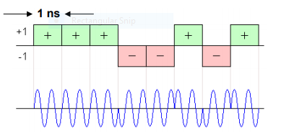 So pulse compression is used to resolve this problem. In Pulse Compression Transmitted pulse is coded to have desired band width. Phase modulation is commonly used method. In this case the pulse is divided into N time slots. Phase at origin is chosen, phase is not changed for some slots and de-phase the signal in other slots by π. Received signal is passed through matched filter.

Pulse compression allows us to use a reduced transmitter power and still achieve the desired range resolution.

**Spectral cleaning or clutter removal:**

Due to various reasons the echoes of the radar may get effected by the ground clutter, system bias, interference etc. The spectrum should be clean before going to further analysis or to have signal peak detection. For example, the ground clutter signal have single spectral peak line at the origin or zero frequency. It is removed by various techniques in order to have comparable signal peak. One way is to taking average of the values of the immediately beside frequencies and replacing that value at the origin.

$P_{n} = {(P_{n+1} + P_{n-1}) }/2$

**Estimation of noise level:**

The estimation of the noise in the spectrum is the called the Noise Level. There are many methods to find the noise level, but only few given near accurate value of the noise level. Peter H.Hildebrand and R.S.Sekhon are given one best method for estimating the noise in 1974.(Peter Hildebrand and R.S.Sekhon et al.,197)

From Doppler spectrum, construct the new spectrum by rejecting the spectral densities stronger than some arbitrary threshold level and checking conditions of the white noise that the spectrum is satisfying. This series of processes will be done by taking decreasing thresholds until the spectrum satisfies the conditions of the white noise. And that threshold value will be taken. The following steps will be computed for estimating the noise

$P=\frac{\sum{S_{n}^{2}}}{N}$

$Q=\frac{\sum{S_{n}^{2} }}{N}-P^{2}$

$R_{n}= {P^{2}}/{Qp}$

where N is the number of independent spectral densities, $p$ the number of lines over which a moving average is taken. For white noise the ratio Rn  should be unity.

**Incoherent Integration:**

Incoherent integration is performed on 4 signals from different time frames and same beam.

This step is done with an assumption that there is no significant change in velocity of air between

consequent time frames. By performing incoherent integration snr of signal is improved as noise power decreases as noise is random while signal power is increased.

**Spectrum smoothing:**

It is a process of taking series of averages over the entire data points. The set of the moving average will be obtained by taking the average of the initial set of points of the data. Then by excluding the initial points and including the next points in the original data, the average will be computed and this repetitive process will be done for entire data and plot the graph. This is called the moving average technique. By this process, the curve will obtain smooth.

$P_{n} = {(P_{n+1} +P_{n}+ P_{n-1}) }/3$

**Estimating moments:**

The whole signal processing is done to extract the spectral zeroth, first and second moments and from the moments the total power , Doppler shift and spectral width will be obtained. From these the Doppler velocity will be computed.

M0 =

M1 =

M2 =

**Computing UVW components of wind:**

Three non coplanar beams data is used to calculate UVW. Let consider that VR1, V R2 ,V R3 and V R4, VR5 are the radial velocities along east, west, north, south and vertical directions respectively.

$V_{R1}=u\sin{θ}+w\cos{θ}$

$V_{R2}=-u\sin{θ}+w\cos{θ}$

$U=\frac{V_{R1}-V_{R2}}{2\sin{θ}}$

$V_{R3}=v\sin{θ}+w\cos{θ}$

$V_{R4}=-v\sin{θ}+w\cos{θ}$

$V=\frac{V_{R3}-V_{R4}}{2\sin{θ}}$

$W=V_{R5}$

**RASS:**

Profiling of temperature can be done using insitu measurement (Radiosonde) or remote measurement RASS ( Radio Acoustic Sound System).RASS uses the effect of temperature on speed of sound in air as a means to sense temperature. It is a combination of Doppler Radar and an acoustic exciter. The Doppler radar profiles the speed of sound i.e refractive index perturbations induced by the acoustic source. The signal we measure is summation of acoustic signal and background wind, so background wind speed is subtracted from signal. As the atmospheric temperature decreases about 6-10 K/km the speed of sound which is dependent on the ambient temperature decreases with altitude.

The wind proﬁler is used to measure speed of propagation of acoustic wavefronts, Ca (ms−1) which is related to ambient temperature Tv(K),

Tv =(Ca/kh)2  Kh comes around 20.047

Absolute temperature T and Tv are related as,

Tv = (1+0.608q)T,

|  |  |
| --- | --- |
| **Reading of the Data File :** | **Coherent Integration :** |

|  |  |
| --- | --- |
| **Clutter Removal Process :**  Formula : $P_{0}=\frac{P_{-1}+P_{1}}{2}$ | **Spectrum Smoothing :** |

|  |  |
| --- | --- |
| **Spectrum computing :** | **Incoherent Integration :** |
|  |  |
|  |  |
|  |  |

**Noise Level Estimation :** 

|  |  |
| --- | --- |
| **Spectral Moment Estimation :** | **Computing UVW components :** |

**Algorithm for calculating velocity(data processing of the MST Radar) :**



**Results:** 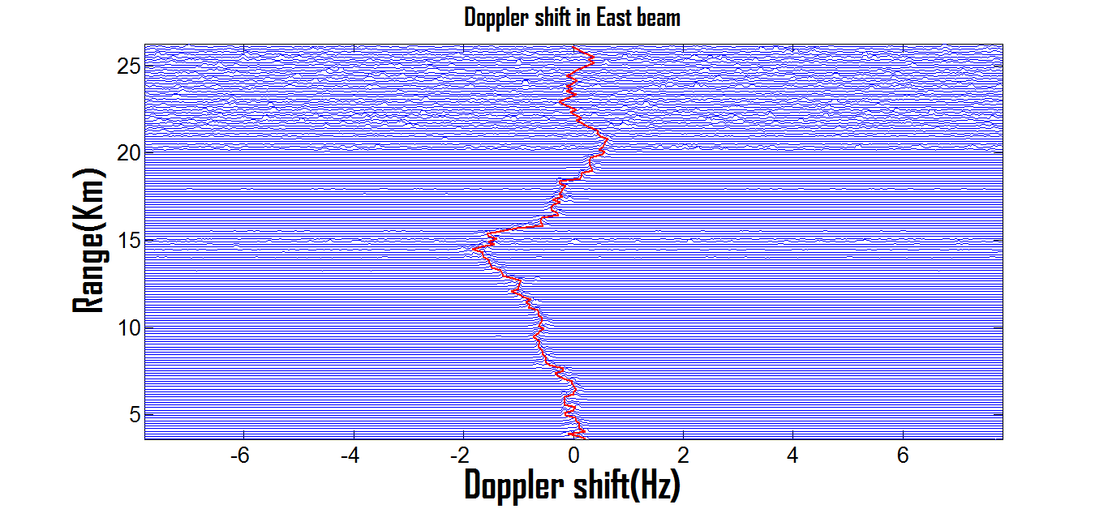

Doppler shift in east beam

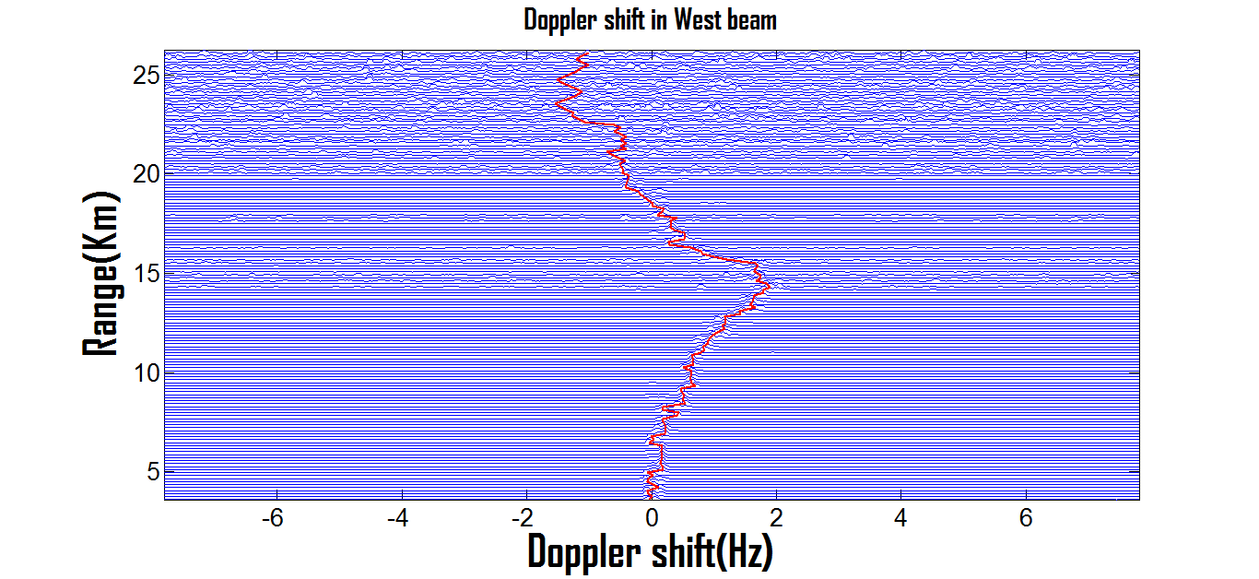 Doppler shift in west beam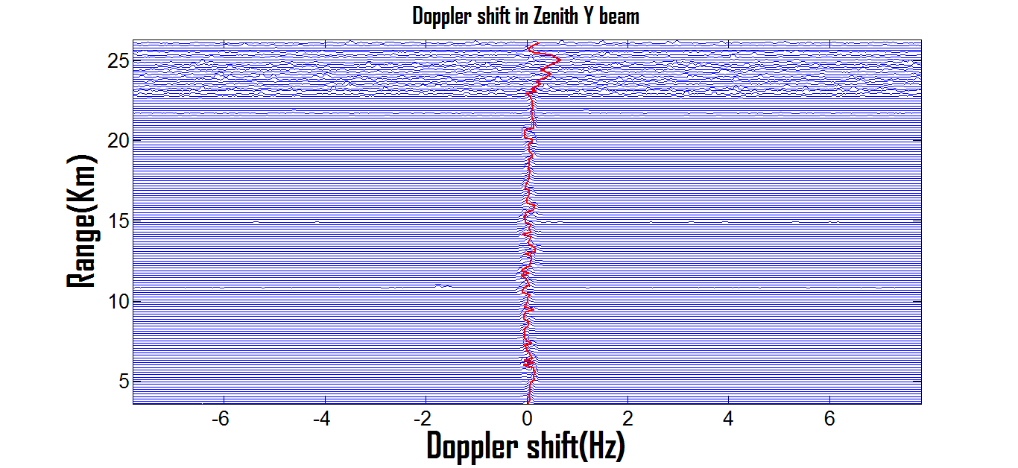

Doppler shift in Zenith Y beam

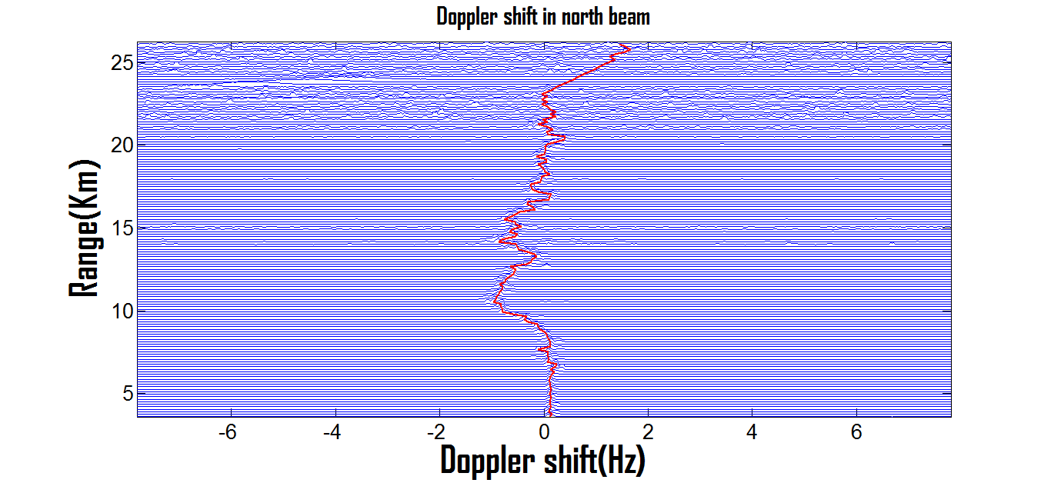Doppler shift in North beam

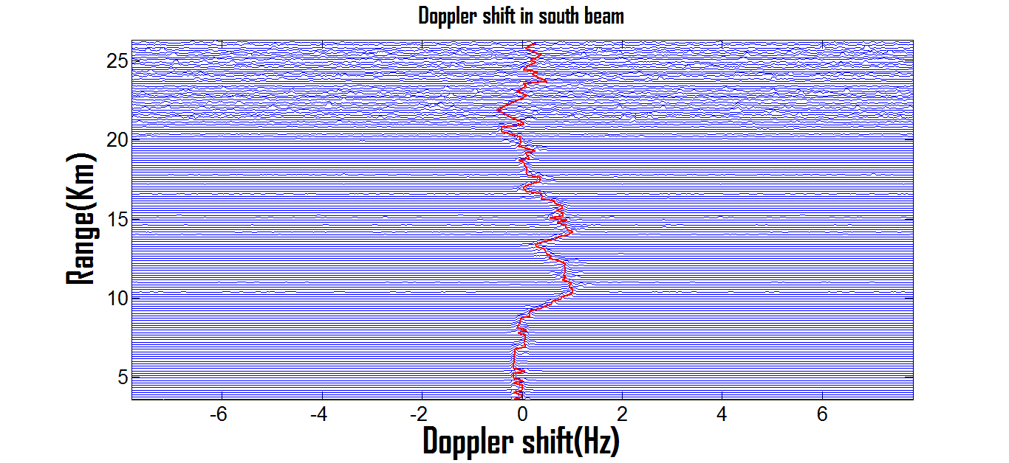

Doppler shift in South Beam

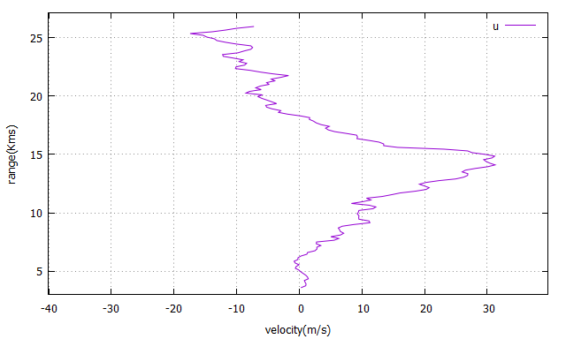

**U component of wind velocity**

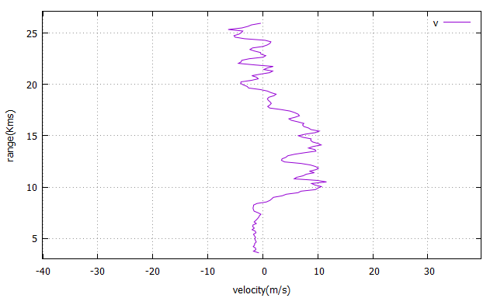

**V component of wind velocity**

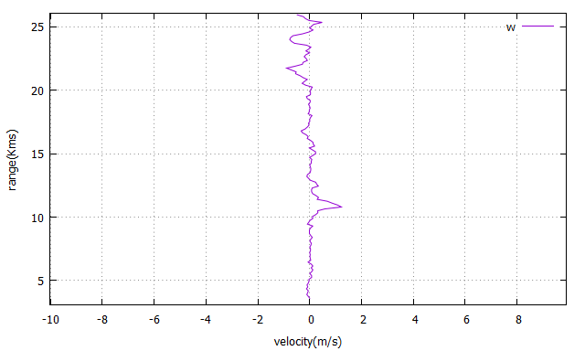

**W component of wind velocity**

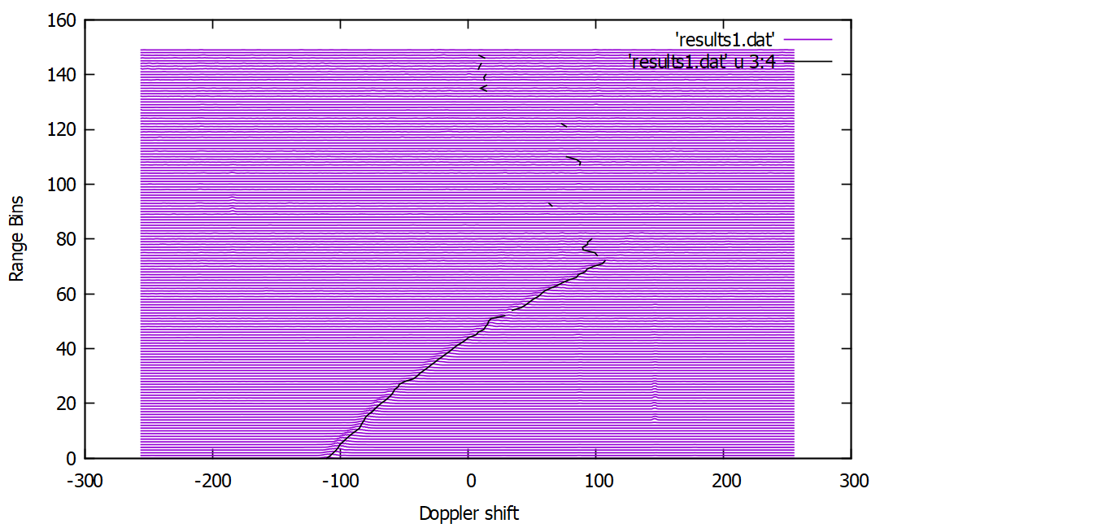**Typical rass plot**

**Comparison between RASS and Radiosonde:**

