1a) Is the number of petitions with Data Engineer job title increasing over time?
Done by MapReduce
1.code of map function
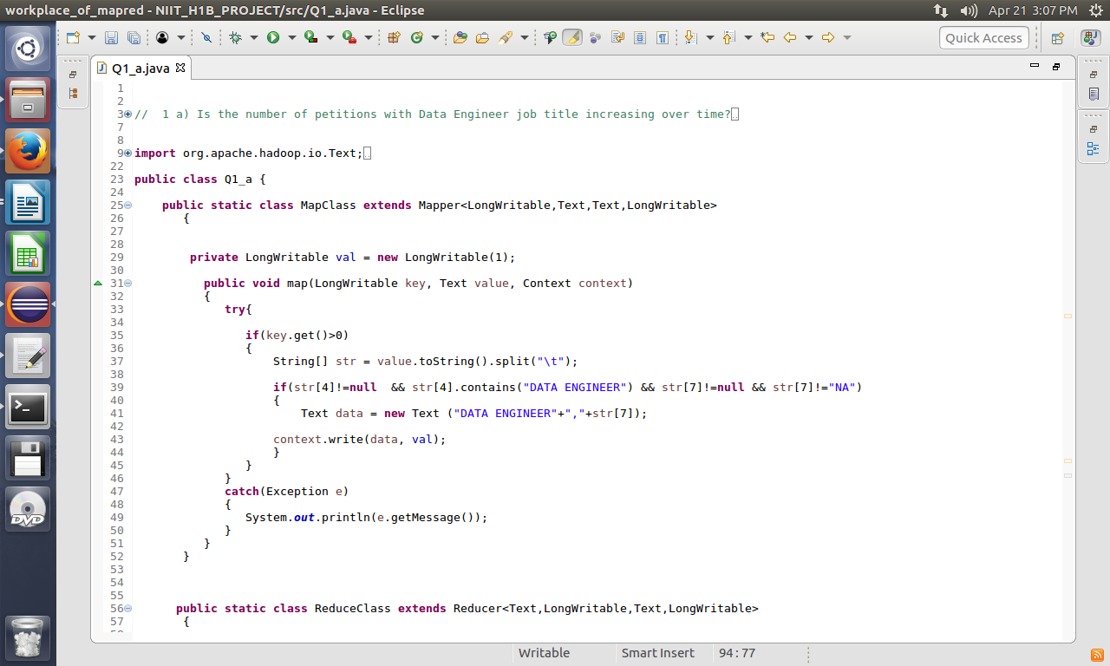
2.code of reducer.
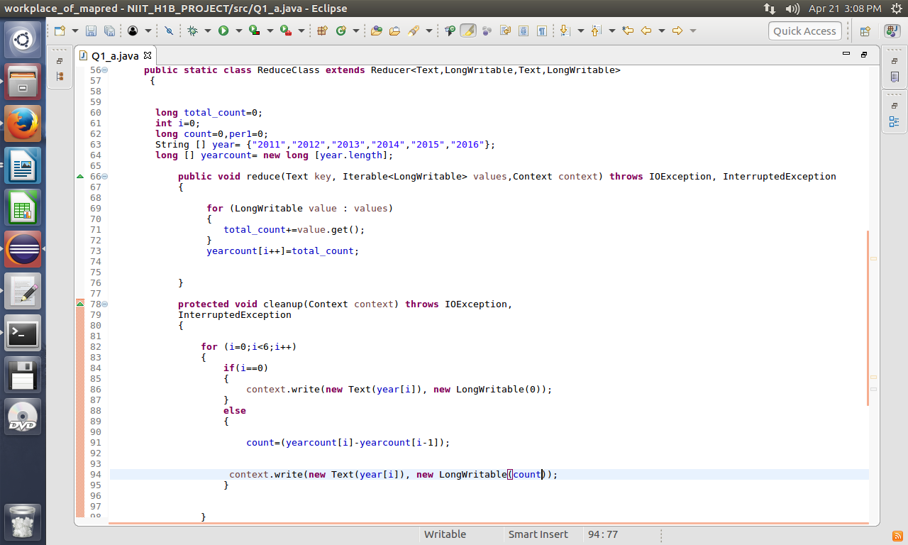
3.code of main function
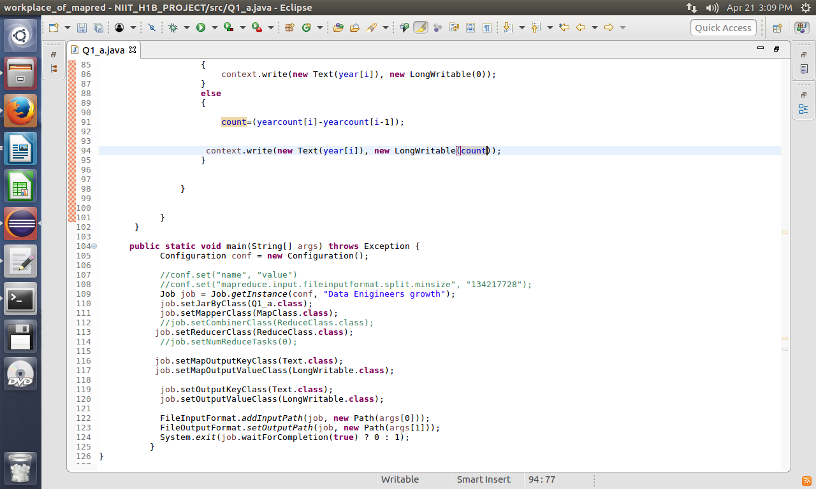
4.output prompt
a.
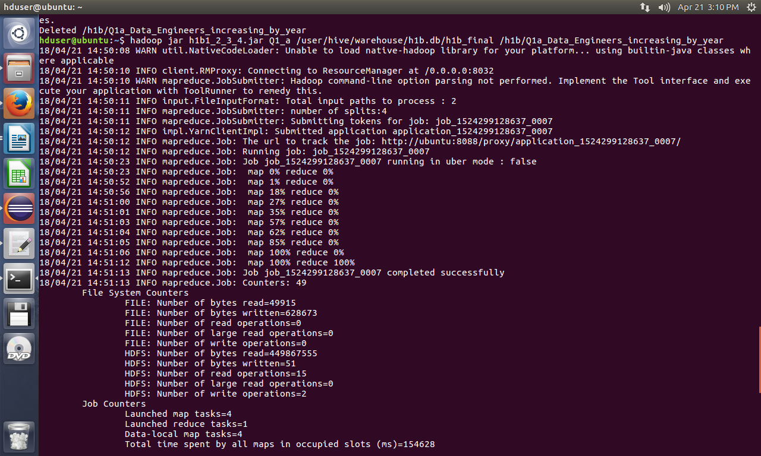

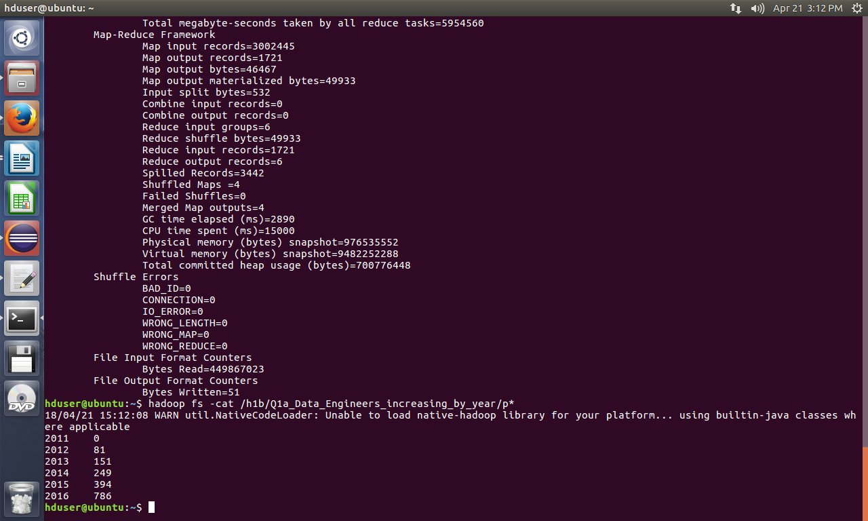
b.

2a) Which part of the US has the most Data Engineer jobs for each year?
Done by MapReduce
1.code of map function
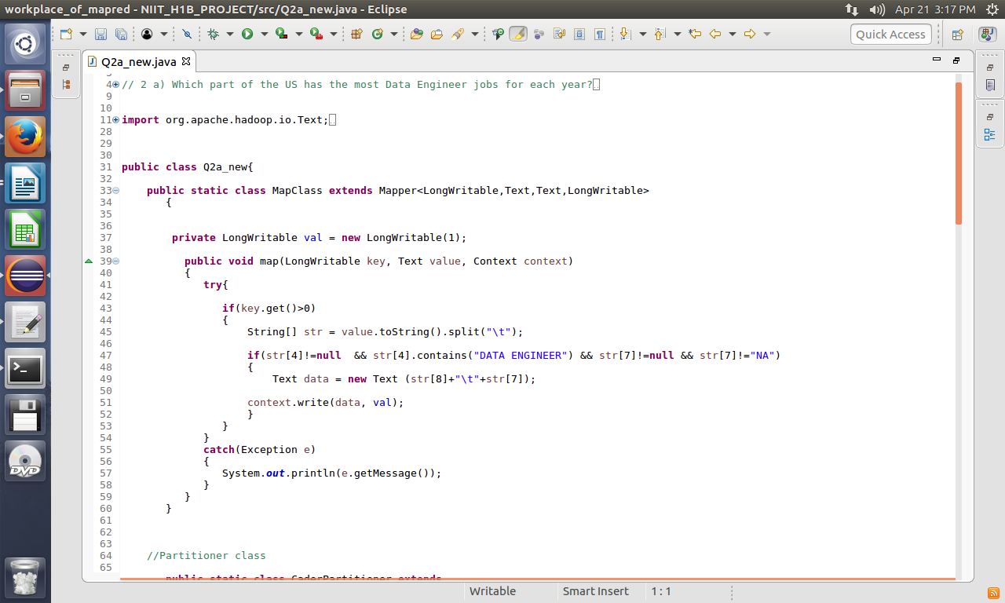
1a. partitioner code
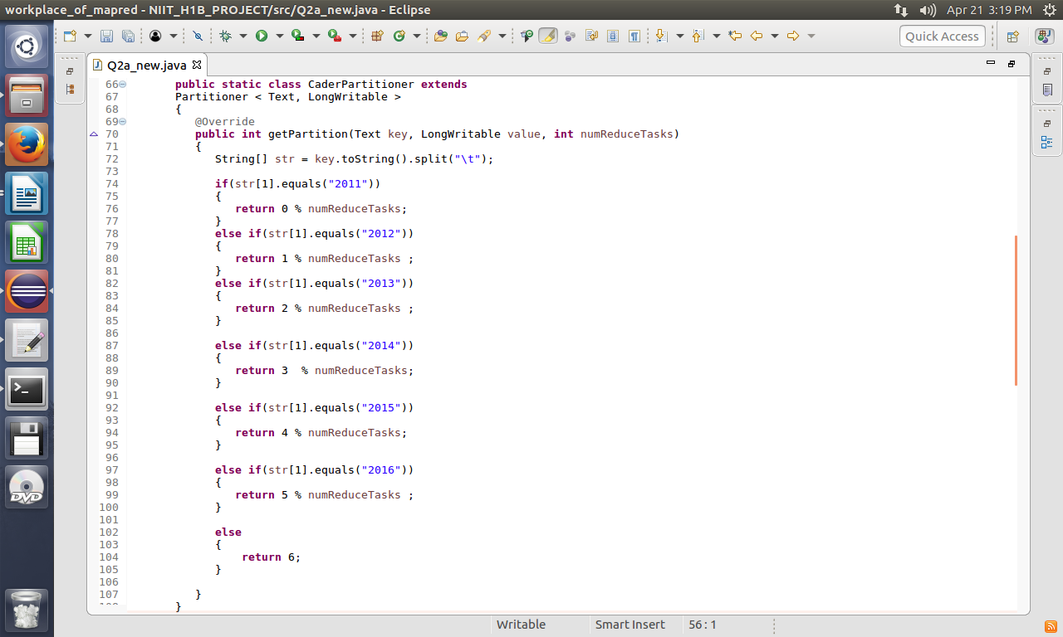
2.code of reducer.
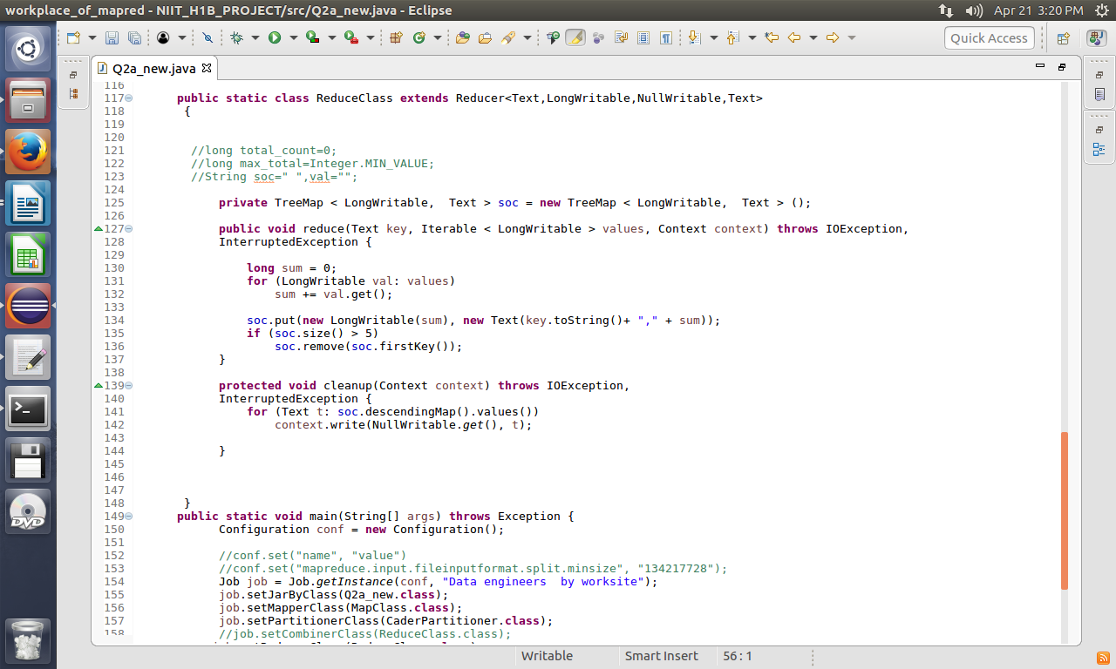

3.code of main function
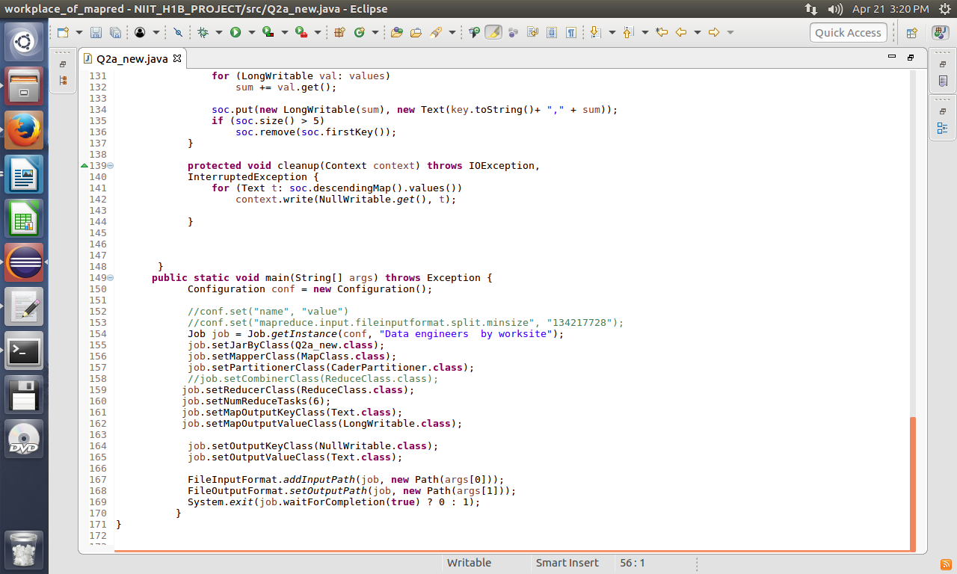

4.output prompt
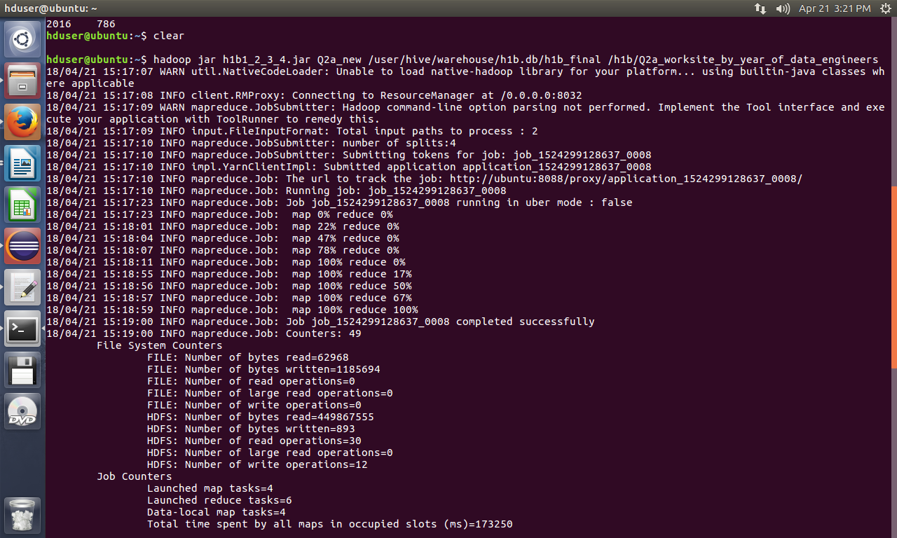

3)Which industry(SOC_NAME) has the most number of Data Scientist positions?
[certified]
Done by MapReduce
1.code of map function
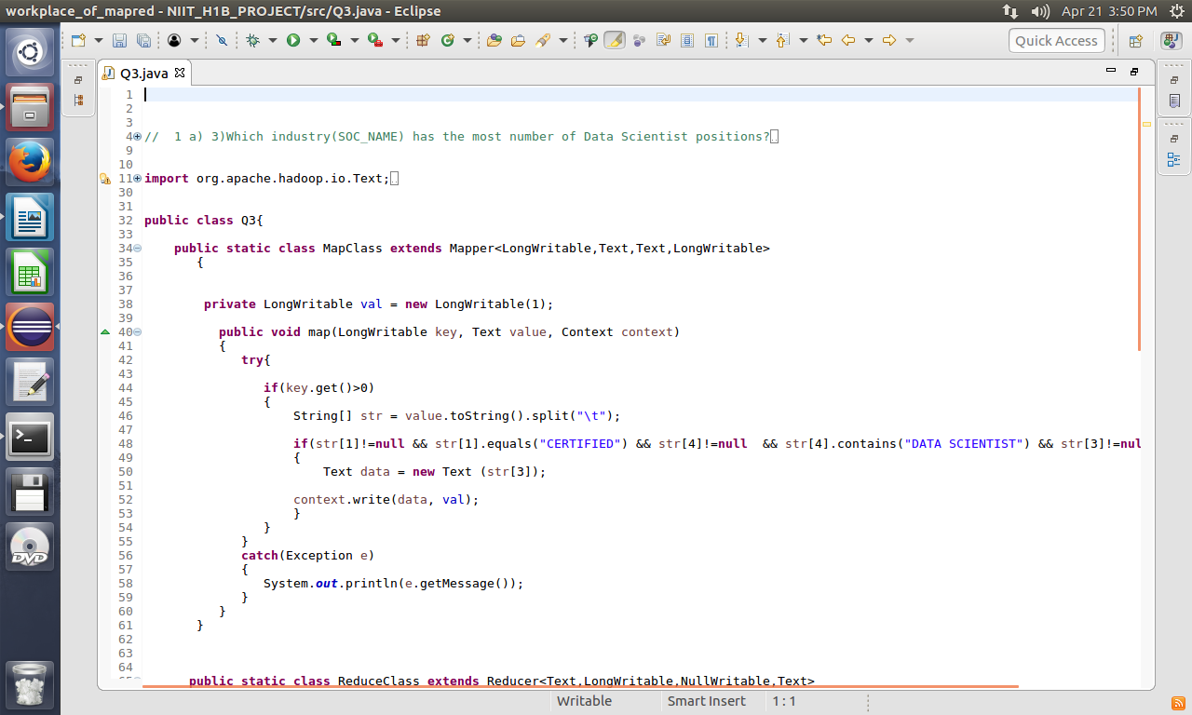
2.code of reducer.
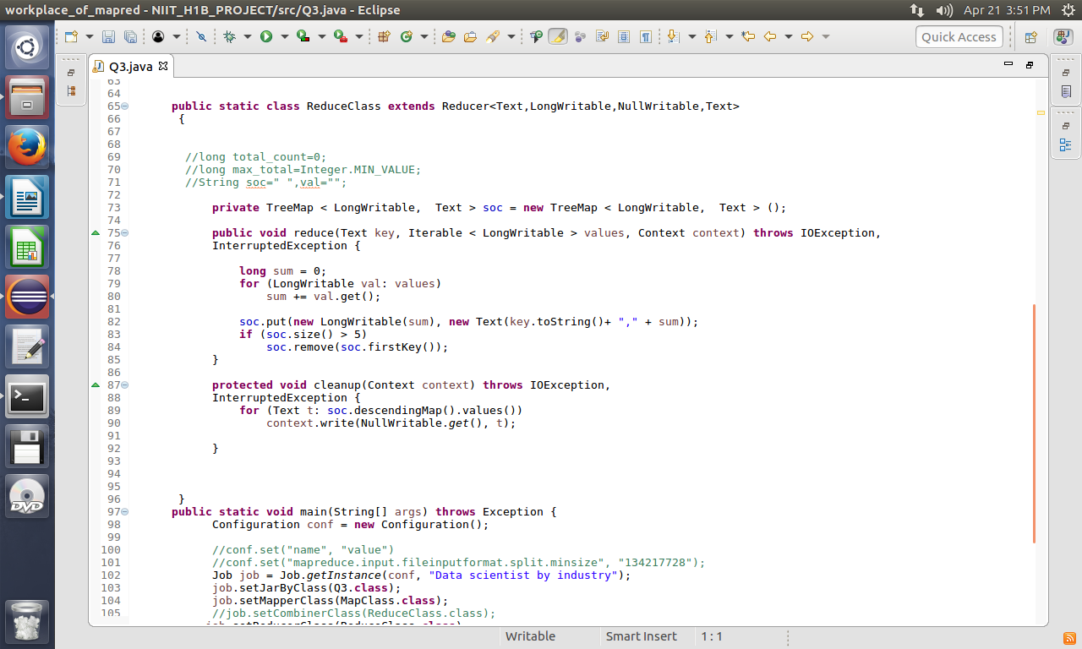
3.code of main function
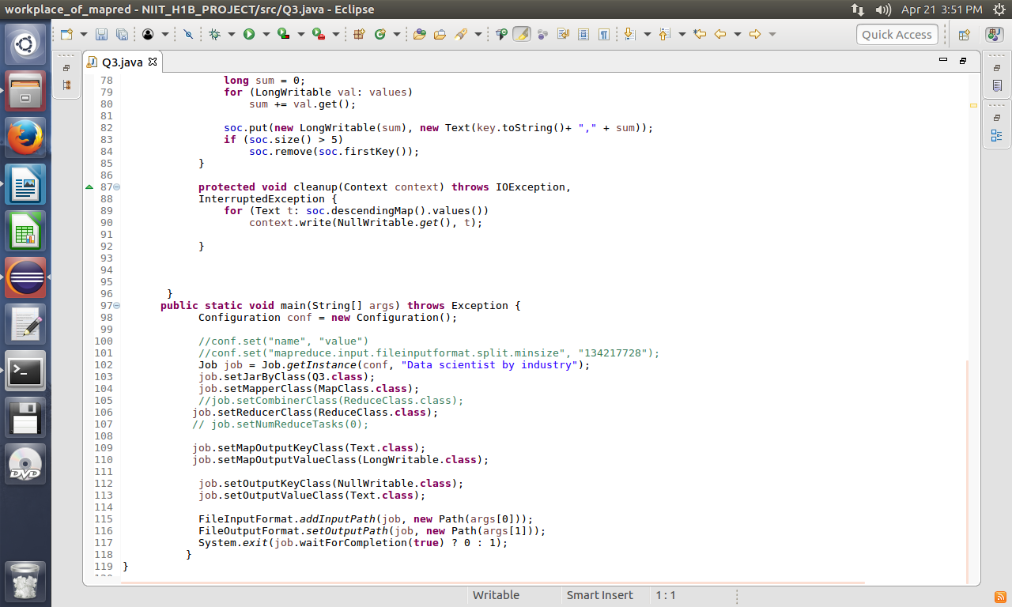
4.output prompt
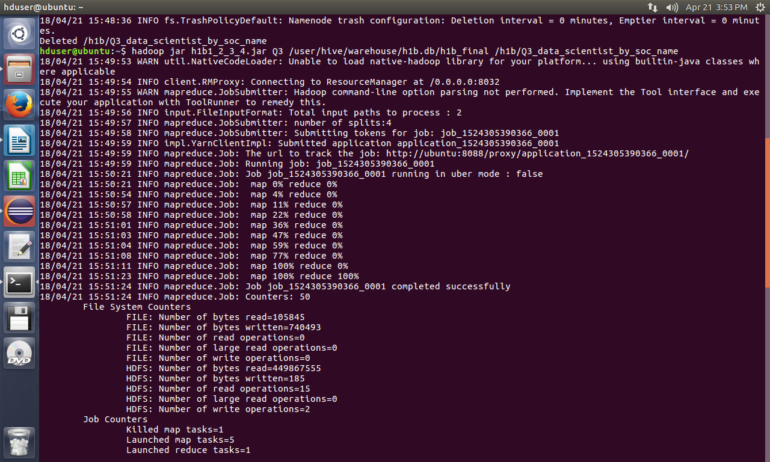

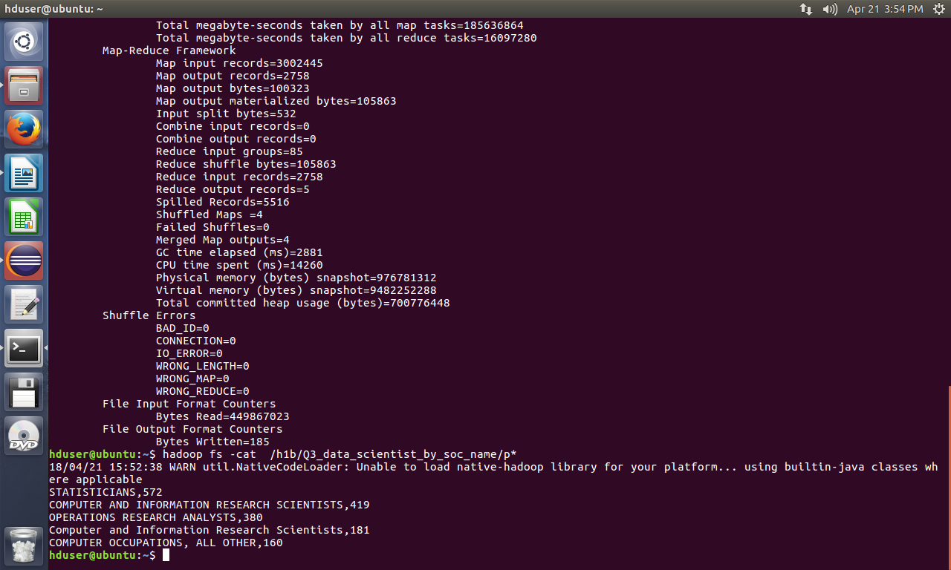

4)Which top 5 employers file the most petitions each year? - Case Status – ALL
Done by MapReduce
1.code of map function
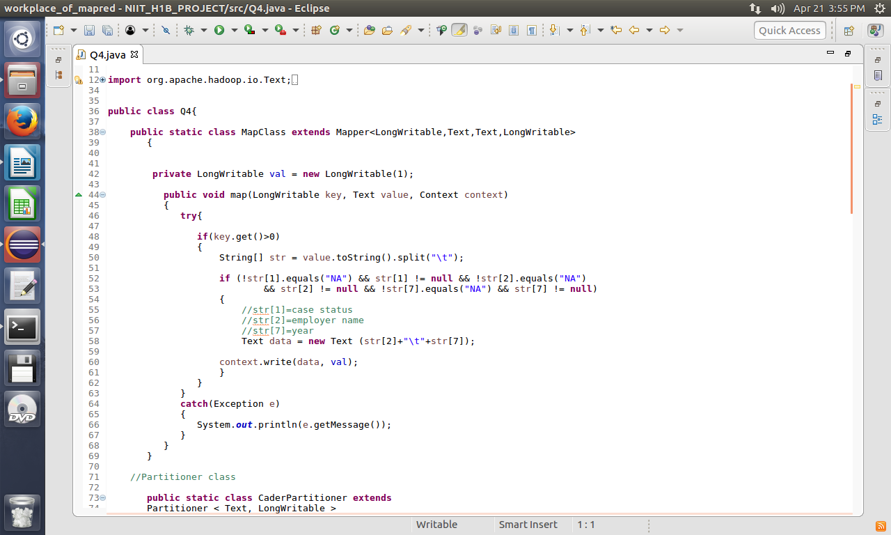
1a. code of partitioner
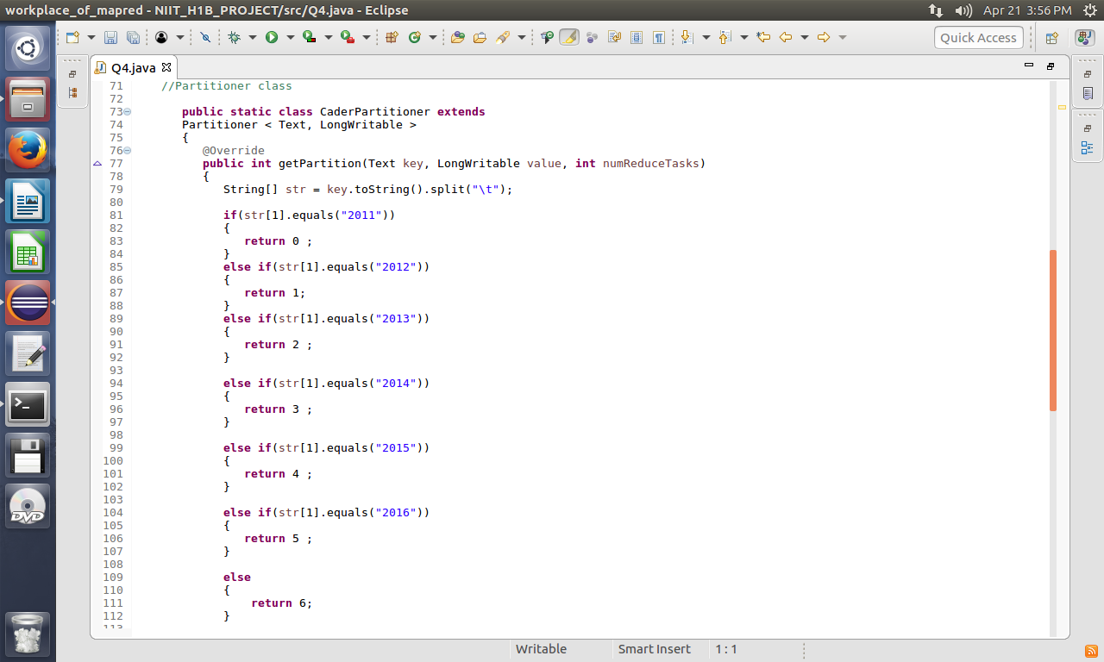
2.code of reducer.
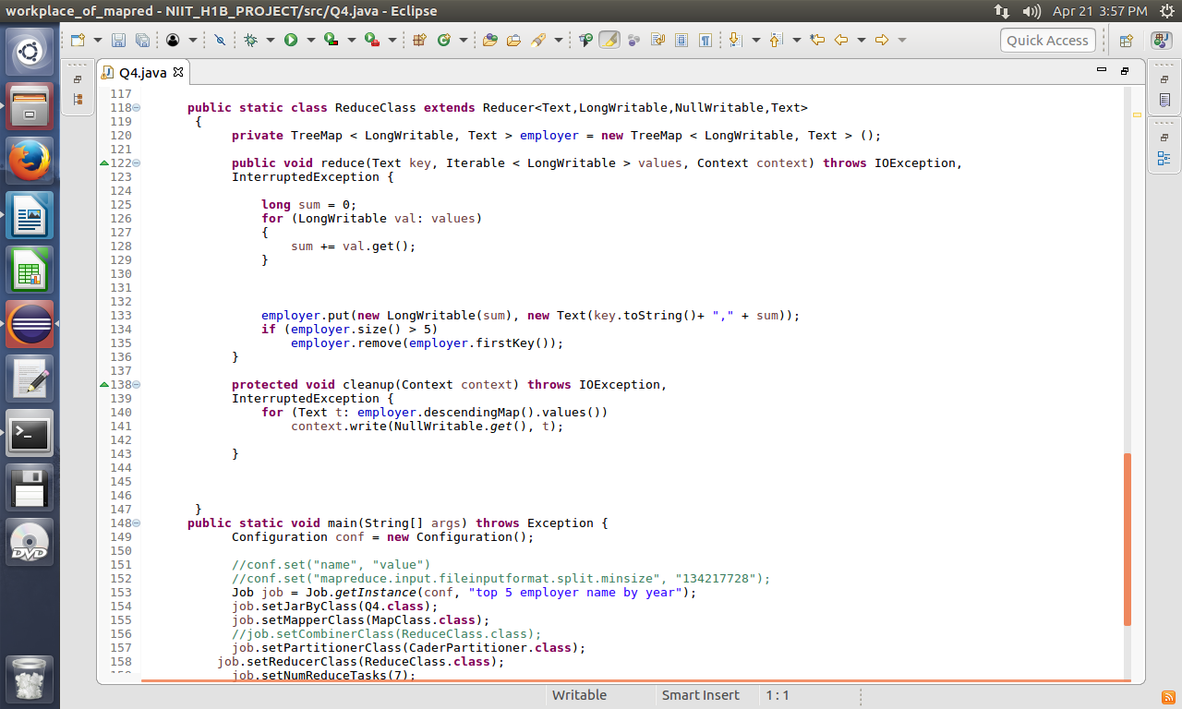
3.code of main function
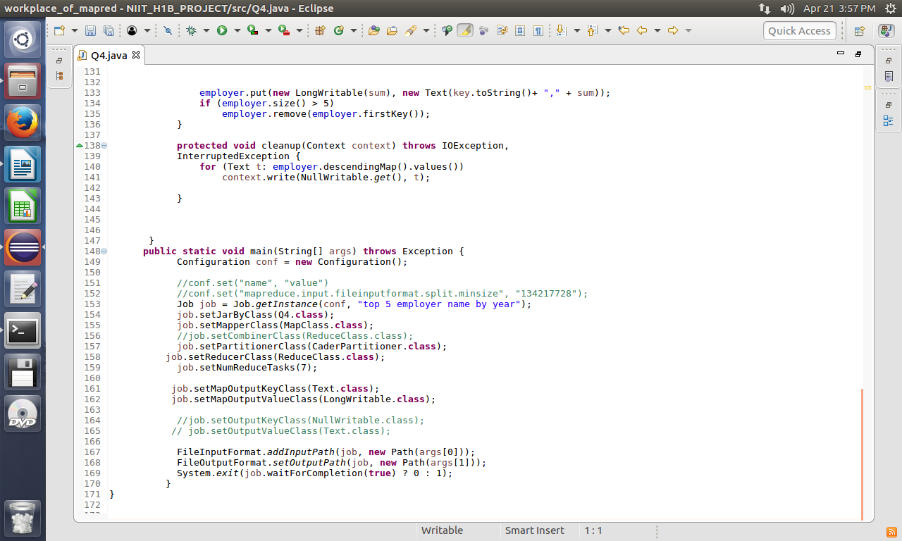

4.output prompt
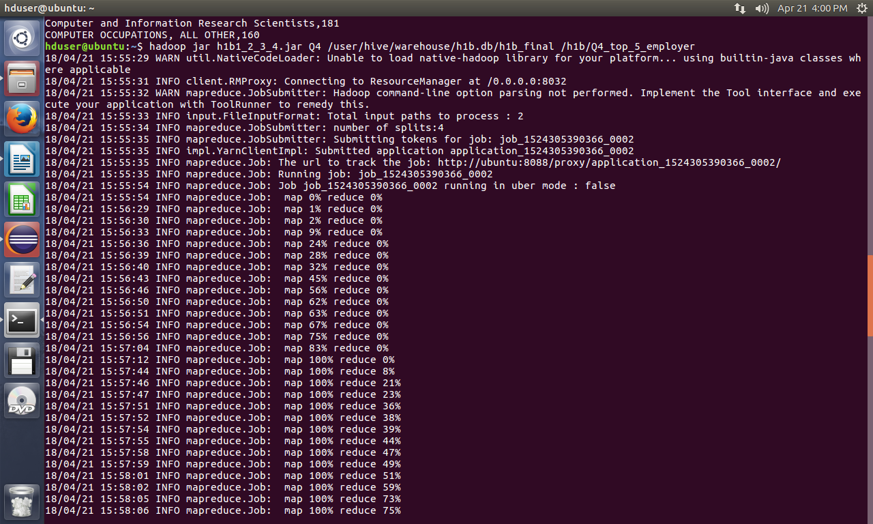
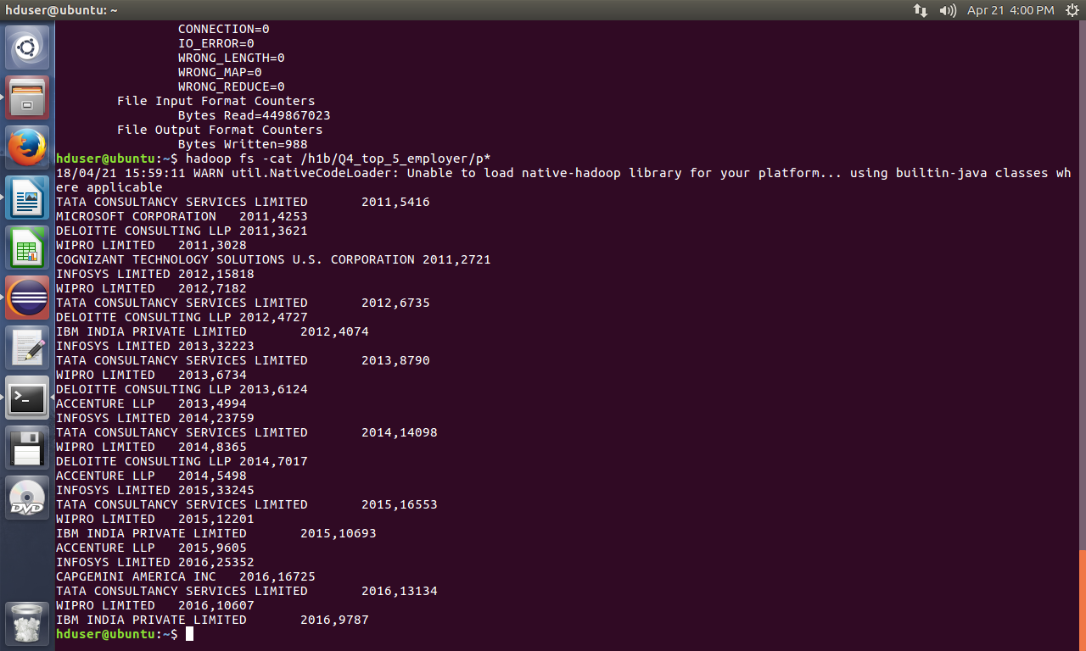

HIVE QUERRES

2 b) find top 5 locations in the US who have got certified visa for each year.[certified]

1. QUERRY
select worksite, count(case_status) as total, year from h1b_final where case_status="CERTIFIED" and year="2015" group by worksite, year order by total desc limit 5 ;

2.OUTPUT


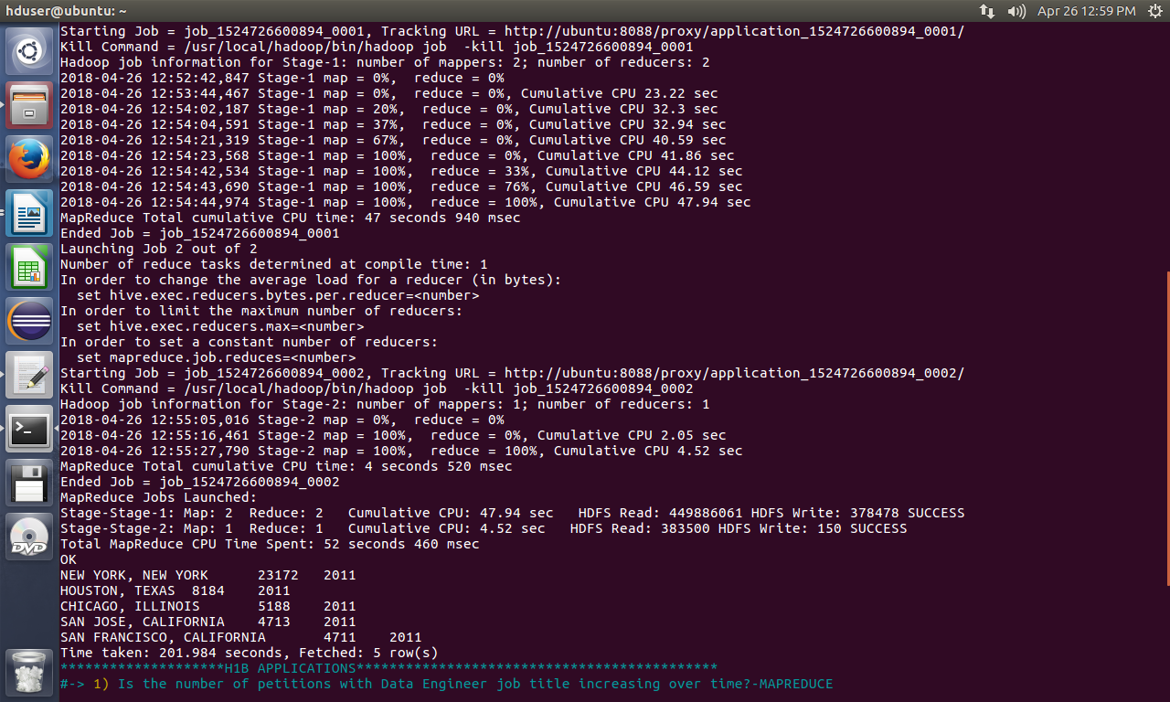

5) Find the most popular top 10 job positions for H1B visa applications for each year?
a) for all the applications
b) for only certified applications.

1. QUERRY
a. select job_title, year, count(job_title) as total from h1b_final where year="2012" group by job_title, year order by total desc limit 5;

b.select job_title, year, case_status, count(job_title) as total from h1b_final where year="2012" and case_status="CERTIFIED" group by job_title, year,case_status order by total desc limit 5;

2.OUTPUT

a.
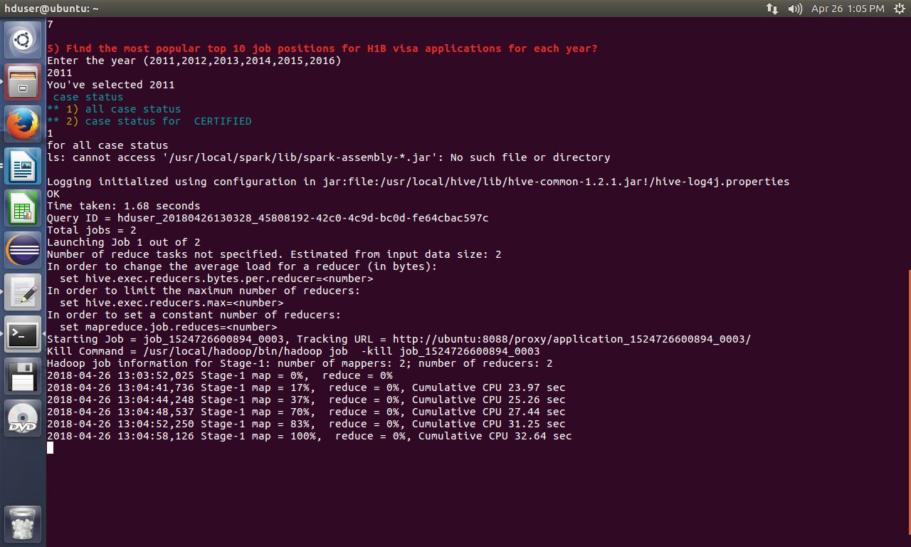

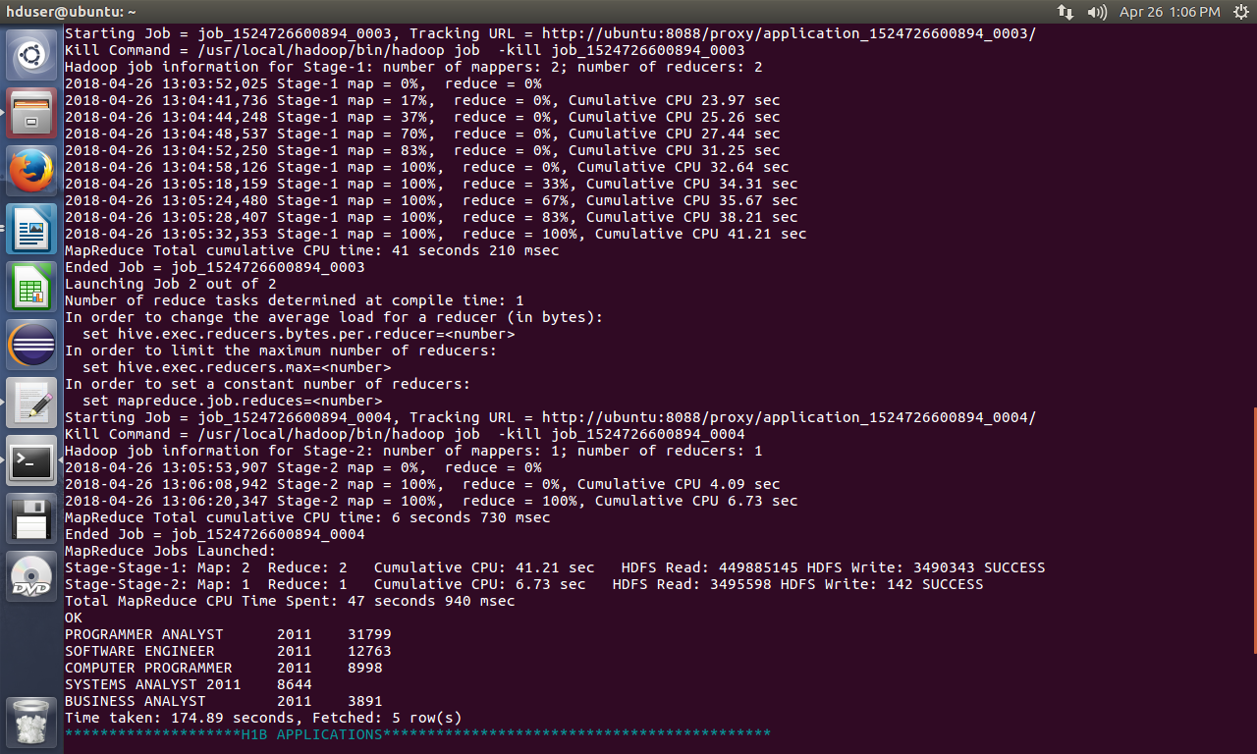
b.

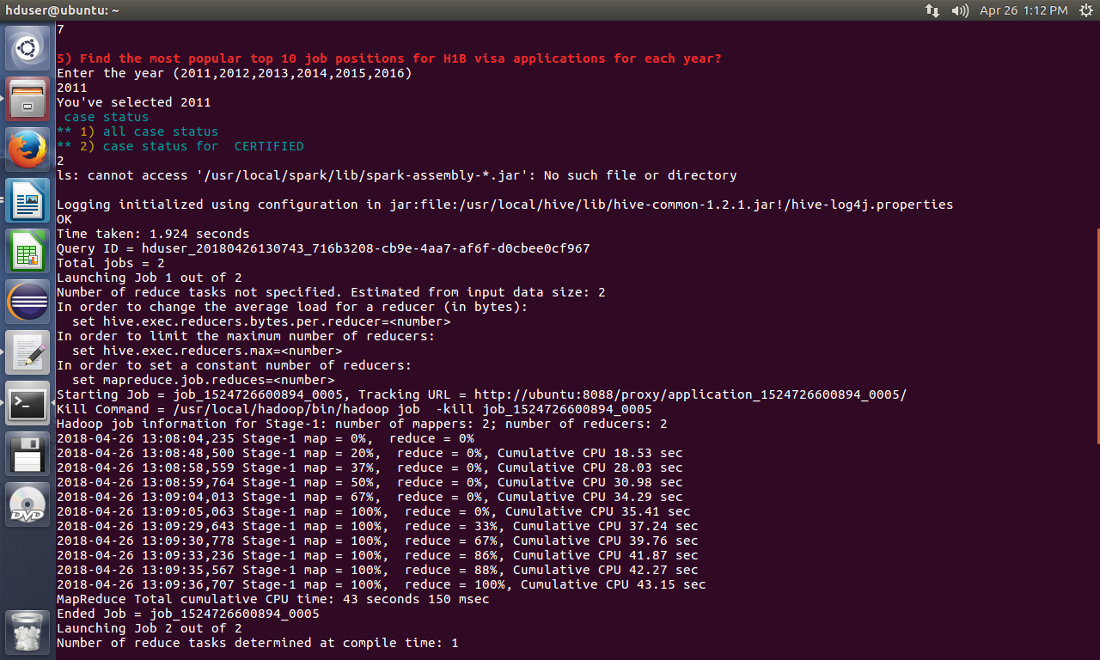

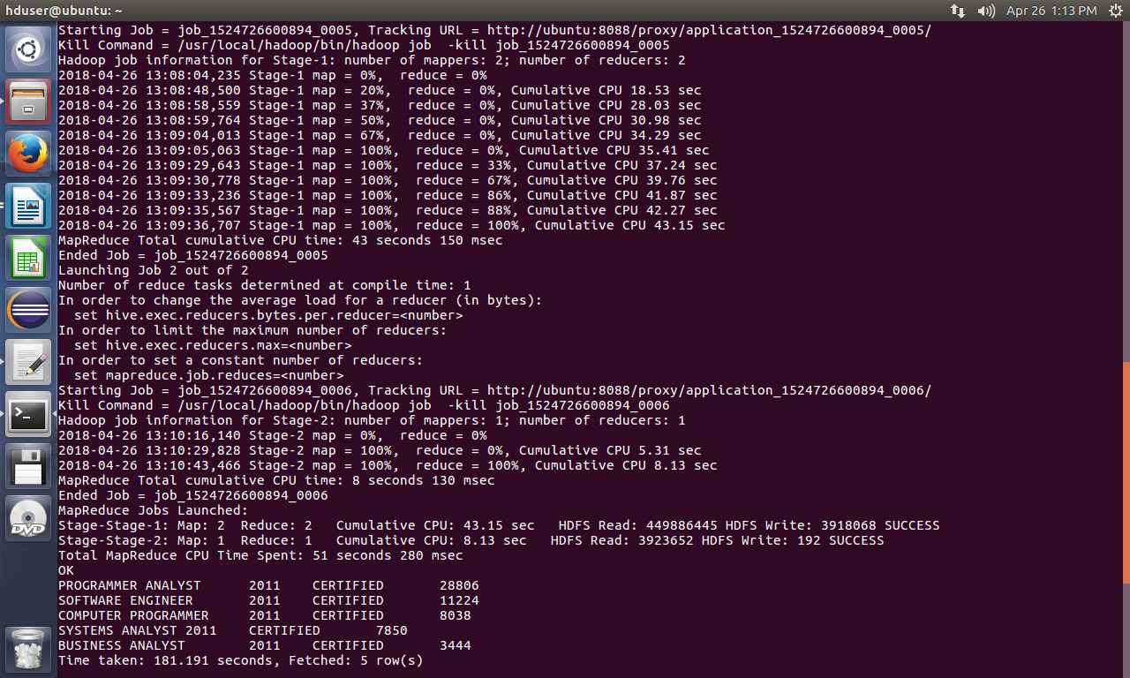

7) Create a bar graph to depict the number of applications for each year [All]

1. QUERRY
select year, count(s_no) as numberOfPetitions from h1b_final group by year order by numberOfPetitions desc;

2.OUTPUT

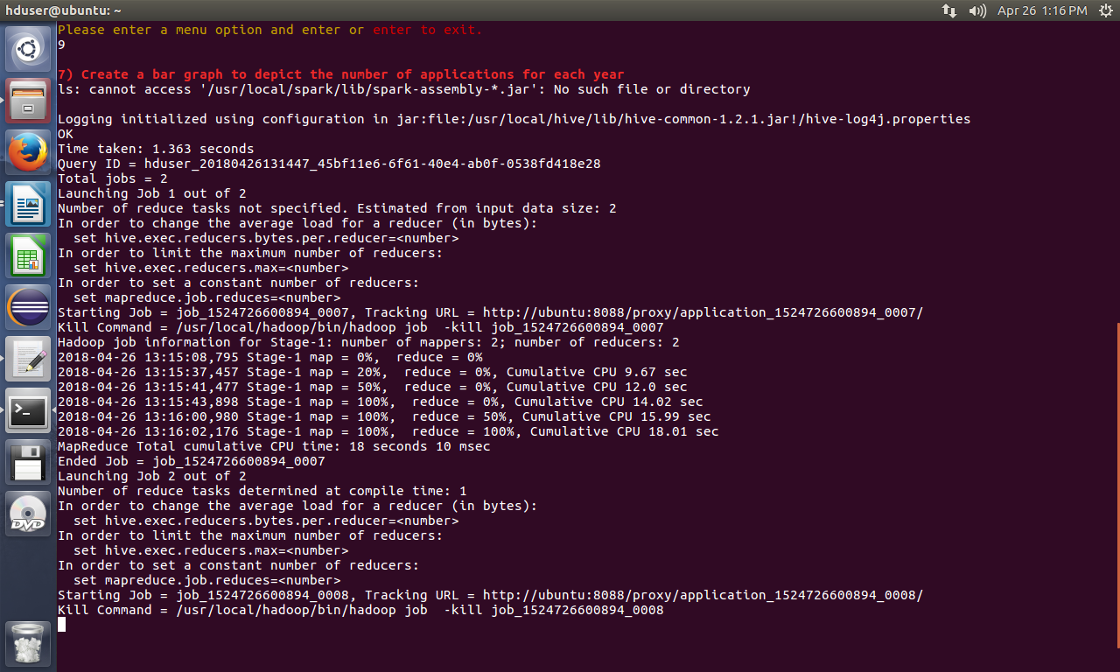

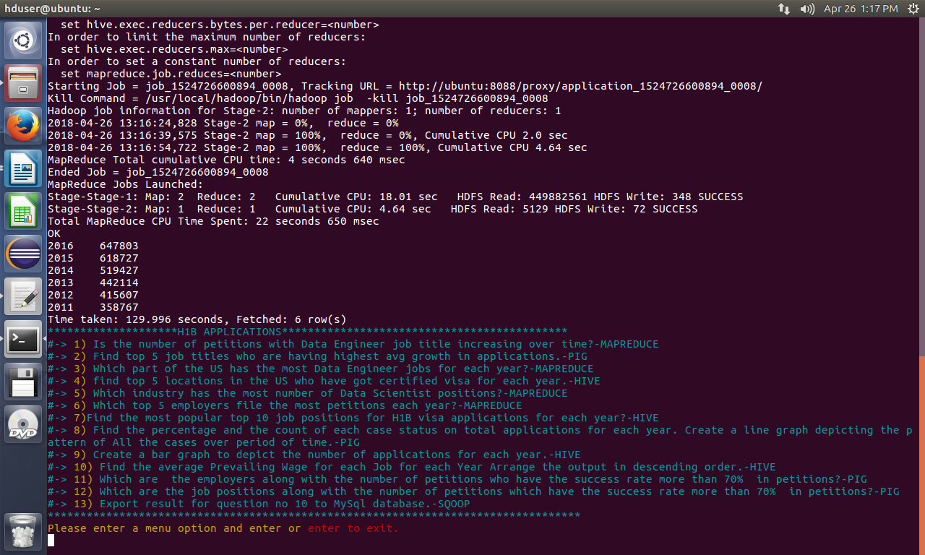
Graph:

8) Find the average Prevailing Wage for each Job for each Year (take part time and full time separate). Arrange the output in descending order - [Certified and Certified Withdrawn.]

1. QUERRY
select job_title,full_time_position,year,avg(prevailing_wage) as average from h1b_final where case_status="CERTIFIED" and year='2011' and full_time_position="Y" group by job_title,full_time_position,year order by average desc;

2.OUTPUT

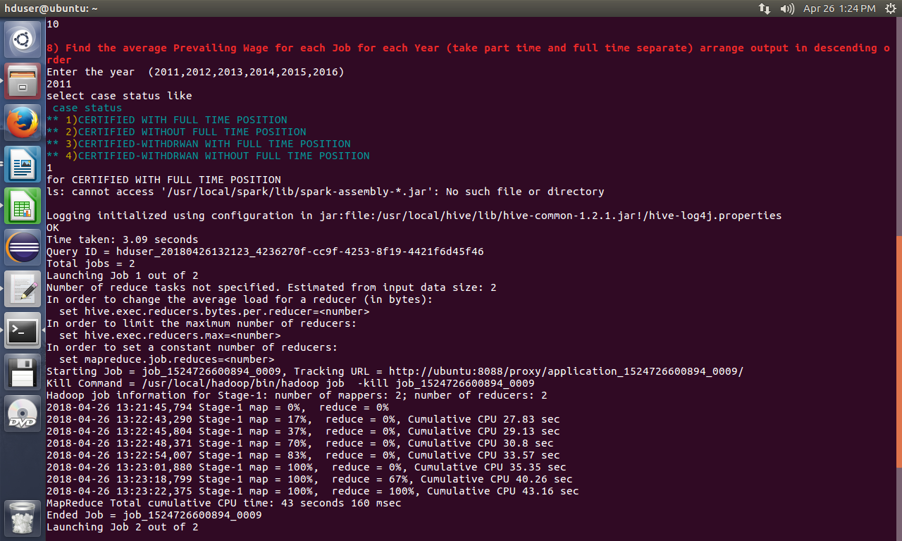

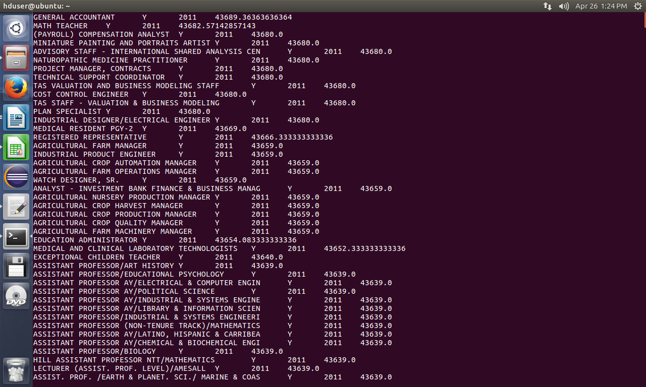

PIG QUERREIS
1b) Find top 5 job titles who are having highest avg growth in applications.[ALL]

1.SCRIPT

-- loading data from hdfs

data = load '/home/hduser/Downloads/H1B_Project/H1B_CSV' USING PigStorage('\t') As (s_no:int, case_status:chararray, employer_name:chararray, soc_name:chararray, job_title:chararray, full_time_position:chararray, prevailing_wage:int, year:chararray, worksite:chararray, longitute:double, latitute:double);
--load data
--dump data;

filterbyYear= filter data by $7 matches '2011'; --filtering data by year
groupbyjob = group filterbyYear by $4; --grouping data by each job title
count_2011= foreach groupbyjob generate group,COUNT($1); --genrated year, job and count

filterbyYear= filter data by $7 matches '2012'; --filtering data by year
groupbyjob = group filterbyYear by $4; --grouping data by each job title
count_2012= foreach groupbyjob generate group,COUNT($1); --genrated year, job and count

filterbyYear= filter data by $7 matches '2013'; --filtering data by year
groupbyjob = group filterbyYear by $4; --grouping data by each job title
count_2013= foreach groupbyjob generate group,COUNT($1); --genrated year, job and count

filterbyYear= filter data by $7 matches '2014'; --filtering data by year
groupbyjob = group filterbyYear by $4; --grouping data by each job title
count_2014= foreach groupbyjob generate group,COUNT($1); --genrated year, job and count

filterbyYear= filter data by $7 matches '2015'; --filtering data by year
groupbyjob = group filterbyYear by $4; --grouping data by each job title
count_2015= foreach groupbyjob generate group,COUNT($1); --genrated year, job and count

filterbyYear= filter data by $7 matches '2016'; --filtering data by year
groupbyjob = group filterbyYear by $4; --grouping data by each job title
count_2016= foreach groupbyjob generate group,COUNT($1); --genrated year, job and count

joined = join count_2011 by $0, count_2012 by $0, count_2013 by $0, count_2014 by $0, count_2015 by $0, count_2016 by $0;
--join all year data in single dataset
yearwisejob= foreach joined generate $0,$1,$3,$5,$7,$9,$11;

--generate progressive growth
progressivegrowth= foreach yearwisejob generate $0,
(float)($6-$5)*100/$5,(float)($5-$4)*100/$4,
(float)($4-$3)*100/$3,(float)($3-$2)*100/$2,
(float)($2-$1)*100/$1;

--average progressive growth
avgprogressivegrowth= foreach progressivegrowth generate $0,($1+$2+$3+$4+$5)/5;
---ordered progressive growth
orderedavggrowth= order avgprogressivegrowth by $1 desc;
--display top5 only
answer = limit orderedavggrowth 5;
dump answer;

2.OUTPUT

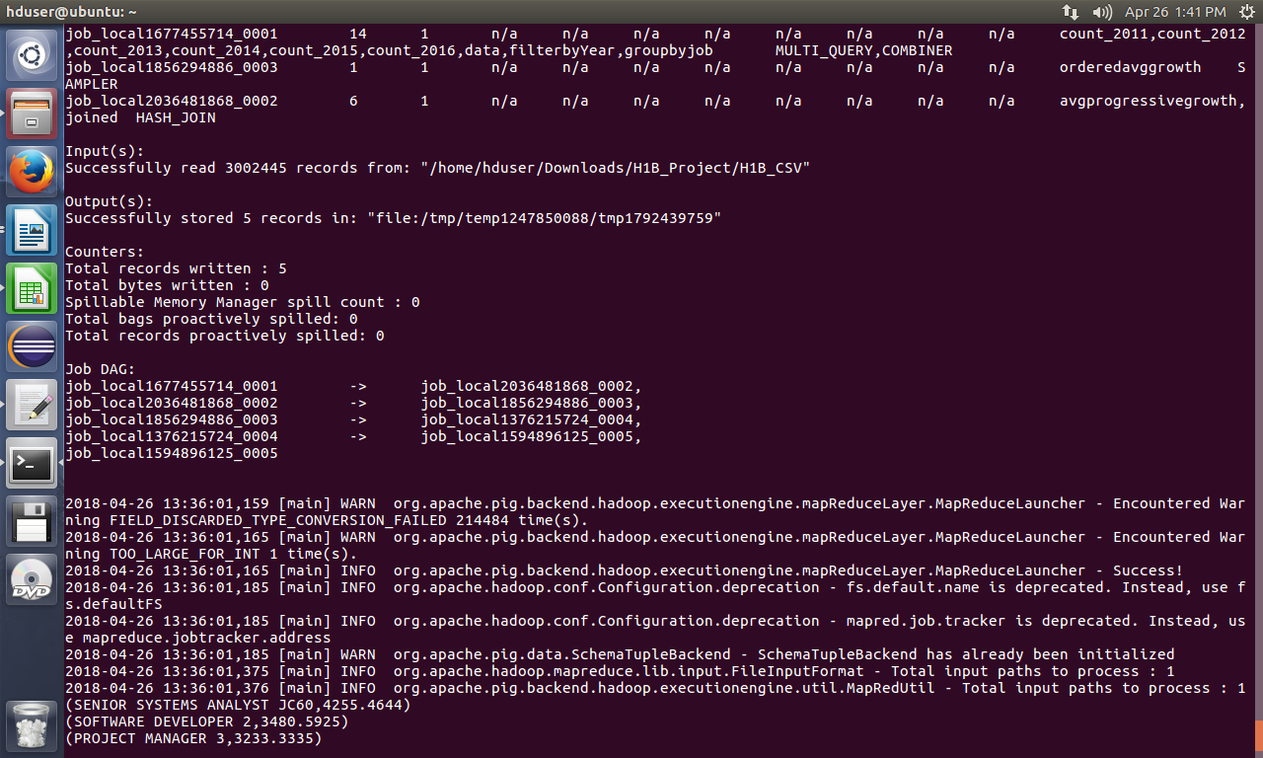

6)Find the percentage and the count of each case status on total applications for each year. Create a line graph depicting the pattern of All the cases over the period of time.

1.SCRIPT

data = load '/home/hduser/Downloads/H1B_Project/H1B_CSV' USING PigStorage('\t') As (s_no:int, case_status:chararray, employer_name:chararray, soc_name:chararray, job_title:chararray, full_time_position:chararray, prevailing_wage:int, year:chararray, worksite:chararray, longitute:double, latitute:double);
--load data

notnullvalues= filter data by $1 is not null and $1!='NA'; --checking for is there any null value present or not and filtering it out.
groupbyyear= group notnullvalues by $7; -- grouping by each year;

totalofcasestatus= foreach groupbyyear generate group, COUNT(notnullvalues.$1); --total of all case status in each year we got

--describe totalofcasestatus;dump totalofcasestatus;

notnullvalues= filter data by $7 is not null and $7!='NA'; --again checking for null values and getting not null values

yearcasestatus= group notnullvalues by ($7,$1);

yearsoccount= foreach yearcasestatus generate group,group.$0,COUNT($1); --group by year and case status

dump yearsoccount;

joined= join yearsoccount by $1,totalofcasestatus by $0;
ans= foreach joined generate FLATTEN($0),(float)($2*100)/$4,$2; --percent generation
dump ans;

STORE ans INTO '/home/hduser/Downloads/H1B_Project/Pig/question6output' USING PigStorage ('\t');

2.OUTPUT

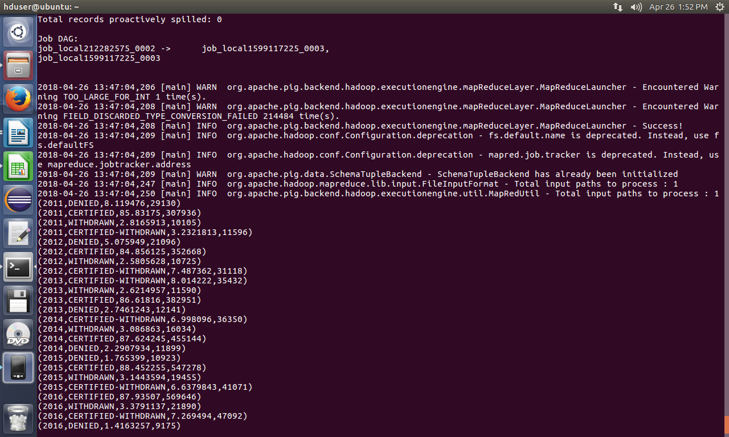

9) Which are the employers along with the number of petitions who have the success rate more than 70% in petitions. (total petitions filed 1000 OR more than 1000) ?

1.SCRIPT

data = load '/home/hduser/Downloads/H1B_Project/H1B_CSV' USING PigStorage('\t') As (s_no:int, case_status:chararray, employer_name:chararray, soc_name:chararray, job_title:chararray, full_time_position:chararray, prevailing_wage:int, year:chararray, worksite:chararray, longitute:double, latitute:double);
--load data

notnullvalues= filter data by $1 is not null and $1!='NA'; --checking for is there any null value present or not and filtering it out.
grpbyemployer= group notnullvalues by $2; --group by employer

total = foreach grpbyemployer generate group, COUNT(notnullvalues.$1); -- counting of eacg employer by case status

certified= filter notnullvalues by $1 == 'CERTIFIED';

certifiedbyemployer= group certified by $2;

totalcertified= foreach certifiedbyemployer generate group,COUNT(certified.$1);
--Group by employername and count the case status = 'CERTIFIED'

certified_w= filter notnullvalues by $1 == 'CERTIFIED-WITHDRAWN';

certified_wbyemployer= group certified_w by $2;

totalcertified_w= foreach certified_wbyemployer generate group,COUNT(certified_w.$1);

--Group by employername and count the case status = 'CERTIFIED'

joined= join totalcertified by $0,totalcertified_w by $0,total by $0; --join of total petitions , certified and cerified withdrawn

--dump joined;

joined= foreach joined generate $0,$1,$3,$5; --selecting required columns;

calsuccesrate= foreach joined generate $0,(float)($1+$2)*100/($3),$3;

succesrateabove70= filter calsuccesrate by $1>70 and $2>1000; --Filter by success-rate greater than 70% and petition count above 1000

finaloutput= order succesrateabove70 by $1 DESC;
dump finaloutput;

2.OUTPUT

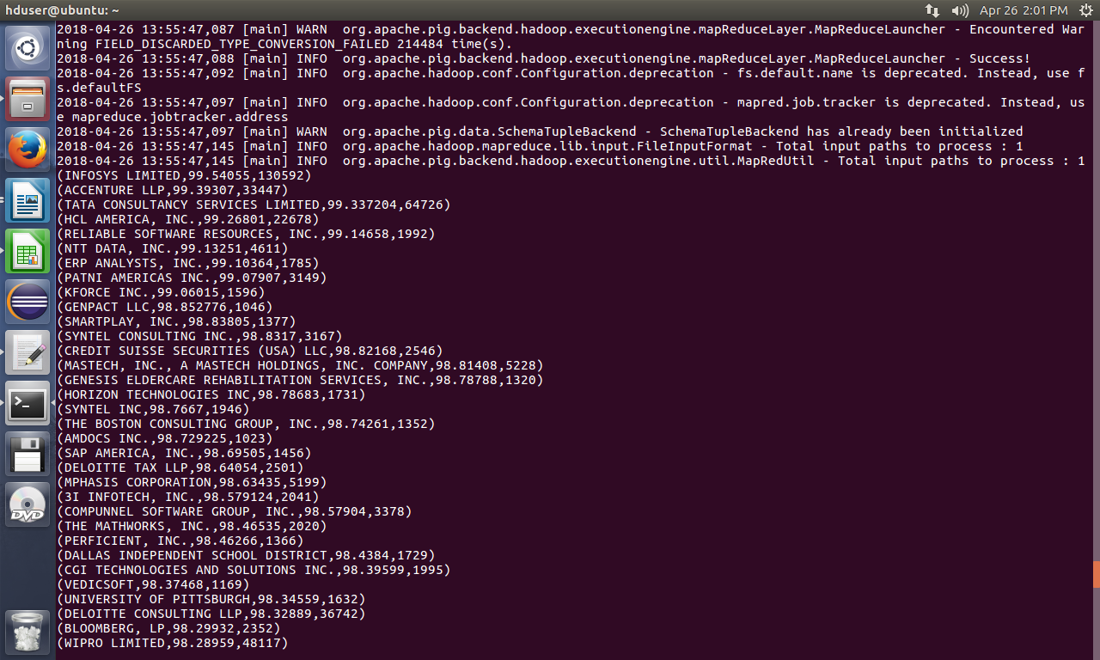

10) Which are the job positions along with the number of petitions which have the success rate more than 70% in petitions (total petitions filed 1000 OR more than 1000)?

1.SCRIPT

--10) Which are the job positions along with the number of petitions which have the success rate more than 70% in petitions (total petitions filed 1000 OR more than 1000)?

data = load '/home/hduser/Downloads/H1B_Project/H1B_CSV' USING PigStorage('\t') As (s_no:int, case_status:chararray, employer_name:chararray, soc_name:chararray, job_title:chararray, full_time_position:chararray, prevailing_wage:int, year:chararray, worksite:chararray, longitute:double, latitute:double);
--load data

notnullvalues= filter data by $1 is not null and $1!='NA'; --checking for is there any null value present or not and filtering it out.
grpbyjob= group notnullvalues by $4; --group by job

total = foreach grpbyjob generate group, COUNT(notnullvalues.$1); -- counting of eacg job by case status

certified= filter notnullvalues by $1 == 'CERTIFIED';

certifiedbyjob= group certified by $4;

totalcertified= foreach certifiedbyjob generate group,COUNT(certified.$1);
--Group by job and count the case status = 'CERTIFIED'

certified_w= filter notnullvalues by $1 == 'CERTIFIED-WITHDRAWN';

certified_wbyjob= group certified_w by $4;

totalcertified_w= foreach certified_wbyjob generate group,COUNT(certified_w.$1);

--Group by job and count the case status = 'CERTIFIED'

joined= join totalcertified by $0,totalcertified_w by $0,total by $0; --join of total petitions , certified and cerified withdrawn

--dump joined;

joined= foreach joined generate $0,$1,$3,$5; --selecting required columns;

calsuccesrate= foreach joined generate $0,(float)($1+$2)*100/($3),$3; ----SUCCESS_RATE=(CERTIFIED+CERTIFIED-WITHDRAWN)/TOTAL X 100

succesrateabove70= filter calsuccesrate by $1>70 and $2>1000; --Filter by success-rate greater than 70% and petition count above 1000

finaloutput= order succesrateabove70 by $1 DESC;
dump finaloutput;

--STORE DATA INTO TEXT FILE
--store finaloutput into '/home/hduser/question10out' using PigStorage('\t');

STORE finaloutput INTO '/home/hduser/Downloads/H1B_Project/Pig/question10output' USING PigStorage ('\t');

2.OUTPUT

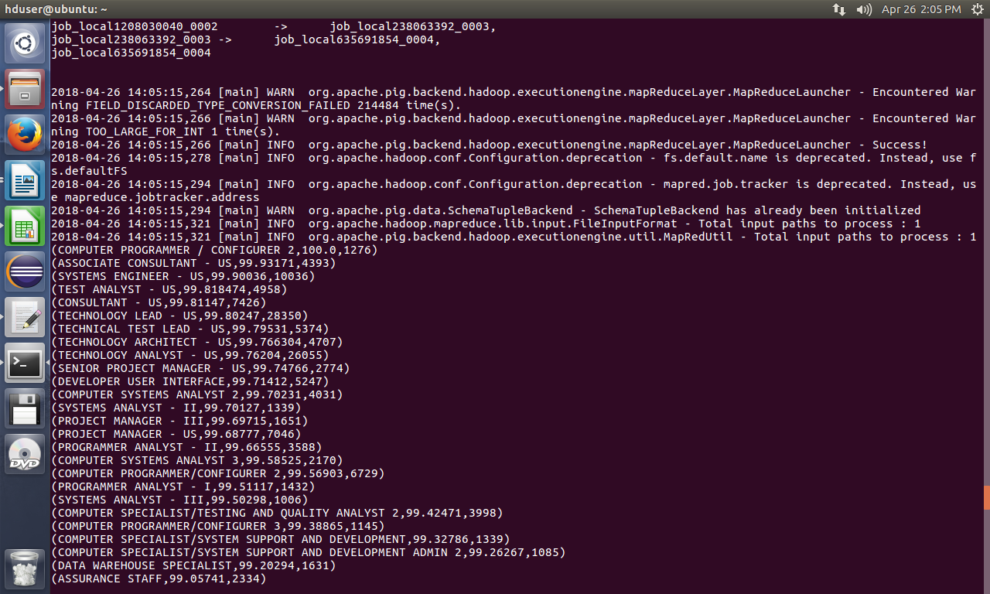

SQOOP QUERRY

11) Export result for question no 10 to MySql database.

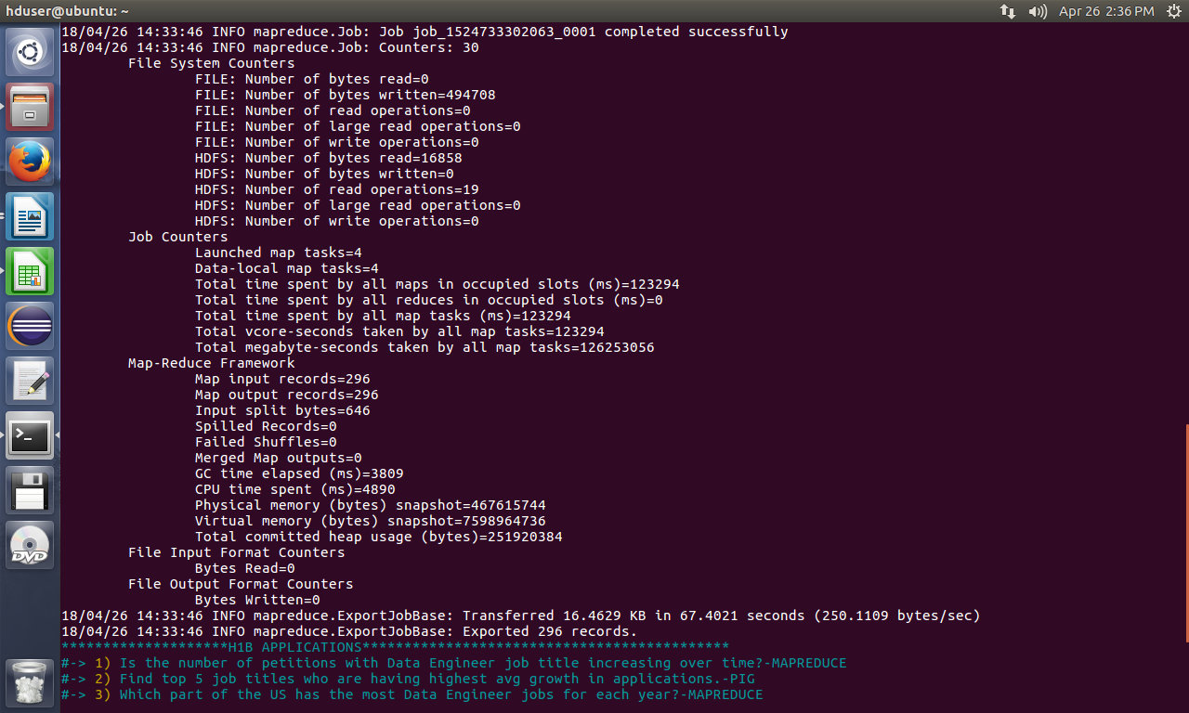
MYSQL



