Scenic Tours & Travels

**Package Summary:**

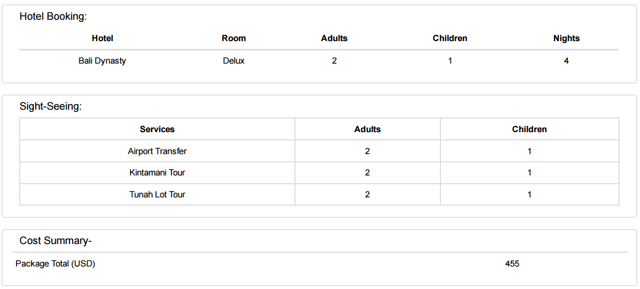

**Tour Itinerary**

**DAY WISE SCHEDULE:**

|  |  |  |
| --- | --- | --- |
| **DAY 1:** |  | **07th April 2017** |
| Transfers: | | Ngurah Rai International Airport to Bali Dynasty Resort |
| Sightseeing | | NIL |

|  |  |  |
| --- | --- | --- |
| **DAY 2:** |  | **08th April 2017** |
| Sightseeing: | | **FULL DAY KINTAMANI VOLCANO TOUR WITH UBUD VILLAGE ON PRIVATE BASIS** |
|  | | Morning after breakfast, proceed for a full day excursion to the Kintamani Volcano. This trip will take you up close & personal with the essence of Bali. It is the most favorite tour of any first time visitor to Bali. Visit the Batubulan village (famous for traditional Batik and hand weavings), Mas village (famous for Wood carving) & then past the Celuk village (famous for silver and gold works). There after proceed to the one of the most historical & ancient Hindu temples in Bali. Continue your tour to The Mount & Lake Batur in Kintamani village for some stunning views of the beautiful locales in this region. Your tour ends in the famous coffee plantation. Here you can look in & taste many kind of coffees from Indonesia including Luwak coffee. |

|  |  |  |
| --- | --- | --- |
| **DAY 3:** | **DATE:** | **09th April 2017** |
| Sightseeing: | | **FULL DAY BENOA BEACH WITH ULUWATU TOUR ON PRIVATE BASIS** |
|  | | An ideal Bali holiday is incomplete without Bali water sports at the famous Tanjung Benoa beach. This beach best known for its aquatic adventure is located in the Benoa peninsula far away from the hustle & bustle. North of Nusa Dua this beach offers a wide range of water sports. Please check with our representatives for all the water sports information. Many shacks & restaurants lined up along the beach make sure that your tummy is full & you enjoy the most. A great southern Bali trip in the evening introduces you to the heart of southern part of the island. The beautiful Uluwatu temple, built on the top of a cliff about 825 feet high facing the vast deep blue Indian Ocean also offers a wonderful view of the sunset. |

|  |  |  |
| --- | --- | --- |
| **DAY 4:** | **DATE:** | **10th April 2017** |
| Transfers: | | Bali Dynasty to Ngurah Rai International Airport |