**Abstract**

*A java program that loads the book details searched for using google books public api.*

## Problem definition , Introduction to program:

Implementation of java program that search for a given search for a given query using google books public api using *HttpUrlConnection*. The result, to be obtained in JSON format, is then needs to be parsed in String Object using *JSONParser*.

The resulted result is passed to a callback function which the updates the UI dynamically by adding *JTextArea* inside a *JPanel* for each of the results obtained.

## Major libraries , features of Java used:

**Multithreading: Multithreading in java** is a process of executing multiple threads simultaneously.

A thread is a lightweight sub-process, the smallest unit of processing. Multiprocessing and multithreading, both are used to achieve multitasking.

However, we use multithreading than multiprocessing because threads use a shared memory area. They don't allocate separate memory area so saves memory, and context-switching between the threads takes less time than process.

Java Multithreading is mostly used in games, animation, etc

**HTTP URL Connection:** The **Java URLConnection** class represents a communication link between the URL and the application. This class can be used to read and write data to the specified resource referred by the URL. The URLConnection class provides many methods, we can display all the data of a webpage by using the getInputStream() method. The getInputStream() method returns all the data of the specified URL in the stream that can be read and displayed.

**JFrame** : The javax.swing.JFrame class is a type of container which inherits the java.awt.Frame class. JFrame works like the main window where components like labels, buttons, textfields are added to create a GUI.

**Jpanel**: The JPanel is a simplest container class. It provides space in which an application can attach any other component. It inherits the JComponents class. It doesn't have title bar.

**JTextField**: The object of a JTextField class is a text component that allows the editing of a single line text. It inherits JTextComponent class.

**JButton:** The JButton class is used to create a labeled button that has platform independent implementation. The application result in some action when the button is pushed. It inherits AbstractButton class.

## Action Event: This class is defined in java.awt.event package. The ActionEvent is generated when button is clicked or the item of a list is double clicked.

Output

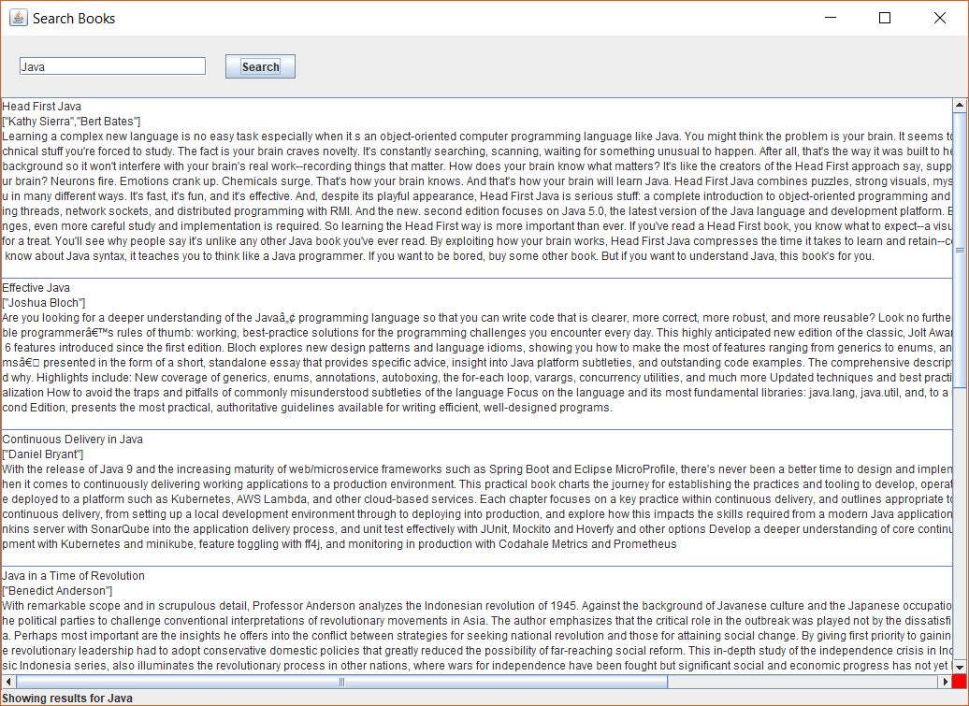

Output when no internet

