Milestone-2 Document: Ride Request API Development & Testing
This document details the design, implementation, and rigorous testing of three critical APIs within the NeuroFleetX Ride Management System: Create, Update, and Delete Ride Requests. These APIs form the backbone of our ride operations, handling everything from initial origin/destination coordinates to real-time traffic, weather factors, taxi assignment, estimated time of arrival (ETA), and dynamic ride status updates. Our focus is on delivering robust, efficient, and reliable services essential for a seamless ride-hailing experience.

-

The Core: RideRequest Entity Overview

At the heart of our system lies the object, a comprehensive representation of every ride initiated by a user
RideRequest
or taxi dispatcher. This entity encapsulates all vital information necessary to manage a ride from inception to completion. Each field is meticulously designed to support dynamic operations and provide crucial data points for effective ride management.


Field Type Description

id Long Primary key for the ride request

originLat Double Starting latitude coordinate

originLng Double Starting longitude coordinate

destLat Double Destination latitude coordinate

destLng Double Destination longitude coordinate

trafficIndex Double Traffic severity on a 0-1 scale (higher = more traffic)

weather String Current weather conditions (e.g., "sunny", "cloudy", "rainy")

assignedTaxiId Long Identifier of the taxi assigned to the ride

eta Double Estimated time of arrival in minutes

status String Current state of the ride: PENDING
/ ASSIGNED / COMPLETED / CANCELLED

All API requests interact with the RideRequestDTO, which is seamlessly mapped to and from the using our MapperService.
RideRequest
entity

API Endpoints: Retrieving Ride Requests
Our system provides a dedicated endpoint to efficiently retrieve all active ride requests within the NeuroFleetX platform.
GET /api/rides

This allows for comprehensive monitoring and data analysis of ongoing operations. The designed for simplicity and direct access to this crucial information.

GET All Ride Requests Endpoint
endpoint is

GET /api/rides
Purpose
Fetch all ride requests currently available in the system, providing a complete overview of the ride management landscape.

Response Example

[
{
"id": 1,
"originLat": 40.7128,
"originLng": -74.0060,
"destLat": 40.7589,
"destLng": -73.9851,
"trafficIndex": 0.7, "weather": "sunny", "assignedTaxiId": 2,
"eta": 12.3,
"status": "ASSIGNED"
}
]

This response structure provides a clear, JSON-formatted array of all ride requests, enabling easy integration with frontend applications and analytics tools.

API Endpoints: Creating New Ride Requests

The ability to create new ride requests is fundamental to the NeuroFleetX system. The endpoint
POST /api/rides
facilitates the seamless initiation of new rides, capturing all necessary details from the user or dispatcher. This process involves careful data conversion and persistence to ensure accuracy and system integrity.

Create a Ride Request Endpoint
POST /api/rides
Purpose
Facilitates the creation of a new ride request within the system, marking the initial phase of a ride's lifecycle.

Request Body Example

{
"originLat": 40.7128,
"originLng": -74.0060,
"destLat": 40.7589,
"destLng": -73.9851,
"trafficIndex": 0.7, "weather": "sunny", "status": "PENDING"
}

Processing Steps

Convert
RideRequestDTO
to
entity using mapperService.toRideRequest().

Persist the new ride request using rideRequestService.saveRideRequest().
RideRequest
RideRequest
RideRequestDTO

Convert the saved
entity back to
for the response.

Success Response Example

{
"id": 1,
"originLat": 40.7128,
"originLng": -74.0060,
"destLat": 40.7589,
"destLng": -73.9851,
"trafficIndex": 0.7, "weather": "sunny", "status": "PENDING"
}

API Endpoints: Updating Ride Requests
The dynamic nature of ride-hailing requires robust capabilities to update existing ride requests. The
PUT /api/rides/{id}
endpoint allows for modifications to critical ride details, including taxi assignment, ETA, and status changes. This ensures that the system accurately reflects the current state of every ride.

Update a Ride Request Endpoint
PUT /api/rides/{id}
Purpose
To update specific details of an existing ride, such as assigning a taxi, adjusting ETA, or changing the ride status.

Request Body Example

{
"originLat": 40.7128,
"originLng": -74.0060,
"destLat": 40.7589,
"destLng": -73.9851,
"trafficIndex": 0.7, "weather": "sunny", "assignedTaxiId": 1,
"eta": 12.5,
"status": "ASSIGNED"
}

Error Handling


If the specified id does not correspond to an existing ride request, a 404 Not Found error will be returned, accompanied by a ResourceNotFoundException message: Ride Request with ID {id} not found.
Success Response Example

{
"id": 1,
"originLat": 40.7128,
"originLng": -74.0060,
"destLat": 40.7589,
"destLng": -73.9851,
"trafficIndex": 0.7, "weather": "sunny", "assignedTaxiId": 1,
"eta": 12.5,
"status": "ASSIGNED"
}

API Endpoints: Deleting Ride Requests
Managing the lifecycle of ride requests also includes the ability to permanently remove them from the system. The endpoint provides this functionality, ensuring that outdated or erroneous requests can be cleaned
DELETE /api/rides/{id}
up effectively. This operation is critical for maintaining data hygiene and system performance.

Delete a Ride Request Endpoint
DELETE /api/rides/{id}
Purpose
To permanently remove a ride request from the NeuroFleetX system based on its unique identifier.

Behavior
ResourceNotFoundException


If the provided
id
404 Not Found
does not match an existing ride request, a response.
will be thrown, resulting in a

If the ride request is found, it will be successfully deleted from the database.

Success Response
204 No Content

A status indicates that the deletion was successful and there is no additional information to send back in
204 No Content
the response body.

Robust Error Handling
Effective error handling is paramount for a reliable API. The NeuroFleetX API is designed to provide clear and informative responses when issues arise, particularly when dealing with non-existent resources. Our primary error mechanism for such scenarios is the ResourceNotFoundException.







Updating Non-Existing Ride
An attempt to update a ride request using an id that does not exist will trigger this exception.

Deleting Non-Existing Ride
Similar to updates, trying to delete a ride with an invalid id will result in a ResourceNotFoundException.

Fetching Invalid ID Requests to retrieve a ride using an id that does not exist will also
be handled by this exception.

This exception ensures that clients receive consistent responses, which can be elegantly wrapped by a
404 Not Found
standard JSON error handler for a uniform error payload across the API.

Comprehensive Testing Plan
Thorough testing is crucial to guarantee the reliability and correctness of our APIs. Our testing strategy combines automated and manual approaches, with a significant focus on Postman for API validation. This plan ensures that all endpoints behave as expected under various conditions, covering both successful operations and anticipated error scenarios.

  - Create Ride Tests

  - Update Ride Tests
Test Case
Input
Expected Output
Create valid ride
Valid JSON payload
HTTP 200 OK + Valid Ride DTO
Missing fields
JSON missing originLat
HTTP 400 BAD REQUEST
Invalid coordinates
lat > 90
Validation error response



  - Delete Ride Tests
Test Case
Behavior
Expected Output
Delete valid ID
Delete an existing ride request
HTTP 204 No Content
Delete invalid ID
Attempt to delete a ride with an
invalid id
HTTP 404 Not Found
Test Case
Behavior
Expected Output
Update existing ride
Modify fields of an existing ride
Successfully updates and returns
HTTP 200 OK
Update non-existent ID
Attempt to update a ride with an
invalid id
Returns HTTP 404 Not Found
Change status to ASSIGNED
Set ride status to ASSIGNED
Automatically updates ETA and
assignedTaxiId

Technology Stack s Tools Utilized
The development of the NeuroFleetX Ride Management System APIs leverages a robust and widely adopted technology stack, ensuring scalability, maintainability, and high performance. Each tool and framework plays a crucial role in delivering a stable and efficient backend service.




Spring Boot 3
Foundation for rapid API development, providing auto- configuration and an embedded server for quick deployment.

Postman
Indispensable for API testing, allowing for easy creation, execution, and management of various test cases.

MapperService
Facilitates clean architecture by handling conversions between
RideRequestDTO
RideRequest
and
entities.

Spring Web + JPA
Provides capabilities for building RESTful APIs and seamless integration with relational databases for data persistence.
CrossOrigin Enabled Ensures smooth integration with frontend applications by allowing
cross-origin requests, enhancing
developer flexibility.

Milestone Achievement s Future Outlook
This milestone marks a significant step forward for the NeuroFleetX Ride Management System. We have successfully delivered a foundational set of APIs that are critical for managing ride requests, backed by thorough testing and robust error handling. The strategic use of modern technologies ensures a scalable and maintainable solution.



API to Create Rides
Successfully implemented for seamless ride initiation.

API to Update Rides
Enables dynamic adjustments to ride parameters and status.

API to Delete Rides
Provides efficient management and cleanup of ride data.

Validation & Error Handling
Robust mechanisms ensure data integrity and clear error feedback.

Postman Tests
Comprehensive testing validates API functionality and reliability.

DTO Mapping
Clean architecture achieved through effective data transfer object mapping.

With these core functionalities in place, we are well-positioned to expand the NeuroFleetX platform, focusing on advanced features and continuous performance optimization in future development cycles.

Postman API Testing:

1. GET All Rides 2. Delete a Ride

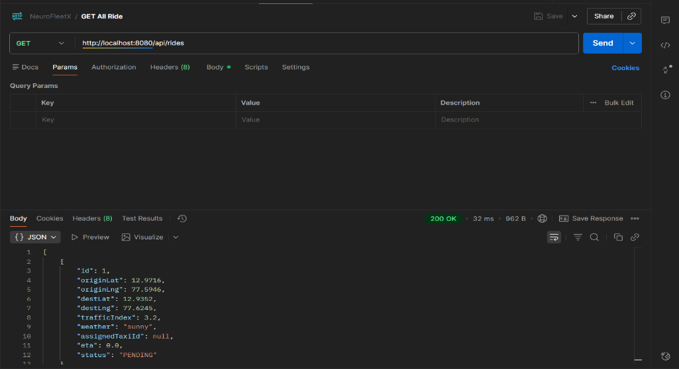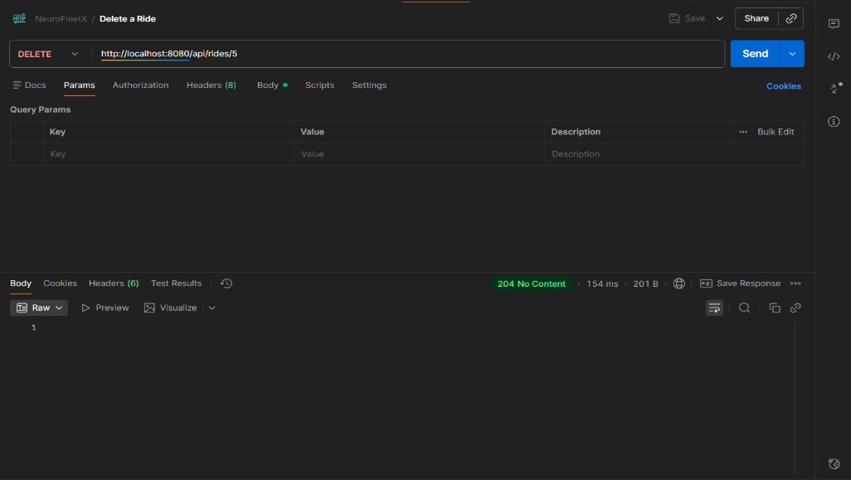

3. Create a Ride 4. Update a Ride

