MILE STONE 2 : NEURO FLEET X
TEAM A -SHALINI

BACKEND FOR THE TAXIS PAGE

- API testing using hopscotch

1.1 GET /api/taxis – Retrieve All Taxis
Purpose: Fetch a list of all taxis currently stored in the database
HTTP Method: GET
Example Response:
[
{
"id": 1,
"name": "Taxi 001",
"latitude": 28.6139,
"longitude": 77.2090,
"batteryLevel": 85,
"status": "AVAILABLE"
},
{
"id": 2,
"name": "Taxi 002",
"latitude": 28.5355,
"longitude": 77.3910,
"batteryLevel": 60,
"status": "BUSY"
}
]
1.2 POST /api/taxis – Create a New Taxi
Purpose: Add a new taxi record to the database.
HTTP Method: POST
Example Request:
{
"name": "Taxi 003",
"latitude": 28.7041,
"longitude": 77.1025,
"batteryLevel": 90,
"status": "AVAILABLE"
}
Response: JSON object with the same fields plus the auto-generated id:
{
"id": 3,
"name": "Taxi 003",
"latitude": 28.7041,
"longitude": 77.1025,
"batteryLevel": 90,
"status": "AVAILABLE"
}

1.3 PUT /api/taxis/{id} – Update an Existing Taxi
Purpose: Modify the details of an existing taxi record.
HTTP Method: PUT
Request Body: JSON object with updated fields:
{
"name": "Taxi 003 Updated",
"latitude": 28.7041,
"longitude": 77.1025,
"batteryLevel": 75,
"status": "CHARGING"
}
Response: JSON object with updated values:
{
"id": 3,
"name": "Taxi 003 Updated",
"latitude": 28.7041,
"longitude": 77.1025,
"batteryLevel": 75,
"status": "CHARGING"
}

1.4 DELETE /api/taxis/{id} – Delete a Taxi
Purpose: Remove a taxi record from the database.
HTTP Method: DELETE
Request: No body required
Response: Empty body and upon calling the get request we see that the parameter passed gets deleted

2. Backend Components
2.1 TaxiDTO (Data Transfer Object)
The TaxiDTO class represents the data structure used in API requests and responses. It contains the same fields as the database but uses primitive types and strings for easier JSON serialization:
- id: Long
- name: String
- latitude: double
- longitude: double
- batteryLevel: int
- status: String
Using DTOs decouples the REST API from internal entity changes and allows for validation and transformation logic.
2.2 TaxiService (Business Logic)
TaxiService is the central service layer that orchestrates all taxi-related operations. It delegates persistence tasks to TaxiRepository while maintaining clean separation of concerns.
Key Methods:
- getAllTaxis(): Returns all taxis from the database
- getTaxiById(Long id): Retrieves a single taxi by ID or returns empty Optional if not found
- updateTaxi(Taxi taxi): Updates an existing taxi record identified by its ID
- deleteTaxi(Long id): Deletes a taxi record by ID
2.3 TaxiRepository (Data Access Layer)
TaxiRepository extends Spring Data JPA's provides implementations for standard CRUD operations:
- findAll(): Retrieves all records
- findById(Long id): Retrieves a single record by primary key
- save(Taxi taxi): Inserts or updates a taxi record
- deleteById(Long id): Deletes a record by ID

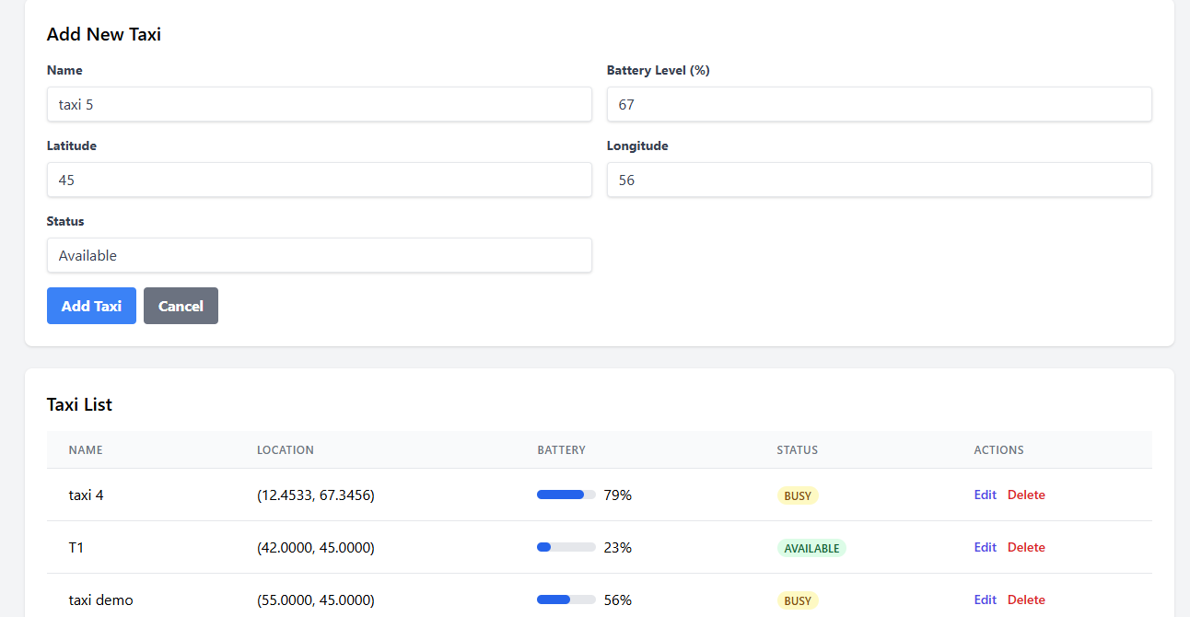

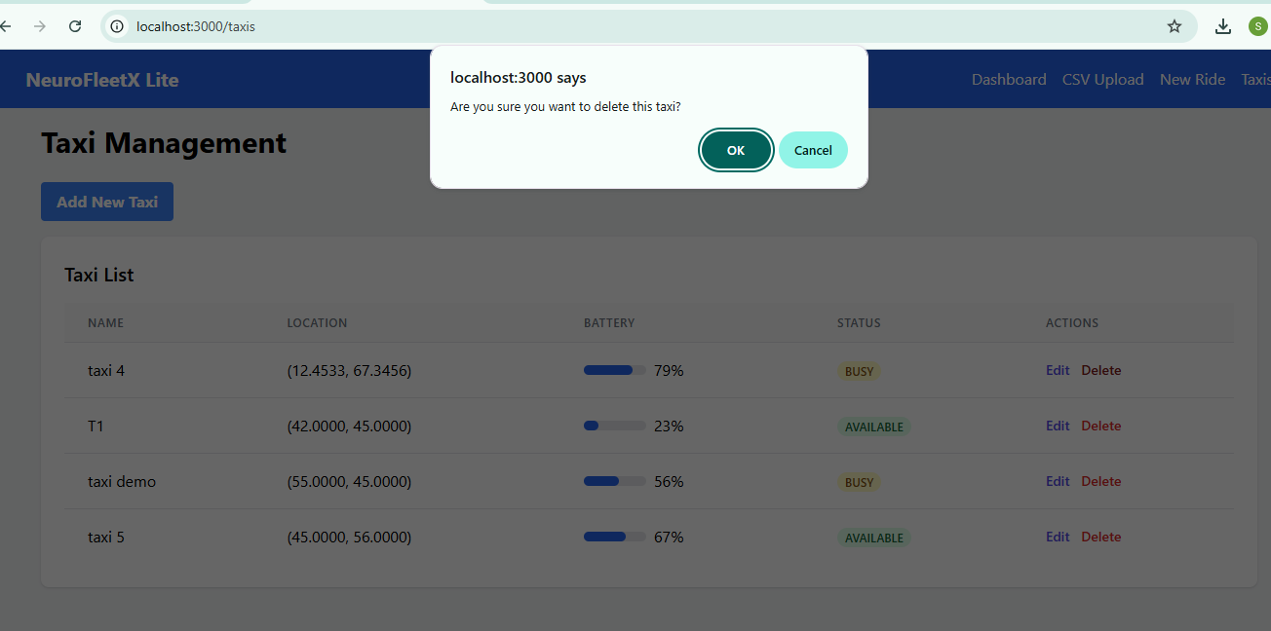

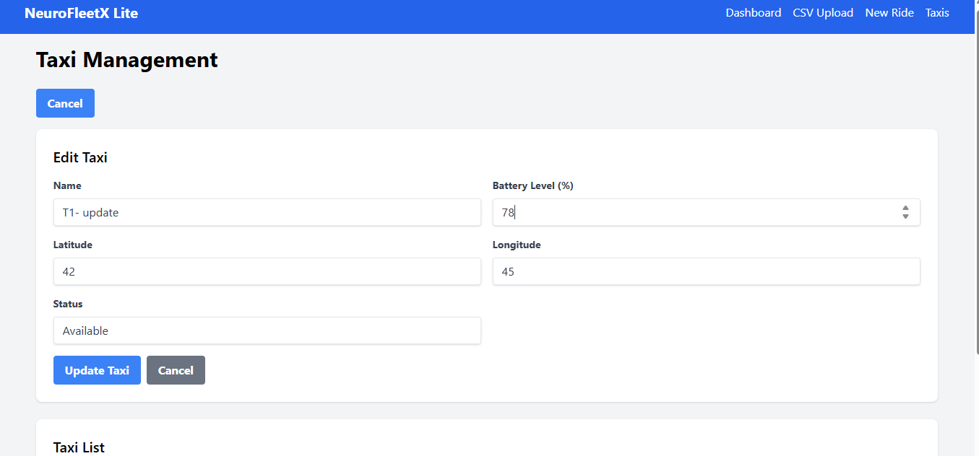

DATA BASE
