Infosys Springboard Virtual Internship 6.0 Completion Report

Team Details <Do not mention any personally identifiable information like email ID, institute details, mobile phone number etc.>

Batch Number: 7
Start date : 10-11-2025
Names: AKHILESH SINGH

Internship Duration: 8 Weeks

1. Project Title

Neurofleetx: Intelligent Taxi Dispatch System

2. Project Objective

The objective of NeuroFleetX is to develop an intelligent taxi fleet management system that streamlines ride booking, enhances user experience, and provides meaningful insights through an interactive interface.

The system aims to support efficient ride management, transparent ride tracking, and data-driven decision making using modern web technologies and intelligent backend services.

3. Project description in detail

NeuroFleetX is an AI-powered taxi fleet management system designed to improve the overall ride-booking experience and fleet operations. The platform allows users to request rides, view ride history, and analyze usage data through a structured and user-friendly interface.

This report focuses on my individual contribution to the user-side frontend of the NeuroFleetX system. The frontend is developed using React.js and serves as the primary interaction layer for users. It handles user inputs, displays system responses, and presents data visually for better understanding.

The user dashboard acts as the central interface, providing navigation to ride requests, ride history, analytics, and profile sections. Users can initiate ride requests by entering pickup and drop-off details through a form-based interface. The frontend validates user input and communicates with backend APIs to process the request and display responses on the UI.

The ride history module presents previously completed rides in a structured list or table format, allowing users to review ride-related information easily. Additionally, the analytics section converts ride data into visual charts and graphs, helping users understand their ride patterns and usage trends at a glance.

My contribution was frontend development, including UI design, component implementation, API integration, and data visualization, with a strong focus on usability and responsiveness.

.
4. Timeline Overview
Week | Activities Planned | Activities Completed
Week 1 | Requirement understanding and UI planning | Requirements analyzed and UI flow planned
Week 2 | Dashboard UI development | User dashboard implemented
Week 3 | Ride request module | Ride request page completed
Week 4 | Ride history module | Ride history UI developed
Week 5 | Analytics implementation | Charts and visual analytics added
Week 6 | UI refinement | Responsive design and styling
Week 7 | Testing AI model, database, | UI testing and bug fixing
Week 8 | Documentation | Frontend documentation completed

5a. Key Milestones
Milestone | Description
Dashboard Completion | User dashboard UI finalized
Ride Request Flow | Ride request feature implemented
Ride History | Structured display of past rides
Analytics | Charts and data visualization completed
Final Review | Frontend testing and submission

5b. Project execution details

Analyzed requirements for user-side functionality

Designed responsive UI using React.js components

Implemented ride request forms with validation

Displayed ride history in a structured format

Visualized ride data using charts and graphs

Integrated frontend with backend APIs

Performed UI testing and improvements

6. Snapshots / Screenshots
Step 1: User dashboard displaying navigation and overview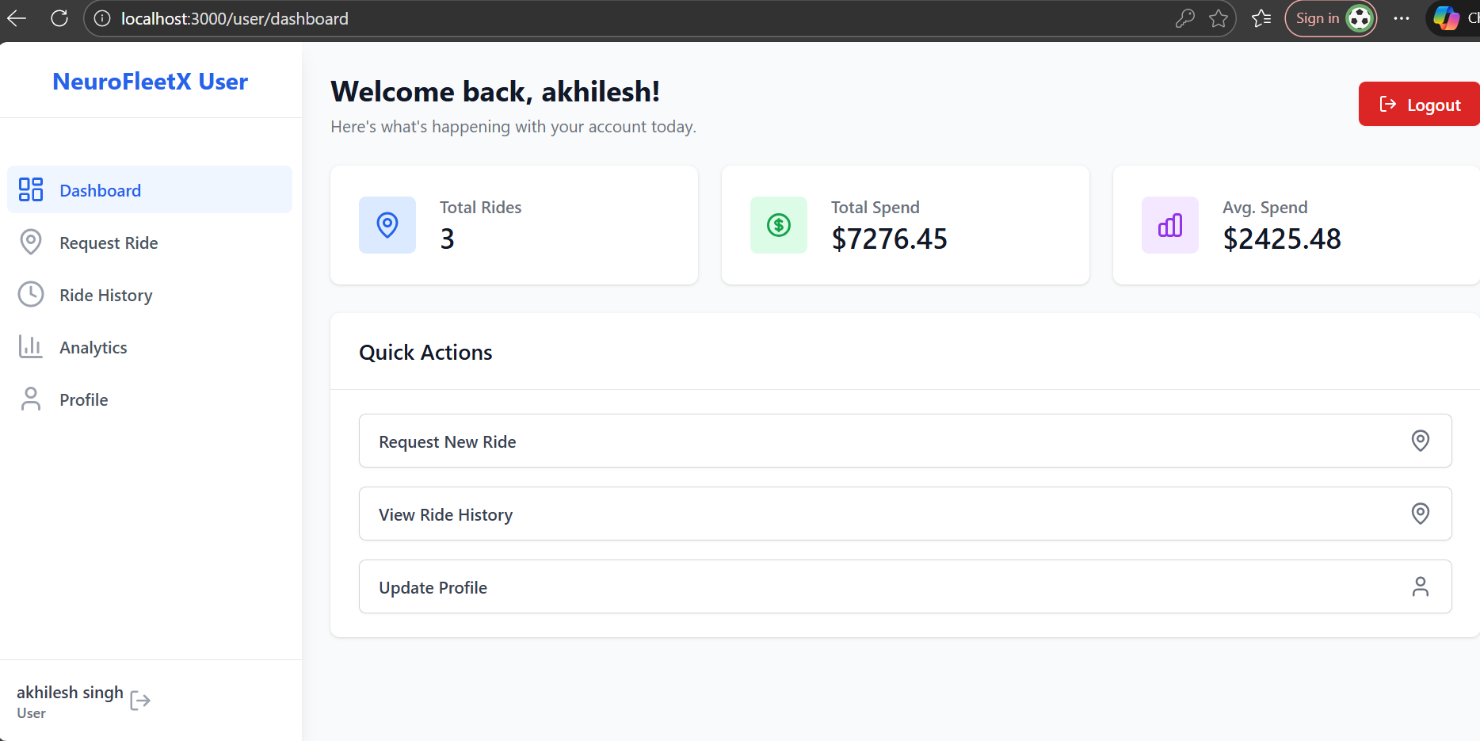
Step 2: Ride request page for entering pickup and drop-off details
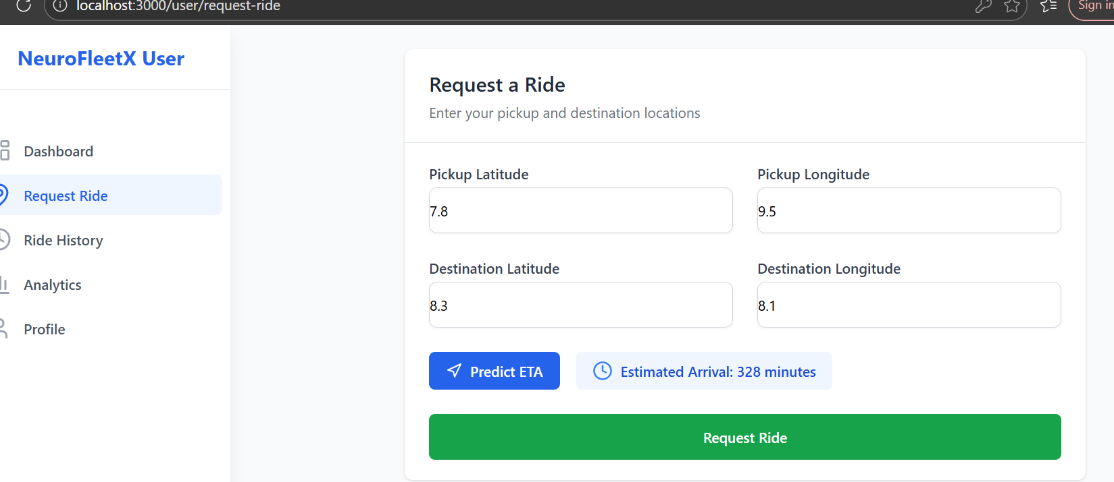
Step 3: Ride history page showing previous rides
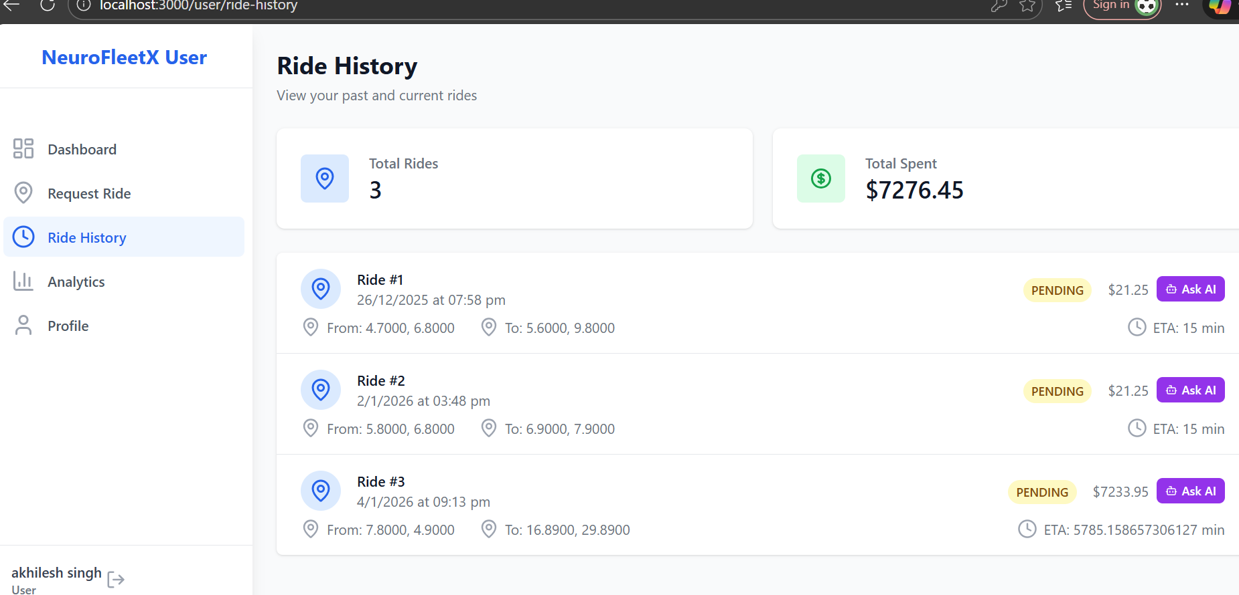
Step 4: Analytics section with charts and graphs
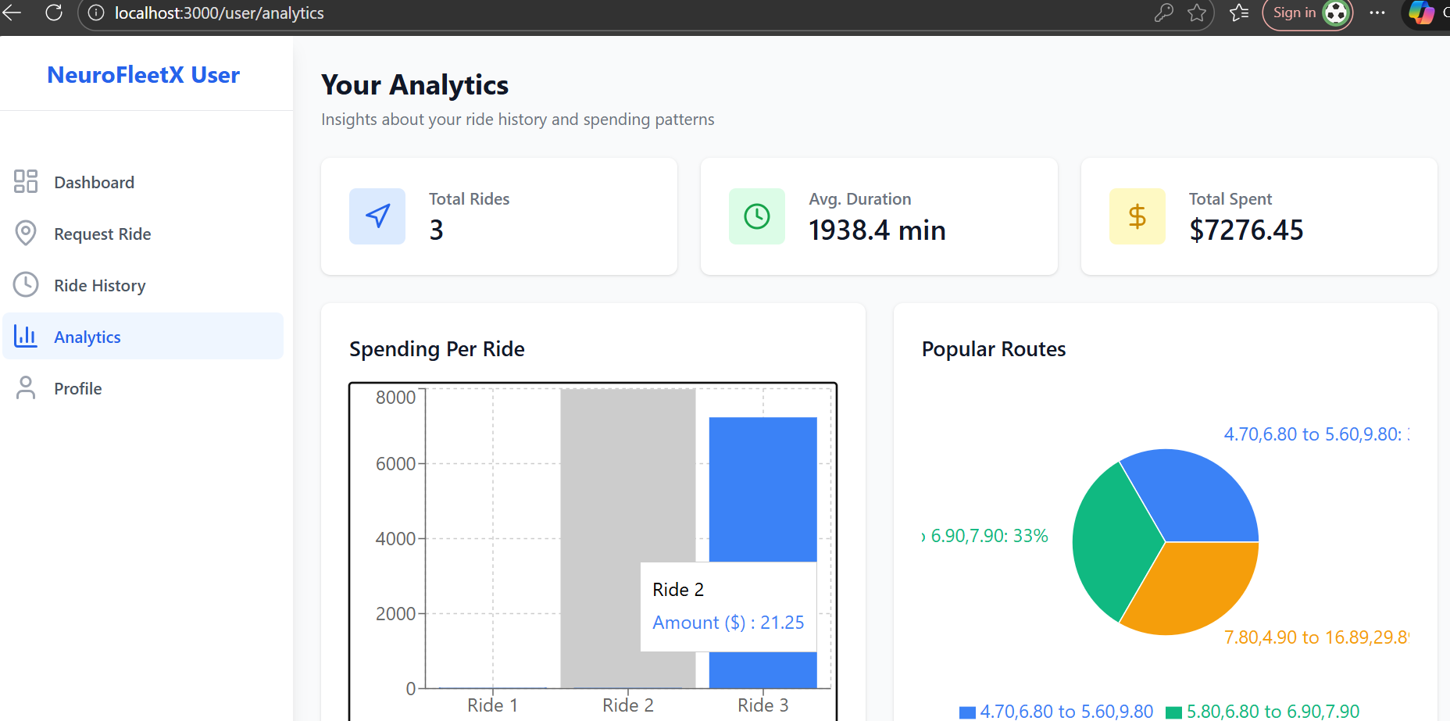
Step 5: User profile section
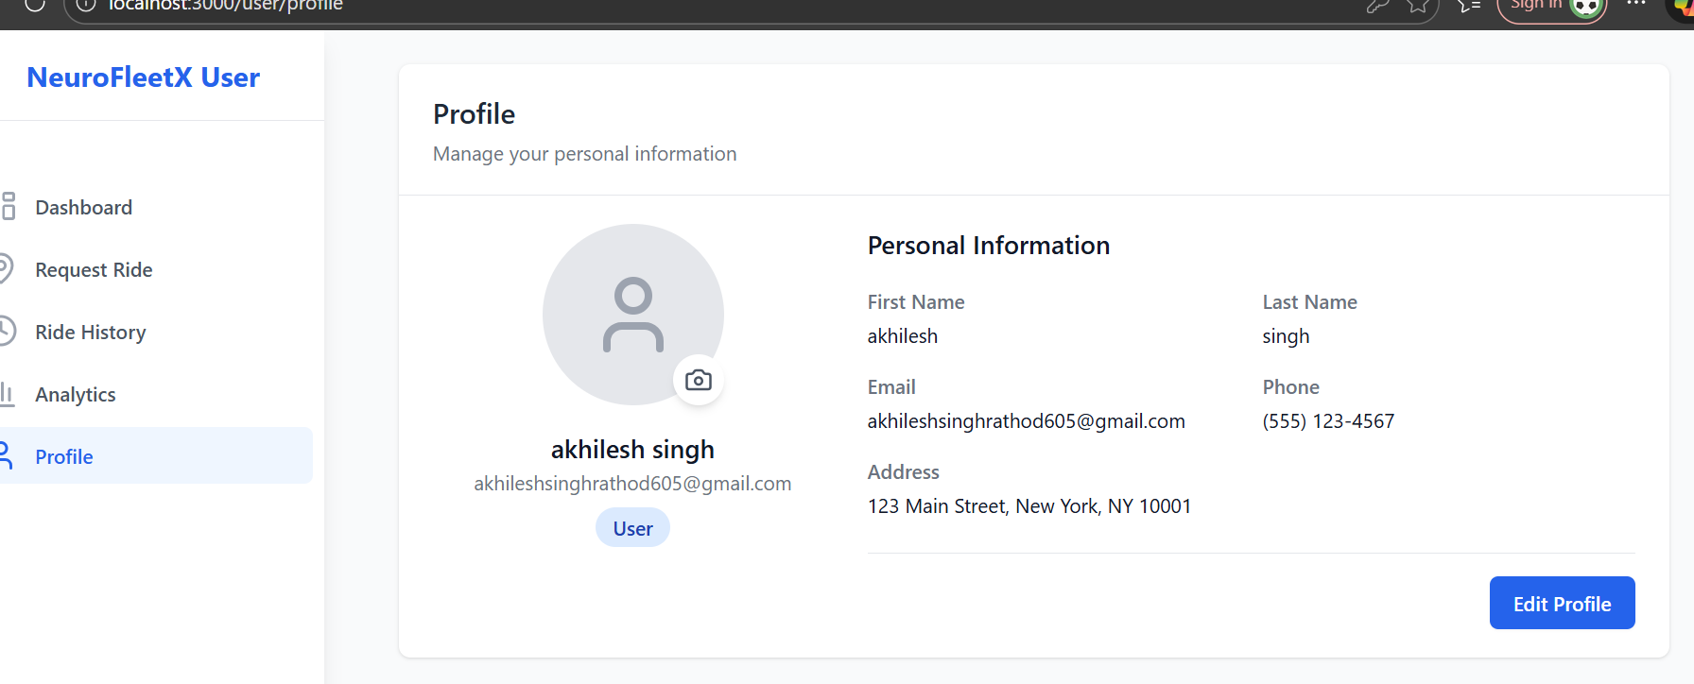

7. Challenges Faced

Managing state across multiple React components

Designing a clean and responsive user interface

Handling API responses and rendering data dynamically

Displaying charts correctly based on user data

8. Learnings & Skills Acquired

React.js and component-based frontend development

State management using React hooks

API integration using Axios

Data visualization using chart libraries

UI/UX design principles

Frontend debugging and testing

9. Conclusion

This project provided valuable hands-on experience in frontend development. My contribution focused on the user-side frontend of the NeuroFleetX system, including dashboard design, ride request flow, ride history, and analytics visualization. The project enhanced my understanding of React.js, user interface design, and real-world frontend application development.

10. Acknowledgements

I would like to thank the organization and mentors for their guidance and support throughout the internship. I am also grateful for the opportunity to work on this project and strengthen my frontend development skills.

