## Breadth First Search (BFS) Algorithm

Algorithm

The steps involved in the BFS algorithm to explore a graph are given as follows -

**Step 1:** SET STATUS = 1 (ready state) for each node in G

**Step 2:** Enqueue the starting node A and set its STATUS = 2 (waiting state)

**Step 3:** Repeat Steps 4 and 5 until QUEUE is empty

**Step 4:** Dequeue a node N. Process it and set its STATUS = 3 (processed state).

**Step 5:** Enqueue all the neighbours of N that are in the ready state (whose STATUS = 1) and set

their STATUS = 2

(waiting state)

[END OF LOOP]

**Step 6:** EXIT

### Example

Consider the graph G shown in the following image, calculate the minimum path p from node A to node E. Given that each edge has a length of 1.

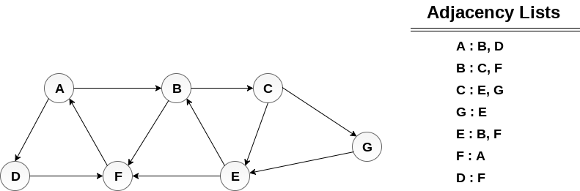  
 

## Solution:

Minimum Path P can be found by applying breadth first search algorithm that will begin at node A and will end at E. the algorithm uses two queues, namely **QUEUE1** and **QUEUE2**. **QUEUE1** holds all the nodes that are to be processed while **QUEUE2** holds all the nodes that are processed and deleted from **QUEUE1**.

**Lets start examining the graph from Node A.**

1. Add A to QUEUE1 and NULL to QUEUE2.

1. QUEUE1 = {A}
2. QUEUE2 = {NULL}

2. Delete the Node A from QUEUE1 and insert all its neighbours. Insert Node A into QUEUE2

1. QUEUE1 = {B, D}
2. QUEUE2 = {A}

3. Delete the node B from QUEUE1 and insert all its neighbours. Insert node B into QUEUE2.

1. QUEUE1 = {D, C, F}
2. QUEUE2 = {A, B}

4. Delete the node D from QUEUE1 and insert all its neighbours. Since F is the only neighbour of it which has been inserted, we will not insert it again. Insert node D into QUEUE2.

1. QUEUE1 = {C, F}
2. QUEUE2 = { A, B, D}

5. Delete the node C from QUEUE1 and insert all its neighbours. Add node C to QUEUE2.

1. QUEUE1 = {F, E, G}
2. QUEUE2 = {A, B, D, C}

6. Remove F from QUEUE1 and add all its neighbours. Since all of its neighbours has already been added, we will not add them again. Add node F to QUEUE2.

1. QUEUE1 = {E, G}
2. QUEUE2 = {A, B, D, C, F}

7. Remove E from QUEUE1, all of E's neighbours has already been added to QUEUE1 therefore we will not add them again. All the nodes are visited and the target node i.e. E is encountered into QUEUE2.

1. QUEUE1 = {G}
2. QUEUE2 = {A, B, D, C, F,  E}

Now, backtrack from E to A, using the nodes available in QUEUE2.

The minimum path will be **A → B → C → E**.