# Depth First Search (DFS) Algorithm

### Algorithm

**Step 1:** SET STATUS = 1 (ready state) for each node in G

**Step 2:** Push the starting node A on the stack and set its STATUS = 2 (waiting state)

**Step 3:** Repeat Steps 4 and 5 until STACK is empty

**Step 4:** Pop the top node N. Process it and set its STATUS = 3 (processed state)

**Step 5:** Push on the stack all the neighbors of N that are in the ready state (whose STATUS = 1) and set their STATUS = 2 (waiting state)

[END OF LOOP]

**Step 6:** EXIT

### Example :

Consider the graph G along with its adjacency list, given in the figure below. Calculate the order to print all the nodes of the graph starting from node H, by using depth first search (DFS) algorithm.

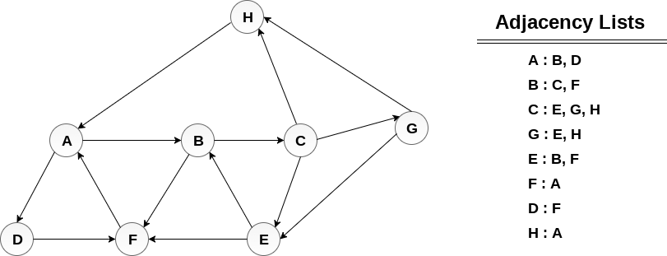

### Solution :

Push H onto the stack

1. STACK : H

POP the top element of the stack i.e. H, print it and push all the neighbours of H onto the stack that are is ready state.

1. Print H
2. STACK : A

Pop the top element of the stack i.e. A, print it and push all the neighbours of A onto the stack that are in ready state.

1. Print  A   { H---A }
2. Stack : B, D

Pop the top element of the stack i.e. D, print it and push all the neighbours of D onto the stack that are in ready state.

1. Print D    { H---A---D }
2. Stack : B, F

Pop the top element of the stack i.e. F, print it and push all the neighbours of F onto the stack that are in ready state.

1. Print F   { H---A---D ---F }
2. Stack : B

Pop the top of the stack i.e. B and push all the neighbours

1. Print B   F   { H---A---D ---F---B }
2. Stack : C

Pop the top of the stack i.e. C and push all the neighbours.

1. Print C    { H---A---D ---F ---B---C }
2. Stack : E, G

Pop the top of the stack i.e. G and push all its neighbours.

1. Print G   { H---A---D ---F ---B---C---G}
2. Stack : E

Pop the top of the stack i.e. E and push all its neighbours.

1. Print E   { H---A---D ---F ---B---C---G---E}
2. Stack :  EMPTY

Hence, the stack now becomes empty and all the nodes of the graph have been traversed.

The printing sequence of the graph will be :

1. H → A → D → F → B → C → G → E