**Dreamline Project Summary**

**Group 26- Cole Pearson, Nausherwan Tirmizi, Brian Kopec, Harshal Patel**

Dreamline is a product that will help customers find the cheapest and most comfortable seat for a flight. Cheapest flights are easy to find and there are many other applications that do exactly the same. Dreamline however, will not only take price into consideration, but will also incorporate comfort level using sensors into the algorithm.

This application will pull ticket prices and aircraft information from airline API’s. It will also collect data from sensors built into smartphones and smart watches such as accelerometer, GPS, pedometer, oximeter, heart rate sensor, and sleep tracker. This sensor data will provide information on how comfortable the flight was based on data points such as REM sleep, repositioning and slight movements of discomfort, oxygen levels, and heart rates determining dehydration. Combining this data with flight information and prices, the application will provide the customer with a Dreamline score for the particular flight. This will represent a score that indicates the quality of the flight balanced with how affordable it is.

The application will go through 3 major scenarios. First and most importantly, is the User browsing through the application website or app, to find a particular flight that fits their needs and find one with the most value. Second is the process of actually booking the flight which will initiate the process of collecting data. The third is the data collection itself, where sensor data is collected from smartphones and smartwatches running the application during a flight that was booked through the application. In the first scenario when a user is browsing for the best flight, they are shown a Dreamline score which is calculated from sensor data collected from other users on that same flight that is stored in the cloud and the prices collected from API calls. In the second scenario, the user purchases a ticket through our application, the revenue of which goes to the airline. By doing this, the user acknowledges that data from the application and any smartwatch the user may have will be collected to provide the database with more sensor data to provide more accurate Dreamline scores. Finally when the user is actually on the flight that they booked with our application, the app will start collecting data throughout the flight from sensors, and send that back to the cloud servers once they have an internet connection.

The application will primarily be a mobile application that can be accessed through smartwatches and will also include a web application. The mobile application must be accessible though android and apple smartphones and watches. There will also be a web application that will display the Dreamline score and relevant information on what determines the comfort levels for a particular flight. We will collaborate with Google Adsense to generate revenue, use cloud services to store and organize sensor data and run web services, and use API calls from Amadeus, Sabre, and TravelPort to collect real time ticket prices and aircraft details. The application will require the device to have necessary sensors built into it. We are assuming that a large portion of our users will have a smartwatch that will allow us to collect a lot of necessary data to create accurate Dreamline scores. We are assuming that users will allow us to track data to be able to use the app. Finally we are also assuming that the application will initially start out with initial sensor data received from beta testers, which will take domestic flights and collect initial data

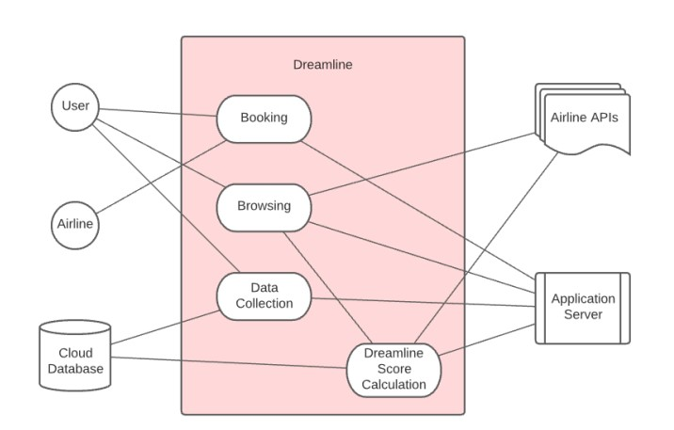

**Requirements:** The system must have a way for the user to input their flight itinerary details. The system must be able to make API calls for ticket availability from different airlines. Travelport (Traht) and DirectConnect (Alvht) are API sources for ticket availability. Along side that the system must be able to intake sensor data from the phone as well as any attached smart devices. After the flight, the user can leave a review which the system must also have a to receive. Using the aforementioned information the system must have a to calculate the dreamline score and assign to each flight

The user will press a button to start tracking data and the system will be tracking data while the user is flying. This data will then be compiled and sent to a database after the user is reconnected to wifi. After the flight, the user will have an option to fill out a form reviewing their experience. This form will be collected then sent to the database.

This product utilizes some external tools such as airline APIs and smart device SDKs as tools for data gathering and Dreamline score calculating. These packages are integrated within our subsystems to ease the process of development. Some outstanding issues exist that can further be addressed with the future development of smart devices and their sensors.