Python Basics Assignment

1. Grade Checker
Code:
score = int(input("Enter the score: "))
if score >= 90:
print("Grade: A")
elif score >= 80:
print("Grade: B")
elif score >= 70:
print("Grade: C")
elif score >= 60:
print("Grade: D")
else:
print("Grade: F")
Explanation:
- Takes user input as a score.
- Uses if-elif-else to decide the grade.
- Prints the grade accordingly.
Screenshot: 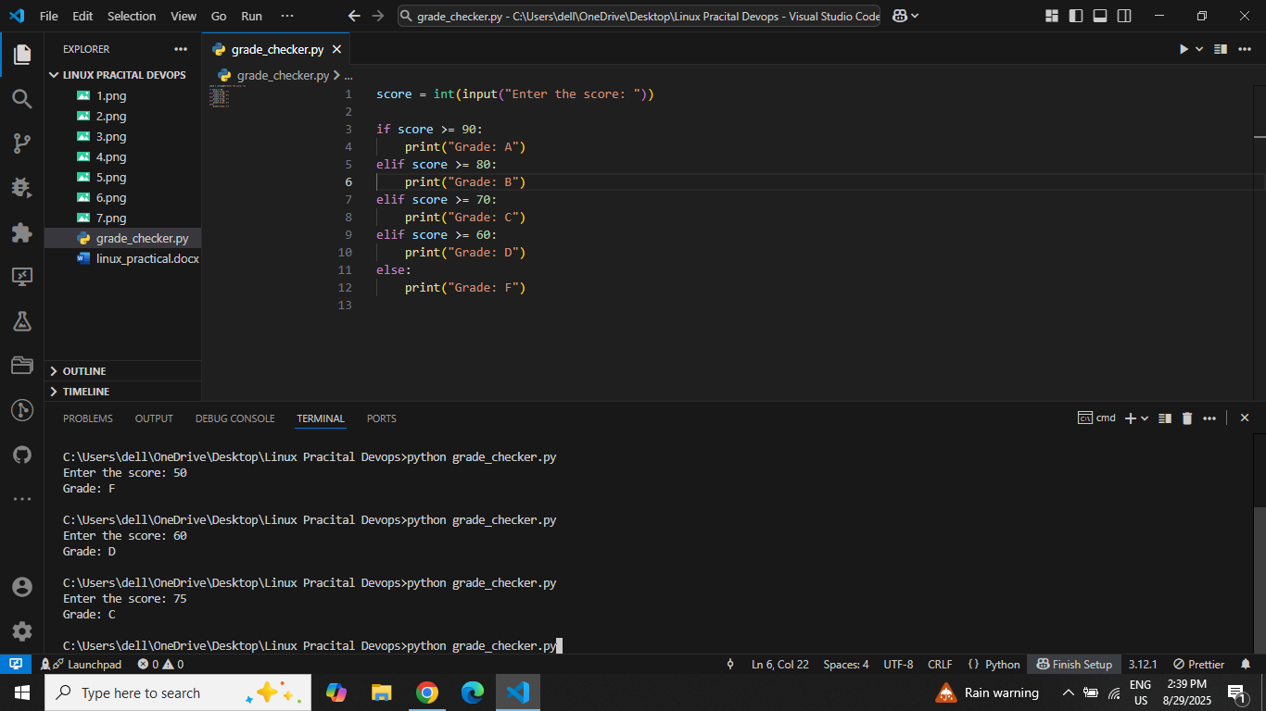

2. Student Grades (Dictionary Operations)
Code:
students = {}

while True:
print("\nOptions:")
print("1. Add new student")
print("2. Update student grade")
print("3. Print all grades")
print("4. Exit")

choice = int(input("Enter your choice: "))

if choice == 1:
name = input("Enter student name: ")
grade = input("Enter grade: ")
students[name] = grade
print(f"{name} added with grade {grade}")
elif choice == 2:
name = input("Enter student name to update: ")
if name in students:
grade = input("Enter new grade: ")
students[name] = grade
print(f"{name}'s grade updated to {grade}")
else:
print("Student not found.")
elif choice == 3:
print("\nStudent Grades:")
for name, grade in students.items():
print(f"{name}: {grade}")
elif choice == 4:
break
else:
print("Invalid choice. Try again.")

Explanation:
- Uses a dictionary to store students and grades.
- Menu-driven program using if-elif-else.
- Allows adding, updating, and printing student grades.
Screenshot: 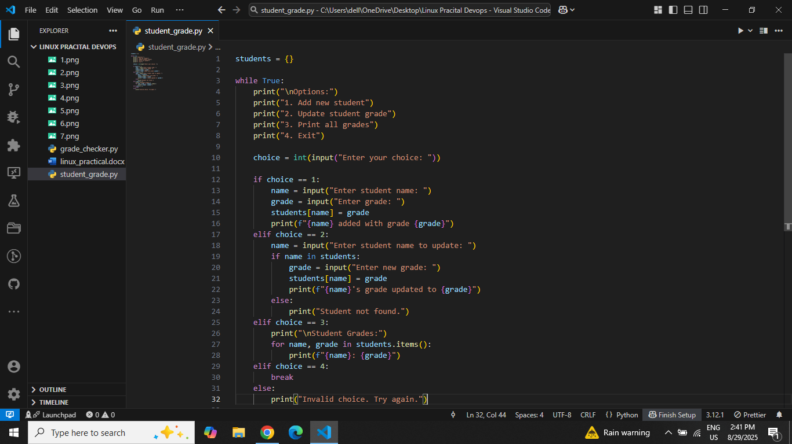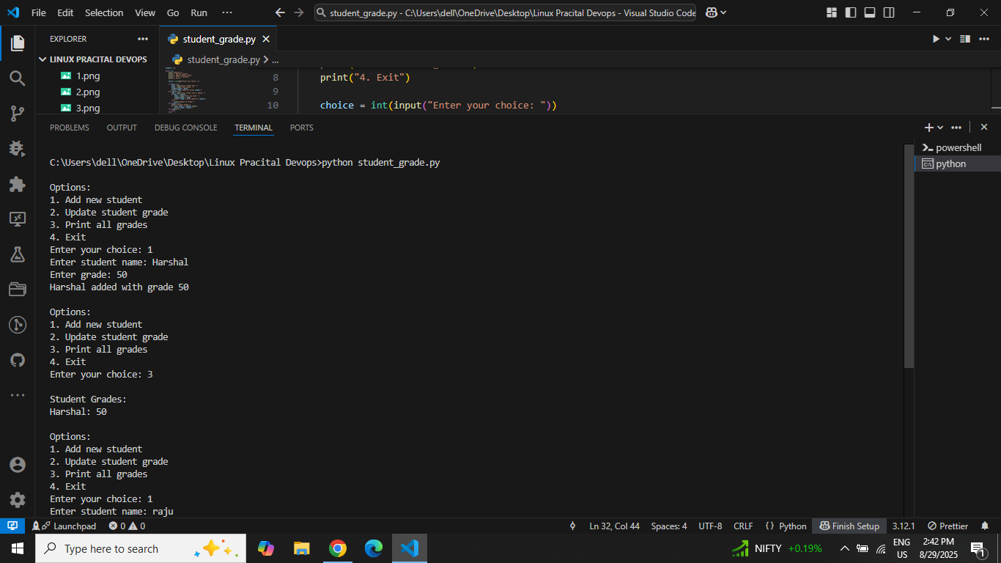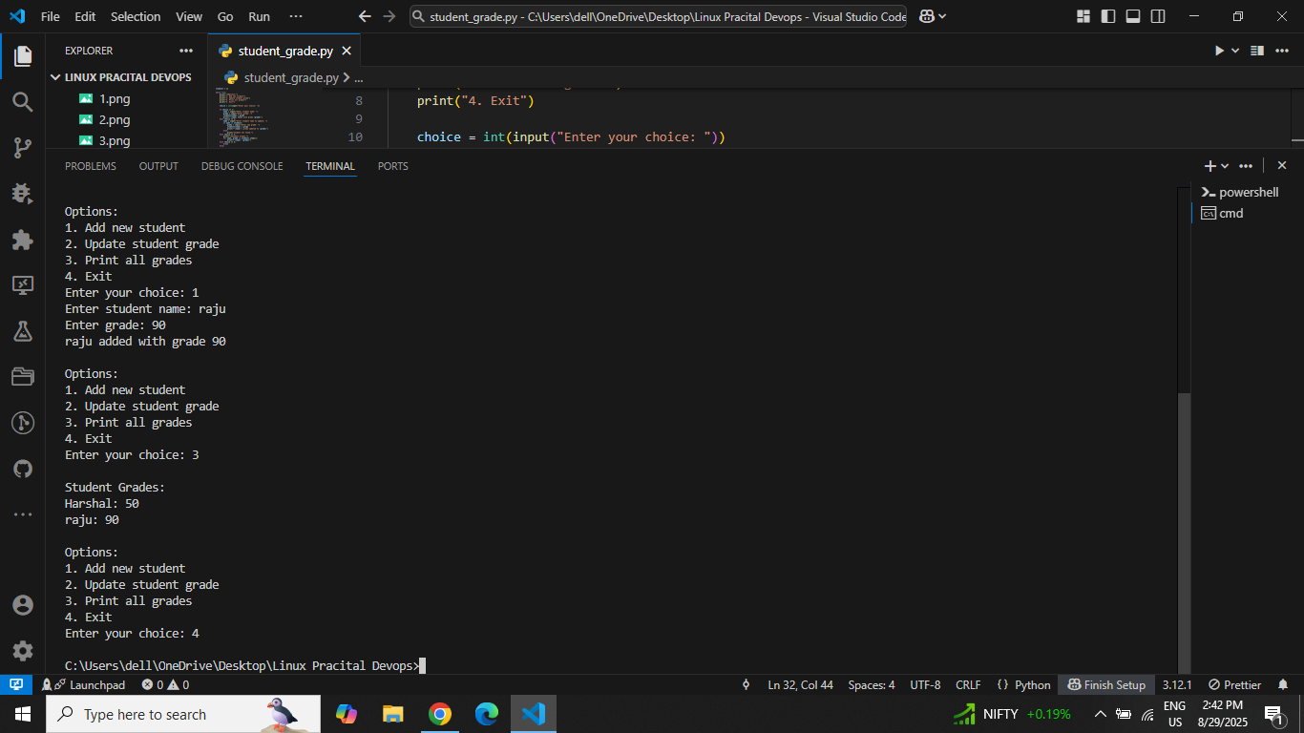

3. Write to a File
Code:
with open("example.txt", "w") as file:
file.write("Hello, this is a test file.\n")
file.write("This line is added using Python write function.\n")

print("Content written successfully to example.txt")
Explanation:
- Opens a file in write mode ("w").
- Writes two lines of text using file.write().
- with block automatically closes the file.
Screenshot: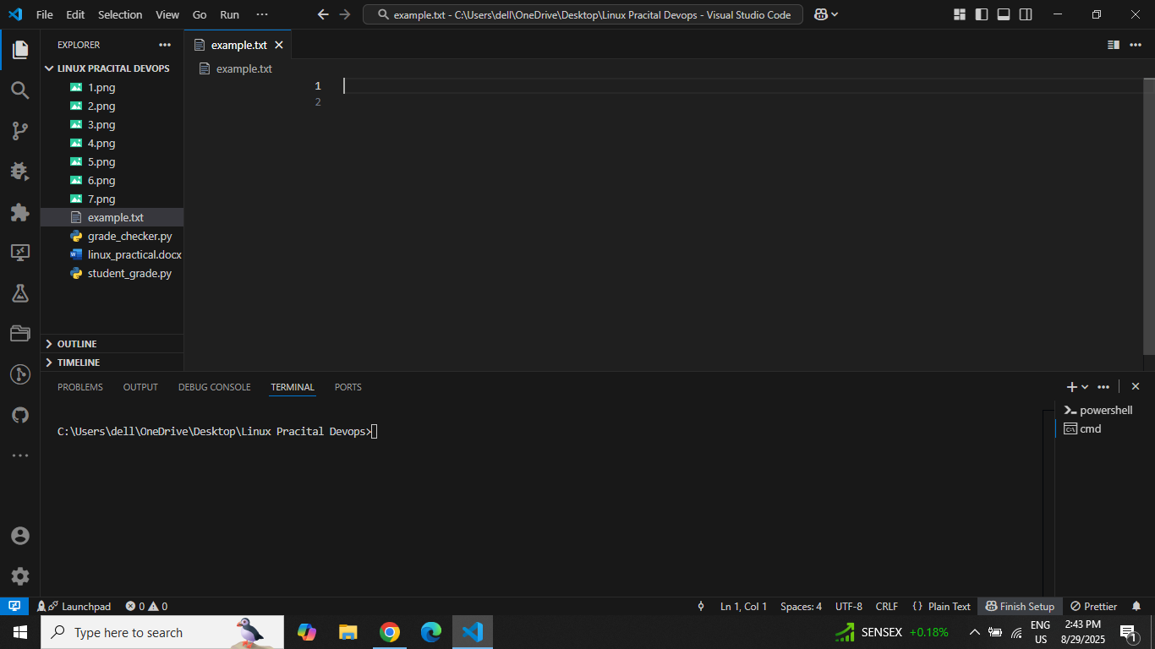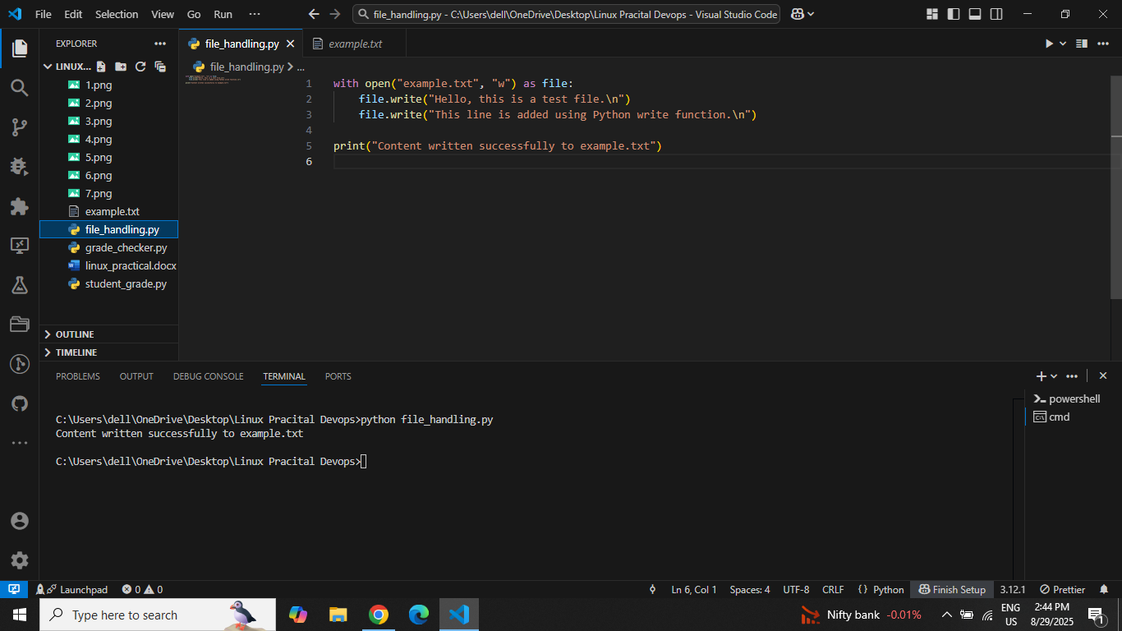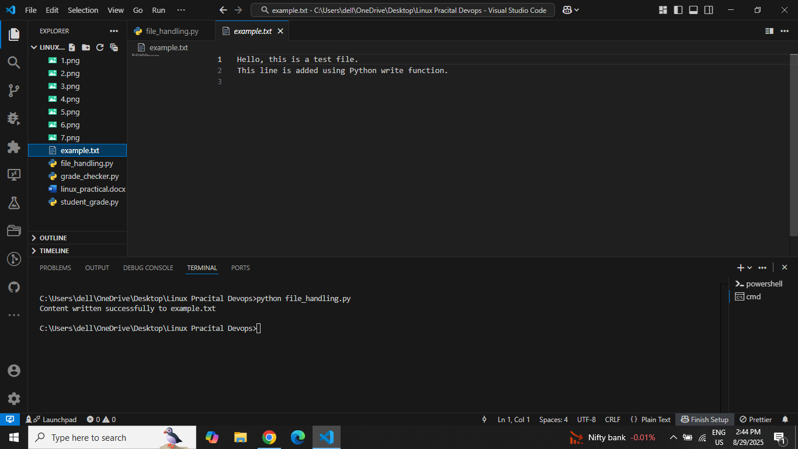

4. Read from a File
Code:
with open("example.txt", "r") as file:
content = file.read()

print("File Content:\n")
print(content)
Explanation:
- Opens the same file in read mode ("r").
- Reads its contents using file.read().
- Prints content to the console.
Screenshot: 