

**Walchand College of Engineering, Sangli**

**(**An Autonomous Institute**)**

**MooD1E-Connecting Students**

MINI PROJECT REPORT

*BY*

**HARSHAL ISHWAR THAKARE 2014BCS025**

**PUNIT BABULAL PATEL 2014BCS062**

**TUSHAR RAJENDRA CHANDAK 2014BCS094**

**DEPARTMENT OF COMPUTER SCIENCE AND ENGINEERING**

**WALCHAND COLLEGE OF ENGINEERING**

SANGLI

APRIL, 2017

**CERTIFICATE**



This is to certify that this project report entitled **“MooD1E-Connecting Students”** submitted to Department of Computer Science and Technology, is a bonafide record of work done by **Harshal Thakare, Punit Patel, Tushar Chandak** under my supervision from 25/01/2017 to 15/04/2017.

Mr. Kiran Kamble Dr . SMRITI BHANDARI

(Project Guide) (HOD, Dept. OF CSE)

Place: Sangli

Date: 15/04/2017

**APPENDIX 3**

**Declaration by Author(s)**

This is to declare that this report has been written by us. No part of the report is plagiarized from other sources. All information included from other sources have been duly acknowledged. We aver that if any part of the report is found to be plagiarized, we shall take full responsibility for it.

**Harshal Thakare 2014BCS025**

**Punit Patel 2014BCS062**

**Tushar Chandak 2014BCS094**

**Place:** Sangli

**Date:** 15/04/2017

**ACKNOWLEDGEMENT**

It is our foremost duty to express our deep sense of gratitude and respect to our guide Prof Kiran Kamble and Dr . S. H. Bhandari (HOD Dept. of Computer Science and Engineering) for their valuable advice and inspiration which made us submit the project successfully.

We are indebted to all the other staff for guiding us as and when possible. Last but not the least, we are thankful to all our colleagues for helping directly or indirectly in our project work.

Members

**Harshal Thakare 2014BCS025**

**Punit Patel 2014BCS062**

**Tushar Chandak 2014BCS094**

**APPENDIX 4**

**Table of Content**

**Title Page No.**

Appendix 1 1

Appendix 2 2

Appendix 3 3

Acknowledgment 4

Table of Content 5

Abstract 6

Chapter 1: Introduction to the MooDlE 7

Chapter 2: Object Oriented Modelling and Designing 8

Use Case Diagram 8

Sequence Diagram 9

Block Diagram and Facilities 10

Chapter 3: Technical Details 11

Platform and Programming Languages 12

Future Scope 12

Conclusion 13

References 14

**ABSTRACT:-**

**MooD1E** provides a simple interface for maintenance of student–faculty information. It can be used by educational institutes or colleges to maintain the records of students easily. The creation and management of accurate, update information regarding a students’ academic career is critically important in the university as well as colleges. Student information system deals with all kind of student details, academic related reports, college details, course details, curriculum, batch details, placement details and other resource related details too. It tracks all the details of a student from the day one to the end of the course which can be used for all reporting, tracking of attendance, progress in the course, completed semesters, upcoming semester year curriculum details, exam details, project or any other assignment details, final exam result and all these will be available through a secure, online interface embedded in the college’s site. It will also have faculty details, batch execution details, students’ details in all aspects, the various academic notifications to the staff and students updated by the college administration. It also facilitate us explore all the activities taking place in the college, different reports and queries are generated based on vast options related to students, batch, course, faculty, exams, semesters, certification and even for the entire college.

**Objectives:**

* The main objective of this system, is to reduce the consumption of time during maintaining the records of college.
* Simple database is maintained. Easy operations for the operator of the system. User interfaces are user friendly and attractive; it takes very less time for the operator to use the system.

**Chapter 1: Introduction to MooDlE**

* **An Introduction to MooD1E**:

Today's education scenario is rapidly changing and demanding. The system demands greater levels of communication between college, student and faculty members to have optimum use of resources. Today's industry talent demands are soaring with more and more skills requirements in all fields. Colleges and institutions generating creative students' needs focused approach on such talents and industries so as avail best of benefits to their candidates passing out. MooD1E is a system fulfilling these demands and enacting as a bridge of communication amongst students, faculties and colleges.

MooD1E defines as an application (more likely web-based), that provides capabilities for multiple users with different permission levels to manage (all or a section of) content, data or information of a website project, or internet / application. Separate divisions are providing to maintain the records of teachers, students, subjects and fees details. Our System also provides an easy way not only to automate all functionalities of a college, but also to provide full functional reports to top management of college with the finest of details about any aspect of college.

* **Application Domain(s):** Colleges , Schools , Private Coaching’s , etc
* **Application User(s):** Students, Teachers, etc.
* **Benefit of Project:** The main benefit is data analysis & review collection for ad-makers movie-makers through emotion recognition.

**Chapter 3: Object Oriented Modelling And Designing**

**Use case diagram**

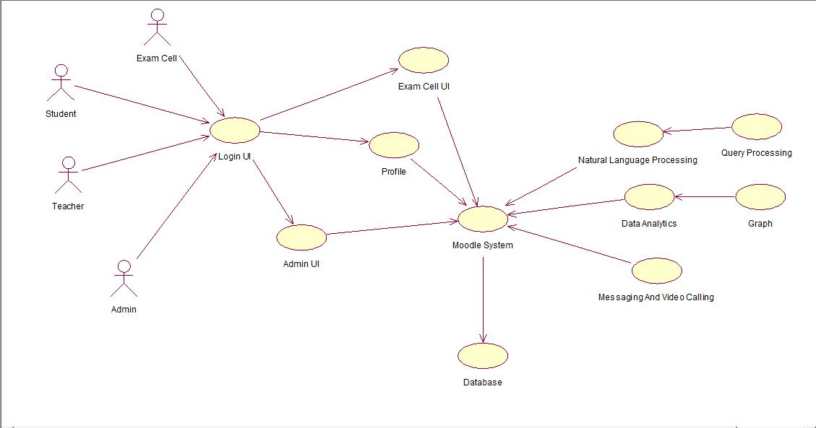

**Sequence Diagram**

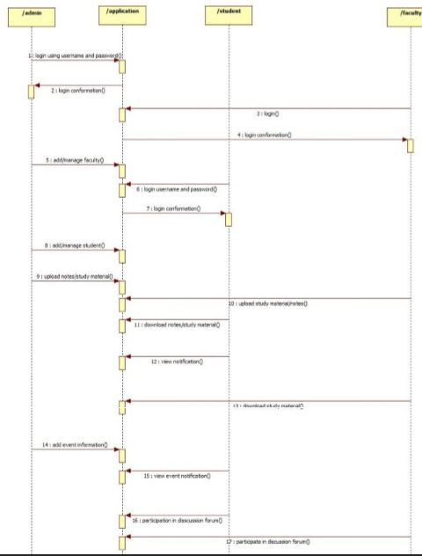

**Block Diagram:-**

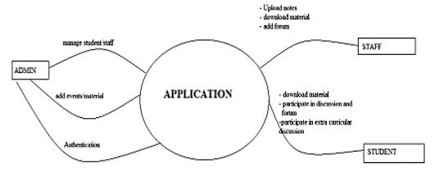

**Facilities for Administrator:**  
1. Registration of students & Faculties  
2. View Student/ Faculty list & their profile (registered only)  
3. Block/Unblock & Delete of Student/ faculty  
4. View all uploaded Articles, Projects & Seminars (self uploaded)  
5. Delete Articles, Projects & Seminars  
6. Post Notice (which is visible to student & faculty after login)  
7. Send internal Messages to a particular student/faculty   
8. Inbox (read messages sent by student/faculty)

|  |
| --- |
| **Facilities for Faculties:**  1. Personal Details form 2. Teaching Details form 3. Can keep sensitive information (like address, phone) public or private so that the information can be visible/invisible on profile 4. Can Edit/Update registration Details 5. Upload images, Articles, Projects, Seminars 6. View images, Articles, Projects, Seminars 7. Delete images, Articles, Projects, Seminars 8. Send Internal Messages to other students, Faculties or Administrator  9. Inbox (Read messages sent by other Student, Faculty or Administrator) 10. Post Notice 11. View Notice(Posted by Administrator or other Faculty)  **Facilities for Students:** 1. Personal Details form 2.View Notice(Posted by Administrator or Faculty) 3. Can keep sensitive information (like address, phone) public or private so that the information can be visible/invisible on profile 4. Can Edit/Update registration Details 5. View images, Articles, Projects, Seminars 6. Send Internal Messages to other students, Faculties or Administrator  7. Inbox (Read messages sent by other Student, Faculty or Administrator) |
|  |  |  |

**Chapter 4: Technical Details**

1. **Node.js**

Node.js is a very powerful JavaScript-based framework/platform built on Google Chrome's JavaScript V8 Engine. It is used to develop I/O intensive web applications like video streaming sites, single-page applications, and other web applications. Node.js is open source, completely free, and used by thousands of developers around the world. Node.js also provides a rich library of various JavaScript modules which simplifies the development of web applications using Node.js to a great extent.

.

1. **Express JS**

Express is a minimal and flexible Node.js web application framework that provides a robust set of features for web and mobile applications. It is an open source framework developed and maintained by the Node.js foundation. Express provides a minimal interface to us to build our applications. It is minimal, providing us the absolutely required tools to build our app and flexible, there are numerous modules available on npm for express, which can be directly plugged into express.

**C. MongoDB**

MongoDB is an open-source document database and leading NoSQL database. MongoDB is written in C++. This tutorial will give you great understanding on MongoDB concepts needed to create and deploy a highly scalable and performance-oriented database. MongoDB is a cross-platform, document oriented database that provides, high performance, high availability, and easy scalability. MongoDB works on concept of collection and document.

**Platform & Programming Language**

1. Programming Languages
   * Node JS
   * JavaScript, PHP
   * HTML,CSS
   * Bootstrap
2. Platforms
   * Web Browsers
     + Google Chrome
     + Firefox
     + Opera

**Desktop Requirements**

* >1Gb RAM
* Webcam
* i3 3rd Gen and Above processor

**Future Scope**

* Data Analysis On Student Performance
* Messaging and Calling Feature
* Natural Language Processing on Query Anaysis

**Conclusion:**

This paper assists in automating the existing manual system . It reduces the man power required and provides accurate information. All years together gathered information can be saved and can be accessed at any time. Therefore the data stored in the repository helps in taking decision by management. All the stakeholders, faculty and management can get the required information without delay

**References**

* [**https://www.tutorialspoint.com/nodejs/**](https://www.tutorialspoint.com/nodejs/)
* [**https://expressjs.com/en/starter/basic-routing.html**](https://expressjs.com/en/starter/basic-routing.html)
* [**https://www.mongodb.com/**](https://www.mongodb.com/)
* [**http://www.youtube.com**](http://www.youtube.com)
* [**http://www.w3schools.com**](http://www.w3schools.com)
* [**https://www.stackcommunity.org**](https://www.stackcommunity.org)