BY:

Harshal Thavrani  
Nikk Jackson

# Game Description & Features

**Meteor** **Madness** is a survival game that summons a shining rock from the top of the screen, smashing into the floor and dealing damage in an area of effect. In this game, the Player is in a spaceship and has to move his spaceship back and forth, left and right, to avoid colliding with meteors. Here the point is not why can't WE destroy meteors? But how long can you hold your spaceship with just three lives and avoid colliding with meteors? So, are you ready to show the world how competent you are? Gear up and launch your spaceship NOW!

Features:

* In this game, the Player will have to control a fast spaceship using keys WASD or ↑↓→← keys to go UP, DOWN, LEFT and RIGHT. Also, Player can use console controller’s Joystick to do the same.
* Player will face Meteors from everywhere and has to use the controls given above to avoid colliding with meteors. Player will get 3 chances if he collides with meteors. After that its GAMEOVER.

Class Diagram:

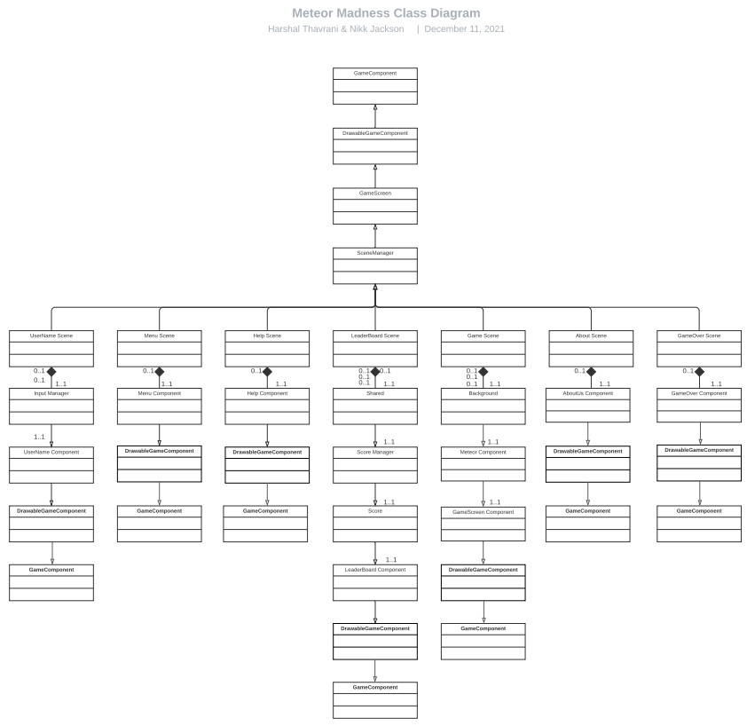

References

Menu background:

<https://www.freepik.com/free-vector/space-banner-with-purple-planet-landscape_13778479.htm#page=1&query=cartoon%20space&position=0&from_view=keyword>

Meteor: <https://opengameart.org/content/meteor-0>

Planet Icon: <https://cdn3.iconfinder.com/data/icons/space-lineal-color-set/512/Saturn-128.png>

Menu Music: <https://www.youtube.com/watch?v=dXSKRd2Lhvk>

GameMusic: <https://www.youtube.com/watch?v=L_OYo2RS8iU&list=PLwJjxqYuirCLkq42mGw4XKGQlpZSfxsYd&index=8>

ButtonSound: https://www.youtube.com/watch?v=ILaQFzeuamU

ButtonSelected: <https://www.youtube.com/watch?v=yxafINGGm4Y>

MenuButtons: Note From, Nikk Jackson and Harshal Thavrani, 2021. No Copyright.

Game Background: Owned by Harshal Thavrani, 2021. Public License Attached.

Spaceship Sprite: Owned by Harshal Thavrani, 2021. Public License Attached.