**DAY -9 ESTIMATE (1-2 hours)**

**TASK 01:**

* Create an EC2 Instance:
  + AMI Linux
  + t2.micro - Instance Type
  + Enable Termination Protection
  + Security Group
    - Open it for:
      * SSH
      * HTTP
      * HTTPS
  + Tag:
    - Key
      * Name
    - Value
      * ProdInstance
  + Key Pair

**TASK 02:**

* Connect with an instance using SSH on Mac/Linux and Windows users can use Putty

**TASK 03:**

* Install Apache Web Server
* Run the Public IP and see the output
* Make sure to Configure the index.html with Custom data.
* Create three more files in the same directory /var/www/html/
  + Home.html
  + Payment.html
  + Login.html

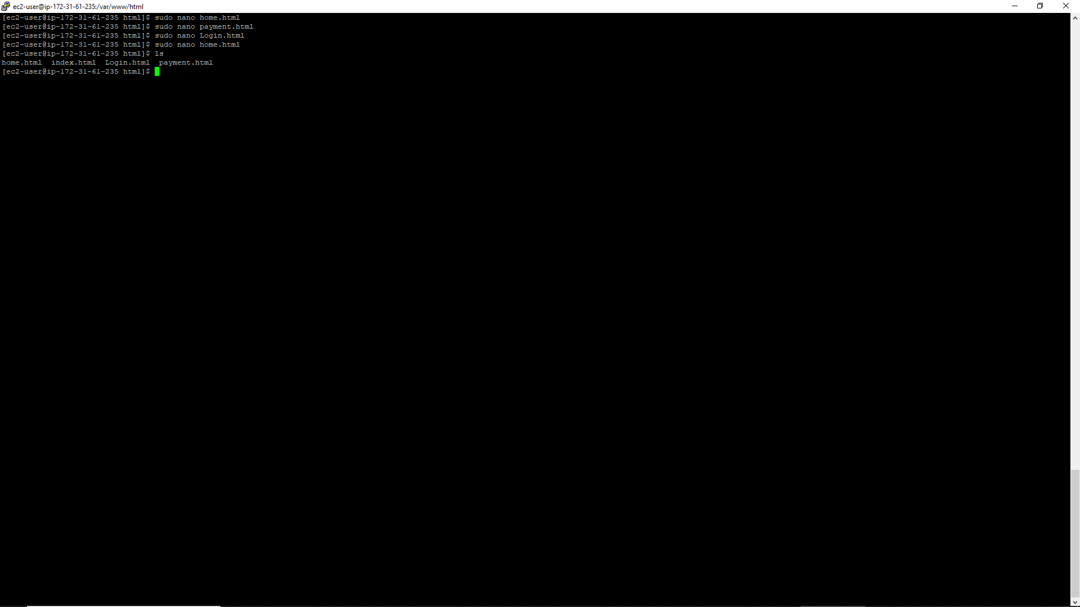

* Run all these pages from EC2 Public IP by Passing the URL.

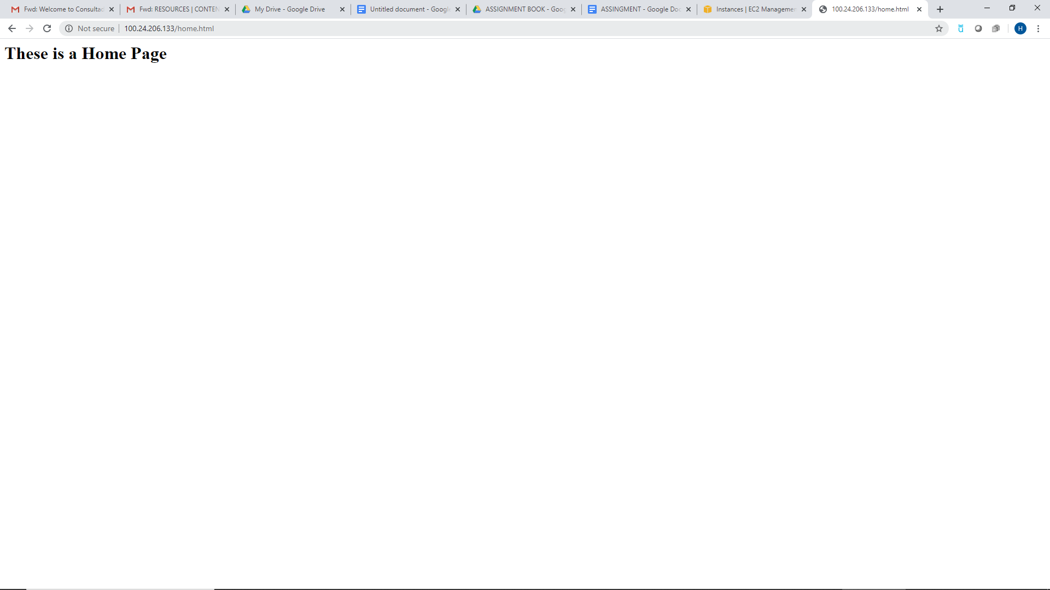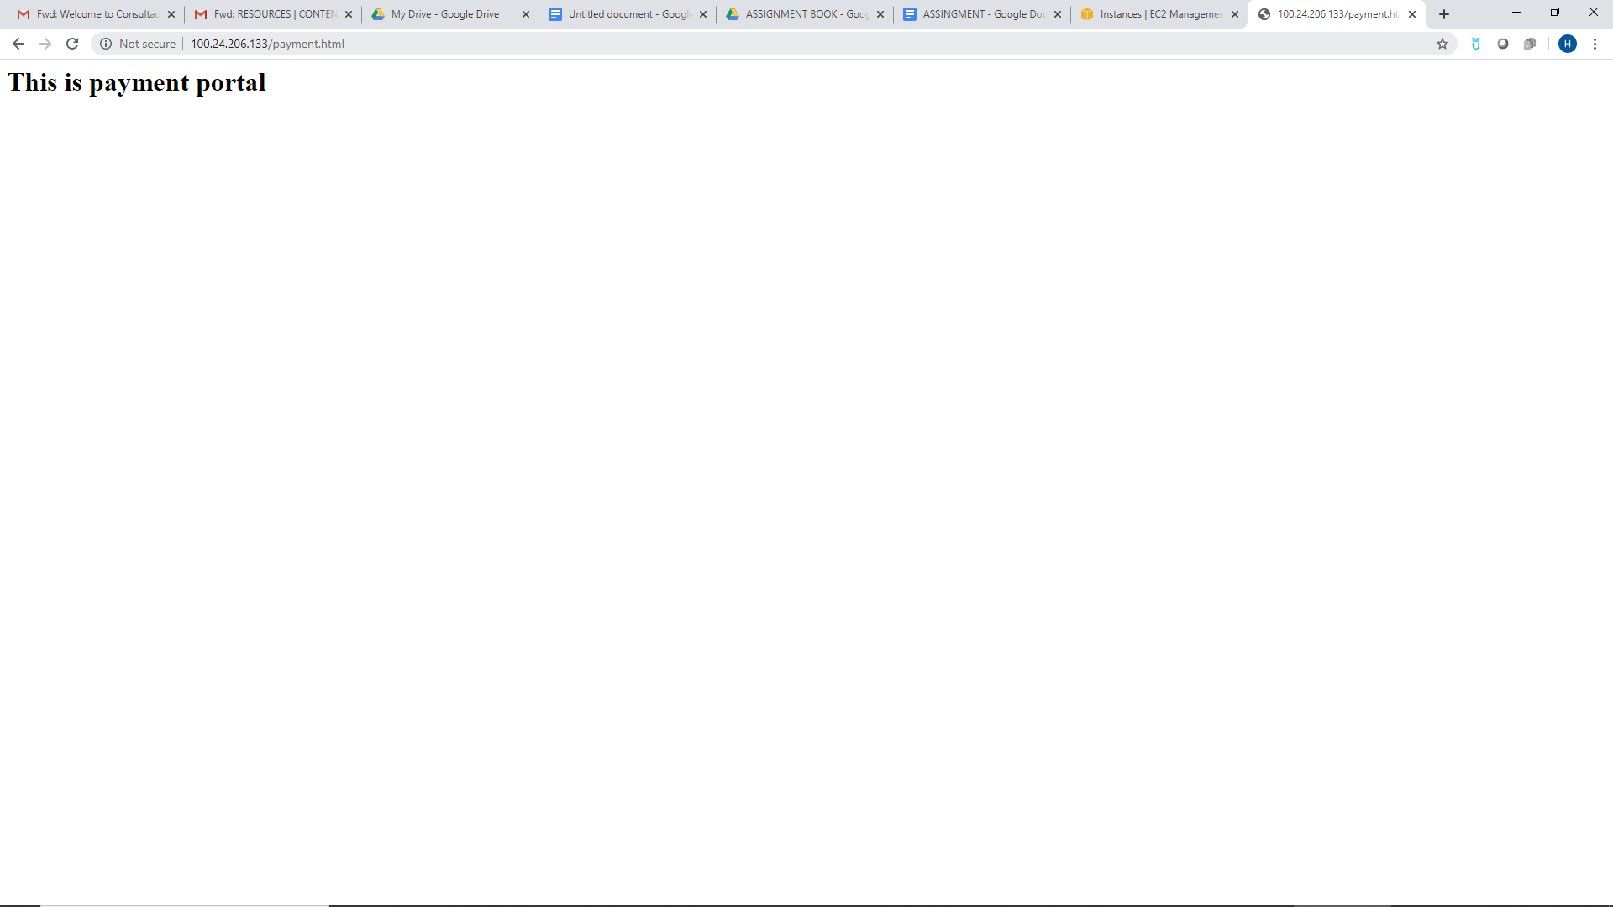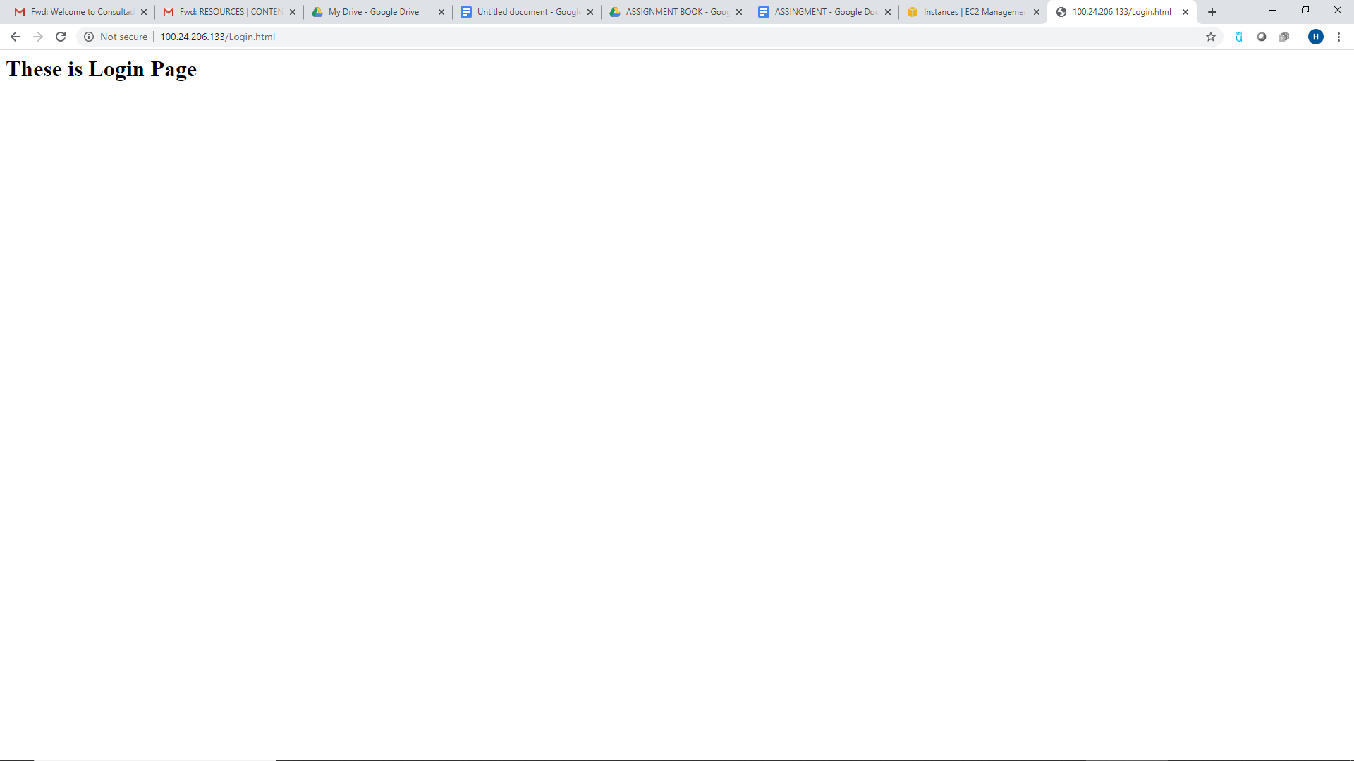

**TASK 04:**

* Install Git on EC2 and Clone all your repositories separately on EC2 in the folder called “repoonec2”.

