**DAY -22 TASK**

**TASK:**

* Learn about Component Lifecycle methods of React.

- Mounting

Birth of your component

React has four built-in methods that gets called, in this order, when mounting a component:

1. constructor()

The constructor() method is called before anything else, when the component is initiated, and it is the natural place to set up the initial state and other initial values.

The constructor() method is called with the props, as arguments, and you should always start by calling the super(props) before anything else, this will initiate the parent's constructor method and allows the component to inherit methods from its parent (React.Component).

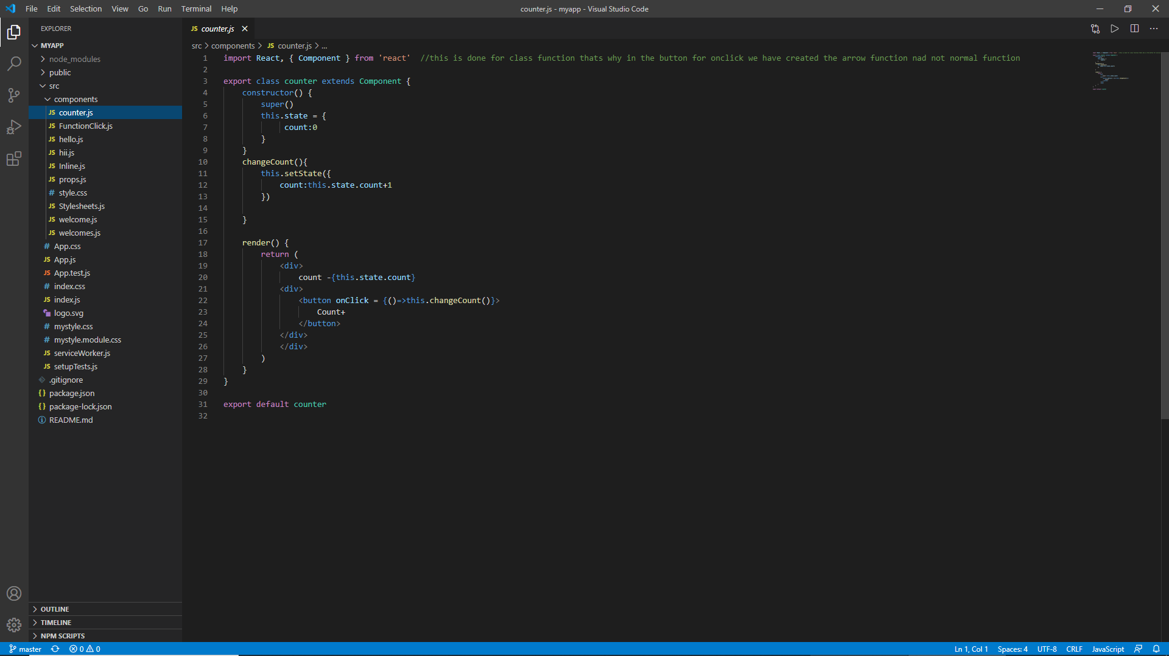

1. getDerivedStateFromProps()

The getDerivedStateFromProps() method is called right before rendering the element(s) in the DOM.

This is the natural place to set the state object based on the initial props.

It takes state as an argument, and returns an object with changes to the state.

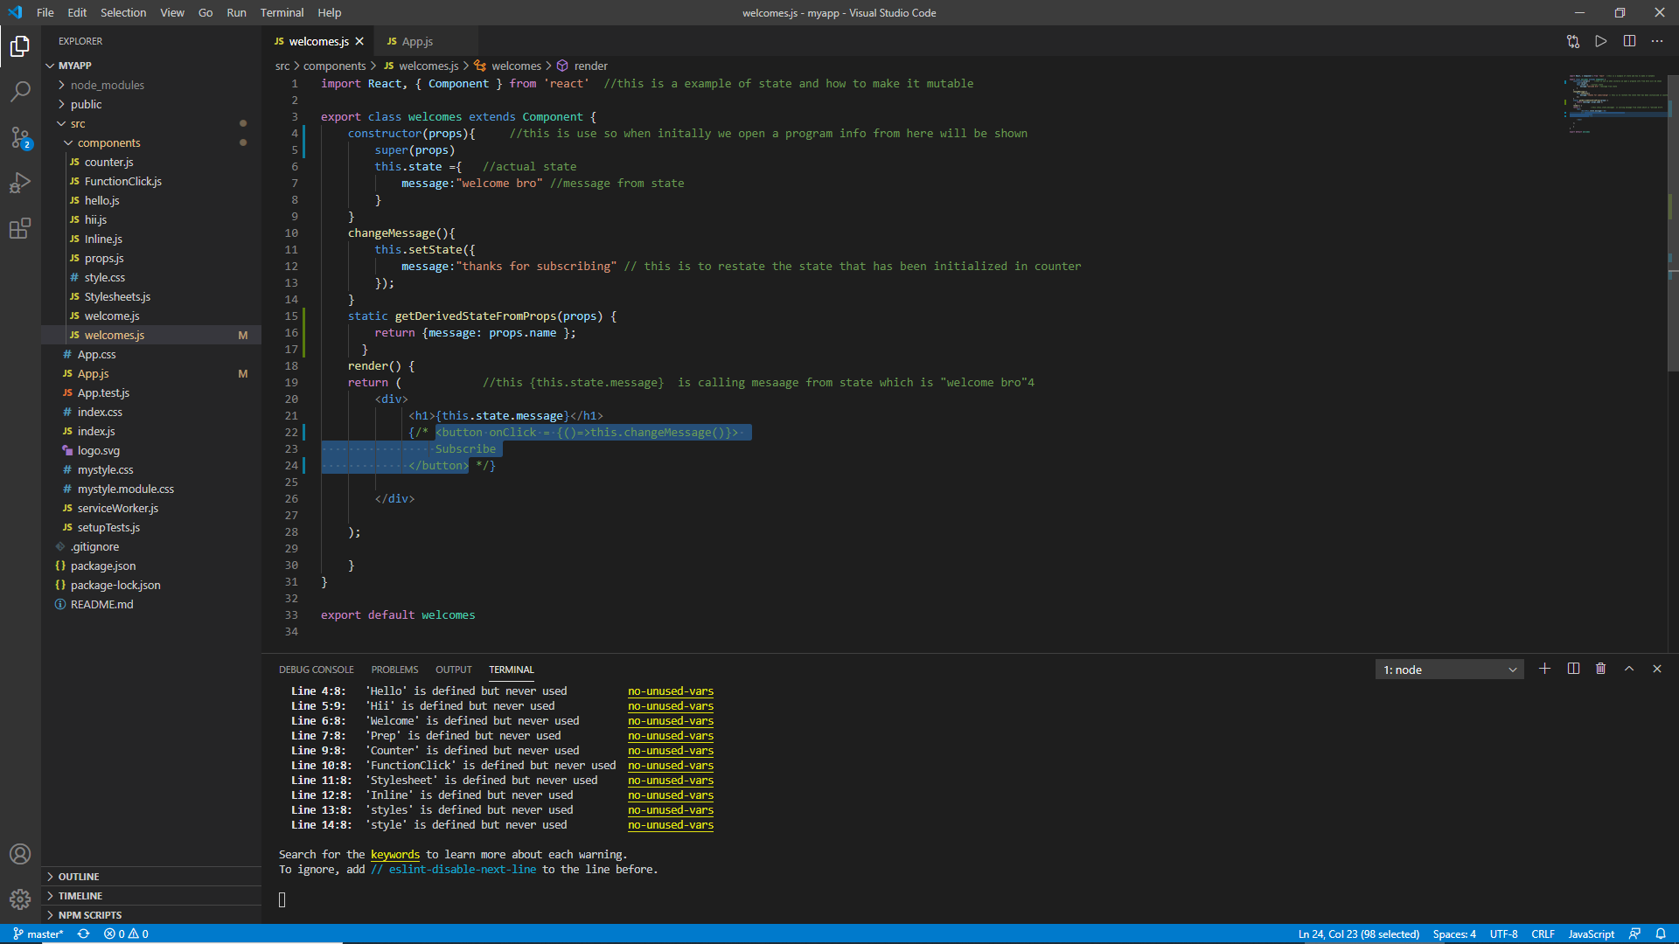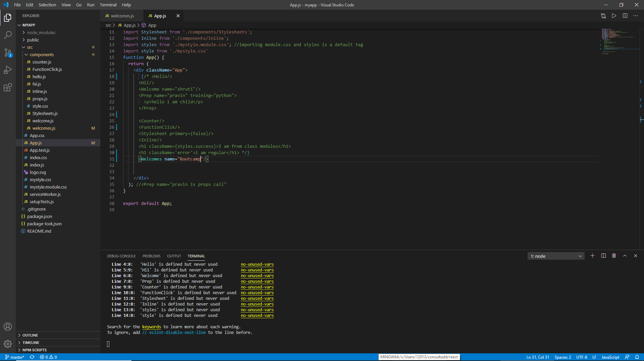

1. render()

The render() method is required, and is the method that actual outputs HTML to the DOM.

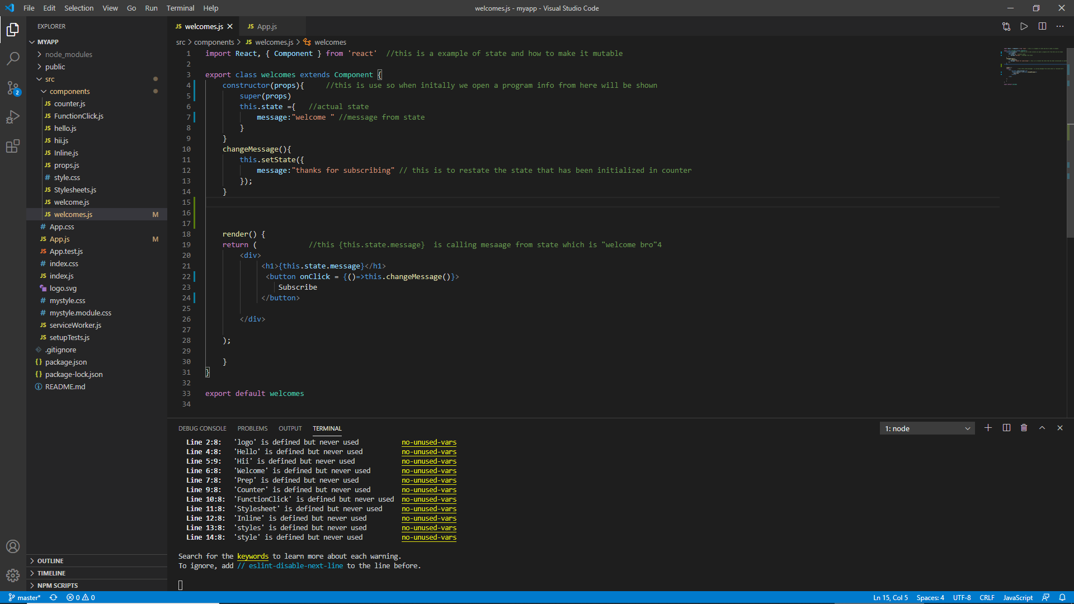





1. componentDidMount()

The componentDidMount() method is called after the component is rendered.

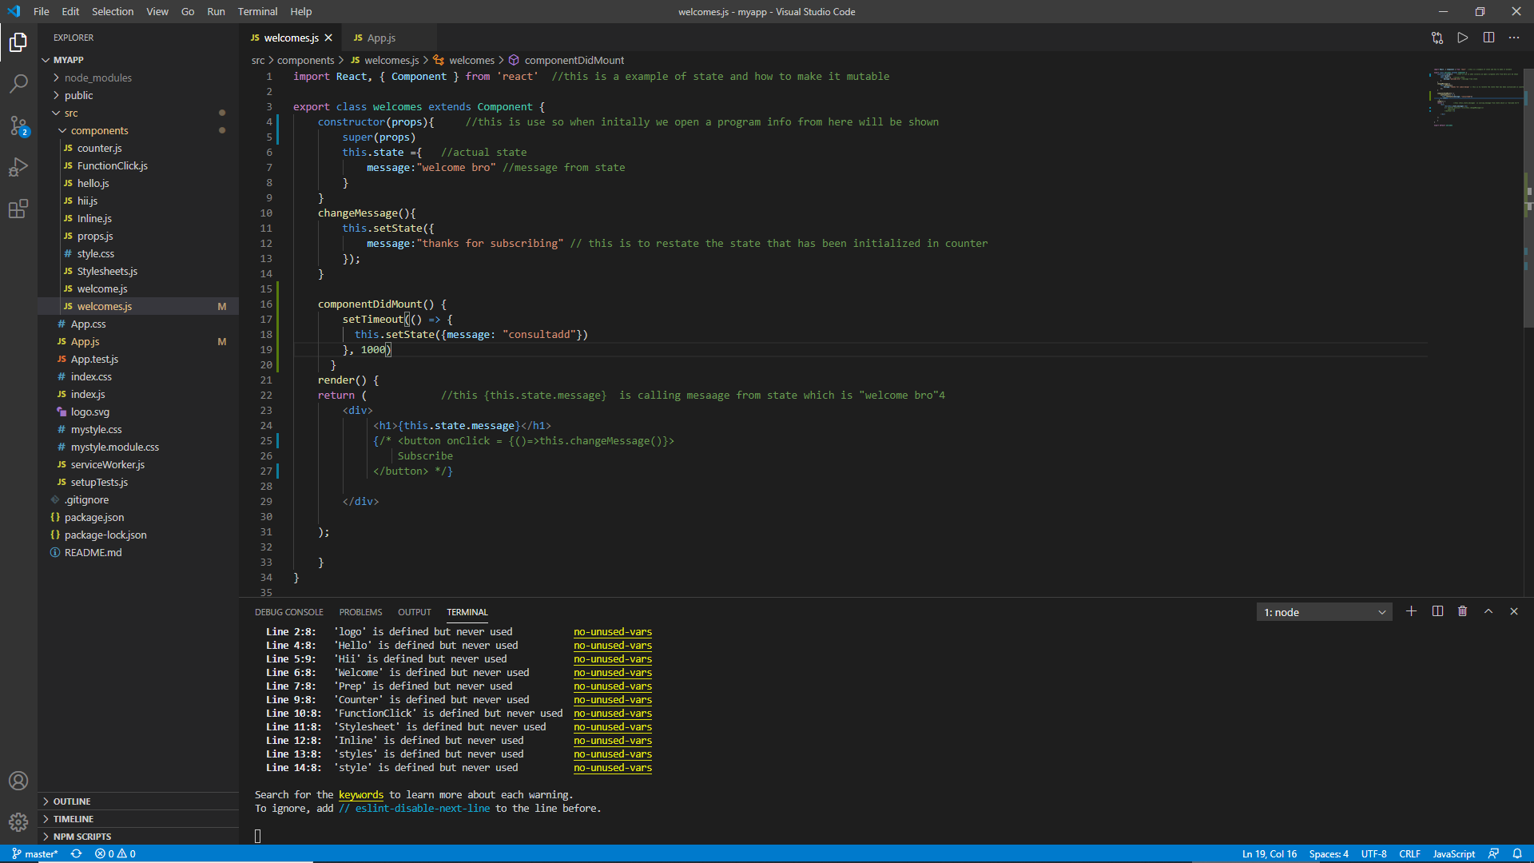



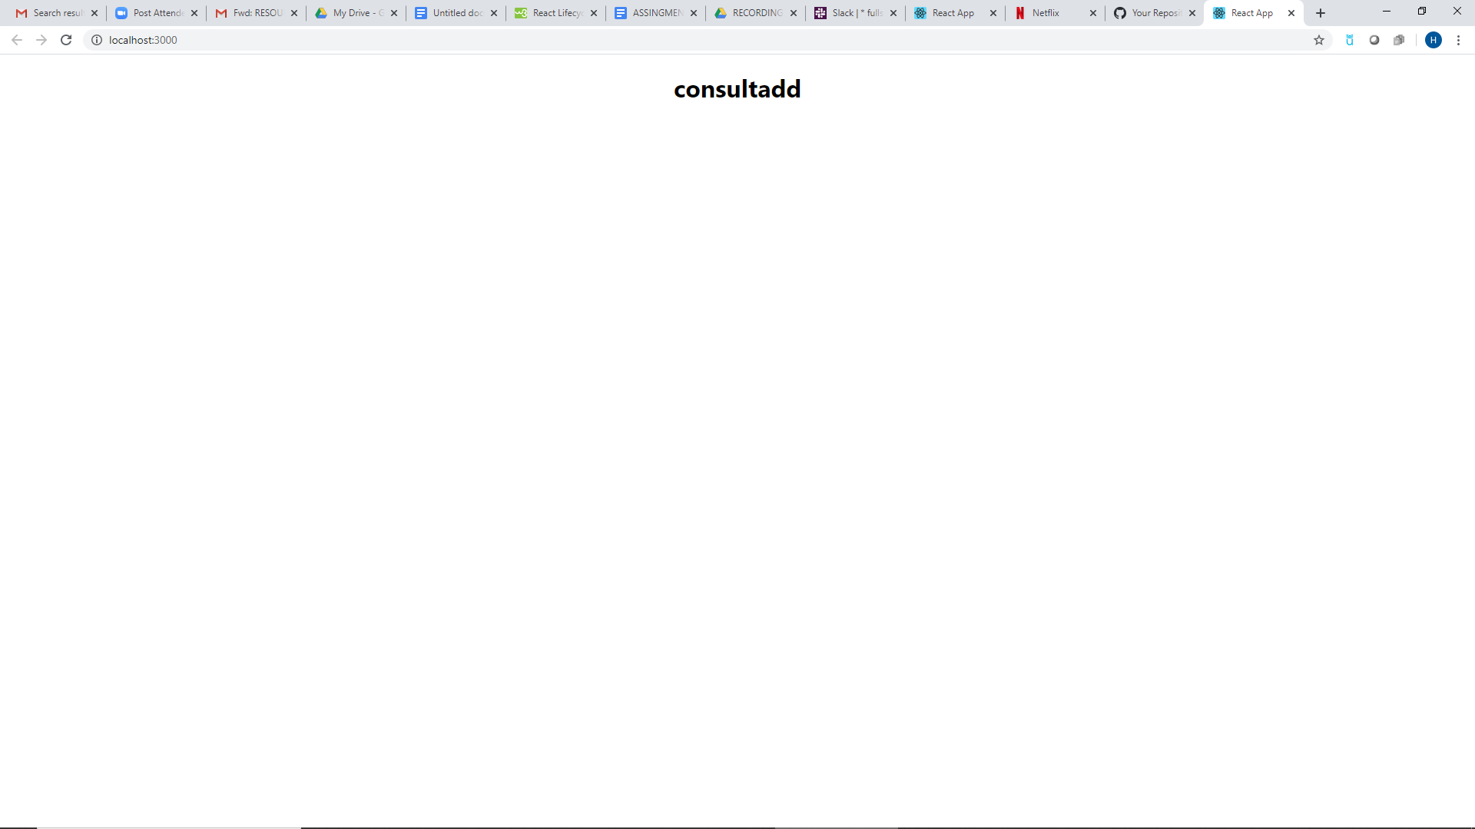

- Updating

Growth of your component

1. getDerivedStateFromProps()

Also at *updates* the getDerivedStateFromProps method is called. This is the first method that is called when a component gets updated.

This is still the natural place to set the state object based on the initial props.

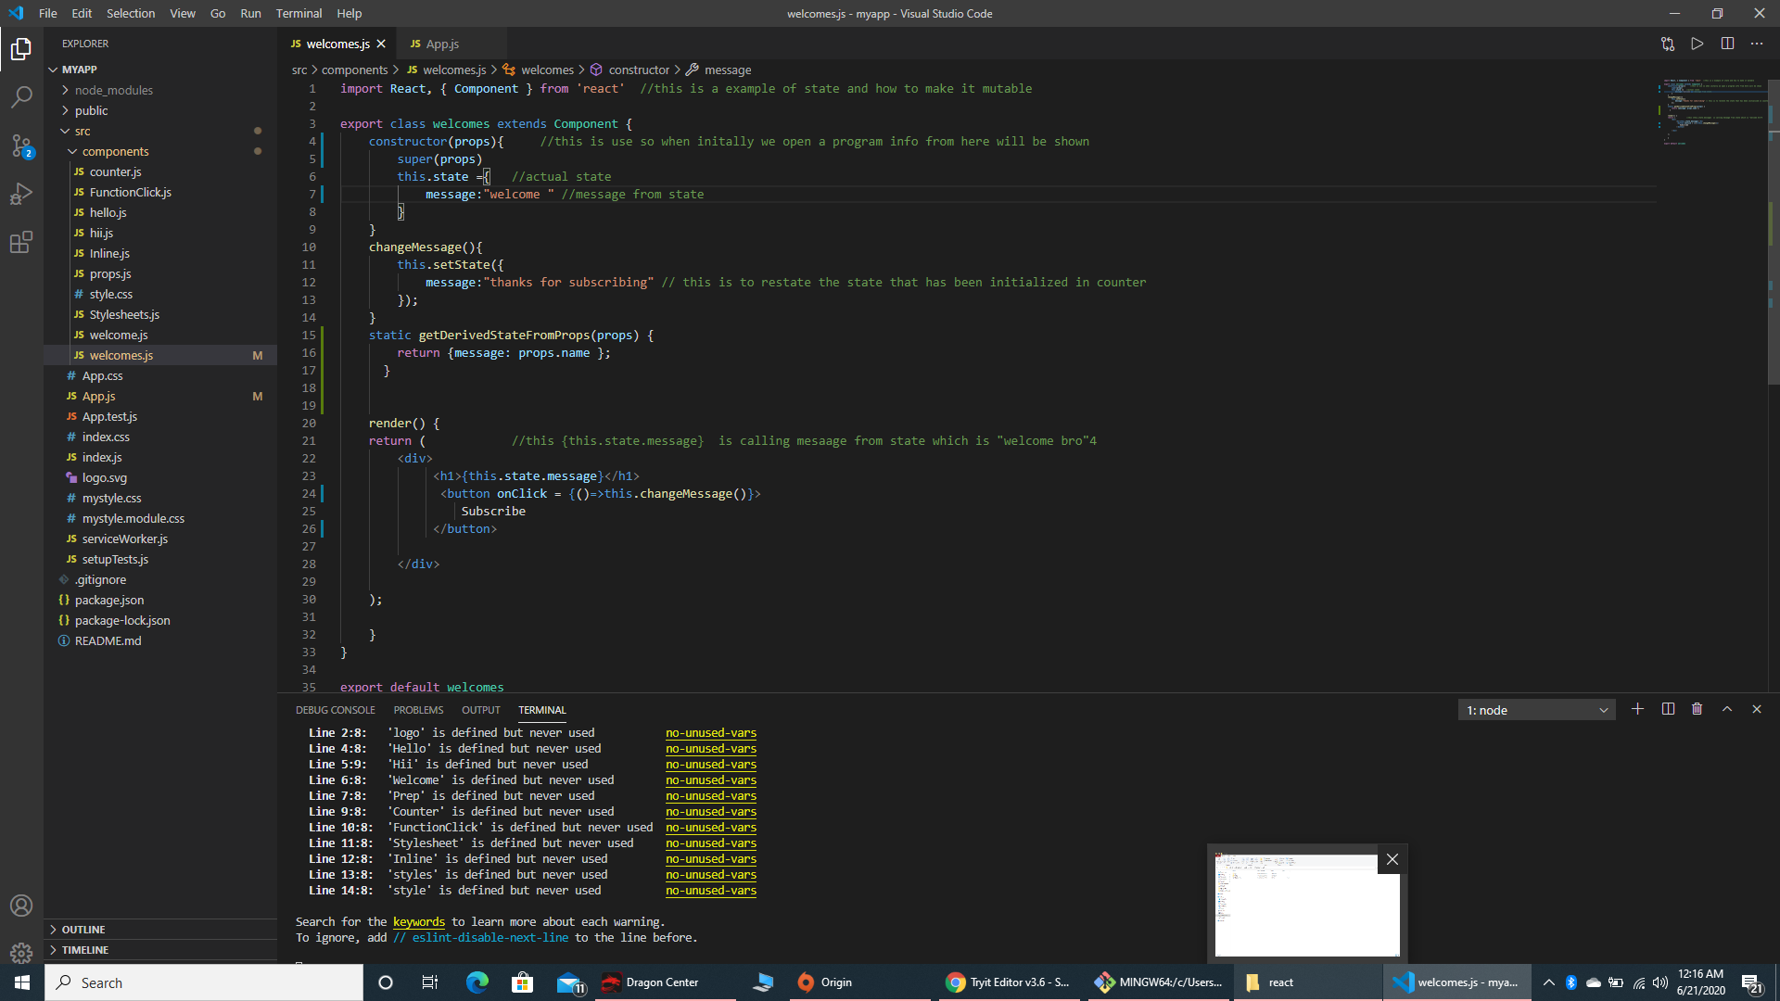

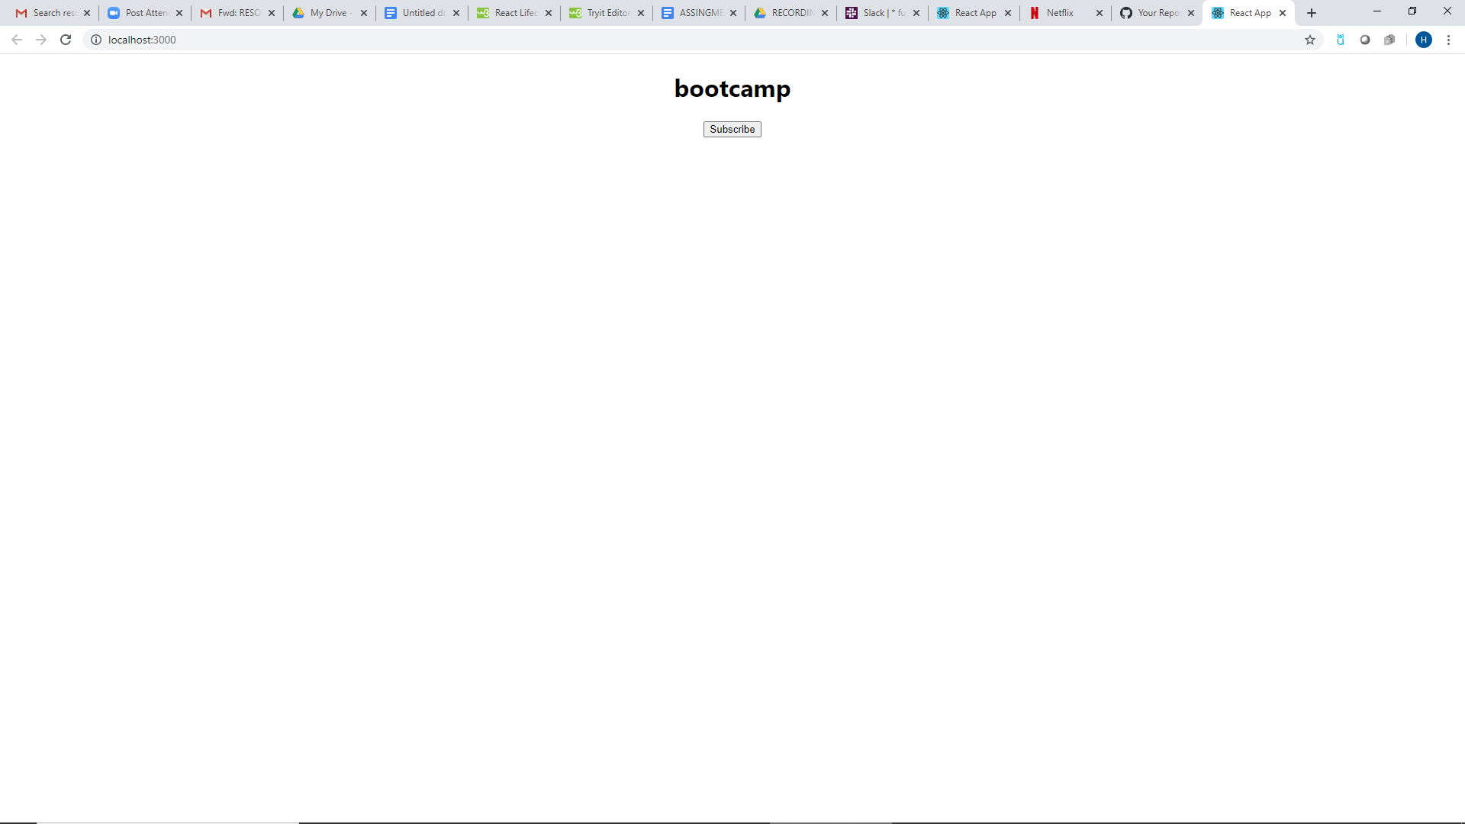

1. shouldComponentUpdate()

In the shouldComponentUpdate() method you can return a Boolean value that specifies whether React should continue with the rendering or not.

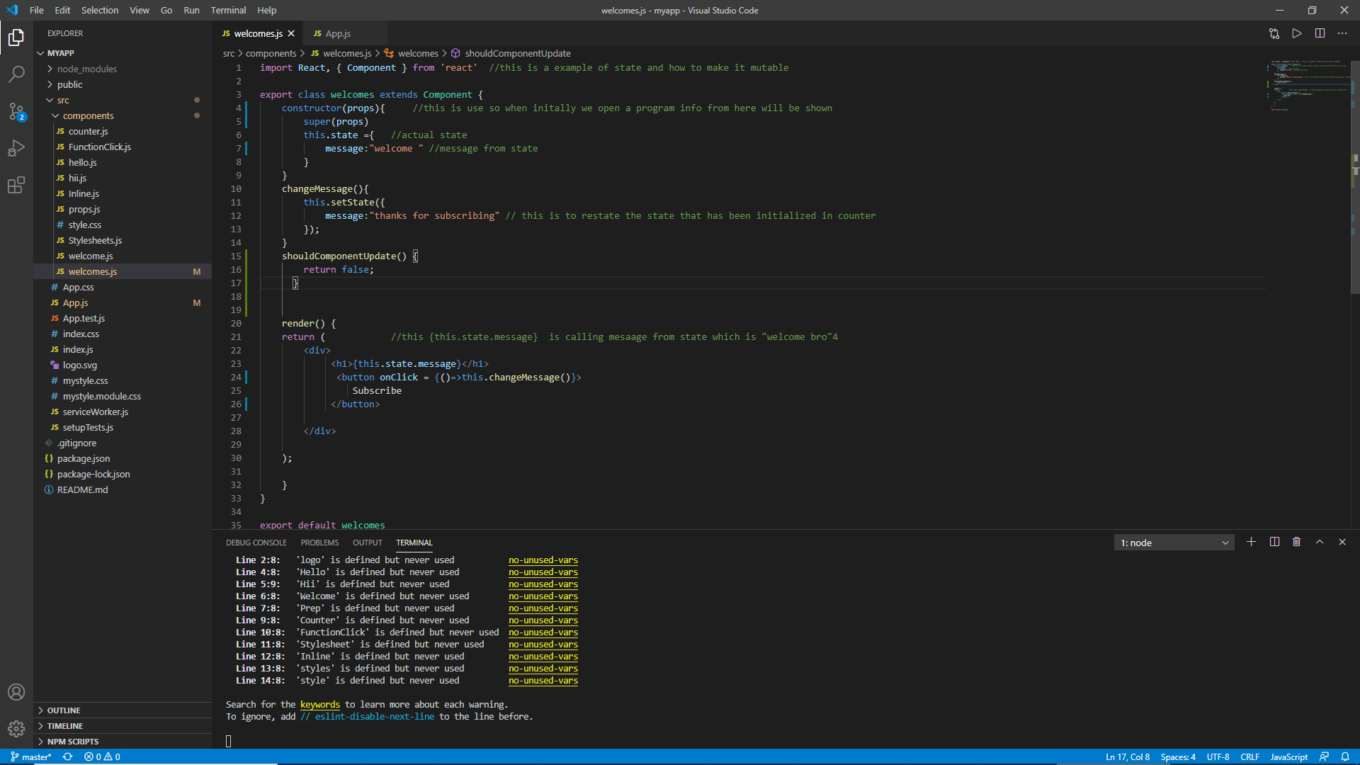



1. render()

The render() method is of course called when a component gets *updated*, it has to re-render the HTML to the DOM, with the new changes.







1. getSnapshotBeforeUpdate()

In the getSnapshotBeforeUpdate() method you have access to the props and state *before* the update, meaning that even after the update, you can check what the values were *before* the update.

If the getSnapshotBeforeUpdate() method is present, you should also include the componentDidUpdate() method, otherwise you will get an error.

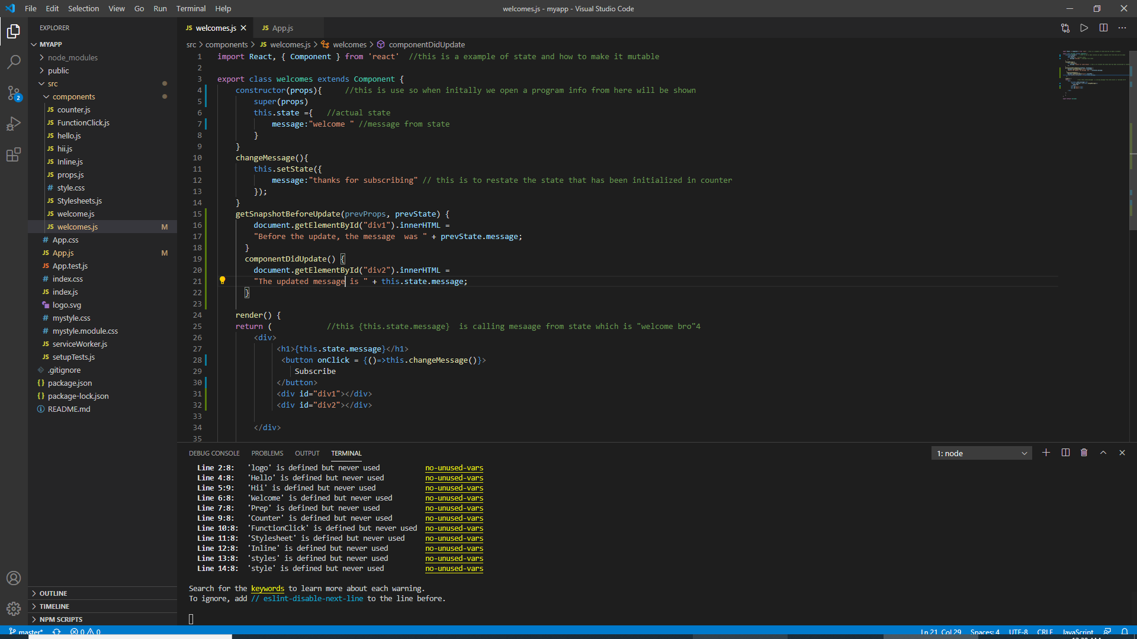





1. componentDidUpdate()

- Unmounting

Death of your component

1 componentWillUnmount()

The componentWillUnmount method is called when the component is about to be removed from the DOM.

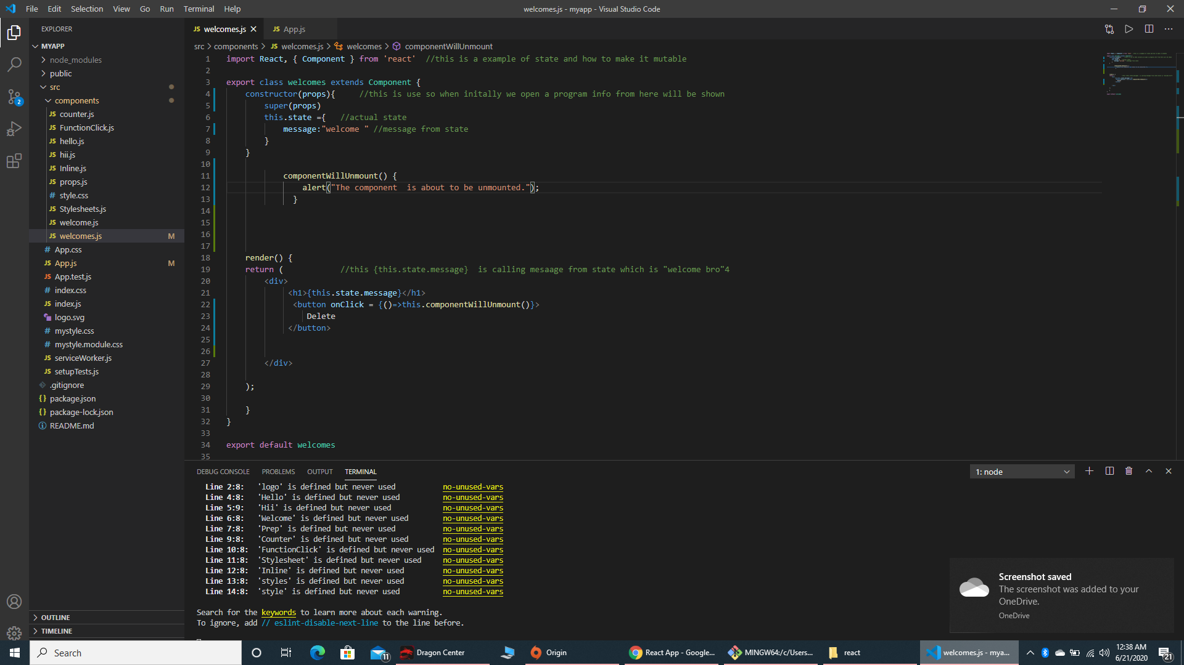



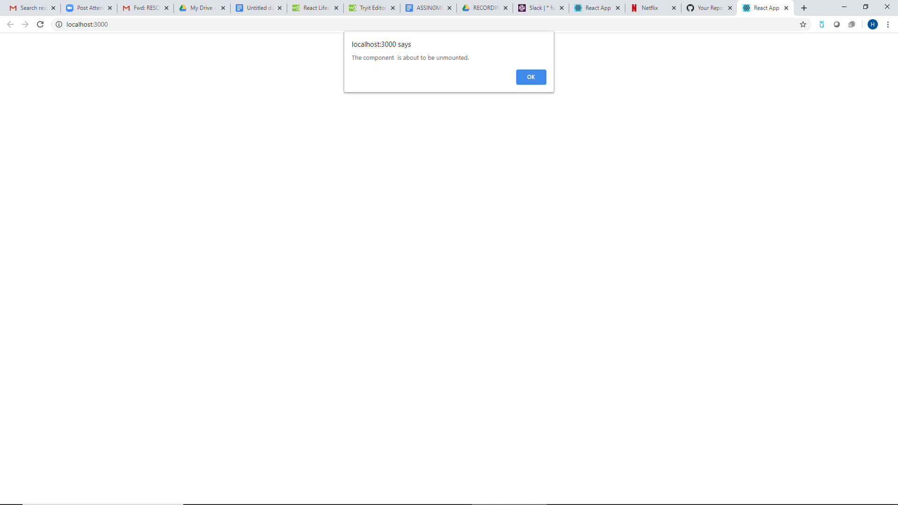

* Create an example code for each lifecycle method in the above three phases.
* Create a document in which all the methods should be explained with a code sample written in the document or pasted from your text editor.
* Push the document on github.