AI Vision Assistant Pro: A Web-Based Framework for Real-Time Object Detection, Crowd Analytics, and Automated Reporting
Harshal Gulabrao Waghe
Department of Electronics and Telecommunication Engineering
Suryodaya College of Engineering and Technology, Nagpur
Nagpur, Maharashtra, India
harshalwaghe91@gmail.com
Abstract—Real-time visual analytics systems often separate object detection, tracking, crowd analysis, storage, and reporting into independent tools. This paper presents AI Vision Assistant Pro, an integrated web application that combines YOLO-based object detection, OpenCV frame processing, browser-camera streaming through WebRTC, lightweight multi-object tracking, crowd-density classification, SQLite persistence, and automated CSV, Excel, and PDF reporting. The system supports live camera streams, uploaded images, and uploaded videos through a Streamlit dashboard. A class-aware tracker combines bounding-box intersection-over-union and centroid distance, retains tracks through temporary missed detections, and confirms an object across multiple frames before including it in unique-object reports. Crowd analytics use frame-level person counts to derive current, maximum, average, and threshold-alert values. Functional validation confirmed the complete input-to-report workflow, stable identity recovery after synthetic missed frames, distinct identities for multiple people, and India Standard Time normalization across history and exported files. The result is a deployable educational framework for surveillance prototyping, classroom demonstrations, and small-scale occupancy analytics without a paid external API.
Keywords—YOLO, object detection, crowd analytics, multi-object tracking, WebRTC, Streamlit, SQLite, automated reporting.

I. INTRODUCTION
Computer vision has moved from offline image analysis toward interactive systems that interpret continuous visual streams. Object detectors provide class labels and bounding boxes, but a practical monitoring application must also maintain object identity, distinguish frame-level occupancy from estimated unique counts, generate crowd alerts, retain evidence, and communicate results through readable reports. The original YOLO formulation demonstrated that object detection can be expressed as a unified regression problem suitable for real-time processing [1]. Modern implementations extend this approach to images, videos, and live streams [8].
AI Vision Assistant Pro addresses the integration problem with a modular Python application. Its main contributions are: (1) a browser-accessible live detection workflow that works across computers, tablets, and phones; (2) same-class and different-class counting; (3) class-aware identity association using spatial overlap and centroid distance; (4) explicit crowd-density rules and threshold alerts; (5) SQLite-backed session history; and (6) downloadable CSV, Excel, and PDF reports with consistent India Standard Time timestamps. The framework is intentionally transparent and rule based, allowing students to inspect every stage without depending on a paid language-model service.
II. RELATED WORK
A. Object Detection
YOLO performs localization and classification in a single inference pipeline [1]. The detector used in this work operates on common everyday classes associated with the COCO dataset, which was designed for context-rich scene understanding and contains object instances in complex natural scenes [2]. The Ultralytics software interface supplies prediction results as class identifiers, confidence scores, and bounding-box coordinates [8]. OpenCV provides frame decoding, color conversion, annotation, and video input/output operations [7].
B. Tracking and Crowd Analysis
Online tracking associates detections over time to reduce repeated counting. SORT established a pragmatic real-time association baseline [3], while Deep SORT added an appearance metric to improve identity continuity [4]. The present system uses a lighter class-aware spatial tracker because the goal is an understandable final-year implementation. Dense-crowd research such as CSRNet estimates density maps for scenes where individuals cannot be reliably localized [5]. In contrast, this system uses person-class detections and is therefore intended for low-to-moderate crowd density.
C. Web Delivery and Persistence
WebRTC standardizes browser APIs and protocols for real-time media exchange [6]. It enables each client device to provide its own camera stream to the deployed application. Streamlit uses a rerun-oriented Python application model with session state for interactive data applications [9]. SQLite supplies a self-contained, serverless database that stores sessions, detections, and crowd logs without a separate database service [10].
III. SYSTEM ARCHITECTURE
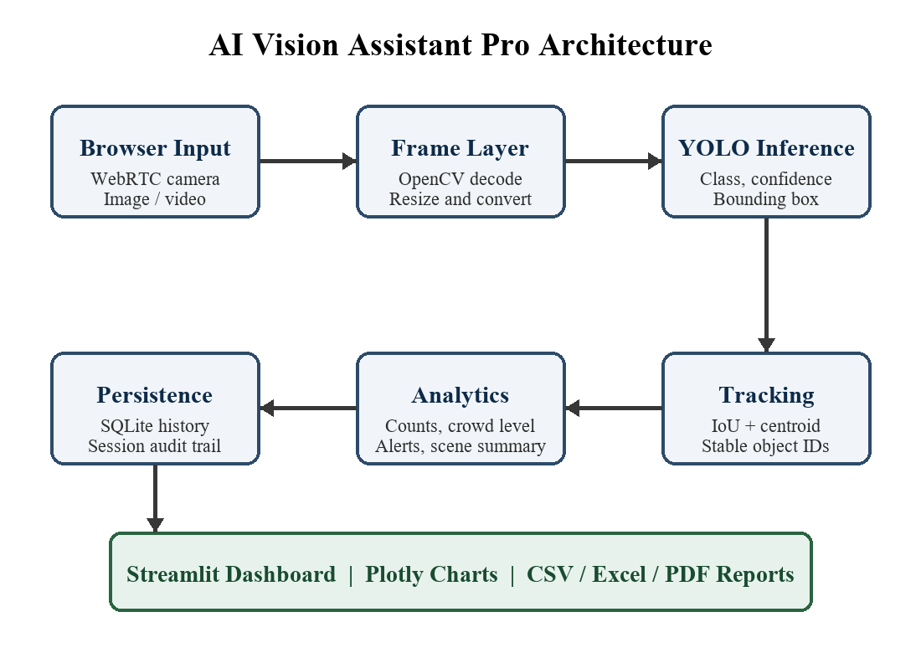
Fig. 1. Modular architecture from browser input to persistent analytics and reports.
Fig. 1 shows the six-stage architecture. Camera, image, or video input is decoded into OpenCV frames. YOLO generates detections, the tracker assigns stable IDs, and the analytics layer calculates object counts, person totals, density levels, and alerts. SQLite stores auditable rows, while Streamlit and Plotly present metrics and reports.
A. Input and Inference Layer
The image workflow accepts JPEG or PNG files. The video workflow processes uploaded MP4 frames and writes an annotated output video. Live mode obtains the camera through WebRTC rather than server-side VideoCapture, which is essential because a cloud server cannot directly open a remote user's camera. Each frame is converted to BGR format, passed to YOLO with a configurable confidence threshold, and annotated with class, confidence, and object ID.
B. Data and Reporting Layer
Three SQLite tables separate session metadata, detection-level evidence, and frame-level crowd logs. Detection rows include timestamp, session ID, frame number, object name, tracking ID, confidence, and bounding-box coordinates. Crowd rows include person count, same-object counts, number of distinct classes, density label, and alert state. Reports are produced directly from these normalized records.
IV. METHODOLOGY
A. Detection Representation
For frame t, each detection is represented as d=(c,s,b), where c is the class, s is confidence, and b=(x1,y1,x2,y2) is the bounding box. Detections below the user-selected confidence threshold are discarded by the inference engine. Same-object counting groups detections by c, whereas different-object counting returns the number of distinct detected classes.
B. Class-Aware Spatial Tracking
A track can match only a detection of the same class. Candidate association combines normalized centroid distance and bounding-box overlap. Let delta be centroid distance, R the recovery distance, and IoU the intersection-over-union. The matching cost is C=(delta/R)+0.65(1-IoU). The lowest finite cost is selected greedily. R expands modestly for temporarily missing tracks, and a track is retained for up to 60 missed frames. This design reduces ID fragmentation caused by short detector failures or bounding-box scale changes.
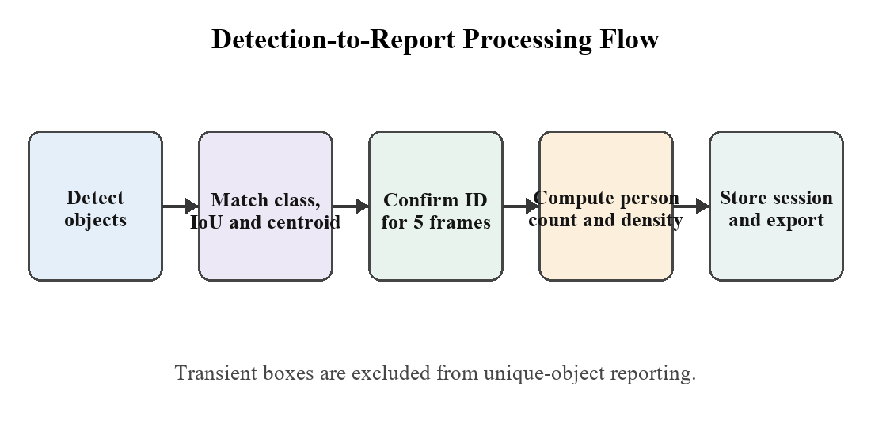
Fig. 2. Class-aware tracking and stable-report confirmation flow.
To prevent transient false positives from inflating unique-object reports, an ID is written as a new unique object only after it has appeared in at least five processed frames. Frame-level crowd counts remain immediate and do not wait for this confirmation.
C. Crowd Density and Alerts
TABLE 1
RULE-BASED CROWD DENSITY LEVELS
Person Count | Density Level
0 | No Crowd
1-5 | Low Crowd
6-15 | Medium Crowd
16-30 | High Crowd
>30 | Very High Crowd
Table I defines the interpretable density policy. A separate user-selected threshold produces an alert when the current person count reaches or exceeds the threshold. For analysis, maximum and average frame-level person counts are more reliable occupancy measures than counting detection rows, because the same individual legitimately appears in many frames.
D. Rule-Based Scene Summary
The scene summary ranks detected classes by frequency, describes the crowd level, and infers a coarse environment from object groups. For example, chairs, laptops, keyboards, and books suggest an indoor office or classroom. This deterministic approach requires no external API key and makes the summary logic reproducible.
V. IMPLEMENTATION
The application is implemented in Python 3.11. Streamlit provides navigation, controls, status messages, and download widgets; OpenCV and Pillow handle image conversion; Ultralytics YOLO performs inference; Pandas organizes tabular records; Plotly renders analytics; ReportLab and OpenPyXL generate PDF and Excel files; and SQLite stores local history. A resource cache avoids repeatedly loading the same YOLO weights. An inference lock protects a cached model when multiple browser sessions request predictions.
The live video is constrained to a stable 16:9 display with a bounded 960x540 stream. A persistent stop control outside the WebRTC component remains accessible even if the media component resizes. Stop events finalize the session, create reports, and expose downloads on the Live Detection page. All timestamps are normalized to Asia/Kolkata and rendered with an IST suffix.
A. Deployment
The repository includes pinned Python dependencies, Streamlit configuration, a Dockerfile, model weights, and writable output directories. The deployed application uses HTTPS, which is required for browser camera permission. STUN servers assist peer connection establishment; restrictive networks may require a TURN relay in future production deployments.
VI. FUNCTIONAL EVALUATION
A. Validation Protocol
Evaluation focused on end-to-end correctness rather than claiming detector accuracy without a labeled benchmark. Tests covered each input mode, storage, reporting, time normalization, and tracker behavior. Synthetic tracking sequences changed box size, introduced a 30-frame detection gap, and presented two simultaneous people.
TABLE 2
FUNCTIONAL VALIDATION RESULTS
Test | Expected Behavior | Result
Image input | Annotated image and CSV | Pass
Video input | Processed MP4 and trend log | Pass
Browser camera | Cross-device WebRTC stream | Pass
30-frame gap | Person retains original ID | Pass
Two people | Two distinct stable IDs | Pass
Stop session | CSV, Excel, and PDF created | Pass
Time handling | History and files use IST | Pass
B. Observed Behavior
The enhanced tracker retained ID 1 while the synthetic person's box changed position and scale, and recovered the same ID after 30 empty frames. In a two-person sequence, IDs 1 and 2 remained distinct. The report pipeline generated all three formats and stored start and end times in IST. These tests validate software behavior but do not constitute a statistical MOT or object-detection benchmark.
C. Interpreting Counts
A detection row is evidence of a tracked object, not a direct crowd total. Current, maximum, and average person counts should be calculated from crowd logs. A distinct person-ID count is an estimate of unique visitors and can still be affected by long occlusion, leaving and re-entering the scene, severe pose change, or multiple visually similar people. Operational dashboards should therefore label this value as estimated unique persons.
VII. DISCUSSION AND LIMITATIONS
The framework demonstrates how detection, tracking, analytics, and reporting can be assembled into one deployable interface. Its strengths are transparency, low setup cost, broad input support, and auditable data. However, detection-based crowd counting is unsuitable for extremely dense scenes where bodies are heavily occluded. The spatial tracker does not use appearance embeddings, so identity switches remain possible after long absence or crossing trajectories. Cloud CPU inference also introduces latency and limits concurrent streams.
Privacy is another important constraint. The system performs object detection rather than face recognition, but live camera frames are still transmitted to the application server during cloud use. A production deployment should add user authentication, explicit retention settings, encrypted report storage, access logs, and a privacy notice. SQLite is appropriate for a single-instance prototype; a multi-user production service should use durable managed storage.
VIII. CONCLUSION AND FUTURE WORK
AI Vision Assistant Pro integrates real-time YOLO detection, cross-device WebRTC input, class-aware tracking, crowd analytics, SQLite history, visualization, and automated reporting in a single web application. Functional tests verified major workflows, improved identity continuity, report generation, and IST timestamp consistency. The project provides a reproducible foundation for education and small-scale occupancy analysis while clearly separating frame-level crowd count from estimated unique visitors.
Future work should benchmark detection and tracking on labeled datasets, adopt ByteTrack or Deep SORT for stronger association, add directional entry/exit line counting, evaluate density-estimation models for highly congested scenes, configure TURN for restrictive networks, and move persistent data to a managed database. GPU-backed inference and role-based access control would further support production use.
REFERENCES
[1] J. Redmon, S. Divvala, R. Girshick, and A. Farhadi, "You Only Look Once: Unified, Real-Time Object Detection," in Proc. IEEE Conf. Computer Vision and Pattern Recognition (CVPR), 2016, pp. 779-788, doi: 10.1109/CVPR.2016.91.
[2] T.-Y. Lin et al., "Microsoft COCO: Common Objects in Context," in Computer Vision - ECCV 2014, 2014, pp. 740-755, doi: 10.1007/978-3-319-10602-1_48.
[3] A. Bewley, Z. Ge, L. Ott, F. Ramos, and B. Upcroft, "Simple Online and Realtime Tracking," in Proc. IEEE Int. Conf. Image Processing (ICIP), 2016, pp. 3464-3468, doi: 10.1109/ICIP.2016.7533003.
[4] N. Wojke, A. Bewley, and D. Paulus, "Simple Online and Realtime Tracking with a Deep Association Metric," in Proc. IEEE Int. Conf. Image Processing (ICIP), 2017, pp. 3645-3649, doi: 10.1109/ICIP.2017.8296962.
[5] Y. Li, X. Zhang, and D. Chen, "CSRNet: Dilated Convolutional Neural Networks for Understanding the Highly Congested Scenes," in Proc. IEEE/CVF Conf. Computer Vision and Pattern Recognition, 2018, pp. 1091-1100.
[6] W3C, "WebRTC: Real-Time Communication in Browsers," W3C Recommendation. [Online]. Available: https://www.w3.org/TR/webrtc/. Accessed: Jun. 27, 2026.
[7] OpenCV, "OpenCV Image Processing and Video Documentation." [Online]. Available: https://docs.opencv.org/. Accessed: Jun. 27, 2026.
[8] Ultralytics, "Ultralytics YOLO Prediction Documentation." [Online]. Available: https://docs.ultralytics.com/modes/predict/. Accessed: Jun. 27, 2026.
[9] Streamlit, "Streamlit App Model and Documentation." [Online]. Available: https://docs.streamlit.io/. Accessed: Jun. 27, 2026.
[10] SQLite Consortium, "SQLite Documentation." [Online]. Available: https://sqlite.org/docs.html. Accessed: Jun. 27, 2026.

