AI-Powered Banking Intelligence Platform: Explainable Customer Churn Prediction, Segmentation, and Retention Decision Support
Harshal Gulabrao Waghe
Department of Electronics and Telecommunication Engineering
Suryodaya College of Engineering and Technology, Nagpur
Nagpur, Maharashtra, India
harshalwaghe91@gmail.com

Abstract—Customer attrition is costly for retail banks because acquisition expense, lost lifetime value, and service disruption accumulate before conventional reporting detects a problem. This paper presents BankIQ, an end-to-end banking intelligence platform that converts tabular customer data into explainable and operational churn interventions. The system combines supervised churn prediction, probability-based risk classification, local feature explanations, K-Means customer segmentation, rule-guided retention recommendations, portfolio analytics, batch CSV scoring, and PDF reporting. A synthetic bank-customer dataset containing 5,000 records was used when no external dataset was available. Logistic regression and random forest models were evaluated using accuracy, precision, recall, and F1-score; the logistic model was selected by F1-score, obtaining 0.553 F1 and 0.655 recall on the holdout set. The deployed React and FastAPI architecture supports customer-linked assessments and vectorized scoring of 5,000 records. The contribution is not a new classification algorithm, but a reproducible decision-support workflow that joins prediction, interpretability, segmentation, and actionable retention guidance while preserving human review.
Index Terms—banking analytics, churn prediction, explainable artificial intelligence, customer segmentation, retention recommendation, FastAPI, machine learning.
I. INTRODUCTION
Digital banking has increased customer choice while reducing the friction of moving between financial providers. For a bank, churn is therefore not merely a binary label; it is an operational risk that affects deposits, product utilization, servicing cost, and long-term relationship value. Conventional dashboards describe attrition after it occurs, but relationship teams need earlier signals, interpretable reasons, and concrete actions. A useful churn system must consequently connect statistical inference with a workflow that bankers can understand and use.
BankIQ addresses this requirement through a full-stack decision-support platform. It predicts whether a customer is likely to leave, reports a calibrated probability and business-readable risk tier, explains influential attributes, assigns a behavioral segment, and proposes retention actions. The same intelligence is available for a single verified customer or a batch portfolio. The application also exposes aggregate analytics and downloadable reports, allowing model output to move beyond an isolated notebook into a traceable business process.
The principal contributions of this work are: (1) a reproducible comparison of linear and ensemble classifiers for customer attrition; (2) an explainability layer based on SHAP when available and model-native importance otherwise; (3) a K-Means segmentation scheme that maps clusters to operational personas; (4) a personalized retention engine; and (5) a deployable React-FastAPI architecture with customer records, batch scoring, analytics, and report generation.
II. RELATED WORK
Customer churn prediction is commonly modeled as supervised binary classification over demographic, account, product, and engagement variables. Logistic regression remains a strong baseline because coefficients provide directional evidence and inference is computationally efficient. Random forests aggregate decorrelated decision trees and can capture nonlinear interactions without extensive manual feature construction [1]. Gradient-boosted trees, including XGBoost, are also widely used for structured data due to regularization, sparsity handling, and scalable training [2]. The present system supports XGBoost when installed but remains functional with scikit-learn models [3].
Predictive performance alone is insufficient in a regulated or high-impact banking context. SHAP unifies additive feature-attribution methods and assigns each feature a contribution to an individual prediction [4]. Such local explanations can help a relationship manager distinguish an inactivity-driven risk from one associated with product depth or account characteristics. Unsupervised clustering complements this customer-level view. K-Means partitions observations around centroids and remains a practical baseline for behavioral segmentation [5]. BankIQ integrates these methods within one operational interface rather than treating prediction, explanation, and segmentation as separate experiments.
III. SYSTEM ARCHITECTURE AND METHODOLOGY
A. Data Model and Preparation
The input schema contains CreditScore, Geography, Gender, Age, Tenure, Balance, NumOfProducts, HasCrCard, IsActiveMember, EstimatedSalary, and the binary target Exited. When an external file is unavailable, a deterministic generator creates 5,000 records with realistic ranges and a probabilistic target influenced by age, geography, activity, product count, tenure, balance, and credit score. In the evaluated dataset, 1,624 customers exited, corresponding to a 32.48% churn rate.
Categorical geography and gender values are one-hot encoded, while numeric variables are standardized. A stratified 80:20 split preserves the target distribution. Preprocessing is fitted only on the training partition and persisted with Joblib so training and production inference use the same transformations. Input constraints are enforced through Pydantic models at the API boundary.
Group | Variables | Processing
Numeric | Score, age, tenure, balance, products, card, activity, salary | Standardize
Categorical | Geography, gender | One-hot encode
Target | Exited | Binary label
TABLE I. INPUT FEATURES AND PREPROCESSING
B. Churn Prediction and Risk Mapping
Logistic regression and random forest classifiers are trained under class-aware settings. An optional XGBoost candidate is added when its dependency is available. Model selection uses the positive-class F1-score, which balances precision and recall under class imbalance. For an input vector x, the selected classifier produces p(y=1|x). A threshold of 0.50 determines the predicted class. The probability is additionally mapped to Low Risk for p less than or equal to 0.40, Medium Risk for 0.40 < p less than or equal to 0.70, and High Risk for p > 0.70. This tiering separates intervention urgency from the binary classification threshold.
C. Explainability, Segmentation, and Recommendations
For individual assessments, the explanation service attempts a SHAP tree explainer when the selected estimator and runtime support it [4]. If SHAP is unavailable, feature importance or linear coefficients are combined with the transformed observation to produce ranked directional reasons. Explanations are translated into customer-facing feature names rather than exposing encoded matrix columns.
Segmentation uses standardized age, tenure, balance, product count, activity, and salary. K-Means is fitted with four clusters and a fixed random seed. Cluster profiles are mapped to Loyal, At-Risk, Premium, and New Customers using churn prevalence, balance, and tenure. The recommendation engine then applies transparent rules: inactivity triggers relationship outreach, high-value at-risk accounts receive premium-benefit suggestions, short-tenure customers receive onboarding rewards, low product depth prompts bundling, and customers without a card receive relevant card-benefit offers.
D. Full-Stack Deployment
The frontend is a responsive React application built with Vite, Tailwind CSS, Axios, and Recharts. FastAPI provides typed REST endpoints for prediction, customer lookup, batch scoring, analytics, segments, administrative records, and reports. SQLite stores customer-linked assessment records, while ReportLab generates PDF briefs. The frontend is deployed on Vercel and the API on Render. Environment-based API URLs and CORS allow the same codebase to run locally and in hosted environments.
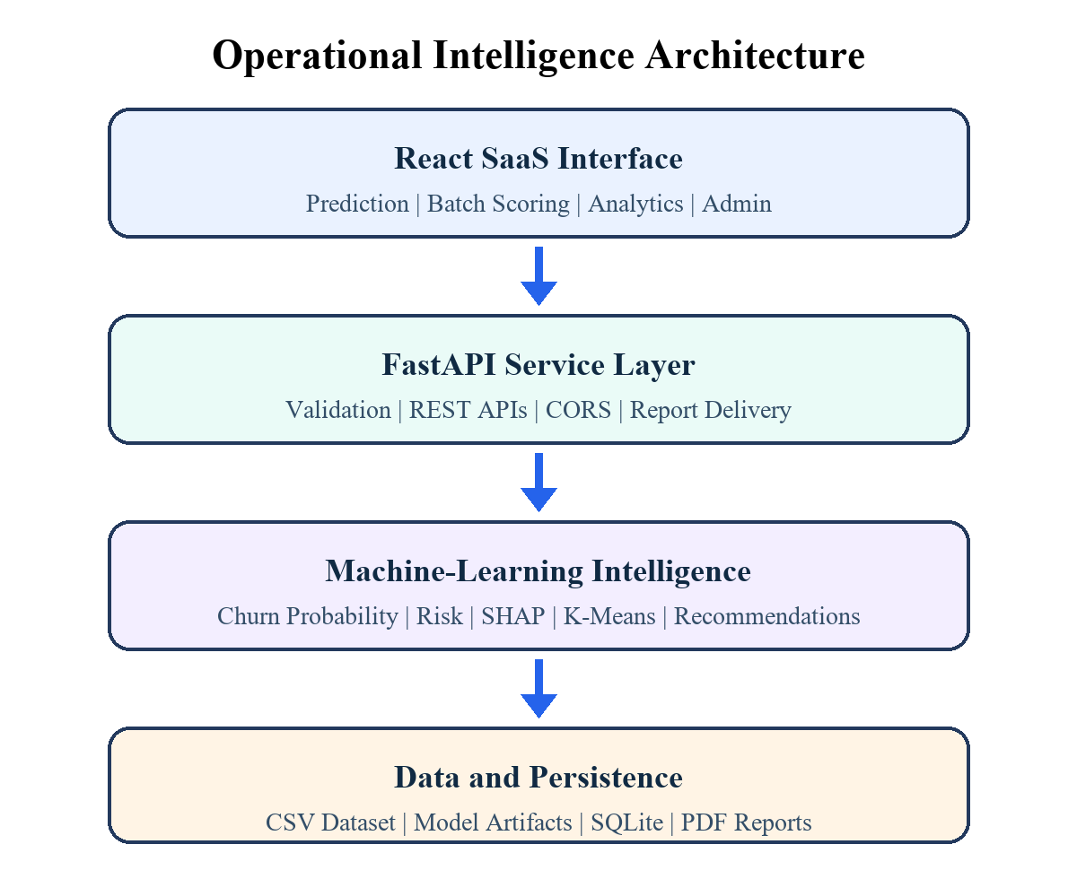
Fig. 1. Layered architecture of the BankIQ platform.
IV. IMPLEMENTATION
The training module loads the CSV file, validates required columns, performs preprocessing, trains candidate models, prints classification reports, and serializes the selected model, preprocessor, scaler, K-Means estimator, and metadata. The inference module lazily loads these artifacts and caches them within the API process. This avoids repeated disk access during interactive requests while allowing startup to remain lightweight.
Operational assessment begins with a searchable customer directory rather than unrestricted manual input. A selected record is converted to the model schema, scored, linked to an external customer identifier, and saved with its probability, risk, segment, reasons, and recommendations. This design improves traceability and distinguishes a production-style assessment from ad hoc scenario testing.
Batch prediction accepts a CSV upload, verifies the schema and a 10,000-row limit, validates records, and transforms the complete matrix in one operation. The model and K-Means estimator then score all rows using vectorized calls. Lightweight business-readable reasons and recommendations are attached before an enriched CSV is streamed to the client. Vectorization replaced an initial row-by-row implementation that exceeded hosted request time limits.
V. EXPERIMENTAL DESIGN AND RESULTS
A. Evaluation Protocol
The experiment used 5,000 synthetic records and a stratified 20% holdout set. Accuracy measures total correctness, precision measures the proportion of predicted churners that actually churned, recall measures the proportion of churners identified, and F1 is the harmonic mean of precision and recall. In retention settings, recall is important because a false negative represents a customer who may leave without intervention; however, low precision can waste outreach capacity. F1 therefore served as the selection criterion.
B. Comparative Performance
Table II reports holdout performance. Random forest achieved the highest accuracy and precision, whereas logistic regression achieved substantially higher recall and the best F1-score. The system therefore selected logistic regression. This result illustrates why model choice should follow the operational objective rather than accuracy alone.
Model | Acc. | Prec. | Recall | F1
Logistic Reg. | 0.655 | 0.478 | 0.655 | 0.553
Random Forest | 0.681 | 0.508 | 0.563 | 0.534
TABLE II. HOLDOUT MODEL PERFORMANCE
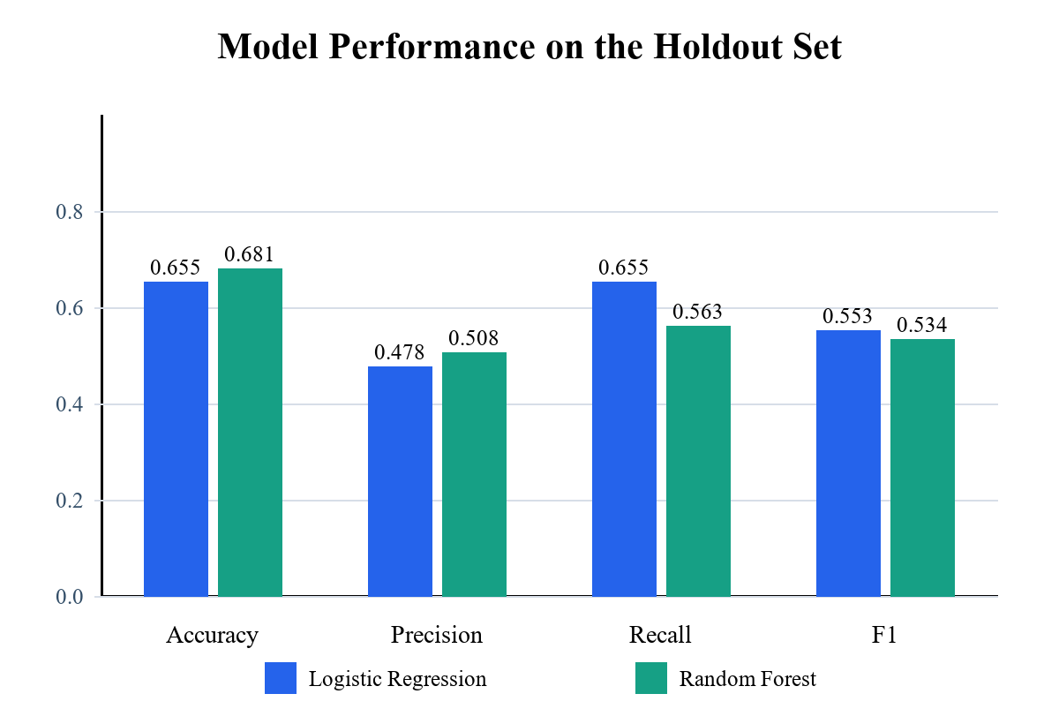
Fig. 2. Comparison of logistic regression and random forest metrics.
C. Deployment-Level Batch Test
A deployment-level test uploaded all 5,000 records to the hosted batch endpoint. After vectorization, the API returned an enriched file containing predictions, probabilities, risk categories, segments, reasons, and recommendations in 4.94 s during a warm-service measurement. This test demonstrates that implementation choices outside the estimator can dominate user-perceived performance. Cold starts remain possible on free hosting, so the client uses a longer timeout and presents loading feedback.
VI. DISCUSSION
The evaluation does not establish state-of-the-art churn accuracy; instead, it validates an integrated architecture. Logistic regression's higher recall suited the stated retention objective, while its linear structure simplified fallback explanations. The random forest's higher accuracy and precision suggest that threshold tuning, probability calibration, or cost-sensitive optimization could produce a better operating point. A bank should select that point according to intervention cost and customer lifetime value.
The combination of risk tiers, feature reasons, segments, and recommendations improves actionability but must not be interpreted as causal advice. A feature that contributes to a prediction is not necessarily a lever that will change behavior. Relationship teams should treat recommendations as hypotheses, record outcomes, and use controlled campaigns to estimate treatment effects.
VII. LIMITATIONS, ETHICS, AND GOVERNANCE
The principal limitation is the synthetic dataset. Its target mechanism produces useful engineering test data but cannot represent the full distribution, policy environment, or behavior of a real bank. Reported metrics therefore demonstrate the pipeline rather than generalizable business performance. External validation on temporally separated, consented, and representative data is required before operational use.
Gender, age, and geography may act as sensitive or proxy attributes. A production model requires legal review, fairness testing across relevant groups, documented feature justification, drift monitoring, access controls, encryption, retention policies, and an appeal or correction process. Human review must remain part of consequential decisions. The platform is intentionally framed as decision support and should not automatically deny products, alter pricing, or initiate adverse action.
SQLite and local report storage are appropriate for demonstration but not durable hosted infrastructure. Managed relational storage, object storage, authentication, role-based authorization, secrets management, audit logging, rate limiting, and secure software development controls are necessary for production. Model cards and data sheets should document intended use, exclusions, metrics, and known failure modes [6].
VIII. CONCLUSION AND FUTURE WORK
This paper presented BankIQ, a deployable banking intelligence platform that unifies churn prediction, probability-based risk, explanations, customer segmentation, retention guidance, batch scoring, analytics, administrative records, and PDF reporting. On the synthetic holdout data, logistic regression was selected with 0.553 F1 and 0.655 recall. The work demonstrates that a resume-scale machine-learning project can be engineered as a coherent decision-support product rather than a standalone prediction script.
Future work includes validation on real and temporally split data, hyperparameter and threshold optimization, probability calibration, fairness and drift dashboards, campaign outcome tracking, uplift modeling, authenticated roles, PostgreSQL persistence, object storage, automated tests, continuous deployment gates, and model registry integration. These additions would move the platform from a portfolio-grade prototype toward a governed banking analytics service.
REFERENCES
[1] L. Breiman, "Random forests," Machine Learning, vol. 45, pp. 5–32, 2001, doi: 10.1023/A:1010933404324.
[2] T. Chen and C. Guestrin, "XGBoost: A scalable tree boosting system," in Proc. 22nd ACM SIGKDD Int. Conf. Knowledge Discovery and Data Mining, 2016, pp. 785–794, doi: 10.1145/2939672.2939785.
[3] F. Pedregosa et al., "Scikit-learn: Machine learning in Python," Journal of Machine Learning Research, vol. 12, pp. 2825–2830, 2011.
[4] S. M. Lundberg and S.-I. Lee, "A unified approach to interpreting model predictions," in Advances in Neural Information Processing Systems 30, 2017.
[5] J. MacQueen, "Some methods for classification and analysis of multivariate observations," in Proc. 5th Berkeley Symp. Mathematical Statistics and Probability, vol. 1, 1967, pp. 281–297.
[6] M. Mitchell et al., "Model cards for model reporting," in Proc. Conf. Fairness, Accountability, and Transparency, 2019, pp. 220–229, doi: 10.1145/3287560.3287596.
[7] W. McKinney, "Data structures for statistical computing in Python," in Proc. 9th Python in Science Conf., 2010, pp. 56–61.
[8] S. Raschka, J. Patterson, and C. Nolet, "Machine learning in Python: Main developments and technology trends in data science, machine learning, and artificial intelligence," Information, vol. 11, no. 4, p. 193, 2020.
[9] S. Grinsztajn, E. Oyallon, and G. Varoquaux, "Why do tree-based models still outperform deep learning on typical tabular data?" in Advances in Neural Information Processing Systems 35, 2022.
[10] FastAPI, "FastAPI documentation." [Online]. Available: https://fastapi.tiangolo.com/. Accessed: Jun. 27, 2026.
[11] React, "React documentation." [Online]. Available: https://react.dev/. Accessed: Jun. 27, 2026.
[12] A. Géron, Hands-On Machine Learning with Scikit-Learn, Keras, and TensorFlow, 3rd ed. Sebastopol, CA, USA: O’Reilly Media, 2022.

