AI-Based Disease Outbreak Prediction Using Laboratory Test Data
with a General Consultation Chatbot
Harshal Gulabrao Waghe
Department of Electronics and Telecommunication Engineering
Suryodaya College of Engineering and Technology, Nagpur
Nagpur, Maharashtra, India
harshalwaghe91@gmail.com
Abstract—Early recognition of abnormal laboratory patterns can support timely public-health investigation, but many academic prototypes either expose a machine-learning model without an accessible interface or provide dashboards without an end-to-end prediction workflow. This paper presents OutbreakAI, a full-stack decision-support prototype that combines laboratory measurements, demographics, symptoms, machine learning, analytics, report storage, and a safety-oriented consultation chatbot. A synthetic dataset of 5,000 records was generated across five disease categories and three risk levels. Numeric features are standardized, categorical variables are one-hot encoded, symptom text is represented by term frequency-inverse document frequency features, and two Random Forest classifiers containing 220 trees each predict disease category and risk level. A transparent clinical-severity layer combines model confidence with abnormal temperature, oxygen saturation, inflammatory markers, white blood cell count, platelets, and blood sugar. On a held-out set of 1,000 synthetic records, the disease classifier obtained 1.000 accuracy and the risk classifier obtained 0.984 accuracy. These results demonstrate software and pipeline feasibility, not clinical validity; prospective evaluation on representative, expert-labeled data is required before any healthcare use.
Keywords—disease outbreak prediction, laboratory test data, Random Forest, public-health surveillance, FastAPI, healthcare chatbot, synthetic data.

I. INTRODUCTION
Disease surveillance depends on timely collection, analysis, interpretation, and communication of health information. Laboratory observations are particularly valuable because changes in white blood cell count, inflammatory markers, platelet count, oxygen saturation, and temperature may provide early signals of infectious or respiratory disease. The World Health Organization (WHO) describes early-warning systems as mechanisms that collect both immediate alerts and periodic surveillance data to support verification and response [1], [2]. However, laboratory values alone do not establish an outbreak or an individual diagnosis; interpretation requires epidemiological context, validated thresholds, and expert review.
This work develops a deployable academic prototype that converts laboratory and symptom inputs into a risk category, likely disease group, outbreak probability, and preventive recommendation. The system also maintains prediction history, visualizes aggregate trends, and provides a rule-based chatbot that supplies general guidance while escalating emergency terms. The contribution is an integrated, reproducible stack rather than a claim of clinical deployment.
The principal contributions are: (1) a multimodal preprocessing pipeline for numeric, categorical, and free-text inputs; (2) separate Random Forest models for disease category and risk classification; (3) a transparent rule layer that adjusts categories and probability using clinically interpretable abnormalities; (4) a full-stack interface with dashboards, reports, and chatbot safety controls; and (5) a deployment design using free-tier web services.

II. RELATED WORK
Random Forest is an ensemble method that combines randomized decision trees and aggregates their predictions. Breiman showed that the method can provide strong generalization while remaining comparatively robust to noise [3]. It is suitable for tabular laboratory data because it models nonlinear interactions, tolerates mixed feature scales after preprocessing, and provides class probabilities. The implementation uses scikit-learn's RandomForestClassifier [4], supported by pipelines and column-wise transformations [5].
Prior public-health systems emphasize that alerts should initiate investigation rather than act as final diagnoses [1]. OutbreakAI follows this principle by presenting outputs as decision-support estimates, displaying a medical disclaimer, and separating emergency chatbot messages from routine advice. The system also preserves a clear distinction between patient-level classification and population-level outbreak surveillance: the dashboard summarizes submitted prototype records but does not estimate real incidence.

III. SYSTEM DESIGN AND METHODOLOGY

A. System Architecture
The application follows a client-server architecture. A React single-page application sends JSON requests through Axios to a FastAPI backend. The backend validates inputs, loads a serialized model bundle with joblib, stores prediction records in SQLite, and returns JSON responses. Cross-origin resource sharing is configured for local and deployed frontend origins [6]. Figure 1 summarizes the primary components.
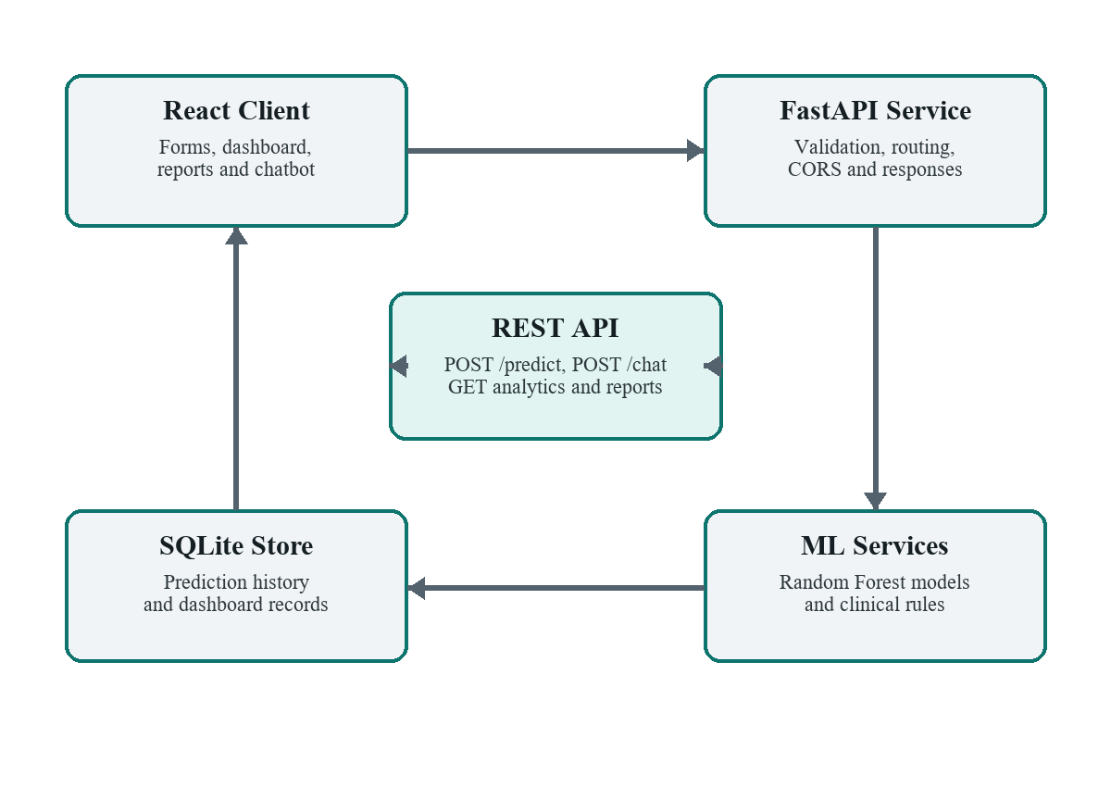
Fig. 1. OutbreakAI full-stack system architecture.

B. Dataset Generation
Because no de-identified institutional dataset was available, a reproducible generator produced 5,000 synthetic records using a fixed random seed of 42. Each record contains age, gender, location, symptom text, and ten laboratory or physiological measurements. Records are assigned to Viral Infection, Bacterial Infection, Respiratory Disease, Dengue-like Illness, or Flu-like Illness. Class-specific perturbations create high WBC and CRP for bacterial cases, lower oxygen saturation for respiratory cases, lower platelet counts for dengue-like cases, and increased temperature for dengue-like and flu-like cases.
TABLE I
MODEL INPUT GROUPS
Group | Variables
Demographic | Age, gender, location
Symptoms | Free-text symptom description
Hematology | WBC, RBC, platelets, hemoglobin
Inflammation | CRP, ESR
Vitals | Temperature, oxygen saturation
Metabolic | Blood sugar

Risk labels are derived from five severity indicators: temperature above 39 °C, oxygen saturation below 93%, CRP above 55 mg/L, platelet count below 110×10³/µL, and WBC count above 15×10³/µL. Zero indicators produce Low risk, one or two produce Medium risk, and three or more produce High risk. This deterministic labeling supports pipeline testing but also makes the evaluation easier than a real clinical task.

C. Preprocessing and Model Training
The dataset is divided into 4,000 training and 1,000 testing records using an 80:20 stratified split. Numeric features are standardized, gender and location are one-hot encoded with unknown-category handling, and symptoms are transformed using TF-IDF with unigrams and bigrams and a maximum of 80 terms. Two independent Random Forest classifiers are trained with 220 trees, balanced class weights, parallel execution, and a fixed random state. The fitted pipelines, metrics, training time, and dataset size are saved in outbreak_model.pkl.
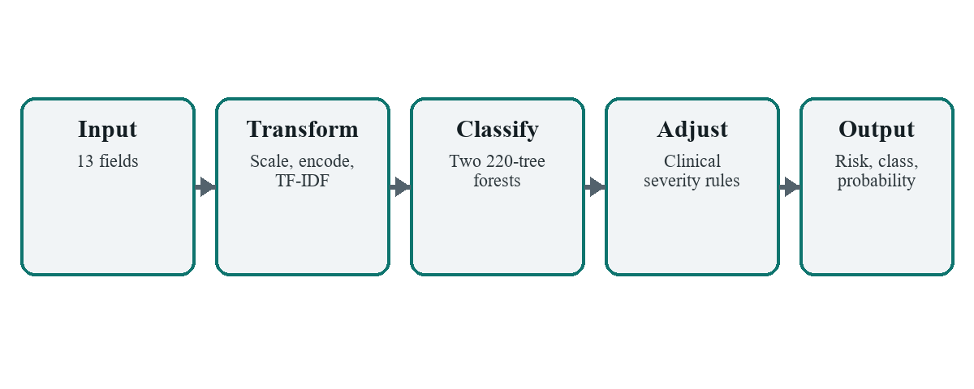
Fig. 2. Prediction preprocessing and inference pipeline.

D. Hybrid Clinical Adjustment
A clinical-severity score S complements the model output. Each input abnormality is normalized to [0,1] and combined as S = 0.20T + 0.25O + 0.15C + 0.10E + 0.12W + 0.13P + 0.05G, where T is temperature elevation, O is oxygen deficit, C is CRP elevation, E is ESR elevation, W is WBC deviation, P is platelet reduction, and G is blood-sugar abnormality. The displayed probability combines an 0.08 baseline, 0.78S, 0.08 model confidence, and an adjustment of 0.00, 0.10, or 0.20 for the model's Low, Medium, or High risk prediction.
Transparent category rules prioritize recognizable patterns: fever with thrombocytopenia suggests a dengue-like category; low oxygen or breathing symptoms suggest respiratory disease; WBC above 12×10³/µL or CRP above 35 mg/L suggests bacterial infection; and fever with cough, sore throat, or body ache suggests flu-like illness. These rules are educational heuristics and are not diagnostic criteria.

E. Consultation Chatbot
The chatbot is intentionally rule based so that its behavior remains deterministic and auditable. It provides general advice for fever, respiratory symptoms, headache, gastrointestinal symptoms, and dengue-like symptoms. Messages containing chest pain, breathing difficulty, unconsciousness, seizure, facial drooping, slurred speech, or sudden weakness trigger an emergency response directing the user to local emergency services. Every response includes a disclaimer and avoids final diagnosis.

IV. IMPLEMENTATION

A. Backend and Database
FastAPI exposes POST /predict and POST /chat together with GET /dashboard, GET /reports, and GET /analytics. Pydantic schemas validate request fields and response types. The model bundle is loaded once through a cached service function, reducing repeated disk access. SQLite provides a compact, serverless, single-file database appropriate for an academic prototype [7]. Prediction history supplies the reports table and aggregate dashboard statistics.
TABLE II
REST API ENDPOINTS
Method | Endpoint | Purpose
POST | /predict | Generate and store prediction
POST | /chat | Return general consultation
GET | /dashboard | Summary metrics
GET | /reports | Prediction history
GET | /analytics | Chart-ready aggregates

B. Frontend and Deployment
The React interface contains a landing page, prediction form, analytics dashboard, consultation chatbot, reports page, and administrative overview. Tailwind CSS supplies responsive styling, Recharts renders interactive charts, React Router manages navigation, and Axios handles API calls. The production frontend is deployed on Vercel and the backend on Render. The API timeout is set to 70 seconds to accommodate possible free-tier cold starts, while the interface reports request errors to the user instead of failing silently.
CORS allows the configured production domain and local development origins. Environment variables separate the backend URL from source code. The public deployment and repository demonstrate reproducibility, but free-tier instance sleep can increase first-request latency and local SQLite persistence may not be durable across every hosting lifecycle.

V. EXPERIMENTAL SETUP
Experiments use the deterministic synthetic dataset and fixed train-test partition described above. Weighted precision, recall, and F1-score are reported to account for class distribution. Accuracy measures the fraction of correct predictions. The disease and risk models are evaluated independently on the same held-out 1,000 records. No test examples are used for fitting.
Functional tests additionally submit low-risk routine values, bacterial-like high-WBC/high-CRP values, respiratory-like low-oxygen values, and dengue-like low-platelet values through the deployed prediction page. This verifies request validation, inference, response rendering, and report storage across the end-to-end stack.

VI. RESULTS AND DISCUSSION
TABLE III
HELD-OUT MODEL PERFORMANCE
Target | Accuracy | Precision | Recall | F1
Disease | 1.0000 | 1.0000 | 1.0000 | 1.0000
Risk | 0.9840 | 0.9843 | 0.9840 | 0.9796

Table III shows perfect disease-category classification and 98.4% risk accuracy on the held-out synthetic set. The disease result is explained by the data generator: each category receives a fixed symptom phrase and category-specific numeric shifts, creating highly separable classes. Consequently, 1.000 accuracy should not be interpreted as evidence of equivalent performance on noisy, incomplete, or overlapping clinical cases.
The risk model's lower F1-score indicates that minority or boundary cases are more difficult even under synthetic labeling. The hybrid layer improves visible responsiveness to clinically recognizable patterns. For example, a demonstration record with WBC 17×10³/µL, CRP 92 mg/L, ESR 58 mm/hr, temperature 39.4 °C, and oxygen saturation 96% returned Bacterial Infection, Medium risk, and a 54.72% outbreak probability. This case confirms that the corrected category logic no longer collapses diverse inputs into one class.
TABLE IV
EXAMPLE END-TO-END OUTPUT
Field | Value
Key inputs | WBC 17; CRP 92; ESR 58; Temp. 39.4
Predicted category | Bacterial Infection
Risk level | Medium
Probability | 54.72%

The dashboard, analytics charts, report history, and chatbot complete the intended functional requirements. Because the output probability is a designed blend rather than a statistically calibrated outbreak prevalence, it should be described as a prototype score. Calibration with epidemiological labels and regional case counts is necessary before the term probability can carry operational public-health meaning.

VII. LIMITATIONS AND ETHICAL CONSIDERATIONS
The primary limitation is synthetic data. The generator cannot reproduce measurement error, missing values, comorbidities, medication effects, demographic imbalance, disease co-occurrence, laboratory reference-range variation, or temporal and geographic clustering. The five broad categories are not formal diagnoses, and a single patient record cannot establish an outbreak. The system has not undergone external validation, prospective testing, clinician review, probability calibration, fairness analysis, or regulatory assessment.
Ethical deployment would require de-identification, explicit consent or lawful public-health authority, access control, encryption, retention policies, audit logs, subgroup performance reporting, and clinical governance. Human review must remain authoritative. Emergency warnings should be localized to the user's jurisdiction, and the chatbot must never replace professional evaluation. These safeguards are reflected in the prototype's disclaimers but are not fully implemented as production controls.

VIII. CONCLUSION AND FUTURE WORK
This paper presented OutbreakAI, a complete web-based disease-outbreak decision-support prototype integrating laboratory data, symptom text, Random Forest models, transparent severity rules, analytics, reports, and a general consultation chatbot. The implementation demonstrates that heterogeneous inputs can be processed and served through a responsive, deployable architecture. Held-out synthetic results were strong, but their interpretation is deliberately limited to pipeline feasibility.
Future work should replace synthetic labels with de-identified, expert-annotated multicenter data; introduce missing-data handling and uncertainty intervals; calibrate probabilities; evaluate temporal and geographic forecasting; compare Random Forest with gradient boosting and sequence models; add explainability using SHAP; and conduct fairness, usability, security, and prospective clinical studies. A population-level forecasting module should incorporate case counts and time windows rather than inferring outbreaks from isolated records.

REFERENCES
[1] World Health Organization, WHO Recommended Surveillance Standards, 2nd ed. Geneva, Switzerland: WHO, 1999.
[2] World Health Organization Regional Office for the Eastern Mediterranean, “Early Warning, Alert and Response Network (EWARN),” [Online]. Available: https://www.emro.who.int/health-topics/ewarn/. Accessed: Jun. 27, 2026.
[3] L. Breiman, “Random forests,” Machine Learning, vol. 45, no. 1, pp. 5–32, 2001, doi: 10.1023/A:1010933404324.
[4] Scikit-learn Developers, “RandomForestClassifier,” scikit-learn documentation, [Online]. Available: https://scikit-learn.org/stable/modules/generated/sklearn.ensemble.RandomForestClassifier.html. Accessed: Jun. 27, 2026.
[5] F. Pedregosa et al., “Scikit-learn: Machine learning in Python,” Journal of Machine Learning Research, vol. 12, pp. 2825–2830, 2011.
[6] FastAPI, “CORS (Cross-Origin Resource Sharing),” [Online]. Available: https://fastapi.tiangolo.com/tutorial/cors/. Accessed: Jun. 27, 2026.
[7] SQLite Consortium, “About SQLite,” [Online]. Available: https://www.sqlite.org/about.html. Accessed: Jun. 27, 2026.
[8] React Team, “React Quick Start,” [Online]. Available: https://react.dev/learn. Accessed: Jun. 27, 2026.
[9] W. McKinney, “Data structures for statistical computing in Python,” in Proc. 9th Python in Science Conf., Austin, TX, USA, 2010, pp. 56–61.

