1. **Introduction**

Milton Friedman, in his seminal work, Capital and Freedom, explained the correlation between economic freedom and political freedom.[1] Since then, there has been a considerable interest in exploring the relationship between the two. These factors are basically used to gauge how well a country is doing. However, they have their flaws and recently, researchers are focusing on another factor – Happiness Index of a country.

The problem though, with that is that the word freedom and happiness are very subjective terms, and hence even qualitatively difficult to measure. However, as more advances were made into the study of political freedom and economic freedom, and happiness, we have a better understanding of the factors that constitute them.

**Research Question**

This research aims to understand how the two factors (economic freedom and political freedom), which are our independent variable, affect the happiness index of a country.

1. **Literature**

For long, the growth rate of GDP – the measure of economic activity of a country, was the metric of economic growth in a country. However, measuring GDP is both difficult and an inadequate measure of a countries’ development. There was a need felt for a broader measure of development. Amartya Sen, in his book, Development as Freedom defines development as expansion of freedoms.[2]

Researchers came up with different measures to measure different aspects of growth, which gave way to measures like economic freedom and political freedom. The question, though remains, that what is the end goal of development? Is it the well being of human population? But well being is subjective. Psychologists were able to study the subject well being data and proposed the creating a happiness measure – National Indicator of Happiness.[3]

As more data was collected regarding the subjective well-being, Economist were able to analyze the data. The statistical findings revealed some important insights about happiness:

1. Although money is important for happiness, but the relation between the two is neither direct nor simple. For example, an increase in salary may not give an individual as much happiness as getting married.
2. The concept of happiness varies greatly between different nations. What may constitute as happiness in the West, may not result in happiness in eastern countries.
3. People get used to their lives and hence the effects of both good life and bad life wear off.[4]

We consider the Happiness Index as our principal measure of development and consider other measures that may affect this measure. For our research, we consider Economic Freedom and Political Freedom.

Significant research has been done on the economic freedom index as economic well being was naturally considered important for the well being of a country’s population. According to Gwartney and Lawson (2001), “Economic freedom means the degree to which a market economy is in place, where the central components are voluntary exchange, free competition, and protection of persons and property”.[5] Prior research suggests that there is a causal relationship between the economic freedom of a country and the subsequent economic well-being.[6] Researchers found a positive direct correlation between the two.[7]

Next, we consider our other independent variable – Political freedom. It is broadly defined as the ability of people to exercise their political rights without any coercion.[8] Political freedom can be decomposed into the opportunity to choose and the capability to choose. We can understand these two components by looking at democratic elections. The process of elections gives citizens the opportunity to choose their government, however, their ability to make informed choice about which candidate to vote for gives them the capability to choose.[9]

Now that we have broadly defined the three measures, the next step is to explore the relationship between the three of them. We study the impact of economic freedom and political freedom on the Happiness score of a country. The hypothesis that we will be testing in this paper is as follows:

*Hypothesis – Happiness Index of a country is directly proportional to economic freedom index and political freedom index.*

1. **Data**

We consider the economic freedom and political freedom data for the years of 2016, 2017, 2018 and 2019, and Happiness score for the years of 2018 and 2019. We use the data for 2019 to test the predictive capabilities of our model.

a) The Happiness data: The data is titled **online-data-chapter-2-whr-[YEAR]**. The data is retrieved from the World Happiness Report (**source**: [https://worldhappiness.report/ed](https://worldhappiness.report/ed/) The world happiness report is a survey of global happiness. It ranks 156 countries on the basis of their happiness. The methpdology involves survey questions that ask people to rate their satisfaction across measures such as satisfaction with their national governments, personal relationships and security. [10]  The data format is csv.

b) Economic Freedom data: The data is titled **economic_freedom_[year]**. The data is retrieved from the Heritage Foundation. **source:** <https://www.heritage.org/index/about>. The Heritage Institute is a non-profit think tank in USA. It is a conservative and libertarian think tank. The think tank comes up with with this score by measuring 12 qualitative and quantitative factors which can be broadly classified into 4 larger categories of Rule of Law, Government Size, Regulatory Efficiency, and Open Markets. Each country is graded on a scale of 0 to 100 for each fator and the final score is averaged to get the country’s final score.[11] The data format is csv.

c) Political Freedom Data: The data is titles **Freedom_Index**. The data is retreived from Freedom House, which is an independent watchdog organization whose work aims to expand freedom and democracy. The index looks at data for rule of law, freedom of expression, beliefs, and respect for women and minorities.[12]The data format is csv.

d) Validation Data: The data is titled **validation_data**. We use data from Cato Institute to validate our data. **Source:** [https://www.cato.org](https://www.cato.org/). Cato Institute is a public policy research think tank dedicated to individual liberty, free markets and peace.[13]The data format is csv.

1. **Data Validation**

We validate our data for economic freedom, political freedom and happiness score by correlating them with similar measures from other insitutitions that do similar research. Cato Institute, which is another libertarian think tank located in the USA, comes out with its own Economic Freedom Index, Human Freedom Index and Personal Freedom Index.

We first correlate our data for economic freedom. Running a correlation in R gives us a correlation coefficient of 0.887. This shows high correlation between the two and hence, we can say that our data for economic freedom score is validated. Figure 2 plots the two data. We can see a clear positive correlation.

Correlating Political Freedom tells us a similar story. If we look at Figure 3, which plots the data

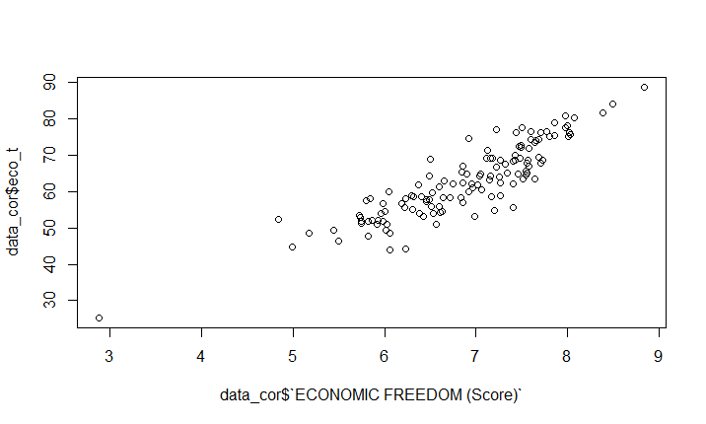

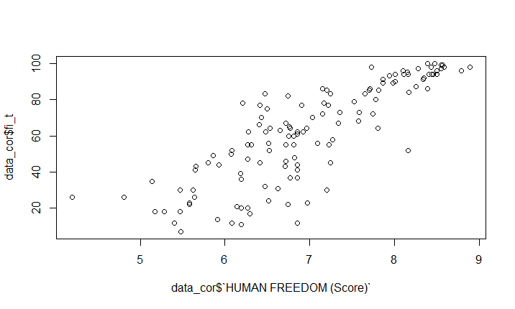

Figure 1: Validation of Economic Freedom Score

Figure 2: Validation of Political Freedom

from Freedom House against our validation data, we see a positive correlation. Running a correlation test gives us a correlation coefficient of 0.833, which again is high and validates our data.

Finally, we look at the correlation between our Happiness Score and Personal Freedom data from Cato. We select the personal freedom data for validation, as a study of the meta data reveals that the factors used to caome up with the Freedom score match closely with those used to formulate the Happiness Score. When we plot the two data (Figure 4), we cannot easily make out the correlation.

Figure 3: Validation of Happiness Score

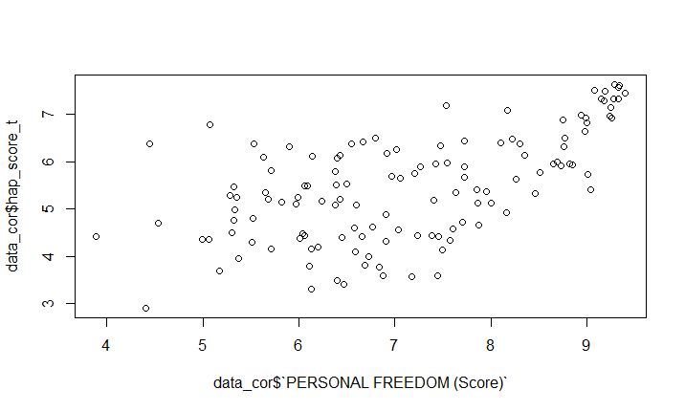

Correlating the two data in R gives us a correlation coefficient of 0.6. This coefficient is not high, hence we do some more research. We look at the methodology of calculating Happiness score and its credibility among researchers. We find that the World Happiness Report is a well-known source of cross-country data and research on self-reported life satisfaction. The underlying source of the happiness scores in the World Happiness Report is the [Gallup World Poll](http://www.gallup.com/services/170945/world-poll.aspx)—a set of nationally representative surveys undertaken in more than 160 countries in over 140 languages. - Our World in Data.[14]

1. **Mathematical Modelling**

**Regression Model**

The general regression equation is as follows:

**Yt = β0 + α1 .Et + α2.Et-1 + α3.Et-2 + β1.Pt + β2.Pt-1 + β3.Pt-2 + ε**

Where, **Y** = Happiness Score

**E** = Economic Score

**P** = Political Freedom Score

Subscript t represents the current year, t-1 represents the previous year and t-2 represents the year before that. We build our model for Happiness Score for the year 2018 (t=2018). We use the

This equation shows all the variables that we will test to see their effect on the Happiness score. We run different iterations by selectively adding and deleting few variables at a time.

**5.1 Base Model**

We select the base model where we regress our dependent variable (Happiness Index) with the independent variables (Political Freedom and Economic Freedom Index) for the same year. We will consider the data for the year 2018. Hence our base model regression equation is:

**Y2018 = β0 + α1 .E2018 + β1.P2018 + ε**

**Base Model Summary**

The p-value for both the factors is small (p-value < 0.05), which means that both the variables are significant at α=0.05. The summary of the model is given in Table 1.

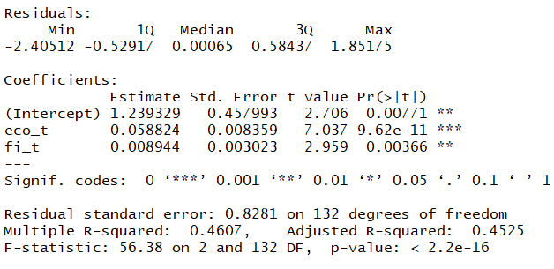

Table 1: Summary for Base Model

**5.2 Iterations**

We modify our base model by adding lagged variables to the equation.

The first iteration (Model 2) considers the effect of both the variables lagged at t-2. The equation is as follows:

**Y2018 = β0 + α1 .E2018 + α2.E2017 + α3.E2016 + β1.P2018 + β2.P2017 + β3.P2016+ε**

The results can be seen in Table 6. When we add all the variables, we find that none of them is significant at α=0.05. Although the model itself is significant and has an adjusted R-squared value of 0.4524.

The results show that adding multiple lagged variables for each measure, when we are considering both the measures is redundant.

We use this insight to develop our next iteration. We only consider the effect of economic freedom for the same year (we do not consider any lagged effect). The equation for iteration 2 (Model 3) is as follows:

**Y2018 = β0 + α1 .E2018 +ε**

The summary for this model can be seen in Table 7. We see that the variable for economic measure becomes significant at α=0.05. The coefficient is positive which implies a positive relationship between the economic freedom score and the happiness score of a country. However, the adj R-sq is 0.4206, which is a drop from the previous iteration that has consisted of all the variables. This implies that the explanatory power of the model has reduced.

We then consider an iteration 3 (Model 4) where we add the lagged (t-1) effect of economic freedom to the Base model. Our regression equation is as follows:

**Y2018 = β0 + α1 .E2018 + α2.E2017 + β1.P2018 + ε**

The summary for this model is given in Table 8. We see that suddenly, the variable Et, which was significant in our base model, becomes insignificant at α=0.05 when we add the lagged variable for economic freedom measure (Et-1), which itself is insignificant. The adjusted R-sq value increases to 0.4557, which is the highest among all the models that we have tested so far. The high explanatory power can be attributed to the inclusion of both the measures.

Finally, we modify our model to consider variables for Economic Freedom score and Political freedom score that have a lag of 1 year. We arrive at this model by building upon insights from our previous iterations. We realized that in order to increase the explanatory power, the model needs to have both the economic freedom score and political freedom score. Additionally, we only consider the measure for 1 year(which in this case is t-1), because if we add variables for multiple years, it only makes our variables insignificant. The equation for Iteration 4 (Model 5) is as follows:

**Y2018 = β0 + α2.E2017 + β2.P2017 + ε**

The model summary for this is given in Table 2. We see that all the variable are significant at α = 0.05. We can also see that the adjusted R-Sq for this model is 0.4598, which is the highest among all the previous regression model

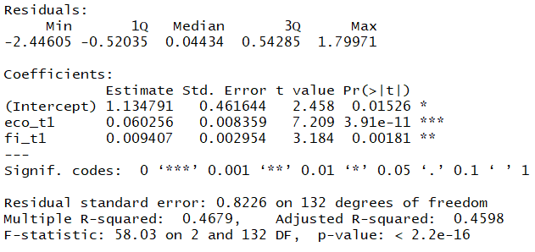

Table 2: Summary for Iteration 4 (Model 5)

1. **Results**

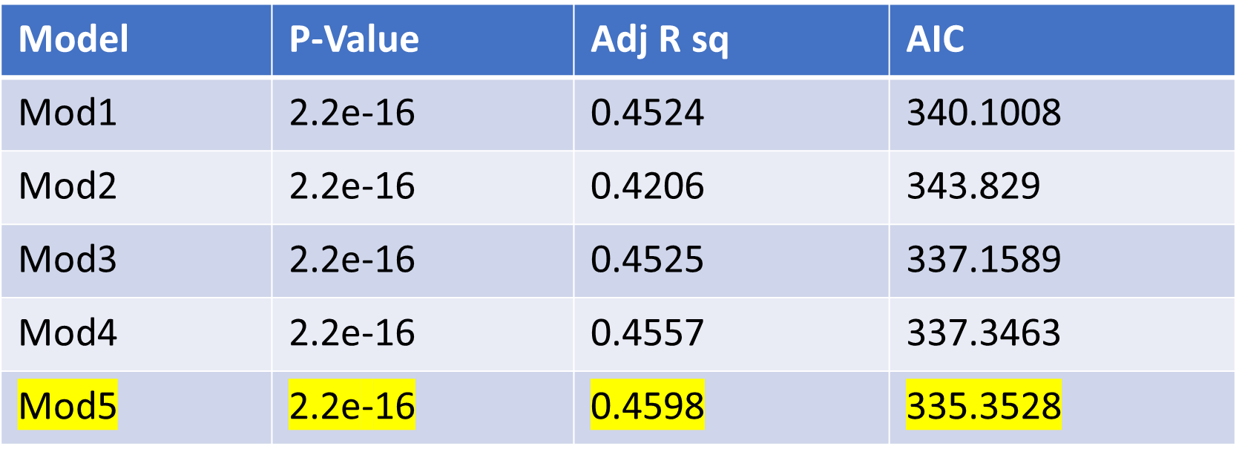

Table 3: Result Summary for all Models

We see that Model 5 (Iteration 4) has the highest Adjusted R-squared and the lowest AIC, hence, of all the models tested, this model explains most of the variation.

The Model is as follows:

**Y2018 = 1.13479 + 0.0602.E2017 + 0.00904.P2017 + ε**

This implies that holding everything else constant (ceteris paribus),an increase of 1 unit of economic freedom results in a corresponding increase of 0.0602 units of the Happiness Score, and ceteris paribus, an increase of 1 unit of political freedom score results in a corresponding increase of 0.00904 units in the Happiness Score.

* 1. **Model Validation**

We realize that the process of iterations incorporated robustness checks as our iterations tested different variables, and for all iterations, we got the Adj R-squatred consistently at around 0.45. Our model can also be validated if it explains a large part of the variation in the Happiness Score for a country. R squared value of 0.45 is good for social science. Hence our model has good explanatory power.

* 1. **Prediction Capability**

After building the regression model, we test the regression coefficients by using them to predict the happiness index for the year of 2017. A similarity in the predicted and the actual index will validate our model. We compare the two by running a two-sample t-test. The t-statistic is 0.18596, which is quite high.

The results of the two tests are as follows:

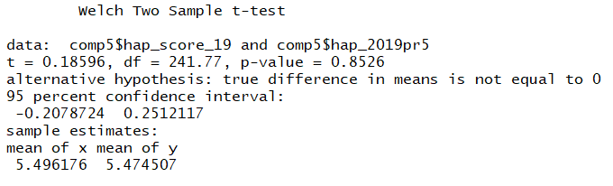

Figure 5

Fig 5. shows the plot of our predicted values against the actual happiness scores. Our model has a centralizing tendency. It underestimates the score at higher happiness scores and overestimates at the lower level.

We see that the model does not have good predictive powers.

1. **Conclusion**

*Our Hypothesis – Happiness Index of a country is directly proportional to economic freedom index and political freedom index.*

*-*All Models have positive coefficients, which implies that there is a positive association between Happiness score, and economic freedom score and political freedom score.

The model that regresses on last year’s economic freedom score and political freedom score has the best fit. This tells us that Happiness can be explained best by the freedoms in the previous year. Another insight that can be drawn is by looking at the coefficients. While the coefficients for economic freedom score is upto second decimal place (0.06), the coefficient for political freedom goes down to third decimal (0.009), which implies that economic freedom affects the Happiness score more than the political freedom score.

We also see that the predictive capabilities of our model are low. As discussed in the earlier section, our model overestimates at lower levels of happiness and underestimates at the higher level. One probable reason for this is that there is a clear divide in the world with countries at two ends of the spectrum. So, when we analyze the data cumulatively, the variations may be balancing out. One way to correct this is to group countries and analyze them separately.

1. **Future Scope**

Future scope involves improving the model by grouping the countries based upon their economic freedom and political freedom. Hence, countries will be divided into 4 groups:

|  |  |  |
| --- | --- | --- |
|  | Low Economic Freedom Score | High Economic Freedom Score |
| Low Political Freedom Score | Group 1 | Group 2 |
| High Political Freedom Score | Group 3 | Group 4 |

Table 4

Our regression model should remain the same i.e.: **Y2018 = β0 + α2.E2017 + β2.P2017 + ε**

However, we can run this model for the 4 groups described above. This should improve the explanatory power as well as the predictive capability of the model.

**Appendix**

**Workflow**

We have detailed the research workflow in figure 1. The first task was to come up with a data management plan. The data management plan is explained in detail in the next section.

We then proceed to validate our data. In order to do that, we correlate our data for each measure (Political freedom, Economic freedom and Happiness Index) with the data for the same measure from other source.

This step is followed by building a regression model and robustness checks.

Figure 6

**Data Management Plan**

Our data management plan was divided into two parts – Data Structure and Storage.

In order to A separate directory for the project is created which is also the working directory for R. Path - C:\Users\harsh\Desktop\Courses\LBJ_Spring19\Database Management\Project\Data_Final_Project.

**i) Storage**

* All downloaded files stored as they were in the directory.
* Store data for 3 years for reproducibility.
* All the data files Directory has a readme file that has details about the data, source and preprocessing.
* All files including the code and readme file is uploaded on Github for version control access.

**ii) Structure**

* All data preprocessing done in R code. The R code is stored as R_Code.R
* Preprocessing done so as to index each score on country name for consistency.
* All data stored in a data frame.
* Except for country names, all data stored as numerical.
* Final dataframe - **dataf** and **data19f**

**Data Dictionary**

|  |  |  |  |  |
| --- | --- | --- | --- | --- |
| **Variable** | **Filename** | **Description** | **Source** | **Type** |
| Country | dataf | Country Name | World Happiness Report | Character |
| hap_score_t | dataf | happiness score for the year 2018 | World Happiness Report | Numeric |
| eco_t | dataf | economic freedom score for the year 2018 | The Heritage Foundation | Numeric |
| eco_t1 | dataf | economic freedom score for the year 2017 | The Heritage Foundation | Numeric |
| eco_t2 | dataf | economic freedom score for the year 2016 | The Heritage Foundation | Numeric |
| fi_t | dataf | political freedom score for year 2018 | Freedom in the World - Freedom House | Numeric |
| fi_t1 | dataf | political freedom score for year 2017 | Freedom in the World - Freedom House | Numeric |
| fi_t2 | dataf | political freedom score for year 2016 | Freedom in the World - Freedom House | Numeric |
|  |  |  |  |  |
| Country | data19f | Country Name | World Happiness Report | Character |
| hap_score_t | data19f | happiness score for the year 2019 | World Happiness Report | Numeric |
| eco_t | data19f | economic freedom score for the year 2019 | The Heritage Foundation | Numeric |
| eco_t1 | data19f | economic freedom score for the year 2018 | The Heritage Foundation | Numeric |
| eco_t2 | data19f | economic freedom score for the year 2017 | The Heritage Foundation | Numeric |
| fi_t | data19f | political freedom score for year 2019 | Freedom in the World - Freedom House | Numeric |
| fi_t1 | data19f | political freedom score for year 2018 | Freedom in the World - Freedom House | Numeric |
| fi_t2 | data19f | political freedom score for year 2017 | Freedom in the World - Freedom House | Numeric |

Table 5

**Model Summaries**

**Iteration 1**

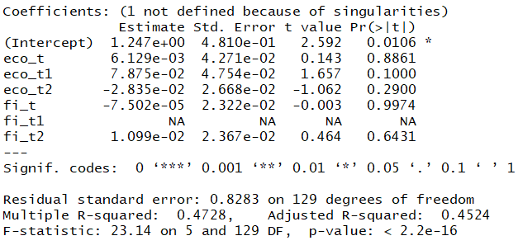

Table 6

**Iteration 2**

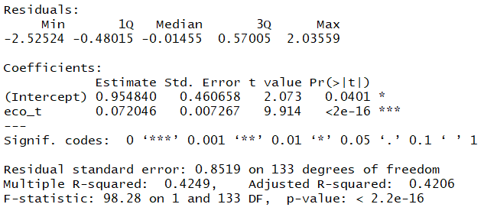

Table 7

**Iteration 3**

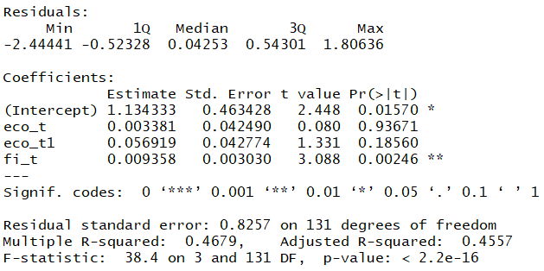

Table 8

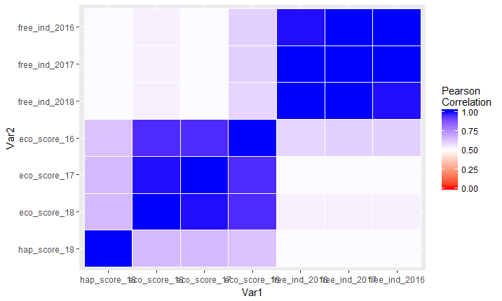

Figure 7: Correlation

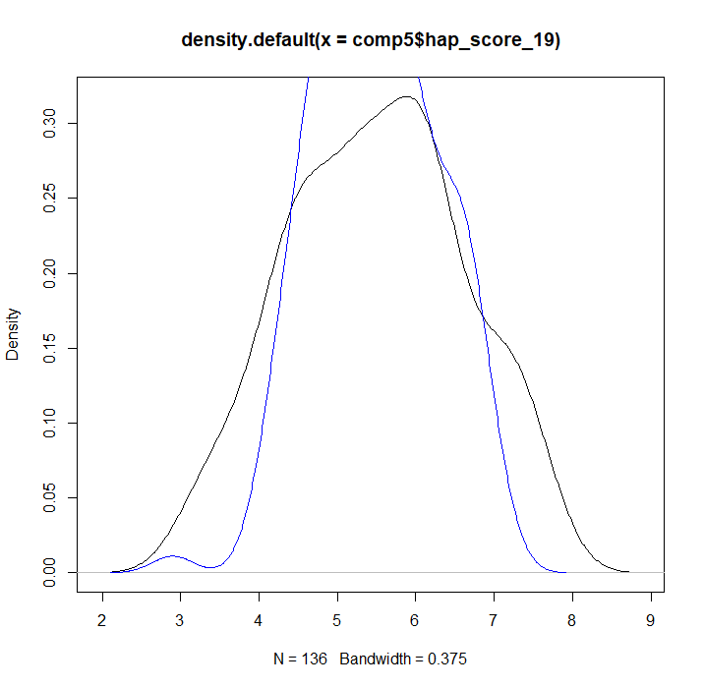

Figure 8: Predicted vs Actual Values

**References**

“2019 Index of Economic Freedom”, The Heritage Foundation, accessed on May 9, 2019, <https://www.heritage.org/index/about>

1. “About Cato”, Cato Institute, accessed on May 8, 2019, <https://www.cato.org/about>
2. “About Freedom House”, Freedom House, accessed May 8, 2019, <https://freedomhouse.org/about-us>

Amartya Kumar Sen, *Development as Freedom* (Oxford: Oxford University Press, 2001)

Blanchflower, David G., and Andrew J. Oswald. *Happiness and the Human development index: the paradox of Australia*. No. w11416. National Bureau of Economic Research, 2005.

Diener, Ed. "Subjective well-being: The science of happiness and a proposal for a national index." *American psychologist*55, no. 1 (2000): 34.

Doucouliagos, Chris, and Mehmet Ali Ulubasoglu. "Economic freedom and economic growth: Does specification make a difference?." *European journal of political economy* 22, no. 1 (2006): 60-81

Friedman, Milton. *Capitalism and freedom*. University of Chicago press, 2009.

Gwartney, James D., and Robert Lawson. *Economic freedom of the world 2001 annual report*. The Fraser Institute, 2001

Helliwell, J., Layard, R., & Sachs, J. (2019). World Happiness Report 2019, New York: Sustainable Development Solutions Network

Ken Farr, W. W.; Lord, R. A.; Wolfenbarger, J. (1998). Economic freedom, political freedom, and economic well-being: causality analysis. *Cato Journal,* 18(2), 247-262

1. Sachs, Jeffrey D., Richard Layard, and John F. Helliwell. *World Happiness Report 2018*. No. id: 12761. 2018.

Sandel, Michael J. *Justice: What's the right thing to do?*. Macmillan, 2010.

1. Veenhoven, Ruut. "Freedom and happiness: A comparative study in forty-four nations in the early 1990s." *Culture and subjective well-being* (2000): 257-288.

1. Friedman, Milton. *Capitalism and freedom*. University of Chicago press, 2009.
2. Amartya Kumar Sen, *Development as Freedom* (Oxford: Oxford University Press, 2001)
3. Diener, Ed. "Subjective well-being: The science of happiness and a proposal for a national index." *American psychologist*55, no. 1 (2000): 34.
4. Blanchflower, David G., and Andrew J. Oswald. *Happiness and the Human development index: the paradox of Australia*. No. w11416. National Bureau of Economic Research, 2005.
5. Gwartney, James D., and Robert Lawson. *Economic freedom of the world 2001 annual report*. The Fraser Institute, 2001
6. Ken Farr, W. W.; Lord, R. A.; Wolfenbarger, J. (1998). Economic freedom, political freedom, and economic well-being: causality analysis. *Cato Journal,* 18(2), 247-262
7. Doucouliagos, Chris, and Mehmet Ali Ulubasoglu. "Economic freedom and economic growth: Does specification make a difference?." *European journal of political economy* 22, no. 1 (2006): 60-81
8. Sandel, Michael J. *Justice: What's the right thing to do?*. Macmillan, 2010.
9. Veenhoven, Ruut. "Freedom and happiness: A comparative study in forty-four nations in the early 1990s." *Culture and subjective well-being* (2000): 257-288.
10. Helliwell, J., Layard, R., & Sachs, J. (2019). World Happiness Report 2019, New York: Sustainable Development Solutions Network
11. “2019 Index of Economic Freedom”, The Heritage Foundation, accessed on May 9, 2019, <https://www.heritage.org/index/about>
12. “About Freedom House”, Freedom House, accessed May 8, 2019, <https://freedomhouse.org/about-us>
13. “About Cato”, Cato Institute, accessed on May 8, 2019, <https://www.cato.org/about>
14. Sachs, Jeffrey D., Richard Layard, and John F. Helliwell. *World Happiness Report 2018*. No. id: 12761. 2018.