**Research Question**

The research question is to explore the correlation between economic freedom of a country and the number of terrorist incidents in that country for the corresponding year.

There is a link drawn between poverty and the tendency of people to indulge in terrorist activities. The rationale behind this is that a person form economically poor background can be easily radicalized into becoming a terrorist. Hence, a country that scores poor on the economic freedom score, will be a hotbed of terrorist activities and will see a large number of terrorist incidents. In this research, we test this hypothesis.

The dependent variable is Number of Terrorist Incidents and independent variable is Economic Freedom Score.

**Data Sets**

The research collects the following independent variables:

1. Economic Freedom Index: Economic Freedom is defined as the ability of an individual to hold labor/property. This dataset consists of the Economic Freedom score for countries in the year 2017.

Source – The Heritage Foundation

Filename – economic_freedom_2017.csv

1. Terrorism Incidents: This is the data on terrorist incidents in every countries. We look at the number of terrorist incidents in a country in the year 2017.

Source – Our World in Data – This website compiles datasets for research purpose. One such dataset was a terrorism dataset.

Filename – terrorist-incidents.csv

The two datasets are merged in a single dataframe that contains Country name, Economic Score and Terrorist incidents. The final dataset is titles **dataf**

**Plot**

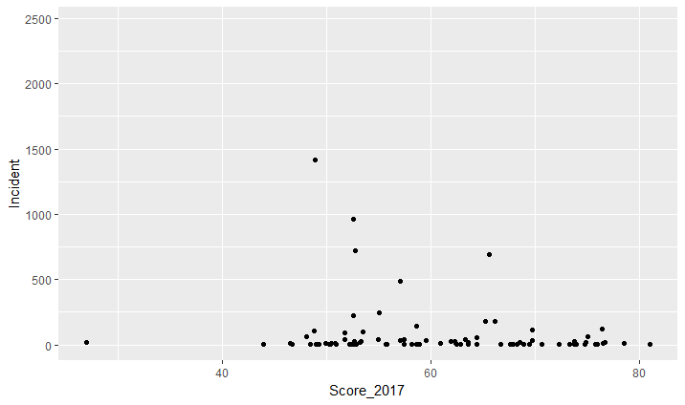

**Regression**

Y = β0 + β1.X

Y = Number of Terrorist Incidents

X = Economic Freedom Score

**Results**

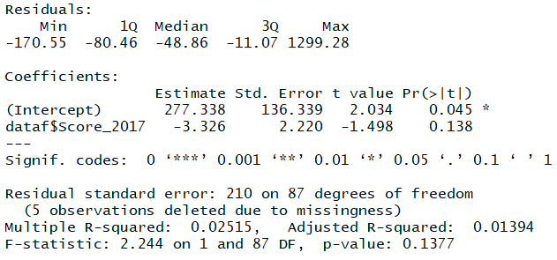

**Conclusion**

The variable economic score is insignificant as p-Value > 0.05. Also the model is insignificant as model p-Value > 0.5.

Hence, We reject our null hypothesis that a country with low economic score will have higher number of terrorist incidents.