Contents
DL 3
1. MLPs: 3
Intuition of NN 3
1.1. Backpropagation 7
1.1.1. What is chain rule? 7
1.1.2. Memorization: 7
1.1.3. Backpropagation 7
1.2. List of Techniques to improve the Neural Network. (notes ss) 9
1.2.1. Hyperparameter Tuning: 9
1.2.2. Solving problems: 11
1.3. Vanishing Gradient: 12
1.3.1. How to recognize 12
1.3.2. Reduce Vanishing Gradient 12
1.4. Early Stopping: 13
1.5. Feature scaling 14
1.6. Drop Out Layers 15
1.7. Regularization: 17
1.8. Activation Functions: 18
Ideal Activation function: 18
1.8.1. Sigmoid: 19
1.9. Weight Initialization: 25
1.10. Batch Normalization: 31
1.11. Optimizers 34
1.12. KERAS Tuner: 45
2. CNN 46
2.1. Why not use ANN on Image Data 46
2.2. Resemblance with Human brain image recognition: 46
2.3. convolutional operation. 47
2.4. Padding and Strides: 49
2.5. Pooling 50
2.6. Backpropagation in CNN: 54
2.7. What does CNN see? 56
2.8. Transfer learning? 57
3. RNN: Recurrent Neural Network 59
- Simple Flow 59
- Why It Understands Sequence 59

DL
Overlapping content:
Types of the NN / ANN:
- FNN (Feed forward neural network) Multilayer perceptron (MLP):
- CNN
- RNN
- GAN
- AUTO-ENCODERS
- TRANSFORMERS

MLPs:

Intuition of NN
Perceptron takes the multiple inputs, each input is taken in certain proportion, decided by the weights (Trained by the backpropagation). Multiple perceptron like this a layer and each layer has many of this, each neurons takes all the inputs, (for first layer these are real inputs), onwards the inputs are outputs of the previous layer in similar manner of proportionate decided by weights. This structure helps understand the complex, non-linear patterns. (better this intuitive understanding).
- Weights determine the influence or importance of each input feature on the output. By adjusting weights, the perceptron learns which features are most relevant for classification, allowing it to orient the decision boundary (the separating line or hyperplane) in the input space.
- Bias allows the perceptron to shift the decision boundary away from the origin. Without a bias, the perceptron could only create boundaries that pass through the origin, limiting the kinds of patterns it can learn. The bias enables the model to fit data where the optimal separation does not go through the origin, increasing its representational power a nd flexibility
What is the intuition of the perceptron trick?
The perceptron trick starts by randomly assigning some values to the weights and biases. The algorithm then goes through each object and checks if it is classified correctly based on the current weights and biases... If it is misclassified, it adjusts the weights and biases in a way that moves the decision boundary closer to the misclassified object.
Multiple loss function can be used in the perceptron, though traditionally uses perceptron loss for binary classification problem.
Perceptron Loss vs. Hinge Loss
Perceptron Loss:
Penalizes only misclassified points.
No margin: correctly classified points have zero loss, no matter how close they are to the decision boundary.
Hinge Loss:
Penalizes both misclassified points and correctly classified points that are close to the boundary (within a margin).
The margin encourages confident, well-separated classifications.

Key Difference:
Hinge loss adds a margin, making the model prefer not just to correct, but also confident classifications. Perceptron loss only cares about whether points are classified correctly, not how confidently.
Main drawback of the perceptron is inability to work on the non-linear data (XOR).
What is XOR function? when both the inputs are same return 0 else return 1.
Multiple layers vs number of neurons?
Having more neurons in a single layer allows a neural network to learn many features at one level of abstraction, but it struggles to efficiently represent complex, hierarchical patterns and may require an impractically large number of neurons for difficult tasks. In contrast, using multiple layers with fewer neurons each enables the network to build hierarchical representations, efficiently combining simpler features into more complex ones, which leads to better generalization and performance on real-world problems. Thus, while both approaches can theoretically approximate complex functions, multilayer networks are generally more effective and practical for most deep learning applications.
In some cases, especially in regression tasks, the same formula—like MSE—can be used both as the loss function during training and as the evaluation metric after training. This means the model is optimized to minimize MSE, and performance is also reported using MSE. However, in most other cases (such as classification), the loss function and evaluation metric are different: the loss guides model training, while the metric (like accuracy) simply measures performance. So, while they can be the same in specific scenarios, they usually serve separate purposes.
MSE Advantages:
- Highly sensitive to outliers: Outliers can disproportionately increase the loss and skew model training.
- Large errors penalized more: Squaring errors means big mistakes have a much greater impact than small ones.
- Units are squared: The loss is in squared units, making interpretation less intuitive.
- No error direction insight: Only measures error magnitude, not whether predictions are too high or too low.
- Assumes normal error distribution: May not reflect performance well if errors are not normally distributed.
- Can encourage overfitting: Model may be overfit to outliers due to their large influence on the loss.
- Scale-dependent: Not directly comparable across datasets with different scales.
MSE disadvantages:
- Highly sensitive to outliers: Large errors are penalized much more than small ones, which can skew training.
- Units are squared: The loss is in squared units, making interpretation less intuitive.
- No error direction insight: Only measures error magnitude, not whether predictions are too high or low.
- Assumes normal error distribution: May not reflect performance well if errors are not normally distributed.
- Can encourage overfitting: Outliers can dominate the loss, leading the model to fit them excessively.
- Scale-dependent: Not directly comparable across datasets with different scales.
Advantages of MAE:
- Simple and intuitive: Easy to understand and interpret, with error in the same units as the data.
- Robust to outliers: Less sensitive to outliers compared to MSE, so extreme values do not overly influence the metric.
- Treats all errors equally: Every error, large or small, is weighted the same, providing a neutral measure of model performance.
Disadvantages of MAE:
- Not differentiable at zero: The absolute value function is not differentiable at zero, which can complicate optimization for some algorithms.
- All errors treated equally: Does not penalize large errors more than small ones, which may be undesirable if large errors are especially problematic.
- Less sensitive to error magnitude: May not be ideal when it is important to prioritize reducing larger errors.
Huber loss?
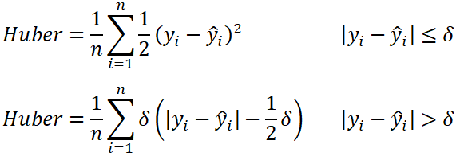
Delta (δ) in Huber Loss is the threshold that decides when to switch from quadratic (MSE-like) to linear (MAE-like) behaviour.
δ = 1.0 # Good start for most cases.
δ = 0.1-0.5 # More MAE-like (heavy outliers) .
δ = 1.5-2.0 # More MSE-like (clean data).
Above delta MAE, below delta MSE.
The subtraction and multiplication by delta in the Huber loss formula ensure the loss function is smooth and continuous at the transition point between the quadratic (MSE-like) and linear (MAE-like) regions, so the penalty changes seamlessly and the optimization remains stable.
Mean Squared Error (MSE) and Mean Absolute Error (MAE) are both popular metrics for evaluating regression models, but they differ in how they treat errors: MSE squares the differences between predicted and actual values, which means it penalizes larger errors much more heavily and makes the model focus on reducing big mistakes, while also providing a smooth, differentiable surface for optimization. In contrast, MAE takes the average of the absolute differences, treating all errors equally regardless of size, making it less sensitive to outliers and ensuring that small and large errors are prioritized at the same level. As a result, MSE is useful when you want to discourage large errors and can tolerate sensitivity to outliers, whereas MAE is preferred when you want a robust, straightforward measure of average error that is not disproportionately influenced by outliers.
MSE is valuable because it prioritizes reducing large errors, but its sensitivity means that outliers can have a disproportionately large impact on model training and evaluation. Therefore, when using MSE, it is very important to perform outlier detection and data cleaning beforehand. This ensures that the model’s performance is not dominated or distorted by a few extreme values, allowing MSE to serve its purpose of minimizing significant prediction errors without being misled by anomalies or noise in the data
If there are a few points with huge errors that are not outliers but genuine, important data points, then using MSE is justified and even desirable. MSE is designed to heavily penalize large errors, so it will push the model to fit these high-error points more closely, ensuring that significant deviations are minimized. This is especially important in applications where large mistakes on genuine data are costly or critical to avoid. The key issue with MSE arises only when those high-error points are outliers or noise; in that case, they can distort the model unnecessarily. But if the points with large errors are valid and meaningful, MSE’s sensitivity helps ensure the model pays extra attention to them, which is often exactly what you want.
Till Gradient descent in Notebook Notes,

Backpropagation

What is chain rule?
The chain rule is a fundamental concept in calculus that allows us to compute the derivative of composite functions—functions made by applying one function to the result of another, like f(g(x)). Intuitively, it tells us how a change in the innermost variable (like x) propagates through each layer of functions to affect the final output. You can visualize this process with the analogy of interconnected gears: imagine x turning the first gear, which in turn rotates a second gear u=g(x), and that gear then drives a third gear y=f(u). The overall effect of turning the first gear on the last is the product of the effects at each step—just as chain rule multiplies the derivatives at each stage. In essence, the chain rule lets us break down and “chain” together the rates of change through each function, so for y=f(g(x)), the derivative is f′(g(x)) ⋅g′(x), capturing how changes ripple through the composition.
let's suppose from one parameter let's say one weight if there 100 different paths which you came across then in that case you, calculate these 100 derivatives sum them multiply the sum with learning rate and subtract from the original values.
Unit balance in Gradient descent formula?
And why not normal maximization principle?
Forward Propagation:
Weights matrix in forward propagation is not the transpose matrix but the normal weight matrix with the shape as (current layer nodes, previous layer nodes). And model.get_weights () return list with arrays as elements with each element.
Loss functions also in notes and mostly same as ML.

Memorization:
A technique in which we use storage to reduce the computation. i.e. a repetitive calculation is stored and called on instead of calculating again, which makes the computation fast on cost of storage.

Backpropagation
Ultimately it is using the gradient descent techniques fundamental principle to calculate the optimized value of that variable or weight in this case just the difference is, the gradient or derivatives are partial chain ones as the function is partial composite function (loss function is the differential function in this case).
Neural networks are optimized (i.e. weights are find out) by gradient descent, but in Neural networks to calculate the differentiation of the weights/independent variables is difficult due to composite partial function dependency with loss function so we use backpropagation in there with memorization, and once the differentiation is calculated we can calculate the new weight value by gradient descent and update the values and everything runs in loop till we converge approximately, is it correct ? so backpropagation is a part of the gradient descent to calculate the derivatives(change with respect to loss) nothing else

How weights are calculated?
So, for one datapoints forward propagation is done, loss is calculated and based of this loss and its gradient with respect to each weight all the weights are updated by back propagation and for second datapoint same process is done but with new weights,

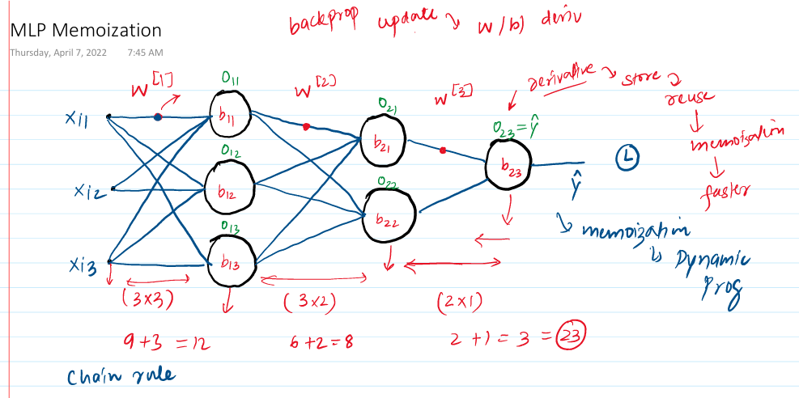

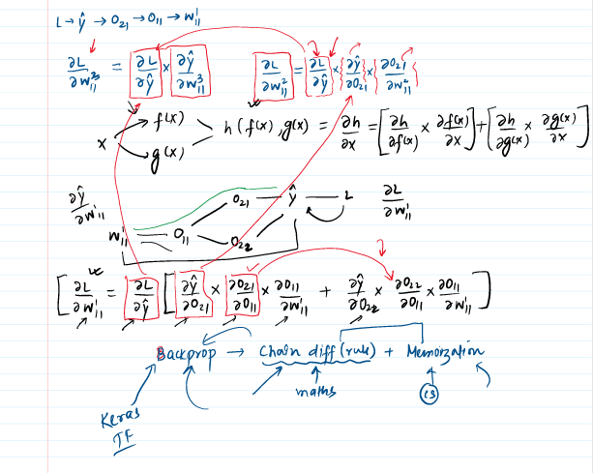
For last layer this is the chain rule (always remember/buy hurt this so that you have the intuition in mind all the time)
(del L / del Pred) * (del Pred / del Output) * (del Output / del weight)
↓ ↓ ↓
(∂L/∂a²) (∂a²/∂z²) (∂z²/∂W²)

Gradient Descent same as ML, only the gradient is calculated by chain rule.
Vanishing Gradient in notes and Colab.

1.2. List of Techniques to improve the Neural Network. (notes ss)

1.2.1. Hyperparameter Tuning:
  - No. of hidden layer: The no. of hidden layers significantly decides how complex patterns are derived from the data. It is preferable to have higher no. of hidden layers compared to the more neurons in the lower no. of hidden layers (two ways to extract complexities either increase the higher no. of neurons or increase the no. of hidden layers). Cause the having more no. of hidden layers helps in a way where initial layers prick the more outline structure of the data, and the deeper layers extract the more intricate and detailed aspect of the data.
The same concept comes very handy in transfer learning, where pre-trained model on generalized data is used after fine tuning on the specific data which extract the fine/specific patterns of the data.
  - No. of Neurons: Input and output nodes are fixed depending on the input and output whereas hidden layer’s nodes are initially supposed to be following the pyramid structure, but that is not the mandatory. No. of neurons are supposed to be sufficient, and you stop adding more neurons when model starts overfitting.
  - Batch size: Two approaches, first one is small batch size more computation with good accuracy always and second one larger batch size with techniques to improve accuracy, but it takes smaller computation and time.
- Gradients from all data points in the batch are averaged together.
- WNEW = WOLD – η × average_gradient
- For smaller batch size it usually taken as 8-32, will take more time but will be accurate, should be used if the other one does not give good accuracy.
- Larger batch (8192) which does not give you high accuracy directly but computationally efficient and accuracy can be increased with a technique called as warming up of learning rate where the learning rate is increased towards the later epochs and initially kept low. Learning rate scheduler is needed.
  - Epochs: You start with any high epoch value but make sure to use early stopping with callback which stops the training after an epoch where there is no significant improvement in model accuracy.
  - Learning rate:
- Learning rate warmup: technically you need to have high learning rate at the start and then decrease that gradually, wherein the high learning rate is not desirable at the very very start due to random initialization of the weights so, learning rate is kept small the start then increase over the first few starting epochs and then the very important normal progression of decaying of learning rate happens, so, learning rate's typical progression is as such which is start very low then warms to high value and then start a usual decay and reduces to lower value. This helps stabilize training by preventing large, erratic updates early on, especially in deep or complex models, and leads to more reliable and effective learning.
Apart from learning rate warmup, several other important aspects and techniques are involved in managing the learning rate during neural network training:
- Learning Rate Decay: Gradually reducing the learning rate over time helps the model converge more smoothly and avoid oscillations near minima. Common decay methods include:
  - Step Decay: Reduce learning rate by a fixed factor after certain epochs.
  - Exponential Decay: Learning rate decreases exponentially.
  - Polynomial Decay: Learning rate decreases following a polynomial function.
  - Inverse Time Decay: Learning rate reduces inversely with time. It decreases the learning rate inversely proportional to the number of training steps or epochs, allowing the model to take larger steps earlier in training and smaller, more precise steps later.
- Adaptive Learning Rates: Optimizers like Adam, RMSprop, and Adagrad adjust learning rates per parameter based on gradient statistics, dynamically tuning the step sizes during training.
- Cyclical Learning Rates: The learning rate cyclically varies between minimum and maximum bounds, which can help escape local minima and improve generalization.
- Learning Rate Schedules: These are pre-defined or dynamic rules that change learning rates during training, sometimes based on validation performance (e.g., ReduceLROnPlateau lowers learning rate when a metric plateaus).
- Batch Size Interaction: Sometimes learning rate is adjusted relative to batch size; larger batches often require adjusting learning rate schedules.
In sum, managing the learning rate involves starting with a careful initial value (sometimes warmed up), applying decay, using adaptive optimizers, or cycling strategies to optimize the training dynamics and convergence of neural networks efficiently.
- Optimizer
- Activation function: During vanishing gradient.

Solving problems:
  - Vanishing / Exploding problems.
- Weight initialization:
- Activation function
- Gradient normalization
- Clipping
  - Not enough data:
- Transfer Learning
- Unsupervised pre-training
  - Slow training:
- Optimizer
- Learning rate scheduler
  - Overfitting:
- L1 and L2 regularization
- Drop out lay
- Early stopping

Vanishing Gradient:
- When the partial derivative of gradient is less than 1, particularly for deep neural network in that case the multiplication of those gradient becomes very low value as those gradients are interdependent for deep layers and calculated using chain rule. i.e. 0.1 * 0.1 * 0.1 turns out to be very low value and eventually gets low gradient value which ultimately gets very low change in new weights and basically no updatation happens. And that is what refer as gradient is vanishing.
- Happens particularly for sigmoid and tanh activation functions.

How to recognize
- Loss function
- on changes: while training an algorithm if don't see changes or decrement in the loss function as the training happens then it means there is vanishing gradient as weights are not getting updated.
- value of weights itself, can be checked during the training and if change is constant then that is slam dunk case of the vanishing gradient.

1.3.2. Reduce Vanishing Gradient
  - Shallow Neural Network:
  - Changing activation function:
ReLU and variants (Leaky ReLU, GELU) have derivatives of 1 for positive inputs, avoiding the saturation problem of sigmoid/tanh where gradients shrink to near-zero and multiply to nothing through deep layer
  - Proper weight initialization (Xavier or He initialization):
Xavier/He initialization sets initial weights so activation variances stay roughly constant across layers, preventing gradients from vanishing due to repeated multiplication by tiny or huge values.
  - Batch normalization:
BatchNorm/LayerNorm keeps activations in a stable range (mean 0, std 1), preventing them from exploding to saturation or shrinking to zero, which stabilizes gradient magnitudes during backprop
  - Residual Network (CNN-Resnet):
Skip connections xl+1=F(xl)+xl let gradients flow directly through the identity path (gradient=1), bypassing multiplication through many layers that would otherwise shrink them exponentially. residual connections "skip" layers by creating a direct path from input to output.

  - Early Stopping: Early stopping is a regularization technique that stops neural network training when the validation loss stops improving, preventing overfitting. During training, if the validation loss doesn’t improve for a set number of epochs (called patience), training halts and the model optionally restores the best weights. It helps save time and ensures optimal performance without manual tuning of epochs.

Why do we observe the validation loss in deep learning while training the actual model?
- Overfitting Detection
Validation loss reveals overfitting when training loss keeps decreasing but validation loss starts increasing, showing the model is memorizing training data instead of learning general patterns.
- Early Stopping
Validation loss guides early stopping by identifying the epoch with minimum validation loss, allowing you to save the best model before continued training degrades generalization.
- Hyperparameter Guidance
Validation loss monitors hyperparameter health—oscillating validation loss indicates too-high learning rate, both losses staying high shows underfitting (need bigger model), providing real-time feedback during training.

  - Feature scaling: Like ML.
If you don’t normalize or scale features in a neural network, features with larger values dominate weight updates, causing uneven learning. This can make gradient descent slow or unstable, create elongated loss surfaces, and push activation functions like sigmoid or tanh into saturation, leading to vanishing gradients. As a result, the network may converge very slowly, get stuck in suboptimal solutions, or ignore smaller-scale features, reducing overall performance.

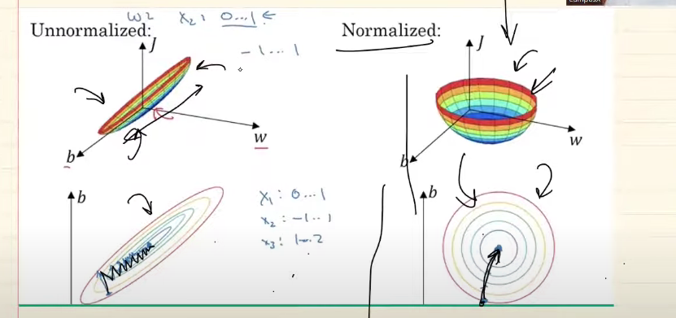

Normalization particularly when the max min ranges are known as marks, CGPA etc. else standardization especially when the feature is leaning towards the normal distribution.
- Normalizing inputs.
- Batch Normalization.
- Normalizing Activation.

  - Drop Out Layers. (Screen shot).
To improve the over fitting of the neural networks we use different techniques like,
- More Data.
- Reduce complexity. (Reducing the no. of parameters).
- Early stopping.
- Regularization.
- Drop out.
- Dropouts: reduces the no. of nodes which intern reduces the overfitting because it reduces the connection and complexity and parameters. And secondly, by drop outing nodes randomly for each epoch NN does over rely on single pattern or does not give more importance to few certain weights only, rather it gets more generalized with no special importance given to any weight/pattern.
- During training with dropout, a random subset of neurons is temporarily deactivated for each batch, meaning their outputs are set to zero and their weight going out of the neurons are not updated whereas the weights coming to the neuron are updated—outgoing weights remain unchanged until the neuron is active again in a future batch. This can very be seen by forward or backward propagation as ouput * weight becomes zero, making the independent things zero or the entire forward propagation as constant. This random deactivation prevents the network from relying too heavily on specific neurons, encouraging it to learn more robust and generalized features, which helps reduce overfitting. During inference, all neurons are active, and no dropout is applied, ensuring the full network contributes to predictions.
- Technique is you usually randomly disconnects the specific no. of neurons each epoch from each layer which improves the accuracy up to 2%, statistically seen.
- How the drop out layer in NN are like the random forest. Like random forest ensemble learning where multiple DT are aggregated to predict similar input just like that multiple NN are trained/created each epoch with different node combinations and at the end sort of aggregation is done while testing/ predicting by taking the (1-p) portion of the weight value. i.e. (1-p) probability of that weight being available for training for all the epochs.
- P = drop out probability/Ratio.
- The dropout rate is typically specified per layer, not for the entire neural network as a whole.
- During prediction, dropout is not applied—all neurons are active, and the weights remain unchanged. To ensure consistency with training, the outputs of each neuron are scaled by the keep probability (e.g., 0.8 if the dropout rate was 0.2). This adjustment matches the expected output levels seen during training, ensuring reliable predictions without altering the learned weights.
- During training with dropout in deep learning, a random subset of neurons is deactivated (their outputs set to zero) in each batch, which means those neurons do not participate in the forward or backward pass for that batch and their associated weights are not updated. This randomness prevents the network from relying too much on specific neurons, promoting redundancy and helping the model generalize better to unseen data by reducing overfitting. During testing or inference, dropout is turned off—all neurons are active—so to maintain consistency with the training phase, outputs of the neurons are handled in either one of two ways,
Both dropout variants randomly deactivate neurons during training to prevent overfitting, but they handle scaling differently to ensure consistent output magnitudes between training and inference.
    - Original Dropout (From the 2014 Srivastava Paper)
During training, neurons are dropped with probability p (e.g., p=0.5 means 50% are set to zero), and no scaling is applied to the remaining activations. This causes the layer's output to be smaller on average since fewer neurons contribute. At inference time, dropout is turned off (all neurons active), but outputs are scaled down by (1-p) to match the reduced scale from training. For example, with p=0.5, inference outputs are multiplied by 0.5. This requires explicit scaling code at test time, which can lead to errors if forgotten.
    - Inverted Dropout (Standard in PyTorch, TensorFlow, etc.)
During training, dropped neurons are set to zero, but the kept neurons' outputs are immediately scaled up by 1/(1-p) (e.g., ×2 for p=0.5). This preserves the expected output magnitude as if no dropout occurred. At inference, dropout is disabled (all neurons active), and no scaling is needed—the network's outputs are already calibrated. Frameworks handle this automatically via train/eval modes, making it simpler and less error-prone.
Key Comparison Table
Phase/Aspect | Original Dropout | Inverted Dropout (Modern)
Training | Drop p%, kept ×1 (output shrinks) | Drop p%, kept ×1/(1-p) (scale preserved)
Inference | All active, ×(1-p) | All active, ×1 (no scaling)
Pros/Cons | Conceptually simple, but inference scaling often buggy | Easier to implement correctly
Inverted dropout is the default today because it avoids manual inference adjustments while maintaining mathematical equivalence.
Practical Tips and tricks:
1. If overfitting then increased p and if there is underfitting then decrease p.
2. Start with application of dropouts after the last layer. (Last layer extract more intricate and details patterns and causes overfitting so to reduce that overfitting).
3. CNN- 40 - 50% P.
4. RNN – 20-30% P.
5. ANN – 10-50% P.
Drawbacks of dropdown layers:
- Delayed convergence. As we sort of use less nodes each epoch it results into delayed convergence of the weights.
- Notes.

Regularization:
- With increase in the no. of neurons model ability of capture the complex relationship increases but at the same time it’s tendency to overfitting increases as well.
- To reduce the overfitting, the effect of the nodes which are causing the overfitting is reduced by diminishing their magnitude value, which makes sure that it helps in capturing the complex average pattern with those diminishing values but does not capture the details of those complex deep patterns in details as we reduce the values of those weights.
Ways to solve overfitting:
- More data.
- Data Augmentation (mainly in CNN, image data).
- Drop out layers.
- Early Stopping.
- Regularization.
There are their ways of regularization:
- L1:
Add SS from Note,
Basically, in L1, a sum of all the weights is added in the loss function and alpha proportionate value of it taken after dividing it with no. of rows.
Means, you add some proportionate sum of the weight which increase the loss function and ultimately reduces the weights can also make them zero in some cases when first and second term at numerator becomes equal in magnitude.
Penalty term is L1 norm. Sparse model in L1 norm.

- L2: Mostly used and same as L1 Except instead of normal sum, sum of the square of the weights is done. Which tends to make the weights go towards zero.
Intuition of how increase the loss makes the weight zero, from notes, but main intuition is backpropagation when we you increase the L without much change in “w” i.e. denominator the minus term becomes bigger and new “w” becomes smaller. Weight decay.
Penalty term is L2 norm. No sparse model in L2 norm.
- L1 + L2:

Activation Functions:
Activation functions in neural networks introduce crucial non-linearity by transforming the linear weighted sum of inputs and biases into a non-linear output. This non-linear transformation enables the network to learn and represent complex patterns and relationships in data, which linear transformations alone cannot capture. Without activation functions, stacking layers would simply result in another linear function, severely limiting the network's ability to model real-world, non-linear problems. By bending and squashing the input space (e.g., via sigmoid or ReLU), activation functions allow neural networks to form complex, curved decision boundaries and approximate a wide range of functions. This non-linearity also facilitates effective gradient-based learning through backpropagation, ensuring that complex hierarchical features can be learned across deep architectures. Thus, activation functions are essential for the power and flexibility of modern deep learning models
Add the screenshot from activation function, 3:27
Screenshot 10:17
Proof from notes which is the final equation of the output comes after which does not have any degree terms involved if linear activation is used which makes it impossible to capture the non-linear relationships in the data.

Ideal Activation function:
- Non-linearity: Activation functions must be non-linear to allow neural networks to learn complex patterns. Without non-linearity, stacking multiple layers would be equivalent to a single linear transformation, limiting the network’s capacity to model real-world, non-linear relationships.
- Differentiability: Activation functions need to be differentiable because training relies on gradient descent, which updates weights based on the derivative of the loss function with respect to the weights. Differentiability ensures gradients can be computed and propagated back through layers for learning.
- Computational Efficiency: Since activation functions are applied at every neuron in every layer, they should be computationally inexpensive. Functions like ReLU are fast to compute, which speeds up training and enables scaling to large networks.
- Zero-centered Outputs: Activation functions that output values centered around zero (like tanh, which outputs between -1 and 1) help stabilize and accelerate training by preventing biases in the gradients and keeping the learning balanced across layers.
- Non-saturating: A non-saturating activation does not have regions where its gradient approaches zero (flat or plateau regions). Saturating functions like sigmoid or tanh have gradients close to zero at very high or low inputs, causing the vanishing gradient problem that slows or stops learning in deep networks. Non-saturating functions like ReLU maintain a constant gradient for positive inputs, preventing gradients from vanishing and allowing effective learning even in very deep architectures.

Different activation functions:

Sigmoid:
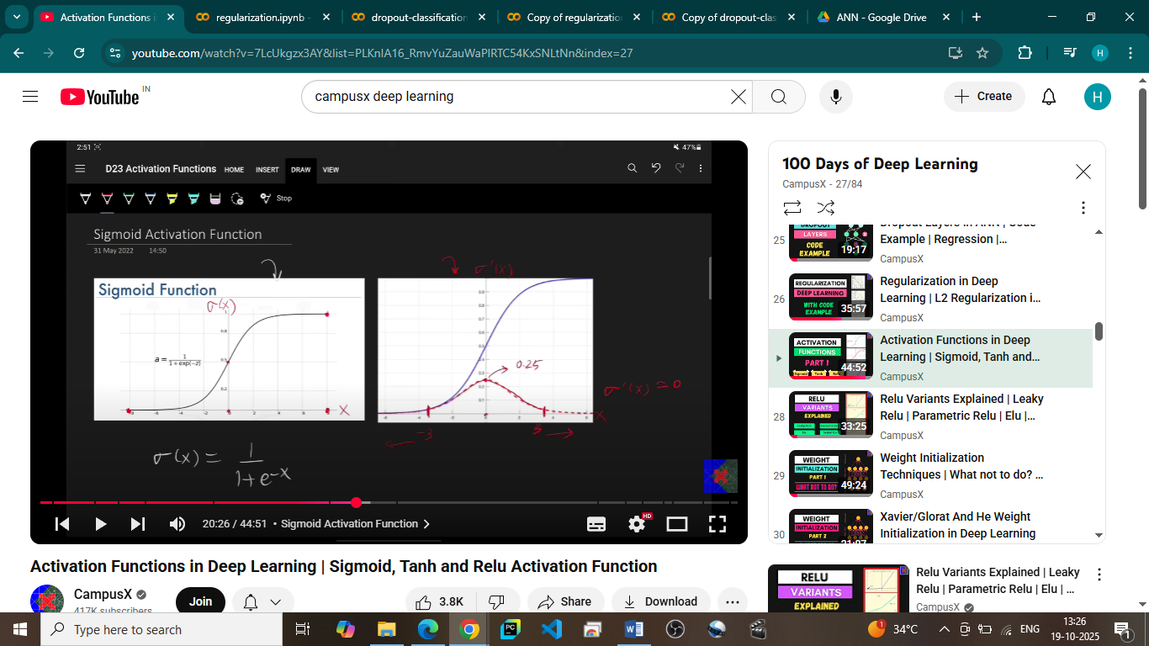
Sigmoid Activation Function in Deep Learning
The sigmoid activation function is a widely used nonlinear function in neural networks, especially for binary classification tasks.
This function smoothly maps any real-valued input into a value between 0 and 1, forming an S-shaped curve. This makes sigmoid outputs interpretable as probabilities, useful for tasks like classifying data into two classes (e.g., spam or not spam).
Why is Sigmoid Useful?
- Introduces non-linearity: By transforming the weighted sum of inputs in a nonlinear way, sigmoid allows networks to learn complex, non-linear decision boundaries instead of just linear ones.
- Differentiable and Monotonic: Sigmoid is differentiable everywhere with a simple derivative related to its output, which simplifies gradient calculations during backpropagation.
- Smooth gradient: Its smoothness helps provide meaningful gradients for moderate input values, enhancing learning.
Typical Use Cases
- Binary classification problems where outputs represent probabilities.
- Tasks like sentiment analysis, fraud detection, and risk assessment.
Limitations of Sigmoid
- Vanishing gradient problem (saturating function): For very high or low inputs (greater than +3 or less than -3), the sigmoid saturates near 1 or 0, and its gradient approaches zero. This slows down or stops training of earlier layers in deep networks. This is why we never used sigmoid in hidden layers only used in outer layers when in case of classification binary problems.
- Output not zero-centred: Sigmoid outputs range from 0 to 1, causing all activations to be positive, which can slow convergence during training.
Non-zero-centered outputs problems
When activations are all positive instead of zero-centered, gradients become biased in one direction causing slower convergence, gradient distributions get skewed and ill-conditioned requiring smaller learning rates for stability, and downstream layers receive constant offset-like inputs they must compensate for with biases/weights, making deep network training progressively harder as bias accumulates through layers.

    - Tanh activation function:
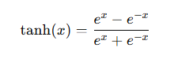

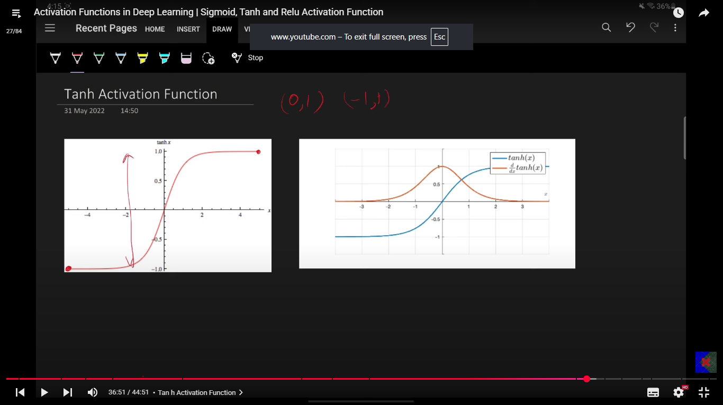

The tanh (hyperbolic tangent) activation function maps inputs to a range of [-1, 1] and is zero-centered, making it more balanced for weight updates compared to sigmoid. Its derivative is 1−tanh⁡2(x)1 - \tanh^2(x)1−tanh2(x), which allows gradient-based optimization.
It is commonly used in hidden layers, especially in RNNs and LSTMs, because it handles positive and negative inputs symmetrically. However, it can suffer from vanishing gradients for very large or small inputs, which can slow learning in deep networks.
The advantages of tanh are that it is zero-centered, which helps balance positive and negative activations, it is smooth and differentiable, making it suitable for gradient-based optimization, and it handles both positive and negative inputs symmetrically, improving learning in hidden layers. The disadvantages are that it can suffer from the vanishing gradient problem for very large or very small inputs, slowing down training in deep networks, and it is computationally slightly more expensive than simpler activations like ReLU, making it less ideal for very deep architectures.
The use cases of tanh include hidden layers of shallow to moderately deep neural networks where zero-centered outputs help balanced learning, and recurrent neural networks (RNNs) or LSTMs, where it is used to regulate hidden state updates. It is also suitable in situations where the output needs to be in the [-1, 1] range, but it is rarely used in very deep networks or output layers where ReLU or other activations are preferred.

    - RELU(Rectified Linear Unit):
ReLU(x)=max(0,x)
ReLU is computationally efficient, avoids the vanishing gradient problem for positive inputs, allows faster and deeper network training, and introduces sparsity since negative activations become zero, which can improve efficiency.
ReLU can suffer from the “dying ReLU” problem, where neurons get stuck outputting zero and stop learning if they only receive negative inputs. It is also not zero-centered, which can sometimes cause imbalance in weight updates.
ReLU is widely used in hidden layers of deep networks, especially CNNs, because it enables efficient training and mitigates vanishing gradients. Variants like Leaky ReLU, Parametric ReLU, and GELU are often used to address the dying ReLU problem.
RELU variants:
Dying RELU problem:
When the neurons output is zero, it is called as dead neuron and once a neuron is dead it always stays dead. And dead neuron is of no use to us, as it won’t ever update the weights, as the backpropogation is not possible in this case explain below.
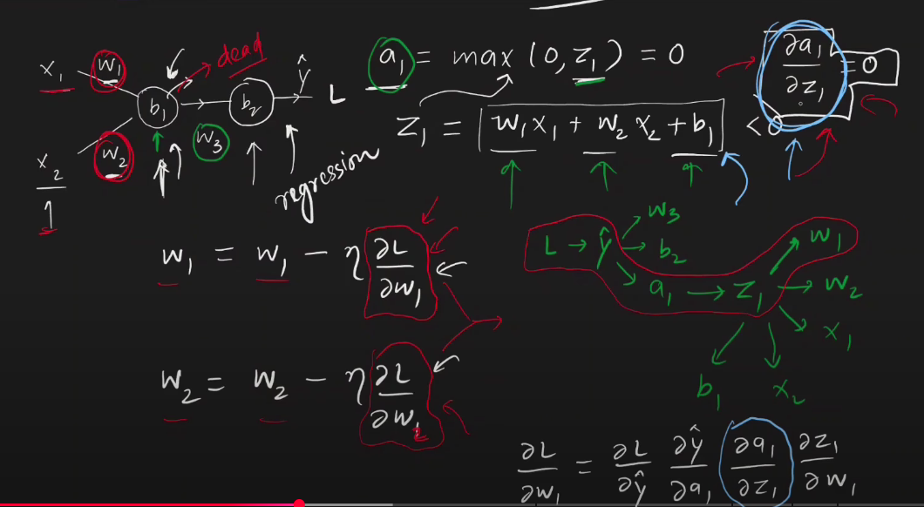
But what could be the reason for first output to be zero/negative, it could be due to high learning rate as cause of high learning rate we might have the weights become negative update updation and second reason could be the bias value could have been set to negative initially, and even the feature inputs are normalized so their values also don’t affect too much, meaning the output of the neuron won’t be made positive by this.
Solutions:
- Low learning rate
- Positive bias value
- Don’t use RELU

Variant of RELU:
    - Leaky RELU:
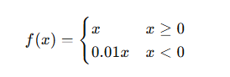

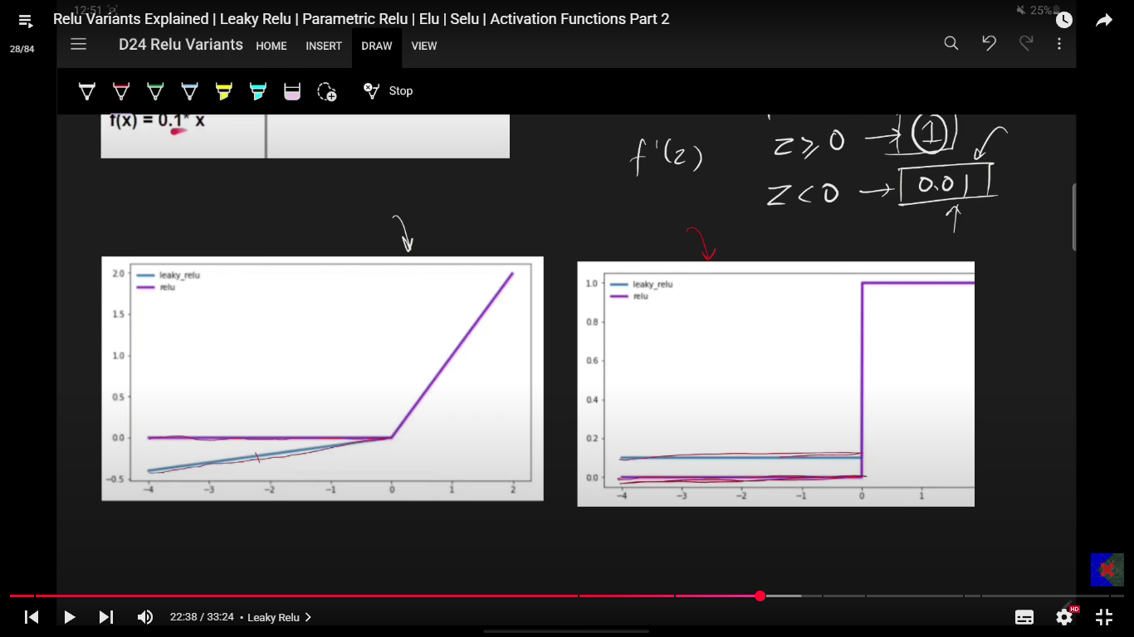

Leaky ReLU is an activation function that modifies the standard ReLU by allowing a small, non-zero output for negative inputs (commonly 0.01×x) instead of zero. This design helps solve the dying ReLU problem, where neurons can get stuck outputting zero and stop learning. Leaky ReLU is computationally efficient, provides nonlinearity, and ensures gradients flow even for negative inputs, which improves learning in deep networks. It is commonly used in hidden layers of deep neural networks, especially CNNs, to maintain active neurons and faster convergence. Its advantages include preventing dead neurons, simple implementation, and faster training compared to sigmoid or tanh. The main disadvantage is that the negative slope is a hyperparameter that may need tuning, and it may still not completely eliminate all inactive neurons in very deep networks.

- Parametric ReLU (PReLU) is an activation function that extends Leaky ReLU by making the negative slope learnable during training instead of fixed. Like Leaky ReLU, it helps prevent the dying ReLU problem by allowing gradients to flow for negative inputs, but its adaptive slope lets the network decide the optimal amount of “leak” for each neuron, potentially improving performance. PReLU is commonly used in deep networks and CNNs, provides smooth gradient flow, and can boost accuracy, but it slightly increases the number of parameters and computational cost. In short, PReLU is essentially a trainable, flexible version of Leaky ReLU.
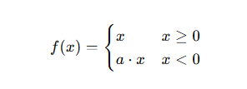

- ELU (Exponential Linear Unit):
ELU (Exponential Linear Unit) is an activation function used in deep learning that behaves like ReLU for positive inputs and exponentially for negative inputs. Mathematically,
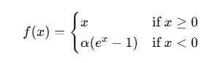
Where α is a positive hyperparameter controlling the saturation for negative inputs. This allows the function to output negative values while maintaining linearity for positive inputs
ELU is commonly used in the hidden layers of deep neural networks and CNNs, especially where standard ReLU may cause neurons to die. It is particularly helpful in networks that require faster convergence, better gradient flow, and zero-centered activations for more stable training.
Advantages: ELU prevents dead neurons by allowing non-zero outputs for negative inputs, provides zero-centered activations which improve weight updates and reduce bias shifts, produces smooth negative outputs that stabilize backpropagation, and can lead to faster and more stable convergence in deep neural networks compared to ReLU.

Disadvantages: ELU is slightly more computationally expensive due to the exponential calculation, can saturate for very negative inputs resulting in small gradients, and requires careful tuning of the α hyperparameter for optimal performance.

- SELU (Scaled Exponential Linear Unit) is an activation function that combines the properties of ELU with scaling to enable self-normalizing neural networks, keeping activations close to zero mean and unit variance. It is defined as f(x)=λxf(x) = \lambda xf(x)=λx for x≥0x \ge 0x≥0 and f(x)=λα(ex−1)f(x) = \lambda \alpha (e^x - 1)f(x)=λα(ex−1) for x<0x < 0x<0, where α ≈ 1.6733 and λ ≈ 1.0507. SELU is mainly used in deep feedforward networks to maintain stable activations and gradients without needing batch normalization. Its advantages include preventing dead neurons, supporting zero-centered and unit-variance activations, improving gradient flow, and enabling faster and more stable training in very deep networks. The disadvantages are that it requires careful weight initialization (LeCun normal), works best with fully connected layers, may not perform well with dropout or convolutional layers without adjustments, and is slightly more computationally expensive than ReLU.

LeakyReLU
Fixed small slope (α=0.01) for negative inputs instead of zero, preventing "dying ReLU" where neurons permanently output zero and stop learning.
Parametric ReLU (PReLU)
Learnable α parameter per channel (not fixed like Leaky ReLU), allowing the network to automatically find the optimal negative slope during training.
ELU
Exponential curve for negative inputs that smoothly saturates to -α (instead of linear slope), pushing mean activations closer to zero for faster learning.
SELU
Scaled ELU with fixed constants (λ, α) that self-normalizes outputs to mean=0, std=1 across layers without needing BatchNorm, but requires specific initialization and feedforward architecture.

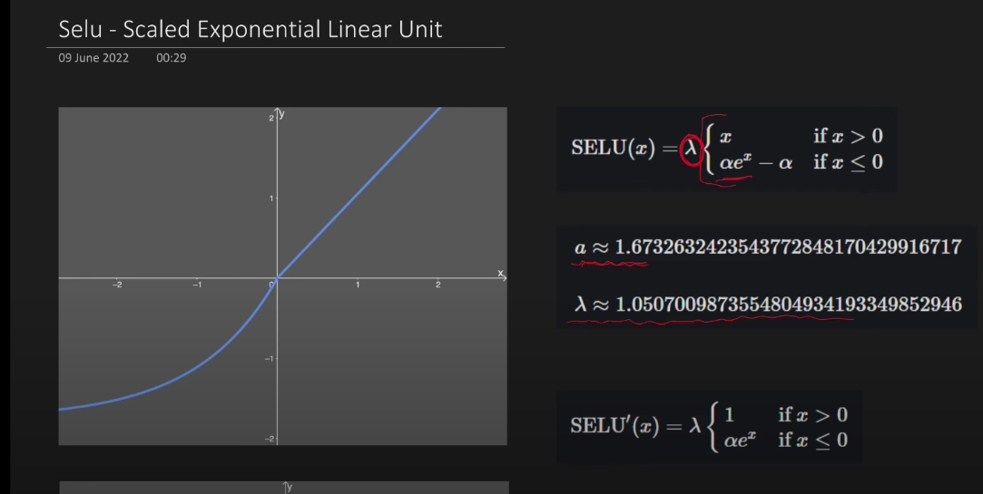

Weight Initialization:
Due to improper weight initialization techniques, few of the issues which could be happening,
- Vanishing gradient
- Exploding gradient
- Slow convergence
What not to do:
CASE 1: Zero initialization
Let’s understand for RELU and TANH, as the weighs are assigned to zero, and so does biases then outputs become zero, and so does the activation in case of RELU and TANH as well, so zero activation output with zero derivative and hence this equal and zero weights do not update and no training happens, those weights remain same till end.
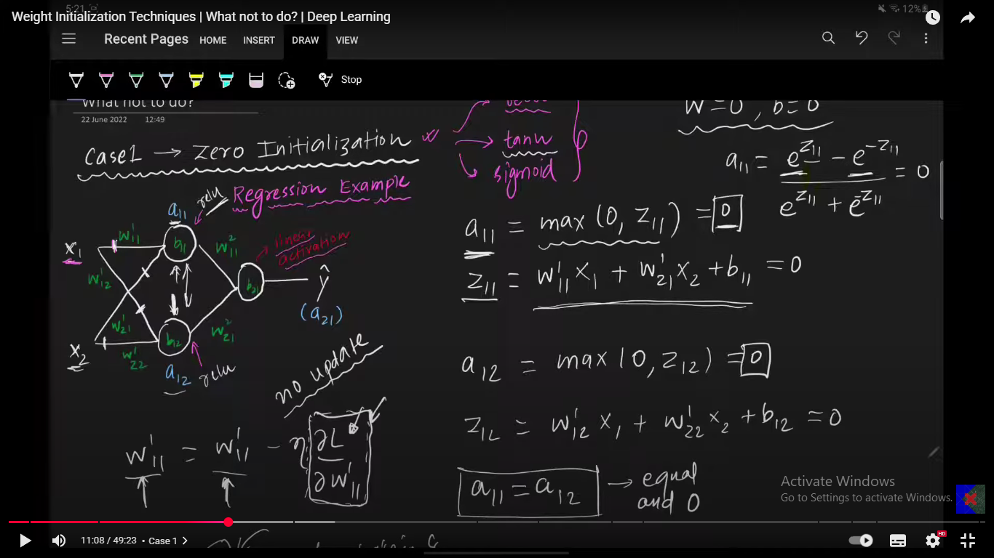
Sigmoid: In case of sigmoid activation function, on initializing the value of the weights to zero the Z output becomes zero but the activation is 0.5 same for all, now in this case the derivatives of the weights are similar except the last term which comes out to be input variable itself, and as this input variable is same for all the weights going from this input to all the neurons of the subsequent layers, this weights will be same as function of input X value, and behaves as one single weight. Explain below, all the neurons in the subsequent layers would behave as if it were a single node, and it will be single node perceptron.
In this case, all the weights would be same after n number of epochs making it as sort of single perceptron with similar N weights
CASE 2: Non-Zero constant values in case of the non-zero constant values of the weights, the case will be similar to above sigmoid case where the weights coming out of single node will be similar as if single weight is acting and the subsequent neuron layer will act as if single node layer like perceptron.
So, in case of the zero-weight initialization model won’t be trained, and in case of the constant value initialization model will act as if a single node model.
So, when the weights are initialized to zero they become constant same weights after training and when weights are initialized constant they remain constant after training, so in both the cases the all weights are going to be same constant, assigning them zero is just start ultimately it would be same constant value only.
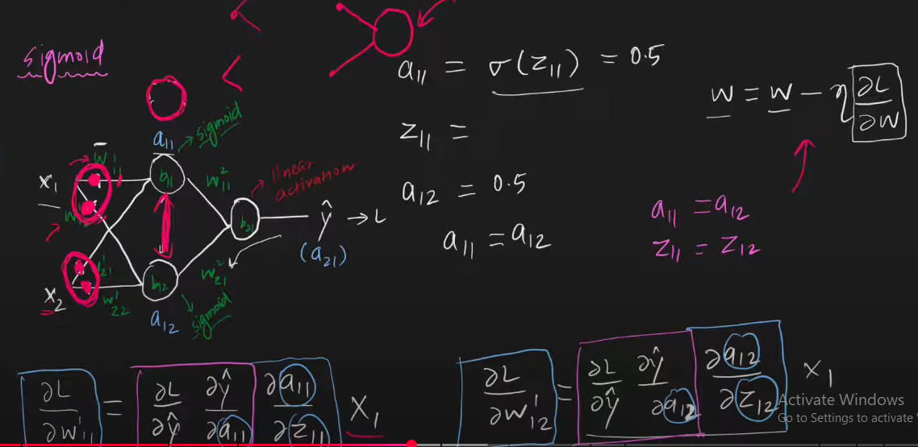
CASE 3: Random initialization with small values: Random initialization with small values, leads to vanishing gradient problem in case of TANH and sigmoid whereas very slow convergence in case of the RELU. On initializing small random values, the activation outputs become close to zero due to the nature of activation functions for those very small, initialized values and particularly for deep NN this activation outputs gets close to zero and zero, as described below.
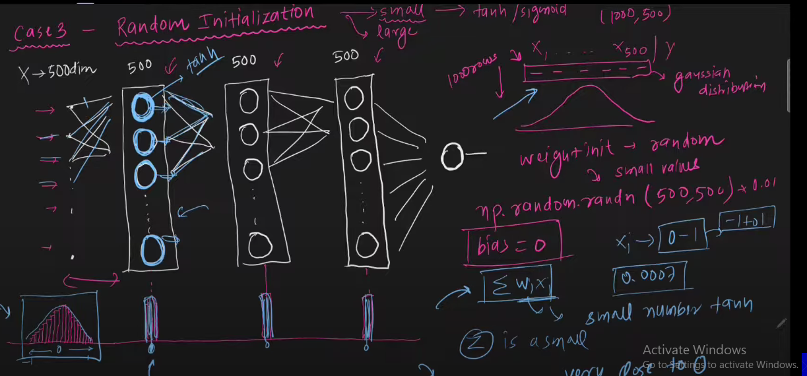
CASE 4: Random initialization with large values.
For large values like (0-1, by the way this is large for weights initialization). Total summation output for large network becomes high and activation in this case for tanh and sigmoid becomes saturated i.e. max/min limiting value is taken multiple times (like 0 or 1 for range of function in 0-1). This saturation may lead to slow training and vanishing gradient. Whereas in case of RELU, this saturation case won’t exists at least at one side as it is not limiting function to one side, but as the activation are pretty high, then the gradients would be pretty high as well in this case and learning steps/weight updation steps, i.e. gradient steps in this case would be very high and abrupt.
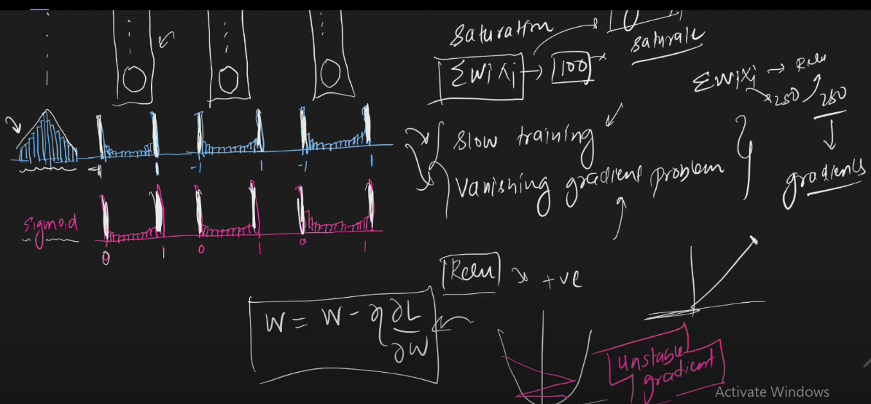
Now, what to do in weight initialization:
There is one heuristic way to initialized weights unlike above 4 cases,
Key mental model (intuition) while initializing weights is?
✅ Always think:
- Inputs to a layer = activations from previous layer
- Outputs of a layer = activations after current layer
- Weight initialization tries to keep variance of above two equal.
- For linear/tanh → z ≈ a → simple formula
- For ReLU → z ≠ a → must compensate in weight initialization
- Each layer’s activations are numbers representing information.
- Across samples, these numbers have a spread (variance) that tells how much the activations differ between inputs.
- If the spread shrinks too much → differences between samples vanish → network loses information → learning becomes slow.
- If the spread grows too much → numbers explode → some neurons dominate → network becomes unstable → gradients blow up.
- So the goal of weight initialization is:
- Make the output activations of each layer have roughly the same spread/variance as the input activations, so that information flows through the network without shrinking or exploding.

Core Advantages of Preserving Variance Across Layers
- Forward signal stability:
  - Keeps the activations from shrinking or exploding as they pass through layers.
  - Ensures the network can propagate information properly from input to output.
  - Prevents vanishing or exploding signals that would make learning slow or unstable.
- Backward gradient stability:
  - Keeps gradients in a reasonable range during backpropagation.
  - Prevents vanishing or exploding gradients, enabling stable and effective weight updates.

What weight initialization does
- When we randomly initialize weights, if we just pick random numbers without thinking about scale:
  - The signals flowing forward through the network can shrink or explode
  - Gradients flowing backward can vanish or explode
  - This makes learning unstable or extremely slow
- Variance-preserving initialization (like Xavier or He):
  - Chooses weights so that the variance of each layer’s output is roughly the same as its input at the start of training
  - Ensures activations and gradients are in a reasonable scale initially
  - This is why it’s better than completely random initialization

Does this guarantee variance stays the same during training?
- No. Once training starts and weights are updated by gradient descent:
  - Activations’ variance can drift
  - Initialization only ensures a good starting point, not perfect variance preservation for the whole training process
- Over many batches and epochs, variance can increase or decrease depending on weight updates

How variance can be controlled during training
- Normalization techniques like Batch Normalization:
  - Dynamically normalize activations to have a controlled mean and variance per batch
  - Helps preserve variance across layers throughout training, even as weights change
- Initialization + normalization together make deep networks trainable and stable, even with many layers

Key idea / intuition
- Think of each layer as a “pipe” carrying information as numbers
- Variance = the “width” of the signal
- Initialization ensures the pipe starts with the right width, so the signal flows properly
- Normalization ensures the pipe stays roughly the same width throughout training
Two methods:
- The real intuition is you want to have input X variance is same as outputs variance across all the layers so that there is no vanishing gradient or saturation of output in activation function or there is no exploding gradient, so to have this same variance of input X and output Y across all the layers we draw weighs from the distribution with variance as 1/(Ni + No). i.e. we scaled the weights by factor of their variance / SD which is 1/n , where n is the number of inputs in the last layer.
There are two ways to apply each technic normal and uniform.

- Xavier/ Glorat (sigmoid / tanh):
To maintain stable variance of activations and gradients across layers, preventing vanishing or exploding gradients that hinder training. Activation functions with roughly zero mean and symmetric output, like sigmoid and tanh.
weights are initialized so that the variance of outputs approximately equals the variance of inputs,
maintaining smooth signal flow.
- Normal implementation with mean = 0 and no fixed ranged with 99.7% values falling in +- 3 variance is as below:

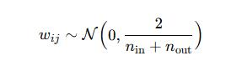

There is one more implementation where the var(W) is 1/N, where N is input weights to the neuron.

- Uniform Implementation: initialize weights from U with range as:

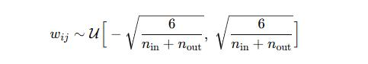

- He (RELU)
He initialization, also known as Kaiming initialization, is designed to overcome vanishing and exploding gradient problems specifically in deep neural networks using ReLU or similar activations. It builds on the insight that ReLU activations output zero for roughly half their inputs, so the variance of weights needs to be scaled differently compared to Xavier initialization.

- He Normal Initialization: Weights are initialized from a normal (Gaussian) distribution,
Mean is zero, and standard deviation is scaled to compensate for the half-rectification effect of RELU layers
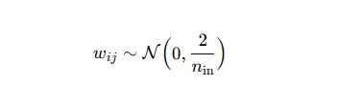

- He Uniform Initialization: The range is chosen to keep the variance of the pre-activation outputs stable under RELU nonlinearities.
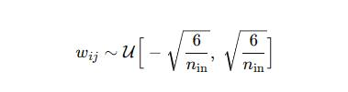

Core Differences from Xavier Initialization
- Variance scaling differs: He uses variance proportional to 2/Nin, while Xavier uses 2/( Nin + Nout )
- He is more suited for ReLU and its variants, which effectively deactivate about half the neurons.
- Xavier is more suited for activations symmetric around zero like sigmoid or tanh.

Batch Normalization:
Internal covariate shift is defined as the phenomenon where the distribution of the inputs to a layer in a neural network change during training because of updates to the parameters in the preceding layers. In other words, as weights and biases in earlier layers are adjusted through gradient descent in each training batch, the activation outputs they produce—which serve as the inputs to subsequent layers—change their statistical properties (such as mean and variance).
Internal covariate shift is the change in the input distribution of a specific hidden layer across training iterations, caused by updates to the weights of preceding layers
Internal covariate shift is the phenomenon where the input distribution to a specific hidden layer changes across training iterations because the weights of preceding layers are updated. It is layer-specific, focusing on one layer at a time, and becomes iteration-specific naturally as training progresses. This shift is not about differences between layers, normal batch variation, or dataset changes, but about how each layer’s inputs drift over time, forcing the layer to continuously adapt and potentially slowing down or destabilizing training. Techniques like Batch Normalization aim to reduce this drift and stabilize training.
it does not matter that different layers have different input distributions from each other
Internal covariate shift causes shifting input distributions per layer during training, leading to slower convergence, unstable training, gradient problems, sensitivity to hyperparameters, and difficulties in training deep models effectively.
Why do we need the distribution same and no internal co-variate shift.
- Prevent vanishing/exploding gradients.
- Keep the loss landscape stable, aiding convergence.
- Prevent activation saturation, allowing effective gradient flow.
- Ensure gradients propagate properly in deep networks.
Batch normalization is done to,
- Reducing Internal co-variate shift
- Faster and more stable training
- Mitigating Vanishing gradient/ Exploding gradient
- Regularization effect

The how?
Batch normalization is nothing but normalizing the output of the neurons, and batch here is of significance as the outputs in a batch are used as normalizing data.
In batch normalization inputs (outputs of the last) to the next layer are sent in a normalized form. There are two ways the normalization can be done,
- Output Normalization Activation
- Output Activation Normalization
First one is preferred mostly.
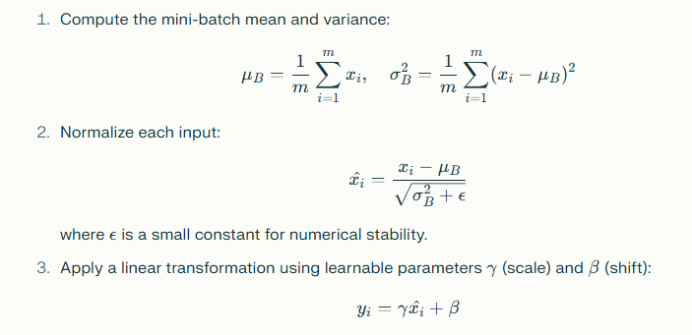
Batch normalization is done layer wise and that too for each neuron in single batch. i.e. for single neuron in a batch all the inputs are passed calculating the Output for each input then the mean and SD of all these numbers is calculated, based on this SD and Mean a normalized value is calculated for each output. Which is then passed though activation function to get activation output. Once the activation of normalized output is calculated then this output is multiplied by learnable parameter and added by a learnable parameter. Both these parameters are learned during training. Now it is very counterintuitive to understand why we do the reverse of normalization by multiplying the normalized output by a parameter and adding by a parameter which is totally reverse of normalization, this is done so that neutralize the normalization in case where there is no need of normalization of outputs, so in a case where there is no need of normalization needed these two learnable parameters learned in a way such a that normalization is neutralized and non-normalized values are returned after this normalization based off the parameters learned.
Batch normalization requires the whole batch at once per layer to calculate accurate normalization statistics and normalize activations accordingly. Which is not the usual case in case of the batch gradient descent where one input is sent throughout by forward propagation.
Batch Normalization while prediction/test:
While prediction, distribution parameters are calculated by Exponential weighted smoothing average (i.e. mean and SD) of batch parameters during training. i.e. all the distribution parameters calculated for each batch during training are used to calculate the distribution parameters in Exponential weighted smoothing manner.
Advantages of Batch Normalization:
    - Stable training which leads to wide range of hyperparameter selection.
    - Faster training as learning rate can be set to high.
    - Regularizer (weak), activation can induce little randomness/noise due to weight aggregated updated.
    - Reduced Dependence on Initialization: Batch Normalization makes training more robust by reducing the sensitivity of the network to the choice of initial weights, making the process easier to configure.
Implementation in KERAS is just add BatchNormalization() layer.

Optimizers
Optimizers are algorithms which optimizes a cost/loss function finding the best independent parameters to minimize the loss function. Gradient descent is the standard optimizing algorithm used which updates the current value of independent parameters based of the magnitude and direction of gradient of loss with itself.
Challenges in GD:
- Learning rate: Optimum value of learning rate must be found out for the dataset. And learning rate needs to be adjusted to lower values as the training goes on.
- Learning rate schedular: the same conditional values of the learning rates as per the progression of learning rate are set and pre-decided in a schedule, and this schedule must be decided prior for every dataset which is not optimum thing to decide the best learning rate.
- Single learning rate: There could be N number of independent parameters, and the need of learning rate could be different for all different independent parameters.
- Local minima: There could be a local minimum existing in the loss function and GD can get stuck in local minima.
- Saddle point: Saddle points affect gradient descent by creating regions where the gradient is near zero, causing the optimization to proceed very slowly or appear stalled because each update makes minimal progress. Although the gradient points toward neither a minimum nor a maximum at these points, the function curves upward in some directions and downward in others, leading to plateaus or flat regions that trap the optimizer temporarily. However, with random initialization or adaptive strategies, gradient descent will eventually escape saddle points, but the presence of these points significantly slows down convergence and poses challenges in high-dimensional optimization landscapes typical of neural networks.
- Curvature in functions describes how the function bends or changes shape locally, captured mathematically by second derivatives or the Hessian matrix. In neural network optimization, curvature affects the training process by shaping the loss landscape: steep curvature can cause large, potentially unstable update steps, while flat curvature regions slow down learning due to small gradients. Understanding curvature helps optimization algorithms make more informed parameter updates, improving convergence speed and stability. Advanced methods that leverage curvature information, like second-order optimizers, can accelerate training but may also introduce complexity and stability challenges.
Optimizers:
      - Momentum
      - NAG
      - ADAGRAD
      - RMSPROP
      - ADAM

Exponentially weighted moving average:
Exponential Weighted Moving Average (EWMA) is a technique used to compute a smoothed average of a time series or sequence of values where more recent data points are given exponentially greater weight than older data. Mathematically, the EWMA at time t is calculated as
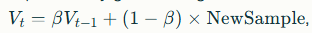
Beta value lies in between the 0-1 and higher beta value meaning the average of higher days, EWMA with 0.9 Beta value will behave as if the average with 10 days and 0.5 as if 2 days.
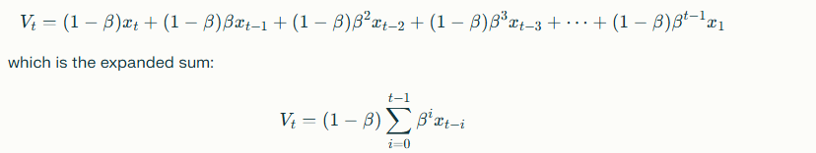
From the above you can see earlier days are weighted with beta cube and beta is less than 1, meaning their weights would be low.
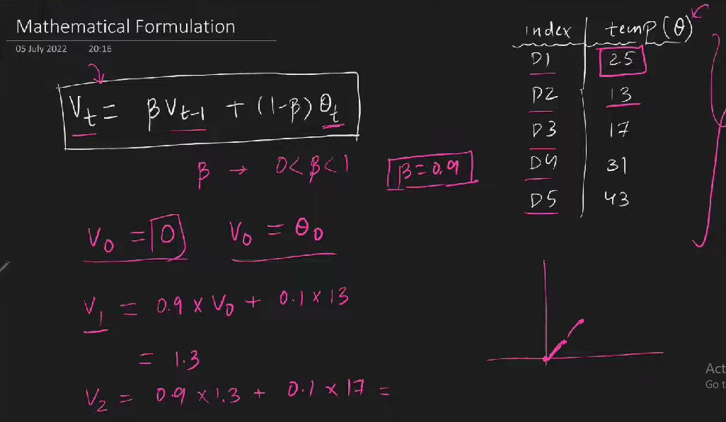

- Momentum
Why?
Mainly in non-convex optimization, there few issues:
- High curvature.
- Consistent gradient (low- gradient).
- Noisy gradient (local minima, abrupt changes in function).
What?
Stochastic Gradient Descent (SGD) with Momentum is an optimization technique that accelerates the convergence of standard SGD by incorporating a memory of past gradients. Instead of updating model parameters solely based on the current gradient, momentum computes a velocity vector, which is an exponentially weighted average of past gradients. This velocity is then used to update the parameters, giving the optimizer “inertia” in directions where the gradient consistently points, while dampening oscillations in directions where the gradient fluctuates.
While calculating the exponential weighted averages (i.e. Vt) we don’t use the term (1-beta) which is just the scaled parameter rather learning rate is used in there to scale the gradients. (By the way there are multiple of these variants, important thing is using weighted running exponential average rather than recent gradient).
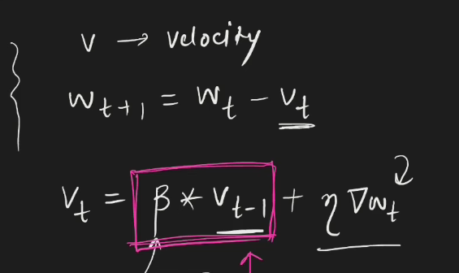
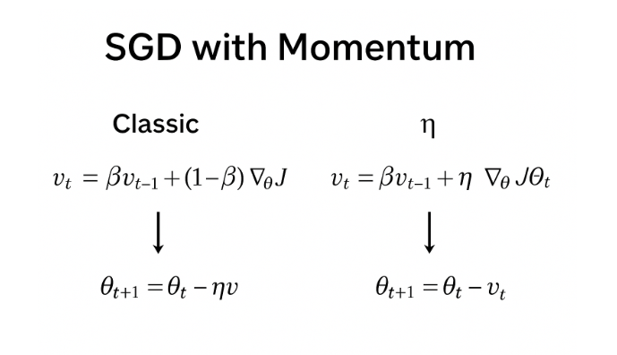
For beta equal to zero the SGD with momentum becomes the classic SGD.
Key Advantages:
- Speeds up convergence in directions with consistent gradients.
- Reduces oscillations in steep or narrow valleys of the loss surface.
- Helps escape shallow local minima.
Drawbacks of SGD with momentum (concise version):
- Can overshoot minima and cause oscillations if learning rate or momentum is high.
- Sensitive to hyper parameters—requires careful tuning of learning rate and momentum.
- Not adaptive—treats all parameters equally, unlike Adam or RMSProp.
- Extra memory needed to store velocity for each parameter.
- May carry old gradient information and move in wrong direction if gradients change abruptly.
Intuition: Like a ball rolling down a hill, momentum allows it to gain speed in the downhill direction while smoothing out small bumps caused by noisy gradients.

- NAG (NESTEROV ACCELERATED GRADIENT):
Normal momentum has drawback of overshooting and oscillating, NAG solves it by little tweak in momentum. NAG uses the gradient of future jumped position rather than the current position.
The look-ahead point is a rough, inexact estimation of where the parameters would move next if momentum were applied blindly; it is used temporarily to compute the gradient, and the actual future point is computed afterward using that gradient.
Only difference with momentum: In NAG, instead of using the gradient evaluated at the current weight position, we use the gradient evaluated at a look-ahead (predicted future) position of the weights.Mathematical intuition:
First the mathematical intuition of the momentum is:
You have two term in update formula, first one is velocity with moving weighted average of previous gradients and second term gradient at the current position. So overall progression towards the global minima is the combination of the two terms. So as we reach towards the optimum point from the slope, the velocity term would be pretty high and irrespective of the current gradient and that is why it does the oscillations.
Now in NAG, one small tweak to solve above issue, rather than using the gradient of the current position, the gradient of the future jumped position is calculated and then the updated is made, so first the gradient at this look ahead position is calculated. Gradient at look ahead position is calculated by weight at look ahead position by

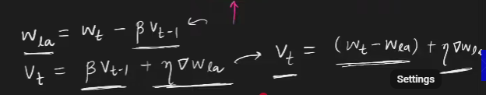

Geometric Intuition:

Momentum VS NAG

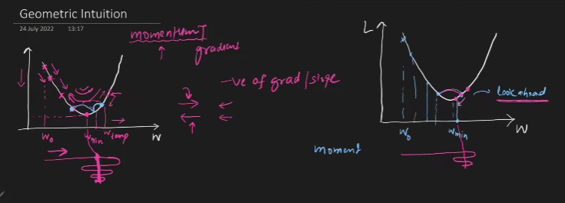

First one is Momentum and second one NAG. Let’s compare near minima, in case of the momentum the first blue position, at this position the velocity term is the weighted combination of last gradients with magnitude and direction which would indicate strong jump in next iteration to the right and second term which is the gradient would also indicate the same i.e. strong jump to the right, so together both the terms do indicate the strong jump towards the right which is not the ideal thing at this position as we need smaller jump but this is the drawback of the momentum and it would lead to strong abrupt changes near solution due to high momentum carried till this point which leads to oscillations, as even in the next step the momentum would be slowed down but the gradient in this direction would again points towards the minima, now depending on the magnitude difference of the velocity term and gradient second third jump would be decided but when the momentum has residue of last n number of days so likely it would dominate the gradient term and it would push you even to the right making the jump even abrupt and oscillatory. And this way with lot of oscillations we do reach to the solution.
Whereas in NAGs case, comparing similar position (first) on second right graph, the momentum (velocity) term is exactly similar but the only difference is second term which gradient now the gradient is not calculated at this position but rather look ahead future jump’s position which lets say is similar as momentum’s case, meaning it would be at right of the minimum (this look ahead is calculated similar to momentum case, so it would be same position). Now second gradient term is calculated from this look ahead position, so the gradient in this case would be definitely opposite to that of momentum (look from diagram) and it would suppress the impact of momentum term on overall update value and rather than having that crazy jump to the right it would have little small jump i.e. it would slow down the momentum a bit or decay the momentum. And similarly for the second jump look ahead point, will be nearer to the solution and in direction and it would have its major impact in new jump and this way we have much smoother and less oscillating moment towards the solution due this decaying factor of look ahead point.

- ADAGRAD (Adaptive gradient)
Adagrad adapts the learning rate individually for each parameter based on how frequently it’s been updated.
- Parameters with large or frequent gradients get smaller learning rates.
- Parameters with small or infrequent gradients get larger learning rates.
This helps especially in sparse data problems (like NLP).
So what happens, in case of sparse feature and sometimes huge difference in scaling of the features, the working of above optimizers does not work that good, cause of few reasons like
- Elongated long bowl, the “elongated long bowl problem” refers to a situation in optimization where the loss surface is shaped like a long, narrow valley — steep in one direction and flat in the other. Reason for above is sparse feature.

- 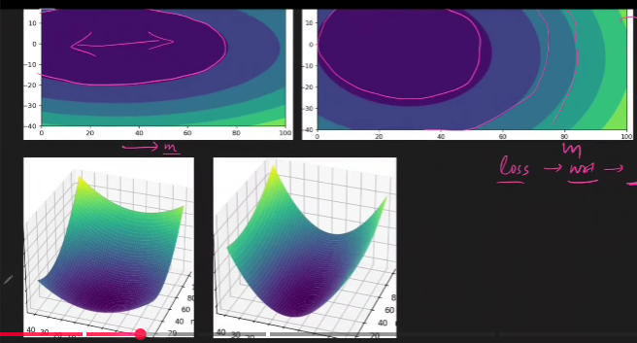

How batch gradient descent works:
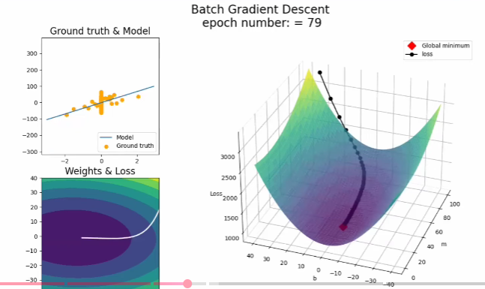
How batch momentum works:
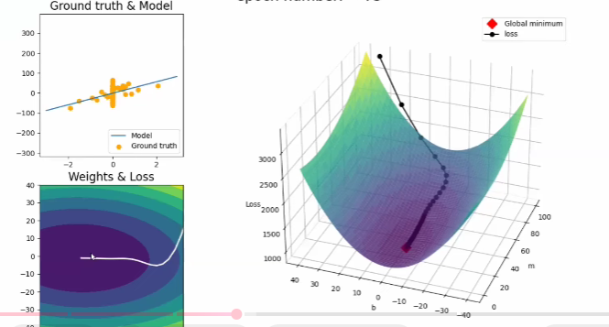

You see in both it does not take the best crossed straight route rather it moves towards one side first (momentum even overshoots in this case) and then the weight update in the second direction happens. But why this happens?
The gradient for the non-sparse data are high as the values are non-zero. So the weight update is dominated in this direction over the weight update in sparse features direction. Usually the weights updates in the non-sparsed direction happens fast over no-significant weight update in other direction like seen in above case. And as the dominant features’ weights are optimized completely then the changes in the other direction can be seen as the changes in those with that constant learning rate is are not overshadowed anymore.
Mathematics and intuition of the algorithm:
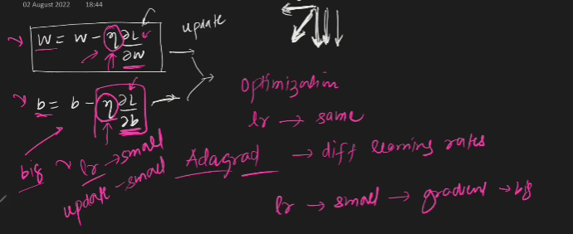

There is no concept of momentum, velocity or EWMA etc. rather the only change in the ADAGRAD from the vanilla gradient descent is, in current gradient term of GD it simply divides this term by square root of the sum of the square of all the previous gradients just to adjust the learning rate as per the previous gradients.
From the above diagram we can see the changes in the both the direction should happen as if the resultant of the two perpendicular vectors. I.e. making the updates in both the direction similar. Now this can’t be done by values in the gradients as they differ so this done by changing the learning rates for each direction. Formula for same is given as:
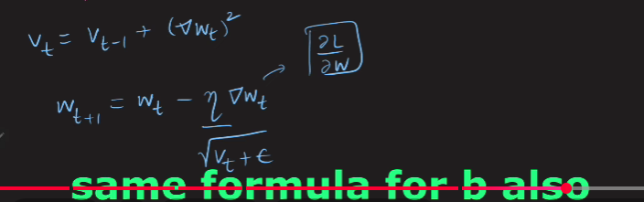
i.e. the learning rate is divided by the running sum of the squares of previous gradients. Square because to adjust the signs which is then taken care by root and epsilon for zero value case handling.
Intuition: learning rates is small for higher gradient feature and high for sparsed features, thus making the updates even.
But ADAGRAD never converges, as we move close to the solution sum of previous weights gets high and high and making it so high eventually it never converges.

- RMSPROP: (Root mean square propagation)
only difference in ADAGRAD and RMSprop is the learning rate is divided by the weighted moving average rather than the sum of squares of all the previous values.

SS

ADAGRAD Uses the entire history of gradients for its adjustment, which causes the learning rate to decrease rapidly over time, as the sum only ever increases which leads to the non-convergence in direction where the learning rate becomes so low due to high previous values of the weights.
Where as in RMSprop due to weighted sum does not make the learning rate that low and helps the convergence.

- ADAM (Adaptive moment estimation):
Momentum, Nesterov uses momentum principle
ADAGRAD, RMSPROP for sparse data uniform learning.
Adam Combines both i.e. Momentum (for speed) and adaptive learning rate.

KERAS Tuner:
Tomorrow, as it seems very practical.

CNN
How human mind processes the images?
- Light from retina goes through optical nerves (cells) to the thalamus and from there to the V1. Electrochemical single is the method through which light moves thorough the nerves.
- Main takeaway is different cells process different aspects.
Convolutional Neural network, also known as convnet, or CNNs are a special kind of neural network for processing data that has a known grid-like topology like time series data(1D) or image(2D).
  - Why not use ANN on Image Data let’s see what happens when you use ANN on image data:
- High computational cost:
The first and obvious thing you must do while using the ANN on image data is, you must convert the horizontal pixels into vertical inputs and stack each horizontal layer of pixel vertically and ultimately give that many number of the inputs to the model, which makes very high no. of inputs to the models and that many connections will be made. Let’s suppose you have image of 1000 X 1000 then (1000000) inputs will be given to the model which makes computation so heavy.
- Overfitting: As there are so many no. of connections and parameters there is chance of high overfitting in the model.
- Loss of important spatial arrangements of the pixels: e.g. from the image, where the 2D essence of the data is lost. i.e. when you convert a 2D data into one 1D it loses the 2D meaning representation. (e.g. dog eyes and nose distance will be lost now in one 1D as they are sequential now earlier there was concept of distance between eyes, nose and lot when those pixels were in 2D)

Image Applications:
- Image classification on labeled data.
- Object detection: Detecting objects in the image.
- Facial recognition: recognized unique facial features and hence unique face.
- Semantic Segmentation. Pixel level object detection. i.e. each pixel is labeled as particular object.
- And many more.

Resemblance with Human brain image recognition:
CNN are inspired by human brain and has similar image processing mechanism.
Initial lower-level features detect the simpler outer features of the images like the human brain cell does, for different image features different brain cell gets activated meaning different brain cell detects the different image feature. Human brain has simple and complex brain cells, simple brain cells detect the simpler outer features whereas the complex brain cells get triggered and detects the more complex patterns.
In human brain has simple cells, complex cells use for image detection, where the simple cells have lower receptive field and are used to detect simpler and initial basic patterns like edges, orientation etc. and i.e. these cells are called orientation cells or feature detectors. Or preferred stimuli.
Whereas the complex cell with bigger receptive field is used to detect the complex patterns in the data.
Intuition of the CNN: Exact similar thing happens in the CNN as well the simpler features are detected by initial filters and as layer by layer you move with different filtering you sort of add those outputs with more complex features detected by the later filters and this is how CNN recognizes the entire image pattern.
Architecture is as such where you have Image arrays as input and then you apply filters on it and do the convolutional process. (with padding, strides or without them). And then add pooling to address few issues raised such as
- Reduced array shape.
- More impact to the centered pixels.
- Overfitting.
- Computational efficiency.
- Memory issue.
- And translational invariance.
Channel is the depth layer of the color image.

convolutional operation.
- 2D: A black and white image is applied with the filter and gets you reduced 2D array with cross multiplying each corresponding element and then adding all the products (dot product).
- For 3D you do the same but with 3D filter the output you get is 2D array only after every entire operation. Cause the 3D convolutional operation happens with the filter having the same depth as your input and you don’t stride/move your filter backwards, but you only move them in 2D and i.e. you get 2D array output as a FEATURE MAP. Size of the feature map is always a 2D array X no. of filters.
- Feature Map: One feature Map after one filter operation. i.e. you combined those feature maps (obviously as many feature maps as no. of filters into one nD array with n being no of filter for one convolutional layer.
- Yes, the feature map produced by one convolutional layer becomes the input to the next convolutional operation in a Convolutional Neural Network (CNN). Each convolutional layer applies its filters to the output (feature maps) of the previous layer, allowing the network to learn increasingly complex and abstract features at deeper layers. This process enables the network to build hierarchical representations, starting from simple patterns like edges in early layers to more complex structures in later layers.
- The real working intuition of the CNNs is developing those filters or rather finding out the right filter to find the right pattern in the image which is simple features/patters which is the case in the earlier layers and deeper convolutional layers has the filter to find out the deeper complex patterns/features. The basic intuition is having the right filter like for simple task like vertical edge detection the filters are simple and known, and in CNN the thing is you need to find the right filters to find the same patterns which are specific to our data.
Here’s the summary of what happens in CNN.
- So, the input to the CNN could be 2D or 3D array given dimensions, and this 2D or 3D decides the depth of the filters in convolutional layers, for 3D input the filter depth is 3D and for the likewise for the 2D input. This extra depth is called as channel.
- But each filter operation produces the output known as feature map or channel which is always 2D, the number of channels is equal to the number of filters, now we have “N” number of channels or feature maps which are equal to the number of filters. Pooling is applied on this feature maps for obvious reasons. And then these features maps are combinedly treated as the input to the next convolutional layer with shape as 2D X channel (No of feature maps / number of filters) and obviously the shape 2D is dependent on the filter shape, strides, padding etc. this is the core of the CNN. After one convolutional operation, activation function (relu) is applied which add little bit of linearity and then the pooling is done. And the filter shape for the next convolutional layer is decides by the output of this pooling layer.

Analogies with ANN.
Trainable parameters: What you calculate weights and biases rights. (Keep the same principle here as well):
What could be the trainable parameter?
Feature maps do look like a trainable parameter, but it is not, is it? Those arrays are something like the output of the ANN. Not something but kind of exactly like the output of the ANN.
And then what is like the weights?
- Filter are neurons.
- Filters are what we want to create and developed for a particular image because those are the arrays or rather values which are getting applied on our input and producing output right. So, we must decide those values and those exact values are nothing but the comparatives of the weights.
- And the biases of each filter
So, trainable parameters are size of the (filter array * No. of. Filters) + biases.
Same for the ANN is, (No. of input * No. of neurons) + no. or neurons
Main thing about the CNN that trainable parameters do not depends upon input parameters at all which was the case in ANN that was creating the high computational complexities and memorization error.

CNN vs ANN
Similarities in CNN, filter are equivalent to the neurons of the ANN with each filter element are trainable parameters like the weight of the ANN, with each filter having one bias just like the neuron. Just like what happens in neuron the weights are multiplied with the weights of the input and then bias is added to the output of the neuron similarly, after a convolutional operation of the filter on entire input (neuron is connected to entire input) the resultant feature map is added by the bias of the filter. And the pooling layer is applied, and the operation is continued. This is very analogous to what we do in ANN.
Input → Convolution (with stride & padding) → Bias Addition → Activation → Pooling
Now the difference is.
- Computational cost: In CNN the trainable parameter is the total filter parameters + their biases, it not at all depends on the input shape. Which is not at all the case it the ANN where the trainable parameters are dependent on the input which increases rapidly with increase in the input though the architecture could be similar.
- Overfitting: With the increase in the number of weights to capture this complicated image patterns the overfitting increases.
- Loss of important feature like spatial arrangement of the feature: Due to filter sliding the spatial correlation between the features is captured.

Padding and Strides:
Padding:
Padding in Convolutional Neural Networks (CNNs) is the technique of adding extra pixels—typically zeros—around the edges of an input image or feature map before applying convolutional or pooling operations. This process is crucial for preserving spatial information at the borders, preventing data loss that can occur when filters overlap only the central regions and ignore the edges. Padding helps maintain consistent output dimensions, especially when using larger filters or when it is necessary for the output size to match the input size (as with "same" padding), and it ensures that features near the image boundaries are not neglected during feature extraction. There are several types of padding: "same" padding (Zero padding) adds enough pixels to keep the output size equal to the input, "valid" padding (No (padding) uses no extra pixels and results in smaller outputs, and "causal"(1D/sequences) padding (used in sequence models) adds padding only to one side to preserve temporal order. Choosing the appropriate padding strategy directly impacts the effectiveness, stability, and flexibility of CNN models in tasks such as image classification, object detection, and segmentation
Strides:
Stride in Convolutional Neural Networks (CNNs) is a fundamental hyperparameter that determines how many pixels the convolutional filter moves at each step as it slides across the input image or feature map, directly influencing the spatial size of the output feature map and the computational efficiency of the network. A larger stride reduces the output dimensions and computational load by skipping more pixels, which is particularly useful when the goal is to extract high-level, global features and when fine-grained details are less important. This down sampling effect helps the network focus on broader patterns, making strides especially valuable in scenarios where efficiency and abstraction are prioritized over detailed feature extraction. However, increasing the stride also risks losing important information, so the choice of stride should be carefully balanced based on the specific task and dataset requirements. In summary, strides are primarily used to control output size, computational cost, and the level of feature abstraction, playing a crucial role in the design and performance of CNNs. Not used mainly these days.
Stride of 2 skips the single row/column whereas the stride of 3 skips 2 columns / rows.
How to calculate the shape after strides and padding
((N+2P – f) / S) + 1, floor in case of decimal.
For each feature map

Pooling
Pooling solves following problems.
  - Memory Issue (dimensionality reduction): Pooling down samples the width and height of feature maps, which decreases the amount of data and computation required as the network grows deeper. This helps manage memory and processing demands, especially for large images or deep networks.
  - Translation Invariance (Only for minor translation chances): By pooling we can remove the location dependency of the extracted features. E.g. would features extracted of cat image like nose, ears, eyes are not specific the location of these features or location of the cate itself. Feature (eye, ear etc.) is a feature irrespective of the location of the cat. Pooling makes the network less sensitive to small shifts or distortions in the input, so features detected in slightly different locations are still recognized
Invariance = General concept (robustness to any variation)
Translation Invariance = Robustness to position changes specifically
  - Overfitting prevention: By reducing the spatial dimensions, pooling layers help prevent overfitting by providing a form of regularization.
  - Feature Hierarchy: Pooling layers help build a hierarchical representation of features, where lower layers capture fine details and higher layers capture more abstract and global features. Hierarchical feature learning in CNNs means the network builds understanding in layers: initial layers focus on fine, local features like edges and textures by processing small receptive fields, while deeper layers capture more abstract, global features such as shapes and whole objects by integrating information over larger spatial areas. Pooling layers help reduce spatial dimensions step-by-step, increasing invariance to small input changes and allowing deeper layers to aggregate broader contextual information, creating a multi-level, progressively complex representation of the input image.
  - Improved Localization: Max pooling in CNNs works by selecting the maximum (most prominent) value within each small region of a feature map. This operation helps highlight the strongest activations that represent the most important or salient features in that area, such as edges or textures. By doing so, max pooling effectively preserves these dominant signals while reducing spatial dimensions. This selective focus on the highest values helps the network better localize important parts of objects in images, which improves tasks like object detection and localization because it emphasizes the key features that define where an object or pattern exists within the image.​ In simple terms, max pooling picks out the "most activated" or "most relevant" features in each region, making it easier for the CNN to identify and locate important objects despite minor variations or noise.
228 X 228 X 3 is the usual input in standard CNN architecture.
Types of the pooling: In KERAS we have only 3, Max, min and global
- Max pooling: Selects the maximum value from each region of the feature map. It is the most widely used pooling method because it retains the most prominent features and provides strong translation invariance. Use max pooling when you want to focus on the most important activations, such as in image classification and object detection tasks.
- Min pooling: Min pooling is a pooling technique that down samples feature maps by selecting the minimum value within each defined region (e.g., a 2×2 window) of the input. Like max pooling, it reduces the spatial dimensions while preserving some information, but instead of capturing the strongest activations, it focuses on the least prominent or lowest values in each region. This can be useful for highlighting background or less active features. However, min pooling is rarely used in practice, especially with RELU activations, because it often results in many zero or very low activations, which can hinder learning and reduce the effectiveness of the network. It may find limited application in specialized tasks where capturing minimal or background features is important, but for most vision tasks, max pooling or average pooling are preferred due to their better performance and informativeness.
- Avg pooling: Average pooling reduces the size of feature maps by taking the mean of values in each region, resulting in smoother, more generalized features. It’s useful when you want to preserve overall information rather than just the strongest activations. L2 pooling.
- Global pooling: Global pooling is a technique in CNNs that reduces each feature map to a single value by applying an aggregation function—such as averaging (global average pooling) or taking the maximum (global max pooling)—across the entire feature map, and is typically used right before the output or dense layer to minimize parameters, prevent overfitting, and make the model robust to varying input sizes. logic of max global and avg global is same as only max and only avg.

- L2 pooling: L2 pooling is a pooling technique in convolutional neural networks where, for each region of the feature map, the Euclidean norm (L2 norm) is calculated by taking the square root of the sum of the squares of all values in that region. This method is less common than max or average pooling but can be useful in cases where a different form of regularization or feature aggregation is needed. L2 pooling provides a balance between capturing strong activations and preserving overall energy in the region, but it is more computationally expensive than max or average pooling and is typically used in specialized applications rather than standard image classification tasks.
How to do it?
- Pooling is done on individual feature map/channel.
- Size (2,2) with strides of 2 is mostly used for aggregation.
Advantages of using pooling?
  - Down sampling (reduced size).
  - Translation Invariance
  - Enhanced features in case of the max pooling.
  - No training needed.

What pooling creates feature invariance?
Pooling provides translation invariance in CNNs by summarizing the most important features within small regions of a feature map called as receptive field, so that small shifts in the position of features do not significantly affect the output. For example, if an object in an image moves slightly to the left or right, max pooling will still capture the strongest activation within each region, regardless of its exact position. This means that even if a feature like an edge or a corner shift within a pooling window, the pooled output remains largely unchanged, allowing the network to recognize the object in different positions. As a result, pooling helps CNNs focus on the presence of features rather than their precise locations, making the network robust to minor translations in the input image.

Why pooling is better than only strides in CNN?
Pooling is often considered better than using only strides for down sampling in CNNs because pooling provides translation invariance by focusing on the presence of features within regions rather than their exact positions, is computationally cheaper and parameter-free compared to learnable convolutions, simplifies network design by decoupling feature extraction from down sampling, and can improve gradient flow in deep networks, making models more robust and easier to train.

CNN Architectures:
Add SS from 6:00
LeNet-5 processes a 32×32 grayscale image through a sequence of layers: the first convolutional layer outputs 28×28×6 feature maps, followed by average pooling to 14×14×6; the second convolutional layer produces 10×10×16 feature maps, then average pooling reduces this to 5×5×16; a third convolutional layer outputs 1×1×120, which is flattened and passed through two fully connected layers with 84 and finally 10 units for classification, efficiently extracting and condensing features at each stage for robust image recognition.

Backpropagation in CNN:
Make sure to complete the backpropagation of the CNN’s in details later.

Data Augmentation:
Data augmentation in convolutional neural networks (CNNs) is a technique used to artificially increase the size and diversity of the training dataset by creating modified copies of existing data. This is done through various transformations such as image rotation, flipping, cropping, translation, brightness and contrast adjustments, and adding noise. The purpose of data augmentation is to help the CNN generalize better, prevent overfitting, and improve model accuracy by exposing it to a wider variety of data conditions without the need for collecting new data. It is especially valuable when the available training data is limited or imbalanced. By simulating real-world variations, data augmentation makes CNN models more robust and reliable.​
Coding in colab, (theoretical concept is simple, it is mainly coding)

What does CNN see?

Transfer learning?

Pretrained model in CNN:
WHY?
- Normal DL models for supervised classification problem needs labelled data in huge quantity for DL.
- Training time is huge as well.
That is why using already pretrained model is handy.

ImageNet dataset: visual database for image with 14 million images of 20000 different classes. These images are labelled in detail with hierarchal details. Around 1 million data is bounding box which is useful for object localization.
Ho: crowd sourcing by amazon service called as mechanical turck.

ImageNet competition (ILSVRC): started in 2010 used subset of the original ImageNet dataset with 1 million images with 1000 classes.
Initially the ML models got the better accuracies with 28%, 25% error rates then comes the AlexNet in 2012 which is the landmark year for DL (image data) by Jeoffrey Hilton which produces the error rate of the 16% (used relu in CNN).
Over the year different model came which are like this:
- ML (2010) 28 %
- ML (2011) 25%
- AlexNet (2012) 16.7%
- ZFNet (2013) 11.7%
- VGG (2014) 7.3%
- GoogleNet 6.7%
- ResNet 3.5%

You can simply get ResNet or any other model and make it predict any image which you want to.

Transfer learning: Why do the transfer learning reason is above which is same as the pretrained model’s reason.
Infect transfer learning is a method of using the already trained model on your problem.

Definition: Transfer learning is a research problem in machine learning that focuses on storing the knowledge gained while solving on problem and applying it to a different but related problem.
Using one domains knowledge to another. E.g. fundamental skills which are like many tasks so use those skills which are learned while learning something different but similar for your current task. Just like learning to ride bicycle and then ride bike. Underlying skillset is similar, so the same basic underlying skills are used for riding bike.
How do we do it?
So, any image model is comprised of Conv2D layers and FC layers, where the convolutional layers are used to extract the spatial features or mainly the initial layers which are mainly CONV2D are used to extract the initial features underlying features. The purpose of the dense layers is to classify the image.
So ultimately you freeze the conv2d part and train your own FC layers. Continued the rest part?
As they say don’t reinvent the wheel, build the car out of it.

Ways of doing transfer Learning?

Feature Extraction: In this method, you use a pre-trained model as a fixed feature extractor. You freeze all the layers of the pre-trained model so their weights do not change, and you only train new layers that you add on top for your specific task. This approach is efficient, requires less data, and is less computationally intensive, but it may be less adaptable if your new task is very different from the original one

Fine-Tuning: This method goes a step further. After initially training the new layers (as in feature extraction), you unfreeze some of the pre-trained model’s layers (often the deeper ones) and continue training the whole model on your new dataset. This allows the model to adjust its previously learned features to better fit your specific task, potentially improving performance, especially if you have a larger or more diverse dataset.
Code in the colab.

Functional API:

RNN: Recurrent Neural Network
NN which works on the sequential data and can preserve the sequence of the data. E.g. NLP task, stock prices or any time series data, sound data etc.
Why do we need RNN’s only (why can’t using ANN won’t work)?
- Variable input: Variable input needs to be handled by zero padding.
- Zero padding: zero padding creates the unnecessary computations,
- Prediction Problem (Incase the larger length of the input needs to be predicted).
- Totally disregarding the sequence of the sequential info.
Intuition of the RNNs?
- There is very much similarity between the RNN and ANN mainly the difference lies in two ways, first one is RNN’s ability to handle the variable size input by use of timestamps and second one is the RNN’s ability to have feedback loops (which gives it the ability to capture the sequential info).
- Nodes in RNNs not only receives the weights and bias as a input but also the input from the previous layers, which gives it a sense of what’s the learning/prediction from the last timestamp, such as every other prediction/ learning of the neuron would have previous learning as a input to it and this way the one input in various timestamp is fed and processed in the RNNs. Output of the last timestamp of the previous input is not fed to the first timestamp of the current input/row in processing, while it receives newly initialized outputs which are then carried/process/updated till all the timestamps are processed for the given row/input.
- In deep technical details the, when one neuron (let’s initial layer neuron) learns from the some aspect (basic info or context about the input) input based of the weights learned by backpropagation it takes into account the last timestamps prediction as well which makes it learns the relationship of the current prediction (some basic/specific aspect which at the end will go add and then we’ll have complete output) with previous output.
- RNNs handle sequences (like words in a sentence) by processing one token at a time, in order, using a "memory" called the hidden state.​

Simple Flow
- Start with token 1: network reads it, creates a hidden state summarizing it. For token 2, it uses that hidden state (memory of token 1) plus token 2 to make a new hidden state. This repeats—token 3 gets memory from 1+2, token 4 from 1+2+3, and so on.​

Why It Understands Sequence
- The hidden state passes forward like a chain: by token 5, it holds the "essence" of all prior tokens (1-4). Only the final hidden state from the top layer moves to the next token; middle layer states help build it but don't pass on. This memory chain lets RNNs grasp order, like knowing "the cat" affects what comes after

How is the input given to the RNN, now as we have seen that we cannot give zero padded input like even if we try ANN.
So input is given to the RNN in timestamp, and for each record (row) the no. of timestamp is as equal to the no. of words in the record.
First, let’s understand how do we encode the data?
Record: My name is BMF.
The ultra strong MF.
No. of unique words = 8
my = [1,0,0,0,0,0,0,0]
name = [0,1,0,0,0,0,0,0]
is = [0,0,1,0,0,0,0,0]
and likewise…….
Now the record would be represented as 2D array of [4 X 8] each row is word of 1 X 8.
And the final input to the RNN would be a 3D tensor of [2 X 5 X 8].
(batch size, sequence length, feature size)
Batch size = N/number of records
Sequence length = max number of words in any of the record.
Feature size = embedding size same for all the words
I plane/row for each entry/input and likewise you have n number of entries for entire dataset.
That one entry looks like from top as max words in input times the embedding size for each word.
i.e. arrangements are as such where one plane for one row and like second horizontal plane for second input.
5 for max no. of word in all the records, that means whenever we have a word less than the max of words in a row there will be an empty row for that record, meaning there will be padding in RNNs as well.
This is how the tensor is given as the input to the RNN.

Now let’s see how each input is feed as a timestamp to the RNN.
For row one, there would be 4 timestamp and first would word “My” with its encoding and let’s say we’ve RNN architecture as such as
input timestamp [ for word “My” 8 X 1] followed by 3 RNN nodes and followed by 1 fully connected node.
So, when for the first timestamp the “My’ enters with 8 inputs of [1,0,0,0,0,0,0,0] and connects to the RNN layer nodes.
Extra thing here is the output of the first-time timestamp [01] will be fed back to the nodes.
And then the processed value is sent to the next node.
Before the formulae of forward propagation let’s calculate the no. of trainable parameters, here.
W1 = 8 X 3
W1R = 3 X 3
W2 = 3
Biase1 = 3
Biase2 = 1
Total = 40
Formula is
(W1. X11) + (W1R. O1) + b1
W1 = [3 X 8]. X11= [8 X 1] + W1R= [3 X 3]. [3 X 1] + [3 X 1] = [3 X 1]
One thing for the first RNN layer as we don’t have any of the outputs, we select either zero-zero or random outputs. And this is how we calculate forward propagation.
How do
Architecture Diagram?
In RNN we have hidden recurrent layer which gives back the output of the first input as a second input along with weight for second timestamp.
Unfolding through time in RNNs means processing the input sequence step-by-step across different timestamps, while the weights for the entire layer (both for the input-to-hidden and hidden-to-hidden connections) remain the same for every timestamp. This is called weight sharing or parameter sharing. Backpropagation is very similar to the ANN, nothing sorts of complicated.
Encoding techniques:
OHE, we represent a word by a vector and sends the 3D tensor as an input to the RNN.

Working:
Understanding for Many to One.
for each input a timestamp is taken as kind of sub input of main input for forward propagation. So, while training actual general training input and output for model i.e. X and Y would be timestamp and actual single token target(positive/Negative) and this is repeated for all sub inputs/timestamp of one input/entry. i.e. for each input forward propagation does not happen once like traditional NN, it happens as many times as the number of timestamps. But the learning happens once after final timestamp, each subsequent timestamp receives the knowledge of all the previous timestamps and hence each timestamps prediction is more relevant and hence after the last timestamps forward propagation, the prediction received is of real significance than all the previous ones, and this prediction is used for loss calculation and learning though back propagation. Hidden states are nothing but the outputs of each layer which are input to next layer as well the input the same layer while forward propagation of the new timestamp. No hidden state info is carried forwarded across dataset inputs/entries/rows, concept of hidden state is only valid and used across single input. For new input again the process starts from the beginning, and all the initialization of h_0 state for all the NN layers is same as the previous input. Hidden state which is nothing but the output of the last layer exists for one entry and is useful to carry forward the info till the point to the next token/timestamp. Hidden state are layer specific as obviously as these hidden states are nothing but the outputs of the layers and i.e. same layer hidden state is passed to the same layer while doing the calculations of the next token’s forward propagation.

h_t^(1)

Where:
- t = timestamp/token number (subscript)
- (1) = layer number (superscript)

h_2^(1)
↑ ↑
│ └─ Layer 1 (superscript in parentheses)
└──── Token/Timestamp 2 (subscript)

Meaning: Hidden state of Layer 1 at Token 2

Actual mathematical working (***Important)
Setup
Architecture:
- Input layer: 3 neurons
- Hidden layer 1: 2 neurons
- Hidden layer 2: 2 neurons
- Output layer: 1 neuron
Input: ["cat", "sat"] Target: Y = 1 (positive)
Word embeddings:
"cat" = [1.0, 0.5, 0.2]
"sat" = [0.8, 0.3, 0.6]

Weights (Pre-initialized)
Layer 1:
W_x^(1) = [[0.5, 0.3],
[0.2, 0.4],
[0.1, 0.6]] (3×2)
W_h^(1) = [[0.7, 0.2],
[0.3, 0.8]] (2×2)
b^(1) = [0.1, 0.1] (2×1)
Layer 2:
W_in^(2) = [[0.4, 0.6],
[0.5, 0.3]] (2×2)

W_h^(2) = [[0.6, 0.4],
[0.2, 0.7]] (2×2)

b^(2) = [0.1, 0.1] (2×1)
Output Layer:
W_y = [[0.9],
[0.4]] (2×1)

b_y = [0.2] (1×1)

FORWARD PROPAGATION

Initialization (t=0)
h_0^(1) = [0, 0]
h_0^(2) = [0, 0]

Token 1: "cat" (t=1)
Step 1: Process Layer 1
Input:
x_1 = [1.0, 0.5, 0.2]
Compute weighted sum:
z_1^(1) = W_x^(1) · x_1 + W_h^(1) · h_0^(1) + b^(1)

W_x^(1) · x_1 = [[0.5, 0.3], [1.0] [0.5×1.0 + 0.3×0.5 + 0.1×0.2] [0.67]
[0.2, 0.4], × [0.5] = [0.2×1.0 + 0.4×0.5 + 0.6×0.2] = [0.52]
[0.1, 0.6]] [0.2]

W_h^(1) · h_0^(1) = [[0.7, 0.2], [0] [0]
[0.3, 0.8]] × [0] = [0]

z_1^(1) = [0.67] + [0] + [0.1] = [0.77]
[0.52] [0] [0.1] [0.62]
Apply activation (tanh):
h_1^(1) = tanh(z_1^(1)) = tanh([0.77, 0.62])
= [0.646, 0.551]

Step 2: Process Layer 2
Input from Layer 1:
h_1^(1) = [0.646, 0.551]
Compute weighted sum:
z_1^(2) = W_in^(2) · h_1^(1) + W_h^(2) · h_0^(2) + b^(2)

W_in^(2) · h_1^(1) = [[0.4, 0.6], [0.646] [0.4×0.646 + 0.6×0.551] [0.589]
[0.5, 0.3]] × [0.551] = [0.5×0.646 + 0.3×0.551] = [0.488]

W_h^(2) · h_0^(2) = [[0.6, 0.4], [0] [0]
[0.2, 0.7]] × [0] = [0]

z_1^(2) = [0.589] + [0] + [0.1] = [0.689]
[0.488] [0] [0.1] [0.588]
Apply activation (tanh):
h_1^(2) = tanh(z_1^(2)) = tanh([0.689, 0.588])
= [0.597, 0.528]

Step 3: Compute Output y_1
Input from Layer 2:
h_1^(2) = [0.597, 0.528]
Compute output:
z_1 = W_y · h_1^(2) + b_y

W_y · h_1^(2) = [[0.9], [0.597] [0.9×0.597 + 0.4×0.528] [0.748]
[0.4]] × [0.528] =

z_1 = [0.748] + [0.2] = [0.948]
Apply sigmoid (for binary classification):
y_1 = sigmoid(0.948) = 1/(1 + e^(-0.948)) = 0.721

Summary at t=1:
x_1 = [1.0, 0.5, 0.2]
h_1^(1) = [0.646, 0.551]
h_1^(2) = [0.597, 0.528]
y_1 = 0.721
Note: We don't calculate loss yet for many-to-one!

Token 2: "sat" (t=2)
Step 1: Process Layer 1
Input:
x_2 = [0.8, 0.3, 0.6]
Compute weighted sum (NOW using h_1^(1)):
z_2^(1) = W_x^(1) · x_2 + W_h^(1) · h_1^(1) + b^(1)

W_x^(1) · x_2 = [[0.5, 0.3], [0.8] [0.5×0.8 + 0.3×0.3 + 0.1×0.6] [0.55]
[0.2, 0.4], × [0.3] = [0.2×0.8 + 0.4×0.3 + 0.6×0.6] = [0.64]
[0.1, 0.6]] [0.6]

W_h^(1) · h_1^(1) = [[0.7, 0.2], [0.646] [0.7×0.646 + 0.2×0.551] [0.562]
[0.3, 0.8]] × [0.551] = [0.3×0.646 + 0.8×0.551] = [0.635]
↑
This is the recurrent connection! Memory from token 1!

z_2^(1) = [0.55] + [0.562] + [0.1] = [1.212]
[0.64] [0.635] [0.1] [1.375]
Apply activation:
h_2^(1) = tanh([1.212, 1.375]) = [0.837, 0.878]

Step 2: Process Layer 2
Input from Layer 1:
h_2^(1) = [0.837, 0.878]
Compute weighted sum (NOW using h_1^(2)):
z_2^(2) = W_in^(2) · h_2^(1) + W_h^(2) · h_1^(2) + b^(2)

W_in^(2) · h_2^(1) = [[0.4, 0.6], [0.837] [0.4×0.837 + 0.6×0.878] [0.862]
[0.5, 0.3]] × [0.878] = [0.5×0.837 + 0.3×0.878] = [0.682]

W_h^(2) · h_1^(2) = [[0.6, 0.4], [0.597] [0.6×0.597 + 0.4×0.528] [0.569]
[0.2, 0.7]] × [0.528] = [0.2×0.597 + 0.7×0.528] = [0.489]
↑
Recurrent connection from previous timestamp!

z_2^(2) = [0.862] + [0.569] + [0.1] = [1.531]
[0.682] [0.489] [0.1] [1.271]
Apply activation:
h_2^(2) = tanh([1.531, 1.271]) = [0.912, 0.852]

Step 3: Compute Output y_2 (FINAL OUTPUT)
Input from Layer 2:
h_2^(2) = [0.912, 0.852]
Compute output:
z_2 = W_y · h_2^(2) + b_y

W_y · h_2^(2) = [[0.9], [0.912] [0.9×0.912 + 0.4×0.852] [1.162]
[0.4]] × [0.852] =

z_2 = [1.162] + [0.2] = [1.362]
Apply sigmoid:
y_2 = sigmoid(1.362) = 1/(1 + e^(-1.362)) = 0.796

Summary at t=2:
x_2 = [0.8, 0.3, 0.6]
h_2^(1) = [0.837, 0.878]
h_2^(2) = [0.912, 0.852]
y_2 = 0.796 ← This is our FINAL prediction!

LOSS CALCULATION

Calculate Loss (Only at Final Timestamp)
For many-to-one, we only use the final output:
Predicted: y_2 = 0.796
True label: Y = 1 (positive)
Binary Cross-Entropy Loss:
Loss = -[Y × log(y_2) + (1-Y) × log(1-y_2)]

Loss = -[1 × log(0.796) + 0 × log(0.204)]
= -[1 × (-0.228) + 0]
= -[-0.228]
= 0.228

Complete Forward Pass Summary
┌─────────────────────────────────────────────┐
│ Token 1: "cat" │
├─────────────────────────────────────────────┤
│ x_1 = [1.0, 0.5, 0.2] │
│ h_1^(1) = [0.646, 0.551] │
│ h_1^(2) = [0.597, 0.528] │
│ y_1 = 0.721 (ignored in loss) │
└─────────────────────────────────────────────┘

┌─────────────────────────────────────────────┐
│ Token 2: "sat" │
├─────────────────────────────────────────────┤
│ x_2 = [0.8, 0.3, 0.6] │
│ h_2^(1) = [0.837, 0.878] ← uses h_1^(1) │
│ h_2^(2) = [0.912, 0.852] ← uses h_1^(2) │
│ y_2 = 0.796 ← FINAL PREDICTION │
└─────────────────────────────────────────────┘

┌─────────────────────────────────────────────┐
│ Loss Calculation │
├─────────────────────────────────────────────┤
│ Loss = CrossEntropy(y_2, Y) │
│ = 0.228 │
└─────────────────────────────────────────────┘

Recurrent Neural Networks (RNNs) are designed to process sequences, such as text, by reading one token at a time and updating an internal memory called the hidden state at each step. At every point, the RNN combines the current token with the previous hidden state, gradually building up a context that reflects the entire sequence so far. After the last token, the final hidden state contains a summary of the whole input, which is then used by the network to make a prediction—such as classifying whether a transaction description is fraudulent—based on the accumulated context. This ability to remember and integrate information across a sequence makes RNNs powerful for tasks where order and context matter.
In RNNs, the same weights are used at every time step, and training optimizes these weights so that the final hidden state after processing the entire sequence provides the best possible summary for making accurate predictions. The goal isn’t to perfect the hidden state at each individual step, but rather to ensure that, by the end of the sequence, the accumulated context in the hidden state leads to the most effective overall result for the task at hand.

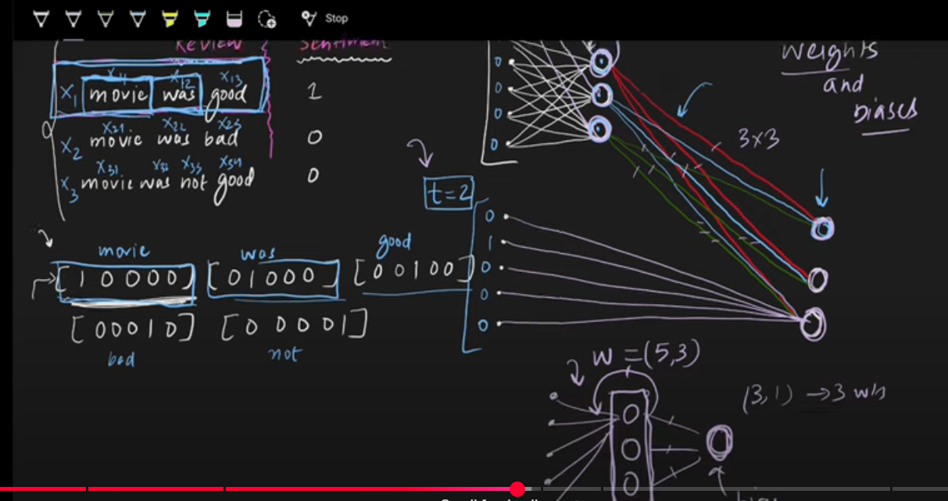
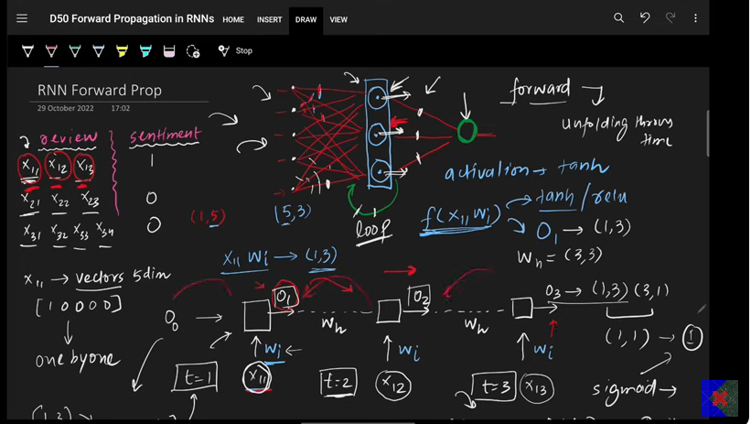
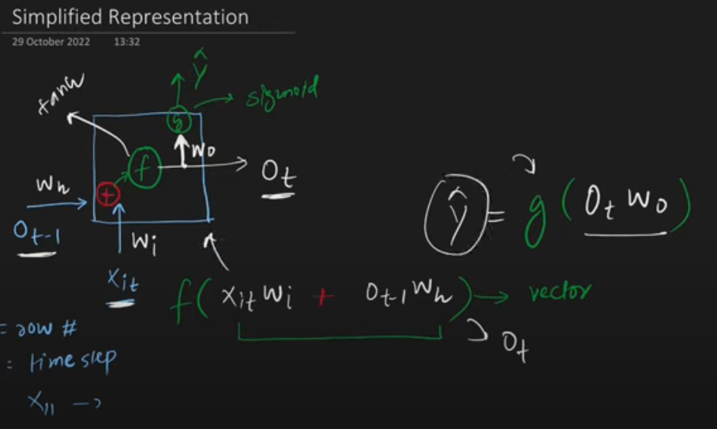

Types of RNN:
- Many to one: Many inputs and one output (General one which we have studied till now).
- One to many: Image description.
- Many to many (Sequence to sequence)/ (encoder decoder).
- One to one.

Backpropagation in RNNs?

Issues in RNNs:
There are majorly two issues in RNN’s:
Problems are problem of long-term dependencies and problem of stagnated training.
- Vanishing gradient descent. Or inability to capture longer term dependencies.
- Exploding gradient problem.

- Vanishing gradient: It is the main problem lying under which is inability to capture the long-term dependenci es.
- Usually for longer timestamps, when you update the weight by gradient descent those values are interdependent on all the previous timestamp derivative values. In the above scenario if you the derivative values to in between 0-1 and tanh is always in between 0-1 then the gradient comes to be very small and that implies the impact of that timestamp would be very less.
- Solution:
- Activation (relu, leaky relu)
- Better weight initialization
- LSTM

- Exploding gradient: It is the main problem where the gradient values are way more consistently and therefore those values comes out be very high for later stamps.
- What is the solution:
- 1. LSTM
- Tanh
- Clipping
LSTM’s Core Idea:
LTM, STM and interaction between both.
As the main reason that RNN’s cannot keep track of the old context, we must make sure somehow that RNN’s keep track of the longer-term dependencies. That is exactly what is done in LSTM’s. So, what does LSTM’s do is, along with short term dependencies like in normal RNN’s they also keep track of the long-term dependencies. So, in LSTM we have one LTM (Longer term memory) which track the long-term meaning/memory/context and STM (short term memory) tracks the shorter-term memory.
So now in LSTM instead of one STM recurrent state we have STM as well as LTM inputs feedback to the nodes of the layers.

In LSTM we have three gates and two operations:
Operation 1: Forget things from cell state and add things in cell state.
Operation 2: Calculates the hidden state.

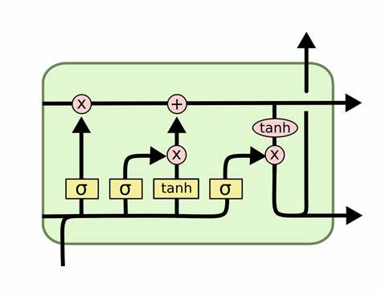
- Forget gate.
- Input gate.
- Output gate.
Cell state is LTM, and hidden state is STM:
So, every state we either forgot something from the LTM or add something to the Cell state (LTM),
Whereas updating the STM.
How does the everything looks like mathematically in LSTM.
Cell state, hidden state looks same where they are vectors of both same sizes. (Ct, Ht).
Like the above two there are four more vectors like Ft, It, Ct, Ot and interestingly they are of same shape as Ct, Ht. i.e. means these six vectors are of same shape
Xt – input vector (can be of any length not restricted to any).
Pointwise operations:
Arrays pointwise operations like (+, X)
Nodes: Each gate array is neural layers with activation function. It is a hyperparameter where the no. of nodes is decided, and they are same for all the layers. The no. of nodes is same as the no. of elements in those arrays like LTM, STM, Ft etc.

LTM and STM are of same shape at both the states, but the input Xt can be different.
Forget GATE:
Let’s suppose we have [1 X 4] input in Xt with 3 nodes in forget gate layer, in that case
The total input to the forget gate layer would be (Xt and ht) right which is called concatenation input, in this case that would be (4 + 3) which would be [1 X 7]
And weight matrix would be (3 X 7) as there are 3 nodes in the layer.
So, the output of the forget gate would be:
$f_{t}= σ ( W_{f}\left[h_{t-1} , X_{t}\right]+ b_{f} )$
$W_{f}$ = (3 X 7)
$h_{t-1}$ = (3 X1)
$X_{t}$ = (4 X 1)
Then the output of this operation would have point wise operation with Ct. So, basically what is happening is we have previous hidden state on processing that hidden state with input of current state we get Ft which is nothing but what to remove from the cell state and that is why we do point wise operation between the Ft which now knows what to remove from the cell state.
Let’s suppose our cell state is [ 5,10,20] and our Ft comes out be [0.5,0.25,0.1] then current cell state after removal would be [2.5,2.5,2] and this is what happens in the forget gate.

Output GATE:
On magnifying the gate, we we’ll two layers in output gate first one is input layer with It array and other one is candidate cell state.
Ct is nothing but the potential information to be added in the cell state whereas it decides what and which of that potential info to add. It has sigmoid loss function whereas Ct has tanh.
The output equations look the same as forget gate with one change in error function.
For candidate cell state it looks like:
$c_{t}=tanh ( W_{c } . \left[h_{t-1} , X_{t}\right]+ b_{c} )$
Though the product of weight and input state is same, but the values are different.

And similarly, for It:
$I_{t}= σ ( W_{t } . \left[h_{t-1} , X_{t}\right]+ b_{i} )$
On calculating the It and Ct we have multiplicative point wise operation which decides the which information out of the potential info is needed to be added in the cell state.
This quantity (Ct X It ) which is the actual filtered info to be added into the cell state is added in the cell state with point wise addition operation.
So, ultimately LSTM could add and maintain the whichever pervious info with the help of this gates. So, the main problem in the RNN which was vanishing gradient or loosing info over the longer distance can be easily fixed in the above case with Ft being one that is nothing is removed from the cell state and the product of Ct and it is zero then the actual cell state is maintained and carried throughout without losing the info.

Output Gate:
Output gate calculates the hidden state from the CELL STATE.
The output hidden layer has equal number of neurons as all the hidden layers with activation function as sigmoid.
Output array is calculated form the hidden state input ht and Xt concatenation with its weight matrix and the multiplicative point wise operation is done with the cell state array after applying tanh activation function. And that gives you the new cell state which is basically calculated from the output cell.
The equations are the same there is not much change as such. Just the direction is different.

ADD the fuckinn diagram here.

GATED Recurrent Unit (GRU):
GRU’s does the same work as LSTM’s but in more efficient way. GRU’s has much less trainable parameters compared to LSTM’s but their performance is comparable to the LSTM’s. Infect in some cases the GRU’s Outperform the LSTM’s.
GRU’s has only two gates compared to the 3 Gates in the LSTM’s and on top of that GRU’s don’t need any cell state to maintain the long-term context it works with the same hidden state.

Setup:
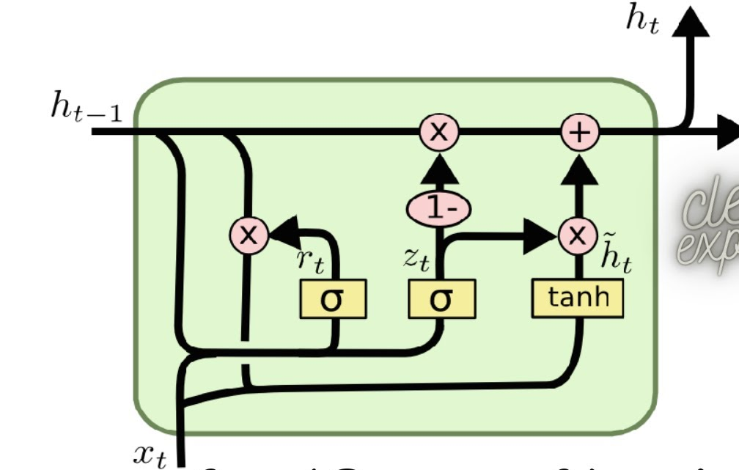

Two gates:
- Restore Gate (Rt) :
- Update Gate (Zt) :
- Candidate hidden state ($\overline{h_{t}}$) :
- Input state (Xt) :
- Previous hidden state(ht-1) :
- Current hidden state (ht) :

The shape of all the above arrays are nothing but the same except for the Xt whose shape depends on input state where as the other shape is same as the no. of neurons in the hidden layers.

Input (Xt):
Input state is a vector based on the vectorization. (OHE, BOW, Embeddings).
BAT CAT RAT
RAT RAT CAT
CAT BAT BAT
- [[1,0,0],[0,1,0],[0,0,1]]
- [[0,0,1],[0,0,1].[0,1,0]]
So, the input (Xt) would be a vector.
Architecture:
In GRU’s what’s happening is you have input Xt and ht-1 from these two we are calculating the ht.

The entire work of calculating the ht from ht-1 is divided into four steps:
- Calculating the reset gate (Rt)
- Calculating the ($\overline{h_{t}}$) (candidate hidden state)
- Calculating the (Zt).
- Calculating the current hidden state (ht).

Flow of the GRU architecture.
- We calculate the ht from the ht-1 and $\overline{h_{t}}$ with the help of the update gate (Zt).
- Whereas we calculate the $\overline{h_{t}}$ from the input Xt and ht with the help of the reset gate.
The process of the GRU happens in two steps:
- First you calculate the candidate $\overline{h_{t}}$from the current input which basically has the essence of the current state information. This $\overline{h_{t}}$ has the potential to be the final ht, or at least some portion of which will become or influence the ht. If we directly take the candidate state as the ht then it will be normal RNN only and we’ll lose the sense of the previous info. So instead of totally replacing the previous ht with candidate memory we’ve add the appropriate extent of it or remove so that it has sense of past and present like LSTMs. So, candidate is nothing but the current hidden state. (RESET GATE).

- On calculating the current hidden state from hidden state, we have update the required portion of that state which is candidate state to a previous hidden state in proportionate amount decided by update gate. (UPDATE GATE)
Let’s take an example of the story of the Vikram.
Vikram fought kali.
Vikram lost and died.
Vikram’s son was brave as Vikram.
He fought and lost to kali.
Vikram’s grandson was not as might as previously kings but he was smart.
He fought kali, was losing initially and but eventually beat kali with his smart strategies and won.
So, during all this story ht would look like:
Let’s suppose ht store contexts like [ power, conflict, tragedy, revenge] .
- [0.7, 0.8, 0.1, 0]
- [0.5, 0.5, 0.9, 0]
- [0.8, 0.3, 0.3, 0]
- [0.7, 0.8, 0.9,0]
- [0.8, 0.5, 0.4, 0]
- [0.7, 0.9, 0.1, 1]

This is how the ht gets updated with respect to the current state on top of the previous ht’s.

How does the calculation flow occurs:

Put the screenshot from the notes.

But anyways, we calculate Rt from the Xt and ht-1, with the help of the Rt X ht-1 and Xt we calculate the candidate state $\overline{h_{t}}$.
From ht-1 and Xt we have Zt and finally form Zt,ht-1,and $\overline{h_{t}}$ we calculate the ht.
So all we have to calculate is Rt and Zt.

Reset Gate (Rt):
Representation [ 0.1, 0.5, 0.9, 1]. It is an array with numbers from 0 - 1.
It is a gate which reset the previous hidden state to a proportionate degree.

How do you calculate Reset Gate(Array):
- You have neural layer with sigmoid as an activation function.
Lets suppose you have a neural layer with 3 neurons and input state is 4 element array.
Then the concatenation input with input Xt and ht-1 would be [1 X 7 ] and Wr = [ 7 X 3 ] so the output would be [ 1 X3 ] reset gate array after adding bias and putting everything into activation function.

$$R_{t}= σ ( W_{r } . \left[h_{t-1} , X_{t}\right]+ b_{r} )$$
Ht-1 = [ 0.8, 0.6, 0.9, 0.4]
Rt = [ 0.5, 1, 0.66, .8]

With the help of the reset gate and input (Xt) you calculate the candidate array with pointwise multiplicative operation that gets you modularize hidden state.
= [ 0.4, 0.6, 0.6, 0.32]

Now this output along with the input (Xt) when put into a neural layer of tanh activation function we get candidate hidden state.

$$\overline{h_{t}} = tanh ( W_{c } . \left[{(h}_{t-1} * R_{t }{), X}_{t}\right]+ b_{i} )$$

Update Gate :
Intuition: Zt decides which state to give more importance to current potential ht which is candidate hidden state or the previous hidden state in formation of the current hidden state.
If we have high Zt then more importance is given to the current hidden candidate state and if the Zt is low then more importance is given to the previous hidden state.
So, Zt decides which state to give more importance to in calculating the current ht. where as Rt decides which factors are more important from the current state which can be made as potential candidate for the actual current hidden state.
So Rt, decides the important parameters with their weights for the candidate hidden state as Rt being the gate where as Zt decides which of the two i.e. previous hidden state(ht) or the candidate hidden state should have higher impact in calculating the actual current hidden state.

$$Z_{t}= σ ( W_{z } . \left[h_{t-1} , X_{t}\right]+ b_{z} )$$

Ht = (1- Zt) * (Ht-1) + (Zt * $\overline{h_{t}}$ )

So, from the Zt one input goes to ht-1 as (1-zt) and other goes to the $\overline{h_{t}}$ and finally we have a additive operation between both to ultimately decide for the current hidden state.

Deep RNN’s:
The Idea in deep RNN is to stack multiple RNN layers stacked upon each other. Results into a extraction of more complex features.
The output of the one RNN which is hidden state is given to the second RNN which stacked on top of that first RNN. Don’t get confused here with output given to the second timestamp.
This output of the ht is given to the second layer RNN for the same timestamp only. And likewise, we complete the timestamp one processing for all RNN layers and then followed for the second timestamp again for the deep layers.
Check code for better understanding.
In deep LSTM’s only the ht is given to the second layer of the LSTM and not the Ct as well. Only Ht.
Story of the LLM’s:
Based on the input output structure there are many types of the RNN’s:
- Many to One RNN models: multiple input but has one output. i.e. sentiment analysis.
- One to Many Analyses: One input generates multiple output. image description module.
- Many to Many:
3.1 : Synchronous : where input length and output length is same. E.g. Part of speech tagging for each word. Named entity recognition for each word.
3.2 : Asynchronous : Where input length and output length is not same. E.g. Language translation, text summarization, question and answers, speech to text (subtitles).
Sequence to sequence problems:
Solves the problem of many to many asynchronous problems.
Which problems does it solves: Language translation, text summarization, question and answers, speech to text (subtitles).
Story of the sequence-to-sequence models consist of 5 parts:
- Encoder Decoder.
- Attention Mechanism
- Transformers
- Transfer Learning
- LLM’s

- Encoder Decoder: Encoder block compresses the input words and pass it to the decoder block.
- Now what decoder does is it uncompressed the input and returns the output.
- Encoder on compression keep the info in context vector which has the essence of all the information.
- So encoder get the information in the form of context vector. But as the words get more and more i.e. sentences gets higher and higher context vector is not able to keep the context of much previous words and it becomes recency biased context vector.
- Sentences with usually words greater than 30 is an issue.

- Attention Mechanism:
- To overcome the drawbacks of the encoder decoder architecture we have attention mechanism.
- Unlike Encoder decoder which has only one context vector to summarize all the information of all the timestamp which then given to the decoder, Attention mechanism has access to all the states of encoder i.e. all the ht’s and ct’s of the encoder for each step unlike one context vector.
- So, for each specific word it does not rely on the compressed context vector which has the context of all the states in one vector.
- Attention mechanism has one neural layer attention layer which decides which of those all the stored state outputs is to be selected for that specific word prediction.
- So, it kind of put attention on the specific needed states which are needed and that happens with the help of the neural layer.
- Higher computational complexity.
- Both the Encode decoder as well as Attention Mechanism both has LSTM in them.

Transformers:
What transformer did, as they changed the landscape through which we process the NLP task.
Attention is all you need. The paper which first describes the transformers.
It does not have any LSTM’s, but it only emphasises attention.
Drawbacks:
Training time
Hardware
Cost

Transfer Learning:
Initially transfer learning would be used only in the CNN. But with
Complete after you watched that content again.

Though the points are as such:
- Pre-Training
- Fine- Tuning
Language models:
Transfer learning applicable model which are trained on very large amount of data.

GPT: GPT is a language model which is trained on the very large data.
GPT 3.5 was 45 TB of data with near about the 175 billion parameters.
Whereas GPT 4 is 1.8 trillion parameters.
Chat GPT is chat bot product developed from the GPT language model.

- Encoder Decoder

Initially for tabular data we had ANN which works fine for tabular data without any sequence in it. For image data we had CNN and for sequential data where there is sequence in the data, we use RNN’s.
But in all the above case we have M inputs and 1 output we can manage variable inputs with zero array but in case there is n outputs it is bit tricky and for the same use sequence to sequence models.
Sequence to sequence models works on m variable inputs and n variable outputs.
Sequence to sequence models basic overview is very simple with one encoder block and other decoder block. Encoder block has LSTM / GRU in it and receives sequential array’s of input and generates a context vector which has the context of the input fed. This context vector is sent to the decoder which receives the one element of the context vector for one timestep and return the final output. But for firsts timestamp it receives one flag called as start which starts the decoding operations and starts producing the outputs whereas at the end decade’s LSTM receives the End flag which stops the anymore output being produced. Now this context vector is nothing but the cell state of the LSTM not both cell as well as hidden state.

Put the images from the Notes here,

Training the architecture by back propagation

Forward propagation.

- How does data look like: In our case let’s take an example of language translation model where we input we have language and output we have translated meaning of that sentence or word.

- Encoding the input to the Encoder and pass it in timestep with multiple timestep generating the context vector. After encoding both the input and output sequential data we have numerical sequence to sequence data whose patters needs to be learned by the sequence-to-sequence architecture.

- Encoder generates the context of the data which is nothing, but it learns the meaning of the sentence of the in encoding only to a degree and passes that learned meaning context to the decoder.

- Now decoder has one fully connected SoftMax layer which is used to predict the output corresponding to each time step. The no of nodes in the SoftMax layers are equal to the timestamp of the decoder. The max probability of the SoftMax layers prob vector is the output of that layer or rather the words corresponding to the index of the max probability as per the encoding.

- And likewise, you predict the next word for the next timestamp based on the same SoftMax probability.

- Here while learning if the decoder predicts the wrong word a right word is still given to the next timestamp as input that is overwriting the wrong output of the previous timestamp which is called forced teaching and this what led you to have optimized fast learning. And obviously the initial weights are defined randomly or initialization techniques. That forced teaching is sort of having proper target column for the input to learn from in decoder. Instead of learning from the wrong learn from the right.

- The probabilities where the prediction is correct are very high compared to the wrong prediction.

Evaluation:
After forward propagation we need to evaluate the prediction accuracy we do that with the help of the loss function.

Put the loss images :
Categorical cross entropy:

Calculate the loss for each timestep with the help of categorical cross entropy and aggregate the entire loss either mean or sum of all the losses of each timesteps.
The loss for the timestep where model was right is lower compared to the losses where model has made mistake.

Once we get the loss now, It’s time for backpropagation.

Initialization of the weight Forward propagation output loss gradient weight update (optimizer) learning rate new_weight new record next epoch.

On calculating the loss, we calculate the gradient and with the help of the optimizer we update the weight parameters with involvement of the learning rate.
This is how the training takes place with final weights.

Prediction:
Pretty much like the training with the difference of force teaching is not there.
And that is how we calculate the new output.
Put the diagram form the notes.

Improvement in sequence-to-sequence models:
- Embeddings:
Using embedding gives you more dense representation of the words with low dimension representation.
So, you add an embedding layer at the beginning.
Pretrained embeddings word2vec, glove etc.
Encoding in encoder and decoder.

- Deep LSTM’s:
Three reasons:
2.1 Long term dependencies: Able to remember the long-term contexts as we have multiple layer context vectors which keeps the longer context in memory and that is why it performs better for longer context vectors.
  - Layered (Hierarchical) representation: lower layer LSTMs understand the word level context like POS etc. whereas the middle layer LSTMs understand the sentence level contexts and finally the top layer LSTM’s understand the paragraph level context.
  - More parameters: On general level when you increased the number of parameters in the Neural network the level of understanding to which the NN understands gets increased and NN understands things on deeper level if we avoid overfitting.

- Reverse the input:
Like give the reverse input in the encoder and the original correct one in Decoder,
The basic logic is that when we give the input in reverse order in encoder and with the correct sequence in the decoder the distance between the initial words and final words in the decoder reduces and that sometimes helps in understanding the initial context far better especially for the languages where the initial words hold more importance.

Transformers:
Work on sequence-to-sequence problems like
- Machine Translation
- Question answers
- Text Summarization
Transforms has self-attention in them which makes them process the multiple sequential input in parallel and hence can be trained on large data which was not possible in sequence-to-sequence models with attentions.
Impact of Transformers:
- Revolutionizing NLP: NLP has been the main thing central thing in AI. With the use of transformer, it got revolutionized
- Democratizing AI: BERT and GPT models have made open source that propelled lot of enhancement in AI
- Multimodal capability: Not only for NLP but transformer can be used instead of CNN, ANN i.e. image or tabular data.
- Acceleration of Gen AI: instead of GANs transformer are used widely.
- Unification of the Deep Learning: Transformers are used for Gen AI, reinforcement learning, NLP etc.

Like mentioned above sequence to sequence to learning with attention has a big flaw of not able to train
2022 – chat GPT, stable diffusion.

Advantages of the Transformers:
- Scalability
- Transfer Learning.
- Multimodal
- Flexible architecture:
  - Only decoder model
  - Only encoder model
- Ecosystem: Lot of libraries like hugging face and lot of open-source work is around Transforms.
- Integrated AI: Transformers with GAN like DALLI, Transformers with reinforcement learning for game playing agents.
- Vision transformer: CNN + transformer
Disadvantages of the Transformers:
- Hi computations
- High data
- Over fitting
- Energy consumptions
- Interpretability
- BIAS (bias from the data and ethical concerns)

Future:
- Improvement in efficiency
- Multimodality
- Responsibility
- Domain specific
- Multilingual
- Interpretability

Self-Attention:
Normal encoding techniques we have are OHE, BOW and TFIDF and finally we have Embedding’s.
In embedding an unsupervised text data is learned by a model which represents a word in a dense vector with each element represents a magnitude value of certain characteristics.

E.g. word “KING”
[0.6, 0.7, 0.9, 0.4] and
“Queen”
[0.4, 0.3, 0.9, 0.6]
Each element of these two arrays would represents a characteristic of the king and queen and value would be the magnitude of those characteristic.
As king and queen are similar words these two vectors are very similar to each other with very minimal angle between them.

As this embedding’s are formed by training huge unsupervised data once and these static embeddings are used over and over again for many different applications where the context of those words would be different but the embedding representation of the words is not contextual but it is static cause it represent the average meaning the word. I.e. a word is represented by single value of the characteristic for all the contexts instead of different vectors for different contexts. Means you have single vectors for all the different context instead of multiple different vectors for different contexts.
With the self-attention you can represent the word with contextual embedding and ultimately that embedding is process by the transformer down the line.
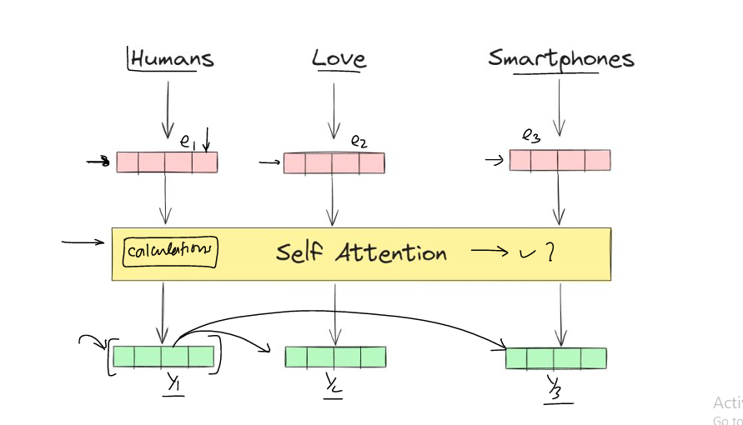
Self-Attention
First principal approach: (for calculating contextual embedding vector)

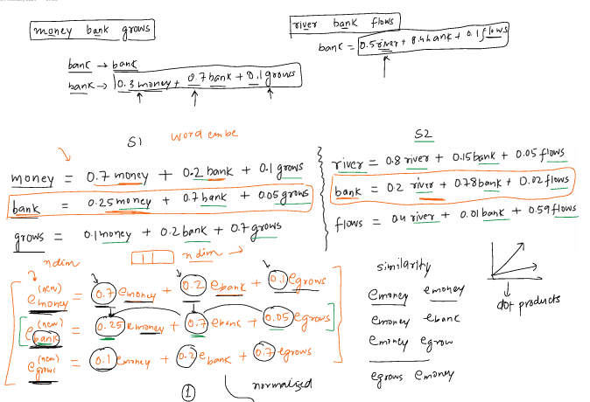

So basically, the new embedding vector for the money is calculated based on the other words by considering the similarity with each word. The similarity between the word embedding is calculated by dot product between the vectors.
The normalized dot product is taken with SoftMax for similarity score.

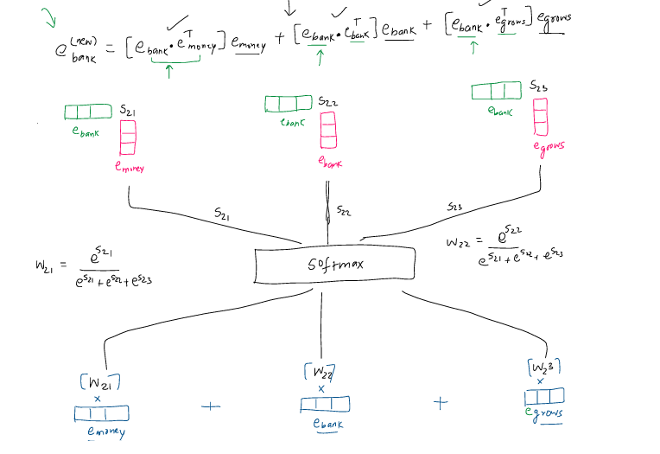

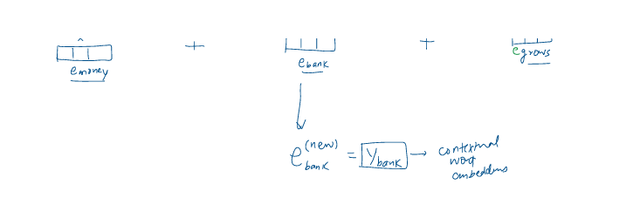

This operation is parallel operation, and no parameters are involved in the above embeddings.

Make sure to upload the file from the local comp.

