- What is fine tuning?
- Pre-Training VS Fine-Tuning
- Prompt Engineering VS Fine-Tuning?
- What does fine tuning actually does?
- Benefits of fine tuning LLM?
- Fine tuning LLM – step by step
- Methods of fine tuning LLMs
- SFT VS SSFT VS RLHF
- 3 options of parameter tuning
- Parameter efficient Fine-Tuning(PEFT)
- Low Rank Adaptation(LoRA) for Fine-tuning LLMs

Life cycle of LLMs. 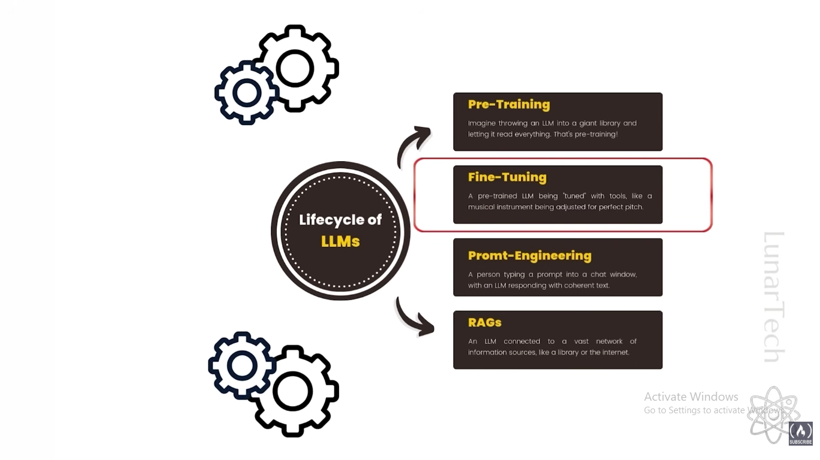

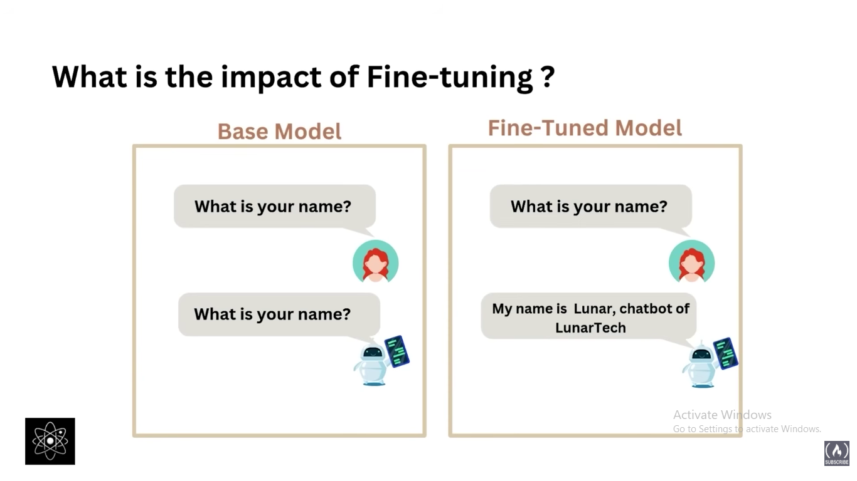

What is Fine tuning?
Fine-tuning is the process in machine learning where a pre-trained model is further trained on a smaller, task-specific dataset to adapt its knowledge to a new, specialized purpose. This typically involves adjusting the model’s parameters or weights, often focusing on the later layers, so it performs better on the target task while retaining the capabilities learned during initial training on a larger, more general dataset. Fine-tuning is a form of transfer learning that allows developers to efficiently create models tailored to new challenges with less data and computation compared to training from scratch
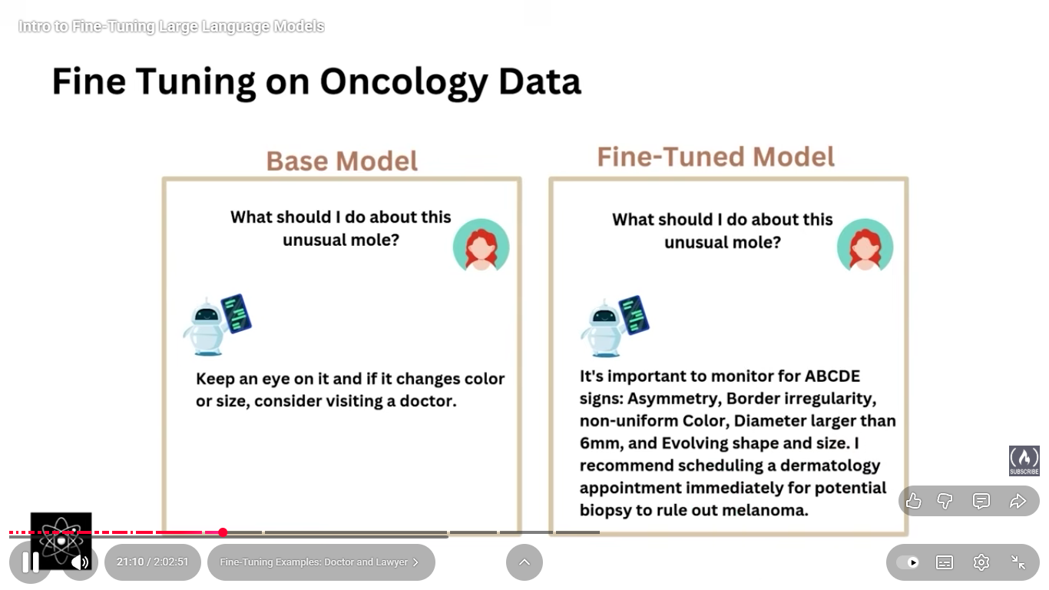

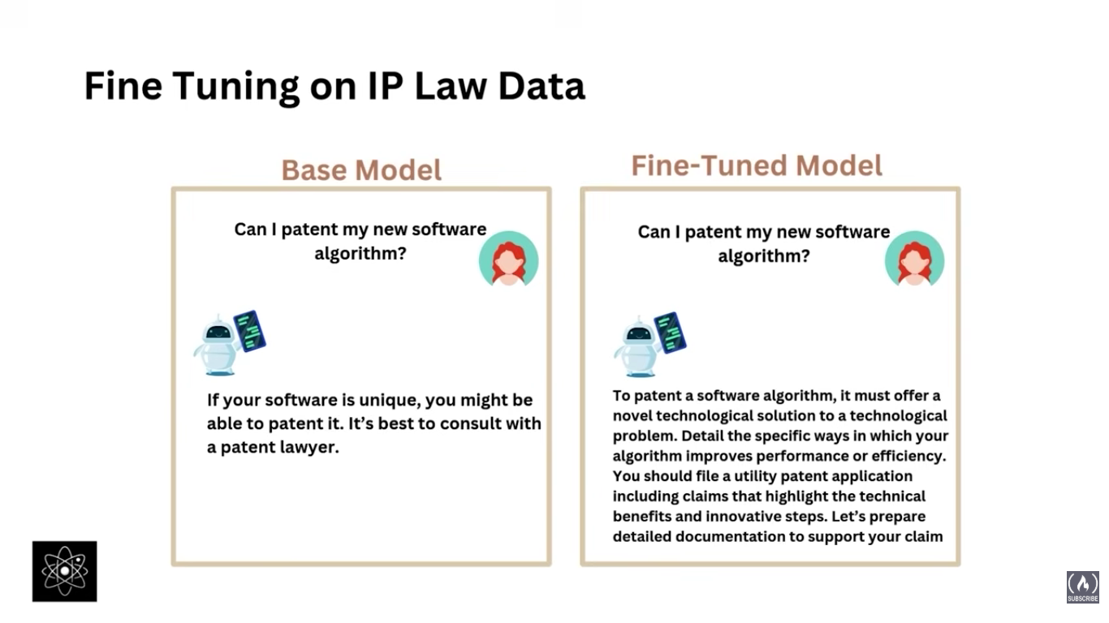

Pretraining is the initial phase where a model learns general patterns, features, and representations from large-scale data (often unlabeled) before being fine-tuned for a specific task. It uses self-supervised or unsupervised learning, such as predicting missing or next words in text (for language models like GPT or BERT) or reconstructing or classifying images (for vision models). After pretraining, the model undergoes fine-tuning on smaller, task-specific labeled datasets to adapt its general knowledge. This approach enables transfer learning, reduces training time and data needs, improves performance and generalization, and allows knowledge reuse across domains. In essence, pretraining builds a strong foundation of broad understanding, while fine-tuning specializes it for particular tasks.
Model | Parameters | Training Data Size | Key Details
GPT-3 | 175 billion | ~570 GB of clean text (~300 billion tokens) | Trained on diverse sources (Common Crawl, Books, Wikipedia, WebText). Introduced few-shot and zero-shot capabilities.
GPT-4 | ~1 trillion (estimated) | Trillions of tokens (several TBs of curated data) | Architecture details not public, but uses a mixture-of-experts (MoE) design — only part of the model activates per token, enabling efficiency. Trained on broader multilingual and multimodal data (text + images).

Aspect | Pretraining | Fine-tuning
Purpose | To teach the model general patterns, structures, and representations from large-scale, diverse data. | To adapt the pretrained model to a specific task or domain.
Data Type | Very large, mostly unlabeled data (self-supervised or unsupervised). | Smaller, labeled dataset specific to the task (e.g., sentiment analysis, object detection).
Data Size | Huge — hundreds of GBs to TBs, with billions to trillions of tokens. | Relatively small — MBs to a few GBs, depending on the task.
Learning Objective | Generic objectives like predicting the next word, masked words, or reconstructing input. | Task-specific objectives like classification, summarization, QA, etc.
Knowledge Learned | General world knowledge, grammar, semantics, features, or visual patterns. | Task-relevant, domain-specific understanding.
Training Cost | Very high — requires massive computation, time, and resources. | Much lower — only modifies model weights slightly.
Examples | GPT, BERT, CLIP, ViT pretrained on large web-scale datasets. | Fine-tuning GPT for chatbot tasks, or BERT for sentiment analysis.

Prompt Engineering VS Fine-Tuning

Aspect | Prompt Engineering | Fine-tuning
Purpose | To guide a pretrained model’s behavior using cleverly designed text prompts — without changing its parameters. | To modify the model’s internal weights so it learns a specific task or style permanently.
Data Requirement | No or very little data — relies on natural language instructions or examples. | Requires labeled datasets (can be small for LoRA/adapter fine-tuning or large for full fine-tuning).
Training Needed | None — the model stays frozen. | Yes — retraining or partial retraining is required.
Speed & Cost | Very fast and cheap — done instantly through prompting. | Slower and costly — needs compute resources and training time.
Flexibility | Highly flexible — you can change behavior anytime by modifying prompts. | More rigid — once fine-tuned, behavior is fixed unless retrained.
Control Over Output | Limited — depends on how well the model understands the prompt. | High — model learns desired patterns, tone, or structure directly.
Examples | “Summarize this text in one line.” or “Write in a formal tone.” | Fine-tuning GPT on customer service chats or medical Q&A data.

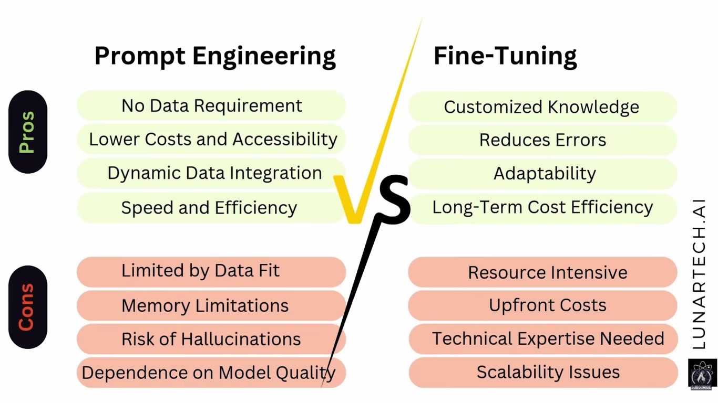

Fine tuning step by step:
- Define your objectives

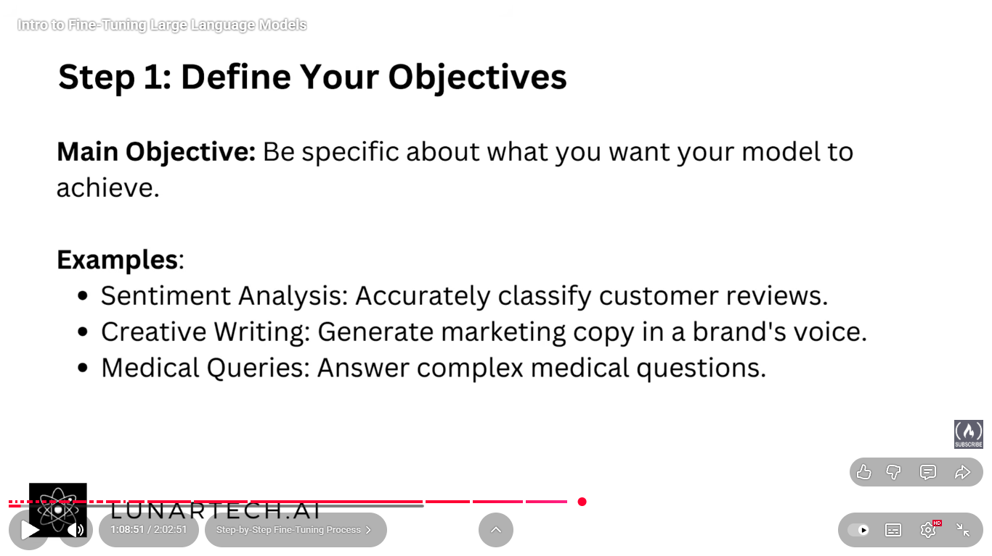

- Preparing data

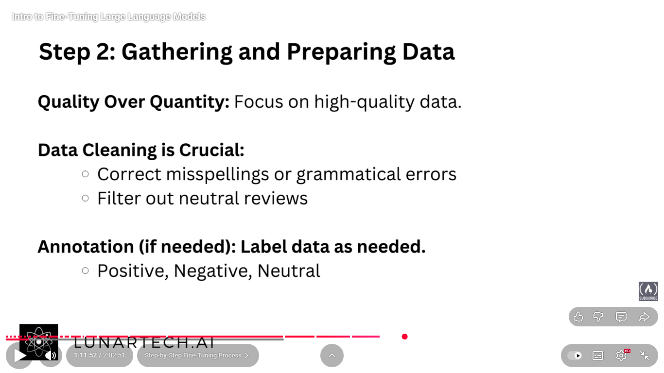
This labeling can be done by the classification models or chat models.

- Choosing a Pre-Trained Model:

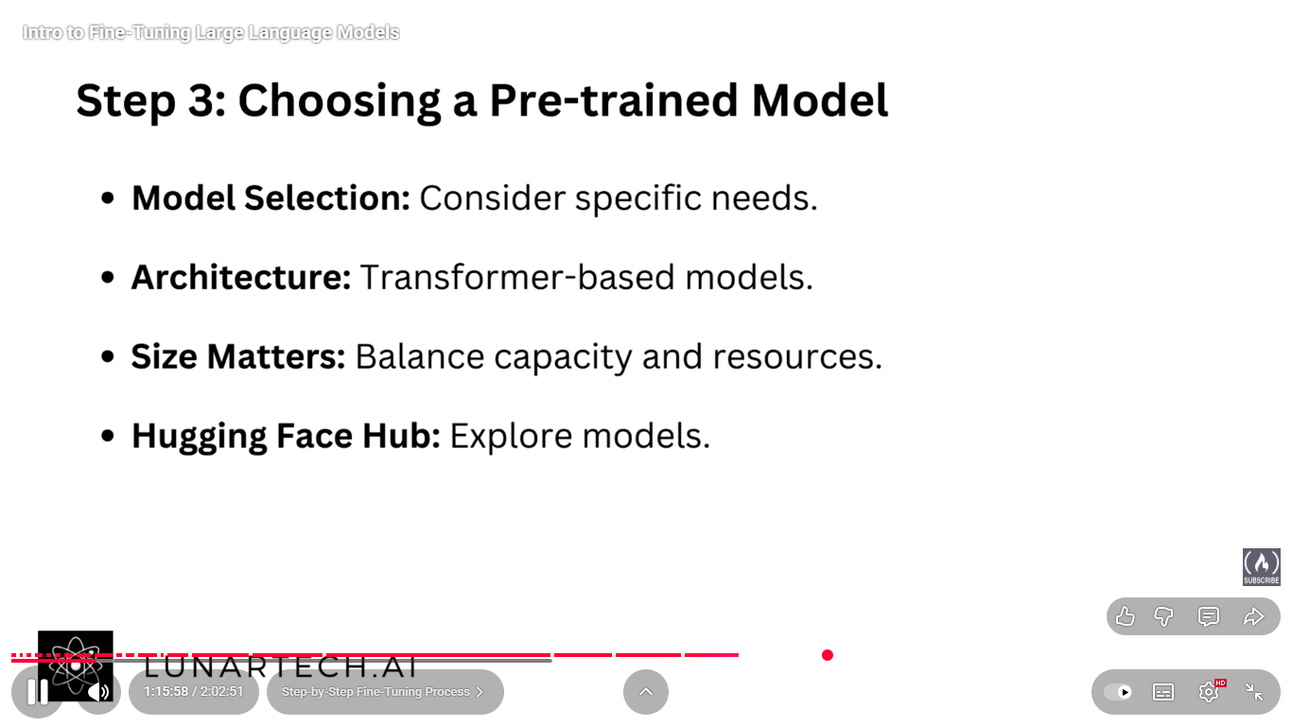
- Fine tuning set-up:

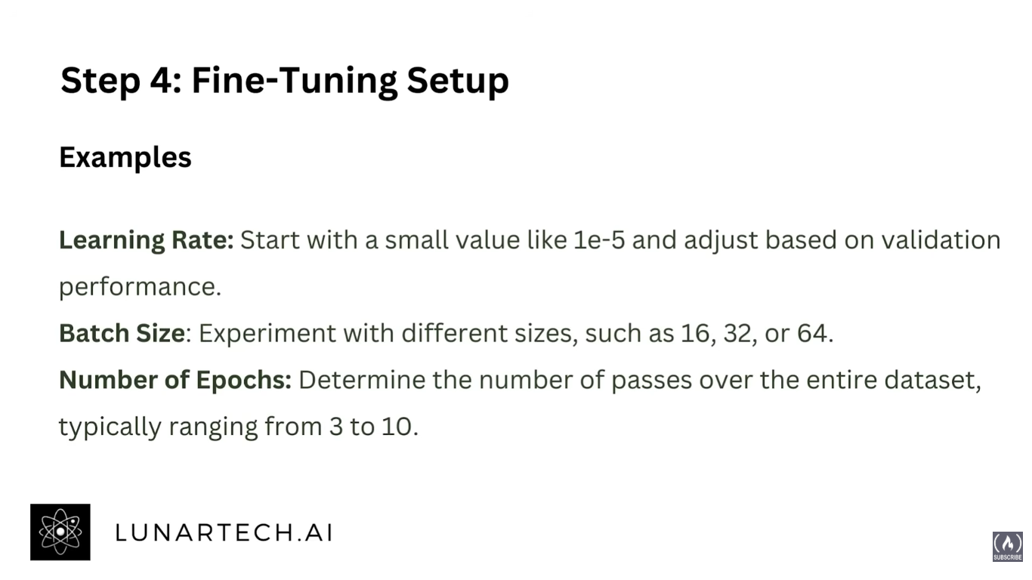

- Training:

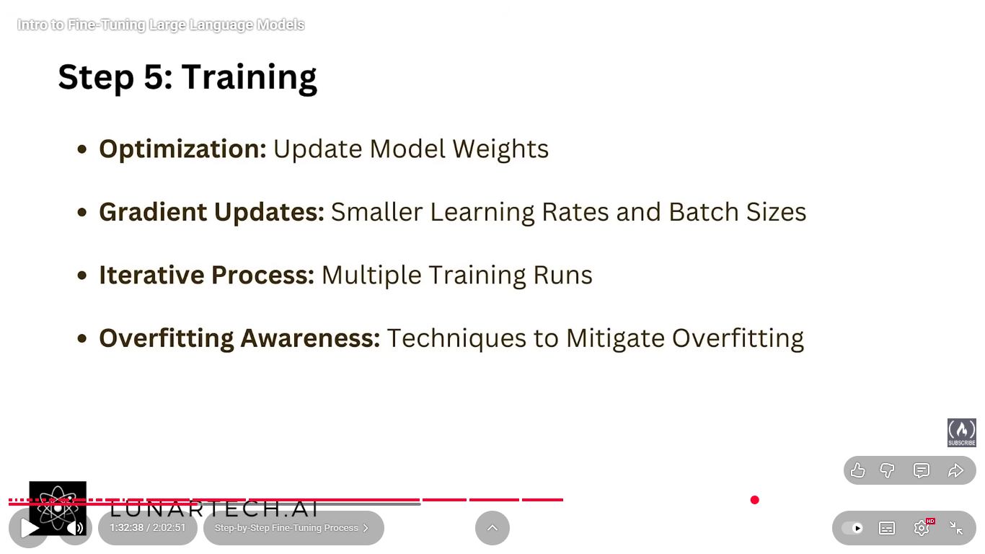

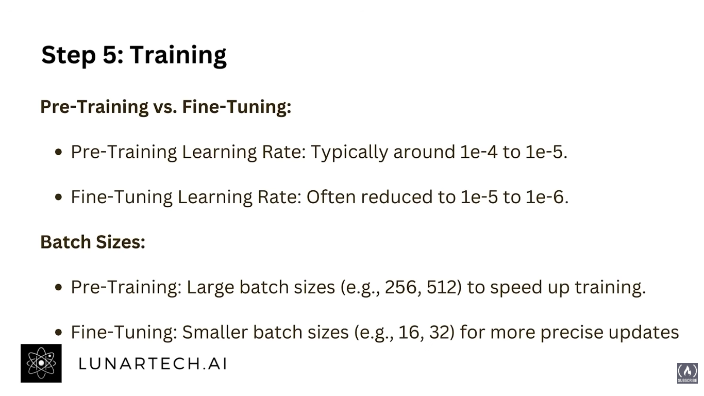

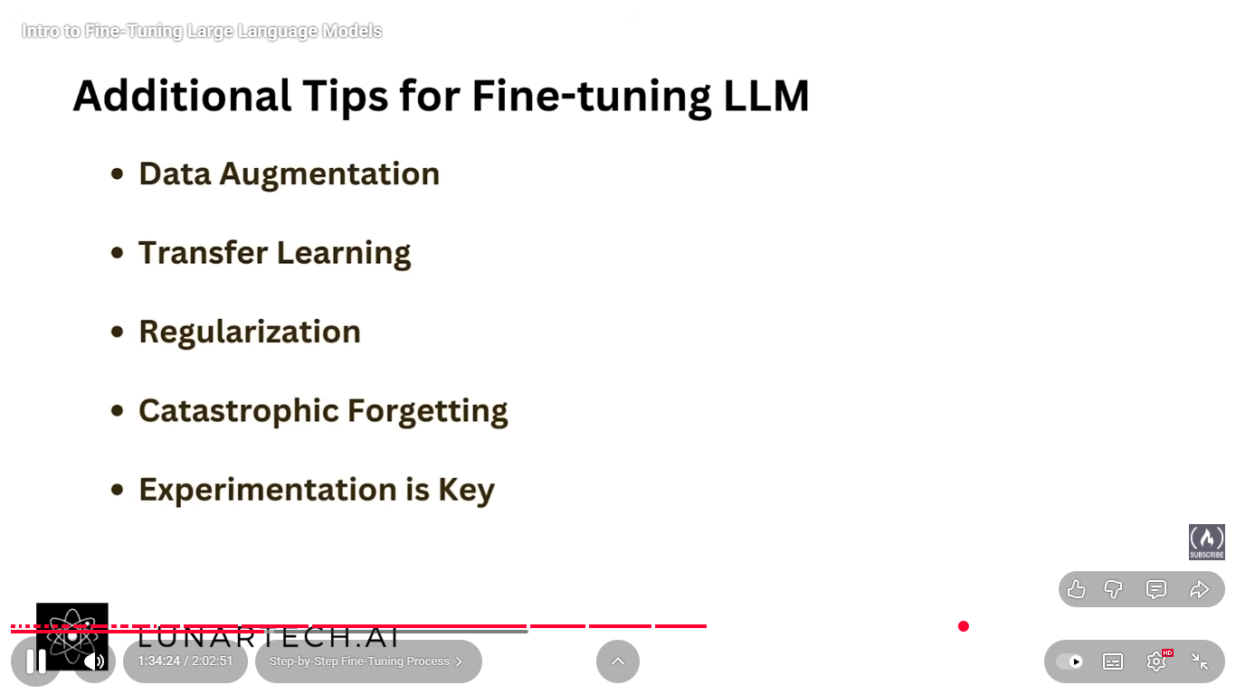

Fine tuning techniques:
Classification:
- Based on type of supervision:
  - Supervised (labeled pairs)
  - Semi-supervised (few labels + unlabeled data)
  - Unsupervised / Self-supervised (no labels)
  - RLHF / Preference-based (reward or ranking feedback)
- Adaptation scope:
  - Full fine-tuning (all weights)
  - Partial fine-tuning (selected layers)
  - PEFT (LoRA, Adapters, Prefix-tuning, BitFit, etc.)
  - Feature-based (model frozen, external head trained)
- By Optimization Objective
What loss function or algorithm drives updates?
- Cross-entropy / MLE
- Contrastive learning
- Reinforcement (PPO, DPO)
- Regularized / continual learning losses
- Multitask or meta-learning losses
- By Purpose / Use Case
- Task adaptation (specific downstream task)
- Domain adaptation (new text domain)
- Instruction following (natural language tasks)
- Alignment (aligning with human feedback)
- Personalization / style tuning
- Continual learning (model updates without forgetting)

  - Supervised fine-tuning (SFT) is the process of training a pre-trained model further on a labelled dataset, where each input xxx has an explicitly provided target output y.
The goal is to align the model’s predictions with these known target outputs using supervised learning (usually via cross-entropy loss).
It is the most fundamental and common form of fine-tuning — all other types (like RLHF, DPO, etc.) usually start after or on top of an SFT stage.

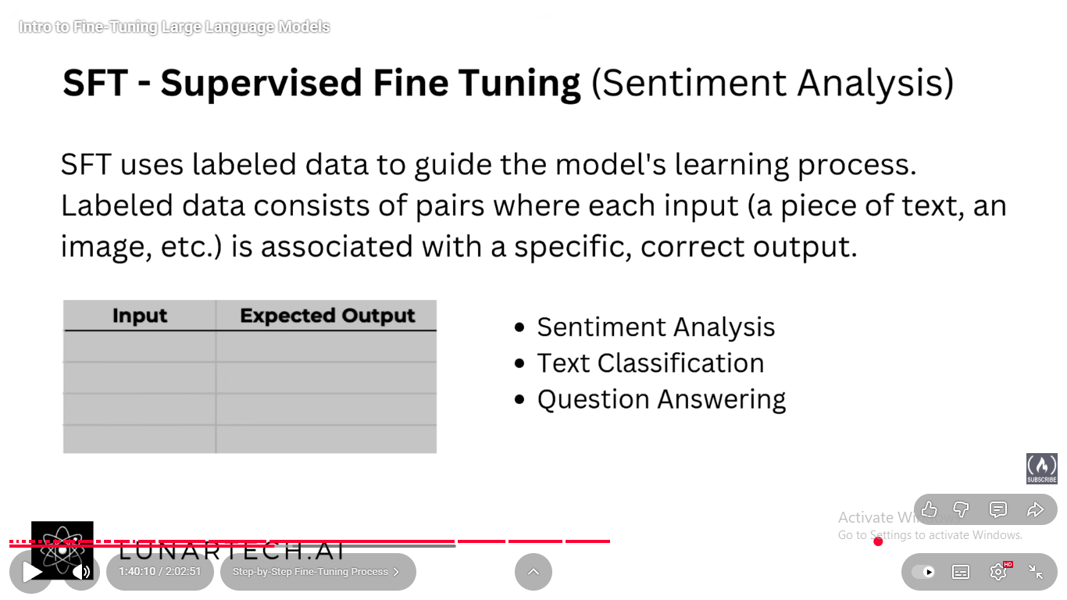
  - Semi-Supervised Fine-Tuning (SSFT): Semi-Supervised Fine-Tuning (SSFT) is a fine-tuning approach that uses a mix of labeled and unlabeled data to adapt a pre-trained model.
It leverages the labeled data to learn task-specific behaviour and the unlabeled data to improve generalization, domain understanding, and data efficiency.
SSFT Strategies:
- Pseudo-Labeling (a.k.a. Self-Training):
In pseudo-labeling, a model trained on a small labeled dataset is used to predict labels for a large set of unlabeled data. These predicted labels (called pseudo-labels) are treated as ground truth, and the model is then retrained on the combination of real and pseudo-labeled data. This approach effectively enlarges the training set and helps the model generalize better, provided the initial model’s predictions are reasonably accurate.
- Consistency Regularization: Consistency regularization enforces that a model’s predictions remain stable when the same unlabeled input is slightly modified — for example, by adding noise, changing phrasing, or applying dropout. The goal is to encourage the model to learn smoother, more robust decision boundaries by focusing on semantic meaning rather than surface variations, improving reliability under data perturbations and distribution shifts.
- Self-Training (Iterative Pseudo-Labeling): Self-training builds on pseudo-labeling by performing the process iteratively: the model first labels the unlabeled data, retrains using these labels, and then repeats this cycle with its improved version generating better pseudo-labels each time. Over iterations, the model refines its internal representations and confidence, allowing it to leverage massive unlabeled datasets even when starting with limited ground-truth labels.
- Co-Training: Co-training trains two or more models on different, complementary “views” or feature subsets of the same data. Each model generates pseudo-labels for the unlabeled samples, which are then used by the other model to continue training. This cross-supervision helps mitigate bias, improve label quality, and encourage diverse feature learning, especially when the data naturally contains multiple perspectives or modalities.
- Teacher–Student / Knowledge Distillation (Semi-Supervised Variant): In this approach, a strong teacher model (often pretrained or larger) generates labels or soft targets for unlabeled data, and a student model (smaller or specialized) learns from both the labeled and teacher-labeled data. This semi-supervised distillation allows knowledge transfer from teacher to student without needing full manual annotation, improving efficiency and domain adaptation while preserving performance.
  - Unsupervised / Self-Supervised (No Labels): In this strategy, the model continues training on unlabeled data using a self-supervised objective, such as masked language modeling (predicting missing words), next-token prediction, or denoising reconstruction. No human-provided labels are used; instead, the model learns from patterns within the data itself. This helps the model absorb domain knowledge, improve representations, and reduce overfitting, especially when labeled data is small. It is commonly used for domain adaptation (e.g., training on large amounts of medical or legal text before task-specific fine-tuning).
  - RLHF / Preference-Based (Reward or Ranking Feedback)
In this strategy, models are fine-tuned using feedback signals instead of explicit labels. Humans (or AI evaluators) provide preferences or rankings over multiple model outputs, indicating which response is better. A reward model is trained on this feedback, and the base model is then optimized—typically via reinforcement learning (RLHF) or simpler methods like Direct Preference Optimization (DPO)—to generate outputs that maximize the reward or align with preferred behavior. This approach is crucial for aligning large language models with human intent, safety, and conversational quality, beyond what supervised labels can achieve.

Sunny Savita
  - Understanding Model Pretraining and Training in AI (PDF notes 2)
  - Transfer learning and model fine tuning? (PDF notes 3)
Transfer learning means taking experience from one problem and using it to solve another related problem.
CNNs are better for transfer learning than LSTMs?
In the pre-transformer era, transfer learning was far more successful and efficient in CNN-based computer vision than in LSTM-based sequential/NLP tasks, because visual features are more universal, and CNN architectures support easy feature reuse — while LSTMs produced task- and domain-specific representations that didn’t generalize as well. This is mainly because CNNs learn hierarchical and spatially invariant features (such as edges, textures, and shapes) that are reusable across different visual domains, and their convolutional weight-sharing structure allows stable and efficient fine-tuning. In contrast, LSTMs depend on sequential context and domain-specific vocabularies, making their learned representations sensitive to data distribution, tokenization, and task type. Additionally, CNNs benefited from large-scale pretrained models like ImageNet networks, while LSTMs lacked standardized large-scale pretraining before models like ULMFiT, further limiting their transfer learning efficiency.

Fine tuning Frameworks:
  - Hugging Face Ecosystem
The foundation of modern LLM fine-tuning.

🔹 What it offers:
- Transformers – Provides ready-made architectures (BERT, GPT, LLaMA, T5, etc.), tokenizers, and trainer APIs for fine-tuning.
- PEFT (Parameter-Efficient Fine-Tuning) – Lets you fine-tune only a small subset of parameters using methods like LoRA, QLoRA, Prefix Tuning, and Adapters — saves huge compute and memory.
- Accelerate – Manages multi-GPU, mixed precision, and distributed fine-tuning automatically.
- TRL (Transformers Reinforcement Learning) – Adds RLHF, DPO, PPO, and SFT pipelines to align models with human or preference feedback.
- Datasets / Evaluate – Tools to easily load, preprocess, and benchmark data.

💡 Why it exists:
Because raw PyTorch or TensorFlow training is too low-level. Hugging Face provides plug-and-play abstractions so you can fine-tune powerful LLMs with just a few lines of code — from consumer GPUs to clusters.
  - DeepSpeed (Microsoft)
Designed for scaling LLM training and fine-tuning efficiently.

🔹 What it offers:
- Memory optimization via ZeRO (Zero Redundancy Optimizer) — splits optimizer states and gradients across GPUs.
- Hybrid engine for CPU/GPU offloading.
- DeepSpeed-Chat – complete RLHF pipeline (Supervised Fine-Tuning → Reward Model → PPO).
- Works as a backend for Hugging Face, Megatron-LM, and PyTorch Lightning.

💡 Why it exists:
Fine-tuning multi-billion-parameter models exceeds GPU memory. DeepSpeed enables you to train 10B+ parameter models on limited hardware by reducing redundancy and distributing memory efficiently.

  - LLaMA-Factory
A GUI/CLI tool to fine-tune models with zero coding.

🔹 What it offers:
- Interactive interface to fine-tune models via web UI or command line.
- Supports SFT, LoRA, QLoRA, DPO, PPO training modes.
- Built on Hugging Face + PEFT + TRL stack.
- Generates training logs, graphs, and evaluations automatically.

💡 Why it exists:
Most researchers or developers just want to fine-tune without writing code. LLaMA-Factory provides a visual, beginner-friendly layer over the Hugging Face ecosystem.

  - Unsloth
An ultra-fast, memory-efficient framework for fine-tuning LLMs on limited hardware.

🔹 What It Offers:
- 2–5× faster fine-tuning through optimized CUDA kernels and fused attention layers.
- Up to 70% lower memory usage with 4-bit QLoRA and PEFT integration.
- Fully compatible with Hugging Face Transformers and PEFT APIs.
- Supports LoRA, QLoRA, SFT, DPO, and chat-tuning (Alpaca, ShareGPT).
- Integrates FlashAttention and Paged Attention for faster context processing.
- Produces models ready for deployment on HF Hub, vLLM, or Text Generation Inference.

💡 Why It Exists:
Fine-tuning large models was traditionally resource-heavy. Unsloth aims to democratize LLM fine-tuning — enabling individuals, researchers, and small labs to fine-tune billion-parameter models on consumer GPUs quickly, efficiently, and without complex distributed setups.

- Axolotl
One-stop orchestrator for open-source LLM fine-tuning.

🔹 What It Offers:
- Configuration-driven fine-tuning (via YAML) for LoRA, QLoRA, DPO, and SFT.
- Built on Transformers + PEFT + TRL + Accelerate + DeepSpeed.
- Handles tokenization, checkpoints, and evaluation automatically.

💡 Why It Exists:
Fine-tuning involves complex setup; Axolotl automates everything, enabling fast, reproducible, end-to-end pipelines for instruction or chat tuning.
- Colossal-AI
Optimized distributed and memory-efficient fine-tuning framework.

🔹 What It Offers:
- 3D parallelism (data, tensor, pipeline).
- Automatic memory optimization and quantized fine-tuning (QLoRA).
- Integration with HF for easy adoption.

💡 Why It Exists:
To handle trillion-scale models efficiently across many GPUs while keeping throughput high and costs low.
- LightLLM:
What it is:
A lightweight, high-performance inference and fine-tuning framework optimized for speed and low memory.
Offers: Efficient GPU scheduling, kernel-level acceleration, paged attention, KV cache sharing, and partial fine-tuning.
Why it exists: To enable ultra-fast inference and selective fine-tuning of large models (e.g., partial layer tuning) with minimal compute cost, ideal for deployment scenarios or low-latency fine-tuning.
- OpenLLM (by BentoML)
What it is:
A production-grade framework for serving and managing fine-tuned LLMs.
Offers: Deployment of LLMs via REST/gRPC APIs, Docker containers, and model registries; integrates with HF, PyTorch, and vLLM.
Why it exists: To bridge the gap between research fine-tuning and real-world deployment — turning models into scalable APIs or microservices.

- FastChat
What it is:
The open-source chat framework behind Vicuna and FastChat-T5 models.
Offers: Multi-turn chat data collection, training scripts for instruction-tuning and alignment, and inference APIs.
Why it exists: To support chat-style fine-tuning and evaluation of conversational LLMs, and to host multi-model chat servers efficiently.

- SkyPilot
A unified orchestration framework for training and fine-tuning across clouds.
🔹 what it offers:
- YAML-based Job Setup – One command to launch fine-tuning jobs anywhere.
- Auto-Provisioning – Dynamically allocates and tears down cloud instances.
- Multi-Cloud Support – AWS, GCP, Azure, and on-prem clusters.
- Integration – Works seamlessly with DeepSpeed, Axolotl, and Hugging Face.
💡 Why it exists:
Because managing infrastructure for fine-tuning is hard — SkyPilot automates cloud setup, scaling, and cost optimization so you can focus purely on model development.

Fine tuning VS RAG VS Agents
Fine-Tuning
What it is:
Fine-tuning means training a pre-trained LLM further on domain-specific or task-specific labeled data so it adapts to that style, vocabulary, or objective.
How it works:
- You take a base model (e.g., GPT, LLaMA).
- Provide it with new examples related to your task (e.g., medical Q&A, legal text).
- The model updates its weights slightly to internalize that knowledge.
When to use:
- When you need specialized style or consistent behavior.
- When your data is stable and high-quality.
- Example: A fine-tuned GPT for medical diagnosis reports or customer support tone.
Pros: Precise, consistent, doesn’t depend on retrieval.
Cons: Expensive, needs lots of data, and can become outdated.
RAG (Retrieval-Augmented Generation)
What it is:
RAG combines information retrieval with generation — the model retrieves relevant documents from an external database before generating the answer.
How it works:
- The query triggers a retriever (like a vector database) to fetch related documents.
- The LLM then reads those documents and uses them to generate an informed answer.
- The model weights are not changed — knowledge is provided dynamically at runtime.
When to use:
- When information changes frequently (e.g., company policies, research papers).
- When you can’t fine-tune or store all knowledge inside the model.
Pros: Up-to-date, cheaper, interpretable (you can see retrieved sources).
Cons: Dependent on retrieval quality; slower due to extra retrieval step.

3. Agents
What it is:
Agents are LLMs with reasoning and tool-using abilities — they can plan, call APIs, use tools, or perform multi-step reasoning to achieve goals.
How it works:
- The model interprets a user goal.
- Decides which tools/actions to use (e.g., search the web, run code, call RAG).
- Executes steps iteratively and combines results for a final response.
When to use:
- When tasks involve actions, planning, or multiple information sources.
- Example: An AI assistant that books flights, summarizes emails, and analyzes data.
Pros: Dynamic, autonomous, capable of complex workflows.
Cons: Harder to control, slower, needs strong tool integration.

Why Finetuning Was Difficult in RNN or LSTM – How Transformers Changed the Game

LSTM vs Transformer | Why Transformers Replaced LSTM in NLP

Master Hugging Face

Hugging Face
Details PDF notes
Hugging Face vs LangChain
LangChain mainly provides you the ability to connect to different LLM APIs, prompting etc. i.e. ability for RAG application, tools for agents (primarily in LangGraph). Whereas Hugging face is an ecosystem which provides different model resource, embedding resource, dataset resource and provides libraries and frameworks for fine tuning and complex DL/AI/Gen AI tasks.
- Hugging face tokens and connecting to hugging face:
There are two kinds of tokens read and write. Do learn the secret in the COLAB.
There are three ways to connect to the hugging face.
CLI, API and COLAB notebook. Details of all three are in COLAB file.
- Hugging Face Dataset library, Preprocessing and Visualization.
In COLAB various datasets are loaded with all the different parameters available. Look at those different dataset loads and do mention those unique things in here.
Visualization is like what it is in normal python.
- Custom dataset: convert a data frame into a dataset format and then do push the file to the dataset repo.
- Tokenization:
- Embedding:
- Download: simple codes in COLAB

Evaluation:
Here is a clear and concise summary of the BLEU, ROUGE, and Perplexity metrics, focusing on their purpose, what they measure, and where they are best used:
BLEU
- Purpose: Measures how closely machine-generated text matches one or more human reference texts.
- What it measures: Precision of overlapping n-grams between generated and reference texts, with a brevity penalty to avoid short outputs.
- Use case: Best suited for machine translation and tasks where a close match to reference text phrasing is desired.
- Interpretation: Higher BLEU means generated text closely matches references in exact wording and phrases.
ROUGE
- Purpose: Measures how much of the important content from reference text is captured in the generated output.
- What it measures: Recall of overlapping n-grams or longest common subsequence between generated and reference texts.
- Use case: Primarily used for summarization and content coverage tasks, where the goal is to capture all salient information.
- Interpretation: Higher ROUGE means more coverage of the original content from references.
Perplexity
- Purpose: Evaluates the fluency and the predictive power of a language model in generating or predicting a sequence of words.
- What it measures: The uncertainty or "surprise" of a model when predicting the next word, using the exponentiated average negative log-likelihood.
- Use case: Used to assess and compare language models' ability to generate coherent and natural text.
- Interpretation: Lower perplexity indicates better confidence and fluency; higher perplexity indicates uncertainty or diverse generation.
Summary Table
Metric | Focus | What it Measures | Main Use Case | Interpretation
BLEU | Precision | N-gram overlap precision | Machine translation | Higher means closer text match
ROUGE | Recall | N-gram and sequence recall | Summarization | Higher means better content coverage
Perplexity | Fluency/Confidence | Predictive probability | Language modeling | Lower means better fluency
This summary should help you understand which metric to use based on your specific generation task—BLEU for exact phrasing, ROUGE for content completeness, and Perplexity for language fluency and model quality.

Fine-Tuning BERT for NLP

LLM Knowledge Distillation
Knowledge distillation:
Knowledge distillation is a machine learning technique where knowledge is transferred from a large, complex model (teacher) to a smaller, more efficient model (student). The main goal is to compress the teacher’s knowledge so the student achieves similar accuracy but with less computational cost and memory footprint. The teacher model is first trained on the original dataset and produces "soft labels" or probability distributions over classes instead of just "hard labels." These soft labels contain rich information about class similarities and uncertainties. The student model is then trained to mimic these softened outputs by minimizing a combined loss function, which incorporates both the traditional classification loss with hard labels and a distillation loss measuring how close the student’s output is to the teachers. By converting student training into a regression-like problem over these probability distributions, the student learns the teacher’s nuanced knowledge. Variants such as response-based, feature-based, and relation-based distillation exist, with applications in natural language processing, computer vision, and other domains where deploying efficient models is crucial.
Kullback-Leibler (KL) Divergence in Distillation Loss
KL divergence is a measure from information theory that quantifies how one probability distribution differs from a reference distribution. For distributions PP (true) and QQ (approximation), KL divergence DKL(P∥Q) DKL (P∥Q) measures the expected extra amount of information needed to encode samples from PP when using a code optimized for QQ. It is non-negative and zero only when the two distributions are identical. In knowledge distillation, KL divergence is used as the distillation loss component to measure the difference between the teacher’s softened output probabilities and the student’s predicted probabilities. Minimizing KL divergence helps the student to closely mimic the teacher’s output distribution, transferring the teacher’s "dark knowledge" about class similarities. The loss function combines KL divergence on softened outputs with standard cross-entropy loss on hard labels, balancing fidelity to the teacher with correctness to ground truth.

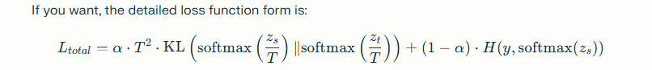

LLM Quantization
- Quantization:
Here is a clear and concise summary of static and dynamic post-training quantization based on the previous discussion:
- Quantization reduces model size and speeds up inference by converting 32-bit floating-point weights and activations into lower precision formats (like int8).
- In static post-training quantization, both weights and activations are quantized before inference using fixed quantization parameters (scale and zero-point).
  - These parameters are computed using a calibration dataset, which is a representative set of inputs passed through the model offline.
  - For each layer, the min and max activation values are found across all calibration samples (taking the overall min and max, not averages), which define the range used to calculate scale and zero-point per layer.
  - This enables efficient integer-only inference with fixed quantization parameters but requires careful calibration to maintain accuracy.
- In dynamic post-training quantization, weights are quantized before inference, but activations are quantized on-the-fly during each inference pass based on the actual input.
  - For each layer and each inference input, min and max activation values are dynamically calculated, and quantization parameters are computed on the spot.
  - This approach does not need any calibration dataset and adapts to input variability, but it incurs additional computational overhead during inference and is usually slower than static quantization.
- Overall, static quantization is preferred for maximizing inference speed and efficiency when a good calibration dataset is available, while dynamic quantization offers simplicity and flexibility at some runtime cost.

Train LLMs (here do the fine tuning stuff, like types and variants and all).
SFT: (after unsupervised training):
- On parameter level:
- Old school:
- Freezing all layers except the last layer: Only the output or head layer is trained while the rest of the model weights remain unchanged. This is computationally efficient and preserves most of the pretrained knowledge while allowing the model to adapt to a new task by adjusting the final mapping.
- Unfreezing and retraining a few of the last layers: A small number of top layers (closer to output) are unfrozen and fine-tuned. This strikes a balance between efficiency and model adaptation capacity, often improving performance especially on tasks closer to the pretrained model’s domain.
- PEFT:
- LoRA/QLoRA: LoRA decomposes weight updates into low-rank matrices, drastically reducing trainable parameters; QLoRA combines LoRA with 4-bit quantization for efficiency on large LLMs.
- DORA: Another variant of low-rank adaptation focusing on efficient updates, similar in spirit to LoRA but with different implementation details.
- Adaptors: Small inserted layers into pretrained models that are trained for the task, leaving the main weights frozen.
- BIFRI: A newer method involving parameter-efficient fine-tuning by injecting trainable parameters in a structured and efficient manner (less common but part of the PEFT family).
- IA3 (Input-Adaptive Adapters): Uses learned vectors to rescale activations inside transformer blocks instead of updating weight matrices, extremely parameter-efficient.
- Prefix Training: Adds trainable continuous vectors ("prefixes") to each transformer layer's input, modulating model behaviour without changing the main weights.
- Prompt Tuning: Only optimizes continuous prompt embeddings at input embeddings level, highly parameter-efficient but sometimes less powerful than prefix tuning.
- On data level:
- Non-instructional
- Instructional FT
- Alignment with human feedback (preference-based learning):
- RLHF (PPO)
- DPO

Why Fine-tuning Was Difficult in RNN or LSTM – How Transformers Changed the Game?

