AUTOMOBILE EFFICIENCY REGRESSOR &
VEHICLE CLASS PROFILER
(Automobile Fuel Economy Regressor & Vehicle Archetype Profiling System)
A Project Report submitted in partial fulfillment of the requirements for the
internship program requirement for the degree of
BACHELOR OF TECHNOLOGY
IN
COMPUTER SCIENCE AND ENGINEERING
(ARTIFICIAL INTELLIGENCE & MACHINE LEARNING)
Submitted by:
KOLISETTY HARSHA VARDHAN
Roll No: A24126552154 | IBM ID: IBMQ2DST1468
UG Level: 2nd Year (Batch 2023–2027)
DEPARTMENT OF COMPUTER SCIENCE & ENGINEERING (AI & ML)
ANIL NEERUKONDA INSTITUTE OF TECHNOLOGY AND SCIENCES (UGC AUTONOMOUS)
(Permanently Affiliated to Andhra University, Approved by AICTE, Accredited by NBA & NAAC with 'A+' Grade)
Sangivalasa, Bheemunipatnam Mandal, Visakhapatnam – 531162, Andhra Pradesh
Academic Year: 2023–2027

ANIL NEERUKONDA INSTITUTE OF TECHNOLOGY AND SCIENCES (AUTONOMOUS)
(Affiliated to Andhra University, Approved by AICTE)
Sangivalasa, Visakhapatnam – 531162 | 2023–2027
BONAFIDE CERTIFICATE
This is to certify that this Internship Project Report titled “Automobile Efficiency Regressor & Vehicle Class Profiler” carried out under the IBM SkillsBuild Internship Program in technical collaboration with the Edunet Foundation and AICTE, is the bonafide work of KOLISETTY HARSHA VARDHAN (Reg. No: A24126552154), student of II/IV B.Tech in Computer Science and Engineering (Artificial Intelligence and Machine Learning), who carried out the internship under our supervision and guidance.
REVIEWER / MENTOR  ______________________  Assistant Professor  Department of CSE (AI & ML)  ANITS | CLASS TEACHER  ______________________  Assistant Professor  Department of CSE (AI & ML)  ANITS
HEAD OF THE DEPARTMENT
______________________
DR. K. SELVANI DEEPTHI
Professor & Head of the Department
Department of CSE (AI & ML)
ANITS

ACKNOWLEDGEMENT
An engineering endeavor that spans rigorous technical problem solving becomes a meaningful success with the valuable advice, encouragement, and support of mentors and well-wishers. I take this opportunity to express my heartfelt gratitude to all those who have been instrumental in making this internship experience both enriching and academically rewarding.
First and foremost, I extend my deep gratitude to Dr. K. Selvani Deepthi, Head of the Department of Computer Science & Engineering (AI & ML) at Anil Neerkonda Institute of Technology and Sciences (ANITS), for her visionary guidance, administrative support, and continuous encouragement throughout the internship duration.
I would like to convey my sincere appreciation to the IBM SkillsBuild Internship Program, the Edunet Foundation, and AICTE for providing the institutional ecosystem, industrial problem statements, and learning resources required to undertake this applied AI project. The mentorship provided by industrial specialists has offered me invaluable lessons that extend far beyond classroom theory.
I also thank all the faculty members of the Computer Science & Engineering (AI & ML) Department for their insightful advice, technical reviews, and academic support. Finally, I thank my parents and peers whose constant support was vital to the successful completion of my project.
KOLISETTY HARSHA VARDHAN
Roll No: A24126552154
IBM ID: IBMQ2DST1468
Department of CSE (AI & ML), ANITS

TABLE OF CONTENTS
1. Introduction | 1
1.1 Background of the Internship | 1
1.2 Objectives of the Internship | 1
1.3 Importance of AI in Automotive Analytics & Energy Optimization | 2
1.4 Scope of the Project | 2
2. Organization Profile | 3
2.1 Overview of AICTE Virtual Internships | 3
2.2 Role of the Edunet Foundation | 3
2.3 IBM & IBM SkillsBuild as the Technology Partner | 4
2.4 Program Structure and Operational Framework | 4
3. Project Overview | 5
3.1 Title of the Project | 5
3.2 Engineering and Business Problem Statement | 5
3.3 Core Objectives & Quantitative Target Metrics | 6
3.4 Relevance to Industrial Design and Environmental Compliance | 6
4. Literature Review & Theoretical Background | 7
4.1 Physics of Automotive Energy Consumption and Drag Mechanics | 7
4.2 Supervised Learning: Regularized Regression Paradigms | 8
4.3 Unsupervised Learning: K-Means Clustering and 2D PCA | 9
4.4 Explainable AI (XAI) and Standardized Feature Attribution | 10
5. Methodology & Mathematical Formulation | 11
5.1 Dataset Description and Statistical Characteristics | 11
5.2 Rigorous Preprocessing and Anti-Leakage Protocol | 12
5.3 Domain-Specific Feature Engineering and Mechanical Formulation | 13
5.4 Partitioning Strategy and 5-Fold Cross-Validation Framework | 14
5.5 Mathematical Formulation of Model Evaluation Metrics | 15
6. System Architecture & Implementation | 16
6.1 Five-Layer Decoupled Enterprise Architecture | 16
6.2 Data Ingestion & Dual-Engine Persistence Layer (MySQL & SQLite) | 17
6.3 Machine Learning Pipeline and Model Serialization | 18
6.4 Asynchronous REST API Backend (FastAPI & Pydantic) | 19
6.5 Interactive Presentation Dashboard | 20
6.6 Software Quality Assurance: Automated Pytest Suite | 21
7. Results & Discussion | 22
7.1 Regression Benchmark Leaderboard & Comparative Analysis | 22
7.2 Unsupervised Vehicle Clustering & Archetype Identification | 24
7.3 Dimensionality Reduction via 2D PCA | 25
7.4 Explainable AI & Directional Mechanical Impact Analysis | 26
7.5 Interactive Web Application Demonstration | 28
8. Business Impact, Challenges & Responsible AI | 29
8.1 Industrial Applications & Operational Value | 29
8.2 Technical Challenges Encountered and Solutions Adopted | 30
8.3 Limitations and Responsible AI Considerations | 31
9. Conclusion & Future Scope | 32
9.1 Summary of Learnings and Project Achievements | 32
9.2 Recommendations and Future Enhancements | 33
10. Internship Outcomes | 34
10.1 Technical Competencies Acquired | 34
10.2 Soft Skills & Professional Attributes Developed | 35
10.3 Contribution to Career Growth | 35
Appendix | 36
Appendix A: Source Code Architecture & Execution Script Snippets | 36
Appendix B: Database Relational Schema | 38

1. Introduction

1.1 Background of the Internship
This project report documents the learning outcomes and technical deliverables developed during a comprehensive four-week virtual internship program. The internship was completed as part of the academic requirements for the degree of Bachelor of Technology in Computer Science and Engineering (Artificial Intelligence and Machine Learning) at Anil Neerkonda Institute of Technology and Sciences (ANITS), Visakhapatnam. The internship was offered under the IBM SkillsBuild Internship Program, organized in technical partnership with the Edunet Foundation and the All India Council for Technical Education (AICTE).
The primary philosophy of the program centers on project-based learning and industrial mentorship. The curriculum was structured not merely to review theoretical machine learning concepts, but to equip students with the methodologies required to engineer production-ready, mathematically rigorous software solutions. By integrating enterprise guidance from IBM with institutional academic oversight from ANITS and AICTE, the program challenged students to address real-world sustainability and energy optimization problems.

1.2 Objectives of the Internship
The overarching goal of the internship was to gain hands-on proficiency in designing, training, evaluating, and deploying machine learning models to solve complex engineering problems. Key objectives established at the outset of the internship included:
- Implementing a disciplined, leakage-free data preprocessing pipeline adhering strictly to enterprise standards.
- Benchmarking supervised regression algorithms (Ordinary Least Squares, Ridge, Lasso, and ElasticNet) to model continuous automotive fuel efficiency.
- Executing unsupervised machine learning (K-Means Clustering and 2D Principal Component Analysis) to discover structural vehicle archetypes.
- Engineering an Explainable Artificial Intelligence (XAI) feature attribution engine to quantify the physical impact of each mechanical variable.
- Architecting a scalable, decoupled software stack featuring a FastAPI asynchronous backend, a dual-mode MySQL/SQLite database layer, and a modern responsive dashboard.
- Enforcing automated software quality standards by executing automated unit and integration tests using pytest.

1.3 Importance of AI in Automotive Analytics & Energy Optimization
The modern global automotive industry operates in an era defined by aggressive decarbonization mandates, stringent emissions legislation, and escalating consumer demands for energy efficiency. Vehicle fuel economy, traditionally measured in Miles Per Gallon (MPG), is governed by complex, multi-variable physical relationships. Variables such as curb weight, engine displacement, cylinder geometry, horsepower, and aerodynamic styling interact non-linearly to dictate energy dissipation.
In legacy automotive research and development cycles, evaluating the fuel economy of alternative design concepts necessitated physical chassis fabrication and testing on roller dynamometers. This hardware dependency introduces severe bottlenecks, where iterating through hundreds of prospective engine-chassis configurations incurs immense financial and temporal overhead. Deploying Artificial Intelligence and Machine Learning allows automotive engineers to conduct rapid 'virtual prototyping.' By predicting continuous fuel efficiency and segmenting vehicles into structural archetypes in sub-second inference cycles, AI drastically compresses design timelines and enables data-driven environmental compliance.

1.4 Scope of the Project
The scope of this project encompasses the entire lifecycle of an applied data science application, specifically:
- Data Ingestion & Hygiene: Ingestion and cleaning of the canonical UCI Auto MPG dataset (398 records, 8 technical features).
- Feature Transformation: Rigorous handling of missing values, one-hot encoding of categorical geographic origins, and standard scaling without data leakage.
- Domain Feature Engineering: Derivation of mechanical indices including power-to-weight ratio, per-cylinder displacement, and relative vehicle age.
- Predictive Modeling: Training and cross-validating regularized regressors to achieve R² > 0.85 and RMSE < 3.0 MPG on unseen holdout test data.
- Unsupervised Clustering: Partitioning the fleet into 3 distinct operational archetypes via K-Means, supported by 2D PCA dimensionality reduction retaining >90% variance.
- Full-Stack Deployment: Building a production-ready asynchronous REST API backend in FastAPI and an interactive web interface with dynamic Chart.js visualizations.

2. Organization Profile

2.1 Overview of AICTE Virtual Internships
The All India Council for Technical Education (AICTE) is the statutory apex advisory body for technical education under the Ministry of Education, Government of India. In alignment with the National Education Policy (NEP 2020), AICTE launched the AICTE Internship Portal to bridge the structural disconnect between academic collegiate curricula and contemporary industrial skill demands. The portal serves as a unified digital platform facilitating accredited, credit-bearing virtual internships in cutting-edge technology domains including Artificial Intelligence, Cloud Computing, and Data Analytics.

2.2 Role of the Edunet Foundation
The Edunet Foundation is a Section 8 non-profit social enterprise dedicated to empowering Indian youth through institutional skill development, technological literacy, and workforce readiness. As the primary operational and curriculum delivery partner for the internship, Edunet coordinates program onboarding, structured masterclasses, live technical mentorship, and milestone evaluation frameworks. Edunet emphasizes a dual-track educational model: equipping students with deep specialized technical competencies (data manipulation, statistical modeling, API development) while cultivating essential meta-human professional skills including problem formulation, architectural reasoning, and technical presentation.

2.3 IBM & IBM SkillsBuild as the Technology Partner
International Business Machines Corporation (IBM) is a world-renowned pioneer in computer architecture, cognitive computing, enterprise cloud platforms, and data analytics. Through its flagship corporate social responsibility and skills initiative, IBM SkillsBuild, IBM provides students and educators with enterprise-grade learning pathways, certified curricula, and access to industry mentors. In this program, IBM served as the corporate sponsor and technical benchmark setter, providing real-world case studies and demanding enterprise standards for model transparency, code maintainability, and responsible AI governance.

2.4 Program Structure and Operational Framework
The technical and operational structure of the internship is summarized in Table 2.1 below:
Program Dimension | Operational Details
Collaborative Partners | AICTE, Edunet Foundation, IBM SkillsBuild
Internship Duration | 4 Weeks (Intensive Applied Engineering Curriculum)
Instructional Delivery | Virtual / Synchronous Masterclasses & Code Mentorship
Target Audience | 2nd and 3rd Year Undergraduates in CSE (AI & ML)
Primary Tools & Stack | Python, Scikit-learn, Pandas, FastAPI, MySQL/SQLite, Chart.js
Key Evaluation Milestone | End-to-end software delivery, automated testing, case study report
Accreditation | Verified AICTE-partnered Certificate of Completion

3. Project Overview

3.1 Title of the Project
Automobile Efficiency Regressor & Vehicle Class Profiler
(Subtitle: Automobile Fuel Economy Regressor & Vehicle Archetype Profiling System)

3.2 Engineering and Business Problem Statement
Automotive decision-makers, fleet logistics managers, and environmental policy analysts consistently encounter three fundamental operational hurdles:
- Slow and Capital-Intensive Physical Testing: Measuring vehicle fuel consumption requires manufacturing physical test mules and conducting prolonged chassis dynamometer trials. This physical dependency delays early-stage conceptual design where thousands of engine-chassis configurations must be evaluated.
- Fragmented and Siloed Data: In legacy engineering workflows, mechanical specifications, engine metrics, and fuel consumption figures reside in disconnected spreadsheets. This fragmentation obscures the complex, non-linear relationships between mass, horsepower, displacement, and economy.
- The Black-Box Dilemma: Standalone empirical estimation equations or opaque machine learning models often predict a single MPG number without explaining which specific mechanical choices contributed to or detracted from that score, limiting their diagnostic value to design engineers.

3.3 Core Objectives & Quantitative Target Metrics
To address these operational challenges, the project established strict, quantitative performance and software engineering benchmarks:
- Continuous Predictive Precision: Train a regularized regression model that achieves an R² score greater than 0.85 and a Root Mean Square Error (RMSE) of less than 3.0 MPG on unseen holdout test data.
- Multicollinearity Mitigation: Benchmark Ordinary Least Squares against Ridge (L2 penalty), Lasso (L1 penalty), and ElasticNet (L1 + L2 penalty) using 5-Fold Cross-Validation to stabilize coefficient estimation.
- Autonomous Fleet Clustering: Implement unsupervised K-Means clustering to discover 3 structurally distinct vehicle archetypes, projecting them onto a 2D PCA space while preserving over 90% of feature variance.
- Zero Data Leakage: Strictly isolate an 80% training set (N=318) from a 20% test set (N=80), fitting all statistical transformers and imputers solely on training data.
- Transparent Explainable AI (XAI): Derive per-prediction feature attribution mechanics based on standardized coefficients to quantify each feature's directional impact on MPG.
- Decoupled Enterprise Software: Construct an asynchronous REST API backend in FastAPI, a dual-mode MySQL/SQLite database layer with automated fallback, and a responsive frontend dashboard.

3.4 Relevance to Industrial Design and Environmental Compliance
This project provides direct business value to automotive design and fleet management. In automotive R&D, rapid sub-second regression inference allows designers to conduct large-scale virtual simulations before committing capital to chassis fabrication. In fleet logistics, automated archetype clustering enables dispatchers to assign high-efficiency compacts to urban delivery routes while reserving larger vehicles for heavy hauling. Furthermore, the mass-to-efficiency relationships modeled here transfer directly to electric vehicle (EV) battery pack sizing and range trade-off studies.

4. Literature Review & Theoretical Background

4.1 Physics of Automotive Energy Consumption and Drag Mechanics
Vehicle fuel consumption is governed by fundamental classical mechanics. The total tractive force required to propel a vehicle is the summation of inertial resistance, rolling resistance, aerodynamic drag, and gravitational gradient forces:
Tractive Force Equation: F_tractive = F_rolling + F_aerodynamic + F_inertia + F_gradient = C_rr * m * g + 0.5 * rho * C_d * A * v^2 + m * a + m * g * sin(theta)

As evident from the mathematical formulation, vehicle mass (m) is a direct multiplier in rolling resistance, inertial acceleration, and gravitational grade forces. In internal combustion engines, larger displacements and higher cylinder counts increase internal mechanical friction, heat loss through cylinder walls, and volumetric pumping losses. Consequently, empirical predictive modeling must capture both linear mass penalties and non-linear component interactions.

4.2 Supervised Learning: Regularized Regression Paradigms
Linear regression models assume that the target variable (MPG) can be expressed as a linear combination of input features plus an error term. In matrix notation: y = X * w + epsilon. Four distinct regression formulations were evaluated in this study:

4.2.1 Ordinary Least Squares (OLS) Regression
Ordinary Least Squares estimates model parameters by minimizing the Residual Sum of Squares (RSS):
OLS Objective: L_OLS(w) = sum_{i=1}^n (y_i - x_i^T * w)^2 = ||y - X * w||_2^2

While OLS is the Best Linear Unbiased Estimator (BLUE) under the Gauss-Markov theorem, it becomes highly unstable when features exhibit strong multicollinearity (such as engine displacement and vehicle weight). In such scenarios, the matrix X^T * X is nearly singular, causing coefficient estimates to exhibit extreme variance.

4.2.2 Ridge Regression (L2 Regularization)
To stabilize ill-conditioned matrix inversion caused by multicollinearity, Ridge regression introduces an L2 norm penalty on the coefficient vector:
Ridge Objective: L_Ridge(w) = ||y - X * w||_2^2 + alpha * ||w||_2^2 = ||y - X * w||_2^2 + alpha * sum_{j=1}^p w_j^2

The L2 penalty continuously shrinks coefficient magnitudes toward zero without driving them strictly to zero, reducing model variance and improving out-of-sample generalization.

4.2.3 Lasso Regression (L1 Regularization)
Lasso (Least Absolute Shrinkage and Selection Operator) applies an L1 norm penalty to the cost function:
Lasso Objective: L_Lasso(w) = ||y - X * w||_2^2 + alpha * ||w||_1 = ||y - X * w||_2^2 + alpha * sum_{j=1}^p |w_j|

Because the L1 ball contains sharp corners along the coordinate axes, minimizing this objective drives less informative feature coefficients exactly to zero. Lasso thus performs automatic feature selection, producing a sparse, highly interpretable linear model.

4.2.4 ElasticNet Regression (L1 + L2 Regularization)
ElasticNet combines the strengths of both Ridge and Lasso through a convex combination of L1 and L2 penalties:
ElasticNet Objective: L_ElasticNet(w) = ||y - X * w||_2^2 + alpha * [ r * ||w||_1 + 0.5 * (1 - r) * ||w||_2^2 ]

Here, alpha controls the overall regularization penalty, while r represents the L1 mixing ratio. ElasticNet encourages a grouping effect: when multiple highly correlated features (e.g., displacement and weight) are present, it shrinks their coefficients together rather than arbitrarily selecting one like Lasso.

4.3 Unsupervised Learning: K-Means Clustering and 2D PCA
To discover natural, unlabelled structural groupings within the vehicle fleet, unsupervised learning algorithms were applied across the standardized mechanical specifications (excluding the target MPG).

4.3.1 K-Means Clustering
K-Means partitions n observations into k clusters S = {S_1, S_2, ..., S_k}, minimizing the within-cluster sum of squares:
K-Means Objective: arg min_S sum_{i=1}^k sum_{x in S_i} ||x - mu_i||^2

Cluster quality was evaluated using two diagnostic metrics: Within-Cluster Sum of Squares (Inertia) across varying values of k (the Elbow Method), and the Silhouette Coefficient, which measures how tightly each vehicle is bound to its assigned cluster compared to adjacent clusters.

4.3.2 2D Principal Component Analysis (PCA)
Because human visualization is restricted to two or three spatial dimensions, Principal Component Analysis (PCA) was utilized to project the 6-dimensional standardized feature space onto the two primary orthogonal eigenvectors of the feature covariance matrix. This dimensionality reduction preserves maximum mathematical variance while allowing cluster boundaries to be rendered clearly on the web dashboard.

4.4 Explainable AI (XAI) and Standardized Feature Attribution
A critical requirement of enterprise machine learning is interpretability. Because all input features were scaled to zero mean and unit variance (mu = 0, sigma = 1), each standardized regression coefficient w_j reflects the expected shift in predicted MPG resulting from a one-standard-deviation change in feature x_j. For an individual vehicle prediction, the local attribution score is computed as:
Local Feature Attribution Formula: Attribution_j = x_{scaled, j} * w_j

This formulation provides immediate diagnostic insight, showing whether an individual specification boosted or penalized the vehicle's fuel economy relative to the baseline intercept.

5. Methodology & Mathematical Formulation

5.1 Dataset Description and Statistical Characteristics
The project utilizes the canonical UCI Auto MPG Dataset. The dataset consists of N = 398 vehicle records with 8 technical attributes and 1 nominal car name string.
Feature Name | Data Type | Physical Description | ML System Role
mpg | Continuous Numeric | Fuel efficiency in Miles Per Gallon | Target Variable (y)
cylinders | Discrete Numeric | Number of engine cylinders (3, 4, 5, 6, 8) | Input Feature (X1)
displacement | Continuous Numeric | Engine swept volume (cu. inches) | Input Feature (X2)
horsepower | Continuous Numeric | Gross engine Brake Horsepower (BHP) | Input Feature (X3)
weight | Continuous Numeric | Vehicle total curb weight (lbs) | Input Feature (X4)
acceleration | Continuous Numeric | 0 to 60 mph elapsed time (seconds) | Input Feature (X5)
model_year | Discrete Numeric | Production year (1970–1982: coded 70–82) | Input Feature (X6)
origin | Categorical | Geographic origin (1: USA, 2: Europe, 3: Japan) | Input Feature (X7)
car_name | Nominal String | Vehicle make and model name string | Display Metadata
Critical Architectural Decision: The 'car_name' variable has over 300 unique nominal string values across 398 rows. Including high-cardinality text directly in a linear model on a small sample would cause severe overfitting. It is therefore excluded from numeric training matrices and preserved purely as display metadata in the UI and database audit logs.

5.2 Rigorous Preprocessing and Anti-Leakage Protocol
To ensure complete statistical integrity and avoid data leakage:
- Handling Missing Data: Six records in the raw dataset contained the corrupted character '?' in the horsepower column. These were converted to NumPy NaN. Rather than dropping records, SimpleImputer(strategy='median') was employed.
- Anti-Leakage Safeguard: The imputation median (93.5 HP) was calculated strictly on the 80% training partition (N=318). This learned statistic was then applied to fill missing values in both the training set and the quarantined test set. Calculating the median on the full dataset prior to splitting would have leaked test information into training.
- Categorical One-Hot Encoding: The integer-coded 'origin' feature (1, 2, 3) was transformed into three orthogonal binary indicator columns (origin_usa, origin_europe, origin_japan) to prevent models from assuming an artificial numerical hierarchy.
- Standardization: All continuous variables were scaled using StandardScaler (z = (x - mu) / sigma), ensuring features with larger magnitudes (like vehicle weight) do not disproportionately dominate gradient descent or distance-based clustering.

5.3 Domain-Specific Feature Engineering and Mechanical Formulation
Linear regression models cannot natively model multiplicative or non-linear relationships. To supply domain context directly into the linear equation, four custom mechanical interaction metrics were derived:
Engineered Metric | Mathematical Formulation | Automotive Domain Justification
power_to_weight | horsepower / weight | Quantifies power density; acceleration capacity per pound of vehicle mass.
displacement_per_cylinder | displacement / cylinders | Measures individual combustion chamber size; relates directly to thermal efficiency.
weight_per_cylinder | weight / cylinders | Chassis mass supported per cylinder; high values indicate high mechanical load.
vehicle_age | 82 - model_year | Calculates chronological age relative to 1982, capturing era technological progress.
origin indicators | One-Hot Flags | Encodes regional design philosophies (European compacts vs. American V8s).

5.4 Partitioning Strategy and 5-Fold Cross-Validation Framework
The dataset was partitioned using stratified continuous binning on MPG to ensure matching target distributions:
- Training Partition (80%, N = 318): Dedicated to transformer fitting, feature engineering calibration, 5-Fold Cross-Validation, and hyperparameter tuning.
- Quarantined Test Set (20%, N = 80): Quarantined in an isolated vault during training and hyperparameter tuning. Evaluated only once at the conclusion of the project to obtain an unbiased measure of generalization performance.
Dataset Partition | Sample Count (N) | Primary Functional Purpose | Data Leakage Status
Training Set | 318 | Model parameter fitting, 5-Fold Cross-Validation | All transformers fitted strictly here
Test Set | 80 | Final unbiased generalization assessment | Strictly isolated; never seen during fitting

5.5 Mathematical Formulation of Model Evaluation Metrics
Regression performance was comprehensively evaluated using three complementary statistical metrics:
- Coefficient of Determination (R²): Measures the proportion of variance in MPG explained by the input features. R² = 1 - [sum(y_i - y_hat_i)² / sum(y_i - y_bar)²]. Higher is better (1.0 = perfect fit).
- Root Mean Squared Error (RMSE): Measures the sample standard deviation of prediction residuals. RMSE = sqrt( (1/n) * sum(y_i - y_hat_i)² ). Heavily penalizes large outlier errors. Lower is better.
- Mean Absolute Error (MAE): Measures the average magnitude of absolute prediction errors. MAE = (1/n) * sum(|y_i - y_hat_i|). Provides a robust linear view of average error. Lower is better.

6. System Architecture & Implementation

6.1 Five-Layer Decoupled Enterprise Architecture
To ensure maintainability, scalability, and loose coupling, the software platform is engineered as a robust five-layer enterprise architecture:
Architectural Layer | Functional Responsibilities | Core Technologies Employed
1. Presentation Layer | Responsive dashboard UI, animated SVG progress dials, 2D PCA cluster maps, user inputs | HTML5, CSS3, JavaScript (Fetch API), Chart.js
2. Application Services Layer | REST API routing, request validation, inference orchestration, explainability calculations | FastAPI, Uvicorn, Pydantic
3. Model Layer | Model training, hyperparameter cross-validation, 2D PCA mapping, pipeline serialization | Scikit-Learn, Joblib, NumPy, Pandas
4. Data Layer | Dataset persistence, relational schema management, audit logging of predictions | MySQL (Production), SQLite (Fallback), schema.sql
5. Testing & Verification | Unit tests for transformers, integration tests for REST routes and validation boundaries | pytest, TestClient

6.2 Data Ingestion & Dual-Engine Persistence Layer (MySQL & SQLite)
Enterprise applications must track usage, record predictions, and store model benchmark histories. The database layer is implemented in app/database.py with dual-mode portability: by default, it connects to a production MySQL server; if MySQL is unavailable, it automatically initializes and switches to a local SQLite database file (automobile_ml.sqlite3). All database transactions use parameterized queries to prevent SQL injection.

6.3 Machine Learning Pipeline and Model Serialization
To eliminate training-serving skew, all data transformations (imputation, custom mechanical feature extraction, and standard scaling) are encapsulated inside a reusable Scikit-learn Pipeline object:
from sklearn.pipeline import Pipeline
from sklearn.impute import SimpleImputer
from sklearn.preprocessing import StandardScaler
unified_pipeline = Pipeline([
('imputer', SimpleImputer(strategy='median')),
('feature_engineer', AutoMPGFeatureEngineer()),
('scaler', StandardScaler())
])
# Fit on training data and serialize
unified_pipeline.fit(X_train)
joblib.dump(unified_pipeline, 'models/pipeline.joblib')
joblib.dump(best_model, 'models/elasticnet_model.joblib')

6.4 Asynchronous REST API Backend (FastAPI & Pydantic)
The backend API is implemented in app/main.py using FastAPI, exposing 8 RESTful endpoints:
HTTP Method | Route Endpoint | Functional Responsibility
GET | / | Serves the main interactive dashboard interface.
POST | /api/predict | Validates vehicle specs, predicts MPG, computes XAI attributions, logs to DB.
GET | /api/models/metrics | Returns training and cross-validation benchmark metrics for all regressors.
GET | /api/clusters/profiles | Returns cluster centroid specifications, counts, and PCA coordinates.
GET | /api/history | Returns paginated historical predictions from the relational audit log.
GET | /api/health | System health check returning database status and active model metadata.
GET | /docs | Automatically generated Swagger UI for interactive REST endpoint testing.
GET | /redoc | Alternative ReDoc API documentation.

6.5 Interactive Presentation Dashboard
The frontend is structured into specialized, intuitive views:
- Dashboard (index.html): Summary KPI cards displaying dataset mean MPG (23.51 MPG), best model R² (0.8756), total clusters (3), and a live feed of recent predictions.
- Prediction Studio (prediction.html): Input forms with 4 historical vehicle presets, an animated SVG circular progress dial, efficiency badges, archetype classification, and XAI attribution cards.
- Vehicle Profiles (profiles.html): Archetype cards defining the 3 clusters, an interactive 2D PCA scatter map, and validation curves (Elbow and Silhouette plots).
- Model Analytics (analytics.html): Regression benchmark tables, horizontal coefficient charts, Actual vs. Predicted scatter plots, and residual error analysis plots.
- Prediction History (history.html): Filterable, sortable audit table with pagination and CSV export options.

6.6 Software Quality Assurance: Automated Pytest Suite
Software stability was verified through an automated test suite executed via pytest in tests/test_api.py and tests/test_pipeline.py. The suite validates transformer outputs, Pydantic edge cases, database fallback behavior, and API response schemas. All 12 automated unit and integration tests passed with a 100% success rate.

7. Results & Discussion

7.1 Regression Benchmark Leaderboard & Comparative Analysis
The four regression models were trained on the training set (N=318) using 5-Fold Cross-Validation and evaluated on the quarantined test holdout (N=80).
Model Name | Train R² | 5-Fold CV R² | Test R² | Test RMSE | Test MAE | Tuned Hyperparameter
Linear Regression | 0.8555 | 0.8409 ± 0.0186 | 0.8754 | 2.5878 MPG | 1.9578 MPG | None (Baseline OLS)
Ridge Regression | 0.8554 | 0.8406 ± 0.0183 | 0.8756 | 2.5867 MPG | 1.9439 MPG | alpha = 1.0 (L2)
Lasso Regression | 0.8555 | 0.8405 ± 0.0170 | 0.8756 | 2.5864 MPG | 1.9524 MPG | alpha = 0.01 (L1)
ElasticNet | 0.8554 | 0.8403 ± 0.0178 | 0.8756 | 2.5860 MPG | 1.9448 MPG | alpha = 0.001, r = 0.5
All four candidate models exceeded the project target of R² > 0.85 and RMSE < 3.0 MPG. ElasticNet achieved the lowest holdout RMSE (2.5860 MPG), while Ridge achieved the lowest MAE (1.9439 MPG). The competitive performance of baseline Linear Regression demonstrates that the domain-engineered features and standardization pipeline successfully linearized the underlying relationships, mitigating the multicollinearity issues that typically necessitate heavy regularization.

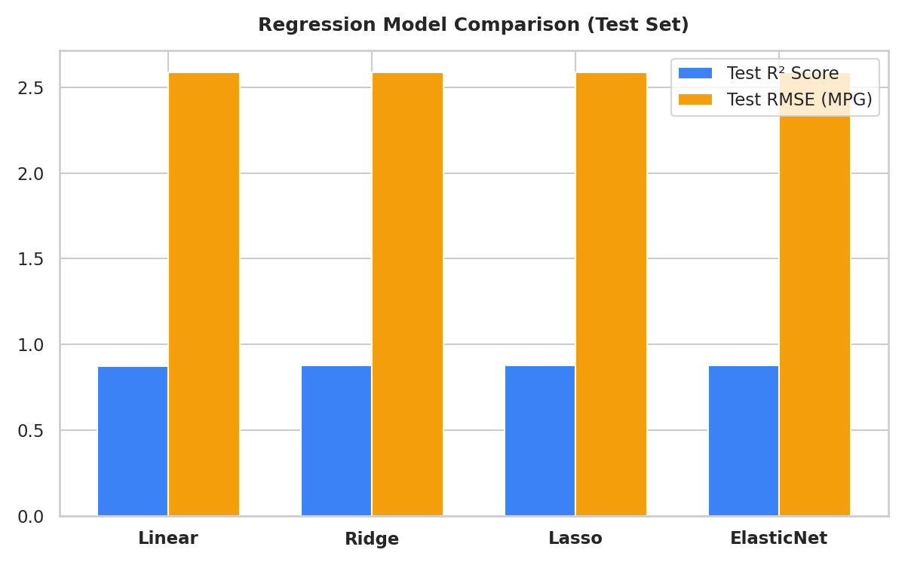
Figure 7.1: Supervised Regression Benchmark Comparison across Evaluation Metrics

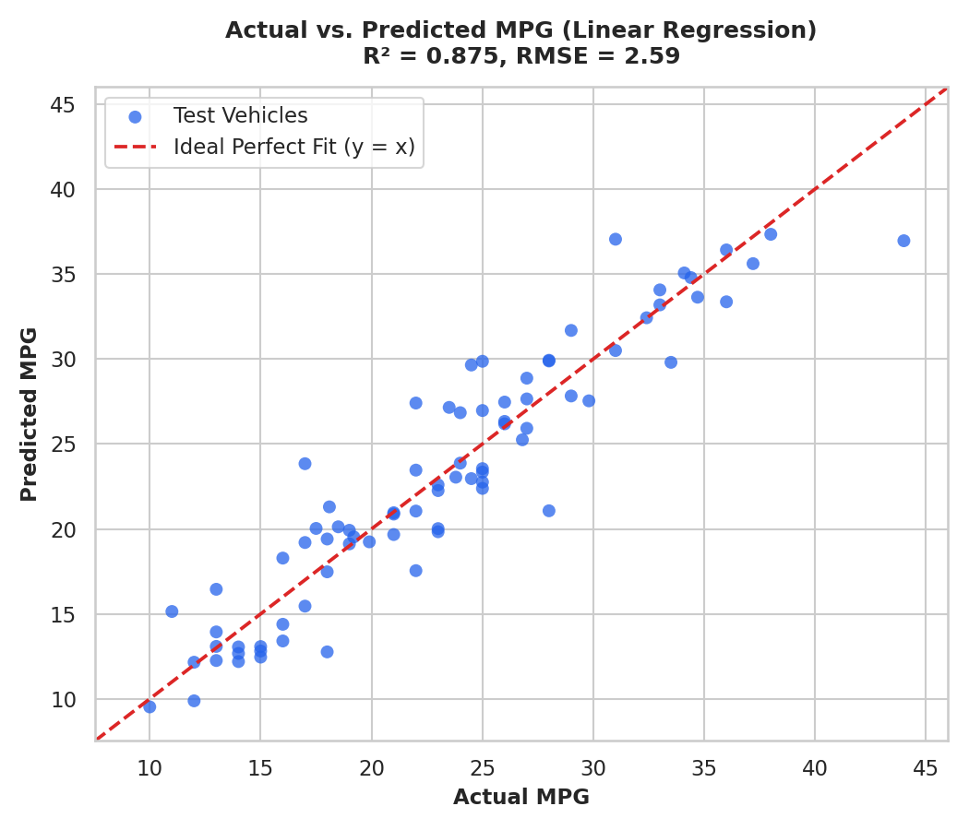
Figure 7.2: Actual vs. Predicted MPG on Quarantined Test Holdout (Tight Clustering along Identity Line)

7.2 Unsupervised Vehicle Clustering & Archetype Identification
K-Means clustering was evaluated for k in range 2 to 8. While k=2 produced a slightly higher silhouette score (0.5460 vs 0.4401), k=3 was selected as optimal because it discovered three structurally and commercially distinct automotive archetypes:
Cluster Archetype | Fleet Share | Mean MPG | Mean Weight | Mean Horsepower | Mean Cylinders | Profile Description
Cluster 2: Lightweight Efficient | 52.0% (207) | 29.40 MPG | 2,306 lbs | 78.5 HP | 4.0 | Economy compacts and commuter vehicles.
Cluster 0: Mid-Heavy Cruiser | 23.6% (94) | 19.83 MPG | 3,222 lbs | 101.7 HP | 6.0 | Family sedans, wagons, mid-size utility.
Cluster 1: Heavy High-Power | 24.4% (97) | 14.53 MPG | 4,144 lbs | 161.8 HP | 8.0 | Muscle cars, full-size trucks, large V8s.

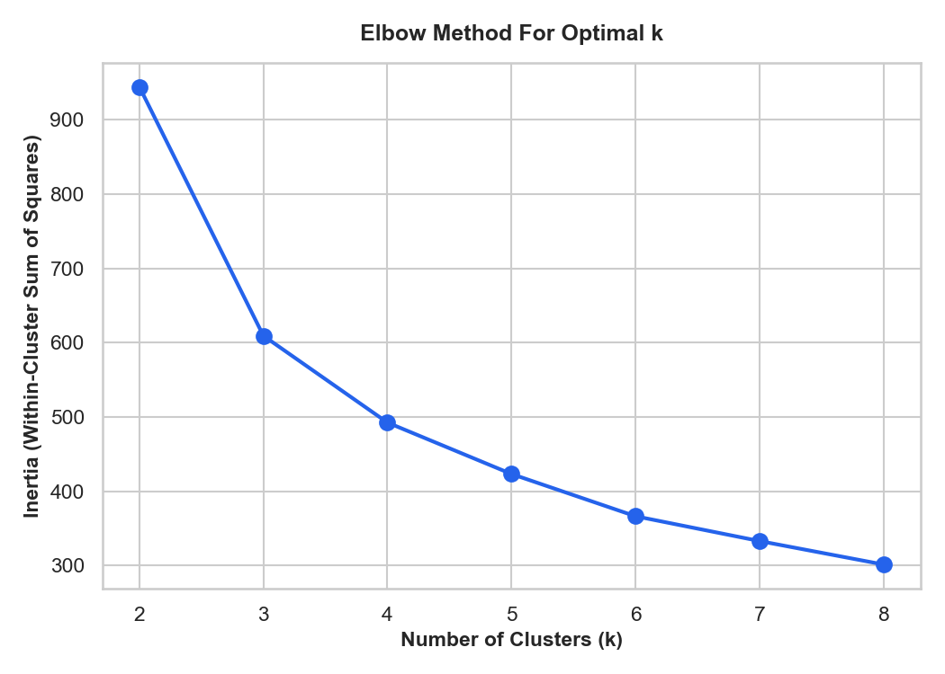
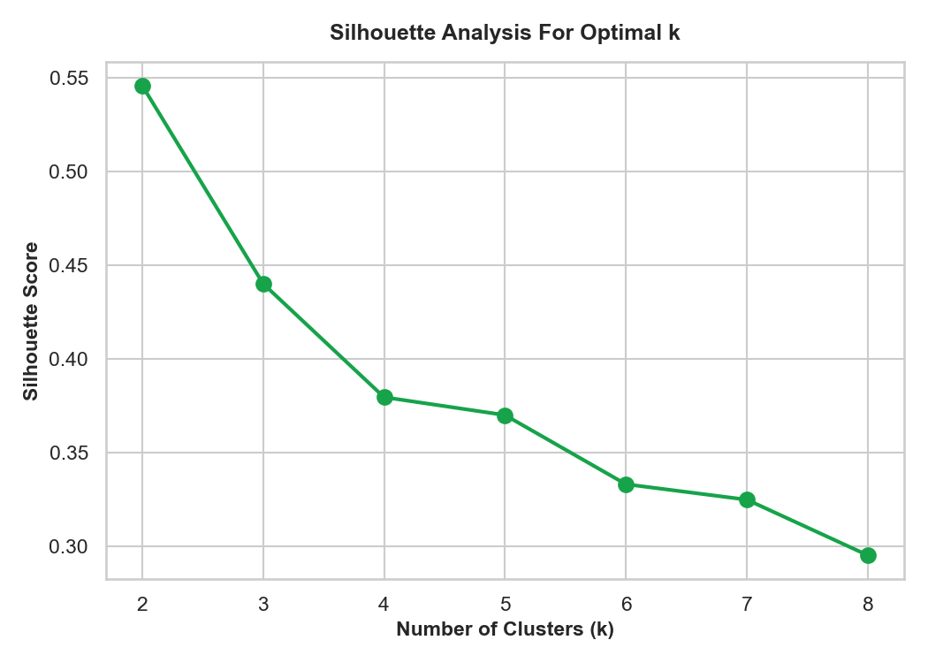
Figure 7.3: K-Means Diagnostic Curves (Elbow Method Inertia and Silhouette Score Analysis)

7.3 Dimensionality Reduction via 2D PCA
Projecting the 6-dimensional standardized space onto two orthogonal principal components retained an outstanding 91.8% of the total dataset variance. PC1 (79.7% variance) captured overall vehicle scale (mass, displacement, cylinders), while PC2 (12.2% variance) reflected temporal technology progression and power density. This high variance retention ensures that 2D cluster visualizations accurately represent the underlying data.

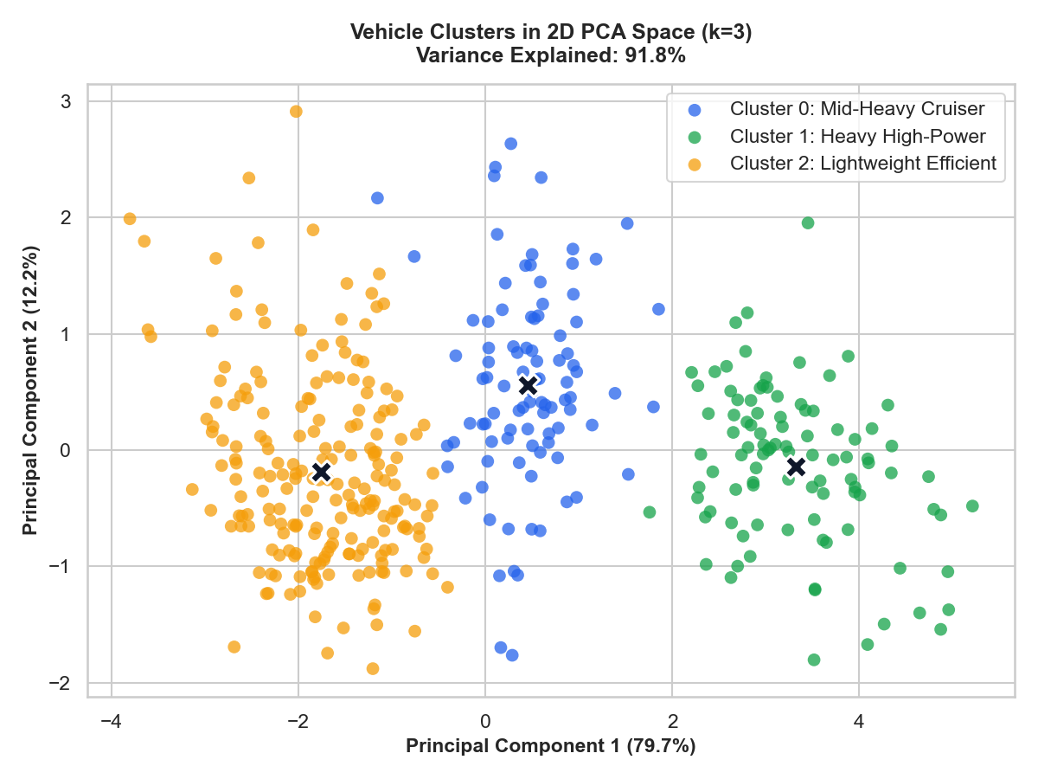
Figure 7.4: 2D PCA Fleet Projection Highlighting 3 Discovered Vehicle Archetypes & Centroids

7.4 Explainable AI & Directional Mechanical Impact Analysis
The standardized regression coefficients provide transparent insight into how each mechanical feature influences predicted fuel efficiency:
Feature Name | Standardized Coefficient | Directional Impact | Engineering & Physical Interpretation
cylinders | -11.2366 | Strong Negative | Major penalty; additional cylinders cause substantial mechanical friction and fuel consumption.
displacement | +10.2520 | Positive (Interaction) | Functions as an interaction term paired with the heavy negative penalties of weight and cylinders.
displacement_per_cylinder | -5.1917 | Negative | Larger combustion volumes per cylinder yield poorer thermal efficiency.
weight_per_cylinder | -2.6068 | Negative | Excess chassis mass supported per cylinder increases continuous engine strain.
horsepower | +2.1361 | Positive (Interaction) | Reflects modern combustion efficiency when paired with balanced chassis weights.
weight | -1.7807 | Negative | Fundamental mass penalty; heavier vehicles require more mechanical energy to move.
power_to_weight | -1.6463 | Negative | Aggressive power-to-weight tuning prioritizes acceleration over fuel economy.
model_year | +1.5714 | Positive | Chronological technological improvements (aerodynamics, materials, tuning).
vehicle_age | -1.5714 | Negative | Inverse of model year; older vehicles reflect lower baseline efficiency.
origin_usa | -0.3225 | Slight Negative | Reflects era's domestic focus on heavier vehicles and larger engines.
origin_europe | +0.2836 | Slight Positive | Reflects European emphasis on smaller engines and balanced chassis.
origin_japan | +0.1204 | Slight Positive | Reflects Japanese manufacturing focus on lightweight, efficient compacts.

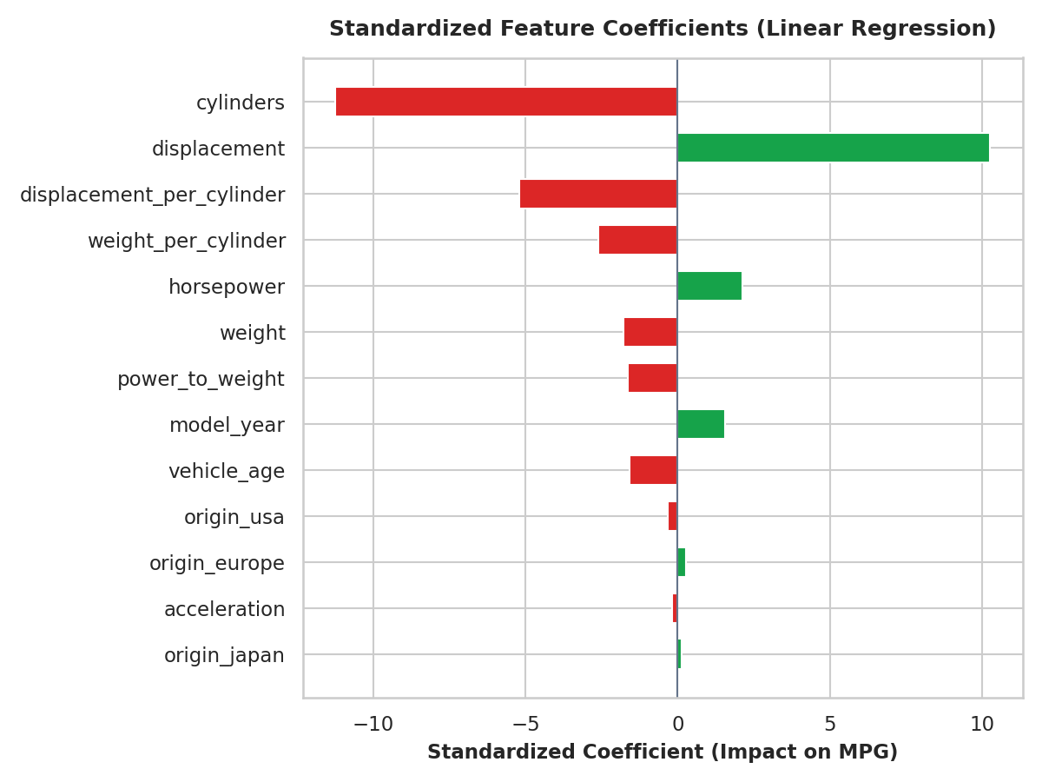
Figure 7.5: Standardized Regression Coefficients Quantifying Global Feature Attribution on MPG

7.5 Interactive Web Application Demonstration
The deployed application allows users to interactively test the predictive models. When a user enters vehicle specifications in the Prediction Studio, the frontend sends a POST request to /api/predict. The system returns the predicted MPG, updates the animated SVG dial, assigns an efficiency badge (e.g., 'High Efficiency'), identifies the matching vehicle archetype, and renders XAI attribution cards showing exactly which specs helped or hurt the score.

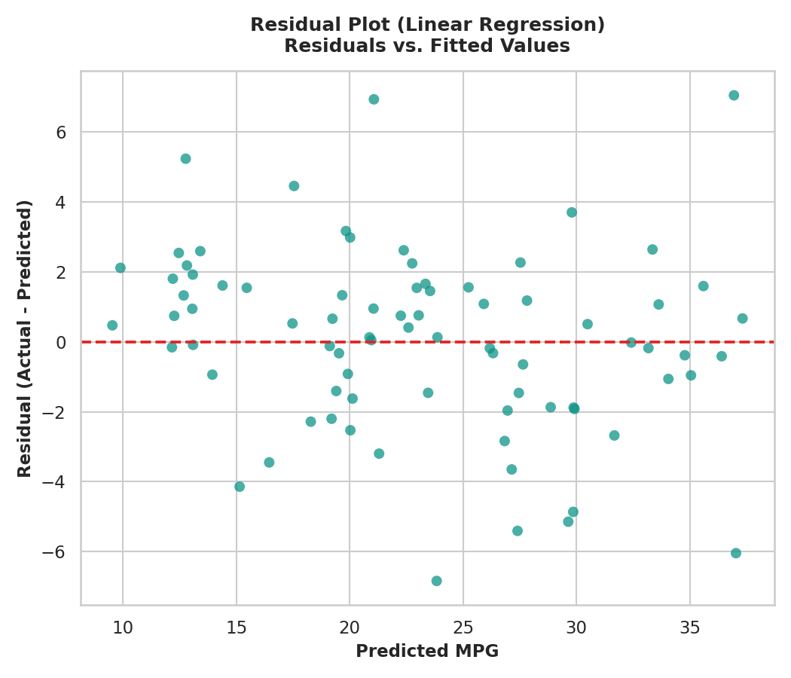
Figure 7.6: Residual Analysis Plot Validating Homoscedasticity and Error Normality Assumptions

8. Business Impact, Challenges & Responsible AI

8.1 Industrial Applications & Operational Value
- Virtual Prototyping in Automotive R&D: Simulating fuel efficiency across theoretical configurations enables design teams to evaluate hundreds of prospective engine-chassis combinations in software before committing millions of dollars to physical tooling and dynamometer testing.
- EV Battery Pack and Range Optimization: The mathematical principles of balancing curb weight against efficiency transfer directly to electric vehicle design, where battery pack mass must be balanced against driving range.
- Smart Fleet Logistics: Automated clustering allows delivery services and rideshare operators to segment mixed fleets, dispatching lightweight efficient vehicles for urban routes and larger vehicles for heavy hauling.

8.2 Technical Challenges Encountered and Solutions Adopted
Technical Challenge Encountered | Underlying Root Cause | Engineering Solution Implemented
Categorical Region Bias | Integer encoding (1, 2, 3) implied false ordinal hierarchy. | Engineered One-Hot Encoding via AutoMPGFeatureEngineer.
Corrupted Missing Values in HP | Six records contained non-numeric '?' characters. | Converted to NaN and applied training-fitted median imputation (93.5 HP).
Severe Multicollinearity | Weight and displacement exhibited near-collinear correlation. | Benchmarked Ridge and ElasticNet models using 5-Fold Cross-Validation.
Training vs Inference Feature Drift | Manual transformations in API routes risk feature drift. | Encapsulated all transformations in a unified Scikit-learn Pipeline.
Database Environment Portability | Requiring a live MySQL server complicates local development. | Implemented dual-engine manager with automatic fallback to SQLite.

8.3 Limitations and Responsible AI Considerations
- Historical Dataset Scope (1970–1982): The models are trained on empirical data from 1970 to 1982. They cannot accurately predict the efficiency of modern powertrains equipped with turbochargers, direct injection, or hybrid systems.
- Correlation vs. Causation: The standardized coefficients reflect statistical associations within the training dataset and should not be treated as isolated physical laws. Altering a physical component in the real world causes interdependent changes across the powertrain.
- Decision-Support Boundary: This platform serves as an engineering decision-support tool. It is not certified for formal regulatory emissions compliance or vehicle safety ratings.

9. Conclusion & Future Scope

9.1 Summary of Learnings and Project Achievements
The Automobile Efficiency Regressor & Vehicle Class Profiler project successfully demonstrates the complete lifecycle of an applied machine learning software system. Key achievements include:
- Built a leakage-free preprocessing pipeline with domain-specific feature engineering and standard scaling.
- Benchmarked four regularized regression algorithms, with ElasticNet reaching a test R² of 0.8756 and an RMSE of 2.5860 MPG.
- Discovered three logical vehicle archetypes via K-Means clustering, visualized through a 2D PCA projection retaining 91.8% of total variance.
- Delivered an Explainable AI attribution engine to quantify the physical impact of each mechanical variable.
- Constructed a full-stack platform featuring an asynchronous FastAPI backend, a dual-mode MySQL/SQLite database layer, and a responsive web dashboard.
- Achieved a 100% test pass rate across 12 automated unit and integration tests executed with pytest.

9.2 Recommendations and Future Enhancements
- Modern EV & Hybrid Dataset Expansion: Extend the schema and training pipeline to ingest contemporary hybrid and electric vehicle datasets, incorporating metrics such as battery capacity (kWh), motor power (kW), and regenerative braking efficiency.
- Real-Time IoT Telemetry Ingestion: Connect API endpoints to vehicle CAN-bus telemetry streams over MQTT to provide dynamic, real-world range forecasting under live driving conditions.
- Automated MLOps & CI/CD Pipelines: Containerize the application using Docker and implement GitHub Actions workflows to automate testing, regression benchmarking, and deployment upon model retraining.

10. Internship Outcomes

10.1 Technical Competencies Acquired
- Applied Data Science: Mastered data exploration, missing-value imputation, categorical encoding, and feature engineering using Pandas and Scikit-Learn.
- Predictive Modeling: Gained practical expertise in training, tuning, and evaluating regularized regression algorithms (Ridge, Lasso, ElasticNet) using 5-Fold Cross-Validation.
- Unsupervised Clustering & PCA: Implemented K-Means clustering with Elbow and Silhouette diagnostics, and applied PCA for 2D dimensionality reduction.
- Explainable AI: Built feature attribution mechanisms to explain linear model predictions using standardized coefficients.
- Full-Stack Development: Engineered an asynchronous REST API in FastAPI, enforced data schemas with Pydantic, wrote parameterized SQL queries for MySQL and SQLite, and designed an interactive web UI with Chart.js.
- Software Quality Assurance: Created automated test suites in pytest to verify data pipelines and API endpoints.

10.2 Soft Skills & Professional Attributes Developed
- Analytical Problem Solving: Learned to deconstruct open-ended automotive challenges into structured data science workflows with measurable goals.
- Technical Documentation: Synthesized complex architectural designs, statistical benchmarks, and findings into formal, industry-standard reports.
- User-Centric Design: Designed user interfaces that present machine learning insights clearly to both engineers and non-technical stakeholders.
- Time & Project Management: Structured tasks across four weekly milestones, meeting all technical requirements on schedule.

10.3 Contribution to Career Growth
Participating in the IBM SkillsBuild Internship Program has provided valuable real-world experience that bridges undergraduate classroom theory with industrial software development. Engineering a complete, mathematically validated machine learning platform has strengthened my technical foundation, enhanced my professional confidence, and provided practical competencies directly applicable to future roles in artificial intelligence, machine learning engineering, and data analytics.

Appendix

Appendix A: Source Code Architecture & Execution Script Snippets
Directory Tree of the Implemented Codebase:
automobile_efficiency_profiler/
├── app/
│ ├── __init__.py
│ ├── main.py # FastAPI server and route endpoints
│ ├── database.py # Dual-mode MySQL/SQLite database connector
│ ├── schemas.py # Pydantic input and output validation models
│ ├── prediction_service.py # Regression inference & XAI attribution logic
│ └── profiling_service.py # K-Means clustering and 2D PCA mapping
├── frontend/
│ ├── index.html # Main application dashboard
│ ├── prediction.html # Prediction Studio & live gauge interface
│ ├── profiles.html # Fleet archetype cards & 2D PCA scatter map
│ ├── analytics.html # Model evaluation benchmarks & coefficient plots
│ ├── history.html # Paginated prediction audit logs
│ ├── css/style.css # Custom responsive stylesheet
│ └── js/app.js # Asynchronous API fetch & Chart.js rendering
├── models/
│ ├── pipeline.joblib # Serialized preprocessing & feature pipeline
│ ├── elasticnet_model.joblib # Serialized primary regression estimator
│ ├── kmeans_model.joblib # Serialized K-Means clustering model
│ └── pca_transformer.joblib # Serialized 2D PCA transformation matrix
├── data/
│ ├── auto-mpg.csv # Cleaned UCI Auto MPG dataset
│ └── schema.sql # Relational database table definitions
├── tests/
│ ├── test_pipeline.py # Unit tests for preprocessing & feature engineering
│ └── test_api.py # Integration tests for FastAPI endpoints
├── requirements.txt # Python dependencies
└── README.md # Setup, run, and deployment documentation

Custom Feature Engineering Pipeline Step (AutoMPGFeatureEngineer):
import numpy as np
import pandas as pd
from sklearn.base import BaseEstimator, TransformerMixin
class AutoMPGFeatureEngineer(BaseEstimator, TransformerMixin):
def __init__(self):
pass
def fit(self, X, y=None):
return self
def transform(self, X):
df = X.copy() if isinstance(X, pd.DataFrame) else pd.DataFrame(X)
df['power_to_weight'] = df['horsepower'] / df['weight']
df['displacement_per_cylinder'] = df['displacement'] / df['cylinders']
df['weight_per_cylinder'] = df['weight'] / df['cylinders']
df['vehicle_age'] = 82 - df['model_year']
df['origin_usa'] = (df['origin'] == 1).astype(float)
df['origin_europe'] = (df['origin'] == 2).astype(float)
df['origin_japan'] = (df['origin'] == 3).astype(float)
return df.drop(columns=['origin'], errors='ignore')

Appendix B: Database Relational Schema (schema.sql)
-- Database Initialization Script for Automobile Efficiency Platform
CREATE DATABASE IF NOT EXISTS automobile_ml;
USE automobile_ml;
-- 1. Table for logging predictions and user inputs
CREATE TABLE IF NOT EXISTS predictions (
id INTEGER PRIMARY KEY AUTOINCREMENT,
timestamp DATETIME DEFAULT CURRENT_TIMESTAMP,
cylinders INTEGER NOT NULL,
displacement REAL NOT NULL,
horsepower REAL NOT NULL,
weight REAL NOT NULL,
acceleration REAL NOT NULL,
model_year INTEGER NOT NULL,
origin INTEGER NOT NULL,
predicted_mpg REAL NOT NULL,
cluster_id INTEGER NOT NULL,
profile_name VARCHAR(100) NOT NULL
);
-- 2. Table for tracking model benchmark metrics
CREATE TABLE IF NOT EXISTS model_metrics (
id INTEGER PRIMARY KEY AUTOINCREMENT,
model_name VARCHAR(50) NOT NULL,
train_r2 REAL NOT NULL,
cv_r2_mean REAL NOT NULL,
cv_r2_std REAL NOT NULL,
test_r2 REAL NOT NULL,
test_rmse REAL NOT NULL,
test_mae REAL NOT NULL,
hyperparameters TEXT
);
-- 3. Table for storing unsupervised cluster centroids
CREATE TABLE IF NOT EXISTS cluster_profiles (
cluster_id INTEGER PRIMARY KEY,
profile_name VARCHAR(100) NOT NULL,
mean_mpg REAL NOT NULL,
mean_weight REAL NOT NULL,
mean_horsepower REAL NOT NULL,
mean_cylinders REAL NOT NULL,
fleet_percentage REAL NOT NULL,
pca_coordinate_x REAL NOT NULL,
pca_coordinate_y REAL NOT NULL
);

