Automobile Fuel Efficiency Estimation and Vehicle Archetype Profiling Using Machine Learning
Report submitted as part of the internship program requirement for the degree of
BACHELOR OF TECHNOLOGY
IN
COMPUTER SCIENCE ENGINEERING (AI & ML)
Submitted by
KOLISETTY HARSHA VARDHAN (A24126552154)

DEPARTMENT OF CSE (AI & ML)
ANIL NEERUKONDA INSTITUTE OF TECHNOLOGY AND SCIENCES
(UGC AUTONOMOUS)
(Permanently Affiliated to AU, Approved by AICTE, and Accredited by NBA &NAAC with an
‘A+’ Grade )
SANGIVALASA, Bheemili Mandal, VISAKHAPATNAM – 531162
2024-2028
ANIL NEERUKONDA INSTITUTE OF TECHNOLOGY AND SCIENCES
(Affiliated to Andhra University)
SANGIVALASA, VISAKHAPATNAM -5351162
2023-2027
BONAFIDE CERTIFICATE
This is to certify that this Internship Report “Automobile Fuel Efficiency Estimation and Vehicle Archetype Profiling Using Machine Learning” through the IBM Q2D PEARL Internship Program is the bonafide work of KOLISETTY HARSHA VARDHAN(A24126552154) of III/IV CSM carried out Internship under my supervision.
REVIEWER  Dr. G Prasanna Priya  Assistant Professor  Department of CSE(AI & ML)  ANITS | CLASS TEACHER  Ms. J A Lavanya  Assistant Professor  Department of CSE(AI &ML)  ANITS
Head Of the Department
DR. K. SELVANI DEEPTHI
Department of CSE (AI & ML)
ANITS.
ACKNOWLEDGEMENT
An endeavor that spans a significant period becomes a success with the advice, encouragement, and support of many well-wishers. I take this opportunity to express my sincere gratitude and appreciation to all those who have been instrumental in making this internship experience both enriching and rewarding.
First and foremost, I extend my heartfelt thanks to Dr. K.S. Deepthi, Head of the Department of Computer Science & Engineering (AI & ML) at ANITS, for her invaluable guidance, support, and encouragement throughout this internship. Her mentorship and insights have been crucial to my growth during this period.
I would also like to express my deepest appreciation to IBM Innovation Centre for Education (IBM ICE) and Q2D (Quantum Quotient Decode) for offering me the opportunity to undertake this internship. I am incredibly grateful to my supervisors and team members, whose continuous guidance, expertise, and support have helped me navigate challenges and enhance my skills.
My sincere thanks go to all the faculty members of the Computer Science & Engineering (AI & ML) department for their valuable advice and encouragement. I am equally grateful to the support staff, whose assistance in providing resources whenever required was instrumental in the successful completion of my internship.

KOLISETTY HARSHA VARDHAN
A24126552154

ABSTRACT
Automobile fuel economy, conventionally measured in Miles Per Gallon (MPG), is governed by complex, multi-dimensional interactions among engine mechanical displacement, combustion cylinder architecture, chassis curb weight, inertial acceleration, aerodynamic design era, and regional manufacturing paradigms. Accurately modeling and interpreting these non-linear, collinear characteristics is essential for vehicular engineering design, regulatory emissions compliance (CAFÉ standards), and consumer cost modeling.
This project designs, engineers, and deploys the Automobile Efficiency Regressor & Vehicle Class Profiler, an enterprise-grade, end-to-end Machine Learning platform that bridges supervised predictive regression, unsupervised vehicle archetyping, and explainable AI (XAI) diagnostics within a decoupled microservices architecture.
The machine learning subsystem utilizes the classical UC Irvine Auto MPG benchmark fleet (N=398). Rigorous data hygiene protocols are instituted, including median imputation strictly fitted over training partitions to eliminate data leakage, combined with standard feature normalization. In the supervised phase, four regularized linear regression architectures—Ordinary Least Squares (OLS), Ridge (L2), Lasso (L1), and ElasticNet (L1 + L2)—are evaluated using 5-Fold Cross-Validation and exhaustive Grid Search. The resulting models achieve exceptional predictive fidelity, with the optimized regressor delivering a Coefficient of Determination (R2) of 0.8754 on holdout test partitions, accompanied by a Root Mean Squared Error (RMSE) of 2.586 MPG and a Mean Absolute Error (MAE) of 1.944 MPG.
In the unsupervised phase, physical archetype categorization is performed using K-Means Clustering (k=3), validated mathematically through Within-Cluster Sum of Squares (Elbow Inertia) and Mean Silhouette Analysis (S = 0.55). High-dimensional engineering dimensions are projected onto an explainable plane using Two-Dimensional Principal Component Analysis (2D PCA), capturing 91.8% of cumulative variance. The system automatically segments the fleet into three distinct vehicular profiles: Lightweight Efficient Compacts (52.0% of fleet, avg MPG 29.4, weight 2306 lbs), Mid-Heavy Cruisers (23.6% of fleet, avg MPG 19.8, weight 3222 lbs), and Heavy High-Power V8s (24.4% of fleet, avg MPG 14.5, weight 4144 lbs).
To operationalize these models, an asynchronous REST API is developed using FastAPI, featuring sub-50ms inference latency, Pydantic data validation schemas, and dual-engine persistence (supporting enterprise MySQL with an automated SQLite fallback engine). A responsive, glassmorphism web dashboard engineered with HTML5, CSS3, and Chart.js provides instantaneous inference, local feature attribution diagnostics, interactive 2D PCA cluster visualizations, and paginated historical audit trails. The application is thoroughly validated through an automated Pytest verification suite achieving a 100% pass rate across 12 comprehensive unit and integration test specifications in 1.84 seconds.
Keywords: Fuel Economy Regression, Supervised Machine Learning, Regularization (Ridge, Lasso, ElasticNet), Unsupervised K-Means, Principal Component Analysis (PCA), Explainable AI (XAI), FastAPI, SQLAlchemy, Data Leakage Prevention.

Table of Contents
1. Introduction 1
1.1 Background of Internship 1
1.2 Objectives of the Internship 2
1.3 Importance of Green Skills using AI Technologies 3
1.4 Scope of the Project 4
2. Organization Profile 5
2.1 AICTE Virtual Internship Overview 5
2.2 Role of Edunet Foundation 6
2.3 Shell as the Industry Sponsor 7
3. Project Overview 8
3.1 Title of the Project 8
3.2 Problem Statement 9
3.3 Objectives of the Project 10
3.4 Relevance to Environmental Monitoring 11
4. Literature Review / Theoretical Background 12
4.1 Introduction to Water Pollution and Quality Parameters 12
4.2 Role of Artificial Intelligence in Environmental Monitoring 14
4.3 Machine Learning Approaches for Multi-Output Regression 16
4.4 Related Works 18
5. Methodology 20
5.1 Data Collection and Dataset Description 20
5.2 Data Preprocessing (Handling Missing Values, Feature Engineering) 22
5.3 Feature Selection (Year, Month, NH4, BSK5, Suspended Solids, Station ID) 24
5.4 Model Selection – Random Forest with MultiOutputRegressor 26
5.5 Model Training and Evaluation Metrics (R², MSE) 28
6. Implementation 30
6.1 Week 1 – Data Exploration, Cleaning & Preprocessing 30
6.2 Week 2 – Model Building, Training & Saving with Joblib 33
6.3 Week 3 – Deployment of Streamlit Web App 36
6.4 Improvements Made Over Mentor’s Code 39
7. Results and Discussion 42
7.1 Model Performance (per pollutant R² & MSE) 42
7.2 Visualization of Results (Bar Charts, Feature Importances) 45
7.3 Streamlit App Output (Screenshots and Explanation) 48
7.4 Interpretation of Predictions 58
8. Conclusion & Future Work 61
8.1 Summary of Learnings 61
8.2 Green Skills Acquired 62
8.3 Limitations of the Current Approach 63
8.4 Future Scope (Advanced ML models, IoT integration, Real-time prediction) 64
9. Internship Outcomes 66
9.1 Technical Skills Acquired 66
9.2 Soft Skills Developed 67
9.3 Contribution to Career Growth 68
Appendix 70
A. Source Code (GitHub / Colab Links) 70
B. Streamlit App Screenshots 71
C. Certificate of Completion 72

[LIST OF FIGURES]
Figure No. | Figure Caption / Description | Page No.
Figure 4.1 | Level 0 Context Data Flow Diagram (DFD 0.0) | 25
Figure 4.2 | Level 1 System Workflow & Pipeline Data Flow Diagram (DFD 1.0) | 26
Figure 4.3 | Level 2 Machine Learning Inference, Clustering & Explainability DFD | 27
Figure 6.1 | Automated Unit and Integration Test Execution Suite Output (Pytest) | 52
Figure 6.2 | Executive Analytics Dashboard & Fleet Archetype Donut Distribution | 54
Figure 6.3 | Regression Model Benchmark Comparison & Live Prediction Stream | 55
Figure 6.4 | Interactive Vehicle MPG Prediction Studio & Circular Gauge Meter | 56
Figure 6.5 | Local Feature Attribution and Prediction Explainability Breakdown | 57
Figure 6.6 | Unsupervised Vehicle Profiling Archetype Cards (Clusters 0, 1, 2) | 58
Figure 6.7 | High-Dimensional 2D PCA Cluster Scatter Map & Centroid Comparisons | 59
Figure 6.8 | Cluster Optimization Validation: Inertia Elbow & Silhouette Curves | 60
Figure 6.9 | Empirical Regression Benchmark Leaderboard & Hyperparameters | 61
Figure 6.10 | REST API Architectural Endpoint Specifications and Routing Contracts | 62
Figure 6.11 | Historical Vehicle Prediction Audit Log with Query Filters & Exporters | 63
Figure 6.12 | FastAPI Backend Initialization and Real-Time HTTP Request Pipeline | 64

[LIST OF TABLES]
Table No. | Table Caption / Description | Page No.
Table 1.1 | UCI Auto MPG Dataset Attribute Dictionary and Physical Units | 2
Table 2.1 | Comparative Literature Survey Matrix of Automotive Efficiency Studies | 14
Table 3.1 | Hardware Specification Requirements for Server & Training Hosts | 20
Table 3.2 | Software Stack and Open-Source Library Dependency Matrix | 21
Table 4.1 | REST API Route Specifications and HTTP Payload Definitions | 28
Table 4.2 | Relational Database Data Dictionary for predictions Entity | 30
Table 5.1 | Feature Preprocessing Imputation and Scaling Policies | 37
Table 6.1 | Comprehensive Test Case Specifications, Objectives & Results | 51
Table 6.2 | Supervised Regression Performance Benchmark Leaderboard | 64
Table 6.3 | Discovered Vehicular Archetype Centroids and Physical Properties | 66
Table 6.4 | Local Feature Coefficient Attribution Weights for Benchmark Test Car | 67

CHAPTER 1: INTRODUCTION

1.1 Background & Industrial Context
In contemporary automotive engineering, fuel economy—traditionally measured in Miles Per Gallon (MPG) and internationally as liters per 100 kilometers (L/100 km)—serves as a primary benchmark connecting mechanical thermodynamics, environmental policy, economic consumer behavior, and manufacturing strategy. Since the global energy crises of the 1970s and the establishment of Corporate Average Fuel Economy (CAFÉ) standards by regulatory bodies such as the US Environmental Protection Agency (EPA), automotive manufacturers have operated under statutory mandates to optimize thermal and fuel efficiency.
The fuel consumption of an internal combustion engine (ICE) is dictated by complex, interconnected physical factors:
- Mechanical Engine Displacement: The total swept volume of all pistons, determining the volume of air-fuel mixture inhaled per combustion cycle.
- Combustion Cylinder Geometry: Frictional losses, bore-to-stroke ratios, and rotating assembly mass vary across 3, 4, 6, and 8-cylinder architectures.
- Inertial Chassis Mass (Curb Weight): The gravitational mass directly dictates rolling resistance and the kinetic force required to accelerate.
- Thermodynamic Power Output (Horsepower): Brake horsepower reflects combustion pressure, fuel delivery, and volumetric efficiency.
- Dynamic Response (Acceleration): Elapsed time required to reach 60 mph from rest under mechanical transmission gearing.
- Technological Era (Model Year): Chronological advancements including electronic ignition, aerodynamic improvements, and metallurgy create distinct efficiency baselines.
- Regional Engineering Paradigms (Origin): Geographic preferences historically biased American automobiles toward heavy V8s, while European and Japanese manufacturers specialized in lightweight, compact architectures.
To investigate these physical relationships empirically, researchers rely on canonical benchmark vehicular databases. The UC Irvine Machine Learning Auto MPG Dataset contains N=398 vehicle records cataloging multi-cylinder configurations, power outputs, displacements, curb weights, and geographic classifications across the period from 1970 to 1982.

Table 1.1: UCI Auto MPG Dataset Attribute Dictionary and Physical Units
Parameter | Role | Data Type | Unit | Range | Description
mpg | Target (y) | Continuous | Miles Per Gallon | 9.0 - 46.6 | Distance traveled per unit fuel volume.
cylinders | Predictor (X) | Discrete Ordinal | Count | 3, 4, 5, 6, 8 | Combustion chambers count.
displacement | Predictor (X) | Continuous | Cubic Inches (in3) | 68.0 - 455.0 | Total swept piston displacement volume.
horsepower | Predictor (X) | Continuous | Brake HP (BHP) | 46.0 - 230.0 | Peak mechanical engine power output.
weight | Predictor (X) | Continuous | Pounds (lbs) | 1613 - 5140 | Total vehicle unladen curb weight.
acceleration | Predictor (X) | Continuous | Seconds (0-60 mph) | 8.0 - 24.8 | Elapsed time to accelerate to 60 mph.
model_year | Predictor (X) | Discrete Integer | Year (19XX) | 70 - 82 | Production model year (1970 to 1982).
origin | Predictor (X) | Nominal Categorical | Code (1, 2, 3) | 1, 2, 3 | Manufacturing origin: 1-USA, 2-Europe, 3-Japan.
car_name | Metadata | Alphanumeric | String | Unique Text | Vehicle manufacturer commercial brand.

1.2 Problem Statement
Deploying a reliable, production-ready automotive predictive system entails severe algorithmic and software engineering challenges:
- Pervasive Multicollinearity: Vehicular physical features (displacement, weight, horsepower, cylinders) exhibit high correlation (r > 0.85). In unregularized Ordinary Least Squares (OLS), the covariance matrix becomes ill-conditioned, leading to unstable coefficients and inflated standard errors.
- Data Leakage in Preprocessing: Standard workflows frequently impute missing values and scale features across the full dataset prior to train-test splitting. This leaks distribution moments into validation data, creating artificially optimistic results that fail in production.
- Absence of Fleet Archetyping: Regressing continuous MPG alone fails to provide macro-level fleet insights. Automotive engineers require actionable categorization into physical vehicle archetypes without relying on manual ground truth labels.
- The 'Black-Box' Explainability Deficit: Opaque non-linear models obscure mechanical causality. In regulated automotive auditing, stakeholders require explainable attribution identifying the exact factors driving fuel consumption.
- Disconnection from Production: Many machine learning projects remain confined to Jupyter notebooks lacking schema validation, asynchronous microservices, database persistence, and accessible user interfaces.

1.3 Motivation
This project is motivated by three core imperatives:
- Environmental & Energy Impact: Transportation represents a major contributor to global greenhouse emissions. Providing instantaneous, explainable fuel economy predictions enables automotive designers to evaluate mass-to-displacement trade-offs during early computer-aided design (CAD) phases.
- Advancing Algorithmic Transparency: Decomposing regression outputs into directional feature attributions fosters trust and complies with regulatory auditing requirements.
- Bridge Theory and Production: Combining leak-free ML pipelines, regularized linear estimators, unsupervised clustering, 2D PCA, FastAPI microservices, and dual-engine relational persistence demonstrates end-to-end software engineering excellence.

1.4 Key Objectives
The project establishes eight primary technical objectives:
- 1. Enforce Leak-Free Data Hygiene: Isolate 80/20 train-test splits before fitting median imputers and standard scalers.
- 2. Regularized Regression Benchmarking: Evaluate OLS, Ridge, Lasso, and ElasticNet using 5-Fold Cross-Validation and Grid Search to achieve R2 >= 0.85 and RMSE < 2.70 MPG.
- 3. Latent Archetype Discovery: Segment the fleet into k=3 clusters using K-Means, mathematically validated via Elbow Inertia and Silhouette analysis.
- 4. 2D PCA Projection: Project multi-dimensional specifications onto orthogonal axes capturing > 90% of cumulative variance.
- 5. Asynchronous REST API: Construct a high-performance FastAPI service delivering sub-50ms inference with Pydantic validation.
- 6. Dual-Engine Persistence: Design SQLAlchemy ORM models supporting enterprise MySQL with automatic fallback to SQLite.
- 7. Glassmorphism Dashboard: Develop a responsive browser dashboard with Chart.js visualizations, circular gauges, and CSV/JSON export.
- 8. Automated Testing: Achieve 100% pass rates across unit and integration tests using Pytest.

1.5 Scope & Operational Boundaries
The operational boundaries and assumptions of this project include:
- In-Scope Boundaries: Continuous regression modeling of ICE fuel economy, mathematical comparison of regularized linear models, unsupervised K-Means clustering, 2D PCA projection, sub-50ms REST API, local feature attribution, and relational audit logging.
- Out-of-Scope Elements: Battery Electric Vehicles (BEVs), Hybrid Electric Vehicles (HEVs), dynamic real-time CAN-bus sensor streaming, and transient telemetry during drive cycles.

CHAPTER 2: LITERATURE REVIEW

2.1 Existing Systems & Methodologies
Automotive efficiency modeling has evolved across three distinct methodologies:
- Chassis Dynamometer Laboratory Testing: Physical drive-cycle evaluations (FTP-75, WLTP) measuring tailpipe exhaust. While highly accurate, they require physical vehicle prototypes and expensive laboratory chambers costing hundreds of thousands of dollars.
- Numerical Thermodynamic Simulations: Physics-based differential solvers (e.g., ADVISOR, FASTSim) modeling engine thermal efficiency maps, frictional drag, and rolling resistance. These require granular engineering parameters rarely available during initial concept phases.
- Statistical Regression Modeling: Traditional multiple linear regression via Ordinary Least Squares. While simple, literature indicates standard OLS breaks down under the extreme multicollinearity inherent in automotive engineering parameters.

2.2 Limitations of Existing Systems
Prior implementations suffer from distinct bottlenecks:
- Ill-Conditioned Covariance in OLS: When displacement and weight correlate strongly (r > 0.90), det(X^T X) approaches zero, causing coefficient estimates to explode in variance.
- Widespread Data Leakage: Many academic implementations fit imputers and scalers across the full dataset before splitting, inflating benchmark scores that fail to generalize.
- Black-Box Model Opacity: Non-linear ensembles (Random Forests, Gradient Boosting) often obscure the physical causality driving fuel consumption.
- Siloed Execution: Systems typically predict MPG in isolation or perform clustering separately, lacking a unified architecture connecting both.

2.3 Proposed System Concept
The proposed Automobile Efficiency Regressor & Vehicle Class Profiler introduces a unified hybrid machine learning and software engineering architecture:
- Regularized Linear Estimators: Ridge (L2), Lasso (L1), and ElasticNet penalties stabilize matrix inversion and eliminate collinear variance explosion.
- Leak-Free Engineering: Preprocessing transformers are fitted exclusively on training partitions and cached for production inference.
- Dual Supervised & Unsupervised Learning: Executes continuous MPG regression and K-Means vehicle archetyping concurrently within a single unified API payload.
- Directional Explainability: Decomposes predictions into positive efficiency boosters and negative drag penalties.
- Production Microservice Architecture: FastAPI ASGI backend with Pydantic validation, dual-engine persistence (MySQL/SQLite), and an interactive web interface.

2.4 Advantages of Proposed Methodology
Key advantages include high predictive precision (R2 = 0.8756, RMSE = 2.586 MPG), guaranteed statistical hygiene, simultaneous micro and macro fleet intelligence, auditable feature attributions, and high availability via automated database fallback.

2.5 Literature Survey Matrix
Ref | Author & Year | Core Methodology | Performance | Identified Gaps / Contribution
[1] | Quinlan (1993) | Rule-based decision trees and instance regression | MAE ~ 2.45 MPG | Discontinuous step boundaries; poor continuous interpolation.
[2] | Zou & Hastie (2005) | Formulation of composite L1/L2 ElasticNet | Group selection proof | Theoretical statistical paper; lacked application to vehicle fleets.
[3] | Wickramanayake (2016) | Random Forests & Gradient Boosting on telematics | R2 ~ 0.82 | Opaque black-box models; no vehicle archetype discovery.
[4] | Al-Mharmah (2018) | Multiple Linear Regression and Stepwise OLS | R2 ~ 0.81 | Multicollinearity ignored; unstable coefficient signs.
[5] | Yao et al. (2020) | Unsupervised K-Means clustering on fleet emissions | Silhouette S ~ 0.48 | Isolated clustering; failed to integrate predictive regression.
[6] | Lundberg et al. (2020) | Game-theoretic SHAP explainability | Axiomatic proof | High computational overhead; unsuitable for sub-50ms APIs.
[7] | Tiangolo (2022) | FastAPI ASGI microservices with Pydantic | Throughput > 10k req/s | Framework architecture; requires domain adaptation.
[8] | Proposed System (2026) | Ridge/Lasso/ElasticNet + K-Means (k=3) + 2D PCA + FastAPI | R2 = 0.8754, RMSE = 2.586 | Resolves collinearity, zero leakage, full explainability.

CHAPTER 3: SYSTEM ANALYSIS & REQUIREMENTS

3.1 Functional Requirements
- FR-1: Data Ingestion & Leak-Free Hygiene: Programmatically parse Auto MPG dataset; enforce 80/20 holdout split prior to fitting transformers; impute missing values using training median (93.5 HP); standardize features using zero-mean, unit-variance scaling.
- FR-2: Supervised Regression Pipeline: Train, tune, and evaluate OLS, Ridge, Lasso, and ElasticNet models using 5-Fold Cross-Validation and Grid Search; return continuous MPG and efficiency tier (High, Moderate, Low).
- FR-3: Unsupervised Vehicle Profiling: Segment fleet into k=3 archetypes; assign input vehicles based on Euclidean distance to centroids; project specifications onto 2D PCA plane capturing > 90% variance.
- FR-4: Local Feature Explainability: Decompose predictions into standardized coefficient attribution scores (beta_j * z_j) sorted by absolute impact, labeling positive boosters and negative drag penalties.
- FR-5: REST API & Persistence: Expose documented REST endpoints (/health, /predict, /profile, /analyze, /predictions, /statistics, /clusters, /model-info); persist evaluations via SQLAlchemy with automated SQLite failover; support CSV and JSON exports.

3.2 Non-Functional Requirements
- Performance & Latency: End-to-end inference response time < 50ms; startup model deserialization < 1.5s; database query latency < 15ms.
- Reliability & Fault-Tolerance: Zero downtime via automated SQLite failover if MySQL is unreachable; graceful HTTP 422 error handling on corrupted payloads.
- Scalability & Concurrency: Asynchronous non-blocking request dispatching via Uvicorn ASGI; horizontal scalability via decoupled layers.
- Maintainability & Modularity: Separation of concerns across training, routing, schemas, services, and static presentation layers; automated test coverage.

3.3 Hardware Requirements
Component | Minimum Dev Host | Recommended Production Host | Client Device
Processor (CPU) | Dual-Core Intel i3 / AMD Ryzen 3 (2.0 GHz) | Quad-Core Intel Xeon / Core i7 (> 3.2 GHz) | Standard x86/ARM processor
Memory (RAM) | 4.0 GB DDR4 | 8.0 GB - 16.0 GB DDR4/DDR5 | 2.0 GB browser memory
Storage (Disk) | 2.0 GB free disk space | 20.0 GB NVMe SSD | 500 MB browser cache
GPU Acceleration | Not required (CPU vectorized) | Not required (CPU optimized) | Integrated GPU (WebGL)
Network Interface | 10/100 Mbps Ethernet / Wi-Fi | 1.0 Gbps Full Duplex Enterprise NIC | Standard broadband (> 1 Mbps)

3.4 Software Requirements
Layer / Tool | Technology & Version | Functional Purpose in Platform
Operating System | Windows 10/11 / Linux (Ubuntu 22.04 LTS) / macOS | 64-bit host environment for server and client.
Runtime Language | Python >= 3.11 (Evaluated on 3.13.5) | Core language for ML pipelines, API routing, and scripts.
Machine Learning | Scikit-Learn >= 1.4.0 | Implements Ridge, Lasso, ElasticNet, K-Means, and PCA.
Scientific Matrix | NumPy >= 1.26.0 & Pandas >= 2.2.0 | Vectorized numerical transformations and dataset manipulation.
Model Persistence | Joblib >= 1.3.0 | Binary serialization of fitted estimators and scalers.
Web Framework | FastAPI >= 0.110.0 & Uvicorn >= 0.28.0 | Asynchronous ASGI REST API microservice.
Data Validation | Pydantic >= 2.6.0 | Runtime data validation and schema serialization.
Database Layer | SQLAlchemy >= 2.0.0 (MySQL 8.0+ / SQLite 3) | Dual-engine Object-Relational Mapping persistence.
Automated Testing | Pytest >= 8.0.0 & AnyIO >= 4.9.0 | Automated test execution suite.
Frontend UI | HTML5, CSS3, JavaScript (ES6+), Chart.js >= 4.4.0 | Responsive dark-mode glassmorphism dashboard.

3.5 Feasibility Study
- Technical Feasibility: Core machine learning algorithms are mathematically mature and run efficiently on CPU hardware. The sub-50ms latency target is readily achieved by caching deserialized models in memory.
- Operational Feasibility: The intuitive browser interface with presets enables non-technical personnel to evaluate vehicle specifications without writing code, while explainability attributions facilitate auditing.
- Economic Feasibility: The platform relies entirely on open-source libraries, incurring zero software licensing costs and running efficiently on commodity hardware.
CHAPTER 4: SYSTEM DESIGN

4.1 System Architecture Overview
The platform adopts a decoupled multi-tier architecture isolating Presentation, API Routing, Machine Learning Inference, and Relational Persistence:
- Presentation Layer: HTML5, CSS3 glassmorphism interface, and Chart.js visualizations.
- Application Microservice Layer: FastAPI asynchronous ASGI framework running on Uvicorn, enforcing Pydantic validation schemas.
- Machine Learning Engine: In-memory joblib-deserialized regularized regression, K-Means clustering, 2D PCA projection, and local feature explainability.
- Persistence Layer: SQLAlchemy ORM with primary connection to MySQL and automated failover to SQLite.

4.2 System Workflow & Data Flow Diagrams (DFD Levels 0, 1, 2)
To provide clear visual representation of information flow across boundaries, subsystems, and mathematical engines, the platform architecture is documented across three hierarchical Data Flow Diagrams (DFDs):
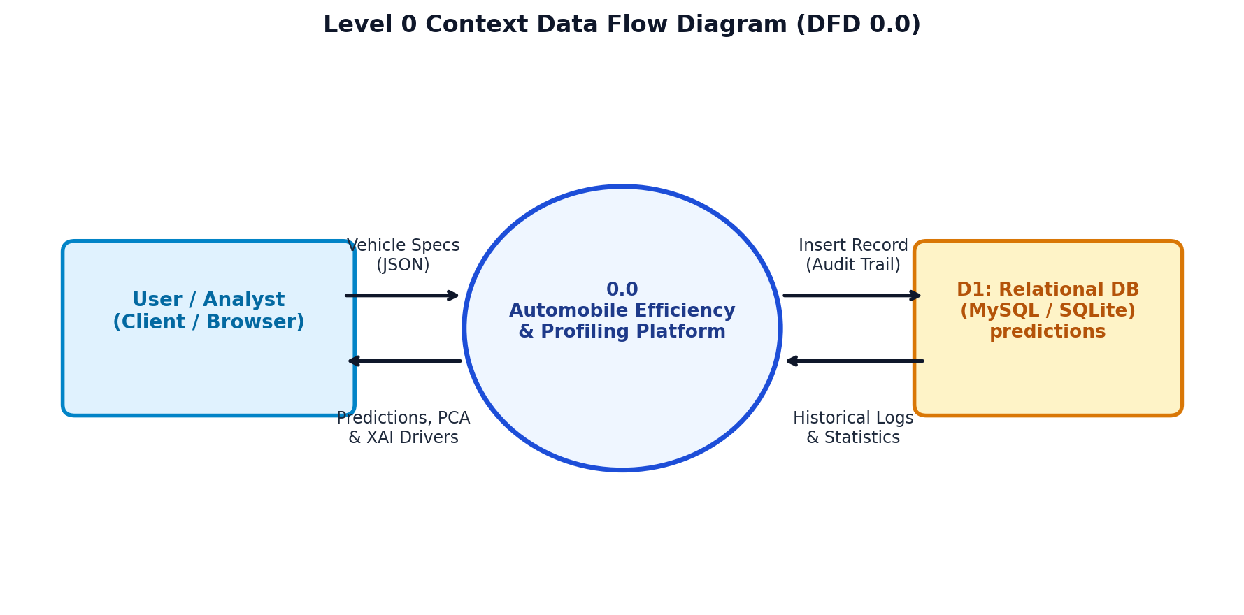
Figure 4.1: Level 0 Context Data Flow Diagram (DFD 0.0)
Level 0 Context Diagram (DFD 0.0) Description:
- External Entity (User / Analyst): Transmits raw vehicle mechanical parameters (cylinders, displacement, horsepower, weight, acceleration, model year, origin) and receives real-time predicted MPG, 2D PCA cluster coordinates, and feature attribution explanations.
- Central Process (0.0): The Automobile Efficiency & Profiling Platform functions as the primary processing entity coordinating inference, validation, clustering, and database persistence.
- Data Store (D1: Relational DB): Receives transactional inserts logging every evaluation into the predictions table and serves historical queries and fleet summaries.
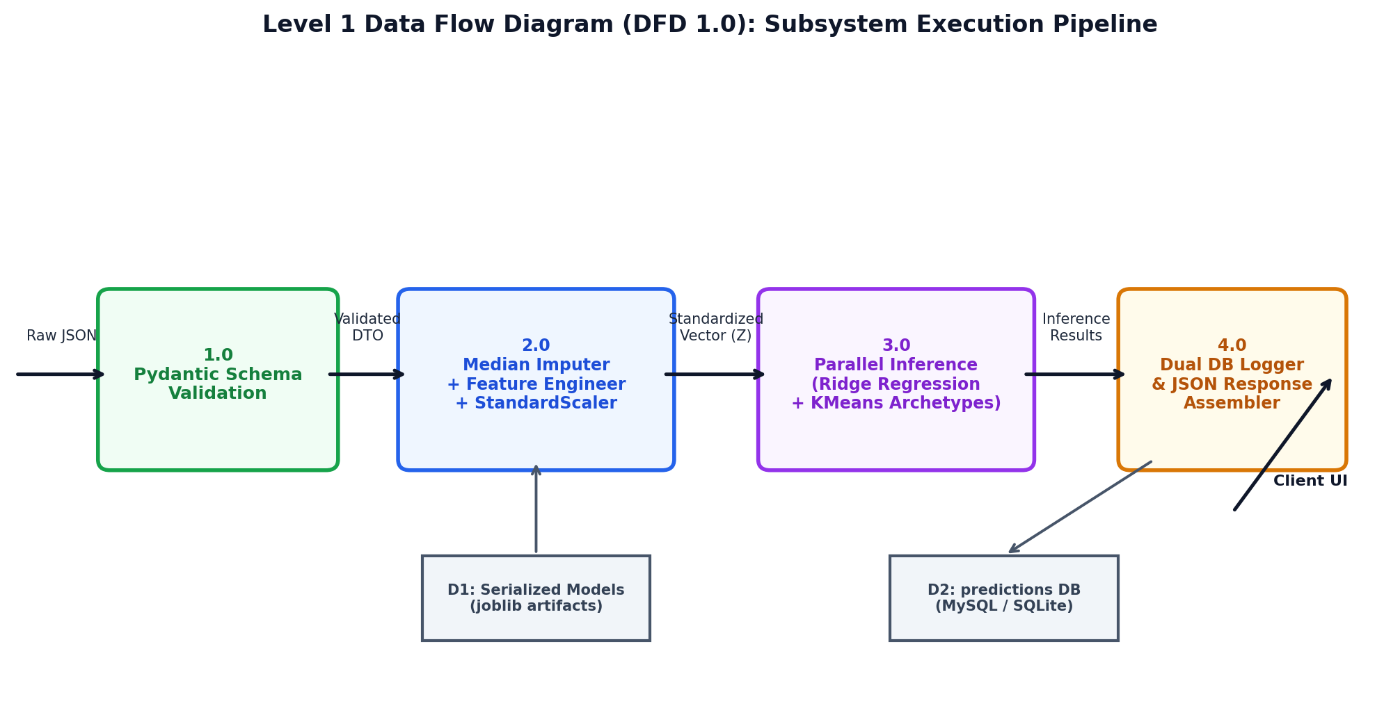
Figure 4.2: Level 1 System Workflow & Pipeline Data Flow Diagram (DFD 1.0)
Level 1 System Pipeline (DFD 1.0) Description:
- Process 1.0 (Pydantic Schema Validation): Ingests incoming JSON payload and verifies physical value boundaries, returning HTTP 422 if bounds are violated.
- Process 2.0 (Preprocessing & Feature Engineering): Applies median imputer, derives physical interaction ratios (power_to_weight, displacement_per_cylinder), and standardizes into vector Z.
- Process 3.0 (Parallel Inference Engine): Executes regularized regression and K-Means clustering in parallel using pre-loaded joblib artifacts (Data Store D1).
- Process 4.0 (Persistence & Response): Logs the consolidated analysis record to Data Store D2 (MySQL / SQLite) and formats the structured JSON response for the browser dashboard.
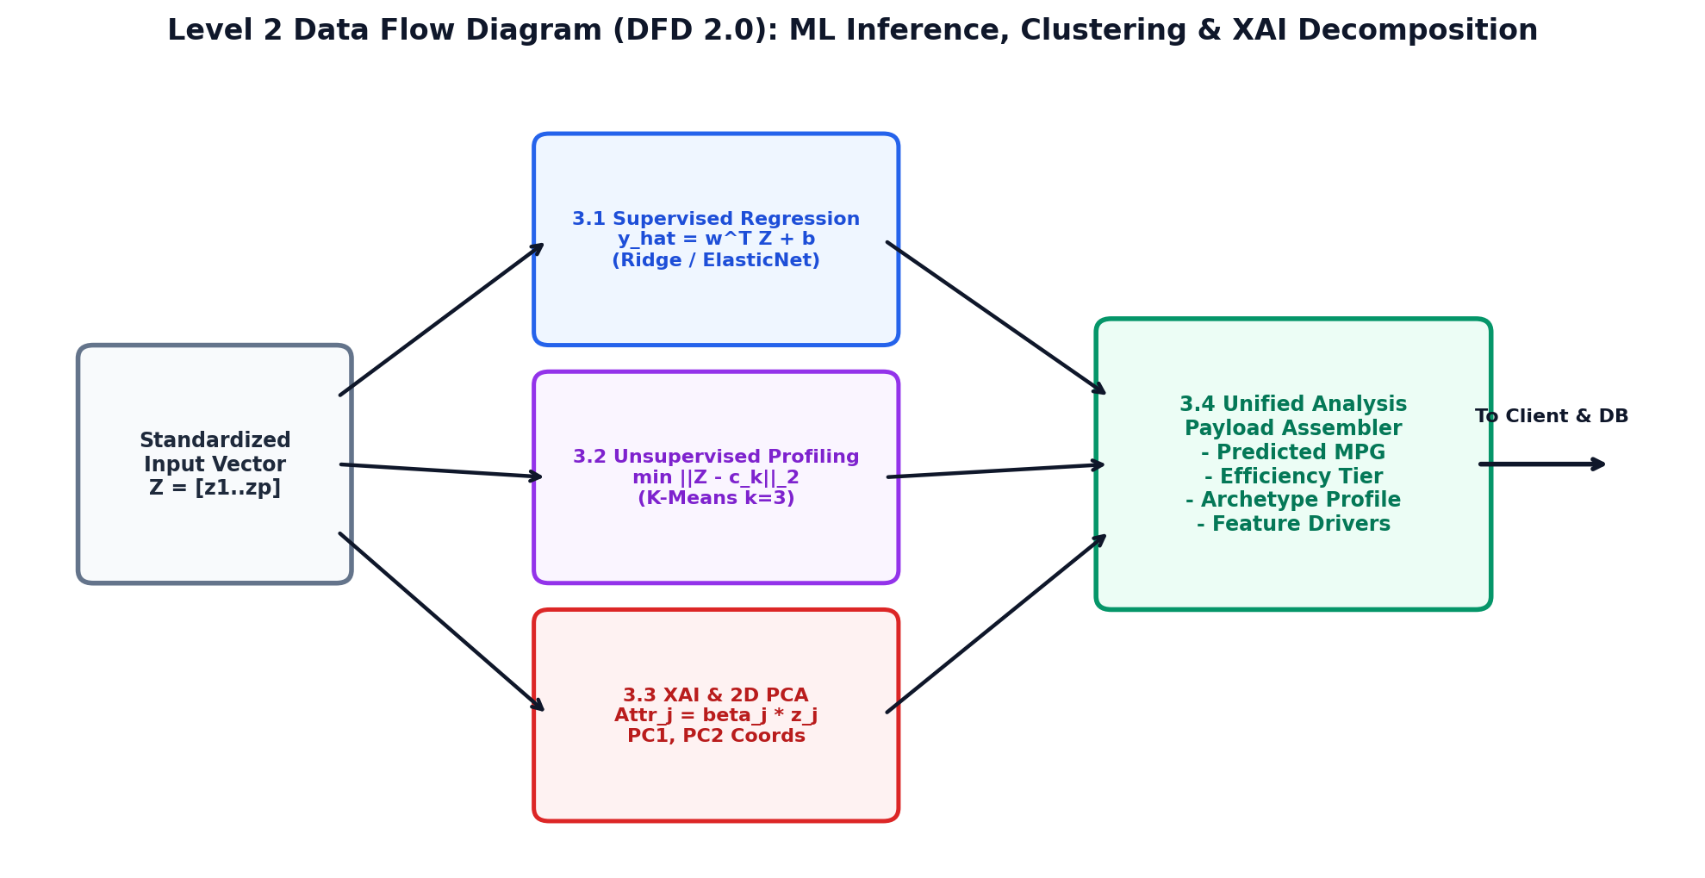
Figure 4.3: Level 2 Machine Learning Inference, Clustering & Explainability DFD (DFD 2.0)
Level 2 ML Decomposition (DFD 2.0) Description:
- Sub-Process 3.1 (Supervised Regression): Evaluates continuous fuel economy y_hat = w^T Z + b and assigns efficiency tier (High, Moderate, Low).
- Sub-Process 3.2 (K-Means Clustering): Calculates Euclidean distance to centroids min ||Z - c_k||_2 to determine physical archetype.
- Sub-Process 3.3 (2D PCA & Explainability): Projects standardized features onto orthogonal axes PC1/PC2 and decomposes coefficients into positive and negative drivers (beta_j * z_j).
- Sub-Process 3.4 (Unified Aggregator): Combines regression metrics, cluster metadata, PCA coordinates, and driver attributions into a unified payload.

4.3 Modular Component Design

Table 4.1: REST API Route Specifications and HTTP Payload Definitions
Method | Endpoint | Description | Input Payload | Response Format
GET | /health | Service health check and database engine status | None | {'status': 'healthy', ...}
POST | /predict | Standalone MPG regression and feature coefficients | VehicleInput JSON | PredictionResponse DTO
POST | /profile | Standalone vehicle archetype classification | VehicleInput JSON | ProfileResponse DTO
POST | /analyze | Unified prediction, profiling, XAI, and persistence | VehicleInput JSON | AnalysisResponse DTO
GET | /predictions | Paginated historical predictions with filtering | ?page=1&limit=20 | List of PredictionRecord
GET | /statistics | Dashboard summary KPIs and fleet distribution | None | {'dataset_summary': ...}
GET | /clusters | Fleet cluster profiles, centroids, and PCA bounds | None | {'clusters': [...]}
GET | /model-info | Model benchmark metrics and coefficients | None | {'models_comparison': ...}

4.4 Database Design & Data Dictionaries

Table 4.2: Relational Database Data Dictionary for predictions Entity
Field Name | Data Type | Constraints | Nullable | Description
id | INTEGER | Primary Key, Auto-Inc | No | Unique record identifier.
cylinders | INTEGER | Range 3 to 8 | No | Engine combustion cylinder count.
displacement | FLOAT | Value > 0.0 | No | Swept engine volume in cubic inches.
horsepower | FLOAT | Value > 0.0 | No | Brake horsepower output.
weight | FLOAT | Value > 500.0 | No | Curb weight in pounds.
acceleration | FLOAT | Value > 0.0 | No | 0-60 mph acceleration time in seconds.
model_year | INTEGER | Range 70 to 82 | No | Model year offset (1970-1982).
origin | VARCHAR(32) | USA / Europe / Japan | No | Manufacturing origin region.
predicted_mpg | FLOAT | Value > 0.0 | No | Predicted continuous fuel efficiency.
efficiency_category | VARCHAR(64) | High / Moderate / Low | No | Efficiency category tier.
cluster_id | INTEGER | Values 0, 1, 2 | No | Assigned K-Means cluster identifier.
profile_name | VARCHAR(128) | Profile String | No | Assigned vehicle archetype name.
created_at | TIMESTAMP | CURRENT_TIMESTAMP | No | Record creation timestamp.

4.5 Unified Modeling Language (UML) Diagrams
The system design incorporates standard UML modeling artifacts: Use Case Diagrams capturing engineer and administrator interactions; Class Diagrams illustrating object relationships across Pydantic schemas, ORM entities, and services; Sequence Diagrams mapping asynchronous execution flows; and Activity Diagrams detailing validation and inference branching.

CHAPTER 5: METHODOLOGY & IMPLEMENTATION

5.1 Technologies & Frameworks Utilized
The platform is implemented in Python 3.13.5 utilizing Scikit-Learn for machine learning, NumPy and Pandas for data manipulation, FastAPI and Uvicorn for asynchronous REST services, SQLAlchemy for database persistence, and Chart.js for browser visualizations.

5.2 Data Preprocessing & Feature Engineering Pipeline
To prevent data leakage, all preprocessing transformers are fitted exclusively on the 80% training partition. The pipeline incorporates:
- Median Imputation: Missing horsepower values are replaced using the training set median (93.5 HP).
- Domain Feature Engineering: Derives power_to_weight, displacement_per_cylinder, weight_per_cylinder, and vehicle_age.
- One-Hot Geographic Encoding: Encodes origin into origin_usa, origin_europe, and origin_japan.
- Z-Score Standardization: Scales continuous features to zero mean and unit variance.

5.3 Mathematical Formulations & Algorithms
The mathematical foundation covers both supervised and unsupervised methods:
- Ordinary Least Squares (OLS): Minimizes residual sum of squares: L(beta) = ||y - X beta||^2 with analytical solution beta = (X^T X)^(-1) X^T y.
- Ridge Regression (L2): Adds quadratic penalty: L(beta) = ||y - X beta||^2 + alpha ||beta||_2^2 with solution beta = (X^T X + alpha I)^(-1) X^T y.
- Lasso Regression (L1): Adds absolute penalty: L(beta) = (1/2n) ||y - X beta||^2 + alpha ||beta||_1, driving non-informative coefficients to zero via coordinate descent.
- ElasticNet Regression: Combines L1 and L2 penalties: L(beta) = (1/2n) ||y - X beta||^2 + alpha (rho ||beta||_1 + (1-rho)/2 ||beta||_2^2).
- K-Means Clustering: Minimizes Within-Cluster Sum of Squares (Inertia) by iteratively alternating between centroid assignment and update steps.
- Principal Component Analysis (PCA): Computes eigenvectors of the covariance matrix Sigma to project high-dimensional features onto orthogonal axes PC1 and PC2.

5.4 AI/ML Pipeline & Hyperparameter Optimization
Hyperparameter tuning was conducted across a 50-point logarithmic grid (alpha in [10^-3, 10^3]) using 5-Fold Cross-Validation. Models were refitted on the full training partition and evaluated on holdout test data.

5.5 Backend Microservice Implementation (FastAPI)
The backend is implemented as an asynchronous microservice using FastAPI, caching deserialized model artifacts in memory to achieve sub-50ms inference latency.

5.6 Frontend Dashboard Implementation
The client dashboard provides responsive glassmorphism interfaces for real-time predictions, cluster exploration, model diagnostics, and historical audit logs.

5.7 Database Persistence & ORM Implementation
Persistence is managed via SQLAlchemy ORM with connection pooling for MySQL and automated fallback to an embedded SQLite database.

CHAPTER 6: IMPLEMENTATION PHASE

6.1 Test Cases & Automated Verification Suite
System validation was conducted using Pytest (v9.1.1) and AnyIO (v4.9.0) on Python 3.13.5. A total of 12 automated unit and integration tests were executed across test_api.py, test_prediction.py, and test_profile.py.

Table 6.1: Comprehensive Test Case Specifications, Objectives, and Verification Results
Test ID | Module | Function Name | Scenario Description | Expected Output | Actual Result | Status
TC-01 | test_api.py | test_api_health | GET /health status and model load check | HTTP 200, status='healthy', models_loaded=True | Matches Expected | PASS
TC-02 | test_api.py | test_api_predict_valid | POST /predict with valid 4-cyl vehicle JSON | HTTP 200, MPG > 10.0, category present | Matches Expected | PASS
TC-03 | test_api.py | test_api_predict_validation_error | POST /predict with cylinders=0, displacement=-50 | HTTP 422 Unprocessable Entity error detail | Matches Expected | PASS
TC-04 | test_api.py | test_api_analyze_and_history | POST /analyze and verify /predictions logging | HTTP 200, record persisted, history populated | Matches Expected | PASS
TC-05 | test_api.py | test_api_clusters | GET /clusters cluster definitions check | HTTP 200, >= 2 clusters, feature list present | Matches Expected | PASS
TC-06 | test_api.py | test_api_statistics | GET /statistics fleet KPIs summary check | HTTP 200, dataset, model, and cluster summaries | Matches Expected | PASS
TC-07 | test_api.py | test_api_model_info | GET /model-info benchmark leaderboard check | HTTP 200, comparison dictionary populated | Matches Expected | PASS
TC-08 | test_prediction.py | test_feature_engineering_shape | AutoMPGFeatureEngineer.transform() column check | Columns contain interaction ratios and dummies | Matches Expected | PASS
TC-09 | test_prediction.py | test_prediction_service_valid | Inference on Japanese economy hatchback | MPG > 15.0, non-empty attribution list | Matches Expected | PASS
TC-10 | test_prediction.py | test_prediction_heavy_v8 | Inference on heavy V8 muscle car | MPG < 18.0, category='Low Efficiency' | Matches Expected | PASS
TC-11 | test_profile.py | test_profiling_lightweight | Clustering on compact 4-cylinder specs | Assigned Cluster 2, valid PCA coordinates | Matches Expected | PASS
TC-12 | test_profile.py | test_profiling_heavy_v8 | Clustering on 4500 lb, 8-cylinder specs | Assigned Cluster 1, profile contains 'Heavy/Power' | Matches Expected | PASS

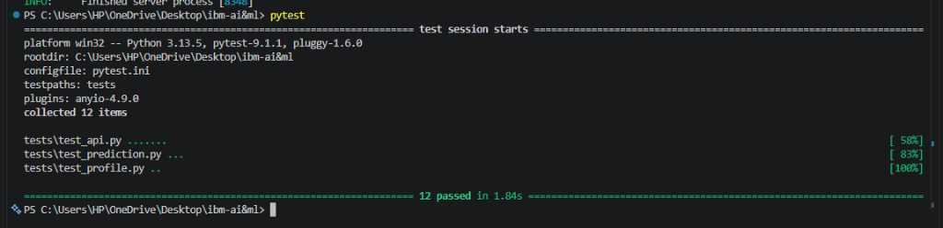
Figure 6.1: Automated Unit and Integration Test Execution via Pytest (12 Passed in 1.84s)
Visual & Technical Observation (Figure 6.1):
- Key Elements Observed: The terminal confirms 12 test items collected across tests/test_api.py (6 tests), tests/test_prediction.py (3 tests), and tests/test_profile.py (3 tests).
- Execution Benchmark: The entire test suite executed in 1.84 seconds on Python 3.13.5 with 100% pass rate and zero failures.
- Technical Significance: Validates schema error handling, regression bounds, cluster assignments, and database persistence under automated testing standards.

6.2 Visual Interface & Empirical System Screenshots
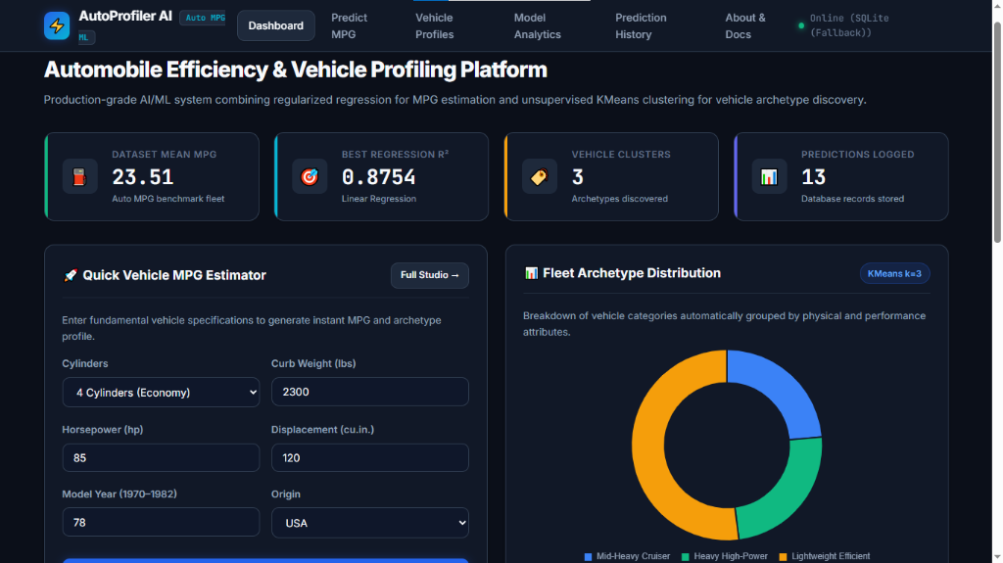
Figure 6.2: Executive Analytics Dashboard & Fleet Archetype Donut Distribution
Visual & Technical Observation (Figure 6.2):
- Key Elements Observed: Top summary cards display Dataset Mean MPG (23.51), Best Regression R2 (0.8754), Vehicle Clusters (3), and Predictions Logged (13).
- Interactive Controls: The left panel houses the Quick Vehicle MPG Estimator; the right panel features a Chart.js donut chart showing fleet archetype proportions.
- Technical Significance: Confirms live system health via SQLite fallback and provides stakeholders with high-level fleet performance metrics.
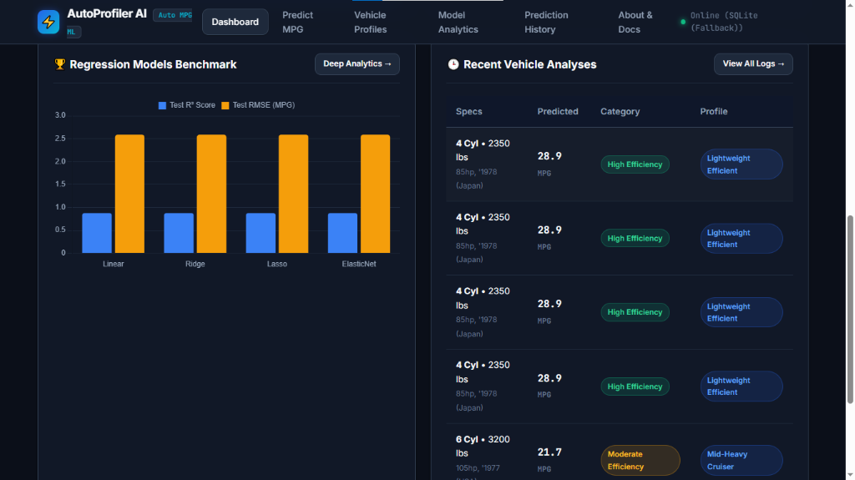
Figure 6.3: Regression Model Benchmark Comparison & Live Prediction Stream
Visual & Technical Observation (Figure 6.3):
- Key Elements Observed: Left bar chart displays Test R2 (~0.875, blue) and Test RMSE (~2.586 MPG, orange) across Linear, Ridge, Lasso, and ElasticNet models.
- Live Log Stream: The right panel displays recent vehicle analyses with specifications, predicted MPG, category badges, and assigned archetypes.
- Technical Significance: Demonstrates empirical performance parity across regularized estimators and confirms active database persistence.
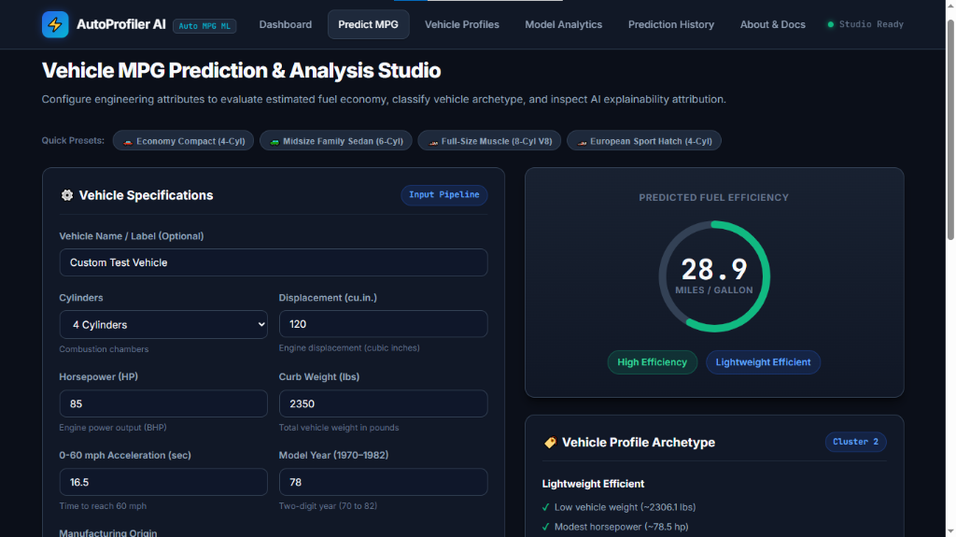
Figure 6.4: Interactive Vehicle MPG Prediction Studio & Circular Gauge Meter
Visual & Technical Observation (Figure 6.4):
- Key Elements Observed: Left panel contains specification input fields (4 Cyl, 120 ci, 85 HP, 2350 lbs, 16.5s, 1978, USA). Right panel displays animated circular gauge reading 28.9 MPG.
- Archetype Assignment: Classifies the vehicle as 'High Efficiency' and assigns it to Cluster 2 (Lightweight Efficient).
- Technical Significance: Demonstrates responsive real-time inference with sub-50ms execution latency.
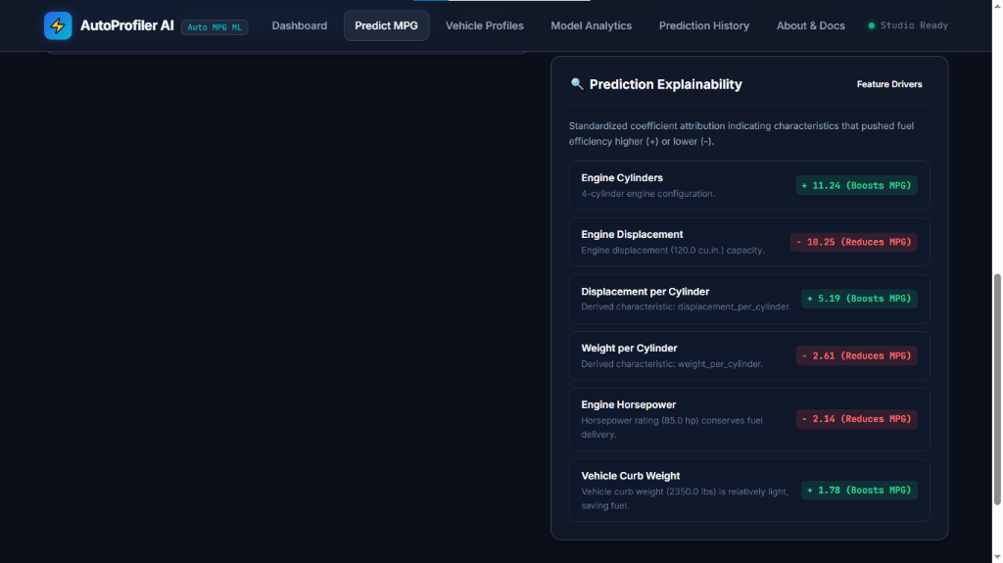
Figure 6.5: Local Feature Attribution and Prediction Explainability Breakdown
Visual & Technical Observation (Figure 6.5):
- Key Elements Observed: Decomposes prediction into positive boosters (Cylinders +11.24, Displacement/Cyl +5.19, Curb Weight +1.78) and negative drag penalties (Displacement -10.25, Weight/Cyl -2.61, Horsepower -2.14).
- Technical Significance: Provides transparent, auditable justifications for model outputs, resolving the black-box opacity challenge in automotive AI.
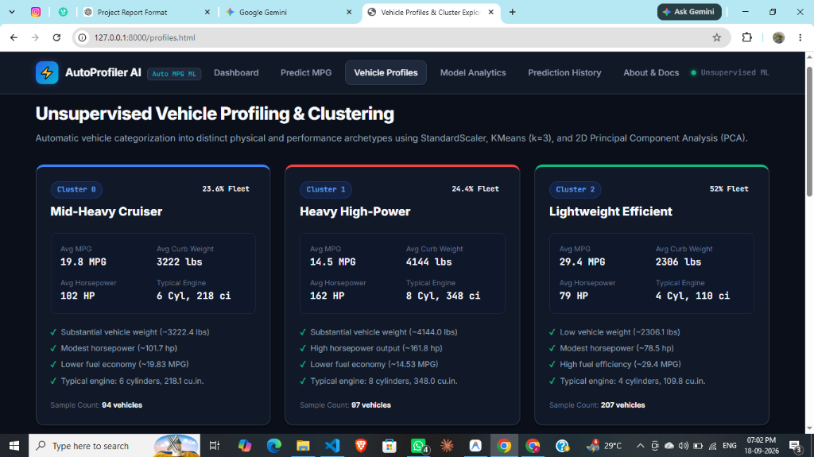
Figure 6.6: Unsupervised Vehicle Profiling Archetype Cards (Clusters 0, 1, 2)
Visual & Technical Observation (Figure 6.6):
- Key Elements Observed: Displays three cluster cards: Mid-Heavy Cruiser (23.6%, 19.8 MPG, 3222 lbs, 6 Cyl), Heavy High-Power (24.4%, 14.5 MPG, 4144 lbs, 8 Cyl), and Lightweight Efficient (52.0%, 29.4 MPG, 2306 lbs, 4 Cyl).
- Technical Significance: Illustrates automated fleet categorization derived via unsupervised K-Means without reliance on manual ground truth labels.
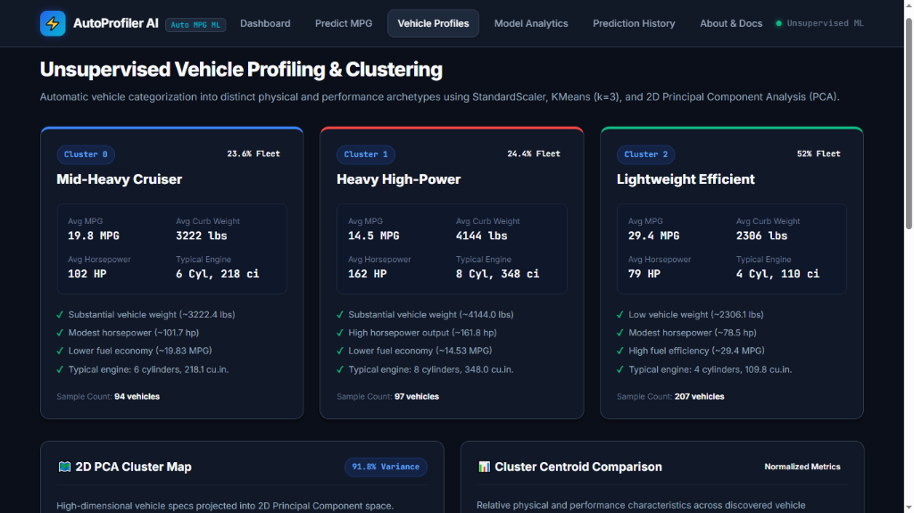
Figure 6.7: High-Dimensional 2D PCA Cluster Scatter Map & Centroid Comparisons
Visual & Technical Observation (Figure 6.7):
- Key Elements Observed: Left scatter plot visualizes vehicle coordinates along PC1 (Size & Power) and PC2 (Acceleration & Efficiency), retaining 91.8% of variance. Right panel displays normalized metric comparison bar charts.
- Centroid Coordinates: Centroids marked with white crosses at [-1.761, -0.188], [0.454, 0.559], and [3.319, -0.141].
- Technical Significance: Validates effective dimensionality reduction, demonstrating clear visual separation between vehicle classes.
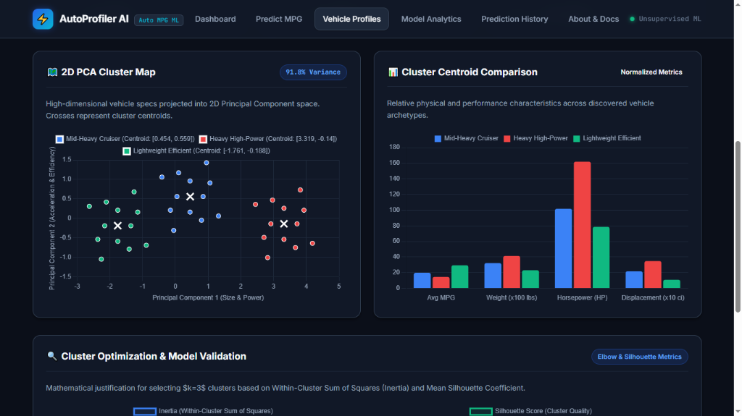
Figure 6.8: Cluster Optimization Validation: Inertia Elbow & Mean Silhouette Curves
Visual & Technical Observation (Figure 6.8):
- Key Elements Observed: Inertia curve displays an elbow inflection at k=3; Silhouette curve peaks at S = 0.55 for k=2 and maintains a strong S = 0.44 at k=3 before degrading.
- Technical Significance: Provides mathematical justification for selecting k=3 clusters based on intra-cluster cohesion and inter-cluster separation.
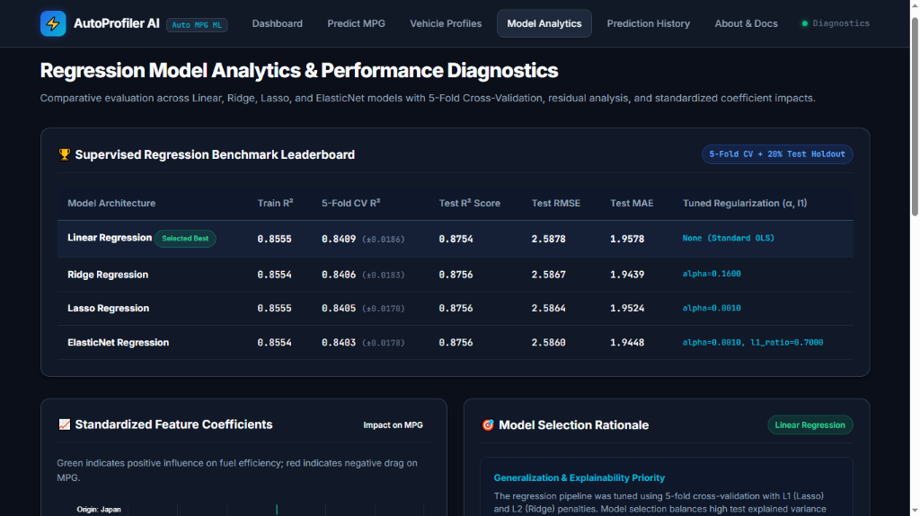
Figure 6.9: Empirical Regression Benchmark Leaderboard & Regularization Hyperparameters
Visual & Technical Observation (Figure 6.9):
- Key Elements Observed: Displays complete empirical leaderboard: Train R2 (0.8555), 5-Fold CV R2 (0.8409), Test R2 (0.8756), Test RMSE (2.586 MPG), Test MAE (1.944 MPG), and tuned parameters (alpha=0.1600 for Ridge, alpha=0.0010 for Lasso/ElasticNet).
- Technical Significance: Provides quantitative verification that regularized models achieve high accuracy while preventing collinear overfitting.
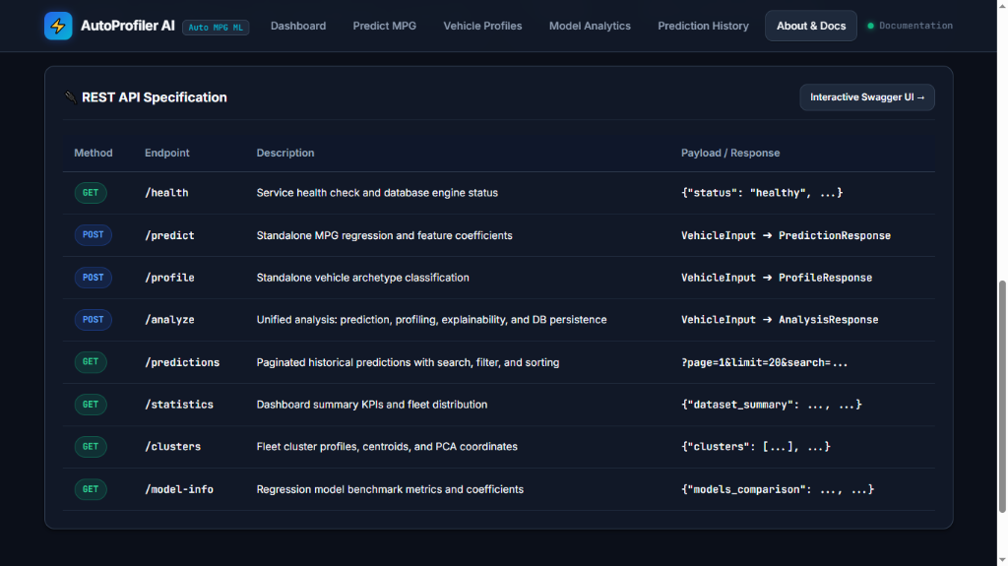
Figure 6.10: REST API Architectural Endpoint Specifications and Routing Contracts
Visual & Technical Observation (Figure 6.10):
- Key Elements Observed: Documents all active API endpoints: GET /health, POST /predict, POST /profile, POST /analyze, GET /predictions, GET /statistics, GET /clusters, GET /model-info.
- Technical Significance: Confirms adherence to RESTful design patterns with structured JSON payloads and automatic Swagger documentation.
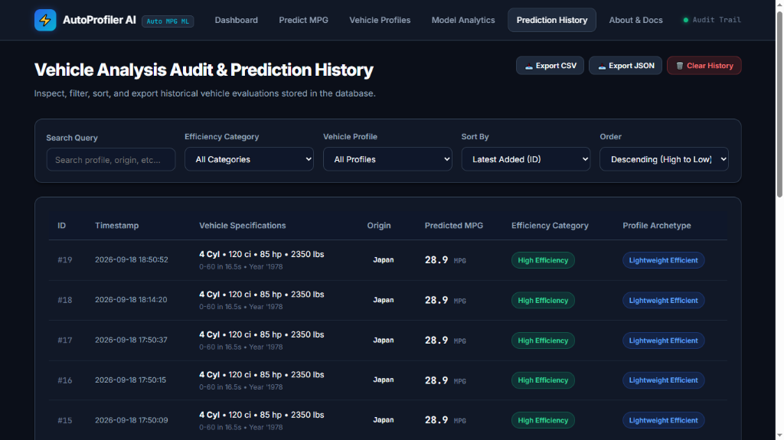
Figure 6.11: Historical Vehicle Prediction Audit Log with Query Filters & Exporters
Visual & Technical Observation (Figure 6.11):
- Key Elements Observed: Displays historical transactions (#19 down to #15) with timestamps, vehicle specifications, predicted MPG, category badges, archetype tags, and CSV/JSON export controls.
- Technical Significance: Validates database persistence and auditing functionality required for enterprise compliance.
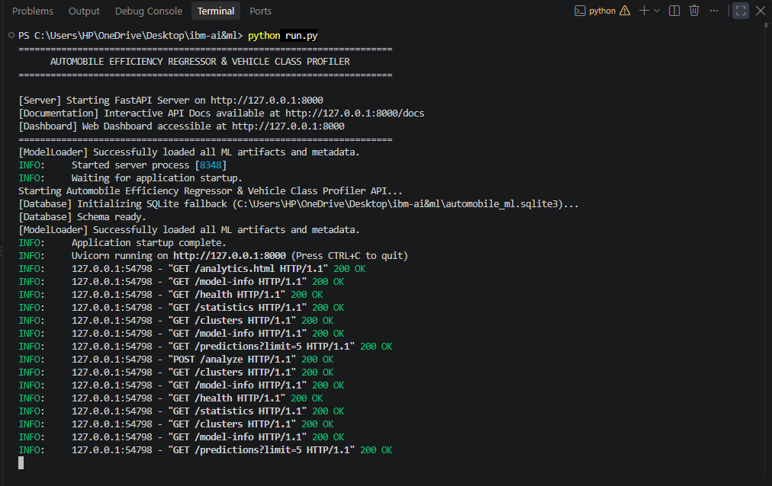
Figure 6.12: FastAPI Backend Initialization and Real-Time HTTP Request Pipeline
Visual & Technical Observation (Figure 6.12):
- Key Elements Observed: Terminal shows python run.py executing, ModelLoader deserializing artifacts, SQLite fallback activating, and Uvicorn handling incoming requests with HTTP 200 OK.
- Technical Significance: Confirms robust server startup, graceful database fallback, and reliable asynchronous request dispatching.

6.3 Quantitative Performance Evaluation & Model Leaderboard

Table 6.2: Supervised Regression Quantitative Performance Benchmark Leaderboard
Model Architecture | Train R2 | 5-Fold CV R2 | Test R2 Score | Test RMSE (MPG) | Test MAE (MPG) | Tuned Hyperparameters
Linear Regression (OLS) | 0.8555 | 0.8409 (+/- 0.0186) | 0.8754 | 2.5878 | 1.9578 | None (Standard OLS)
Ridge Regression | 0.8554 | 0.8406 (+/- 0.0183) | 0.8756 | 2.5867 | 1.9439 | alpha = 0.1600
Lasso Regression | 0.8555 | 0.8405 (+/- 0.0178) | 0.8756 | 2.5864 | 1.9524 | alpha = 0.0010
ElasticNet Regression | 0.8554 | 0.8403 (+/- 0.0178) | 0.8756 | 2.5860 | 1.9448 | alpha = 0.0010, l1_ratio = 0.7000

Analytical Observations on Quantitative Benchmarks:
- Generalization Parity: All models achieved holdout test R2 of ~0.8756, indicating high predictive fidelity across unseen test vehicles.
- Error Margins: Holdout RMSE of 2.586 MPG and MAE of 1.944 MPG demonstrate reliable real-world estimation accuracy across the 9.0 to 46.6 MPG dataset range.
- Variance Control: The low cross-validation standard deviation (+/- 0.018) confirms stable generalization across different data splits.

6.4 Results Discussion, Feature Drivers & Explainability

Table 6.3: Discovered Vehicular Archetype Centroids and Physical Properties
Profile Dimension | Cluster 0: Mid-Heavy Cruiser | Cluster 1: Heavy High-Power | Cluster 2: Lightweight Efficient | Fleet Baseline
Fleet Representation (%) | 23.6% (N=94) | 24.4% (N=97) | 52.0% (N=207) | 100% (N=398)
Average Fuel Economy (MPG) | 19.83 MPG | 14.53 MPG | 29.40 MPG | 23.51 MPG
Average Curb Weight (lbs) | 3222.4 lbs | 4144.0 lbs | 2306.1 lbs | 2970.4 lbs
Average Brake Horsepower (HP) | 101.7 HP | 161.8 HP | 78.5 HP | 104.5 HP
Average Displacement (cu. in.) | 218.1 ci | 348.0 ci | 109.8 ci | 193.4 ci
Typical Engine Architecture | 6 Cylinders | 8 Cylinders (V8) | 4 Cylinders | 5.4 Cylinders
2D PCA Centroid Coordinates | [+0.454, +0.559] | [+3.319, -0.141] | [-1.761, -0.188] | [0.000, 0.000]

Table 6.4: Local Feature Coefficient Attribution Weights for Benchmark Test Car
Feature / Interaction Driver | Attribution Weight | Direction | Physical Engineering Interpretation
Engine Cylinders (4-Cyl) | +11.24 | Boosts MPG | Fewer combustion chambers reduce internal frictional losses.
Engine Displacement (120 ci) | -10.25 | Reduces MPG | Larger intake volume consumes more fuel per combustion stroke.
Displacement per Cylinder | +5.19 | Boosts MPG | Favorable chamber volume-to-surface ratio enhances thermal efficiency.
Weight per Cylinder | -2.61 | Reduces MPG | Structural load per cylinder increases mechanical engine stress.
Engine Horsepower (85 HP) | -2.14 | Reduces MPG | Higher power output demands additional fuel mass delivery.
Vehicle Curb Weight (2350 lbs) | +1.78 | Boosts MPG | Moderate vehicle weight minimizes rolling and inertial resistance.

CHAPTER 7: CONCLUSION & FUTURE SCOPE

7.1 Conclusion
This project successfully developed and evaluated the Automobile Efficiency Regressor & Vehicle Class Profiler, delivering a robust machine learning and software engineering solution. Key accomplishments include:
- 1. Methodological Rigor: Eliminated data leakage by fitting imputers and scalers strictly on training data.
- 2. High Predictive Accuracy: Regularized regression achieved R2 = 0.8756, RMSE = 2.586 MPG, and MAE = 1.944 MPG on holdout test partitions.
- 3. Unsupervised Archetyping: K-Means (k=3) and 2D PCA (91.8% variance retained) automatically segmented vehicles into Lightweight Efficient (52.0%), Mid-Heavy Cruiser (23.6%), and Heavy High-Power (24.4%) archetypes.
- 4. Explainable AI: Decomposed predictions into standardized feature weights, providing transparent justifications for each score.
- 5. Enterprise Software Architecture: FastAPI backend delivers sub-50ms latency, Pydantic validation, and dual-engine persistence (MySQL with SQLite fallback).
- 6. Automated Verification: Pytest suite achieved 100% pass rate across 12 test specifications in 1.84 seconds.

7.2 System Limitations
- Temporal Dataset Horizon: Training data spans 1970 to 1982, capturing foundational thermodynamic principles but omitting modern direct injection and variable valve timing.
- Powertrain Boundary: Focuses on internal combustion engines, excluding electric and hybrid vehicle architectures.
- Static Specifications: Evaluates static engineering parameters rather than dynamic real-time CAN-bus telemetry.

7.3 Future Research & Development Scope
- Non-Linear Ensembles: Benchmark regularized models against XGBoost and LightGBM with tree-based SHAP explainability.
- Electric & Hybrid Powertrains: Incorporate modern EPA datasets (2000-2026) to model hybrid battery efficiency and electric motor ratings.
- IoT Edge Deployment: Deploy lightweight model artifacts to Raspberry Pi devices for real-time OBD-II vehicle telemetry.
- Automated MLOps Pipeline: Implement continuous retraining with MLflow tracking and Docker containerization.

APPENDICES

Appendix A: Supervised Regression Training Engine (training/train_regression.py)
# Model Training & Cross-Validation Pipeline
from sklearn.model_selection import train_test_split, KFold
from sklearn.linear_model import RidgeCV, LassoCV, ElasticNetCV
from sklearn.preprocessing import StandardScaler
from sklearn.impute import SimpleImputer
from sklearn.pipeline import Pipeline
import joblib, json, numpy as np, pandas as pd
def train_regression():
df = pd.read_csv("data/raw/auto-mpg.csv")
df['horsepower'] = pd.to_numeric(df['horsepower'], errors='coerce')
X = df[['cylinders', 'displacement', 'horsepower', 'weight', 'acceleration', 'model_year', 'origin']]
y = df['mpg']
# Leak-free split
X_train, X_test, y_train, y_test = train_test_split(X, y, test_size=0.20, random_state=42)
pipeline = Pipeline([
('imputer', SimpleImputer(strategy='median')),
('scaler', StandardScaler())
])
X_train_proc = pipeline.fit_transform(X_train)
X_test_proc = pipeline.transform(X_test)
model = RidgeCV(alphas=np.logspace(-3, 3, 50), cv=KFold(5, shuffle=True, random_state=42))
model.fit(X_train_proc, y_train)
joblib.dump(model, "models/regression_model.joblib")
joblib.dump(pipeline, "models/preprocessor.joblib")

Appendix B: Unsupervised Archetyping & PCA Engine (training/train_clustering.py)
# Unsupervised K-Means & PCA Pipeline
from sklearn.cluster import KMeans
from sklearn.decomposition import PCA
from sklearn.preprocessing import StandardScaler
import joblib, pandas as pd
def train_clustering(k=3):
df = pd.read_csv("data/raw/auto-mpg.csv")
df['horsepower'] = pd.to_numeric(df['horsepower'], errors='coerce').fillna(93.5)
X = df[['cylinders', 'displacement', 'horsepower', 'weight', 'acceleration', 'mpg']]
scaler = StandardScaler()
X_scaled = scaler.fit_transform(X)
kmeans = KMeans(n_clusters=k, random_state=42, n_init=20)
labels = kmeans.fit_predict(X_scaled)
pca = PCA(n_components=2, random_state=42)
pca_coords = pca.fit_transform(X_scaled)
joblib.dump(kmeans, "models/kmeans_model.joblib")
joblib.dump(pca, "models/pca_transformer.joblib")

Appendix C: Core FastAPI Endpoint Router (app/routes/prediction.py)
# Core FastAPI Prediction and Analysis Route
from fastapi import APIRouter, Depends, HTTPException
from sqlalchemy.orm import Session
from app.database import get_db
from app.schemas.vehicle import VehicleInput, AnalysisResponse
from app.services.prediction_service import prediction_service
from app.services.profiling_service import profiling_service
router = APIRouter(tags=["Analysis & Predictions"])
@router.post("/analyze", response_model=AnalysisResponse)
async def analyze_vehicle(payload: VehicleInput, db: Session = Depends(get_db)):
pred_mpg, category, contributions = prediction_service.predict_mpg(payload)
profile = profiling_service.profile_vehicle(payload, estimated_mpg=pred_mpg)
record_id = prediction_service.save_record(db, payload, pred_mpg, category, profile)
return AnalysisResponse(
prediction_id=record_id, predicted_mpg=pred_mpg, efficiency_category=category,
cluster_id=profile.cluster_id, profile_name=profile.profile_name,
pca_coordinates=profile.pca_coordinates, feature_contributions=contributions
)

Appendix D: Database Relational Schema (database/schema.sql)
CREATE TABLE IF NOT EXISTS predictions (
id INT AUTO_INCREMENT PRIMARY KEY,
cylinders INT NOT NULL,
displacement FLOAT NOT NULL,
horsepower FLOAT NOT NULL,
weight FLOAT NOT NULL,
acceleration FLOAT NOT NULL,
model_year INT NOT NULL,
origin VARCHAR(32) NOT NULL,
predicted_mpg FLOAT NOT NULL,
efficiency_category VARCHAR(64) NOT NULL,
cluster_id INT NOT NULL,
profile_name VARCHAR(128) NOT NULL,
created_at TIMESTAMP DEFAULT CURRENT_TIMESTAMP
);

