WEEK 4 FINAL REPORT
Comprehensive Data Analysis Reporting and Presentation
Virtual R Data Analyst Internship

1. Introduction
This final report integrates the work completed during Weeks 1–3 of the Virtual R Data Analyst Internship. The project uses the Titanic passenger dataset to demonstrate a complete analytical workflow: data preparation, exploratory visualization, statistical testing, predictive modeling, evaluation, and communication of findings. The report is structured for both technical reviewers and non-technical stakeholders.

2. Data Preparation
The original dataset contains 891 records and 12 variables. Missing Age values were replaced with the median, missing Embarked values were replaced with the modal category, and a CabinKnown indicator was created to retain information about cabin availability without inventing missing cabin values. FamilySize and IsAlone were also derived to support analysis.

3. Visualization Findings
The visualization stage found an overall survival rate of 38.4%. The strongest visible difference was by sex: female survival was 74.2% compared with 18.9% for males. Passenger class also showed meaningful differences. These findings guided the subsequent statistical analysis.
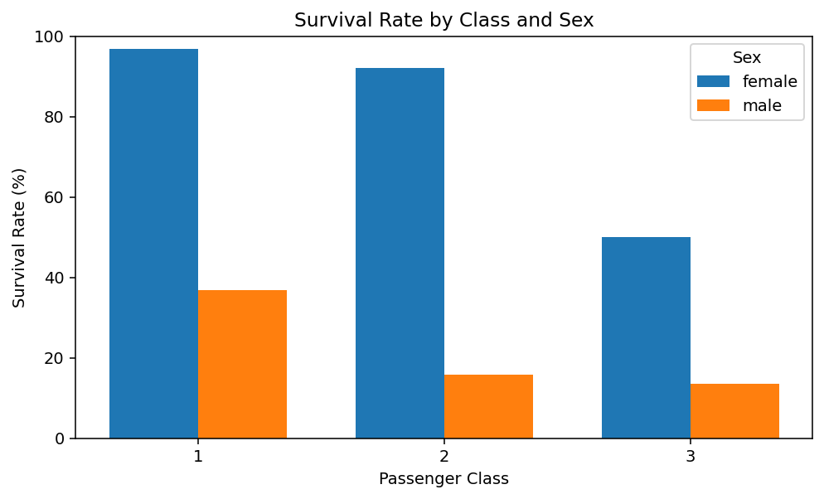
Figure 1. Integrated visualization of survival by class and sex.

4. Statistical Analysis
The chi-square test of sex versus survival produced p=1.197e-58, providing strong evidence of an association between the two categorical variables. This formal test supports the pattern observed visually. The analysis demonstrates the value of combining visual evidence with statistical evidence rather than relying on charts alone.
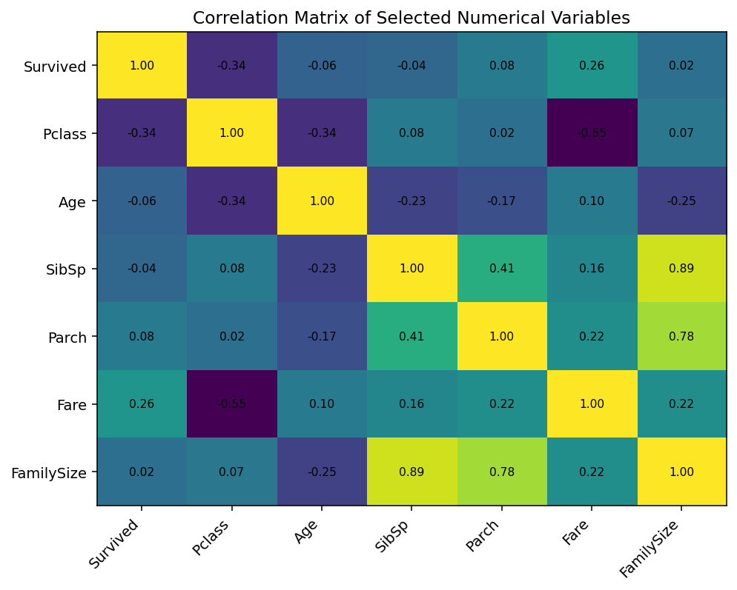
Figure 2. Correlation matrix used during exploratory statistical analysis.

5. Predictive Modeling
A logistic regression classifier was developed because survival is a binary outcome. The model used passenger class, sex, age, family counts, fare, embarkation, family size, and whether the passenger was alone. An 80/20 stratified split was used for holdout evaluation, followed by five-fold cross-validation.
Evaluation metric | Result
Accuracy | 0.816
Precision | 0.810
Recall | 0.681
F1 Score | 0.740
ROC-AUC | 0.851
The final baseline model achieved 0.816 accuracy and 0.851 ROC-AUC on the holdout set. Five-fold cross-validation produced a mean accuracy of 0.798. The model is therefore useful as an interpretable baseline, although more advanced algorithms and feature engineering could potentially improve performance.
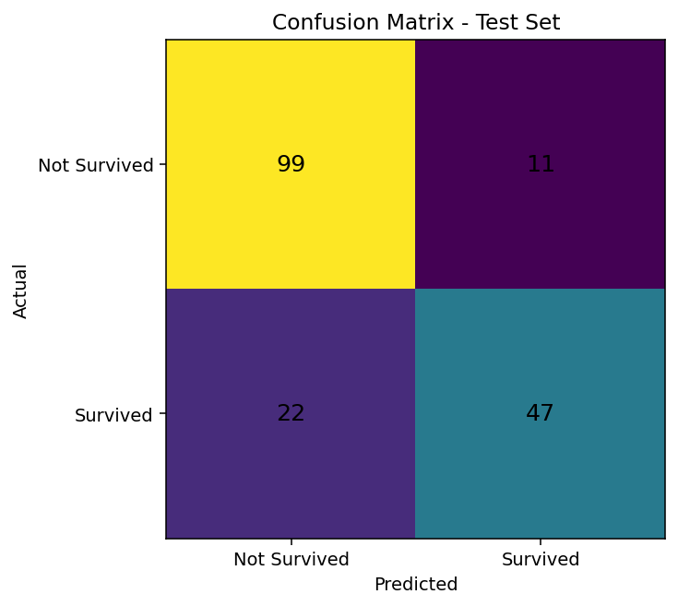
Figure 3. Final model confusion matrix.
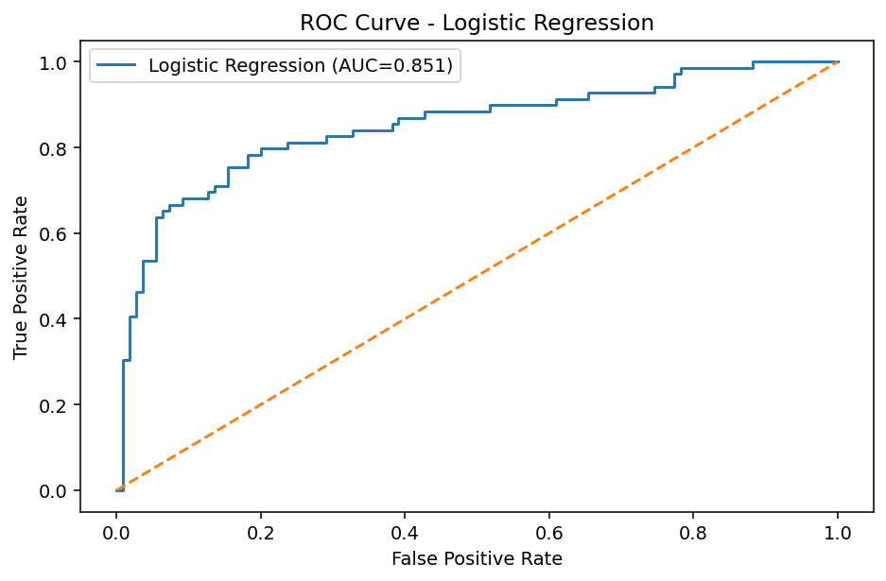
Figure 4. Final model ROC curve.

6. Business and Practical Implications
Although the Titanic dataset is historical rather than a modern business dataset, it demonstrates a transferable decision-making principle: analytical teams should identify important segments, validate apparent patterns statistically, and then quantify predictive performance before drawing conclusions. In a real organization, the same workflow could be applied to customer churn, loan default, employee attrition, sales conversion, or other binary outcomes.

7. Challenges Encountered and Solutions
- Missing data: handled using median/mode treatment and an explicit indicator for missing cabin information.
- Mixed variable types: categorical and numerical variables were processed separately in the modeling workflow.
- Interpretation: different chart types were selected based on the analytical question.
- Model evaluation: a holdout test set and cross-validation were used to reduce dependence on a single split.
- Communication: technical outputs were translated into plain-language findings for non-technical readers.

8. Recommendations for Future Work
- Compare logistic regression with random forest, gradient boosting, and support vector machine models.
- Use systematic hyperparameter tuning and repeated cross-validation.
- Investigate interaction effects, particularly between sex and passenger class.
- Perform more detailed outlier and sensitivity analysis.
- Create an interactive R Shiny dashboard for stakeholder exploration.
- For a business deployment, monitor model drift, fairness, and data-quality changes over time.

9. Final Conclusion
The four-week project demonstrates a complete R-based data analytics workflow. Week 1 established a clean analytical dataset; Week 2 converted that dataset into effective visual stories; Week 3 added hypothesis testing and a predictive classification model; and Week 4 integrated the results into a cohesive professional report. The project highlights the importance of combining data quality, visualization, statistical reasoning, model evaluation, and clear communication. The resulting workflow is reproducible and provides a strong foundation for more advanced analytics.

10. Integrated R Code
# Week 4: Comprehensive Titanic Analysis - Integrated R Workflow
library(tidyverse)
library(caret)
library(pROC)
# 1. Load and prepare data
titanic <- read.csv("train.csv", stringsAsFactors=FALSE)
titanic_clean <- titanic %>%
mutate(
Age=ifelse(is.na(Age), median(Age, na.rm=TRUE), Age),
Embarked=ifelse(is.na(Embarked),
names(sort(table(Embarked), decreasing=TRUE))[1],
Embarked),
CabinKnown=ifelse(is.na(Cabin),0,1),
FamilySize=SibSp+Parch+1,
IsAlone=ifelse(FamilySize==1,"Yes","No"),
SurvivedLabel=ifelse(Survived==1,"Survived","Not Survived")
)
# 2. Visualization
ggplot(titanic_clean, aes(x=Sex, y=Survived)) +
stat_summary(fun=mean, geom="col") +
scale_y_continuous(labels=scales::percent_format())
ggplot(titanic_clean, aes(x=factor(Pclass), y=Survived, fill=Sex)) +
stat_summary(fun=mean, geom="col", position="dodge") +
scale_y_continuous(labels=scales::percent_format())
ggplot(titanic_clean, aes(x=Age, y=Fare, color=SurvivedLabel)) +
geom_point(alpha=0.5)
# 3. Statistical analysis
chisq.test(table(titanic_clean$Sex, titanic_clean$Survived))
t.test(titanic_clean$Survived ~ titanic_clean$Sex)
# 4. Logistic regression with cross-validation
model_data <- titanic_clean %>%
mutate(
Survived=factor(Survived, levels=c(0,1),
labels=c("NotSurvived","Survived"))
) %>%
select(Survived,Pclass,Sex,Age,SibSp,Parch,Fare,Embarked,FamilySize,IsAlone)
set.seed(42)
idx <- createDataPartition(model_data$Survived,p=.80,list=FALSE)
train <- model_data[idx,]
test <- model_data[-idx,]
model <- glm(Survived ~ Pclass + Sex + Age + SibSp + Parch +
Fare + Embarked + FamilySize + IsAlone,
data=train, family=binomial)
summary(model)
prob <- predict(model,test,type="response")
pred <- factor(ifelse(prob>=.5,"Survived","NotSurvived"),
levels=levels(test$Survived))
confusionMatrix(pred,test$Survived)
roc_obj <- roc(test$Survived,prob,levels=c("NotSurvived","Survived"))
auc(roc_obj)
# 5-fold cross-validation
ctrl <- trainControl(method="cv",number=5,classProbs=TRUE,
summaryFunction=twoClassSummary)
cv_model <- train(Survived ~ Pclass + Sex + Age + SibSp + Parch +
Fare + Embarked + FamilySize + IsAlone,
data=model_data,method="glm",family=binomial,
trControl=ctrl,metric="ROC")
cv_model

