WEEK 3 TASK REPORT
Statistical Analysis and Predictive Modeling using R
Virtual R Data Analyst Internship

1. Dataset and Objective
The Titanic dataset from the previous weeks was retained to provide continuity. The objective was to move from descriptive visualization to formal statistical analysis and a classification model that predicts survival. The target variable is Survived, and predictors include passenger class, sex, age, family-related variables, fare, embarkation, and family status.

2. Hypothesis Testing
A chi-square test was used to evaluate the relationship between sex and survival. The test produced a p-value of approximately 1.197e-58, indicating a statistically significant association at the 5% significance level. The null hypothesis that survival and sex are independent is therefore rejected. A two-sample comparison of the binary survival indicator also produced a p-value of approximately 2.284e-61.

3. Correlation and Distribution Analysis
Correlation analysis was performed on selected numerical variables including survival, passenger class, age, family counts, fare, and family size. Correlation is used here as an exploratory diagnostic rather than proof of causation. The matrix helps identify variables that may carry overlapping information before modeling.
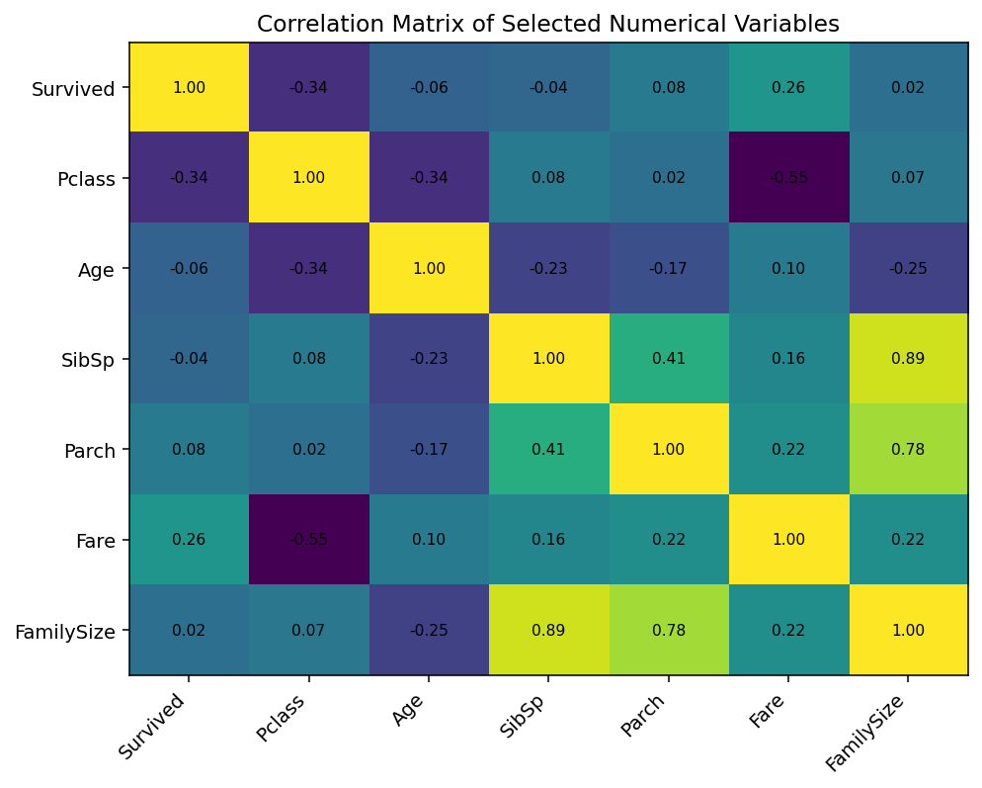
Figure 1. Correlation matrix of selected numerical variables.

4. Logistic Regression Model
Because the target variable has two outcomes, logistic regression was selected as the primary predictive model. The dataset was split into 80% training and 20% testing data using stratification to preserve the survival-class proportions. Numerical predictors were standardized and categorical predictors were encoded within the modeling pipeline.

5. Model Performance
Metric | Test-set result
Accuracy | 0.816
Precision | 0.810
Recall | 0.681
F1 Score | 0.740
ROC-AUC | 0.851
The model achieved a test accuracy of 0.816 and ROC-AUC of 0.851. Five-fold cross-validation produced a mean accuracy of 0.798 with a standard deviation of 0.018. These results indicate that the model captures meaningful survival patterns while still leaving room for improvement.
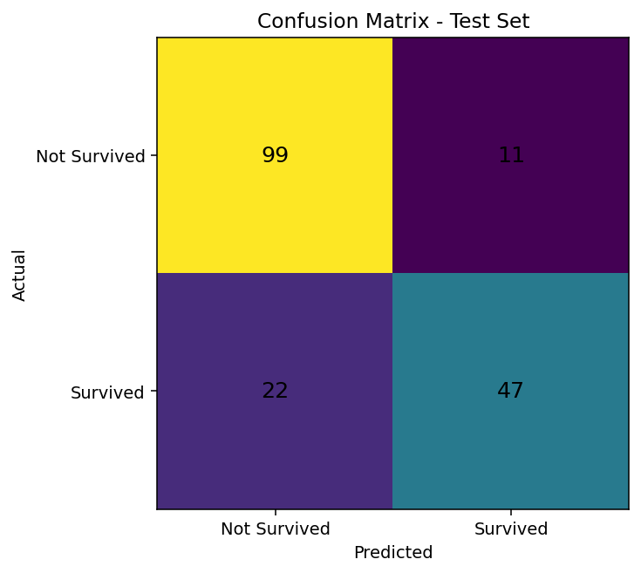
Figure 2. Confusion matrix for the test set.
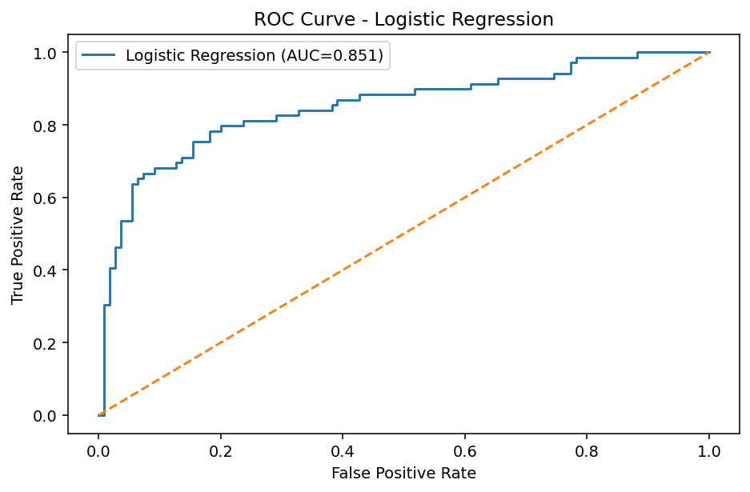
Figure 3. ROC curve for logistic regression.

6. Diagnostic Interpretation
The confusion matrix shows the numbers of correctly and incorrectly classified passengers in each outcome class. ROC-AUC evaluates ranking performance across classification thresholds and is useful when accuracy alone does not tell the complete story. Cross-validation provides an additional check that the observed performance is not dependent only on one train/test split.

7. Strengths and Limitations
- Strength: Logistic regression is interpretable and appropriate for a binary target.
- Strength: Stratified splitting and five-fold cross-validation provide more reliable evaluation.
- Limitation: The Titanic dataset is historical and relatively small, so results should not be generalized beyond the dataset.
- Limitation: Imputation and feature construction choices can influence model results.
- Improvement: Compare logistic regression with decision trees, random forests, or gradient boosting.
- Improvement: Tune hyperparameters and compare multiple validation metrics.

8. R Code Appendix
# Week 3: Statistical Analysis and Predictive Modeling
library(tidyverse)
library(caret)
library(pROC)
titanic <- read.csv("train.csv", stringsAsFactors=FALSE)
titanic_clean <- titanic %>%
mutate(
Age=ifelse(is.na(Age), median(Age, na.rm=TRUE), Age),
Embarked=ifelse(is.na(Embarked),
names(sort(table(Embarked), decreasing=TRUE))[1],
Embarked),
FamilySize=SibSp+Parch+1,
IsAlone=ifelse(FamilySize==1,"Yes","No"),
Survived=factor(Survived, levels=c(0,1),
labels=c("NotSurvived","Survived"))
) %>%
select(Survived,Pclass,Sex,Age,SibSp,Parch,Fare,Embarked,FamilySize,IsAlone)
# Hypothesis test: survival is independent of sex
sex_table <- table(titanic_clean$Sex, titanic_clean$Survived)
chisq.test(sex_table)
# Two-sample comparison of survival indicator by sex
t.test(as.numeric(titanic_clean$Survived)-1 ~ titanic_clean$Sex)
# Train/test split
set.seed(42)
idx <- createDataPartition(titanic_clean$Survived, p=0.80, list=FALSE)
train <- titanic_clean[idx,]
test <- titanic_clean[-idx,]
# Logistic regression
model <- glm(Survived ~ Pclass + Sex + Age + SibSp + Parch +
Fare + Embarked + FamilySize + IsAlone,
data=train, family=binomial)
summary(model)
# Predictions and confusion matrix
prob <- predict(model, newdata=test, type="response")
pred <- ifelse(prob >= 0.5, "Survived", "NotSurvived")
pred <- factor(pred, levels=levels(test$Survived))
confusionMatrix(pred, test$Survived)
# ROC-AUC
roc_obj <- roc(test$Survived, prob, levels=c("NotSurvived","Survived"))
auc(roc_obj)
# 5-fold cross-validation
ctrl <- trainControl(method="cv", number=5, classProbs=TRUE,
summaryFunction=twoClassSummary)
cv_model <- train(Survived ~ Pclass + Sex + Age + SibSp + Parch +
Fare + Embarked + FamilySize + IsAlone,
data=titanic_clean, method="glm", family=binomial,
trControl=ctrl, metric="ROC")
cv_model

9. Conclusion
The Week 3 task extended the earlier exploratory work into formal statistical testing and predictive modeling. The hypothesis test confirmed a strong association between sex and survival, while logistic regression provided a practical baseline classifier. Model diagnostics and cross-validation demonstrated how predictive performance should be evaluated systematically. The next stage is to integrate these findings into a comprehensive report and communicate their practical implications.

