WEEK 2 TASK REPORT
Data Visualization and Insight Communication using R
Virtual R Data Analyst Internship

1. Dataset Overview
This report continues with the Titanic passenger dataset used in Week 1. The dataset contains 891 records and 12 original variables describing passenger characteristics, ticket information, fare, embarkation, and survival outcome. The cleaned version retains the original analytical structure while adding FamilySize, IsAlone, and SurvivedLabel. The purpose of this week is not only to create charts, but to select visual forms that make patterns understandable to both technical and non-technical audiences.

2. Visualization Design Approach
Six complementary visualizations were developed using ggplot2. Bar charts were used for categorical comparisons, a histogram for distribution, a scatter plot for relationships between numerical variables, a line chart for a small ordered family-size sequence, and an age-group chart for segmented comparison. Each visualization answers a specific analytical question and is accompanied by an interpretation.

3. Survival Rate by Sex
The bar chart compares the proportion of passengers who survived across sex categories. The female survival rate was 74.2%, compared with 18.9% for males. This is a strong visual contrast and makes the importance of sex immediately understandable. A bar chart was selected because the variable is categorical and the objective is to compare magnitudes.
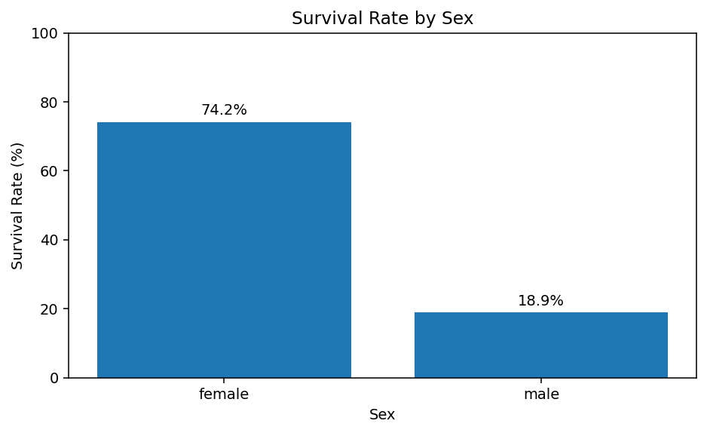
Figure 1. Survival rate by sex.

4. Passenger Class and Sex
The grouped bar chart combines passenger class and sex. It reveals that survival differs across classes and that the difference between males and females remains visible within classes. This chart was chosen because two categorical dimensions need to be compared simultaneously.
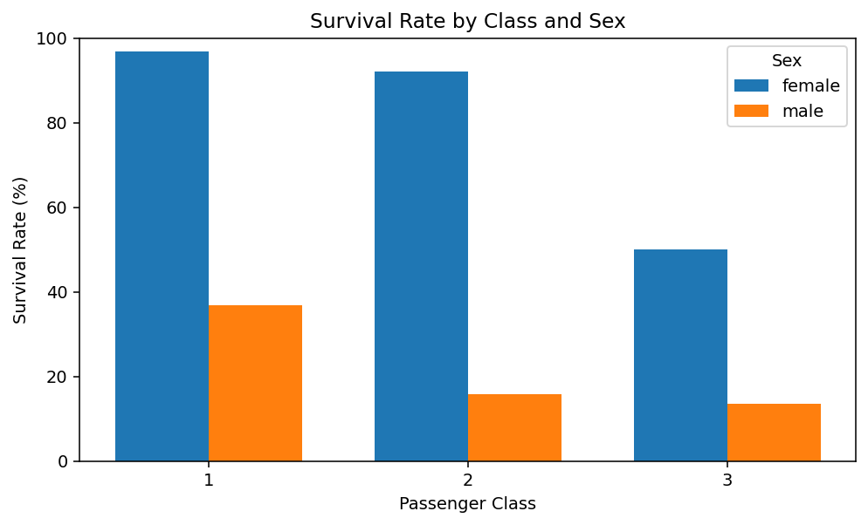
Figure 2. Survival rate by passenger class and sex.

5. Passenger Age Distribution
The histogram shows the distribution of passenger ages after median imputation. It provides an immediate view of where the observations are concentrated and whether the distribution is symmetric or skewed. A histogram is appropriate because Age is continuous numerical data.
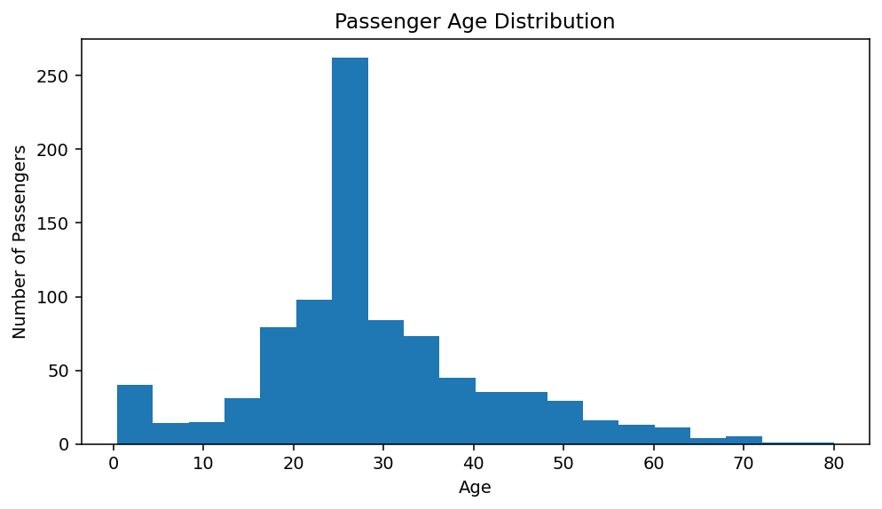
Figure 3. Passenger age distribution.

6. Age and Fare Relationship
The scatter plot examines whether age and fare show visible patterns when passengers are separated by survival outcome. The visualization is useful for detecting clusters, spread, and potential relationships that are not obvious from summary statistics alone. Scatter plots are appropriate for two numerical variables.
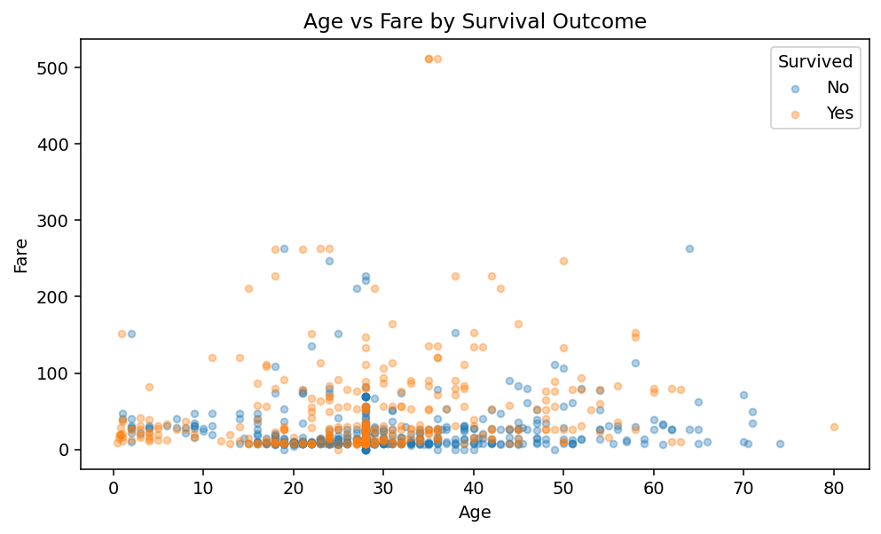
Figure 4. Age versus fare by survival outcome.

7. Survival Rate by Family Size
The line chart shows survival rate across small family sizes. Survival is not simply a linear function of family size; the pattern varies across family groups. A line chart was selected because family size is ordered and the goal is to show how the summary metric changes across that ordered sequence.
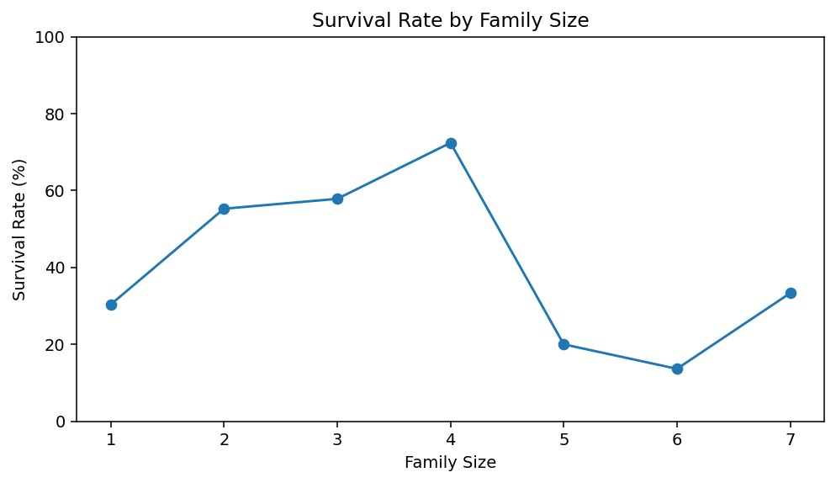
Figure 5. Survival rate by family size.

8. Survival by Age Group
Segmenting passengers into age groups provides a more accessible interpretation than a continuous age variable. The resulting bar chart highlights differences among children, young adults, adults, and older passengers. This supports communication with non-technical stakeholders because age bands are easy to understand.
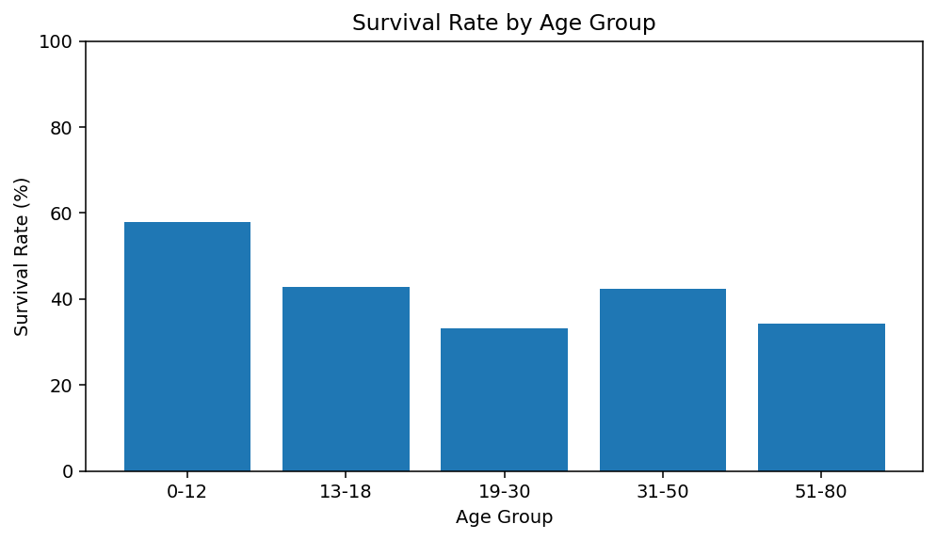
Figure 6. Survival rate by age group.

9. Key Insights
The visual analysis consistently shows that survival was strongly associated with sex and passenger class. The charts also demonstrate why a single visualization is insufficient: categorical comparisons, distributions, numerical relationships, and ordered trends require different visual forms. Using multiple focused charts improves analytical storytelling and reduces the risk of hiding important patterns.

10. R Code Appendix
# Week 2: Data Visualization and Insight Communication
library(tidyverse)
titanic <- read.csv("train.csv", stringsAsFactors = FALSE)
titanic_clean <- titanic %>%
mutate(
Age = ifelse(is.na(Age), median(Age, na.rm=TRUE), Age),
Embarked = ifelse(is.na(Embarked),
names(sort(table(Embarked), decreasing=TRUE))[1],
Embarked),
FamilySize = SibSp + Parch + 1,
IsAlone = ifelse(FamilySize == 1, "Yes", "No"),
SurvivedLabel = ifelse(Survived == 1, "Survived", "Not Survived")
)
# 1. Bar chart
ggplot(titanic_clean, aes(x=Sex, y=Survived)) +
stat_summary(fun=mean, geom="col") +
scale_y_continuous(labels=scales::percent_format()) +
labs(title="Survival Rate by Sex", y="Survival Rate")
# 2. Grouped bar chart
ggplot(titanic_clean, aes(x=factor(Pclass), y=Survived, fill=Sex)) +
stat_summary(fun=mean, geom="col", position="dodge") +
scale_y_continuous(labels=scales::percent_format()) +
labs(title="Survival Rate by Class and Sex", x="Passenger Class")
# 3. Histogram
ggplot(titanic_clean, aes(x=Age)) +
geom_histogram(bins=20) +
labs(title="Passenger Age Distribution", x="Age", y="Count")
# 4. Scatter plot
ggplot(titanic_clean, aes(x=Age, y=Fare, color=SurvivedLabel)) +
geom_point(alpha=0.5) +
labs(title="Age vs Fare by Survival Outcome", color="Outcome")
# 5. Line chart
family_summary <- titanic_clean %>%
filter(FamilySize <= 7) %>%
group_by(FamilySize) %>%
summarise(SurvivalRate=mean(Survived))
ggplot(family_summary, aes(x=FamilySize, y=SurvivalRate)) +
geom_line() + geom_point() +
scale_y_continuous(labels=scales::percent_format()) +
labs(title="Survival Rate by Family Size", y="Survival Rate")
# 6. Age-group comparison
titanic_clean %>%
mutate(AgeGroup=cut(Age, breaks=c(0,12,18,30,50,80),
labels=c("0-12","13-18","19-30","31-50","51-80"))) %>%
group_by(AgeGroup) %>%
summarise(SurvivalRate=mean(Survived)) %>%
ggplot(aes(x=AgeGroup, y=SurvivalRate)) +
geom_col() +
scale_y_continuous(labels=scales::percent_format()) +
labs(title="Survival Rate by Age Group", y="Survival Rate")

11. Conclusion
The Week 2 work demonstrates the use of R visualization techniques to convert cleaned data into clear analytical evidence. The visualizations were designed around specific questions rather than created only for decoration. The resulting charts communicate survival differences, demographic patterns, and relationships among numerical variables. The workflow can be extended in future tasks with statistical testing and predictive modeling.

