WEEK 1 TASK REPORT
Data Cleaning and Preliminary Analysis with R
Virtual R Data Analyst Internship | Week 1
Intern | Bandi Harsha Moulika Sri Bala Tulasi
Task | Data Cleaning and Preliminary Analysis with R
Dataset | Titanic Passenger Dataset (891 records, 12 variables)
Tools | R, tidyverse, ggplot2, R Markdown / Word reporting

1. Task Objective
The objective of this week’s task is to demonstrate a complete beginner-level data analysis workflow in R, starting from dataset selection and inspection and progressing through data cleaning, missing-value treatment, transformation, descriptive statistics, and preliminary visual analysis. The Titanic passenger dataset was selected because it contains both numerical and categorical variables and includes realistic data-quality issues such as missing ages, missing cabin information, and a small number of missing embarkation values. This makes it appropriate for practicing the core skills expected from an entry-level data analyst.

2. Dataset Selection and Overview
The Titanic passenger dataset contains information about 891 passengers. Important fields include passenger class, sex, age, number of siblings/spouses aboard, number of parents/children aboard, ticket information, fare, cabin, port of embarkation, and the survival outcome. The target variable used for preliminary analysis is Survived, where 0 represents non-survival and 1 represents survival.
- Rows: 891 passenger records.
- Columns: 12 original variables.
- Numerical variables include Age, Fare, SibSp, Parch, PassengerId, and Survived.
- Categorical/text variables include Pclass, Name, Sex, Ticket, Cabin, and Embarked.
- Missing values are present in Age, Cabin, and Embarked.
- The dataset is suitable for both data-cleaning practice and exploratory analysis.

3. Initial Data Quality Assessment
Before cleaning, the dataset contained 866 missing cells. The largest missingness was in Cabin (687 records), followed by Age (177 records) and Embarked (2 records). The initial assessment focused on data types, missing values, duplicate records, and basic summary statistics.
Variable | Missing | Treatment
Age | 177 | Median imputation
Cabin | 687 | Converted to CabinKnown flag
Embarked | 2 | Mode imputation

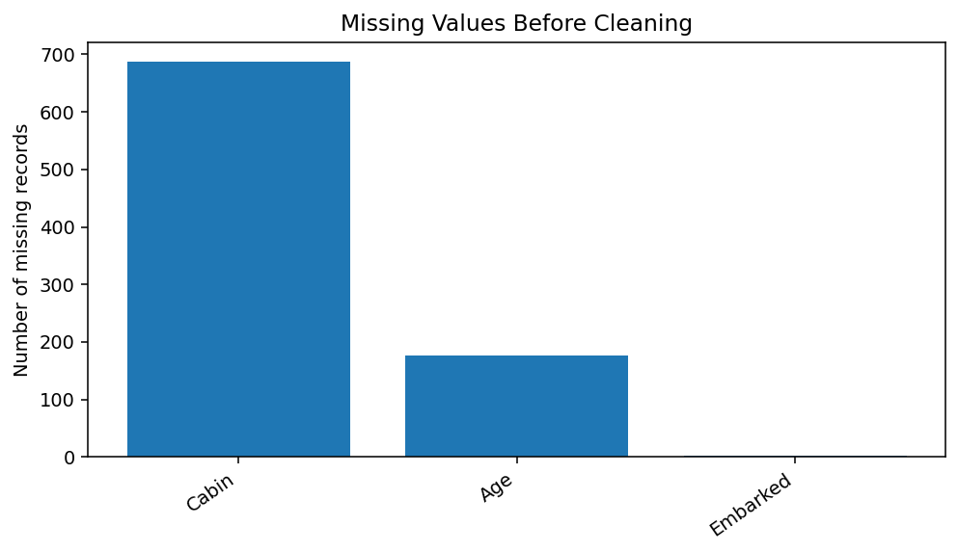
Figure 1. Missing-value profile before cleaning.

4. Data Cleaning and Transformation
The cleaning process was designed to preserve as much information as possible while making the dataset easier to analyse. Missing Age values were replaced with the median age (28.0), which is less sensitive to extreme values than the mean. Missing Embarked values were replaced with the most frequent category. Instead of attempting to guess missing cabin numbers, a new CabinKnown indicator was created to record whether cabin information was available. Additional derived variables were created for FamilySize and IsAlone. Finally, Pclass, Sex, and Embarked were converted to categorical variables.
# Week 1 - Titanic Data Cleaning and Preliminary Analysis in R
# Packages
library(tidyverse)
# 1. Load the dataset
titanic <- read.csv("train.csv", stringsAsFactors = FALSE)
# 2. Inspect structure and missing values
str(titanic)
summary(titanic)
colSums(is.na(titanic))
# Cleaning and transformation
titanic_clean <- titanic %>%
mutate(
Age = ifelse(is.na(Age), median(Age, na.rm = TRUE), Age),
Embarked = ifelse(is.na(Embarked),
names(sort(table(Embarked), decreasing = TRUE))[1],
Embarked),
CabinKnown = ifelse(is.na(Cabin), 0, 1),
FamilySize = SibSp + Parch + 1,
IsAlone = ifelse(FamilySize == 1, "Yes", "No"),
SurvivedLabel = ifelse(Survived == 1, "Yes", "No")
)

After the cleaning operations, the selected analysis fields contained no missing values for Age and Embarked, while the original Cabin field was retained and its availability was represented by CabinKnown. The cleaned dataset therefore had 687 remaining missing cells, all belonging to the original Cabin field.

5. Descriptive Statistics
Variable | Count | Mean | Median | Minimum | Maximum
Age | 891.00 | 29.36 | 28.00 | 0.42 | 80.00
Fare | 891.00 | 32.20 | 14.45 | 0.00 | 512.33
FamilySize | 891.00 | 1.90 | 1.00 | 1.00 | 11.00

The cleaned dataset has an overall survival rate of 38.4%. The median fare is 14.45, and the median age after imputation is 28.0. These values provide a baseline for more advanced analysis in later stages.

6. Preliminary Analysis and Key Findings
The first comparisons examined survival by sex and passenger class. These grouped summaries are useful because they reveal strong differences in the target variable without requiring a predictive model.
Sex | Passengers | Survival Rate
female | 314 | 74.2%
male | 577 | 18.9%
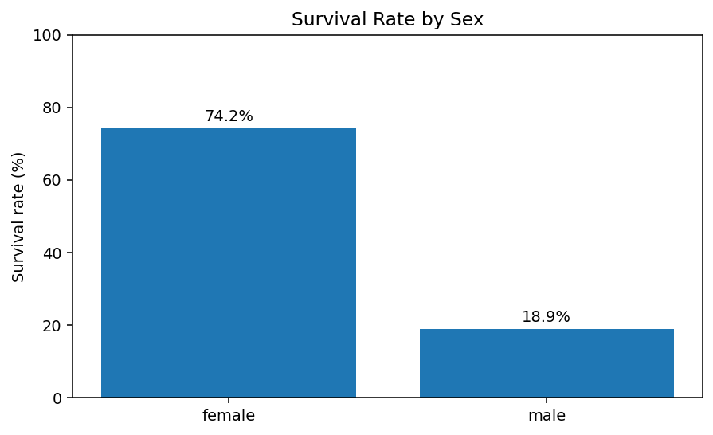
Figure 2. Survival rate by sex.
Passenger Class | Passengers | Survival Rate
1 | 216 | 63.0%
2 | 184 | 47.3%
3 | 491 | 24.2%
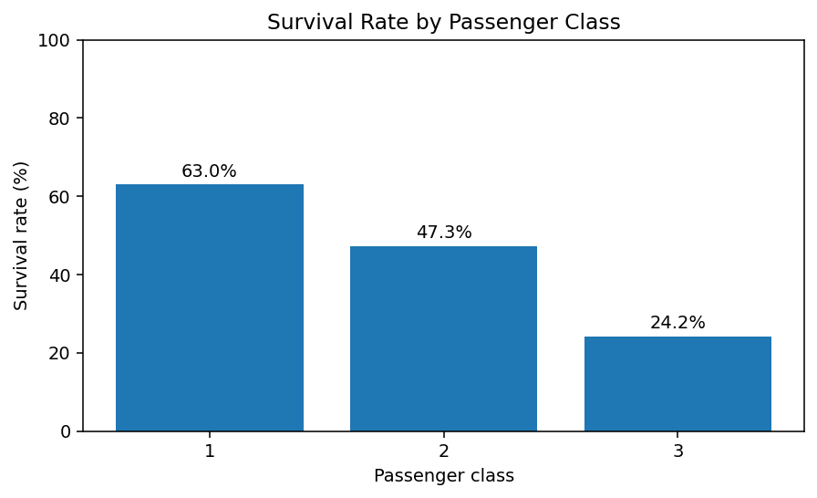
Figure 3. Survival rate by passenger class.
Women had a substantially higher observed survival rate (74.2%) than men (18.9%). Survival also varied by passenger class: Class 1 recorded approximately 63.0%, Class 2 approximately 47.3%, and Class 3 approximately 24.2%. These results suggest that sex and socioeconomic position represented by passenger class are important variables for deeper analysis.

7. Age Distribution
Age was examined after median imputation. The distribution shows that the majority of passengers were adults, while children form a smaller but meaningful part of the sample. The histogram also helps identify the spread of the variable and provides an initial check for unusually extreme observations.
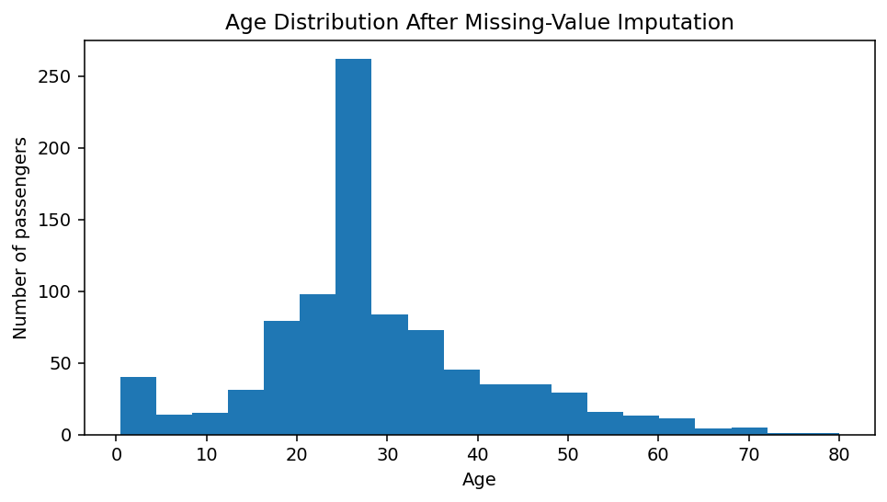
Figure 4. Age distribution after median imputation.

8. R Code Appendix
The following R code is the reproducible workflow used for the task. It can be executed in RStudio after placing the Titanic CSV file in the working directory. The code uses tidyverse functions for inspection, cleaning, transformation, grouping, and visualization.
# Week 1 - Titanic Data Cleaning and Preliminary Analysis in R
# Packages
library(tidyverse)
# 1. Load the dataset
titanic <- read.csv("train.csv", stringsAsFactors = FALSE)
# 2. Inspect structure and missing values
str(titanic)
summary(titanic)
colSums(is.na(titanic))
# 3. Clean missing values
titanic_clean <- titanic %>%
mutate(
Age = ifelse(is.na(Age), median(Age, na.rm = TRUE), Age),
Embarked = ifelse(is.na(Embarked),
names(sort(table(Embarked), decreasing = TRUE))[1],
Embarked),
CabinKnown = ifelse(is.na(Cabin), 0, 1),
FamilySize = SibSp + Parch + 1,
IsAlone = ifelse(FamilySize == 1, "Yes", "No"),
SurvivedLabel = ifelse(Survived == 1, "Yes", "No")
)
# 4. Convert selected fields to categorical variables
titanic_clean$Pclass <- as.factor(titanic_clean$Pclass)
titanic_clean$Sex <- as.factor(titanic_clean$Sex)
titanic_clean$Embarked <- as.factor(titanic_clean$Embarked)
# 5. Check that missing values were handled
colSums(is.na(titanic_clean))
# 6. Descriptive statistics
summary(titanic_clean[, c("Age", "Fare", "FamilySize")])
# 7. Preliminary analysis
titanic_clean %>%
group_by(Sex) %>%
summarise(
Passengers = n(),
SurvivalRate = mean(Survived) * 100
)
titanic_clean %>%
group_by(Pclass) %>%
summarise(
Passengers = n(),
SurvivalRate = mean(Survived) * 100
)
# 8. Visualisations
ggplot(titanic_clean, aes(x = Age)) +
geom_histogram(bins = 20) +
labs(title = "Age Distribution", x = "Age", y = "Count")
ggplot(titanic_clean, aes(x = Sex, y = Survived)) +
stat_summary(fun = mean, geom = "col") +
scale_y_continuous(labels = scales::percent_format()) +
labs(title = "Survival Rate by Sex", y = "Survival Rate")
ggplot(titanic_clean, aes(x = Pclass, y = Survived)) +
stat_summary(fun = mean, geom = "col") +
scale_y_continuous(labels = scales::percent_format()) +
labs(title = "Survival Rate by Passenger Class", y = "Survival Rate")

9. Limitations and Recommendations
- Median imputation is simple and practical for a beginner task, but it reduces natural age variability.
- Cabin information is highly incomplete, so the CabinKnown flag is more reliable for this stage than guessing individual cabin values.
- The analysis is descriptive and does not establish causation between passenger characteristics and survival.
- Future work can compare interactions among sex, class, age, and family size.
- A later task could build logistic regression, decision-tree, or random-forest models and evaluate them with train/test splits.
- Outlier analysis, correlation checks for numerical variables, and cross-validation can improve the next stage of the project.

10. Conclusion
This Week 1 task demonstrates the complete foundation of a data-analysis workflow: selecting a suitable public dataset, inspecting data quality, treating missing values, creating useful derived variables, generating descriptive statistics, and communicating initial findings through visualizations. The Titanic dataset was particularly useful because it contains both categorical and numerical information and realistic missing-data challenges. The preliminary results show clear differences in survival across sex and passenger class, providing meaningful directions for deeper analysis. The project also establishes a reproducible R workflow that can be extended in later internship tasks.

