HCAI Dashboard Documentation and Technical Details

Dashboard Overview
The HCAI dashboard is implemented as a Shiny application in R, with downloadable regional HTML reports, produced using R markdown. The R code is hosted on two GitLab repositories; hcai_backend and hcai_frontend. It uses data from the UKHSA's Data Capture System (DCS) - a platform for the mandatory surveillance of bloodstream infections: Staphylococcus aureus, Escherichia coli, Klebsiella spp., Pseudomonas aeruginosa bacteraemia, and non-bloodstream Clostridioides difficile infections. By running the reproducible analytical pipeline (RAP) the elements of the dashboard infrastructure and processes all come together - the data inputs, data cleaning and processing. R functional imports and report generation all occur on running of the RAP hosted in the back-end container of the dashboard infrastructure. Upon cleaning and processing a standardised HCAI line list will feed into the regional reports and the dashboard app. The dashboard app itself is hosted within the front-end container where the code for all R shiny dashboard modules and visualisations is located.

DCS Infection Data Reporting
Trust-based reporting:
For the trust-based analysis in this dashboard, cases are assigned to the trust (reporting organisation) that reported the specimen. This reporting is only for NHS acute trusts. Where cases (numerator) are assigned to historic or incorrect trusts not represented in the bed occupancy data (denominator), they are excluded.
ICB-based reporting:
For the Integrated Care Board (ICB)-based analysis in this dashboard, cases are first assigned to a sub ICB Location (formerly Clinical Commissioning Group - CCG). This is the attributed organisation. A tracing algorithm matches the patient to a record on the NHS Spine and then attributes to a sub ICB location based on this information. Cases are then aggregated from sub ICBs to ICBs using the ONS Geoportal sub ICB to ICB lookup. An exclusion is made when the case cannot be allocated to an existing ICB.
Architectural Diagram
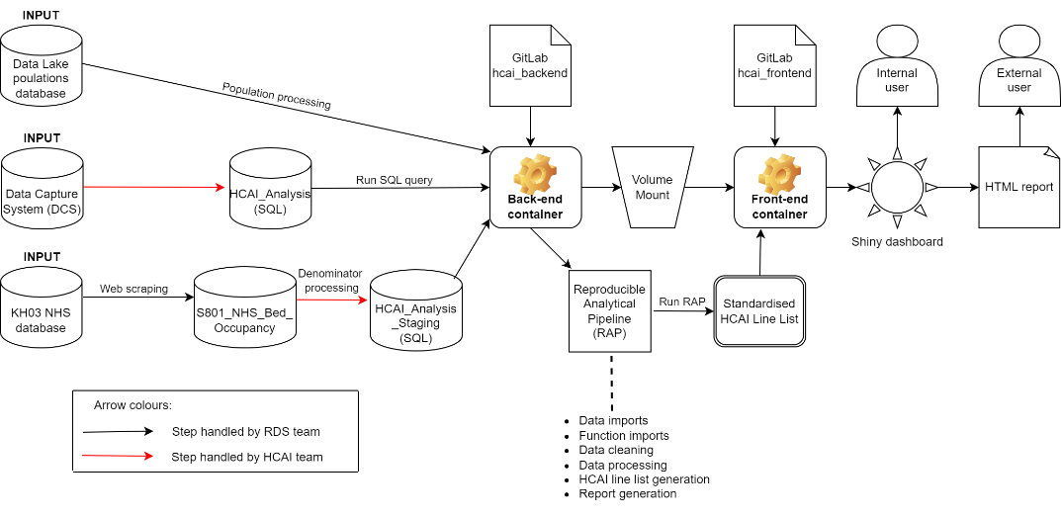
Figure 1: A full architectural diagram illustrating the full dashboard infrastructure, from the inputs to the front-end and back-end containers all the way to the end user.

Data Inputs
There are three raw data inputs into the HCAI dashboard infrastructure. These are fed into the back-end container by running the reproducible analytical pipeline (RAP):
Data Capture System (DCS)
Data from the DCS is fed into the SQL database HCAI_Analysis (a SQL mirror of the DCS). The case data for all infections displayed on the dashboard is queried from HCAI_Analysis.
The enhanced surveillance system, hereafter HCAI DCS, captures information on each MRSA, MSSA and Gram-negative bacteraemia, and CDI case in order to give trusts and IS Providers a more accurate picture of their situation allowing targeted intervention in problem areas and to contribute to building a better evidence base regarding risk factors for infection.
DCS timelines:
HCAI_Analysis is a day behind DCS. A month's data is 'signed off' by 15th of the following month, so we consider a month complete when we extract data from HCAI_Analysis on the 16th. E.g. On 1st-15th September the data presented in the app would finish on 31st July, because August is not complete so we would not present any information about August cases at all. On 16th September that day's update would start to show August data too, so we now show all data up to 31st August.
KH03
Raw KH03 online NHS database ---> S801_NHS_Bed_Occupancy internal HPDW database ---> HCAI_Analysis_Staging internal HFN17 database ---> HCAI dashboard
The KH03 data is used within this dashboard as the denominators for NHS trust based rate calculations.
Bed days data is avaliable in KH03 as average daily number of occupied beds in the quarter (total bed days in quarter / number of days in the quarter).
For this dashboard the KH03 data must be converted to an estimate of the total monthly number of occupied beds (based off the average daily number of occupied bed in the month (total bed days in month / number of days in the month) )
The KH03 is a quarterly collection from all NHS organisations that operate beds, open overnight or day only. It collects the total number of available bed days and the total number of occupied bed days by consultant main specialty. The data is programmatically web-scraped from Statistics » Bed Availability and Occupancy – KH03 (england.nhs.uk) on a weekly basis. From here it is fed into the internally hosted database as part of the HPDW. This raw data is located within S801_NHS_Bed_Occupancy which contains raw figures for total occupied beds, including all specialities. The figures are collected as bed days, which are broken down into day only and overnight. Our internal documentation for this data can be found here: KH03 - Bed occupancy data - Regions Data Science - Confluence (phe.org.uk).
From S801_NHS_Bed_Occupancy the data can be queried by the HCAI national team who are responsible for the processing of this data. This data processing occurs to take into account apportionment of bed days data from one trust to another upon trust mergers and demergers (including historical changes). Once this processing has been applied to the latest quarter data and quality checks have been passed, it has been agreed that the HCAI national team will upload this processed denominator data to HCAI_Analysis_Staging (SQL database). From here we can query the Trust denominators into our back-end container and they can be used within our trust rate calculations.
After import; the data must be processed to the total number of occupied beds of occupied bed in the month. This is achieved on running of the RAP by the full_monthly_denominator_calc function. This can take two formats of KH03 data: either the average daily bed days figures over the quarter or the total quarterly bed days (average daily bed days multiplied by the number of days in the quarter). You can specify which format the bed days will be imported by altering the functional argument 'daily_or_total'.
The format in which we are expected to receive the processed bed days denominators from the HCAI analysis team in HCAI_Analysis_Staging is total quarterly and therefore the parameter of the full_monthly_denominator_calc function is set to 'total'. The function will then then take the unique financial years present in the denominator data and automate the calculation of how many days are present in each quarter of each financial year and each month of each financial year (this takes into account leap years). Using these figures total number of occupied beds of occupied bed in the month are calculated for each trust and each quarter for bed days and overnights. This data is then fed back into the RAP for use downstream in HCAI case rate calculations.
Populations
ICB denominator data are calculated as aggregations of the constituent Sub-ICB location population estimates. These Sub-ICB mid-year population estimates from the ONS are accessed through the populations database in the LAKE19 SQL Server . The query extracts old ccg / sub-ICB populations including the latest available populations. When the latest year populations are not available the latest available year will be carried forward and used. The current latest year available for for ccg populations is 2020.
Sub-ICB populations are then processed and grouped by ICB with the Sub-ICB populations summed together to get a total ICB population using the ONS Sub-ICB to ICB lookup. These populations are then used for the ICB rate calculations.

Data Cleaning - R/data_cleaning.R · master · Regions Data Science / hcai_backend · GitLab (phe.gov.uk)
As part of our RAP the HCAI_Analysis raw data must be cleaned to generate a standardised HCAI line list. On the running of the RAP; the raw data is fed through a data cleaning script where a number of different processes occur in line with the HCAI national teams cleaning. The data cleaning script data_cleaning.R is based on the MON3_analysis V2.R script provided to us. After discussion with the HCAI national team we have picked out the sections of their script that are relevant to us and fine tuned their methodologies to increase the efficiency and readability of the code. The different sections of the data cleaning are outlined in the dropdowns below, summarising the specifics. Following data cleaning the final section of the data cleaning script (line 288) is necessary for dashboard specific cleaning purposes; including renaming of organisms and splitting the line list into Sub-ICB data and Trust data.
ID processing
Lines 10 to 58
The initial data processing with firstly involve pulling in the raw HCAI data. The total number of each INFECTION_EPISODE_ID will be counted and using a print statement a notification will alert that there is a duplicate ID along with the actual ID number as well for any troubleshooting that may need to occur in the DCS source data. After being notified that there is in fact a duplicate there is a section of code that will retain the duplicate with the latest CREATED_DATE. To note - the MON3_analysis V2.R script removes all copies of duplicates, so this differs to our methods.
Further ID processing will then occur to handle any null IDs. In line with the HCAI national team methods null IDs are filtered out of the dataset along with a print statement to notify of how many null IDs are present.
Prior Trust Exposure processing
Lines 60 to 252
The field APPORTIONMENT_CATEGORY comes from the raw DCS data. This assigns a prior trust exposure to the given case using a DCS algorithm. The HCAI national team informed that the DCS occasionally misclassifies this field, so it is not reliable to use this. Therefore, case by case: we disregard the DCS Apportionment Category and use functions to categorise cases according to other fields such as date of onset, inpatient details and discharge information. These are all fields we are pulling from HCAI_Analysis. All cases of bacteraemia and CDI infection have onsets of either hospital-onset or community-onset based on the algorithms applied. This is then split into prior trust exposures of Community Onset - Healthcare Associated (COHA), Hospital Onset - Healthcare Associated (HOHA), Community Onset - Community Associated (COCA), Unknown (COUN) and No information (COMI) and specifically for C. difficile infections Community Onset - Indeterminate Association (COIA). The functions used to apportion the prior trust exposures to each individual case were developed by Olisaeloka Nsonwu of UKHSA and are located here on GitLab.
Methods:
1) Check question entries have values expected and flag if they are not- there has been occasions where entries have not been as expected. (This check has been implemented by us)
There are 8 fields brought in from the raw DCS data that are answers to patient questions which are used to categorise the prior trust exposure. There questions must only contain answers of "Yes", "No", "Don't know" or NA. Therefore a check is performed to identify if any of these fields contain any answers that are not as expected. Using a print statement there will then be notification if this is the case and the IDs in question will be displayed. The cases with these answers will be filtered out of the dataset so not to break the functions further down.
2) Prior healthcare questions are checked to see that they align to the specific organisms that they should. This will eliminate opportunity for nonsensical answers i.e. when more than one question per organism is answered. While this check is carried out, the same questions that are in different fields dependent on the organism the case attains to are united into one field for processing purposes.
3) A number of functions from the obai package are then ran to categorise the new apportionment categories case by case. The dcs_apportionment function is used first for the bloodstream infections and then for C. difficile. The discharge_exposure function is then ran followed by the dcs_hcai_cats to assign each case a new apportionment category.
4) As explained above COIA is only possible for C. difficile so a check is carried out to notify if any C. difficile cases are assigned a new apportionment category of anything other than COIA. If this is the case a print statement will inform of this and these cases will be filtered out.

Trust Fixes
Lines 254 to 268
Where Trust have closed (merging and de-merging for example) the DCS is not timely to address these closures. Therefore manual changes are done to map closed trusts to their new designated code and name. the table below outlines the mapping that is applied in the data cleaning script:
Closed trust code - name | New trust code - name
RVY - SOUTHPORT AND ORMSKIRK HOSPITAL NHS TRUST | RBN - MERSEY AND WEST LANCASHIRE TEACHING HOSPITALS NHS TRUST
RA4 - YEOVIL DISTRICT HOSPITAL NHS FOUDATION TRUST | RH5 - SOMERSET NHS FOUNDATION TRUST
Commissioning Hubs
Line 270 to 280
Agreed methodology for reporting on Commissioning Hubs for ICB based metric
- All cases with an Attributed Organisational location (Sub-ICB location) that attain to a Commissioning Hub will have their organisational code mapped to 13Q - National Commissioning Hub 1 in Yorkshire and Humber.
- Sub-ICB locations are aggregated up to ICB locations for ICB based metrics. 13Q must be included in the count for NHS West Yorkshire Integrated Care Board (QWO) so an additional row is added to the Sub-ICB lookup to aggregate all Commissioning Hub cases (now all 13Q) to QWO. (This additional row is added in the RAP where the lookup is imported).
- It must be noted that if we were reporting at a Sub-ICB level then 13Q would not be included in counts. Commissioning Hubs, when looking at Attributed Organisations, are only reported on at an ICB level and NOT at a Sub-ICB level.
- Commissioning Hubs as attributed organisations have no effect on Trust based reporting (reporting organisations).
- NOTE- 13Q is included in the Sub-ICB aggregation to QWO ICB but does not have a population to contribute to the total QWO ICB population that is aggregated up to using the lookup.

Data Processing
After data cleaning has occurred there is a dataset of Trust case data and a dataset of Sub-ICB data. There are then a number of functions that are run to further process these two datasets separately into the required format for both a trust metric and an ICB metric.
Trust data
The trust data is further processed separately to the ICB data. Currently trusts in which there is not denominator data are filtered out. At the time of writing this documentation this only includes 3 different trusts. By viewing the back-end terminal you will be able to see print statements that inform on the number of trusts filtered out and the number of cases of these trusts that are filtered out. Cases are then grouped, summarised and completed in order to get monthly trust counts.
ICB data
The sub-ICB data is also further processed, separately to the trust data. If sub-ICBs are not present in the sub-ICB to ICB lookup then they will be filtered out. At the time of writing this includes cases with NA sub-ICBs and historic sub-ICBS. As with the trust data by viewing the back-end terminal you will be able to see print statements that inform on the number of trusts filtered out and the number of cases of these sub-ICBS that are filtered out. Cases are joined to their ICB and are grouped, summarised and completed in order to get monthly ICB counts.

Rate Calculations
The way in which rates are calculated for HCAI cases has been something that has tended to differ between regions. Another key aim of this dashboard has been to unify the way in which these rates are calculated. The dashboard displays both Trust rates and ICB rates- with calculations differing.
Trust rates are displayed as per 100,000 bed-days, with the number of cases of infection reported by the Trust in a calendar month being the numerator and the calculated monthly bed occupancy of the Trust being the denominator. There are two delineations of trust rates values that are available to see; cases with prior trust exposure COHA and with HOHA. For these two types of rates the denominators used are shown in the table below.
ICB rates are displayed as per 100,000 population, with the number of cases of infection assigned to the ICB using the tracing algorithm in a calendar month being the numerator and the mid-year population estimate for the ICB in the respective calendar year being the denominator.
Prior trust exposure | Denominator | Denominator source | Organisation level
HOHA | Bed days (overnight only) | KH03 | Trust
COHA | Bed days + day admissions | KH03 | Trust
All prior trust exposures | ONS ICB mid-year populations | LAKE19 SQL Server | ICB

Dashboard Hosting through OpenShift
Continuous Integration, Continuous Deployment best practice for data pipelines and dashboards is used to deploy as a containerised web application within the OpenShift Kubernetes platform. Automated, daily Extract-Transform-Load (ETL) pipelines ensure figures included in the dashboard are always reflective of the most current data.

