

NET GUARDIAN
Behavioural Fingerprinting and Risk Based Quarantine for Small Network Security

Computing Project | (CNT 5015)
Lecturer Name – Miss Hashini.
Miyuru Dias | CL/HDNET/CMU/55/33
st20344978

Cardiff Student ID | ICBT Index Number | Name | Roles
Leader  st20344978 | ICBT/CL/HDNET/CMU/55/33 | K.P. Miyuru Sandeepa | Project Manager
st20344973 | ICBT/CL/HDNET/CMU/55/29 | E.H. Harshana Adithya | Developer
st20344977 | ICBT/CL/HDNET/CMU/55/32 | A. Isara Kanchana | Network Engineer
Team Members

Table of Contents
Abstract 4
Acknowledgement 5
1. Executive Summary 6
2. Introduction and Background 7
3. Problem Statement 8
4. Aim 9
5. Objectives 10
6. Research Questions 11
7. Literature Review and Related Work 12
8. Proposed System 13
8.1 System Concept 13
8.2 Behaviour Drift Score 14
8.3 Risk Scoring Model 15
8.4 Automatic Quarantine 15
9. System Architecture 15
10. Technologies and Tools 18
11. Development Methodology 19
12. Team Roles and Task Allocation 20
13. Work Plan (4-Phase Implementation Schedule) 21
14. Testing and Evaluation Plan 22
15. Live Demonstration Plan 23
16. Expected Outcomes and Deliverables 24
17. Project Risk Assessment and Mitigation 25
18. Ethical and Legal Considerations 26
19. Resource and Budget Requirements 27
Conclusion 28
References 29

Abstract

Small scale networks in places like cafes, tutorial centers, hostels, schools, and small offices normally do not have a network administrator assigned to monitor all devices attached (computers, laptops, mobiles, printers, cameras, and IoT). This creates room for a hacker to penetrate a device, and it continues to be 'alive' as far as it is still able to scan the network, contact unknown remote servers, and even transmit some form of information without any way of notifying a change in its behavior. This research introduces NetGuardian; a lightweight network security solution tailored for small scale networks unable to afford expensive security equipment. Unlike other solutions, this system does not use signature-based intrusion detection or machine learning techniques to classify the intrusions. NetGuardian creates a unique behavioral baseline for every single device in terms of ports used, DNS queries made and amount of information transferred. Upon the crossing of this risk threshold by the cumulative drift of a particular device, the system triggers an alert for the administrator, as well as auto-quarantine of the device, in case auto-quarantine is active. The project aims at developing this system in the course of four weeks by means of a team of three members, who will use entirely open-source technologies (Python, Flask and SQLite). The work is divided into the capture of network traffic and discovery of devices, the development of rules and the calculation of risk scores, and finally, the development of a web interface for monitoring the system.

Acknowledgement

It is important that we thank our supervisor, Miss Hashini, for the invaluable support she has provided to us in planning and developing this project. It was her suggestions which played a pivotal role in deciding the course of action for NetGuardian and in making us analyze our problem.
We would also like to extend our appreciation to ICBT Campus and the teaching staff at the Computing Project CSE 5015 module who have provided us with all the necessary resources and facilities to complete this project. Lastly, we would like to thank each other as a group for making this project come to fruition and also our families and friends for all their patience and support throughout this process.

Executive Summary

These small networks, which consist of those utilized by cafés, tutorials, hostels, small organizations, and schools, generally lack any real insight regarding device behavior. While the administrator might be able to tell that there is a connection to the network, he or she does not know whether the device is acting normally. This means that an exploited device will be able to go unnoticed for long periods of time.
NetGuardian is a lightweight, behavior-based network security solution specifically intended to fill this need for small-scale networks unable to afford the expensive enterprise-level security tools. Instead of wondering if the packet is malicious, the software in question will be asking “does the device behave abnormally?”. It creates an individual behavioral profile for each device in the form of a baseline (contacted ports, DNS traffic, amount of data, etc.), constantly measures the live behavior and compares it against the baseline based on a Behavior Drift Score, then assigns a numerical risk score to abnormal behavior. When this risk score exceeds a predefined limit, NetGuardian moves to administrator alerts and, if enabled, quarantines the device.
The project scope developed for three-person team for four phases duration in terms of the development period. This includes networking, which is about capturing network traffic, discovering devices, and putting them into quarantine, cyber security, which is concerned with designing behavioural rules, developing a risk score model, and simulating attacks, and finally, application development, whereby a web dashboard is created for real-time monitoring and reporting. This provides a considerable contribution from each member. The entire project uses only open-source software (Python, Flask, SQLite).

Introduction and Background

Today, more and more small and midsize organizations such as cafes, coaching classes, hostels, schools, and small office spaces use Wi-Fi and LAN connections that include various devices such as laptops, mobiles, printers, cameras, and IoT-based devices. However, in such environments, there is no presence of a network administrator, and hence it is difficult to know the activity of all the devices on the network.
All typical home and small business routers are capable of determining that there is a connection and logging the amount of traffic going through a device, but both fail to determine whether the behavior of the device is normal. It is significant since most practical breaches remain silent; when a device gets infected by some malicious software, it remains ‘connected’ while starting to scan a network, connect to new external devices and steal information. Conventional monitoring can see no more than “Laptop connected.”
NetGuardian is proposed as a solution to address this problem. Rather than using a detection approach that is signature-based (identifying bad patterns) or a machine learning-based detection system that classifies attacks and intrusions – two approaches which are widely applied in student cybersecurity projects - NetGuardian generates a behavioural profile of every device on the network and compares the current state of the network to this baseline behaviour. Network defense in this context can therefore be reduced to one fundamental question: “Is this device behaving as it usually does?”

Problem Statement

Now let us examine the common scenario of small-office network use: A user’s notebook logs into the network daily and interacts with the printer and file server used by the company. In case that notebook gets infected with some malicious software, it will hardly reveal its presence through some distinctively malicious action. Rather, it is going to scan other machines on the network, initiate contact with unknown IP addresses, create too many connections and try to make contact via rare ports. The common monitor used in such small networks will merely detect that there is a machine “logged in” - it does not have a way to understand that its actions are different from what it should be.
These four issues are directly related to what NetGuardian aims to solve:
- No behavioral baseline: smaller networks do not capture what is “normal” for each device, so there is no data against which suspicious activity can be measured.
- Delayed discovery: without a behavior measurement process in place, a compromised machine can continue operating for some time without being detected.
- Manual and reactive remediation: even where suspicious behavior is eventually detected, isolation of the device will require technical expertise and likely a manual effort on the part of personnel.
- Unaffordable solutions: current security products, including those that measure behavioral activity, are designed for large enterprises and therefore not feasible for café, school, hostel, or small office environments.

Aim

Designing and testing NetGuardian, which is a behavior-based network security system that determines the baseline of activity of each networked computer, calculates the extent to which there is deviation from the baseline as a risk score and raises an alarm if the risk crosses the pre-determined threshold.

Objectives

- To create a network monitoring tool for a small LAN network that is able to monitor device traffic metadata (MAC/IP address, ports accessed, DNS requests, amount of data) passively, using only software means and without any additional hardware.
- To create a behavioral profile for each discovered device, based on its traffic history during the monitoring period.
- To develop and implement an algorithm to calculate the Behaviour Drift Score to identify how different the current activity of the device is from the base line activity of the device.
- To develop and implement a risk scoring engine that uses rules such as port scanning, DNS issues, unknown destination, etc., and calculates a combined risk score for each device.
- To develop a web interface that displays information such as device inventory, live risk scores, alerts, behavior patterns, etc.
- To develop and implement an automatic action mechanism in which the firewall rule is changed or VLAN assigned based on the calculated risk score.
- To test the above system for different attacks like port scan, unknown device, high traffic, etc., by running these in a controlled lab network.

Research Questions

- RQ1 - How can passive traffic metadata be leveraged in building a robust per-device behavior baseline in a month-long development period?

- RQ2 - Which combination of behavioral attributes (port scans, DNS anomalies, traffic amount, newly accessed locations, connectivity frequency) yields the most robust risk score with the minimum number of false positives for a small network?

- RQ3 - How do the effects of an automated quarantine response, which is activated through thresholds, compare to the effects of alerts to administrators alone?

Literature Review and Related Work

The detection of network intrusion can be classified into two broad types: signature-based detection, where traffic is detected based on comparison with a pre-existing repository of known attacks; and anomaly detection or behaviour-based detection, where abnormal activities are detected based on deviation from the normal expected activities. Signature-based detection is very efficient at detecting known attacks; however, it fails to detect novel attacks and attacks that take time to manifest themselves in order to evade detection because they don’t correspond to any of the pre-existing signatures. This problem is extensively discussed in many papers in the field of intrusion detection, including NIST Special Publication 800-94; and this is why the security world has started shifting towards behavioural approaches to intrusion detection.
MITRE ATT&CK and other similar frameworks detail the tactics and techniques used by an infected host, such as scanning the network, creating unusual connections, and exfiltrating data, which are almost directly analogous to the behavior that NetGuardian monitors for (scanning ports, connecting to new destinations, and abnormal data volumes).
As far as the field of student and open-source security projects goes, current conversations about projects going on show that types of projects such as AI phishing detectors, general purpose machine learning IDS systems, honeypots, and blockchain security systems have been overdone with many groups submitting almost identical implementations of their own. On the other hand, relatively a smaller number of easy-to-understand student projects implement a combination of the concept of a lightweight behaviour drift score at the device level with an automated quarantine action once the threshold is exceeded, targeted towards smaller resource constrained networks and not enterprises. This is the niche that NetGuardian fills: a well-known field of study (IDS), with a proven solution (behavioural fingerprinting + risk-based quarantine).
It serves as just a beginning for the project. During the transition from project proposal to full report, it is advisable for the team to add additional information related to the concepts of anomaly-based intrusion detection, device fingerprinting, and small network security through citations from reputable journals, papers, and books.

Proposed System

8.1 System Concept

The basic principle behind NetGuardian is to build the profile of each new device detected in the network on the basis of its behavior, rather than looking into packets for suspicious activity. Each device, identified via its MAC and IP addresses, is regularly analyzed taking into account such parameters as the connection rate, ports attempted to be connected to, DNS queries performed, used bandwidth, destination IP addresses and many more. After establishing the baseline for the normal behavior of the device, the primary question raised by NetGuardian is "How different is this device from the norm?".

Example device behaviour profiles
Device | Typical Normal Behavior
Printer | Mostly receives print jobs from known internal hosts
Student / staff laptop | Web browsing, DNS lookups, HTTPS traffic to familiar domains
Phone | Web browsing, DNS lookups, messaging app traffic
CCTV unit | Communicates only with the camera / recording server
Unknown / new device | No baseline yet — treated as elevated risk until profiled

8.2 Behaviour Drift Score

The Behaviour Drift Score is the project's key innovation: a single metric describing how far a device's current activity has moved from its historical normal behaviour.
Behaviour Drift = Current Behaviour − Historical Normal Behaviour

Worked example — Laptop-04:
Metric | Normal | Observed | Drift
DNS requests / day | 40 | 300 | ↑ 650%
Distinct external IPs / day | 12 | 85 | ↑ 608%
Ports contacted | 5 | 42 | ↑ 740%
Data uploaded | 50MB | 900MB | ↑ 1700%

When combined with all the indicators, Laptop-04 in the above example gets a Behaviour Drift score of about 87%, which gets converted by the risk-scoring engine to the HIGH-risk category, and results in an alert to the administrator.

8.3 Risk Scoring Model

Each detected anomaly indicator contributes a fixed weight to a device's overall risk score out of 100. Weights are configurable, and can be tuned during the testing phase to reduce false positives.
Indicator | Weight
Port scanning detected | +30
Unknown / unrecognized device | +20
DNS anomaly (unusual query volume or destinations) | +20
Traffic-volume spike | +15
Connection to a new / unfamiliar destination | +15
Maximum combined score | 100

Risk Band | Score Range | Dashboard Status | System Response
Low | 0 – 39 | Green – Normal | Continue monitoring, no action
Medium | 40 – 69 | Amber – Suspicious | Flag on dashboard, log for review
High | 70 – 100 | Red – Critical | Alert administrator; trigger automatic quarantine

8.4 Automatic Quarantine

When the risk score for the device exceeds the threshold of being in the high-risk category, NetGuardian goes into action: the administrator is notified via the dashboard, and the device is then isolated by means of any of several isolation techniques based on the lab setup available – Linux iptables/nftables rules, VLAN isolation, or simulation of a Cisco ACL. If live isolation cannot be performed with the available hardware setup, the action of isolating the device is demonstrated in a lab setup.

System Architecture

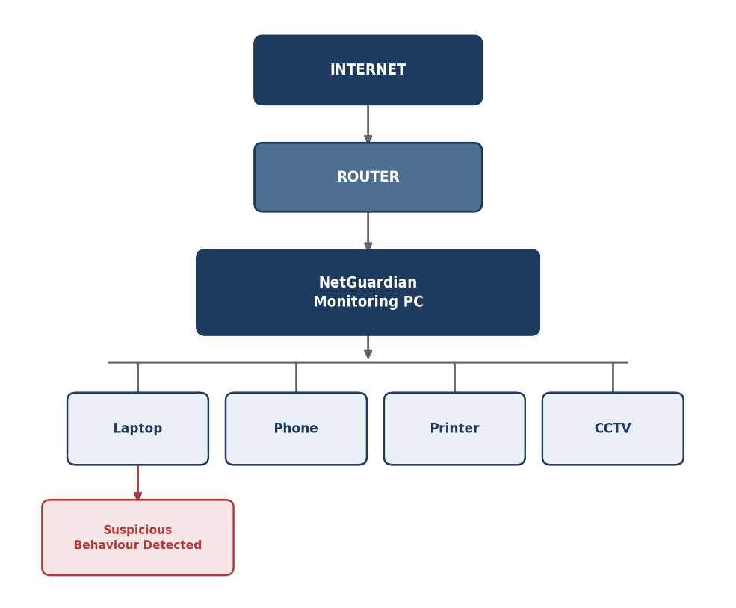
NetGuardian sits between the router and the connected devices on a small lab network, passively capturing traffic metadata from a monitoring PC without interfering with normal network operation.
Figure 1: NetGuardian Network Monitoring Topology

The monitoring PC captures traffic metadata for every discovered device (Laptop, Phone, Printer, CCTV, and any newly connected device), builds a behavioural baseline per device, and flags deviations shown here as the laptop exhibiting suspicious behaviour.

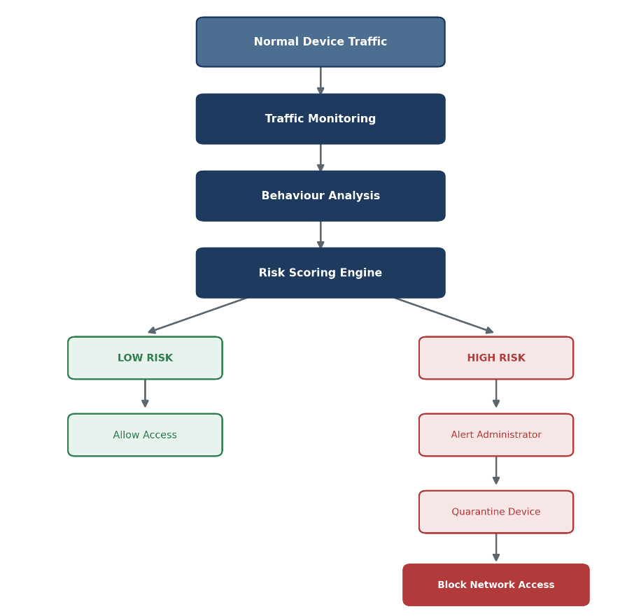
Once a deviation is flagged, the system follows a consistent detection-to-response workflow, moving from raw traffic through behavioural analysis and risk scoring to either normal access or an escalating containment response:
Figure 2: Detection-to-Response Workflow

Technologies and Tools

Layer | Technology | Purpose
Traffic capture | Python, Scapy, Wireshark / tshark | Passive packet and metadata capture on the lab network
Detection & scoring logic | Python | Baseline profiling, drift calculation, risk-scoring rules
Backend / API | Python (Flask) | Serves device, alert, and risk data to the dashboard
Data storage | SQLite | Stores device profiles, traffic history, alerts, and scores
Dashboard / frontend | HTML, CSS, JavaScript (Chart.js) | Live device list, risk levels, alerts, and history graphs
Network enforcement | Linux iptables / nftables, VLAN tagging, simulated Cisco ACL | Implements the automatic quarantine response
Collaboration & version control | Git and GitHub | Source control and task tracking across the 3-member team
Documentation & diagrams | Word / Google Docs, draw.io | Report writing and architecture diagrams

Development Methodology

With the time frame of four weeks in mind, we are going to use an agile process which involves four sprints in one month, where each sprint follows the work plan in Section 13. There will be a short review session after each sprint in order to prevent integration problems among the networking, detection, and dashboard modules.
- Sprint planning: a short meeting at the beginning of each week for each team member to make sure about the deliverables of the week.
- Daily standup meetings: stand-up meetings every day or almost every day in order to detect any problem early on due to the time pressure.
- Integration: all the modules (capture, detection, and dashboard) are gradually integrated in each week through one common Git repository instead of being integrated just at the end of the project.
- Sprint review: a demonstrable increment at the end of each week regardless of its completeness.

Team Roles and Task Allocation

The project divides naturally into three substantial, parallel workstreams, giving each of the three group members clear ownership while remaining tightly integrated.
Member 1 - Networking Lead
• Design the lab network topology and configure the router / access point
• Implement device discovery (MAC/IP identification) and passive traffic capture
• Build the packet/metadata collection pipeline using Scapy and Wireshark/tshark
• Implement the quarantine mechanism: firewall rules, VLAN configuration, or simulated ACLs

Member 2 - Cybersecurity & Detection Lead
• Define suspicious-behaviour rules (port scan, DNS anomaly, traffic spike, new destination)
• Design and implement the Behaviour Drift Score and risk-scoring engine
• Build and run controlled attack simulations for testing (Section 14)
• Tune detection thresholds to balance detection accuracy against false positives

Member 3 - Dashboard & Application Lead
• Build the Flask backend and SQLite data model for devices, alerts, and history
• Develop the web dashboard: device list, live risk levels, and alert feed
• Implement historical behaviour views and the manual/automatic quarantine control
• Compile security reports and export views used in the final demonstration

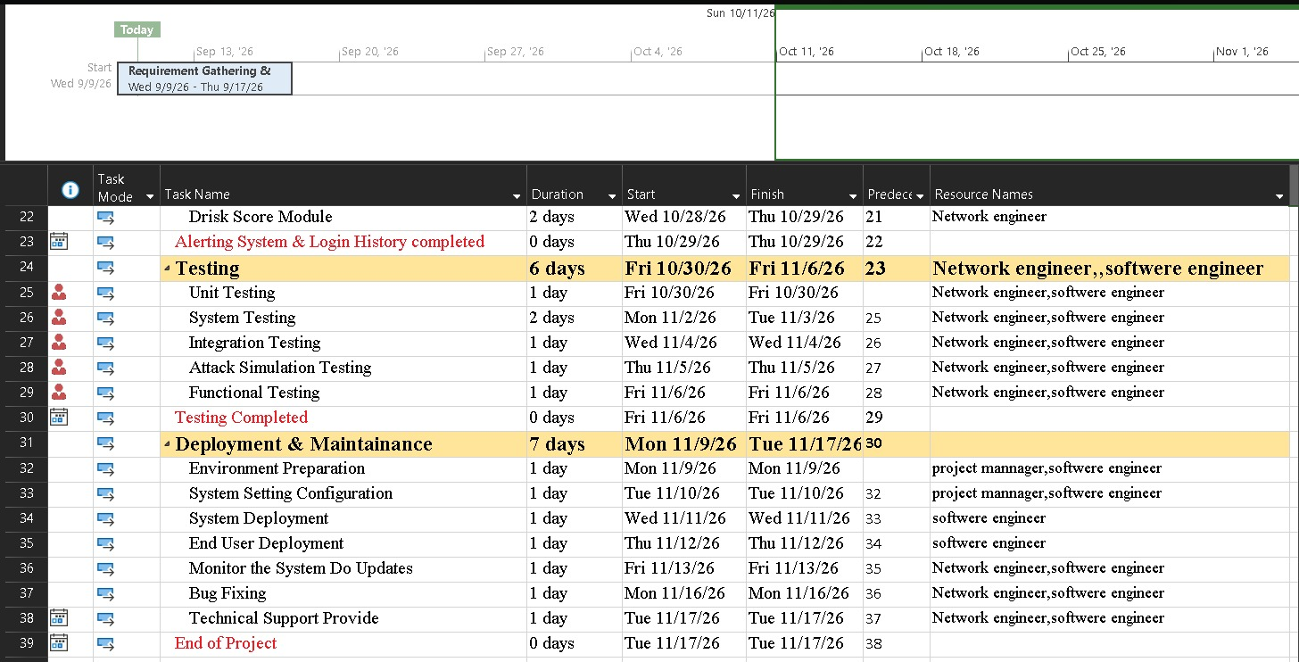
Work Plan (4-Phase Implementation Schedule)
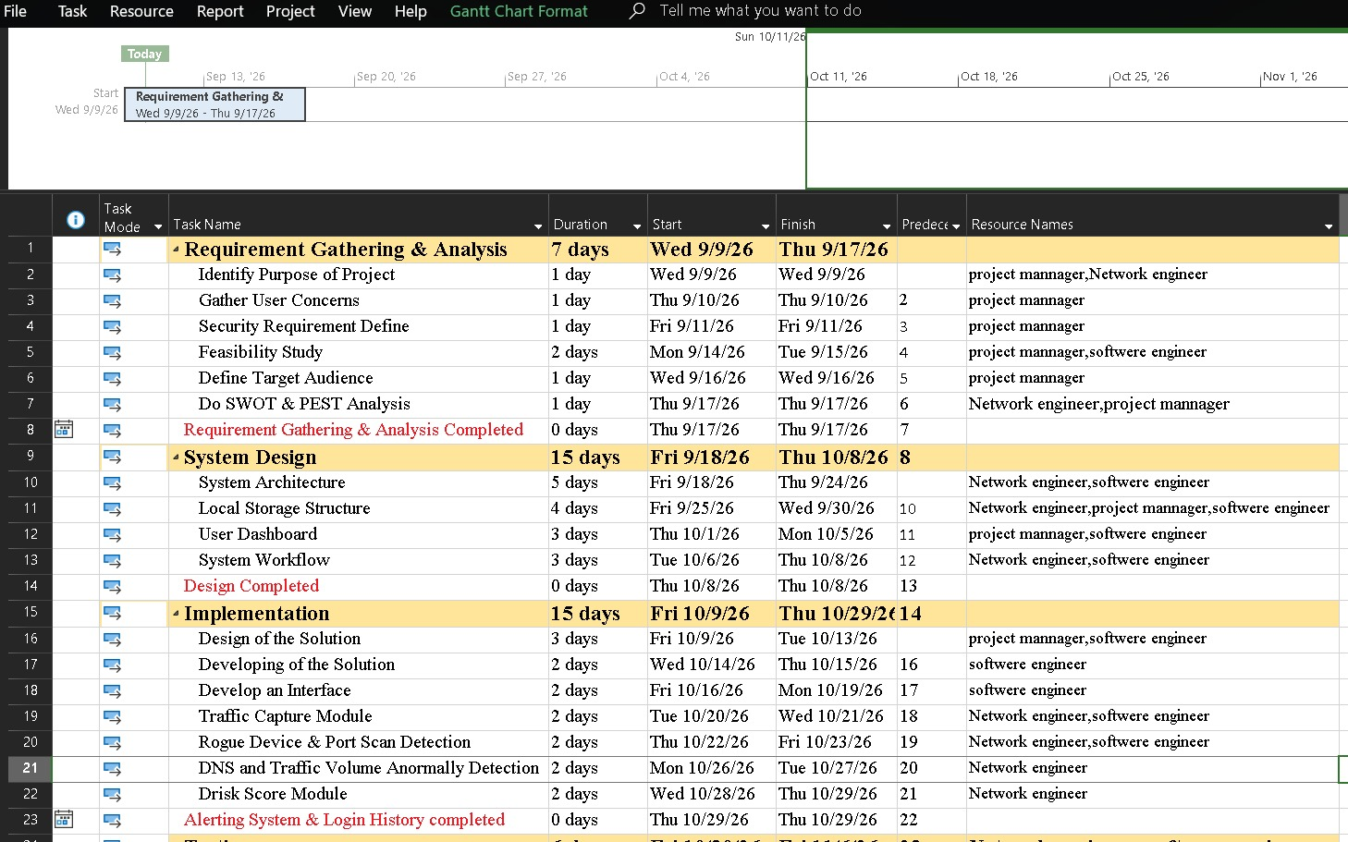
Phase | Focus | Key Deliverables
Phase 1 | Network foundation | Requirements & architecture finalized; lab network and device discovery working; traffic capture running; database schema and basic dashboard shell in place
Phase 2 | Detection | Rogue-device, port-scan, DNS-anomaly, and traffic-volume anomaly detection implemented
Phase 3 | Risk & response | Behavioural baseline and drift score complete; risk-scoring engine, alerting, device history, and quarantine mechanism implemented
Phase 4 | Testing & presentation | Full test pass (Section 14) complete; screenshots and graphs collected; report, presentation, and live demo finalized

Testing and Evaluation Plan
NetGuardian will be tested exclusively on an isolated lab network that the team owns and controls (see Section 18). Each scenario below is repeated at least three times to check for consistency before the final demonstration.
Test Scenario | Purpose | Expected Result
Normal network baseline | Confirm known devices are correctly profiled with no false alerts | All devices shown as LOW risk on the dashboard
Unknown / rogue device appears | Verify new, unprofiled devices are flagged appropriately | New device flagged as elevated risk until a baseline is established
Simulated port scan | Verify port-scan detection and scoring | Risk score rises; device flagged SUSPICIOUS or CRITICAL depending on scope of scan
Abnormal traffic volume | Verify traffic-volume anomaly detection | Risk score increases proportionally to data-volume deviation from baseline
Multiple simultaneous suspicious behaviour | Verify combined-indicator scoring and automatic quarantine | Combined score exceeds high-risk threshold; automatic quarantine triggers
Legitimate but unusual activity (e.g. software update) | Check for false positives on benign behaviour spikes | Risk score rises only moderately and does not trigger unnecessary quarantine

Evaluation metrics
- Detection accuracy: proportion of simulated attacks correctly flagged as elevated risk
- False-positive rate: proportion of legitimate activity incorrectly flagged as high risk
- Response time: elapsed time from anomalous activity to alert / quarantine action
- Usability: informal feedback on dashboard clarity, gathered from lecturer/peer walkthroughs

Live Demonstration Plan

The final demonstration will be based around a live performance demonstrating a complete life cycle from before → attack → detection → response.
Normal network
Five devices are demonstrated to be connected and profiled in the network, all in the state of LOW risk on the dashboard (Laptop 01, Phone 01, Printer, Laptop 02, CCTV).
Controlled attack introduced
A port scan is initiated against the network using a machine owned by the team. The dashboard changes in real-time and shows Laptop 02 change its status to SUSPICIOUS with a growing risk score, as a port scan is detected.
Escalation and automatic response
Risk is further escalated (for example, additional suspicious destinations or increase in traffic). The risk score of the device surpasses the critical risk threshold, the dashboard shows the device to be in the state of CRITICAL, and NetGuardian quarantines the device (dashboard shows the device in the state of BLOCKED).

Expected Outcomes and Deliverables

- A working NetGuardian prototype covering traffic capture, behavioural baseline, risk scoring, and automatic quarantine
- A web-based dashboard showing live device risk levels, alerts, and behaviour history
- Source code repository with clear documentation of each member's contribution
- A completed project report covering design, implementation, testing, and evaluation
- A presentation deck and a live (or recorded) before → attack → detection → response demonstration
- Test and evaluation results, including detection-accuracy and false-positive-rate figures

Project Risk Assessment and Mitigation

These are project-delivery risks facing the team over the four-week build — distinct from the network security risks NetGuardian itself is designed to detect.
Risk | Likelihood | Impact | Mitigation
Tight timeline | High | High | Agile weekly sprints with fixed weekly deliverables and early integration
Uneven workload across the three components | Medium | Medium | Weekly standups and shared task board; cross-review between members
Packet-capture library / permissions issues | Medium | Medium | Early spike/prototype of the capture module in Week 1 to surface issues early
Lab network instability during testing | Low | Medium | Use a dedicated, isolated lab network with a documented backup configuration
Scope creep beyond the core MVP | Medium | High | Lock the minimum viable feature set after Week 1; treat extras as stretch goals only

Ethical and Legal Considerations

All monitoring, traffic capture, and attack simulation shall be done using a network that belongs to the team or one that has been granted authorization for its use in writing. Any scanning, monitoring or attack simulation against any university, public or third-party network without written permission is not allowed.
- Metadata of traffic is obtained only for the purpose of detecting and is not disclosed outside of the project team and assessors
- The traffic information collected is restricted to just enough for behavioral analysis (headers and metadata and not message contents)
- Simulated attacks are all carried out on lab equipment within the control of the team and do not affect real user networks
- The collected data shall be retained only for the duration of the project after which the captured traffic logs will be erased

Resource and Budget Requirements

NetGuardian is intentionally designed to avoid specialized or expensive hardware. Most required resources are equipment the team already owns; the table below is indicative and should be confirmed against local pricing before submission.
Item | Purpose | Notes
Router / Access Point | Core of the lab network | Team-owned or department lab equipment
Monitoring PC / Laptop | Runs capture, detection, and dashboard software | Existing team laptop is sufficient
3–5 Client Devices | Represent normal network devices for testing (laptop, phone, printer, etc.) | Devices the team already owns
USB Wi-Fi Adapter (monitor-mode capable) | Optional improves wireless capture if built-in adapter lacks monitor mode | Only required if the default plan targets Wi-Fi rather than a wired lab segment
Software / Tooling | Python, Scapy, Flask, SQLite, Wireshark | All open-source and free of charge

Overall budget impact is expected to be minimal to none, since the project relies on open-source software and hardware the team already has access to.

Conclusion

NetGuardian takes a familiar problem, network intrusion detection and approaches it through a specific, demonstrable mechanism: per-device behavioural fingerprinting combined with a quantified drift score and an automatic, risk-based quarantine response. This gives the three-member team a project that is realistically achievable within a four-week timeline, distributes substantial and distinct work across networking, detection, and application development, and produces a genuinely compelling live demonstration. By focusing on how a device's behaviour changes over time rather than matching traffic against known-bad signatures, NetGuardian offers small networks a practical, low-cost path toward the kind of behavioural visibility that is normally reserved for enterprise security tooling.

References
- Ahmed, J., Gharakheili, H.H., Raza, Q., Russell, C. and Sivaraman, V., 2019. Monitoring enterprise DNS queries for detecting data exfiltration from internal hosts. IEEE Transactions on Network and Service Management, 17(1), pp.265-279.
- Bhuyan, M.H., Bhattacharyya, D.K. and Kalita, J.K., 2014. Network anomaly detection: methods, systems and tools. IEEE Communications Surveys & Tutorials, 16(1), pp.303-336.
- Chandola, V., Banerjee, A. and Kumar, V., 2009. Anomaly detection: A survey. ACM Computing Surveys, 41(3), pp.1-58.
- CrowdStrike, 2024. What is User and Entity Behaviour Analytics (UEBA)? [online] Available at: https://www.crowdstrike.com/cybersecurity-101/identity-protection/user-and-entity-behavior-analytics-ueba/.
- Garcia-Teodoro, P., Diaz-Verdejo, J., Macia-Fernandez, G. and Vazquez, E., 2009. Anomaly-based network intrusion detection: Techniques, systems and challenges. Computers & Security, 28(1-2),.
- MITRE ATT&CK Framework, MITRE Corporation — catalogue of adversary tactics and techniques post-compromise.
- Moustafa, N., Hu, J. and Slay, J., 2019. A holistic review of network anomaly detection systems: A comprehensive survey. Journal of Network and Computer Applications, 128, pp.33-55.
- Nadler, A., Aminov, A. and Shabtai, A., 2019. Detection of malicious and low throughput data exfiltration over the DNS protocol. Computers & Security, 80, pp.36-53.
- National Institute of Standards and Technology (NIST), Special Publication 800-94, Guide to Intrusion Detection and Prevention Systems (IDPS).

