MAINCRAFTS TECHNOLOGY
HARSHA IRAPPA PAWATE

VLSI Design Internship — Task 2
Introduction to Verilog HDL and RTL Design of Basic Combinational Circuits

This document presents the RTL design, Verilog implementation, testbenches, and verification methodology for basic logic gates, a half adder, and a full adder, completed as part of Task 2 of the VLSI Design Internship.

1.Introduction
This task focuses on learning Verilog Hardware Description Language (HDL) and Register Transfer Level (RTL) design. The objective is to design basic combinational circuits, write testbenches, simulate them using Icarus Verilog, and verify the outputs using GTKWave

2.Objective
- Learn Verilog HDL.
- Design basic logic gates.
- Design Half Adder and Full Adder.
- Write testbenches.
- Simulate circuits using Icarus Verilog.
- Verify outputs using GTKWave

Software |  | Purpose
Visual Studio Code - |  | Writing Verilog programs
Icarus Verilog - |  | Compiling and simulating Verilog code
GTKWave - |  | Viewing simulation waveforms

Truth Table (AND / OR / NOT / NAND / NOR / XOR)

A | B | AND | OR | NOT(A) | NAND | NOR | XOR | XNOR
0 | 0 | 0 | 0 | 1 | 1 | 1 | 0 | 1
0 | 1 | 0 | 1 | 1 | 1 | 0 | 1 | 0

1 | 0 | 0 | 1 | 0 | 1 | 0 | 1 | 0
1 | 1 | 1 | 1 | 0 | 0 | 0 | 0 | 1

Half Adder
A Half Adder is a combinational logic circuit used to add two single-bit binary numbers. It produces two outputs: Sum and Carry. The Sum output represents the least significant bit of the addition, while the Carry output indicates whether a carry is generated. Half Adders are the basic building blocks of arithmetic circuits and are widely used in digital systems.

A | B | Sum | Carry
0 | 0 | 0 | 0
0 | 1 | 1 | 0
1 | 0 | 1 | 0
1 | 1 | 0 | 1

Full Adder
A full adder extends the half adder by including a carry-in (Cin) input, allowing multi-bit binary addition through cascaded stages. Sum is computed as the XOR of all three inputs, and Cout is high whenever at least two of the three inputs are high.

Expected Truth Table

A | B | Cin | Sum | Cout
0 | 0 | 0 | 0 | 0
0 | 0 | 1 | 1 | 0
0 | 1 | 0 | 1 | 0
0 | 1 | 1 | 0 | 1

1 | 0 | 0 | 1 | 0
1 | 0 | 1 | 0 | 1
1 | 1 | 0 | 0 | 1
1 | 1 | 1 | 1 | 1

Waveforms:

- AND Gate:

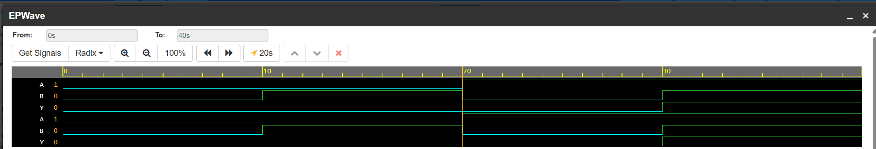

2. OR Gate:

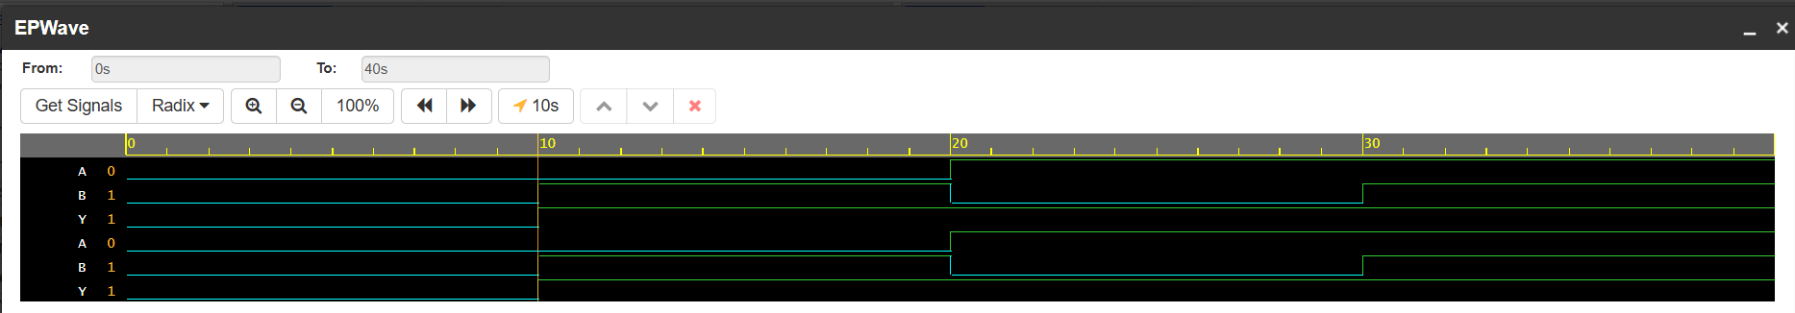

3. NAND Gate:

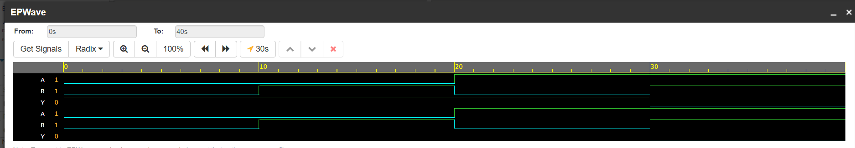

4.NOR Gate:

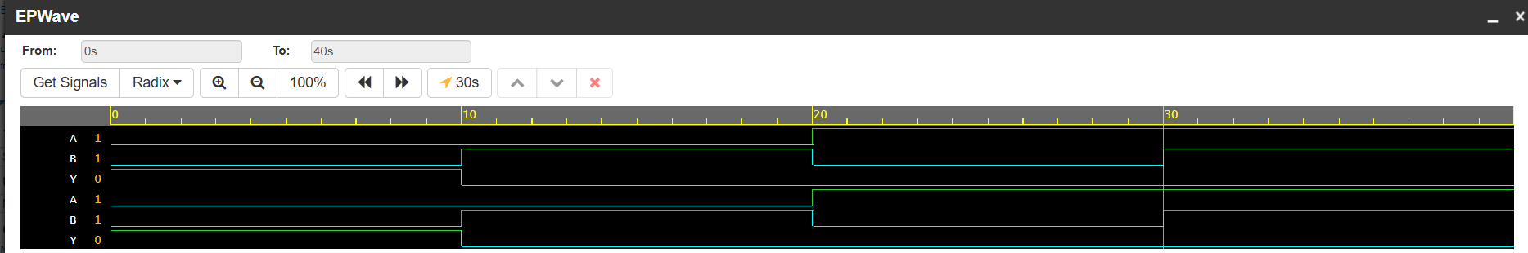

5. XOR Gate:

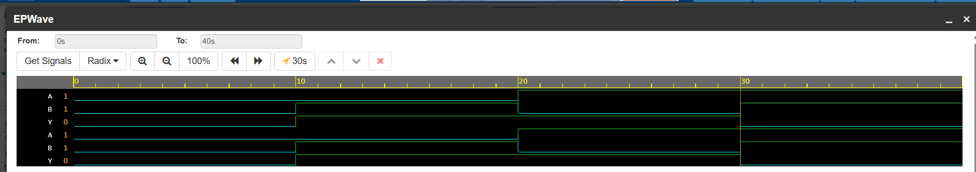

6. XNOR Gate:

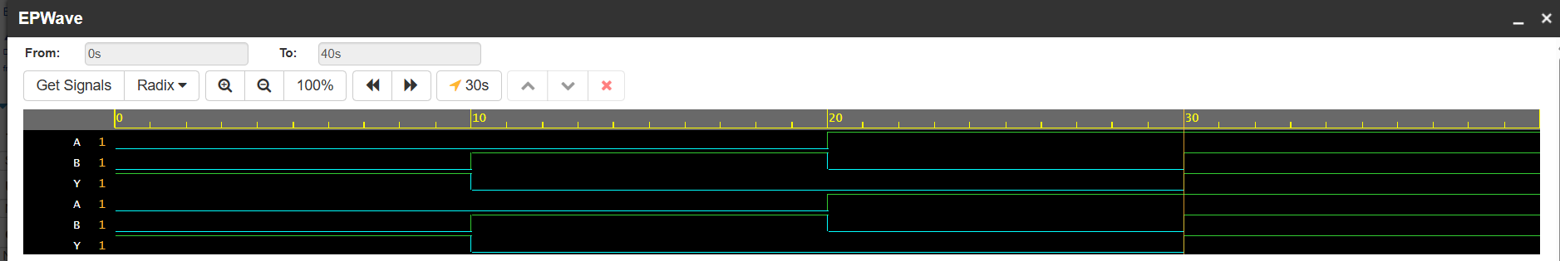

7. NOT Gate:

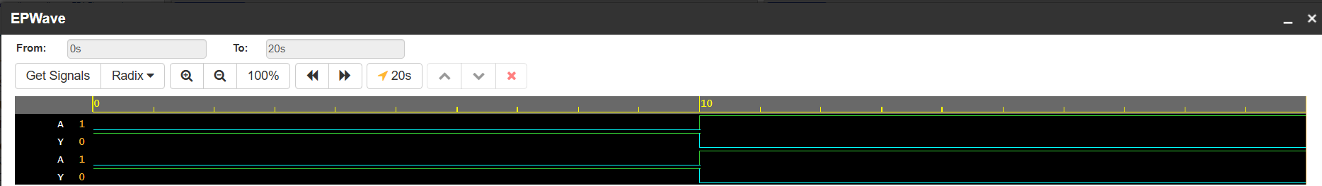

8. HALF ADDER :

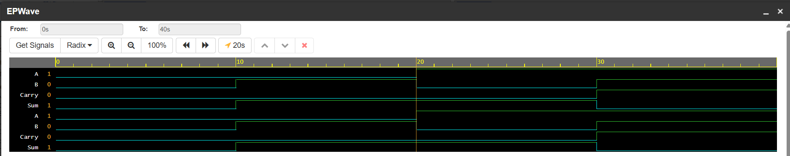

9. FULL ADDER :

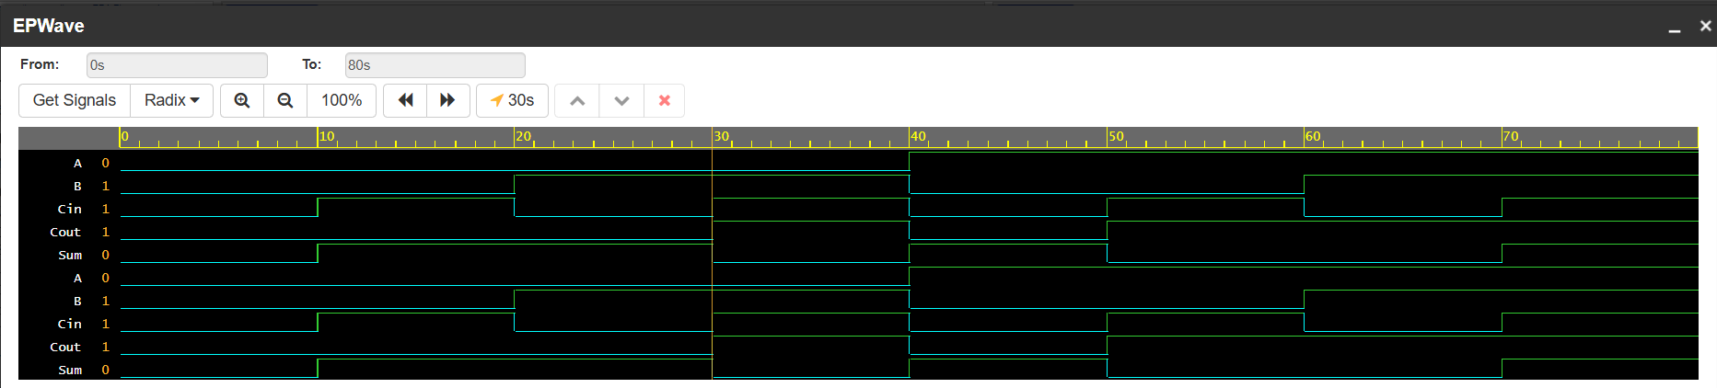
Design Logic
The objective of this task was to design and simulate basic combinational logic circuits using Verilog HDL. Each circuit was implemented as an independent Verilog module using continuous assignment (assign) statements, where the output depends only on the current input values. Separate testbench modules were developed for each circuit to generate all possible input combinations and verify the correctness of the output.
The Verilog modules were compiled using Icarus Verilog, and the simulations generated Value Change Dump (VCD) files. These VCD files were viewed in GTKWave, allowing the input and output waveforms to be analyzed. The implemented circuits included the seven basic logic gates (AND, OR, NOT, NAND, NOR, XOR, and XNOR) along with the Half Adder and Full Adder. The design logic followed the standard Boolean expressions for each circuit, ensuring correct digital functionality.

Simulation Results
The designed Verilog modules were successfully compiled and simulated without errors. Testbenches applied different combinations of input signals, and the corresponding outputs were observed using GTKWave. The generated waveforms matched the expected truth tables for all implemented circuits.
For the logic gates, the output waveforms verified the correct Boolean operations under all input combinations. The Half Adder correctly generated the Sum and Carry outputs, while the Full Adder correctly produced the Sum and Carry-out outputs for all possible combinations of A, B, and Carry-in (Cin). The successful simulation confirmed that all Verilog designs were functionally correct and behaved as expected.

Testbench Methodology
A testbench was developed for each Verilog module to verify the functionality of the designed combinational circuits. The testbench instantiated the Design Under Test (DUT) and applied all possible input combinations using an initial block with appropriate time delays (#10). The simulation generated a Value Change Dump (VCD) file using the $dumpfile and $dumpvars system tasks. The VCD file was then viewed in GTKWave to observe the input and output waveforms. The simulation results were compared with the expected truth tables to confirm the correct operation of each logic gate, Half Adder, and Full Adder.
Steps Followed
- Created the Verilog module for the required logic circuit.
- Developed a separate testbench to instantiate the Design Under Test (DUT).
- Applied different input combinations sequentially using an initial block.
- Generated a VCD file using $dumpfile and $dumpvars.
- Compiled the design and testbench using Icarus Verilog.
- Executed the simulation to generate waveform data.
- Opened the generated VCD file in GTKWave.
- Verified the output waveforms against the corresponding truth tables.
- Confirmed that the simulated outputs matched the expected results for all input combinations.

Key Learning Outcomes
- Learned the basic syntax and structure of Verilog HDL.
- Designed and simulated basic logic gates using RTL modeling.
- Understood the use of the assign statement for combinational logic.
- Learned to write and execute Verilog testbenches.
- Performed simulation using Icarus Verilog.
- Verified circuit functionality using GTKWave.
- Gained practical knowledge of digital logic design and waveform analysis.

Summary
In this experiment, all seven basic logic gates were successfully implemented using Verilog HDL. Separate testbenches were written to verify each circuit, and the generated waveforms were analyzed using GTKWave. The outputs obtained during simulation matched the theoretical truth tables, confirming the correctness of the implemented designs.

Conclusion
The experiment was successfully completed by designing, simulating, and verifying the basic logic gates using Verilog HDL. The use of Icarus Verilog and GTKWave provided a practical understanding of digital circuit design, simulation, and verification. This task strengthened the understanding of RTL design concepts and laid the foundation for designing more complex digital systems.

