**Part 1:**

1.Create a custom dimension that pulls the id from a URL. Example:

[www.yoursite.com/mypage.html?id=11111](http://www.yoursite.com/mypage.html?id=11111)

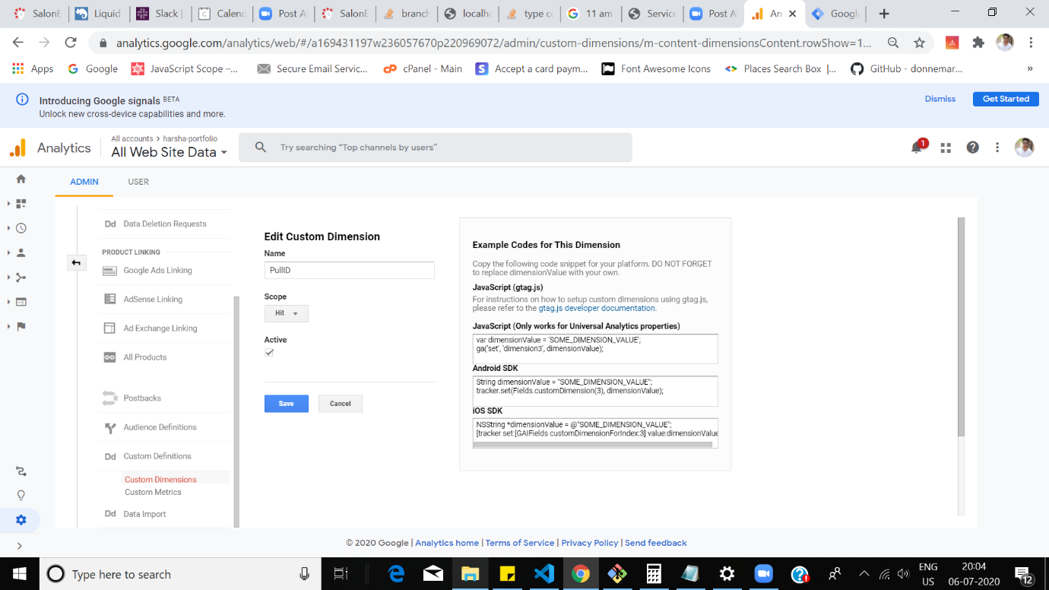

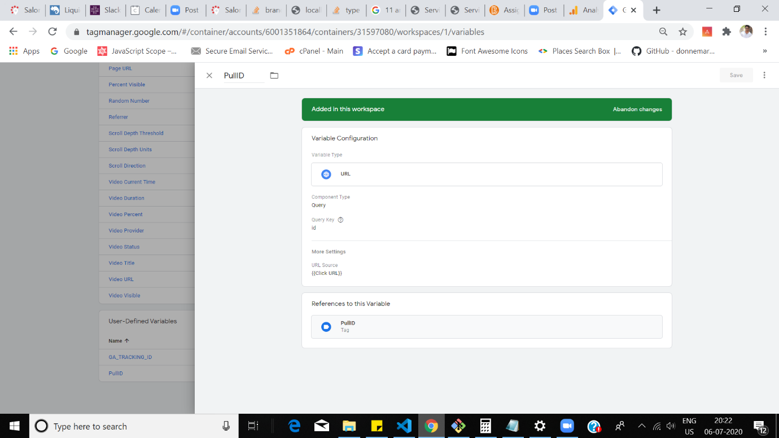

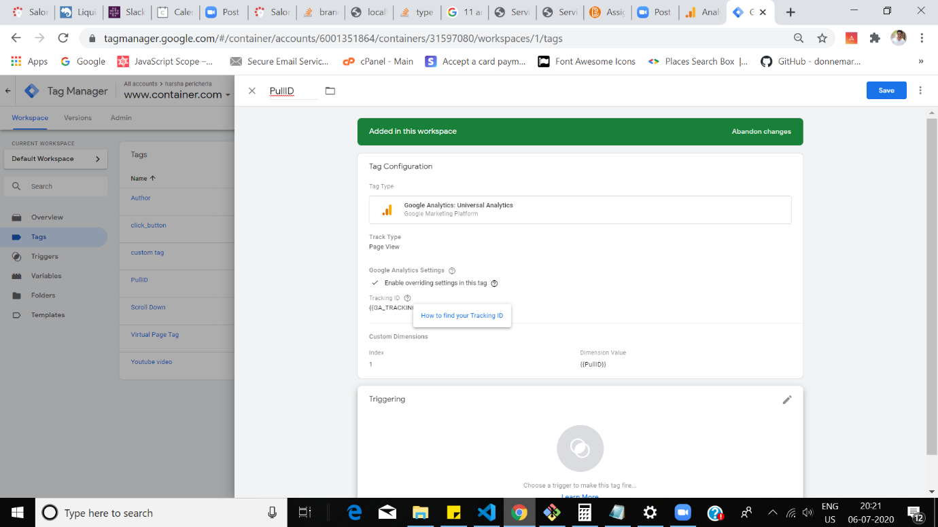

2. Create a custom dimension that pulls the id from a form input using a JavaScript variable

Ans. 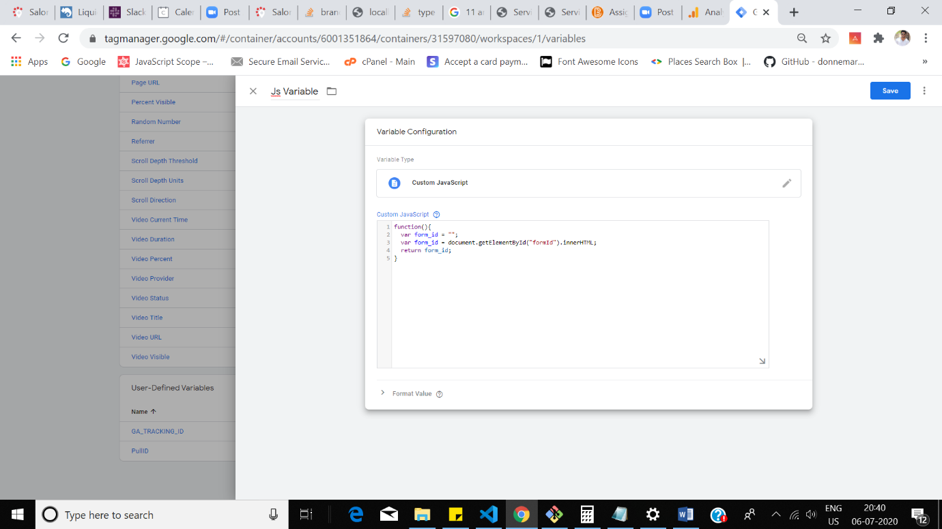

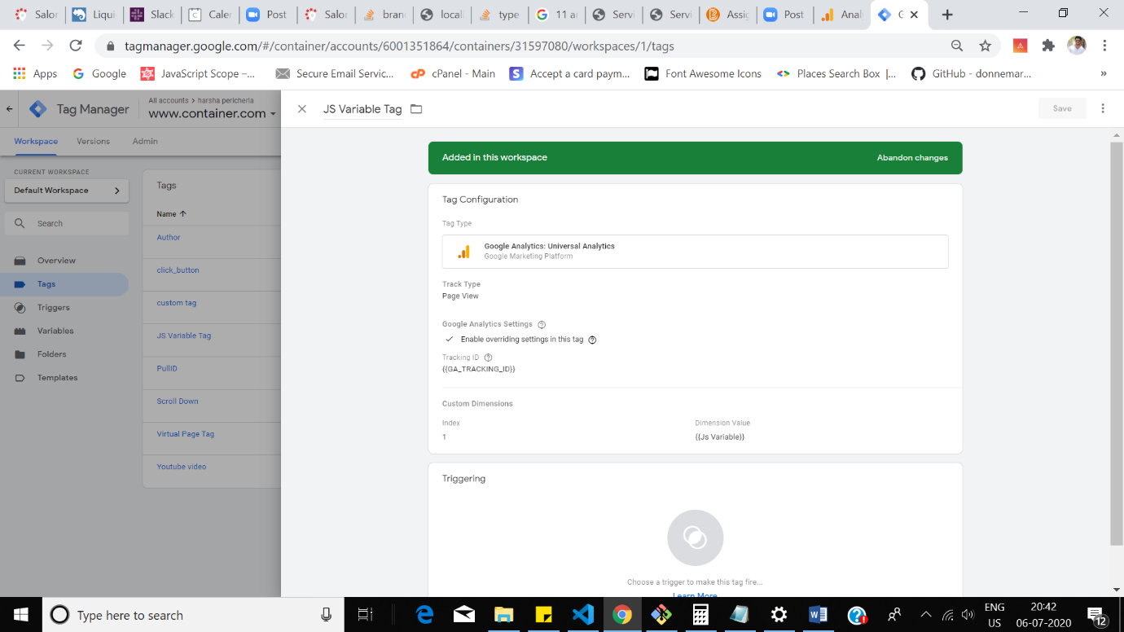

3. Create a calculated metric that determines the average number of pages viewed by users

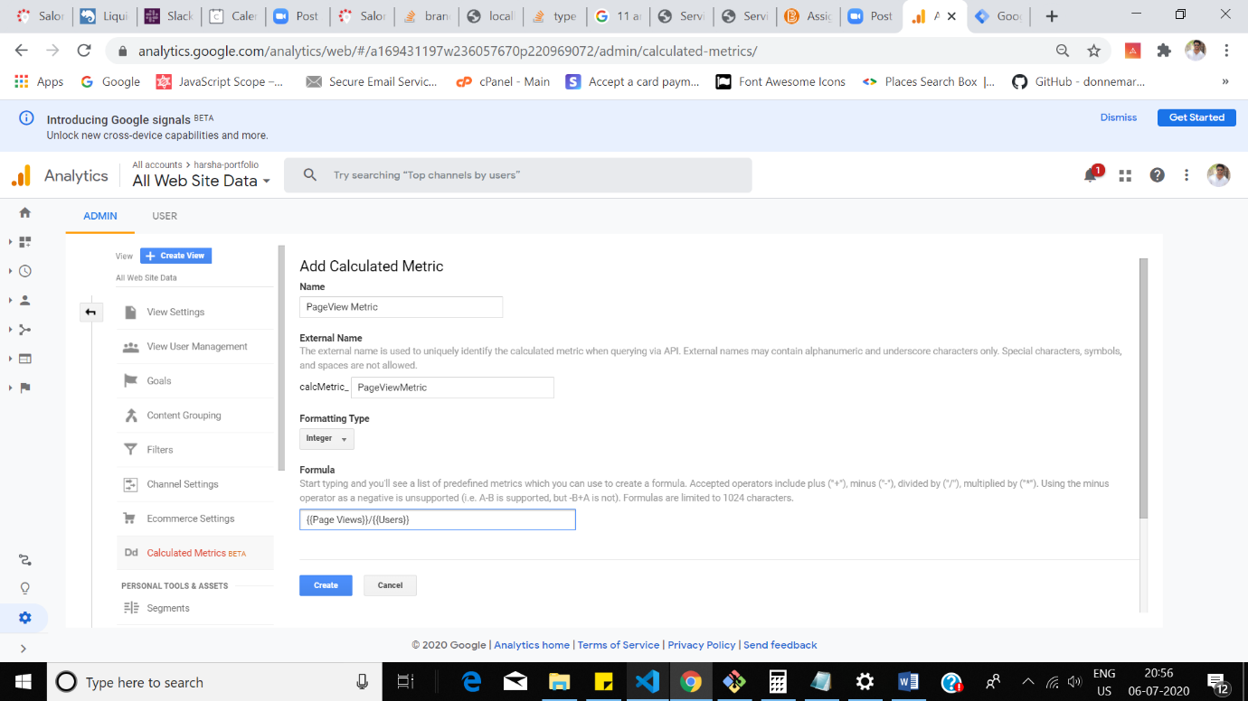

Metric: {{Page Views}}/{{Users}}

**Part 2:**

1. What is the biggest privacy concern with Google Analytics, according to the case study.

Ans. Google Analytics stores the user’s Ip address. It can also track the user using the ip address. Some of the laws in European countrues prohibit this.

1. Explain what anonoymizeip is, and how it works?

Ans. Anonoymizeip rounds the last digit of the ip address to zero. For example, the ipaddress “192.168.0.104” gets reduced down to “192.168.0.0” there by preserving the anonymity of the user. This technique anonymnizes the user but google can still identify which region has highest page views.