Reporting:

1. Create a report with primary dimension Gender, secondary dimension Age. Take a screenshot of the data.

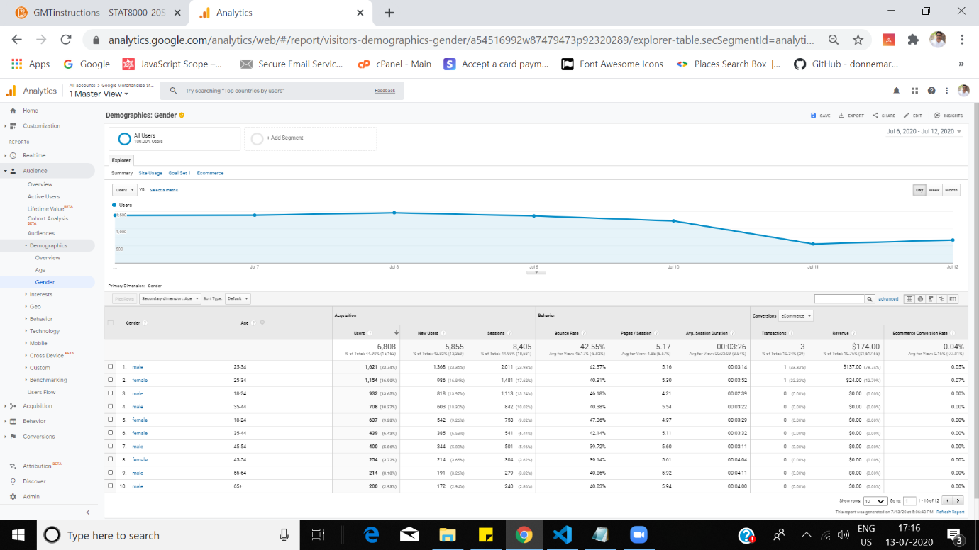

1. Create a report with primary dimension channels, secondary country, filtered to display only those from India. Take a screenshot of the data.

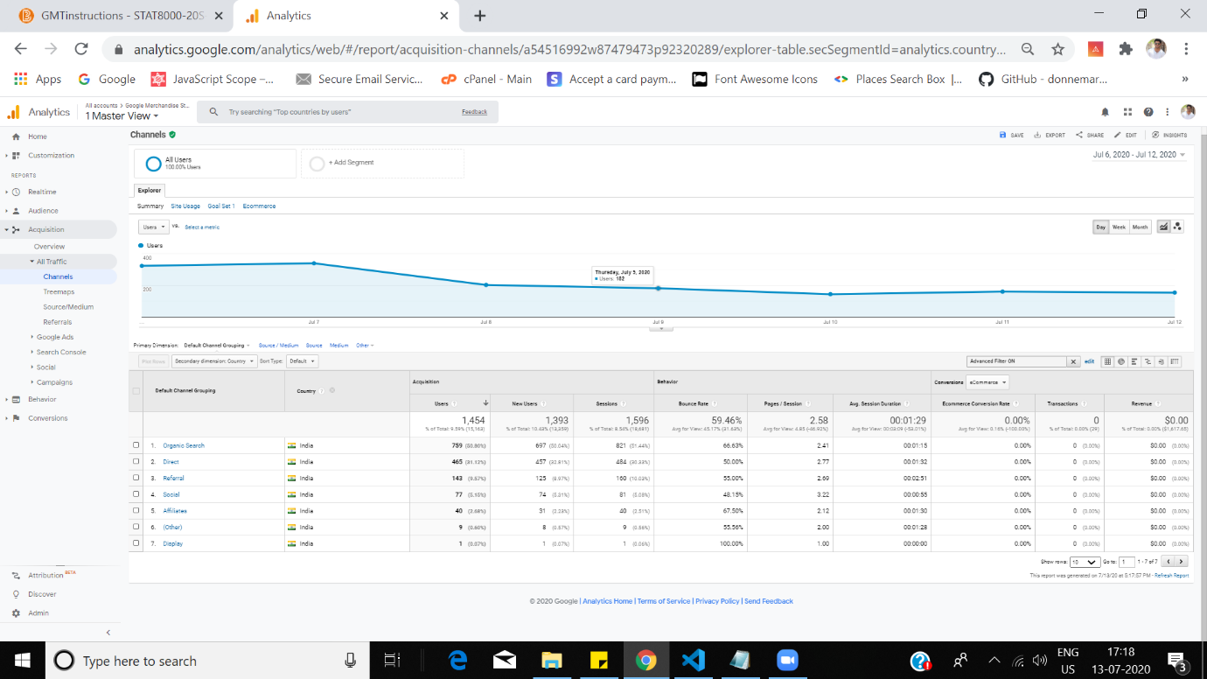

1. Create a segment that contains all men who first visited home.html and then visited store.html. Take a screenshot of the Summary bar on the right.

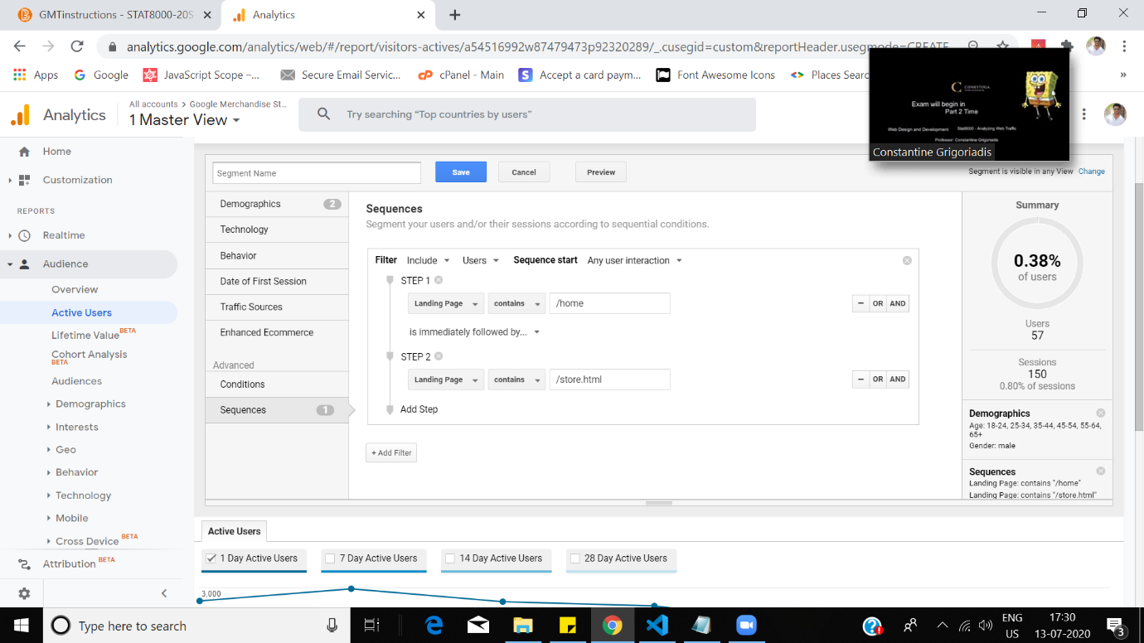

Analysis:

1. Imagine you work for a website that just introduced a new e-mail advertisement campaign. How could you evaluate the effectiveness of the campaign using Google Analytics?

Ans. We could evaluate the effectiveness of the campagin by checking how many leads have been generated. After the leads generation we measure how many of those leads have been converted.

1. Your manager wants to easily track how many people subscribe to your newsletter. How would you do this with Google Analytics?

Ans. We can track the people who are subscribing to the newsletter by creating a tag in the google tag manger for which we will attach a trigger that fires upon clicking on the subscribe button. Therefore whenever a user clicks that button we could easily track him.