**Roll No: 147241**

**Name: Sri Harsha Aditya**

**LP Assignment 6**

**Question 1:**

%{

#include <stdio.h>

#include <string.h>

int lno=0;

int len=0;

char largest[100];

int features=0;

%}

%%

[\n] {

lno++;

features=0;

printf("\n");

}

"+"+0{0,3}("-")+ {

printf("Feature %s",yytext);

if(strlen(yytext)>len){

len = strlen(yytext);

strcpy(largest, yytext);

}

//features++;

}

. {

}

%%

int yywrap(){

return 1;

}

int main(){

printf("Enter text");

//strcpy("largest", "");

yylex();

printf("Lines: %d ", lno);

printf("Largest feature: %s", largest);

return 0;

}

INPUT :

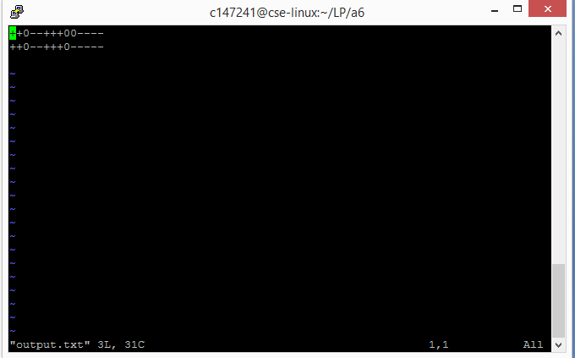

OUTPUT:

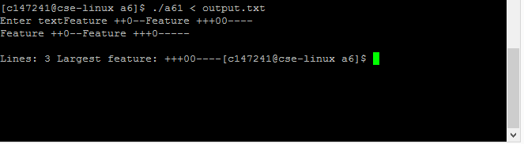

**LP Assignment 6**

**Question 2:**

d ("10"|"11"|"12"|"13"|"14"|"15")

%{

#include <stdlib.h>

#include <stdio.h>

#include <string.h>

int lno=0;

int prev=-1;

%}

%%

[\n] {

lno++;

prev=-1;

printf("\n");

}

[0-9]|{d} {

if(prev==-1){

prev = atoi(yytext);

}else{

int num = atoi(yytext)-prev;

if(num>0){

printf("+");

}else if(num<0){

printf("-");

}else{

printf("0");

}

prev = atoi(yytext);

}

//printf("Feature %s",yytext);

}

. {

}

%%

int yywrap(){

return 1;

}

int main(){

//printf("Enter text");

yylex();

//printf("Lines: %d ", lno);

return 0;

}

INPUT :

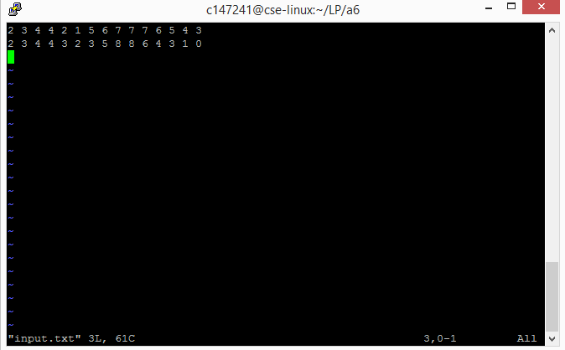

OUTPUT:

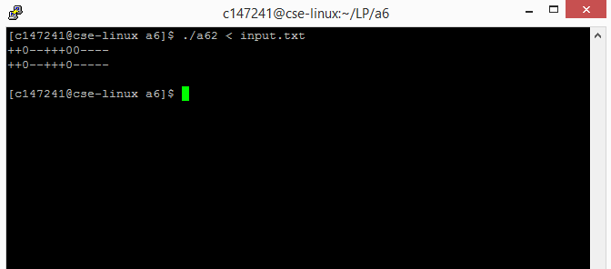

**LP Assignment 6**

**Question 4:**

d ("10"|"11"|"12"|"13"|"14"|"15")

%{

#include <stdlib.h>

#include <stdio.h>

#include <string.h>

int lno=0;

int prev=-1;

%}

%%

[\n] {

lno++;

prev=-1;

printf("\n");

}

[0-9]|{d} {

if(prev==-1){

prev = atoi(yytext);

}else{

int num = atoi(yytext)-prev;

if(num>0){

printf("+%d",num);

}else if(num<0){

printf("%d",num);

}else{

printf("0");

}

prev = atoi(yytext);

}

//printf("Feature %s",yytext);

}

. {

}

%%

int yywrap(){

return 1;

}

int main(){

//printf("Enter text");

yylex();

//printf("Lines: %d ", lno);

return 0;

}

INPUT:



OUTPUT:

