DataBase

And Related Operations

From:
Harsha S N
Computer Science and Department

To:
Computer Science Department
Shri Vidydhiraj polytechnic kumta

Table Of Contents

Sl. No. | Contents
1 | Database
2 | Types of databases
3 | CRUD Operations
4 | Indexing
5 | Aggregation
6 | Acid Properties
7 | CAP Theorem

DATABASE

What is database?
A database is a collection of data, usually stored in electronic form. A database is typically designed so that it is easy to store and access information.



Why database is needed ?
- A database stores and manages a large amount of data on a daily basis. This would not be possible using any other tool such as a spreadsheet as they would simply not work
- A database is pretty accurate as it has all sorts of build in constraints, checks etc. This means that the information available in a database is guaranteed to be correct in most cases.
- In a database, it is easy to update data using various Data Manipulation languages (DML) available.
- Databases have various methods to ensure security of data. There are user logins required before accessing a database and various access specifiers. These allow only authorised users to access the database.
- It is very easy to access and research data in a database. This is done using Data Query Languages (DQL) which allow searching of any data in the database and performing computations on it.

Types Of Database Sytems
Relational Database:
A relational database is the database management system in which data is stored in distinct tables from where they can be accessed or reassembled in different ways under user-defined relational tables. A relational database consists of tables, and a table consists of rows and columns. Each table has a special column that contains only distinct and unique values that are called primary key. This primary key is used to define the relationship between the tables.

Non-relational Database:
Non-Relational Databases are also calleNoSQL databases are completely different from SQL databases and work differently. It has to deal with semi-structured or unstructured data. Rather than containing tables, it consists of files within various folders. They can possess any kind of data, whether JSON, XML, etc. So, creating and managing data in NoSQL is easy and faster.d No-SQL databases, that doesn't require any table, fields, or records.

CRUD Operations

CRUD is an abbreviation that stands for Create, Read, Update, and Delete or Destroy.

Create operation :
In CRUD, the create operation does what the name implies. It means creating an entry. This entry could be an account, user information, a post, or a task. In a SQL database, to create is to INSERT. In a NoSQL database like MongoDB, you create with the insert() method

. Read Operation:
This access could mean the user getting access to the created entries right after creating them, or searching for them. Searching is implemented to allow the user to filter out the entries they don’t need.In a SQL database, to read is to SELECT an entry. In a NoSQL database like MongoDB, you read with the find() or findById() method.

Update Operation:
UPDATE is the operation that allows you to modify existing data. That is, editing the data.In a SQL database, you use UPDATE to update an entry. In a NoSQL database like MongoDB, you can implement an update feature with the findByIdAndUpdate() method.

Delete Operation:
To delete is to get rid of an entry from the UI and the database. In a SQL database, DELETE is used to delete an entry. In a NoSQL database like MongoDB, you can implement delete with the findByIdAndDelete() method.
Indexing

An index is a database structure that you can use to improve the performance of database activity. A database table can have one or more indexes associated with it.An index is defined by a field expression that you specify when you create the index. Typically, the field expression is a single field name, like EMP_ID. An index created on the EMP_ID field, for example, contains a sorted list of the employee ID values in the table. Each value in the list is accompanied by references to the records that contain that value.
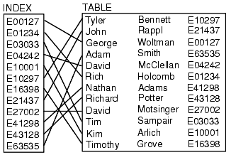

A database driver can use indexes to find records quickly. An index on the EMP_ID field, for example, greatly reduces the time that the driver spends searching for a particular employee ID value. Consider the following Where clause:
WHERE emp_id = 'E10001'
Without an index, the driver must search the entire database table to find those records having an employee ID of E10001. By using an index on the EMP_ID field, however, the driver can quickly find those records.

Aggregate Function
An aggregate function in SQL returns one value after calculating multiple values of a column.

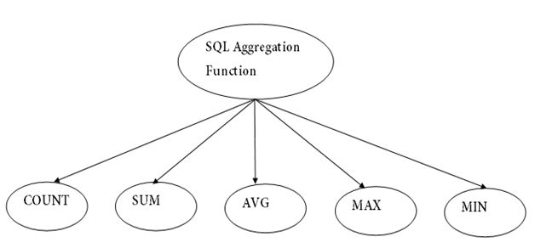

COUNT FUNCTION :
COUNT function is used to Count the number of rows in a database table. It can work on both numeric and non-numeric data types.COUNT function uses the COUNT(*) that returns the count of all the rows in a specified table. COUNT(*) considers duplicate and Null.
Syntax:
COUNT(*)

SUM Function :
Sum function is used to calculate the sum of all selected columns. It works on numeric fields only.
Syntax:
SUM(*)

AVG function :
The AVG function is used to calculate the average value of the numeric type. AVG function returns the average of all non-Null values.

Syntax:
AVG(*)

MAX Function :
MAX function is used to find the maximum value of a certain column. This function determines the largest value of all selected values of a column.
Syntax :
MAX(*)

MIN Function :
MIN function is used to find the minimum value of a certain column. This function determines the smallest value of all selected values of a column.
Syntax :
MIN(*)

ACID Properties

Atomicity :
All changes to data are performed as if they are a single operation. That is, all the changes are performed, or none of them are.For example, in an application that transfers funds from one account to another, the atomicity property ensures that, if a debit is made successfully from one account, the corresponding credit is made to the other account.

Consistency :
Data is in a consistent state when a transaction starts and when it ends. For example, in an application that transfers funds from one account to another, the consistency property ensures that the total value of funds in both the accounts is the same at the start and end of each transaction.

Isolation :
The intermediate state of a transaction is invisible to other transactions. As a result, transactions that run concurrently appear to be serialized. For example, in an application that transfers funds from one account to another, the isolation property ensures that another transaction sees the transferred funds in one account or the other, but not in both, nor in neither.

Durability :
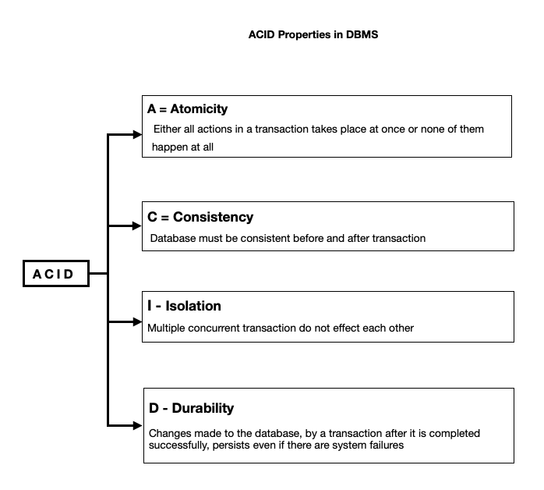
After a transaction successfully completes, changes to data persist and are not undone, even in the event of a system failure. For example, in an application that transfers funds from one account to another, the durability property ensures that the changes made to each account will not be reversed.

CAP Theorem
The CAP theorem, originally introduced as the CAP principle, can be used to explain some of the competing requirements in a distributed system with replication. It is a tool used to make system designers aware of the trade-offs while designing networked shared-data systems.
The three letters in CAP refer to three desirable properties of distributed systems with replicated data: consistency (among replicated copies), availability (of the system for read and write operations) and partition tolerance (in the face of the nodes in the system being partitioned by a network fault).
The CAP theorem states that it is not possible to guarantee all three of the desirable properties – consistency, availability, and partition tolerance at the same time in a distributed system with data replication.

Consistency :
Consistency means that all clients see the same data at the same time, no matter which node they connect to. For this to happen, whenever data is written to one node, it must be instantly forwarded or replicated to all the other nodes in the system before the write is deemed ‘successful.’

Availability :
Availability means that that any client making a request for data gets a response, even if one or more nodes are down. Another way to state this—all working nodes in the distributed system return a valid response for any request, without exception.

Partition tolerance :
A partition is a communications break within a distributed system—a lost or temporarily delayed connection between two nodes. Partition tolerance means that the cluster must continue to work despite any number of communication breakdowns between nodes in the system.
Conclusion

