ASSIGNMENT-1

Question1)

Sol: --select cast(acquired_at as date) from tutorial.crunchbase_acquisitions

select acquirer_category_code,avg(at-ft)

from(

select t2.acquirer_category_code,cast(t2.acquired_at as date) as at,cast(t1.founded_at as date)as ft from tutorial.crunchbase_companies t1 inner join tutorial.crunchbase_acquisitions t2

on t1.permalink=t2.acquirer_permalink

)as tt

group by acquirer_category_code

Question 2)

select quarter,count(acquired_month)

from(

select RIGHT(acquired_quarter,2) as quarter, acquired_month

from tutorial.crunchbase_acquisitions)as tt

group by quarter

question 3)

select (category_code), AVG(funding_total_usd) from tutorial.crunchbase_companies

where category_code is not null

group by category_code

question4)

select investor_name,count(investor_category_code) from tutorial.crunchbase_investments

where investor_country_code='USA'

group by investor_name

order by count(investor_category_code) DESC

Question 5)

select funding_round_type,rt,avg(raised_amount_usd)

from

(select funding_round_type,RIGHT(funded_quarter,2) as rt, raised_amount_usd

from tutorial.crunchbase_investments)as tt

group by funding_round_type,rt

Question 6)

select AA.company_name from

(select company_name, investor_country_code

from tutorial.crunchbase_investments_part1) as AA,

(select company_name, investor_country_code

from tutorial.crunchbase_investments_part2 where investor_category_code='finance') as BB

where AA.company_name = BB.company_name and AA.investor_country_code='JPN'

and BB.investor_country_code='ISR'

Result:No results

question 7)

select category_code,avg(funding_total_usd) as average

from tutorial.crunchbase_companies

where status='operating'

group by category_code

order by average desc

Question 8)

1. For each category, what percent of companies received funding within 3 years of their founding?​

Sol:

select A.category,A.count/B.count*100 as percentage from

(

select category, cast(count(*) as float) from

(

select category,(fft-ft)as days

from

(select category_code as category,

cast(founded_at as date) as ft,cast(first_funding_at as date) as fft

from tutorial.crunchbase_companies

where category_code is not null)

as t11

where ft is not null and fft is not null) as num

where days <= 1095

group by category )as A,

(select category, cast(count(*) as float) from

(select category,(fft-ft)as days

from

(select category_code as category,

cast(founded_at as date) as ft,cast(first_funding_at as date) as fft

from tutorial.crunchbase_companies

where category_code is not null)

as t11

where ft is not null and fft is not null)as dum

group by category)as B

where A.category=B.category

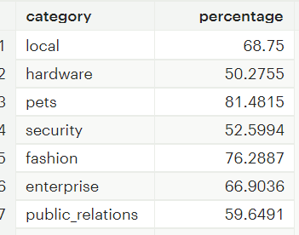

question 9)

select localtimestamp-cast(last_funding_at as timestamp) as diff

from tutorial.crunchbase_companies

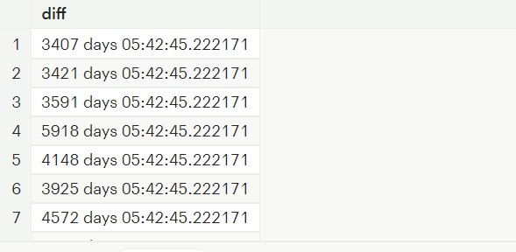

question 10)

select category_code,sum(funding_rounds) as sumfundingrounds

from tutorial.crunchbase_companies

where category_code is not null

group by category_code

order by sumfundingrounds desc

ASSIGNMENT-2

select airname,c1,c2,percentage,cancel,tcan,dense_rank() over (order by percentage) as q6,dense_rank()

over (order by ccity)as q7

from

(select airname,c1,c2,c2/c1*100 as percentage,cancel, cancel/c1 *100 as tcan, ccity

from

(SELECT t1.airline_name as airname,cast(count(t1.airline_name) as float) as c1,cast(sum(

CASE

when t1.arrival_delay>0 then 1

else 0

end)as float)as c2,cast(sum(t2.cancelled) as float) as cancel, count(distinct t1.destination_city) as ccity

FROM

tutorial.flights as t1

inner join tutorial.us_flights as t2

on t1.flight_number=t2.flight_num

inner join tutorial.flight_revenue as t3

on t1.destination_airport=t3.destination_airport

group by t1.airline_name) as tt1

)as tt2



