Depression Classifier

Team Name : Code Racers

***Mentor :*** *Ms.D.Deepa.,M.E.,(Ph.D)*

*Gaddam Harshavardhan(****LEAD****)*

*Mamilla Jaahnavi*

*M Himasree*

*V Sai Keerthi Reddy*

**Abstract:**

Depression is a major health issue that impacts major impact on the stability of mind. With the extension of various social media platforms, an expansion of number of different platforms enabled people to interact and share their experiences . These provided a large dataset for identification of common traits among depressed people and identify them using various machine learning algorithms.

The limit to which we can identify the depressed traits of the person is necessary to determine the level of depression. The classification plays a major role in determining the kind of help a depressed person needs and also, the person with suicidal thoughts need to be identified and helped according to his condition. This website provides the survey about the use of machine learning algorithm and web applications in the analysis of depression.

**Introduction:**

Depression is quite common among different age groups and is a very serious mental illness that affects our mental state, how we perceive things and how to act on stimulus which is given to the nervous system. Everyone feels sometimes down or low in their lives but when this feeling persist for longer time instances, it affects general cognitive function of the brain. The more careful task is proper separation of the symptoms depression from sadness or the blues.

**Project Output:**

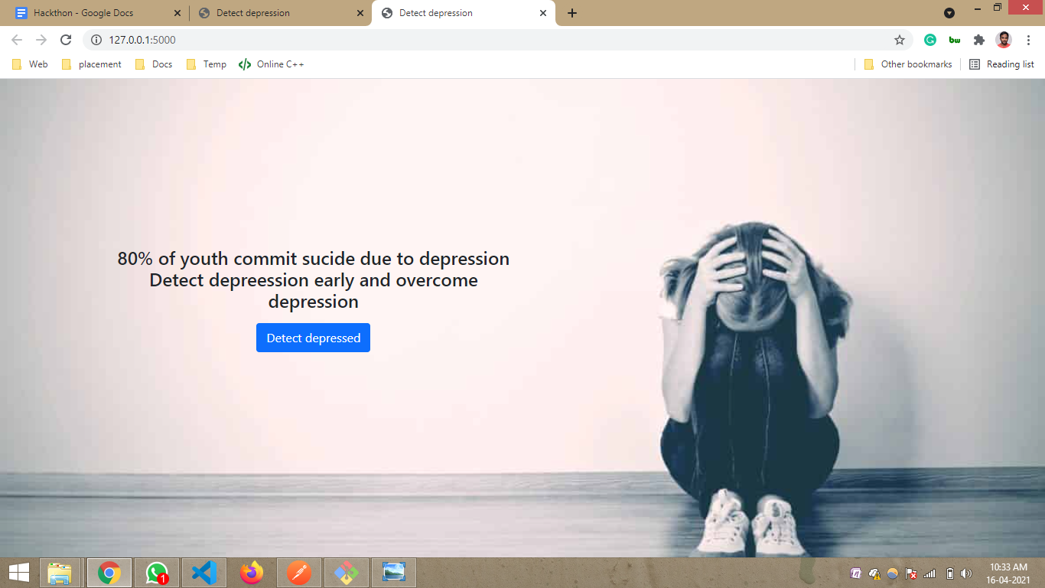

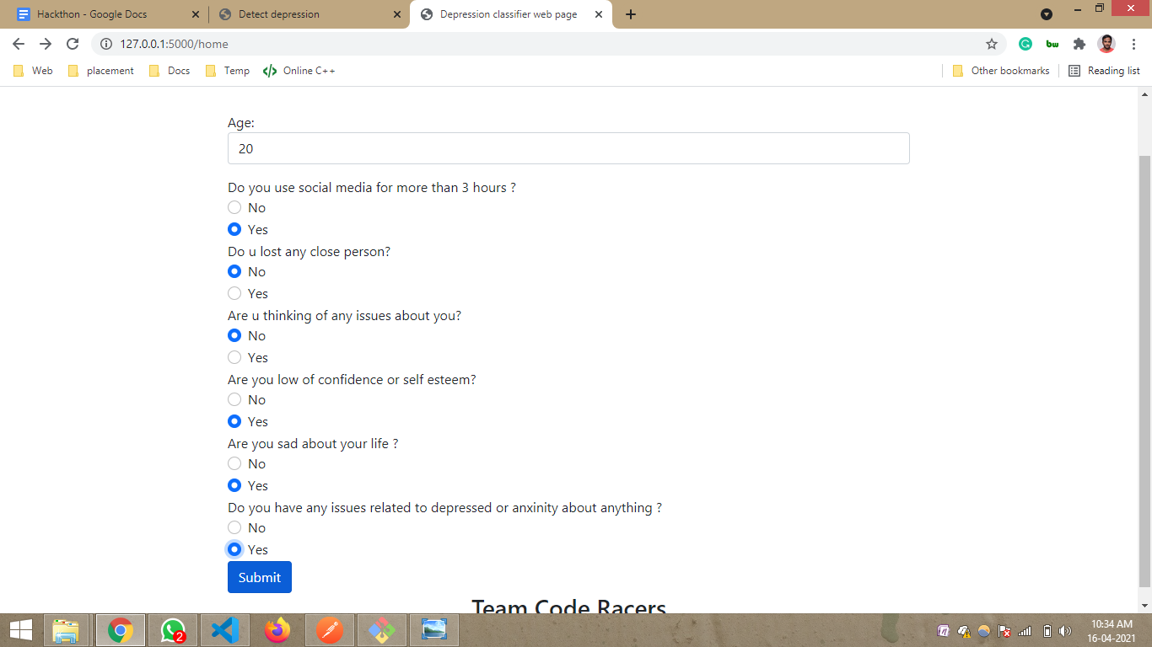

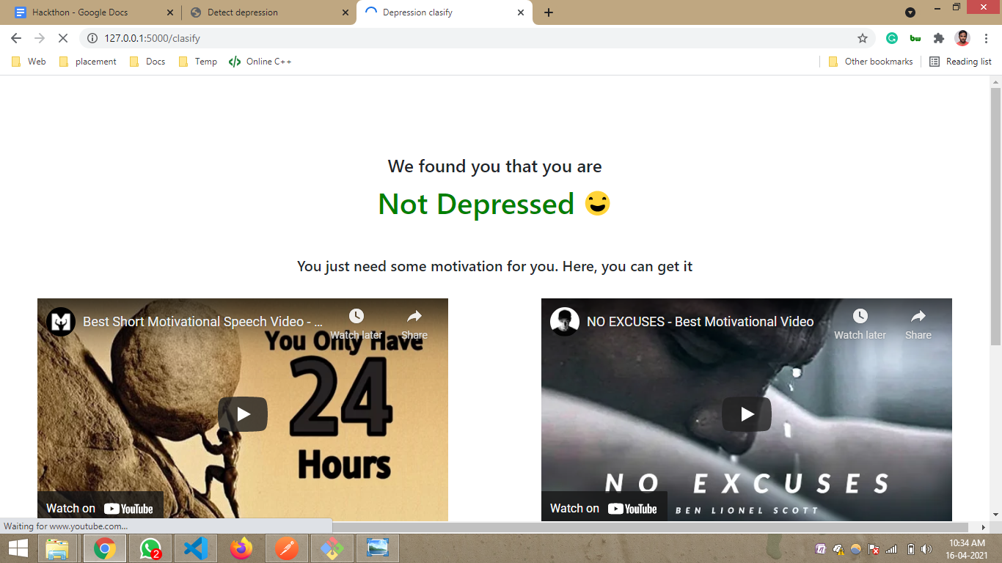

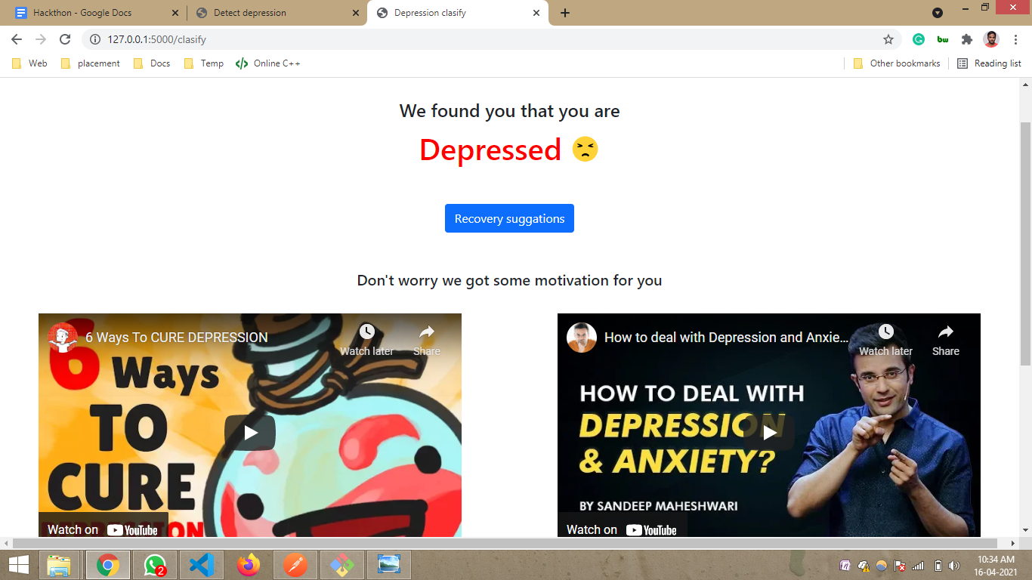

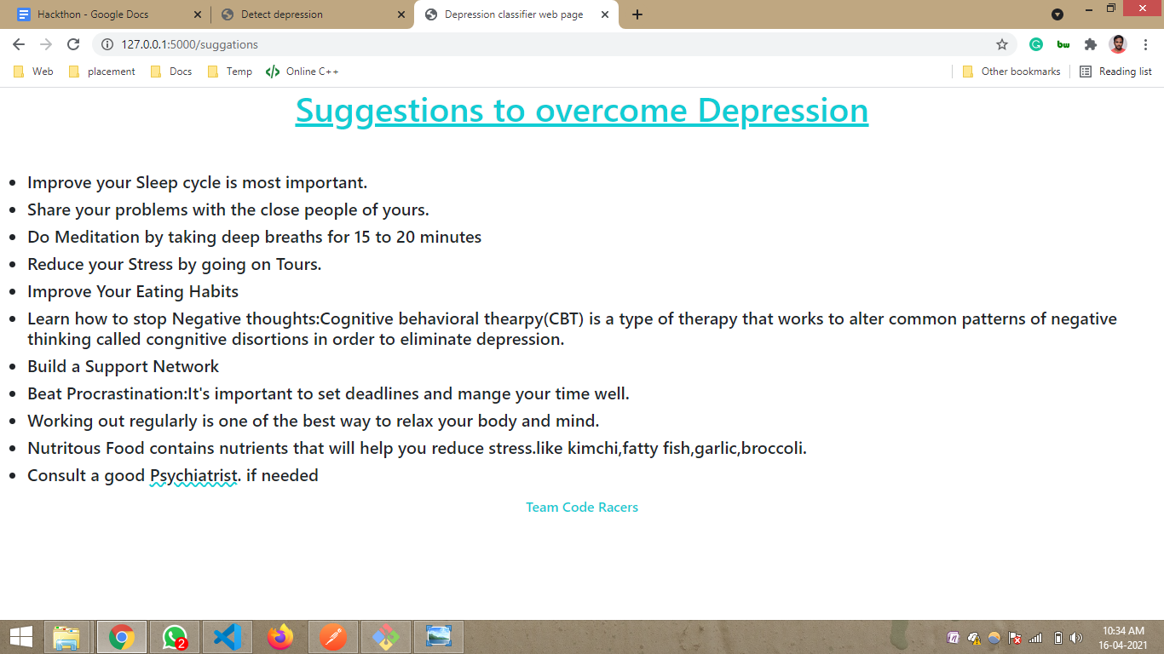

***References:***

1)<https://youtu.be/3SDkzDlw1yc>

2)<https://youtu.be/TgGc_tUcjgk>

3)<https://youtu.be/r01DOmPpxjg>

4)<https://youtu.be/fLeJJPxua3E>

5)<https://youtu.be/-ozOLVOS-R8>

6)<https://youtu.be/Bi-7pho5XB8>