**SQL Codes to Verify iPhone Sales Data**

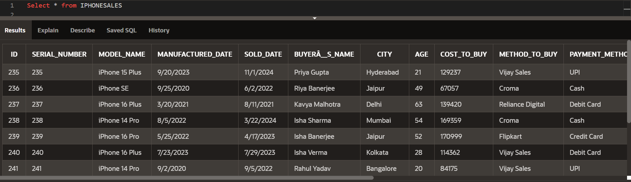

**Explanation:** This query retrieves the complete table in the dataset.

**1. Query Names of All Distinct Cities**

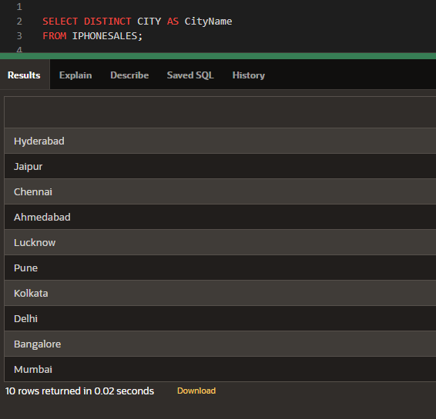

**Explanation:** This query retrieves the names of all unique cities in the dataset. The DISTINCT keyword ensures that each city appears only once in the result.

**2. Query Average Customer Feedback Rating**

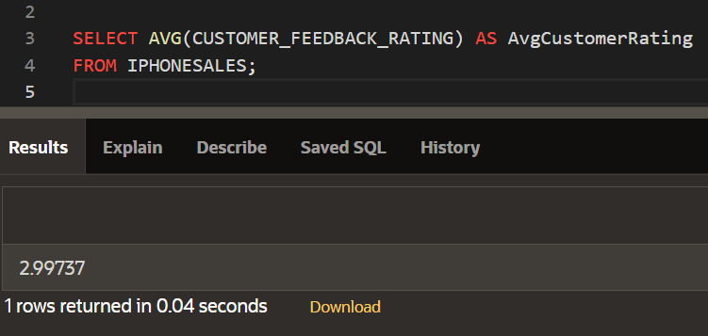  
**Explanation:** This query calculates the average customer feedback rating across all entries in the dataset. The AVG function is used for this purpose.

**3. Query Total Gadgets Sold**

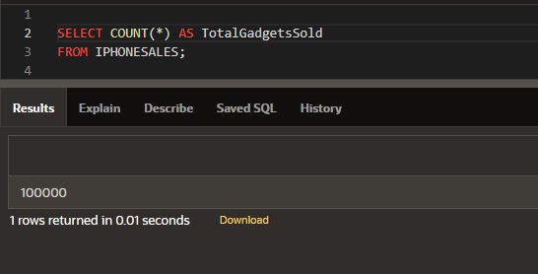  
**Explanation:** This query calculates the total gadgets sold across all entries in the dataset. The **COUNT (*)** function is used for this purpose.

**4. Query for Count of Customer with ACTIVE Warranty**

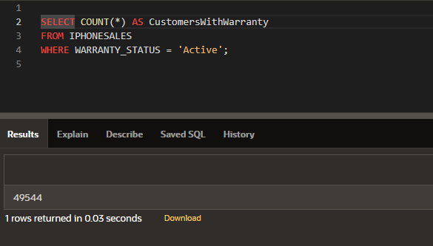  
**Explanation:** This query calculates the count of customers with active warranty across all entries in the dataset.

**5. Query for count of Customers with different Payment method in Decreasing order.**

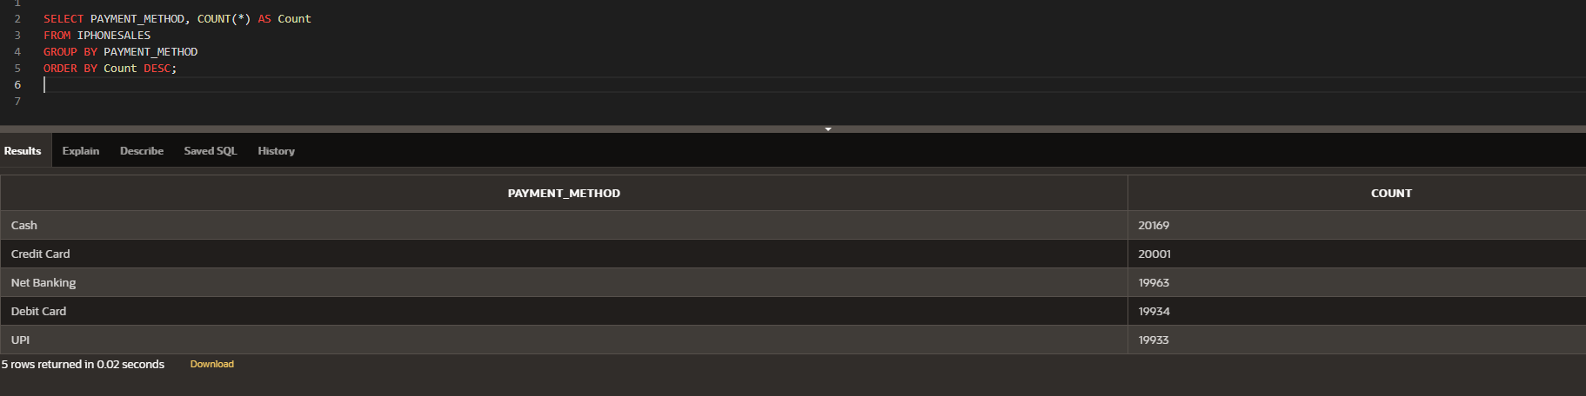  
**Explanation:** This query calculates the count of customers with different payment methods in decreasing order.

**6. Query for count of Customers from different cities in Decreasing order.**

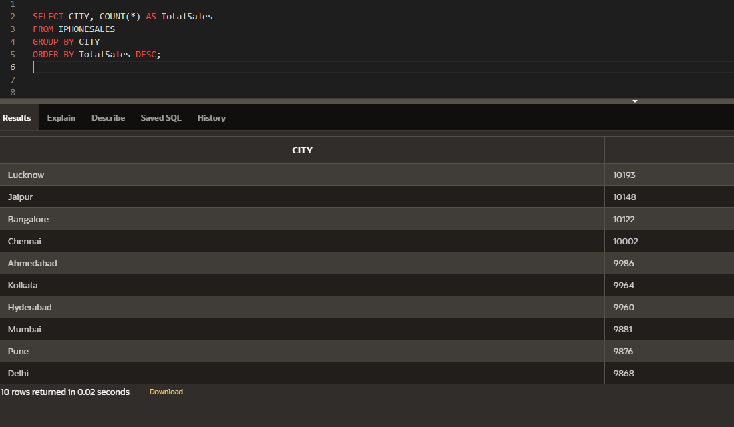  
**Explanation:** This query calculates the count of customers from different cities in decreasing order.

**7. Query for count of Customers who bought gadgets and by method they bought in Decreasing order.**

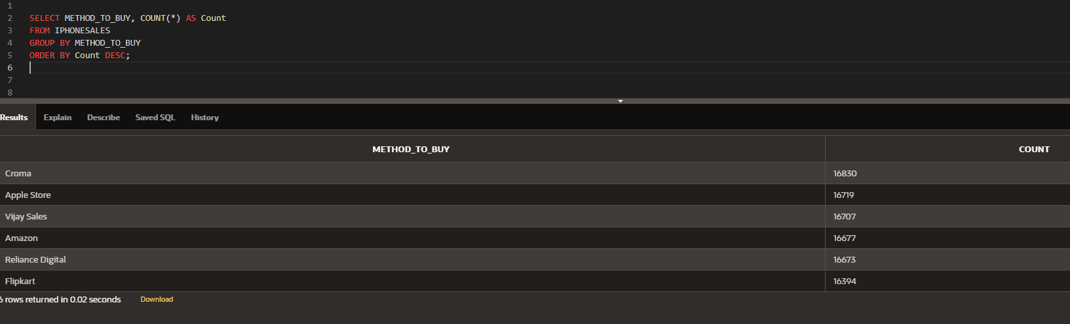  
**Explanation:** This query calculates the count of customers who bought gadgets and by the method they bought in decreasing order.

**8. Query for Total Income from Sales.**

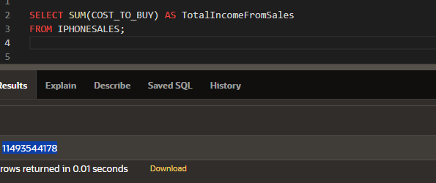  
**Explanation:** This query calculates the sum of total income generated from the sales.

**9. Query for count of Customers with the reason of purchase in Decreasing order.**

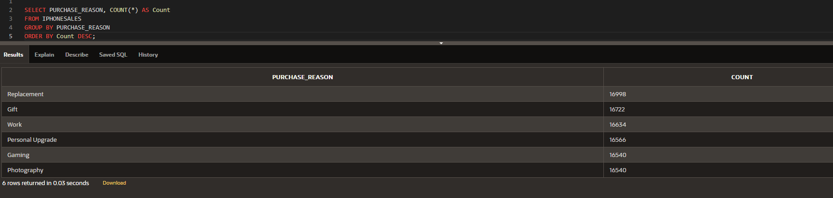

**Explanation:** This query calculates the count of customers with the reason of purchase in decreasing order.