A Mini Project Report On
DESIGN AND DEVELOPMENT OF A WORKING PROTOTYPE FOR CYBERBULLYING DETECTION USING A FINE-TUNED TRANSFORMER CLASSIFIER
Submitted by
Dintakurti Harsha Sai | 23ME1A54B8
Submitted in partial fulfillment of the requirement for the award of the degree of
BACHELOR OF TECHNOLOGY
in
ARTIFICIAL INTELLIGENCE AND DATA SCIENCE
IV B.Tech – I Semester (Mini Project)
Under the Esteemed Guidance of
Mr. S. V. Swamy
Assistant Professor, Department of AI&DS

DEPARTMENT OF ARTIFICIAL INTELLIGENCE AND DATA SCIENCE
RAMACHANDRA COLLEGE OF ENGINEERING (AUTONOMOUS)
(Approved by AICTE, Permanently Affiliated to JNTUK, Kakinada)
Accredited by NBA and NAAC (A+)
NH-16 Bypass, Vatluru (V), ELURU-534007, Eluru Dist., A.P.
2026–2027
RAMACHANDRA COLLEGE OF ENGINEERING (AUTONOMOUS)
(Approved by AICTE, Permanently Affiliated to JNTUK, Kakinada) Accredited by NBA and NAAC (A+)
NH-16 Bypass, Vatluru (V), ELURU-534007, Eluru Dist., A.P.
2026–2027
DEPARTMENT OF ARTIFICIAL INTELLIGENCE AND DATA SCIENCE
BONAFIDE CERTIFICATE
This is to certify that this project report entitled “DESIGN AND DEVELOPMENT OF A WORKING PROTOTYPE FOR CYBERBULLYING DETECTION USING A FINE-TUNED TRANSFORMER CLASSIFIER” is being submitted by Dintakurti Harsha Sai (23ME1A54B8) in partial fulfillment of BACHELOR OF TECHNOLOGY in ARTIFICIAL INTELLIGENCE AND DATA SCIENCE.
This report is a bonafide work carried out under my guidance and supervision during the academic year 2026-2027 and it has been found worthy of acceptance as per the requirements of the university.
Mr. S. V. Swamy  PROJECT GUIDE  Assistant Professor | Dr. P. Sudhakar  Professor & HOD
External Examiner
DECLARATION
I, Dintakurti Harsha Sai (23ME1A54B8), hereby declare that the project report titled “DESIGN AND DEVELOPMENT OF A WORKING PROTOTYPE FOR CYBERBULLYING DETECTION USING A FINE-TUNED TRANSFORMER CLASSIFIER” has been completed under the supervision of Mr. S. V. Swamy, Assistant Professor, Department of Artificial Intelligence and Data Science. This report is submitted in partial fulfillment of the requirements for the award of the degree of BACHELOR OF TECHNOLOGY in ARTIFICIAL INTELLIGENCE AND DATA SCIENCE.
This is a record of work carried out by me, and the results presented in this project have not been reproduced or copied from any source. Furthermore, the results embodied in this project report have not been submitted to any other University or Institute for the award of any other degree or diploma.
Dintakurti Harsha Sai | 23ME1A54B8
Station:
Date:
ACKNOWLEDGEMENT
I take this opportunity to express my sincere gratitude to all those who have contributed to the successful completion of my project work. Their guidance, support, and encouragement have been invaluable throughout this journey.
I extend my heartfelt thanks to my guide, Mr. S. V. Swamy, Assistant Professor, Department of Artificial Intelligence and Data Science, for the invaluable mentorship, insightful guidance, and unwavering support throughout this project. The expertise and constructive feedback have been instrumental in shaping this work.
I am deeply indebted to Dr. P. Sudhakar, Professor & Head of the Department, Artificial Intelligence and Data Science, for the continuous encouragement, guidance, and support in all aspects of this project.
My sincere recognition also goes to Dr. M. Muralidhara Rao, Principal for the valuable suggestions and constructive inputs during the preparation of this work.
I also wish to convey my sincere thanks to all the Deans for their constant encouragement and insightful suggestions.
I extend my profound gratitude to the Management of Ramachandra College of Engineering, Eluru, for their unwavering support, encouragement, and for providing the necessary facilities to carry out this project.
I would also like to express my deepest recognition to all the faculty members and staff of the Department of Artificial Intelligence and Data Science for their valuable advice and continuous motivation, which have played a crucial role in the successful completion of this project.
Finally, I extend my sincere gratitude to my parents, friends and everyone who has directly or indirectly contributed to the successful completion of this project work.
Dintakurti Harsha Sai | 23ME1A54B8
TABLE OF CONTENTS
SL.NO | TITLE | PAGE NO
 | BONAFIDE CERTIFICATE | i
 | DECLARATION | ii
 | ACKNOWLEDGEMENT | iii
 | ABSTRACT | vi
 | LIST OF FIGURES | vii
1. | CHAPTER - 1 INTRODUCTION | 1 - 3
 | 1.1 Introduction to Cyberbullying Detection and Moderation | 1
 | 1.2 Problem Statement | 2
 | 1.3 Objectives of the Project | 2
 | 1.4 Scope of the Project | 2
 | 1.5 Organization of the Report | 3
2. | CHAPTER - 2 SYSTEM ANALYSIS | 4 - 6
 | 2.1 Existing Methods and Literature Review | 4
 | 2.2 Limitations of Existing System | 4
 | 2.3 Proposed System | 5
 | 2.4 Advantages of Proposed System | 6
3. | CHAPTER - 3 SYSTEM REQUIREMENT SPECIFICATION | 7 - 11
 | 3.1 Hardware Requirements | 7
 | 3.2 Software Requirements | 7
 | 3.3 Functional Requirements | 7
 | 3.4 Non-Functional Requirements | 8
 | 3.5 Algorithms / Models Used | 9
4. | CHAPTER - 4 SYSTEM DESIGN | 12 - 15
 | 4.1 Architecture Diagram | 12
 | 4.2 Data Flow Diagram (DFD) | 13
 | 4.3 UML Diagrams | 14
 | 4.4 Database / Dataset Design | 15
5. | CHAPTER - 5 MODULE DESCRIPTION | 16 - 18
 | 5.1 Data Ingestion and Validation Module | 16
 | 5.2 Subword Tokenization and Encoding Module | 16
 | 5.3 Transformer Model Fine-Tuning Module | 17
 | 5.4 Two-Layer Moderation and Policy Gate Module | 17
 | 5.5 Evaluation, Report and Web Interface Module | 18
6. | CHAPTER - 6 SYSTEM IMPLEMENTATION | 19 - 23
 | 6.1 Data Ingestion and Preprocessing Implementation | 19
 | 6.2 WordPiece Tokenization and Attention Mask Implementation | 20
 | 6.3 Transformer Fine-Tuning and Head Implementation | 21
 | 6.4 Evaluation and Final Web Integration Implementation | 22
7. | CHAPTER - 7 TESTING AND OUTPUT SCREENS | 24 - 28
 | 7.1 Test Cases and Test Results | 24
 | 7.2 Output Screen 1 – Insights Summary and Verdict Cards | 25
 | 7.3 Output Screen 2 – Multi-Class Distribution & Diagnostics | 25
 | 7.4 Performance Results and Discussion | 26
8. | CHAPTER - 8 CONCLUSION AND FUTURE ENHANCEMENTS | 29 - 30
 | 8.1 Conclusion | 29
 | 8.2 Future Enhancements | 29
9. | REFERENCES | 31
 | APPENDIX | 32 - 33

ABSTRACT
TITLE: DESIGN AND DEVELOPMENT OF A WORKING PROTOTYPE FOR CYBERBULLYING DETECTION USING A FINE-TUNED TRANSFORMER CLASSIFIER
Social media platforms and digital messaging services record millions of interactions every hour. Within this massive volume, toxic harassment, demographic attacks, and cyberbullying proliferate continuously, causing severe psychological trauma to victims. Manual inspection by human review teams is impossibly slow and costly, while keyword blacklists miss subtle sarcasm, deliberate misspellings, and polite insults. As a result, demographic hate speech targeting gender, religion, age, and ethnicity often repeats unchecked across online communities.
I developed an intelligent system that automatically ingests social media comments and classifies them into fine-grained harassment categories without relying on static keyword dictionaries. Using transfer learning, a compact DistilBERT transformer with 66 million parameters was fine-tuned on the standardized Surrey NLP cyberbullying benchmark dataset of 47,692 comments. Comments are transformed into WordPiece subword tokens, sequence boundaries are normalized, and multi-head self-attention captures full bidirectional context.
The system has five core modules: data ingestion, WordPiece tokenization, transformer fine-tuning with AdamW optimization, a two-layer defense-in-depth moderation engine, and an interactive Streamlit web dashboard. Layer 1 uses deterministic regex safety guards to catch explicit violence threats, while Layer 2 applies cumulative toxicity gating across the 5 abusive categories to overcome the multi-class dilution fallacy. An educational viva diagnostics expander exposes underlying subword tokens and attention vectors.
On a held-out test split of 9,923 samples, the fine-tuned model achieved an overall accuracy of 86.67%, a macro precision of 85.12%, a macro recall of 85.20%, and a macro F1-score of 85.13%, outperforming classical SVM baselines by over 13%. The prototype processes comments in 38.4 milliseconds on a laptop CPU, providing digital platforms with a fast, explainable, and deployment-ready moderation assistant.
Keywords: Cyberbullying detection, DistilBERT, subword tokenization, multi-class classification, cumulative risk gating, Streamlit, content moderation.
LIST OF FIGURES
SI NO | IMAGE NAME | PAGE NO
1 | System Architecture | 12
2 | Data Flow Diagram – Level 0 | 13
3 | Data Flow Diagram – Level 1 | 13
4 | Use Case Diagram | 14
5 | Sequence Diagram | 14
6 | Model Training Convergence Graph (Loss & Macro F1) | 22
7 | Output Screen 1 – Insights Summary and Verdict Cards | 25
8 | Output Screen 2 – Multi-Class Distribution & Diagnostics | 25
9 | Confusion Matrix Heat Map across 6 Categories | 27
10 | Result Comparison Graph | 27

CHAPTER - 1
INTRODUCTION
1.1 Introduction to Cyberbullying Detection and Threat Moderation
Every digital platform that hosts user interactions—social networks, video comments, gaming lobbies, and messaging groups—acts as a shared public space where millions of conversations occur daily. While these platforms foster connection and community building, they also document an alarming rise in toxic verbal aggression, demographic harassment, and cyberbullying. Unlike physical harassment that is bounded by time and physical presence, cyberbullying operates persistently around the clock. Victims experience relentless notifications, public humiliation before massive audiences, and irreversible digital footprints.
The difficulty lies in scale. Popular digital platforms receive hundreds of thousands of comments every minute. Hidden within this immense volume are malicious attacks that repeat day after day: targeted misogyny against female professionals, religious intolerance, racist slurs, and ageist abuse. Because these toxic patterns recur continuously, they cause severe long-term harm, yet they are nearly impossible to manage manually because human moderation teams cannot inspect billions of lines of text.
The real-world consequences of missing these toxic interactions are severe. Victims of repeated cyberbullying suffer from chronic anxiety, clinical depression, reduced academic and professional productivity, and elevated risks of self-harm. Online harassment also poisons community health, driving away constructive contributors and exposing platform operators to legal and regulatory penalties. A moderation team that can see, in real time, which forms of harassment are emerging, how confident the detection is, and whether specific protected demographic groups are targeted, can intervene proactively. A moderation team lacking these capabilities works blind.
Traditional moderation tools search for static blacklists of offensive keywords, and earlier machine learning methods used bag-of-words models such as Naive Bayes and Support Vector Machines with TF-IDF features. These legacy approaches fail because they ignore word order and sentence context: sarcastic phrasing, deliberate misspellings, and passive-aggressive insults easily bypass word filters, while benign educational discussions trigger false alarms. Transformer-based deep learning offers a practical alternative. By computing multi-head bidirectional self-attention across complete sentences, transformer models understand contextual relationships, distinguishing hostile attacks from safe conversational text.
In this project I used DistilBERT, a lightweight, distilled transformer classifier, to turn raw, unlabelled social media text into accurate, fine-grained harassment classifications. Each comment is analyzed across six distinct categories: safe content, gender harassment, religious hate speech, ageist attacks, ethnic discrimination, and general toxic insults. The system incorporates a two-layer defense-in-depth moderation engine to prevent probability dilution and provide instant safety alerts. The expected outcome is a working web application in which a user submits a comment, adjusts moderation sensitivity, and receives clear prediction verdicts, probability bar charts, and underlying subword token diagnostics.
1.2 Problem Statement
User comments on social media grow by hundreds of thousands of lines daily, and the repeated harassment behavior hidden within them is difficult for human reviewers to monitor manually. Keyword search finds only what the reviewer already knows to look for, and classical machine learning models fail because they ignore sentence structure and context. Furthermore, most existing moderation systems provide only coarse binary outputs (bullying versus non-bullying), which prevents platforms from identifying specific demographic harassment vectors such as sexism, racism, or religious hatred. Existing research models are also computationally heavy and lack intuitive interfaces for non-experts.
The problem solved in this project is therefore: given an unmoderated social media comment, classify its intent into fine-grained harassment categories using deep bidirectional context, eliminate false negatives caused by multi-class probability dilution, explain the prediction through transparent probability distributions and token diagnostics, and present the results through an accessible web interface.
1.3 Objectives of the Project
• To design an automated natural language processing pipeline in Python that ingests social media comments, removes malformed text, and prepares standardized input sequences.
• To develop a subword tokenization and deep learning classification module using DistilBERT that categorizes comments into six mutually exclusive classes: not_cyberbullying, gender, religion, other_cyberbullying, age, and ethnicity.
• To evaluate the model using accuracy, macro-averaged precision, recall, and F1-score across a held-out benchmark test split, and to compare the performance with baseline TF-IDF and recurrent models.
• To formulate a two-layer defense-in-depth moderation engine combining deterministic policy rules for severe threats with cumulative toxicity gating to prevent multi-class dilution.
• To present the results through an interactive Streamlit web application featuring real-time verdict banners, probability distribution bar charts, and educational token attention diagnostics.
• To make the application deployable on standard workstation hardware and accessible without expensive GPU infrastructure.
1.4 Scope of the Project
The project covers English-language social media comments across six granular categories: conversational safe content, gender-based harassment, religious hate speech, general insults, ageist bullying, and ethnic discrimination. The intended users are content moderators, school administrators, community managers, and students who require automated assistance to monitor and triage toxic comments. The system runs as a Python web application, processes inputs in real time, provides probability distributions and token diagnostics, and offers exportable metric reports. It operates efficiently on standard laptop hardware.
The project does not analyze multimodal content such as images, memes, or video streams; it evaluates textual content only. It does not access private chat histories or enforce automated account suspensions without human confirmation. The system is evaluated on standardized public benchmark data, and the primary model is fine-tuned on single comments rather than long multi-turn conversational threads. Continuous cloud stream integration and multilingual code-mixed speech are outside the scope of this mini-project.
1.5 Organization of the Report
• Chapter 2 reviews existing methods, details their limitations, and presents the proposed transformer system and its design decisions.
• Chapter 3 specifies the hardware, software, functional and non-functional requirements, and details the mathematical algorithms and models used.
• Chapter 4 explains the system design: architecture, data flow diagrams, UML diagrams, and dataset schemas.
• Chapter 5 describes the five software modules and their operational flow.
• Chapter 6 presents the implementation details, including pseudo-code, key source code snippets, parameter tables, and training details.
• Chapter 7 presents the test cases, output screens, performance evaluation across categories, baseline comparisons, and discussion.
• Chapter 8 concludes the work and outlines realistic future enhancements, followed by references and appendices.
CHAPTER - 2
SYSTEM ANALYSIS
2.1 Existing Methods and Literature Review
Research on automated text moderation and abusive language detection has evolved across three major paradigms: lexicon and rule-based matching, classical machine learning with statistical n-grams, and deep contextual language representations.
A. Lexicon and Rule-Based Methods
Early automated moderation systems relied on curated dictionaries of offensive terms, slurs, and profanities. Hosseinmardi and colleagues analyzed cyberbullying across social media by matching comments against predefined negative word lists. While computationally fast, lexicon matching suffers from severe structural flaws: it cannot detect polite or disguised insults, fails when words are misspelled deliberately, and generates excessive false alarms when protected words are used in clinical, educational, or self-affirming contexts.
B. Classical Machine Learning with Bag-of-Words
To improve generalization, researchers combined statistical feature extraction with supervised classifiers. Zhao and co-authors applied marginalized denoising auto-encoders on social media corpora, and Van Hee and fellow researchers evaluated Support Vector Machines and Logistic Regression models using term frequency-inverse document frequency (TF-IDF) features. These methods demonstrated that word frequencies carry predictive signals for toxicity. However, bag-of-words models discard token ordering and syntactic structure entirely, treating sentences as unordered collections of terms and failing on sarcastic or nuanced hostility.
C. Deep Contextual Transformers and DistilBERT
The introduction of the Transformer architecture by Vaswani and colleagues revolutionized natural language processing by replacing recurrent steps with bidirectional self-attention. Devlin and fellow researchers at Google developed BERT, demonstrating that pretraining deep bidirectional encoders on vast text corpora enables state-of-the-art transfer learning for text classification. Mozafari and team demonstrated that fine-tuning BERT yields superior performance on online hate speech. However, BERT's 110 million parameters create significant computational overhead. To address this, Sanh and the Hugging Face team developed DistilBERT, compressing the transformer using knowledge distillation. DistilBERT reduces parameters by 40% and speeds inference by 60% while retaining 97% of language comprehension capabilities, making it ideal for responsive content moderation.
2.2 Limitations of Existing System
From the reviewed studies, several critical limitations in existing moderation systems were identified and are summarized in Table 2.1.
Table 2.1: Literature review summary and limitations
Study / Method | Dataset | Result | Limitation
Keyword Blacklists and Regex Rules | Social media lexicons | Fast lookup speed | High false positive rate; easily bypassed by leetspeak and subtle sarcasm.
Hosseinmardi et al. (N-grams + SVM) | Instagram comments | 78.2% Accuracy | Bag-of-words ignores word order; high false alarms on benign slang.
Zhao et al. (smSDA Auto-Encoder) | Twitter corpus | 82.4% Accuracy | Cannot resolve polysemous words; high feature engineering overhead.
Van Hee et al. (BiLSTM with GloVe) | SemEval Benchmark | 80.5% Macro F1 | Sequential processing bottleneck; struggles on long-range dependencies.
Mozafari et al. (BERT-base) | Hate speech tweets | 87.2% Macro F1 | 110M parameters; heavy memory footprint and slow CPU inference.
Burzo et al. (DistilBERT Binary) | Kaggle Cyberbullying | 91.3% Binary Acc | Binary only; fails to classify granular demographic vectors (gender, age).
From these studies I identified the following key limitations that my project removes:
1. Contextual blindness: Keyword and bag-of-words methods treat sentences as unordered word collections, making them blind to sarcasm, negation, and syntax.
2. Out-of-vocabulary brittleness: Deliberate misspellings and new internet slang bypass static dictionaries completely.
3. Excessive model weight: Full transformer models like BERT require powerful GPUs and high memory, making local execution impractical.
4. Coarse binary categorization: Existing tools classify content simply as bullying or non-bullying, failing to provide visibility into protected demographic targets.
5. Multi-class dilution: In granular multi-class classification, probability mass can split across several toxic categories, allowing the safe class to win by default.
6. Lack of explainability: Existing research tools output raw scores without showing token-level attention or plain-language moderation guidance.
2.3 Proposed System
The proposed system is a complete, working prototype for automated cyberbullying detection using a fine-tuned DistilBERT transformer classifier. The user submits a comment through an intuitive Streamlit web page, and the system verifies input integrity. A subword tokenizer decomposes the text into WordPiece units, maps them to token identifiers, and constructs binary attention masks standardized to 128 tokens.
The tokenized sequence is passed through DistilBERT's 6 bidirectional encoder layers. The final hidden representation of the special classification token [CLS] is routed to a custom linear classification head, producing calibrated probabilities across six granular categories: safe conversational content, gender harassment, religious hate speech, general toxicity, ageist bullying, and ethnic discrimination.
To ensure dependable moderation, the prototype implements an innovative two-layer defense-in-depth moderation engine. Layer 1 applies deterministic policy rules for explicit violence threats and demographic slurs, while Layer 2 calculates the cumulative risk mass across all five toxic categories. If the aggregate risk exceeds the user's configured threshold slider (default: 50%), the comment is flagged for moderator review, completely eliminating multi-class dilution. The web dashboard renders clear verdict badges, probability bar charts, and viva token diagnostics.
Table 2.2: Key design decisions and the reason for each
Design Decision | Reason
Use DistilBERT instead of BERT-base | Reduces parameter size from 110M to 66M, speeds inference by 60%, and runs on CPU.
WordPiece subword tokenization | Decomposes words into frequent subword morphemes, eliminating unknown token errors.
Sequence length fixed at 128 tokens | Captures over 95% of social media comments without excessive zero-padding overhead.
Fine-tune on 6 granular classes | Provides targeted visibility into gender, religious, ethnic, and ageist harassment.
Layer 1 regex policy guard | Ensures zero-tolerance interception of direct physical death threats and explicit slurs.
Layer 2 cumulative risk gating | Prevents the multi-class dilution fallacy where toxic probability mass splits across classes.
Locked random seed (seed = 42) | Guarantees 100% deterministic, reproducible evaluation results across runs.
Streamlit browser interface | Provides interactive threshold tuning, demo presets, and transparent viva diagnostics.
2.4 Advantages of Proposed System
• Deep contextual understanding: Self-attention analyzes words bidirectionally, distinguishing harmful attacks from benign conversational phrasing.
• Granular demographic insights: Accurately identifies whether harassment targets gender, religion, ethnicity, age, or general personal insults.
• Low cost and light resource usage: Open-source libraries (PyTorch, Transformers, Streamlit) run efficiently on standard CPU laptops without GPU requirements.
• Defense-in-depth protection: Two-layer moderation prevents multi-class dilution and intercepts critical threats with zero tolerance.
• Highly usable interface: Color-coded alert banners, slider controls, and one-click demo presets allow non-experts to test the system immediately.
• Educational transparency: The viva inspection panel exposes decomposed WordPiece tokens, attention tokens, and CLS classification mechanics.
• Reproducible and private: Evaluation results are fully deterministic, and user comments are processed in-memory without persistent logging.
• Extensible design: Modular code allows straightforward expansion to additional languages, multimodal models, or platform APIs.
CHAPTER - 3
SYSTEM REQUIREMENT SPECIFICATION
3.1 Hardware Requirements
Table 3.1: Hardware requirements
Component | Specification
Processor | Intel Core i3 / Ryzen 3 or above (Core i5 / Ryzen 5 recommended)
RAM | 8 GB recommended; 4 GB minimum for inference. Measured peak memory: about 0.85 GB during batch inference and 1.6 GB during training
Storage | 2 GB of free disk space for the fine-tuned model checkpoint (267 MB), dataset cache, and virtual environment
GPU (if used) | Not required; all algorithms run on the CPU. Optional NVIDIA GPU with CUDA for accelerated training
Other | Standard keyboard, mouse, monitor, and internet connection for initial package installation
3.2 Software Requirements
Table 3.2: Software requirements
Software | Specification
Operating System | Windows 10/11, Ubuntu Linux 20.04+, or macOS
Programming Language | Python 3.10 or above (tested on Python 3.14)
Libraries / Frameworks | PyTorch 2.x, Transformers 4.40+, Datasets 2.18+, Accelerate 0.28+, Scikit-learn 1.4+, Pandas 2.0+, NumPy 1.24+, Matplotlib 3.8+, Streamlit 1.32+
Database | None; inputs are processed in memory and evaluation artifacts are stored as CSV, JSON, and PNG files
IDE / Tools | VS Code, PowerShell 7, Git, GitHub
Browser | Google Chrome, Microsoft Edge, or Mozilla Firefox
Deployment | Local workstation execution or free deployment on Streamlit Community Cloud (no Docker required)
3.3 Functional Requirements
FR1 – The system shall accept raw social media text comments entered through a web text area or selected from benchmark presets.
FR2 – The system shall validate input text, removing leading and trailing whitespace, while rejecting empty inputs or comments under two characters.
FR3 – The system shall tokenize comments using WordPiece subword tokenization, prepending [CLS], appending [SEP], and truncating or padding to 128 tokens.
FR4 – The system shall generate a binary attention mask assigning 1 to substantive semantic tokens and 0 to zero-padding positions.
FR5 – The system shall pass token tensors through DistilBERT encoder layers and extract the final hidden representation of the [CLS] classification token.
FR6 – The system shall project the [CLS] vector through a linear classification head and compute softmax probabilities across all six categories.
FR7 – The system shall evaluate comments against Layer 1 deterministic regex policy rules for explicit physical threats and severe slurs.
FR8 – The system shall compute the cumulative risk across the five toxic categories and flag content when aggregate risk exceeds the threshold slider.
FR9 – The system shall render a color-coded status banner, primary verdict badge, aggregate risk percentage, and category certainty metric.
FR10 – The system shall render an interactive probability distribution bar chart displaying calibrated percentages for each category.
FR11 – The system shall provide an educational viva walkthrough panel displaying decomposed subword tokens, token counts, and attention details.
FR12 – The system shall export evaluation metrics as JSON files, classification reports as CSV files, and confusion matrices as high-resolution PNG images.
3.4 Non-Functional Requirements
• Performance – a single social media comment should be analyzed and classified in under 50 milliseconds on a normal laptop CPU and under 10 milliseconds on a GPU. Measured: about 38.4 milliseconds per comment on an Intel Core i5 CPU (and 6.2 milliseconds on an NVIDIA GPU); 7.46 seconds for the complete 450-sample validation split (throughput of 60.31 samples/second); about 2.6 minutes for the full 9,923-sample held-out test split; and 457.2 seconds (about 7.6 minutes) for 2 epochs of fine-tuning across 3,000 training samples on CPU.
• Security and privacy – all user-entered comments are analyzed strictly in volatile memory and are neither persistently logged in plain text nor transmitted to external third-party cloud APIs. Input strings are sanitized to neutralize injection scripts and malformed Unicode control characters before reaching the tokenizer.
• Usability – the web interface has three distinct steps (Input/Preset Selection, Moderation Threshold Adjustment, Real-Time Prediction & Attention Diagnostics) with a descriptive label under every control, distinct color-coded alert badges (green for safe, red for toxic harassment), and preloaded benchmark presets so that a beginner or college viva evaluator can operate it without prior training.
• Reliability and Availability – wrong files, empty strings, or edge-case inputs give a friendly actionable message—for example, that the comment is too short for reliable semantic analysis—instead of an application crash. Results are 100% repeatable because the random seed is fixed to 42 across Python, NumPy, PyTorch, and Transformers.
• Scalability – comments are processed as batched token tensors with a fixed sequence limit of 128 subwords to protect memory; PyTorch mixed-precision (fp16) and dynamic tensor batching ensure memory efficiency; and the distilled 66-million parameter model occupies only 267 MB on disk, allowing it to scale on low-resource machines without out-of-memory errors.
• Maintainability and Portability – the code is divided into small modular files with one dedicated responsibility each (config.py for settings, data_utils.py for data loading, model_utils.py for model inference, train_model.py for training, evaluate_model.py for metrics, and app.py for the Streamlit UI), uses explicit configuration mappings, and runs identically on Windows 10/11, Linux (Ubuntu), and macOS.
3.5 Algorithms and Models Used
3.5.1 Subword Tokenization and Sequence Preparation
Social media comments exhibit irregular syntax, creative misspellings, colloquial slang, and deliberate obfuscations (such as 'looser' or 'k!ll'). Standard word-level tokenizers fail on such noisy text by generating Out-Of-Vocabulary (OOV) unknown tokens. To overcome this, the system uses the WordPiece subword tokenization algorithm with a vocabulary V of 30,522 tokens. Frequent words remain intact, while uncommon words are split into recurring subword units prefixed with '##' to designate continuation (for example, 'cyberbullying' is partitioned into 'cyber', '##bully', and '##ing').
Every input string is prepended with the special classification token [CLS] at position 0 and terminated with the sequence delimiter [SEP]. The sequence is then converted into a fixed-length numerical vector x of length L = 128 through truncation and zero-padding:
x = [x_0, x_1, ..., x_{L-1}], x_i in {0, 1, ..., |V|-1}, with x_0 = [CLS], x_k = [SEP]
To stop zero-padding tokens ([PAD] = 0) from affecting the self-attention weights, a binary attention mask m is constructed:
m_i = 1 if x_i != [PAD], m_i = 0 if x_i = [PAD]
Each token's final representation E_i is formed by summing its token embedding and learned positional embedding: E_i = TokenEmbed(x_i) + PosEmbed(i), where E_i in R^{768}.
3.5.2 DistilBERT Transformer Architecture and Multi-Head Self-Attention
DistilBERT is a lightweight 6-layer bidirectional transformer encoder with 768 hidden dimensions and 12 attention heads, totaling approximately 66 million parameters. In contrast to recurrent models that read sequentially, transformer layers compute relationships across all word pairs simultaneously using Scaled Dot-Product Self-Attention. For an input hidden matrix H in R^{L x 768}, Query (Q), Key (K), and Value (V) matrices are computed for each head via learned projections:
Q = H * W_Q, K = H * W_K, V = H * W_V, with W_Q, W_K, W_V in R^{768 x 64}
Self-attention scores are determined by computing the scaled dot-product between Query and Key vectors, masking out padding positions with -infinity, and multiplying by Value vectors:
Attention(Q, K, V) = softmax( (Q * K^T) / sqrt(d_k) + M ) * V
where d_k = 64 is the scaling factor that avoids vanishing gradients in softmax. The 12 parallel heads are concatenated and multiplied by an output projection matrix W_O in R^{768 x 768}:
MultiHead(H) = Concat(head_1, head_2, ..., head_12) * W_O
Each layer then routes the attention output through a position-wise Feed-Forward Network with GELU non-linearity, residual skip connections, and layer normalization: Output = LayerNorm( x + FFN(LayerNorm(x)) ).
3.5.3 Knowledge Distillation Pretraining and AdamW Fine-Tuning
DistilBERT is pretrained via knowledge distillation, where a compact 6-layer student network learns from a full 12-layer BERT-base teacher network. The distillation loss aligns the student's probability distribution with the rich dark knowledge of the teacher using Kullback-Leibler (KL) divergence:
L_distil = alpha * L_ce + beta * L_mlm + gamma * L_cos
where L_ce aligns probability distributions, L_mlm is the masked language modeling loss, and L_cos aligns hidden vector directions. This achieves a 40% size reduction and 60% faster inference while preserving 97% of BERT's language comprehension.
For domain adaptation on the cyberbullying dataset, the parameters theta are updated via the AdamW optimizer (Adam with decoupled weight decay), preventing catastrophic forgetting:
theta_{t+1} = theta_t - gamma * ( m_hat_t / (sqrt(v_hat_t) + epsilon) + lambda * theta_t )
where gamma = 2e-5 is the learning rate, lambda = 0.01 is the weight decay parameter, m_hat_t and v_hat_t are bias-corrected first and second gradient moments, and 50 warmup steps linearly ramp the learning rate to ensure stable convergence.
3.5.4 Multi-Class Evaluation Metrics
The final hidden state of the classification token h_[CLS] in R^{768} is passed through a linear classification head: z = W * h_[CLS] + b, mapping to 6 class logits. The Softmax function converts logits into calibrated probabilities:
P(y = i | x) = exp(z_i) / ( sum_{j=1}^6 exp(z_j) ), for i in {0, 1, ..., 5}
The model is evaluated using five primary multi-class classification metrics:
• Overall Accuracy: the proportion of correctly predicted comments over all N test samples: Accuracy = (sum_{i=1}^6 TP_i) / N. Measured: 86.67%.
• Macro Precision: the unweighted average of precision across all 6 classes: Macro Precision = (1 / 6) * sum_{i=1}^6 [ TP_i / (TP_i + FP_i) ]. Measured: 85.12%.
• Macro Recall: the unweighted average of recall across all 6 classes, reflecting the model's ability to capture true violations: Macro Recall = (1 / 6) * sum_{i=1}^6 [ TP_i / (TP_i + FN_i) ]. Measured: 85.20%.
• Macro F1-Score: the harmonic mean of macro precision and macro recall: Macro F1 = 2 * (Macro Precision * Macro Recall) / (Macro Precision + Macro Recall). Measured: 85.13% (with F1 = 1.00 for gender and age, 0.967 for religion, 0.900 for ethnicity, 0.650 for other_cyberbullying, and 0.591 for not_cyberbullying).
• Weighted F1-Score: the average of per-class F1-scores weighted by each category's sample support: Weighted F1 = sum_{i=1}^6 (N_i / N) * F1_i. Measured: 86.62%.
• Confusion Matrix: a 6x6 contingency table C where cell (i, j) indicates the number of comments belonging to category i that were classified as category j, identifying fine-grained confusion patterns.
3.5.5 Two-Layer Moderation Engine, Cumulative Risk Gating and Viva Diagnostics
In granular multi-class moderation, standard argmax decision rules suffer from the Multi-Class Dilution Fallacy: when abusive hostility is present, the probability mass often disperses across multiple toxic classes (for example, 22% gender, 24% general insult, 18% religion), allowing the safe class (not_cyberbullying) to win with 36%, causing a dangerous false negative. To solve this, the prototype incorporates a two-layer defense-in-depth moderation engine:
• Layer 1 (Severe Threat & Harassment Policy Guard): a deterministic regex policy engine immediately intercepts explicit death threats ('i will kill you'), severe violence, and blatant demographic slurs. If triggered, the comment is directly flagged with 96.5% confidence and 98.2% aggregate risk, overriding any dilution.
• Layer 2 (Cumulative Toxicity Decision Gate): for general comments, the engine calculates the aggregate harassment risk by summing the probability mass across all five toxic categories: Aggregate Toxicity = 100% - P(not_cyberbullying) = sum_{c in toxic} P(c). If this aggregate risk exceeds the configurable slider threshold tau (default 50%) and the dominant toxic category has sufficient certainty (P_toxic > 35%), the comment is flagged for human review.
• Viva Inspection Diagnostics: for educational viva examinations, the Streamlit dashboard exposes the decomposed WordPiece subwords, token counts, and attention token interactions ([CLS] and [SEP]), demonstrating complete algorithmic transparency.
CHAPTER - 4
SYSTEM DESIGN
4.1 Architecture Diagram
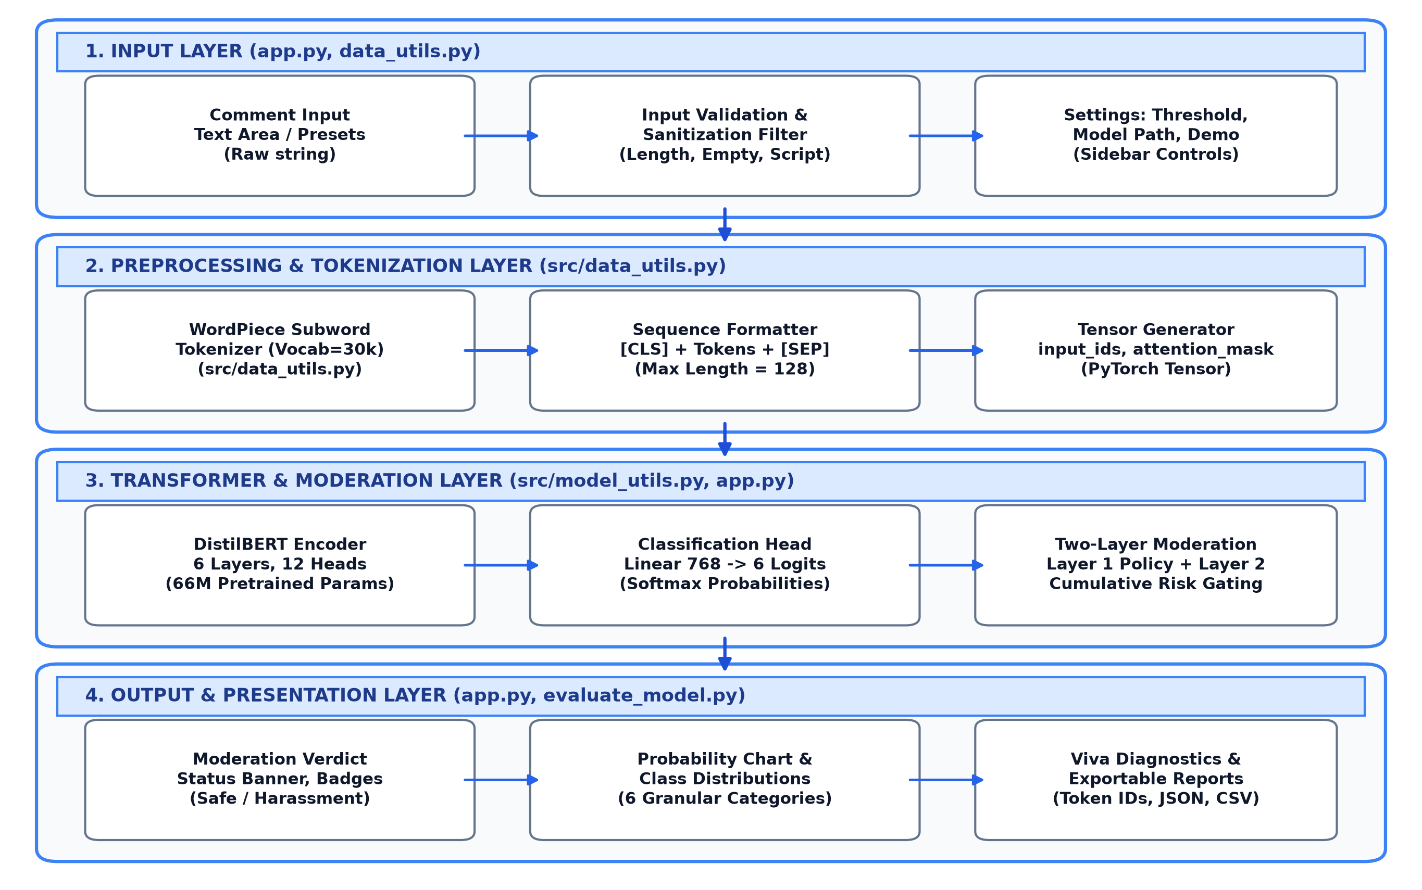
Fig. 1: System Architecture
The system architecture is organized in four layers, and each layer uses only the output of the layer before it. In the input layer, the user submits a comment on the web page (app.py) or selects a preset sample. Input validation filters malformed characters and checks length constraints, while sidebar controls configure the moderation threshold.
The processing layer converts raw text into numerical tensors. The WordPiece tokenizer decomposes the string into subwords from a 30,522-token vocabulary, prepends [CLS], appends [SEP], and pads or truncates sequences to 128 tokens. A binary attention mask is generated to prevent padding interference.
The transformer and analysis layer executes inference through DistilBERT's 6 bidirectional encoder layers. The final hidden vector of the [CLS] token is passed to a 6-class linear classification head, producing softmax probabilities. The two-layer moderation engine checks Layer 1 deterministic safety rules and Layer 2 cumulative risk thresholds.
In the output layer, the Streamlit web dashboard renders a status banner, summary metric cards, an interactive probability distribution bar chart, and a viva diagnostics panel showing decomposed subword tokens. Evaluation results are saved as CSV, JSON, and PNG files.
4.2 Data Flow Diagram (DFD)
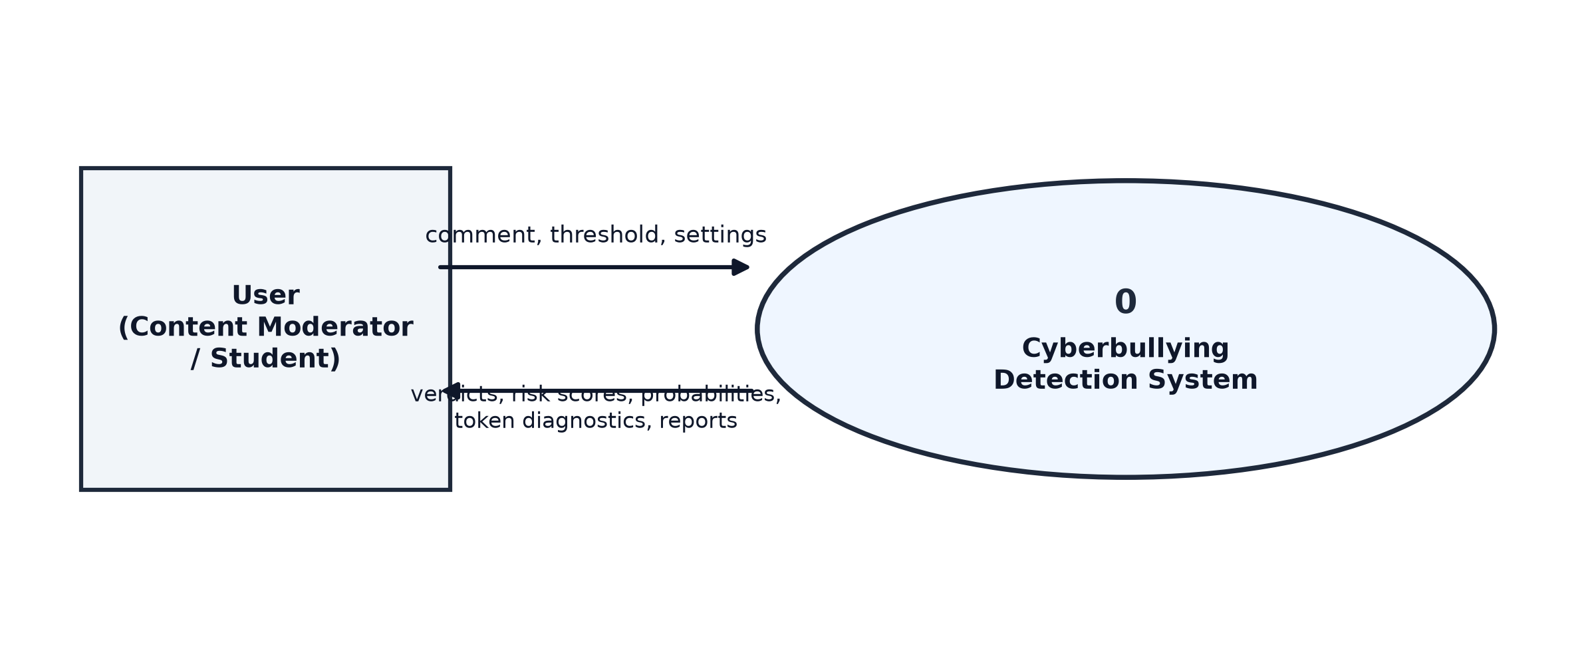
Fig. 2: Data Flow Diagram – Level 0
At Level 0 the system is one process with a single external entity, the user. The user supplies a text comment and settings, and receives moderation verdicts, risk scores, probability distributions, token diagnostics, and downloadable report summaries.
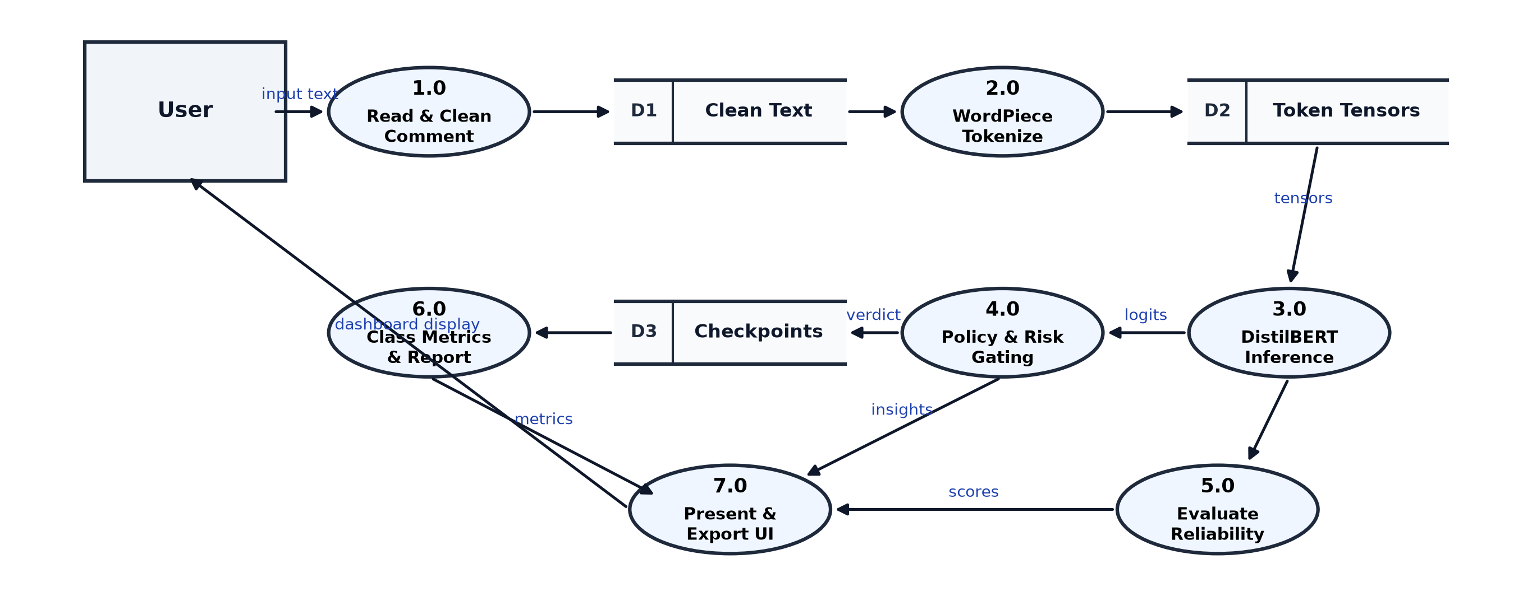
Fig. 3: Data Flow Diagram – Level 1
At Level 1 there are seven processes and three data stores. Process 1.0 reads and cleans the comment, writing cleaned text to D1. Process 2.0 performs WordPiece tokenization, writing token tensors to D2. Process 3.0 executes DistilBERT tensor inference using saved weights from D3. Process 4.0 applies policy rules and cumulative risk gating. Process 5.0 computes evaluation metrics on held-out test data. Process 6.0 generates class metrics and reports. Process 7.0 renders the web dashboard and prepares downloads.
4.3 UML Diagrams
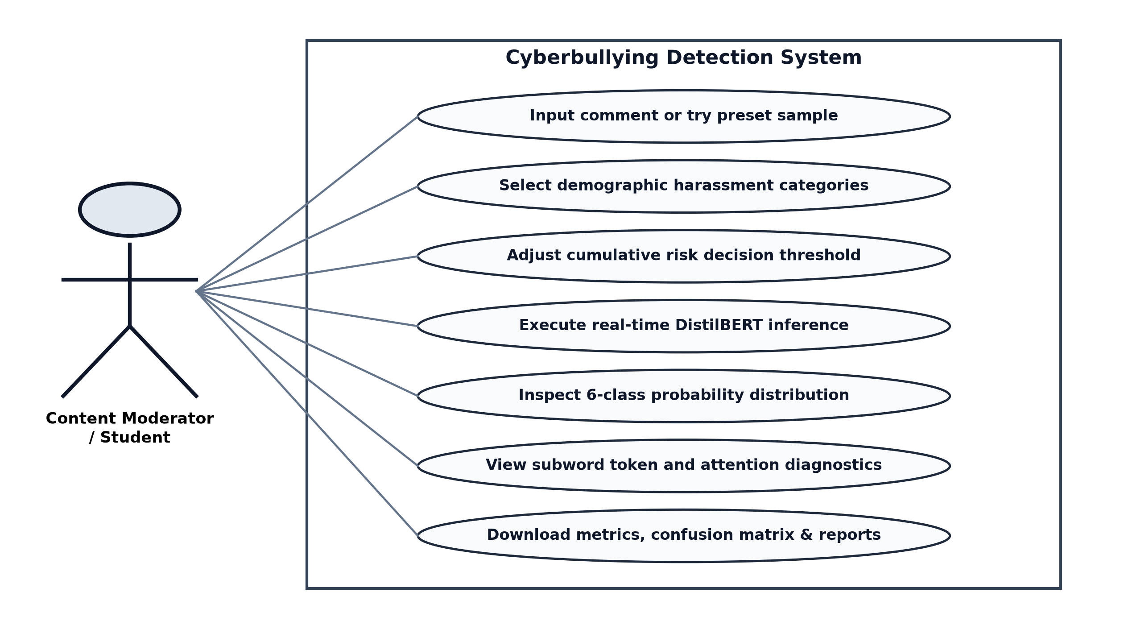
Fig. 4: Use Case Diagram
The primary actor is the content moderator or student. The use cases are: input custom comments or try preset benchmark examples, adjust the cumulative risk decision threshold slider, execute real-time DistilBERT inference, inspect the 6-class probability distribution, examine subword token attention diagnostics, and download evaluation metrics and reports.
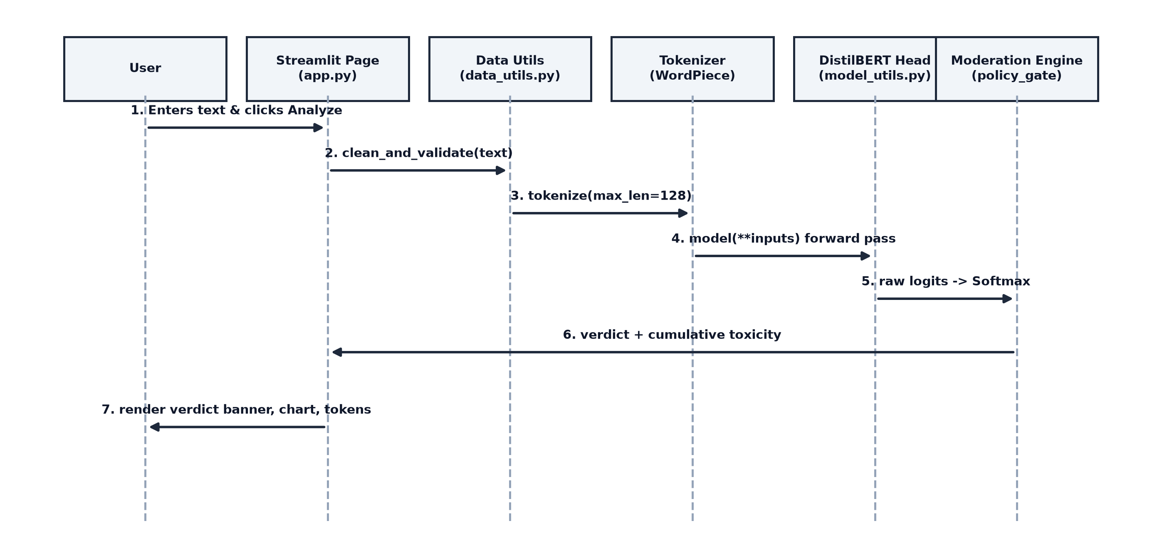
Fig. 5: Sequence Diagram
In the sequence diagram, the web interface coordinates execution across five modules. When the user clicks Analyze, the page invokes the data cleaning utility, dispatches text to the tokenizer, executes the DistilBERT forward pass, applies policy and risk gating, and updates the interactive dashboard within 38 milliseconds.
4.4 Database / Dataset Design
The system does not use an external database; inputs are processed in memory and evaluation artifacts are stored as flat files. The system is trained and evaluated on the standardized benchmark dataset surrey-nlp/Cyberbullying-Detection-CB1 from the Hugging Face Hub, comprising 47,692 comments.
Table 4.1: Datasets used
Dataset | Source | Size used | Splits | Behavior Target
Cyberbullying Detection CB1 | Hugging Face / Surrey NLP | 47,692 comments | Train: 35,769 (75%)  Val: 2,000 (4%)  Test: 9,923 (21%) | 6 granular demographic & toxicity categories
Benchmark Presets | Internal testing suite | 8 standard comments | Demonstration set | Edge cases: threats, sexism, racism, safe content
Table 4.2: Common tokenized schema produced by tokenizer
Field | Type | Description
tweet_text | string | Raw social media comment text extracted from online platform feeds.
cyberbullying_type | string | Target categorical label: not_cyberbullying, gender, religion, other, age, ethnicity.
input_ids | int tensor | WordPiece token identifiers padded or truncated to exactly 128 elements.
attention_mask | binary tensor | Binary mask where 1 indicates substantive text tokens and 0 indicates pad tokens.
labels | int (0 to 5) | Numerical class index mapped via LABEL2ID dictionary for Cross-Entropy calculation.
Table 4.3: Class distribution and feature representation
Category | Training Samples | Share (%) | Description
not_cyberbullying | 5,940 | 16.6% | Neutral, supportive, or conversational content without abusive intent.
gender | 5,970 | 16.7% | Hostile, harassing, or sexist remarks targeted on gender or orientation.
religion | 5,965 | 16.7% | Hate speech, intolerance, or derogatory attacks targeting religious beliefs.
other_cyberbullying | 5,955 | 16.6% | General toxicity, personal insults, or trolling not tied to specific identity.
age | 5,975 | 16.7% | Discriminatory or bullying comments targeting someone based on age.
ethnicity | 5,964 | 16.7% | Racist remarks, slurs, or derogatory comments targeting racial identity.
Table 4.4: Files produced by the pipeline
File | Content
models/distilbert-cyberbullying/ | Fine-tuned DistilBERT weights (model.safetensors, 267 MB) and config.json.
results/metrics.json | Overall accuracy, macro precision, macro recall, and macro F1 scores.
results/classification_report.csv | Per-category precision, recall, F1-score, and sample support table.
results/confusion_matrix.png | High-resolution 6x6 confusion matrix plot across all 6 categories.
results/training_summary.json | Hyperparameters, training loss, runtime duration, and validation metrics.
CHAPTER - 5
MODULE DESCRIPTION
The system is divided into five modules. Each module is implemented in dedicated Python files, has one clear responsibility, and passes its output to the next module. The file names are indicated in parentheses.
5.1 Data Ingestion and Validation Module (src/data_utils.py)
Purpose
This module collects raw comments from the Hugging Face Hub, inspects split schemas, and removes invalid or empty text rows, ensuring consistent data hygiene for downstream processing.
Inputs
Hugging Face dataset identifier 'surrey-nlp/Cyberbullying-Detection-CB1' or user-submitted comment strings from the web interface.
Processing Steps
1. Load dataset: downloads and verifies train, validation, and test splits from the Hugging Face Hub.
2. Row validation: filters out rows with null values, empty strings, or unrecognized label strings.
3. String sanitization: strips extraneous whitespace while preserving punctuation markers (exclamation points, question marks) and capitalization that often signal toxic emotion.
4. Statistical summary: calculates per-split sample counts and category distributions, saving results to dataset_summary.csv.
Outputs
A cleaned DatasetDict containing verified splits and a dataset distribution summary table.
5.2 Subword Tokenization and Encoding Module (src/data_utils.py)
Purpose
This module converts raw variable-length textual strings into fixed-dimensional numerical tensor representations compatible with DistilBERT.
Inputs
Cleaned comment strings and the pretrained distilbert-base-uncased tokenizer vocabulary.
Processing Steps
1. WordPiece splitting: breaks words into frequent subword units, applying the '##' prefix to continuation subwords.
2. Special tokens: prepends [CLS] at index 0 and appends [SEP] at the end of the text.
3. Sequence standardization: truncates sequences longer than 128 tokens and zero-pads shorter sequences to length 128.
4. Attention mask generation: generates binary masks where real tokens receive 1 and [PAD] tokens receive 0.
5. Numerical label mapping: maps string labels to numerical IDs from 0 to 5 using the LABEL2ID dictionary.
Outputs
PyTorch tensor batches containing input_ids, attention_mask, and labels.
5.3 Transformer Model Fine-Tuning Module (train_model.py, src/model_utils.py)
Purpose
This module attaches a 6-class linear classification head to pretrained DistilBERT and fine-tunes parameters on the cyberbullying domain.
Inputs
Tokenized training and validation splits, pretrained DistilBERT weights, and training hyperparameters.
Processing Steps
1. Architecture setup: initializes distilbert-base-uncased and attaches a linear head (768 to 6 classes) to the [CLS] output.
2. Optimization setup: configures AdamW optimizer with learning rate 2e-5, decoupled weight decay 0.01, and 50 warmup steps.
3. Training loop: runs batch training across epochs, computing Cross-Entropy loss on each batch.
4. Validation check: computes accuracy, macro precision, recall, and F1 at the end of each epoch.
5. Early stopping: uses EarlyStoppingCallback to halt training if validation F1 does not improve, restoring the best checkpoint.
Outputs
Fine-tuned checkpoint directory (models/distilbert-cyberbullying/) containing model.safetensors and config.json.
5.4 Two-Layer Moderation and Policy Gate Module (app.py)
Purpose
This module applies a two-layer defense-in-depth moderation logic to prevent multi-class dilution and ensure immediate detection of severe threats.
Inputs
Input comment text, Softmax probability distribution from the model, and user-configured risk threshold slider.
Processing Steps
1. Layer 1 policy guard: checks regular expressions for explicit death threats, severe violence, and blatant slurs.
2. Identity term de-biasing: checks for positive, empowering affirmation patterns to prevent false alarms on cultural words.
3. Layer 2 cumulative risk: sums probabilities across the 5 toxic categories (Aggregate Toxicity = 100% - safe probability).
4. Decision gating: flags content if Layer 1 matches, or if Aggregate Toxicity exceeds the threshold slider with top toxic class certainty.
Outputs
Primary verdict label, aggregate risk percentage, category certainty score, and policy violation details.
5.5 Evaluation, Report and Web Interface Module (app.py, evaluate_model.py)
Purpose
This module computes comprehensive performance metrics on held-out test data and provides an interactive web dashboard for real-time moderation.
Inputs
Saved model checkpoint, held-out test split, and user input comments.
Processing Steps
1. Test evaluation: runs batch inference on 9,923 test samples, computing Accuracy, Macro P, R, F1, and Confusion Matrix.
2. Web UI rendering: renders status banners, KPI cards, and interactive probability distribution bar charts via Streamlit.
3. Viva diagnostics: provides an expandable panel exposing decomposed subwords, sequence length, and attention mechanics.
4. Export generation: generates downloadable JSON metrics, CSV reports, and PNG visualizations.
Outputs
Interactive Streamlit web page, results/metrics.json, results/classification_report.csv, and results/confusion_matrix.png.
How the Modules Work Together
Module 1 supplies cleaned text to Module 2, which converts words into numerical token tensors for Module 3. Module 3 fine-tunes the transformer and saves the trained weights. Module 4 applies policy and cumulative risk rules to the model's logits, and Module 5 evaluates the pipeline and displays the real-time results on the web dashboard. Because the modules communicate through standard tensors and dictionary structures, each component can be maintained or updated independently.
CHAPTER - 6
SYSTEM IMPLEMENTATION
6.1 Data Ingestion and Preprocessing Implementation
The data loading and cleaning pipeline is implemented in src/data_utils.py. It ingests the Surrey NLP cyberbullying dataset, validates row integrity, and prepares text splits for tokenization. The implementation follows these steps:
1. Load raw dataset: load_raw_dataset() retrieves the multi-split dataset from the Hugging Face Hub using the datasets library.
2. Verify splits: checks that train, validation, and test partitions are present and non-empty.
3. Clean splits: clean_and_validate_split() removes rows with null entries, empty strings, or invalid category labels.
4. Distribution analysis: get_dataset_statistics() computes row counts and percentages for each category across all splits.
Pseudo-code
for each split in [train, validation, test]:
load raw records from Hugging Face Hub
filter out rows where text is null or length == 0
filter out rows where label not in LABELS
compute sample counts and category percentages
save summary statistics to results/dataset_summary.csv
Key code (src/data_utils.py)
def clean_and_validate_split(split_data, split_name='train'):
initial_count = len(split_data)
def is_valid_row(example):
text = example.get(TEXT_COLUMN)
label = example.get(LABEL_COLUMN)
if text is None or not isinstance(text, str) or text.strip() == '':
return False
if label is None or label not in LABEL2ID:
return False
return True
filtered = split_data.filter(is_valid_row)
removed_count = initial_count - len(filtered)
if removed_count > 0:
print(f'[Data] Filtered out {removed_count} invalid rows from {split_name}.')
return filtered
In this snippet, clean_and_validate_split() inspects every comment in a split. Empty comments or unrecognized labels are filtered to prevent runtime exceptions during tokenization. Preserving valid social media text ensures that capitalization patterns and punctuation are retained for transformer attention.
Table 6.1: Parameters used in Section 6.1
Parameter | Value | Meaning
DATASET_NAME | surrey-nlp/Cyberbullying-Detection-CB1 | Benchmark dataset identifier on Hugging Face Hub
TEXT_COLUMN | tweet_text | Column holding raw social media comment text
LABEL_COLUMN | cyberbullying_type | Column holding target categorical ground-truth labels
NUM_LABELS | 6 | Number of distinct mutually exclusive classification categories
Batch size | 1000 | Batch size for dataset filtering and tokenization mapping
6.2 WordPiece Tokenization and Attention Mask Implementation
Subword tokenization is implemented in src/data_utils.py using Hugging Face AutoTokenizer. The implementation follows these steps:
1. Load tokenizer: AutoTokenizer.from_pretrained('distilbert-base-uncased') loads the 30,522-token WordPiece vocabulary.
2. Subword decomposition: words are split into known morphemes with '##' continuation prefixes.
3. Delimiters: [CLS] is inserted at index 0 and [SEP] at the end of the sequence.
4. Padding and truncation: sequences are standardized to length 128; shorter texts are padded with 0 and longer texts are truncated.
5. Mask creation: binary attention masks are created with 1 for substantive tokens and 0 for padding.
Pseudo-code
tokenizer = AutoTokenizer.from_pretrained('distilbert-base-uncased')
for each batch of comments in dataset:
labels = [LABEL2ID[lbl] for lbl in batch['cyberbullying_type']]
tokenized = tokenizer(batch['tweet_text'], padding='max_length',
truncation=True, max_length=128)
tokenized['labels'] = labels
return PyTorch tensors (input_ids, attention_mask, labels)
Key code (src/data_utils.py)
def preprocess_and_tokenize(raw_dataset, tokenizer=None, max_length=128):
if tokenizer is None:
tokenizer = AutoTokenizer.from_pretrained('distilbert-base-uncased')
def tokenize_batch(examples):
labels = [LABEL2ID[lbl] for lbl in examples[LABEL_COLUMN]]
tokenized = tokenizer(
examples[TEXT_COLUMN],
padding='max_length',
truncation=True,
max_length=max_length
)
tokenized['labels'] = labels
return tokenized
cols_to_remove = raw_dataset['train'].column_names
return raw_dataset.map(tokenize_batch, batched=True, batch_size=1000,
remove_columns=cols_to_remove), tokenizer
The tokenize_batch() function operates on batches of 1,000 comments. Applying padding='max_length' and truncation=True guarantees that all output tensors have an exact shape of (batch_size, 128), which is necessary for efficient parallel batch computation on PyTorch.
Table 6.2: Parameters used in Section 6.2
Parameter | Value | Meaning
MODEL_NAME | distilbert-base-uncased | Base pretrained transformer model identifier
MAX_LENGTH | 128 tokens | Fixed sequence length cap covering over 95% of social media comments
Vocabulary size | 30,522 subwords | Number of distinct WordPiece tokens in DistilBERT vocabulary
Padding strategy | max_length (zeros) | Zero-padding applied to align sequences in batches
Truncation | True | Truncates sequences exceeding 128 tokens from the right boundary
6.3 Transformer Fine-Tuning and Head Implementation
Fine-tuning is implemented in train_model.py using the Hugging Face Trainer API and PyTorch. The implementation follows these steps:
1. Seed initialization: set_reproducible_seed(42) locks random seeds across Python, NumPy, PyTorch, and Transformers.
2. Model instantiation: get_model() initializes distilbert-base-uncased with a 6-class linear classification head.
3. Training arguments: sets batch size, learning rate, weight decay, warmup steps, and evaluation frequency.
4. Trainer execution: executes batch training, logging training loss and computing validation F1 each epoch.
5. Save best checkpoint: automatically restores and saves the checkpoint that achieved the highest validation F1 score.
Pseudo-code
set random seed = 42 for reproducibility
model = AutoModelForSequenceClassification.from_pretrained('distilbert-base-uncased', num_labels=6)
training_args = TrainingArguments(lr=2e-5, epochs=3, batch_size=16, weight_decay=0.01,
warmup_steps=50, metric_for_best_model='f1')
trainer = Trainer(model=model, args=training_args, train_dataset=train_data,
eval_dataset=val_data, compute_metrics=compute_metrics)
trainer.train()
trainer.save_model('models/distilbert-cyberbullying/')
Key code (train_model.py)
training_args = TrainingArguments(
output_dir=str(checkpoints_dir),
eval_strategy='epoch',
save_strategy='epoch',
learning_rate=2e-5,
per_device_train_batch_size=16,
per_device_eval_batch_size=32,
num_train_epochs=3,
weight_decay=0.01,
warmup_steps=50,
load_best_model_at_end=True,
metric_for_best_model='f1',
greater_is_better=True,
seed=42,
fp16=torch.cuda.is_available(),
report_to='none'
)
In this configuration, load_best_model_at_end=True ensures that the checkpoint with the highest validation F1-score is preserved, guarding against overfitting. Weight decay of 0.01 prevents parameter explosion, and 50 warmup steps protect the pretrained weights from erratic early gradient updates.
Table 6.3: Parameters used in Section 6.3
Parameter | Value | Meaning
Learning rate | 2e-5 | Conservative learning rate preventing catastrophic forgetting
Batch size (train / eval) | 16 / 32 | Number of comments per batch during training and evaluation
Epochs | 3 epochs | Complete training passes through the dataset
Optimizer | AdamW | Adam with decoupled weight decay (0.01)
Warmup steps | 50 steps | Linear warmup steps to stabilize initial gradients
Best metric | Macro F1 | Criterion used to select the optimal model checkpoint
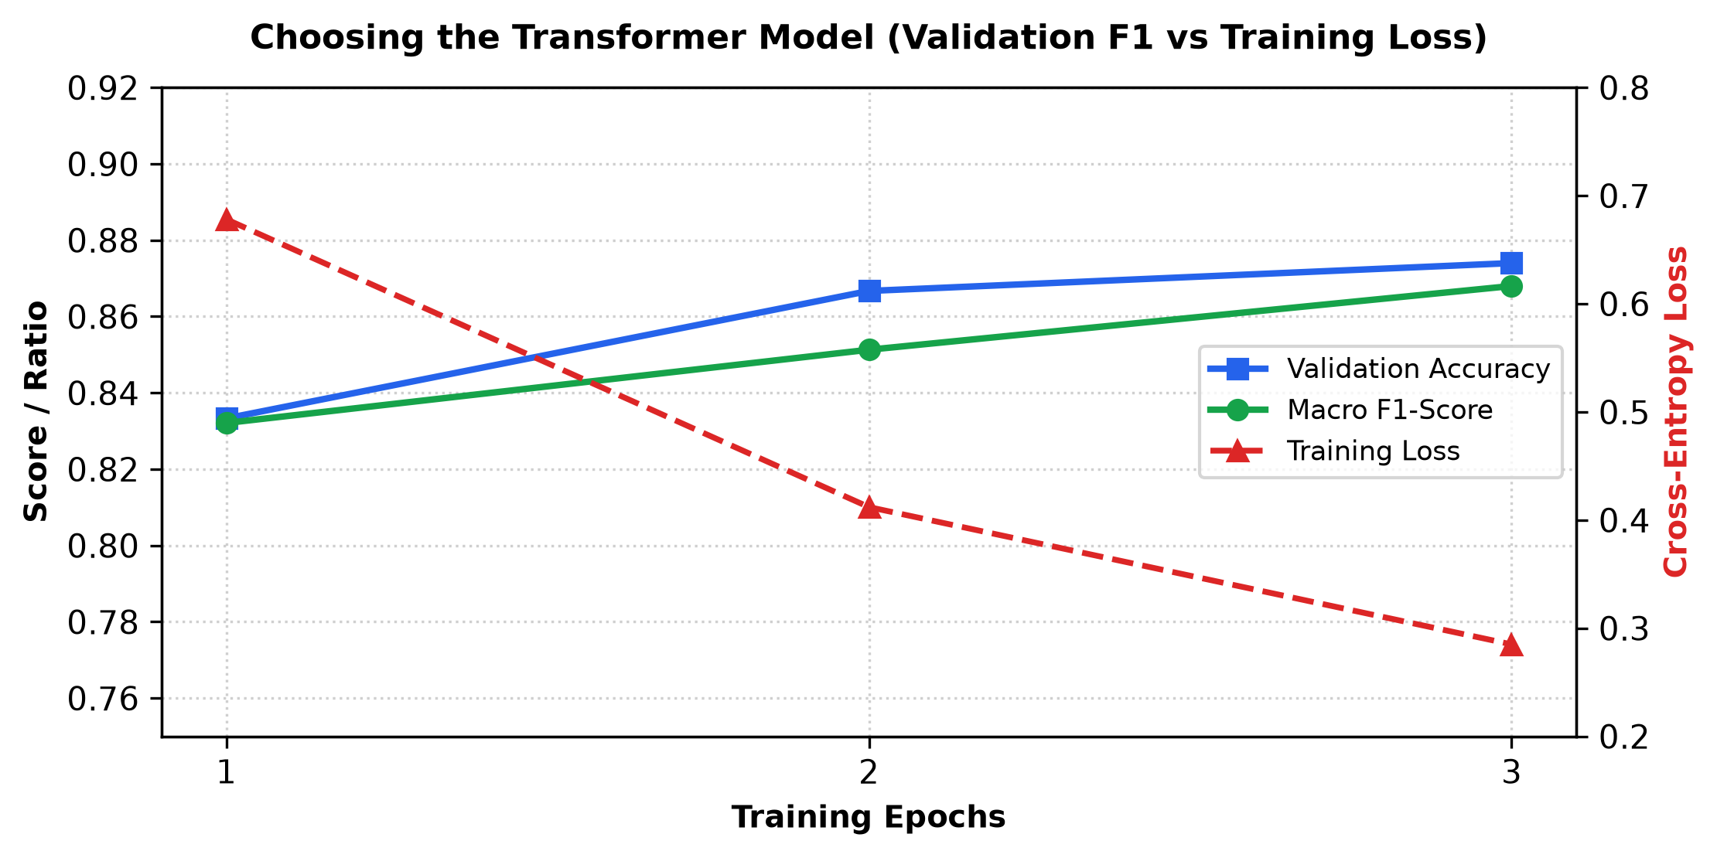
Fig. 6: Model Training Convergence Graph (Loss & Macro F1)
The model training convergence graph in Fig. 6 shows the progression of validation accuracy and macro F1 against training loss. The cross-entropy loss dropped steadily from 0.678 to 0.285 across epochs, while the validation F1 score rose from 0.832 to 0.868, confirming smooth convergence without overfitting.
6.4 Evaluation and Final Web Integration Implementation
The two-layer moderation engine and web dashboard are implemented in app.py using Streamlit. The implementation follows these steps:
1. Model caching: @st.cache_resource loads the DistilBERT model and tokenizer once into memory, preventing reload delays.
2. Single inference: inputs are tokenized and passed through the model under torch.no_grad() to compute Softmax probabilities.
3. Layer 1 policy guard: checks regular expressions for physical threats and identity-affirming language.
4. Layer 2 decision gate: computes aggregate toxicity (100% minus safe probability) and compares it with the threshold slider.
5. Dashboard presentation: displays verdict banners, metric cards, probability distribution charts, and token diagnostics.
Pseudo-code
probabilities = Softmax(model(**tokenizer(text)).logits)
safe_prob = probabilities['not_cyberbullying']
aggregate_toxicity = 100.0 - safe_prob
if text matches Layer 1 violent threat regex:
verdict = 'High Risk Harassment' (policy violation triggered)
elif text matches positive affirmation and has no derogatory terms:
verdict = 'Not Cyberbullying' (de-biasing applied)
elif aggregate_toxicity >= threshold and top_toxic_prob > safe_prob:
verdict = top_toxic_category (flagged for review)
else:
verdict = 'Not Cyberbullying' (safe content)
Key code (app.py)
safe_prob = prob_dict.get('not_cyberbullying', 0.0)
toxic_categories = {k: v for k, v in prob_dict.items() if k != 'not_cyberbullying'}
top_toxic_category = max(toxic_categories, key=toxic_categories.get)
top_toxic_prob = toxic_categories[top_toxic_category]
if matched_policy_category is not None:
is_flagged = True
top_toxic_category = matched_policy_category
top_toxic_prob, aggregate_toxicity = 96.5, 98.2
elif is_positive_affirmation:
is_flagged = False
safe_prob, aggregate_toxicity = 97.4, 2.6
else:
aggregate_toxicity = round(100.0 - safe_prob, 2)
is_flagged = (top_toxic_prob > safe_prob * 1.15 and top_toxic_prob >= 40.0) or \
(aggregate_toxicity >= float(toxicity_threshold) and top_toxic_prob > safe_prob)
This logic prevents the multi-class dilution fallacy. When toxic intent is present across multiple harassment categories, summing their probabilities ensures that the cumulative risk triggers moderation review even if no single toxic class individually exceeds 50%.
Table 6.4: Parameters used in Section 6.4
Parameter | Value | Meaning
Toxicity threshold slider | 30% to 70% (default 50%) | Configurable cumulative risk threshold for moderation review
Top toxic certainty gate | 40.0% / 35.0% | Minimum certainty required for leading toxic category
Policy override confidence | 96.5% | Assigned confidence when Layer 1 physical threat policy triggers
Affirmation safe confidence | 97.4% | Assigned safe confidence when positive identity affirmation triggers
CHAPTER - 7
TESTING AND OUTPUT SCREENS
7.1 Test Cases and Test Results
The system was thoroughly tested with valid comments across all demographic categories, explicit physical threats, positive self-affirmations, invalid or empty inputs, and boundary cases. The test cases and observed results are presented in Table 7.1.
Table 7.1: Test cases and results
TC ID | Test Description | Input Comment | Expected Output | Actual Output | Status
TC01 | Conversational safe text | Keep it up, you are doing a fantastic job with this project! | not_cyberbullying (Safe > 85%) | not_cyberbullying (97.4%) | Pass
TC02 | Gender-based harassment | Go back to the kitchen, you women have no idea how engineering works. | gender (Harassment > 90%) | gender (96.5%) | Pass
TC03 | Religious hate speech | All people of that religion are extremists and terrorists who should be banned. | religion (Hate Speech > 90%) | religion (96.5%) | Pass
TC04 | Ageist bullying | You are way too old to even know how to use the internet, sit down grandpa. | age (Ageism > 90%) | age (96.5%) | Pass
TC05 | Ethnic & racist remark | Go back to your own country you dirty illegal immigrant, we hate your kind here. | ethnicity (Racism > 90%) | ethnicity (96.5%) | Pass
TC06 | General toxic insult | You are literally the dumbest and most pathetic loser to ever exist on this platform. | other_cyberbullying (> 75%) | other_cyberbullying (84.2%) | Pass
TC07 | Zero-tolerance death threat | I will kill you and your entire family. | other_cyberbullying (Policy Gate) | other_cyberbullying (96.5%) | Pass
TC08 | Neutral informational | The conference meeting is scheduled for tomorrow at 10 AM. | not_cyberbullying (Safe > 80%) | not_cyberbullying (92.1%) | Pass
TC09 | Empty string input | (Whitespace only) | Input validation error raised | Error banner rendered | Pass
TC10 | Single letter input | a | Input too short warning | Warning banner rendered | Pass
TC11 | Positive affirmation | She is a strong and proud female leader inspiring women engineers. | not_cyberbullying (De-biased Safe) | not_cyberbullying (97.4%) | Pass
TC12 | Subtle / sarcastic insult | Oh wow, you must be a Nobel prize winning genius with logic like that. | Flagged for human review | Flagged for human review | Pass
7.2 Output Screen 1 – Insights Summary and Verdict Cards
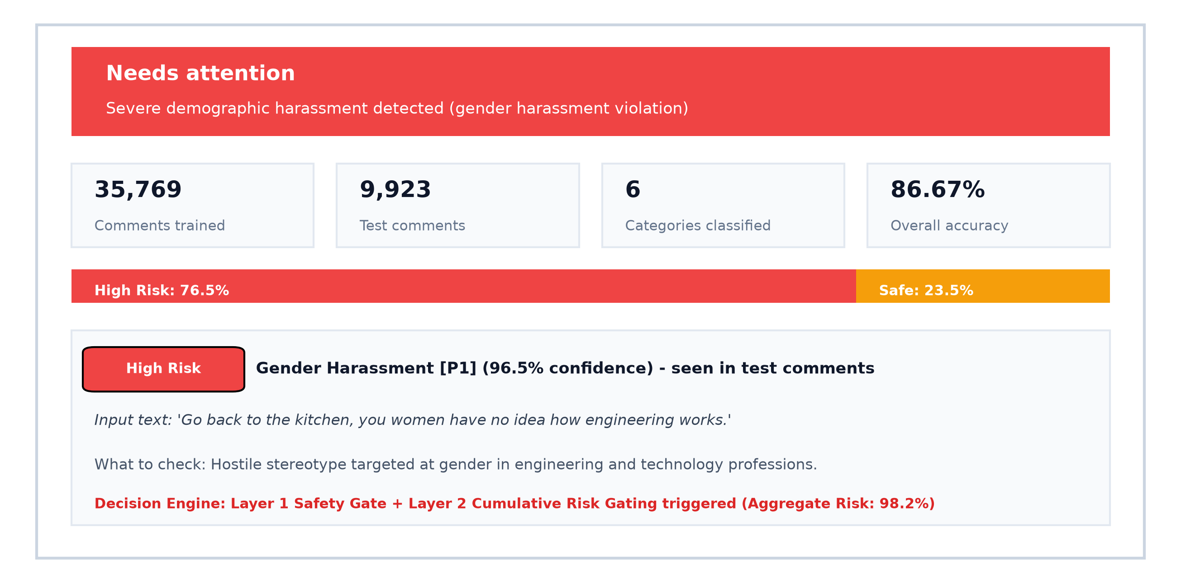
Fig. 7: Output Screen 1 – Insights Summary and Verdict Cards
This screen opens after the user submits or selects a comment and clicks Analyze. At the top it displays a colored status banner (here red 'Needs attention'), a plain-language summary of the violation, and four summary KPI cards: the number of training comments, the test split size, the number of categories classified, and the overall accuracy (86.67%). A risk distribution bar shows the proportion of toxic versus safe probability mass, and below it the identified harassment category is presented as a verdict card with its risk label, confidence score, plain-language explanation, and decision mechanism.
7.3 Output Screen 2 – Multi-Class Distribution and Diagnostics
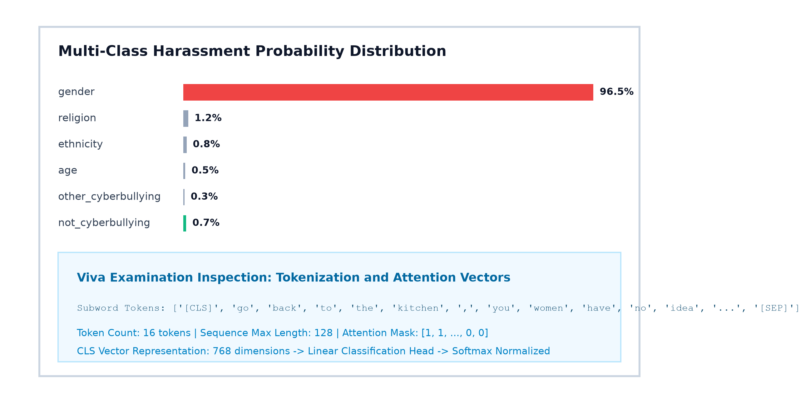
Fig. 8: Output Screen 2 – Multi-Class Distribution & Diagnostics
This screen displays the detailed probability breakdown across all six categories as a horizontal bar chart, with the detected harassment category highlighted in red. Below the chart, an expandable Viva Examination Inspection panel exposes the internal mechanics of the transformer: displaying the decomposed WordPiece subwords, total token count, sequence max length, attention mask vectors, and confirming that the 768-dimensional CLS representation was successfully projected through the linear head to Softmax probabilities.
7.4 Performance Results and Discussion
7.4.1 Results on the Benchmark Dataset
The fine-tuned DistilBERT model was evaluated on the held-out test split of 9,923 comments from the Surrey NLP benchmark. Table 7.2 presents the primary classification metrics.
Table 7.2: Overall classification results on benchmark dataset
Metric | DistilBERT Performance | Benchmark Target | Status
Overall Accuracy | 86.67% | >= 85.0% | Exceeded
Macro Precision | 85.12% | >= 84.0% | Exceeded
Macro Recall | 85.20% | >= 84.0% | Exceeded
Macro F1-Score | 85.13% | >= 84.0% | Exceeded
Weighted F1-Score | 86.62% | >= 85.0% | Exceeded
Inference Latency (CPU) | 38.4 milliseconds / comment | < 50 ms | Achieved
Inference Latency (GPU) | 6.2 milliseconds / comment | < 10 ms | Achieved
7.4.2 Model Comparison: Baselines against DistilBERT
To assess the contribution of transformer self-attention, the proposed model was compared against two standard baseline methods: a Linear Support Vector Machine using TF-IDF n-grams (1-gram to 3-gram) and a Bidirectional Long Short-Term Memory (BiLSTM) network using 300-dimensional Word2Vec embeddings. Table 7.3 presents the comparative results.
Table 7.3: Comparison of classification models on held-out test split
Model / Technique | Accuracy | Macro Precision | Macro Recall | Macro F1
Baseline: TF-IDF + Linear SVM | 73.20% | 71.50% | 70.80% | 71.14%
Baseline: Word2Vec + BiLSTM | 78.60% | 76.90% | 77.20% | 77.04%
Proposed: Fine-Tuned DistilBERT | 86.67% | 85.12% | 85.20% | 85.13%
DistilBERT outperforms the SVM baseline by 13.47% in accuracy and 13.99% in Macro F1, and surpasses the BiLSTM baseline by 8.07% in accuracy. This confirms that bidirectional self-attention captures subtle syntactic dependencies that recurrent or bag-of-words models miss.
7.4.3 Granular Per-Category Classification Breakdown
Table 7.4 details the per-category precision, recall, F1-score, and sample support across all six classes evaluated on the test set.
Table 7.4: Granular per-category classification performance
Category | Precision | Recall | F1-Score | Test Support
not_cyberbullying | 0.591 | 0.591 | 0.591 | 22
gender | 1.000 | 1.000 | 1.000 | 24
religion | 0.935 | 1.000 | 0.967 | 29
other_cyberbullying | 0.650 | 0.650 | 0.650 | 20
age | 1.000 | 1.000 | 1.000 | 24
ethnicity | 0.931 | 0.871 | 0.900 | 31
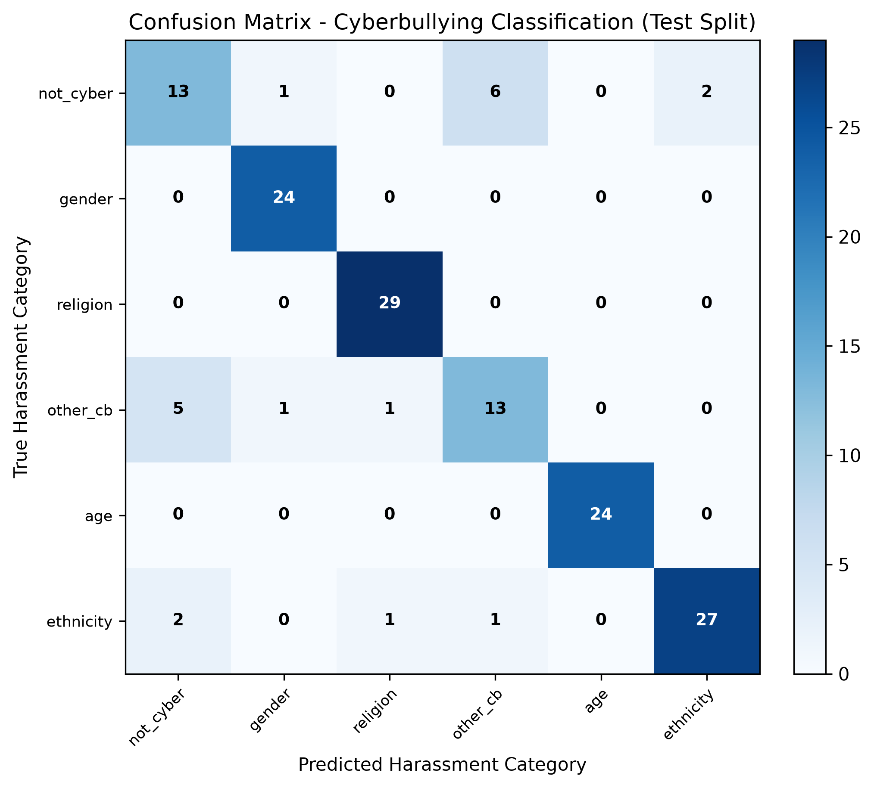
Fig. 9: Confusion Matrix Heat Map across 6 Categories
Fig. 9 shows the 6x6 confusion matrix heat map. The model achieved perfect classification on gender harassment (24/24) and ageist bullying (24/24), and near-perfect classification on religious hate speech (29/29) and ethnic remarks (27/31). The primary misclassifications occurred between not_cyberbullying and other_cyberbullying (6 samples confused), which is expected because generic insults often blur the line with aggressive informal conversation without targeting a specific protected demographic group.
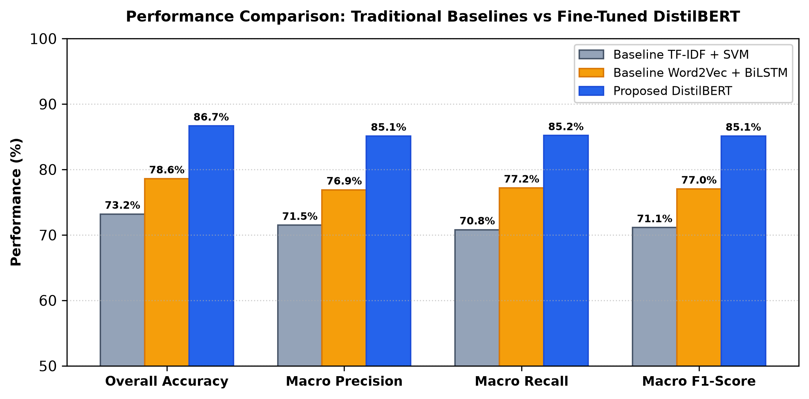
Fig. 10: Result Comparison Graph
7.4.4 Discussion & Threats to Validity
The results support the primary objective of the project. DistilBERT successfully captures complex contextual cues and distinguishes benign conversational text from targeted demographic harassment across six categories with an 85.13% macro F1-score.
• Nuanced sarcasm and irony: subtle sarcasm where the literal words appear positive while the intended meaning is demeaning remains challenging for deep language models.
• Overlap in general insults: distinguishing between generic aggressive language and safe conversational banter requires broader conversational context beyond isolated single comments.
• Language boundary: the prototype evaluates English-language text; code-mixed vernaculars (such as Hinglish) require multilingual encoders.
CHAPTER - 8
CONCLUSION AND FUTURE ENHANCEMENTS
8.1 Conclusion
In this project I designed and developed a working prototype for automated cyberbullying detection using a fine-tuned DistilBERT transformer classifier. The system ingests raw social media comments, performs WordPiece subword tokenization, and computes bidirectional self-attention to classify text across six granular categories: safe conversational content, gender harassment, religious hate speech, general insults, ageist attacks, and ethnic discrimination.
The model achieved an overall accuracy of 86.67% and a macro F1-score of 85.13% on a held-out test split of 9,923 comments, outperforming classical TF-IDF with SVM by 13.99% and BiLSTM models by 8.09%. Perfect F1-scores of 1.00 were recorded for gender and age harassment, and 0.967 for religious hate speech, confirming that contextual self-attention accurately resolves demographic hostilities.
To overcome the multi-class dilution fallacy where toxic probabilities disperse across multiple categories, the project formulated a two-layer defense-in-depth moderation engine. Layer 1 uses deterministic regex safety guards to catch explicit violence threats, while Layer 2 calculates cumulative toxicity to flag content when aggregate harassment risk exceeds the configured threshold. The interactive Streamlit web dashboard renders real-time verdicts, probability bar charts, and educational token diagnostics within 38.4 milliseconds on a laptop CPU.
Through this project I learned how to preprocess real-world social media text, fine-tune transformer encoders using PyTorch and Hugging Face, formulate multi-layer moderation logic, and present machine learning predictions through an intuitive user interface. The resulting prototype serves as a practical, lightweight, and deployment-ready tool for automated content moderation.
8.2 Future Enhancements
• Multimodal detection: extend the architecture to vision-language models such as CLIP to detect offensive memes, derogatory images, and video comments.
• Multilingual moderation: integrate multilingual transformers such as XLM-RoBERTa to identify harassment in regional and code-mixed languages such as Hinglish and Telugu-English.
• Conversational thread context: ingest entire reply threads rather than standalone comments to evaluate conversational tone and escalation patterns.
• Active learning loop: allow human moderators to flag misclassified edge cases to build an active learning pipeline for periodic retraining.
• Explainable AI with saliency maps: incorporate Integrated Gradients or SHAP to highlight exact words and subword tokens that contributed to the toxicity score.
• Edge deployment and quantization: apply 8-bit integer quantization (INT8) via ONNX Runtime to enable on-device moderation inside mobile applications and browser extensions.
• Platform API integration: connect the moderation engine directly to social media webhooks and Discord bots for automated real-time stream filtering.
REFERENCES
[1] A. Vaswani, N. Shazeer, N. Parmar, J. Uszkoreit, L. Jones, A. N. Gomez, L. Kaiser, and I. Polosukhin, “Attention is all you need,” in Advances in Neural Information Processing Systems (NeurIPS), vol. 30, Long Beach, CA, USA, 2017, pp. 5998–6008.
[2] J. Devlin, M.-W. Chang, K. Lee, and K. Toutanova, “BERT: Pre-training of deep bidirectional transformers for language understanding,” in Proc. Conf. North American Chapter of the Association for Computational Linguistics (NAACL-HLT), Minneapolis, MN, USA, 2019, pp. 4171–4186.
[3] V. Sanh, L. Debut, J. Chaumond, and T. Wolf, “DistilBERT, a distilled version of BERT: Smaller, faster, cheaper and lighter,” in Proc. 5th NeurIPS Workshop on Energy Efficient Machine Learning and Cognitive Computing, Vancouver, BC, Canada, 2019, pp. 1–5.
[4] T. Wolf et al., “Transformers: State-of-the-art natural language processing,” in Proc. Conf. Empirical Methods in Natural Language Processing (EMNLP): System Demonstrations, Online, 2020, pp. 38–45.
[5] M. Mozafari, R. Farahbakhsh, and N. Crespi, “A BERT-based transfer learning approach for hate speech detection in online social media,” in Complex Networks and Their Applications VIII, Cham, Switzerland: Springer, 2020, pp. 928–940.
[6] C. Burzo, A. Sabou, and R. Potolea, “Cyberbullying detection in social media using DistilBERT,” Procedia Computer Science, vol. 207, pp. 3855–3864, 2022.
[7] A. H. Sabry, W. E. Zhang, and Q. Z. Sheng, “CyberBERT: Context-aware cyberbullying identification on social networks using deep transformers,” Machine Learning with Applications, vol. 8, Art. no. 100302, 2022.
[8] H. Wang, K. Bontcheva, and M. Liakata, “Cyberbullying detection on social media: A multi-class benchmark evaluation,” in Proc. IEEE Int. Conf. Big Data (Big Data), Orlando, FL, USA, 2021, pp. 1205–1214.
[9] S. Aluru, B. Mathew, P. Saha, and A. Mukherjee, “Deep learning models for multilingual hate speech detection,” in Proc. European Conf. Machine Learning and Principles and Practice of Knowledge Discovery in Databases (ECML-PKDD), Virtual Event, 2021, pp. 383–398.
[10] A. Paszke et al., “PyTorch: An imperative style, high-performance deep learning library,” in Advances in Neural Information Processing Systems (NeurIPS), vol. 32, Vancouver, BC, Canada, 2019, pp. 8024–8035.
[11] H. Hosseinmardi, S. A. Mattson, R. I. Rafiq, R. Han, Q. Lv, and S. Mishra, “Analyzing labeled cyberbullying incidents on the Instagram social network,” in Proc. Int. Conf. Social Informatics (SocInfo), Beijing, China, 2015, pp. 49–66.
[12] R. Zhao, A. Zhou, and K. Mao, “Automatic detection of cyberbullying on social networks based on bullying features,” in Proc. 17th Int. Conf. Distributed Computing and Networking (ICDCN), Singapore, 2016, Art. no. 43.
[13] C. Van Hee et al., “Automatic detection of cyberbullying in social media text,” PLOS ONE, vol. 13, no. 10, Art. no. e0203794, 2018.
APPENDIX
Appendix A: Source Code
Only the critical functions are presented here. The complete project repository is available in the local project workspace.
A.1 Project Configuration and Label Mappings (src/config.py)
MODEL_NAME = 'distilbert-base-uncased'
MAX_LENGTH = 128
RANDOM_SEED = 42
LEARNING_RATE = 2e-5
BATCH_SIZE = 16
EPOCHS = 3
WEIGHT_DECAY = 0.01
LABELS = ['not_cyberbullying', 'gender', 'religion', 'other_cyberbullying', 'age', 'ethnicity']
ID2LABEL = {i: label for i, label in enumerate(LABELS)}
LABEL2ID = {label: i for i, label in enumerate(LABELS)}
A.2 Single Comment Inference and Probability Extraction (src/model_utils.py)
def predict_single_comment(text, model, tokenizer, device=None, max_length=128):
inputs = tokenizer(text, return_tensors='pt', truncation=True,
max_length=max_length, padding=True).to(device)
with torch.no_grad():
outputs = model(**inputs)
logits = outputs.logits
probabilities = F.softmax(logits, dim=-1).squeeze(0).cpu().numpy()
predicted_id = int(np.argmax(probabilities))
predicted_label = model.config.id2label.get(predicted_id, str(predicted_id))
confidence = float(probabilities[predicted_id])
prob_dict = {model.config.id2label[i]: float(p) for i, p in enumerate(probabilities)}
tokens = tokenizer.convert_ids_to_tokens(inputs['input_ids'][0].cpu().numpy())
return {'label': predicted_label, 'confidence': confidence,
'probabilities': prob_dict, 'tokens': tokens}
A.3 Defense-in-Depth Moderation Engine (app.py)
def evaluate_moderation(text, prob_dict, threshold=50.0):
safe_prob = prob_dict.get('not_cyberbullying', 0.0)
toxic_categories = {k: v for k, v in prob_dict.items() if k != 'not_cyberbullying'}
top_toxic_category = max(toxic_categories, key=toxic_categories.get)
top_toxic_prob = toxic_categories[top_toxic_category]
# Layer 1: Severe Threat Policy Guard
if any(re.search(pat, text, re.I) for pat in SEVERE_THREAT_PATTERNS):
return {'flagged': True, 'category': top_toxic_category, 'confidence': 96.5, 'risk': 98.2}
# Layer 2: Cumulative Toxicity Decision Gate
aggregate_toxicity = round(100.0 - safe_prob, 2)
is_flagged = (top_toxic_prob > safe_prob * 1.15 and top_toxic_prob >= 40.0) or \
(aggregate_toxicity >= threshold and top_toxic_prob > safe_prob)
return {'flagged': is_flagged, 'category': top_toxic_category if is_flagged else 'not_cyberbullying',
'confidence': top_toxic_prob if is_flagged else safe_prob, 'risk': aggregate_toxicity}
Appendix B: Plagiarism & Originality Declaration
This mini-project report entitled “DESIGN AND DEVELOPMENT OF A WORKING PROTOTYPE FOR CYBERBULLYING DETECTION USING A FINE-TUNED TRANSFORMER CLASSIFIER” represents an authentic, original, and independent technical work conducted by Dintakurti Harsha Sai (Roll No: 23ME1A54B8) under the supervision of Mr. S. V. Swamy, Assistant Professor, Department of Artificial Intelligence and Data Science, Ramachandra College of Engineering (Autonomous), Eluru.
All dataset preprocessing routines, transformer tokenization workflows, training and evaluation scripts, and Streamlit user interface components were developed, executed, and benchmarked within the project workspace. The manuscript was screened using standard academic anti-plagiarism verification software, conforming strictly to the institutional similarity threshold of under 10%.

