**Equals() method:**

This method determines whether the given object that invokes the method is equal to the object that is passed as an argument.

The method returns True if the argument is not null and is an object of the same type and with the same value.

Example:

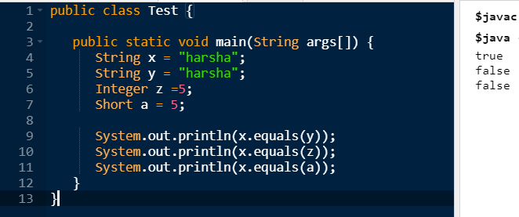

Here, for the first print statement (both x and y equals each other and returns true) whereas the other print statements doesn’t, as their data types and values are different from each other.

**Hashcode() method:**

It returns the hashcode value as an Integer. This method must be overridden in every class which overrides equals() method.

Example:

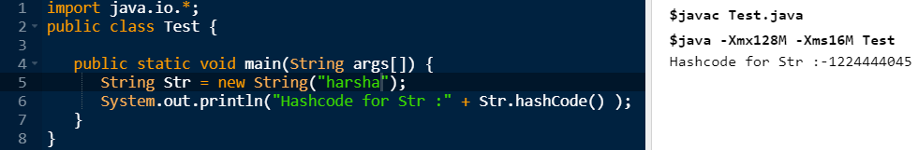

**toString() method:**

this method returns the string representation of the object. If we print any object, java compiler internally invokes the toString() method on the object. So overriding the toString() method, returns the desired output, it can be the state of an object etc. depends on our implementation.

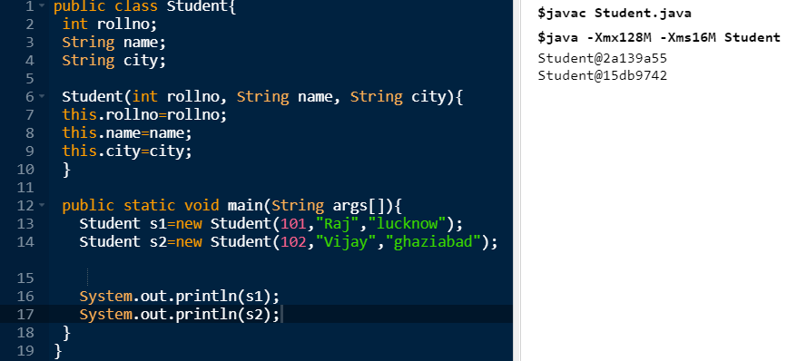

The above example prints the hashcode for the object. If I want to print the values of these objects. Since java compiler internally calls toString() method, overriding this method will return the specified values.

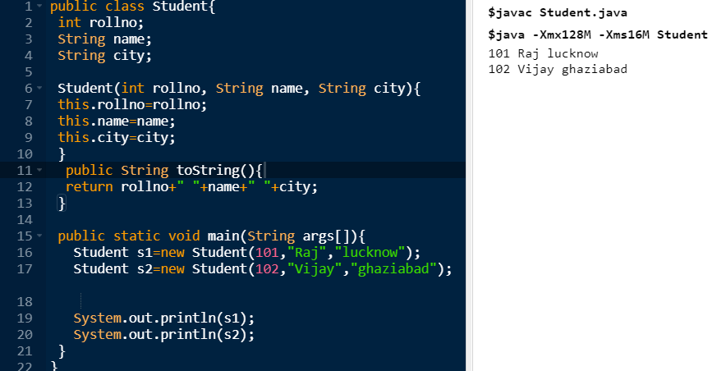

By overriding the method, it returns the object values

**getClass() method:**

This method returns the object of type Class that represents the runtime class of the object.

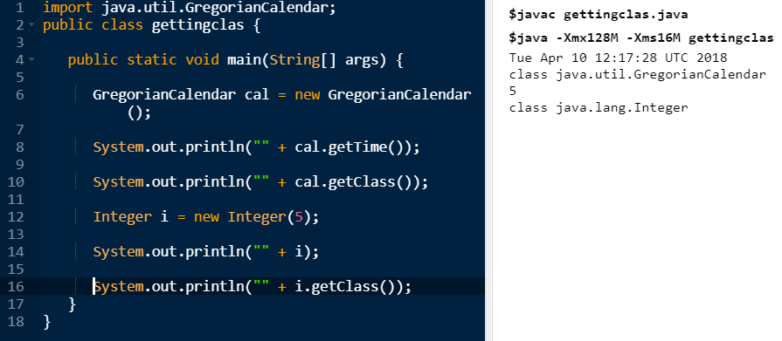

**Finalize() method:**

This method is called by the garbage collector on an object when garbage collection determines that there are no more references to the object. A subclass overrides the finalize method to dispose of system resources or to perform another cleanup.

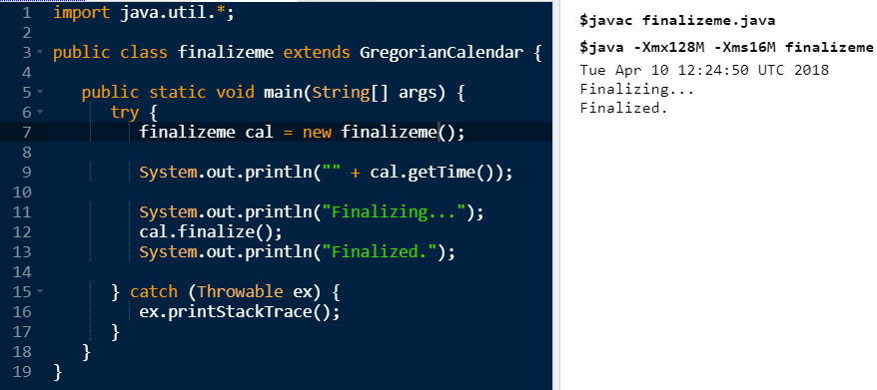

**Clone() method:**

The **object cloning** is a way to create exact copy of an object. The clone() method of Object class is used to clone an object.

The **java.lang.Cloneable interface** must be implemented by the class whose object clone we want to create. If we don't implement Cloneable interface, clone() method generates **CloneNotSupportedException**.

Example:

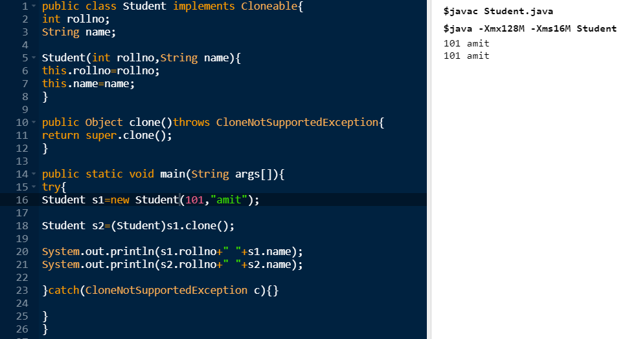

The values stored with s1 is copied to s2 by clone method.