**Introduction**

logistic regression is another strategy acquired by machine gaining from the field of measurements. It is the go-to strategy for order issues. Despite the name "logistic regression" this isn't a calculation for regression issues (where the assignment is to anticipate a genuine esteemed yield).

Logistic Regression is somewhat like Linear Regression as in both have the objective of evaluating the qualities for the parameters/coefficients, so the toward the finish of the preparation of the machine learning model we got a capacity that best portray the connection between the known information and the yield esteems.

Dissimilar to linear regression, the expectation for the yield is changed utilizing a non-linear capacity called the logistic capacity (a few varieties this name is: sigmoid capacity and logit work). I'm not heading off to the subtle elements of the math behind logistic regression as it's not compulsory to comprehend and have the capacity to apply this calculation, however it isn't so much that muddled and, in the event, that you know and comprehend linear regression you will think that it’s simple to get this one.

Considering how the model is found out, the expectations made by logistic regression can likewise be utilized as the likelihood of a given information occasion having a place with class 0 or class 1. Logistic regression measures the connection between the straight out ward variable (target class: yes/no, spam/not spam, positive/negative,… ) and at least one free factors by evaluating probabilities.

**Objectives**

* To implement the Logistic regression with new data set which is not used in class
* To show the graph in TensorBoard
* Changing the hyperparameter and comparing the result

**Approaches/Methods**

Initially, I have considered iris data for logistic regression.

1. Reading the dataset.

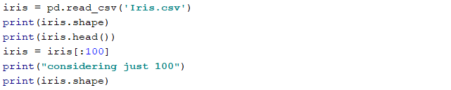

After the file is read, to do the binary classification, I’m considering the first 100 rows from the data.

Iris-setosa species is linearly distinguishable from the other two, however the other two are not linearly detachable from each other. To keep the species balance Iris-setosa and Iris-versicolor are chosen.

1. Numerical processing of the data.

Replacing Iris-setosa as 0, Iris-versicolor as 1.



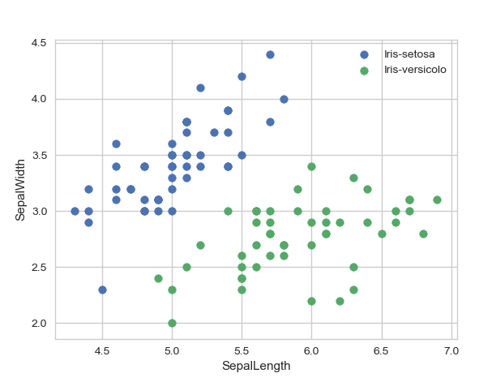

1. Splitting the data.

Training set: 80% and test set: 20%

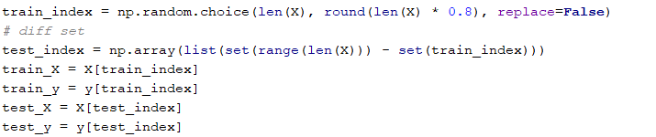

1. Normalized processing



1. Building the model for the framework.

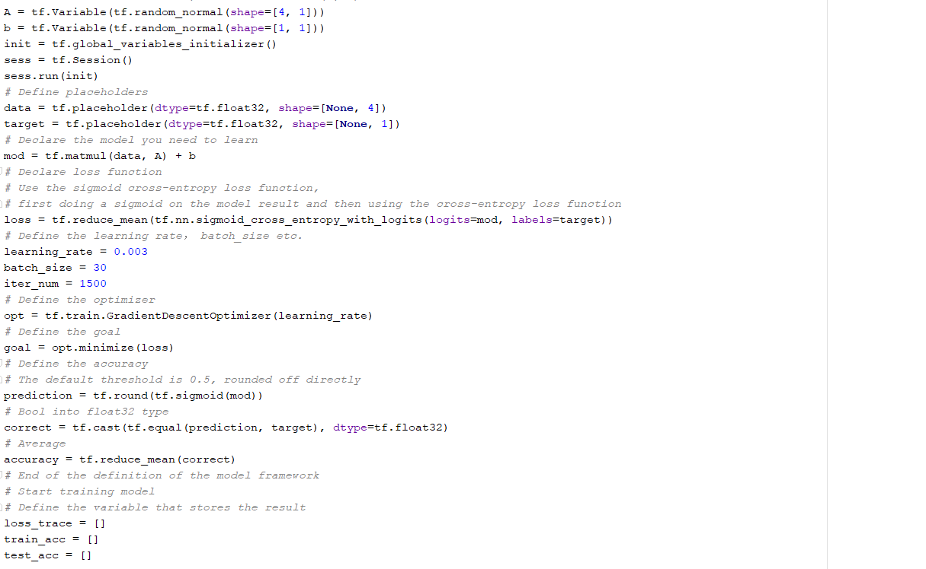

1. Training the model.

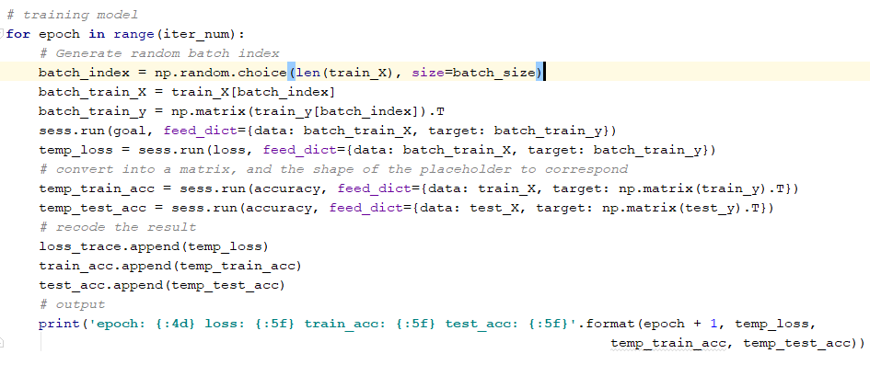

1. Visualization.

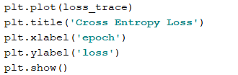

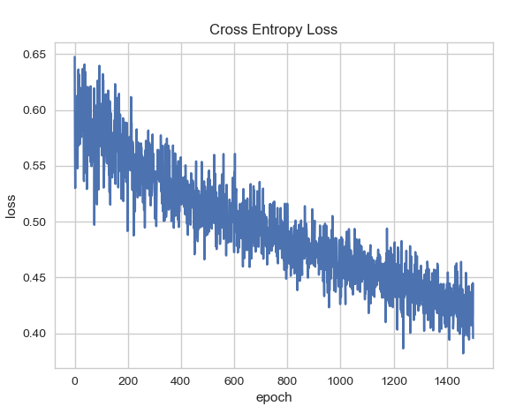

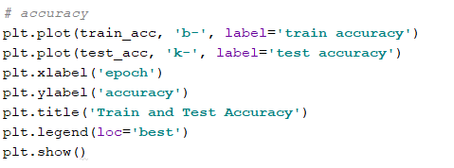

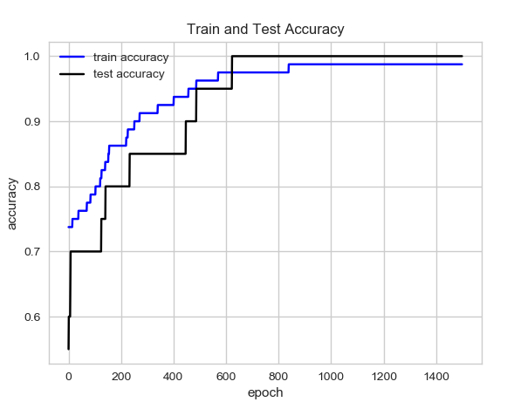

**Datasets**

<https://github.com/harshasaranam/deep-learning/blob/master/Assignment-01/documentation/Iris.csv>

**Parameters**

Here, I’m considering learning rate and batch size as my parameters to differentiate it.

Learning rate, batch size.

**Use-cases for changing parameters**

* learning_rate = 0.003  
  batch_size = 30
* learning_rate = 0.003  
  batch_size = 50
* learning_rate = 0.005  
  batch_size = 30

**Evaluation & Discussion**

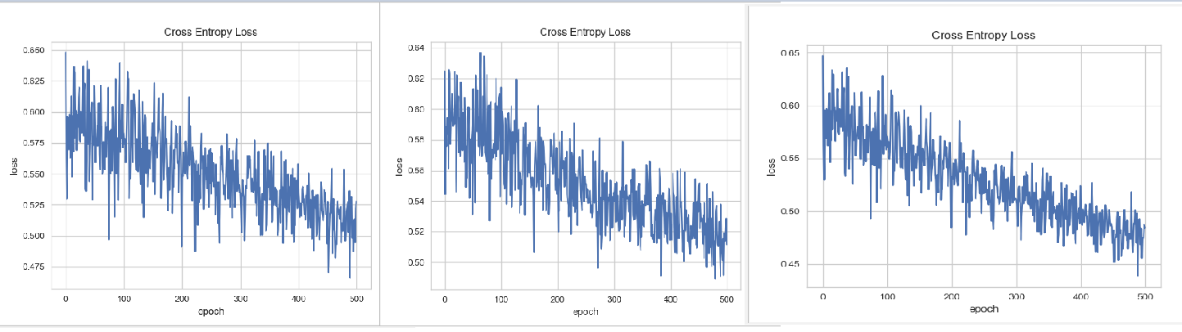

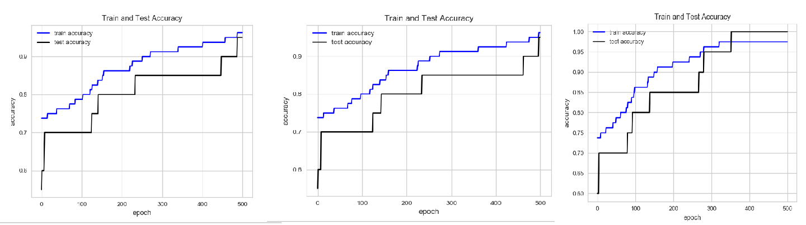

Based on the changing parameters, the above pictures shows the difference in the results.

**Conclusions:**

Tasks are performed by changing the parameters using the logistic regression.