**Introduction:**

Here, in this assignment, I performed CNN, RNN and LSTM model on the idmb reviews to find the accuracy and loss on different parameters.

**Objectives:**

To implement the CNN, RNN and LSTM model to classify the data which is not used in class. I have used idmb dataset to find the accuracy and loss on different parameters.

**Approaches/methods:**

Created demonstrate has numerous layers in which first layer has inserts words into low dimensional vectors and after that utilizing different channel sizes convolution is performed by the following layers.

**Workflow:**

After gathering the required information, I kept running beneath orders on the model to prepare and anticipate the outcome.

**Datasets:**



**Parameters:**

Here, I have chosen batch size as my parameter to differentiate the accuracy.

**Evaluation & Discussion:**

On training the data, we get the following graph as a result from the logs session.

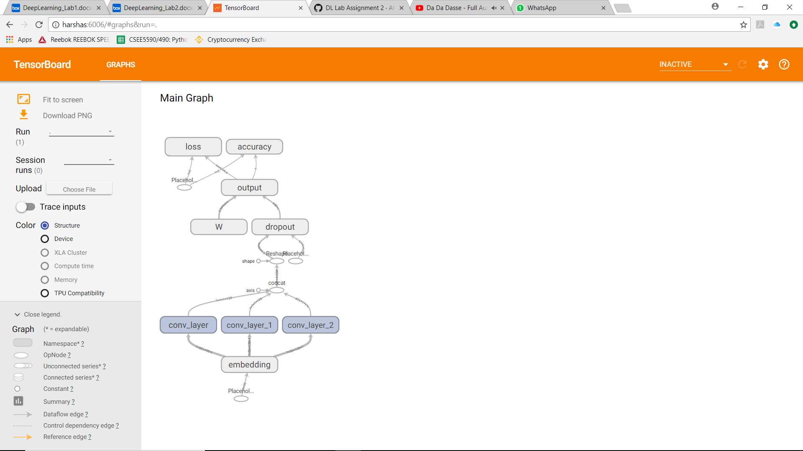

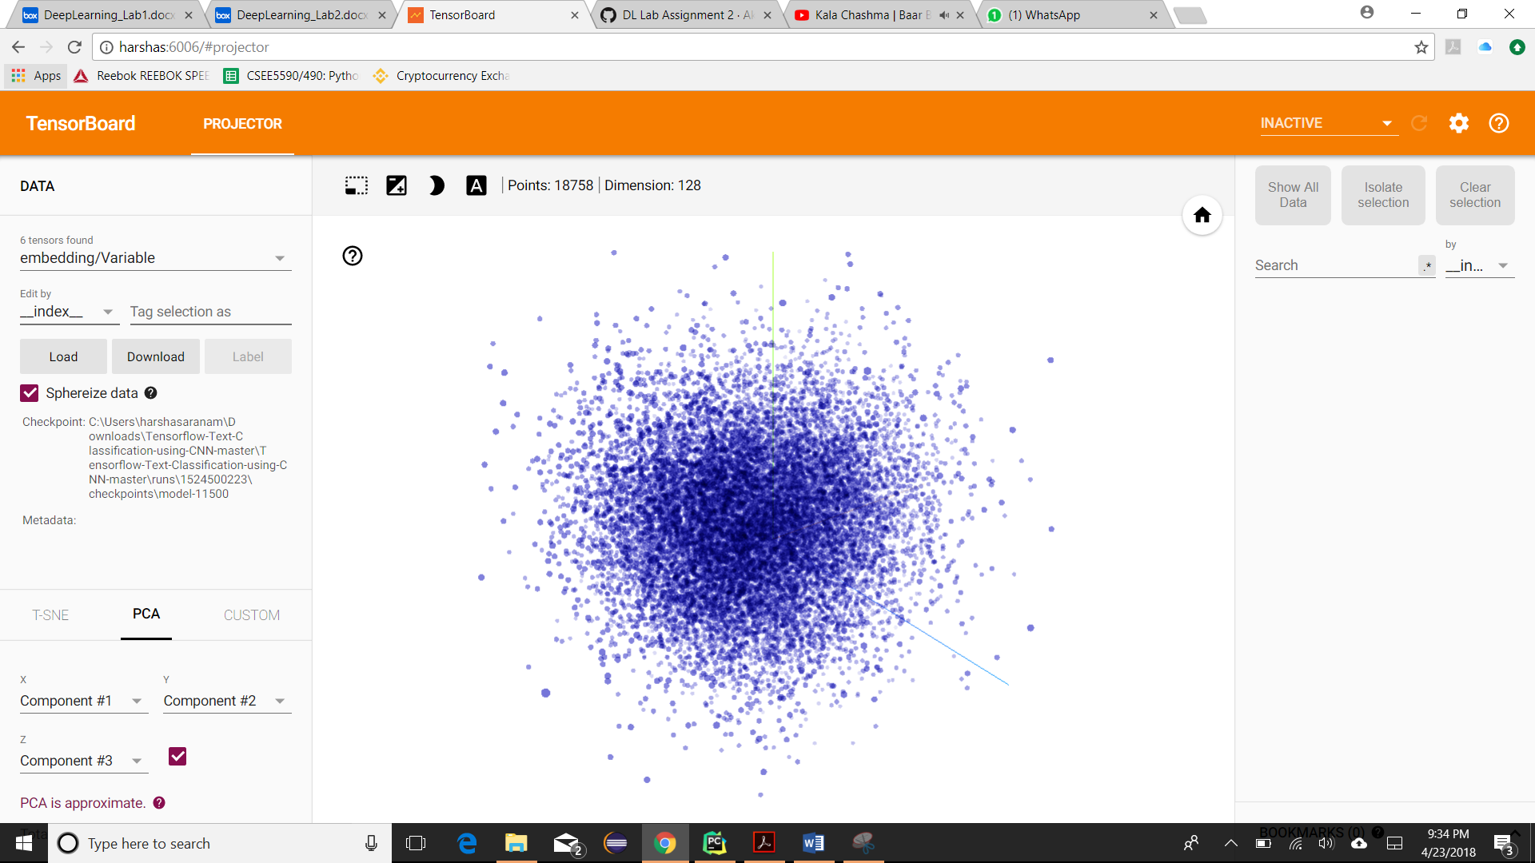

The code that we executed to provide the graph and trained.

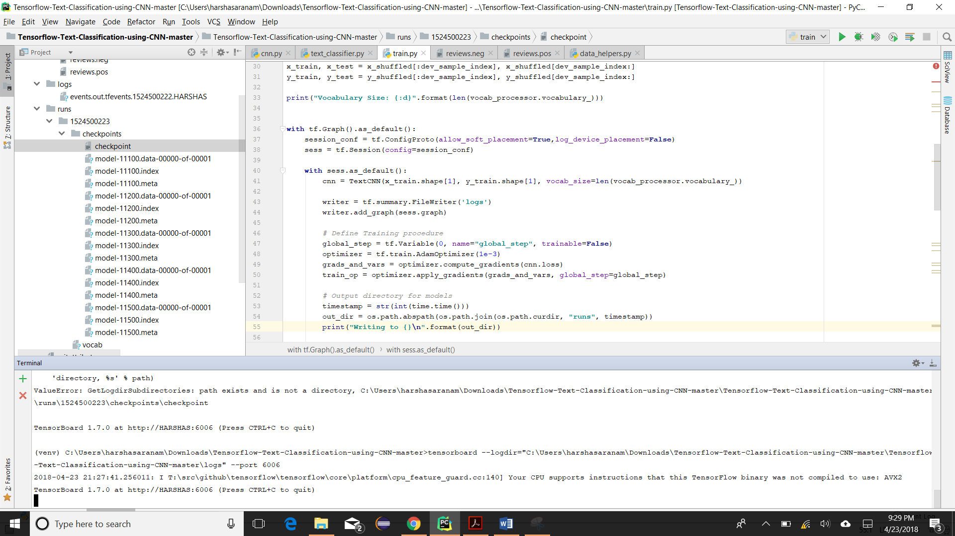

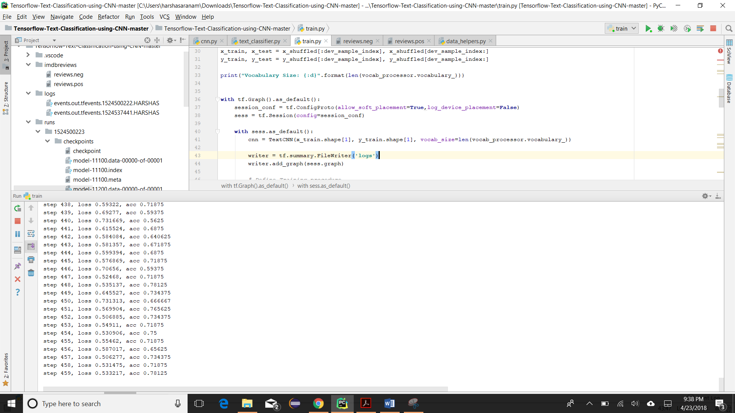

After changing the batch size parameter,

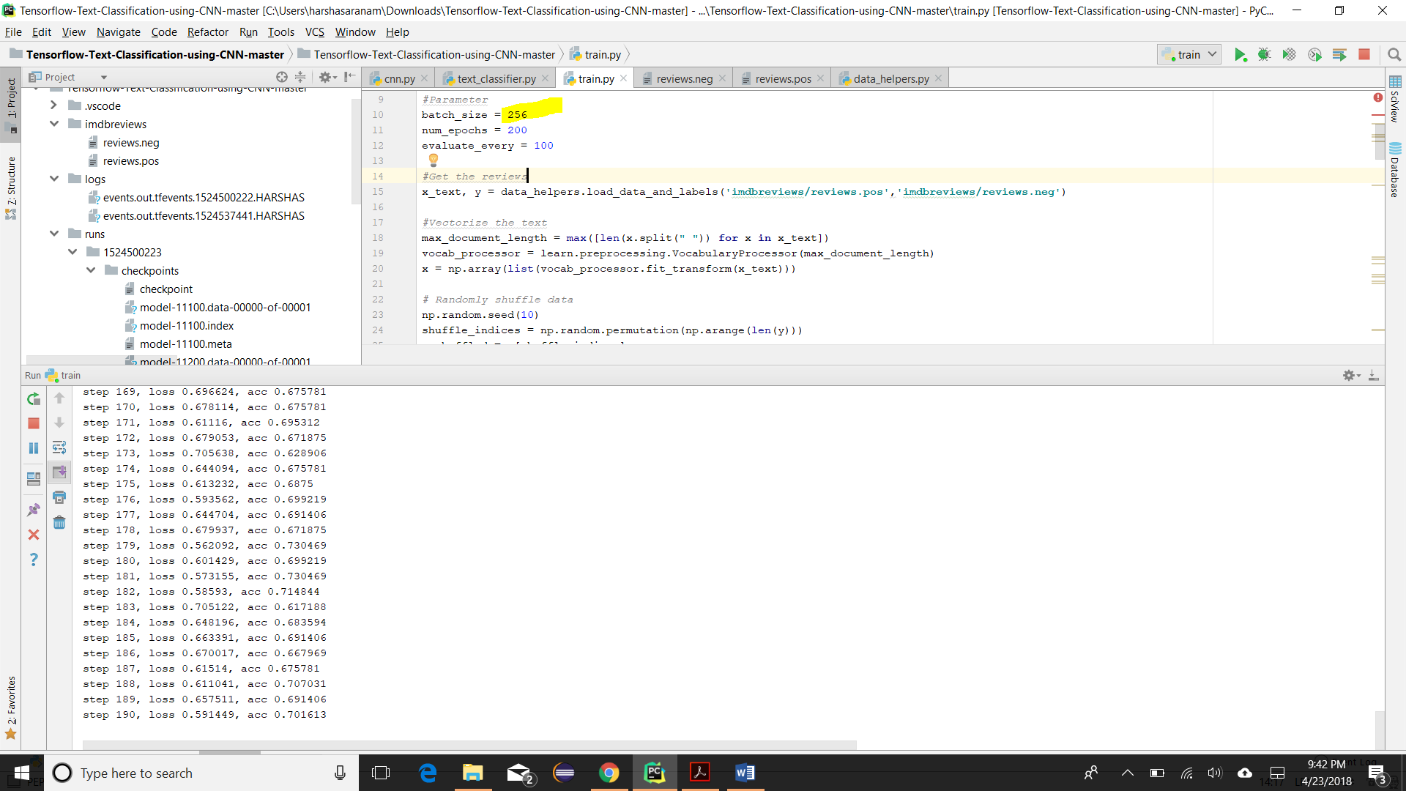

On changing the batch size, the time taking to process the data is slow, but accuracy increases.

Batch size is increased from 64 to 256, to differentiate.

Conclusion:

Finally, with the increase in the batch size, accuracy increased and time taking is also increased.