Please use MSSQL/MYSQL/Oracle for the following, First question(Q1) is mandatory:

1. Write a SQL query to create these tables in your database with the following characteristics:

a. Add the primary key “Emp_ID” to the Employees Table. Also, mention what are the constraints used in SQL.

b. Add foreign key “EMP_REF_ID” in Variables Details and Designation Table that references “Emp_ID” in Employees Table

2. What are the four different types of joins? Give examples of each by performing the joins on the Employees table and Designation Table.

4 types of Joins are:

Full Outer Join : Common records if in both tables the column on join has same value then such records are taken plus the rest of the records are also taken.

Inner Join : Only the matched records are taken from both tables.

Left Inner Join : The matched records from both tables and rest unmatched records of the left table

Right Inner Join: The matched records from both tables and rest unmatched records of the right table

Let’s do join on employees and designation table for instance based on the empid column

|  |  |  |  |  |  |
| --- | --- | --- | --- | --- | --- |
| **EMP_ID** | **FIRST_NAME** | **LAST_NAME** | **SALARY** | **JOINING_DATE** | **DEPARTMENT** |
| 001 | Manish | Agarwal | 700000 | 2019-04-20 09:00:00 | HR |
| 002 | Niranjan | Bose | 20000 | 2019-02-11 09:00:00 | DA |
| 003 | Vivek | Singh | 100000 | 2019-01-20 09:00:00 | DA |
| 004 | Asutosh | Kapoor | 700000 | 2019-03-20 09:00:00 | HR |

|  |  |  |
| --- | --- | --- |
| 001 | Asst. Manager | 2019-02-20 00:00:00 |
| 3 | Senior Analyst | 2019-01-11 00:00:00 |
| 8 | Senior Analyst | 2019-04 -06 00:00:00 |
| 5 | Manager | 2019-10-06 00:00:00 |

Full Join:

The first rows are matched and all the rest rows will also be joined and if corresponding table not having value in that column it will be filled with null

Inner Join, Only the matched rows are fetched, so here only the first row

Left Inner Join, The first matched row and the rest 3 rows of the left table( here employees)

Right Inner Join, The first matched row and the rest 3 rows of the right table( here employees)

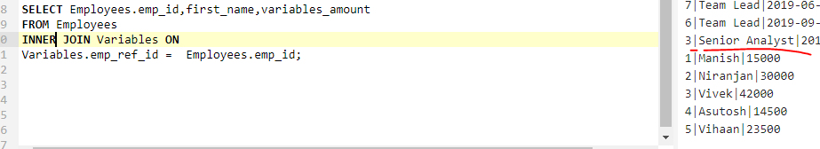

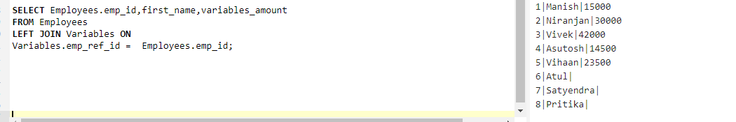

a. Write a query to get the employee details(full name and department) who received the highest and the least variables

b. Write a query to get the designation which has got the highest and second lowest amount (salary + variables) for the whole year of 2019. Get the corresponding amount values.

c. What is cross join? Write a query to give an example of the same by performing it on the Employees table and Designation table.

d. What are the clauses used with Select statements and what are the orders of it? Write a query to get the employee details who got their designations updated in the second half of the year 2019(July to December), sorted by the “variables_amount” (highest to lowest) where the department name of the Employee has the letter ‘A’ in it.

3. What is a Cursor? Write a query/queries to use the cursor to store the Employees Name( full name) for the HR department into a variable called ‘emp_names’

a. What is Normalization and explain different forms of normalization with examples. (preferable with the above tables)

Normalization is the process to have tables in an organized fashion to adhere to business constraints and logic.

3 types of Normalisation are there:

1ST Normal Form – atomicity, every attribute should comprise of single value and not composite values,if composite separate them into separate columns

2ND Normal Form – any table in 1NF should not have partial dependency in cases of composite primary keys this violates

3rd Normal Form – Transient Dependency – the attributes other than primary key columns should not have any sort of dependency on other non primary attributes

b. What is the stored procedure? Write a stored procedure to call the query that you have written for Q2.a

Please find my responses in the below

