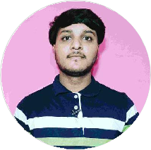
Dheeraj R Handral

Electronics and Communication Engineer
To work sincerely and honestly to the best to my ability and potential to contribute the overall growth of Organisation

agrawaldk0000@gmail.com 7353XXXX36 Aligarh, India

EDUCATION

B.E(Electronics and Communication Engineer)(Student)

Don Bosco Institute of Tecnology

Banglore.
11/2020- Currently student 6.0CGPA

PUC(PCMC)

Surana Ind.PU College,Banglore
05/2018 - 03/2020, 79%

High School

Hongirana School of Excellence
04/2013 - 05/2015, 72%

INTERNSHIP

SKILLS
Time Management

Eﬀective Communication
Problem Solving

Leadership

TECHNICAL SKILLS
Designing Software( Autocad and Solidwoorks) Coding Languages ( Python, C++ )
MS oﬃce

PROJECT (3rd year)

Water quality monitoring system:-
The system mainly was to detect the quality of water and constantly monitor TDS and temperature of water. It consists
of TDS and temperature sensors, arudino uno board. Sensor continue to read values of water and the values are displayed
on computer/laptop.

LANGUAGES
Kannada
Full Professional Proﬁciency

English
Full Professional Proﬁciency

INTERESTS
Creating Videos
Creativity
Reading

